**EXPERIMENT 4**

**Title:** Convolution of two sequences using graphical methods and using commands verification of the properties of convolution

**Objective:**

1. Understand the principle of linear convolution between two finite sequences

2. Compute the discrete LTI system output

**Theory:**

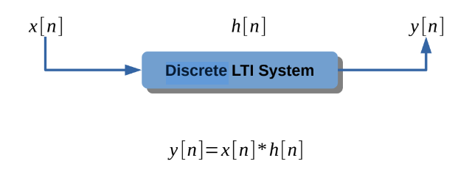

**Program:**

import numpy as np

import matplotlib.pyplot as plt

xn = np.array([1, -1, 2, -1, 3])

lx = xn.size

ix = -1

hn = np.array([1, -1, 1])

lh = hn.size

ih = -1

ly = lx + lh - 1

iy = ix + ih

yn = np.zeros(ly)

for i in range(lx):

for j in range(lh):

yn[i + j] += (xn[i]*hn[j])

print("Input = ",xn)

print("Impulse response = ",hn)

print("Output = ",yn)

nx = np.arange(ix,ix+lx)

nh = np.arange(ih,ih+lh)

ny = np.arange(iy,iy+ly)

plt.figure(figsize=(12,8))

plt.subplot(3, 1, 1)

plt.stem(nx, xn, label = "Input")

plt.xlim([min(ny)-1,max(ny)+1])

plt.grid()

plt.subplot(3, 1, 2)

plt.stem(nh, hn, label = "Impulse response")

plt.xlim([min(ny)-1,max(ny)+1])

plt.grid()

plt.subplot(3, 1, 3)

plt.stem(ny, yn, label = "Output")

plt.xlim([min(ny)-1,max(ny)+1])

plt.grid()

plt.show()

**Output:**

Input = [ 1 -1 2 -1 3]

Impulse response = [ 1 -1 1]

Output = [ 1. -2. 4. -4. 6. -4. 3.]

