**Project 2**

1. **Setup highly available sharded cluster**
2. **Set up 4 shard servers** on 4 different VM’s with same command as below:

mongod.exe -f "C:\Program Files\MongoDB\Server\3.4\conf\mongo-shard.cfg" --install --serviceName MongoSH01 --serviceDisplayName MongoSH01 --serviceDescription "Mongo Shard 1" –shardsvr

Didn’t assigned different ports as I had 4 VM’s and could run it on default shard port i.e. 27018 on each server. Same config file mongo-shard.cfg file used on all 4 shards as below:

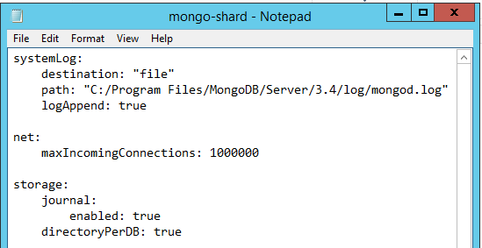

1. **Set up 3 replicated config servers** on 3 different VMS with below command:

mongod.exe -f "C:\Program Files\MongoDB\Server\3.4\conf\mongo-configset.cfg" --install --serviceName MongoCF01 --serviceDisplayName MongoCF01 --serviceDescription "Mongo Config Server" --configsvr --replSet CF01

Didn’t assigned different ports for Config servers as I had 3 different VM’s and could run it on default replication port i.e. 27019 on each server. Same config file mongo-configset.cfg file used on all 3 config servers as below:

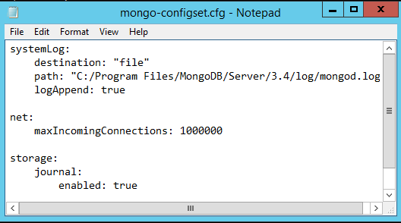

Run commands as per below for configuring replication by connecting one of the config server:

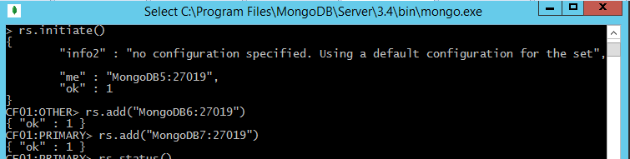

1. **Set up 2 routers** on 2 different VMS with below command:

mongos.exe -f "C:\Program Files\MongoDB\Server\3.4\conf\mongo-router.cfg" --install --serviceName MongoRT --serviceDisplayName MongoRT --serviceDescription "Mongo Router"

Didn’t assigned different ports for routers as I had 2 different VM’s and could run it on default router port i.e. 27017 on each server. Same config file mongo-router.cfg file used on all 2 routers as below:

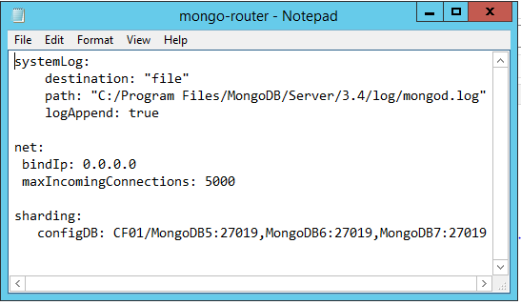

Run commands as per below for configuring shard information by connecting one of the config server:

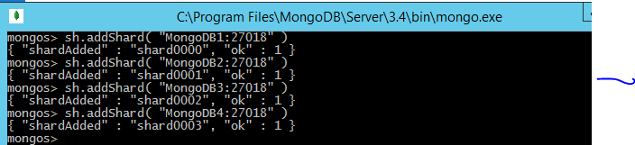

1. **Downloaded and imported some CSV’s for project as per below**

mongoimport --port 27017 --db proj2 --collection Addressing --type csv --file C:\MongoDB\911_Addressing_-_Street_Name_Master_List.csv –headerline

mongoimport --port 27017 --db proj2 --collection Consumer_Complaints --type csv --file C:\MongoDB\Consumer_Complaints.csv –headerline

1. **Shard the DB and collection** as per below:

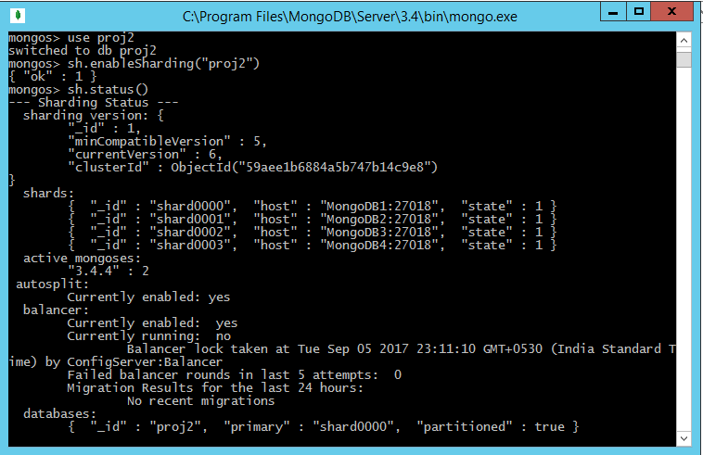



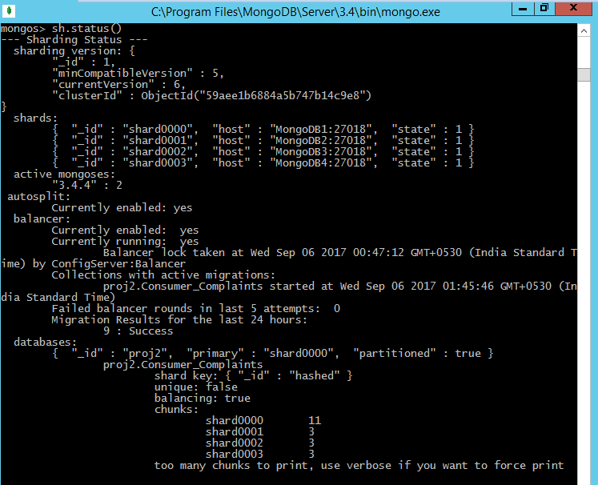

1. **Create indexes**

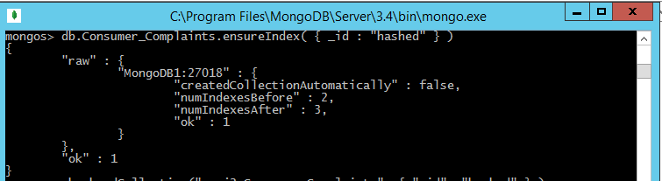

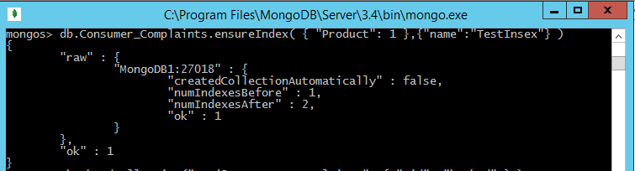

1. Perform aggregation to create sample reports and dashboards
2. In below example aggregation in Mongo used to check Complaints related to Credit Cards

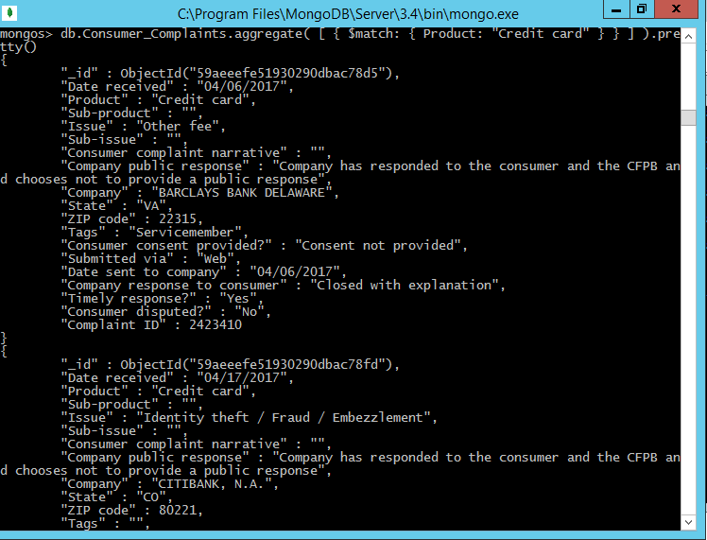

1. Below report was taken from Purchase orders using Mongo Aggregation to get total amount paid per Vendor in Austin City

