CS3543 Lab Assignment 1

Member 1: RAJ DEEPAKNATH PATIL (CS18BTECH11039)

Member 2: DEEPANSHU CHOUHAN (CS18BTECH11009)

Member 3: HIMANSHU BISHNOI (CS16BTECH11018)

Member 4: VIJAY PONNEKANTI (CS16BTECH11028)

# General Instructions

1. This assignment must be conducted and submitted by a group of students (at least 2 members, up to 4 members). The same mark will be offered to the students in the same group regardless of individual contributions.
2. The assignment is customized for Ubuntu + KVM environment. It is highly recommended for non-Ubuntu users to enable dual boot on your laptop computer and install Ubuntu. If you would like to work on another operating system and virtualization platform, you need to interpret the Ubuntu/KVM terminology to another environment's terminology.
3. Each group should create a locally copy of this question file and the supplemental presentation file, give the answer to the local copy, and submit in a form of PDF file.
4. Only up to one submission must be made per group.
5. Name and Student ID of all the group members must be mentioned. Any student, whose name and student ID are not properly mentioned, may not receive marks no matter how much his/her contribution could be.
6. Do not send any private comment to separately mention the name and student ID of group members.
7. If you want to send a pcap file from a VyOS VM to your host Ubunt, you can give an IP address to the linux bridge which the VyOS VM connects to. You may enable sshd on the VM and use scp on the host Ubuntu.

# Warming Up

In this lab assignment, each team is requested to form the network using Linux Bridge and VMs running Ubuntu servers and VyOS routers. R1, R2, R3 are routers, H1 and H2 are hosts. The IP address for each subnet has not been fixed. You need to fix the prefix information and properly note down to configure the hosts and routers based on it. 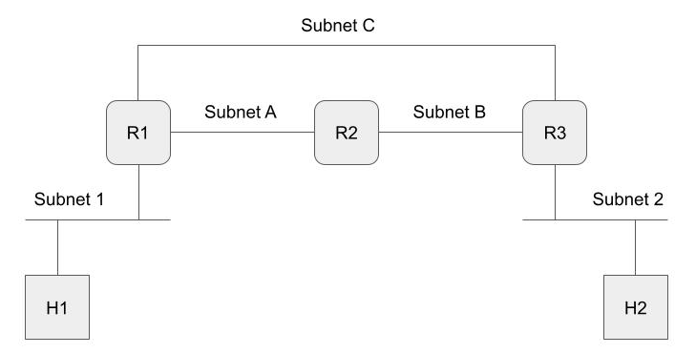

Question 1. (5 marks all together)

Fill the blanks in Table 1 to clarify NIC and IPv4 to belong to Subnets 1 to 4. If there is no corresponding NIC belonging to a subnet, mention “N/A”. All the prefixes must be planned by yourself.

|  |  |  |  |  |  |  |
| --- | --- | --- | --- | --- | --- | --- |
|  | **Linux Bridge** | **H1** | **H2** | **R1** | **R2** | **R3** |
| **Subnet 1** | **LBr1** | *eth0*  *192.168.10.1/24* | N/A | *eth0*  *192.168.10.2/24* | N/A | N/A |
| **Subnet 2** | **LBr2** | N/A | *eth0*  *192.168.11.1/24* | N/A | N/A | *eth0*  *192.168.11.2/24* |
| **Subnet A** | **LBrA** | N/A | N/A | *eth1*  *192.168.12.1/24* | *eth0*  *192.168.12.2/24* | N/A |
| **Subnet B** | **LBrB** | N/A | N/A | N/A | *eth1*  *192.168.13.1/24* | *eth1*  *192.168.13.2/24* |
| **Subnet C** | **LBrC** | N/A | N/A | *eth2*  *192.168.14.1/24* | N/A | *eth2*  *192.168.14.2/24* |

Question 2. (5 marks)

Illustrate the network diagram that appropriately contains the information given in Table 1. The full mark will be given if the network diagram fully covers the information given in the table. (Linux Bridge and other information must also be mentioned for the sake of explainability of answers to the following questions). The original presentation file can be locally copied to your Google Drive and used to work on this assignment.

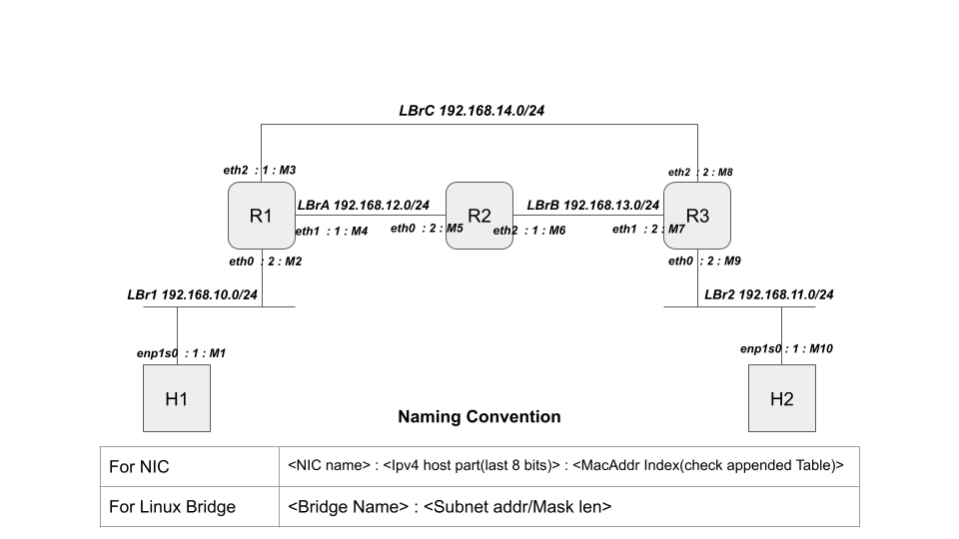

Mac Addr Index (check figure above)

|  |  |  |  |
| --- | --- | --- | --- |
| Mac addr index | Mac addr | Mac addr index | Mac addr |
| M1 | *52:54:00:3d:0d:cb* | **M6** | *52:54:00:21:97:c8* |
| M2 | *52:54:00:65:f9:ba* | **M7** | *52:54:00:67:a6:2b* |
| M3 | *52:54:00:32:f7:34* | **M8** | *52:54:00:32:ae:79* |
| M4 | *52:54:00:eb:f9:16* | **M9** | *52:54:00:c5:bd:38* |
| M5 | *52:54:00:6e:94:af* | **M10** | *52:54:00:63:d4:41* |

# NIC configuration and Static Routing Instruction

1. Configure all NICs of the hosts and routers (H1, H2, R1, R2 and R3) as planned in Table 1 and the network diagram.
2. Manually configure the routing table of all the routers so that 1) the path from H1 to H2 is always {H1 -> R1 -> R3 -> H2} and 2) the path from H2 to H1 is always {H2 -> R3 -> R2 -> R1 -> H1}.
3. Make sure that H1 and H2 can ping with each other.

Question 3.1 (5 marks)

Paste the screen capture of the ping command from H1 and H2 to show that the static routing configuration is working to allow H1 and H2 to communicate with each other.

H1 to H2

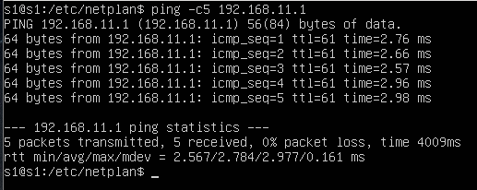

H2 to H1

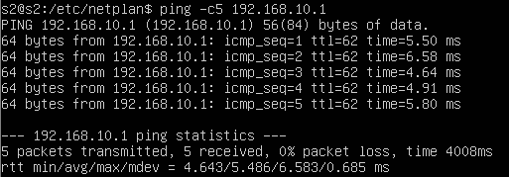

Question 3.b (5 marks)

Paste the screen capture of the routing table of R1.

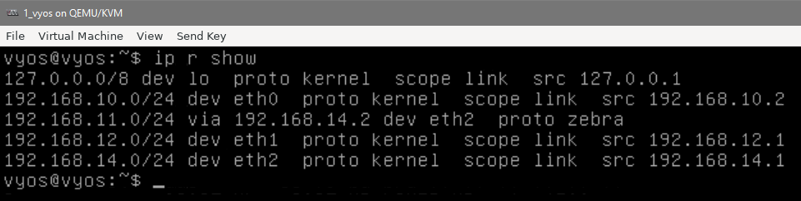

Question 3.c (5 marks)

Perform traceroute from H1 to H2 so that the path is following the instruction. Paste the screen capture of the traceroute result of H1.

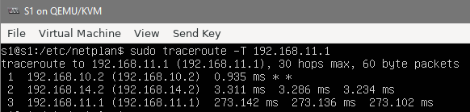

Question 3.d (5 marks)

Perform traceroute from H2 to H1 so that the path is following the instruction. Paste the screen capture of the traceroute result of H2.

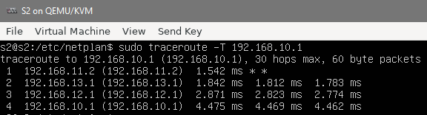

Question 3.e (5 marks for the perfect answer.)

When a packet from H1 to H2 is transmitted by R1, whose MAC address is set as the destination address in the Ethernet header? Answer the names of node and NIC respectively.

Short Answer:

NIC name and Node: ***eth2 of Router 3(router3) with MacAddress as M8 i.e. :*** *52:54:00:32:ae:79*







Proof:

Running tcpdump on R1 and R3 filtering packets as follows and use `-e` to observe the ethernet headers:

Pinging H1 to H2:

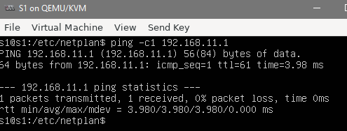



Tcpdump output on R1:

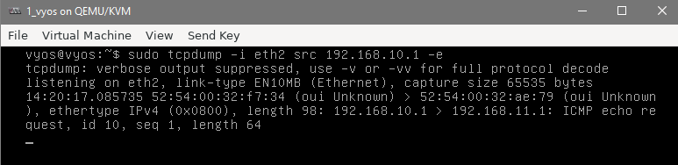



Tcpdump output on R3:

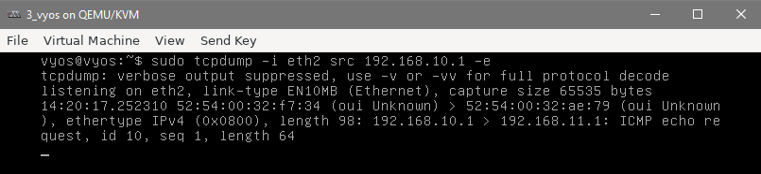



#

# Dynamic Routing Instruction using OSPF

#

1. Flush the static routing configuration from all the routers.
2. Enable tcpdump on both of R1’s NICs, on which OSPF is enabled,and save (write) the captured packets. The packet capture files will be used to answer a question.
3. Enable OSPF. You can configure all the NICs of routers to belong to Area 0.
4. Make sure that H1 and H2 can ping with each other.

Meta Information:

Router-ids in the configuration have been set as shown below and the all of them have been set to area 0 as requested in the question.

|  |  |
| --- | --- |
| Router | Router id in ospf configuration |
| R1 | 0.0.0.1 |
| R2 | 0.0.0.2 |
| R3 | 0.0.0.3 |

Question 4.a. (5 marks all together)

Perform traceroute from H1 to H2 as well as from H2 to H1. 1) Explain the path of both directions, 2) paste the screen captures of traceroute for both directions.

1. In both cases, this time, The shorter path is chosen – the one that skips R2 completely i.e. the one that uses the linux Bridge LbrC.

* Output for H1 to H2

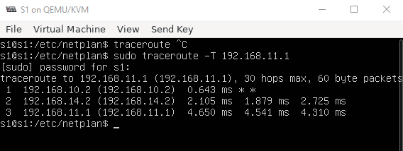

* Output for H2 to H1

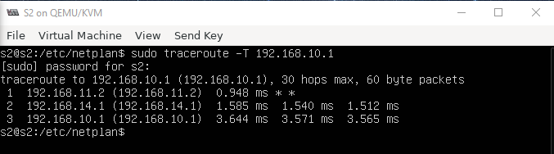

Question 4.b (5 marks all together)

Paste screen captures of 1) the routing table of R1, and 2) the list of OSPF neighbors.

1. Routing table of R1

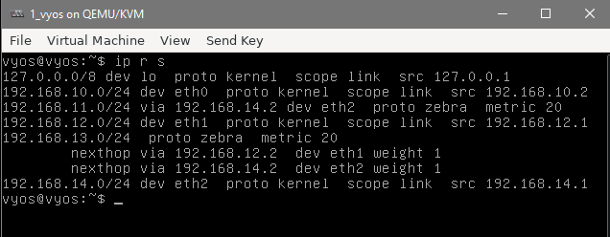

1. OSPF Neighbors

* Summary

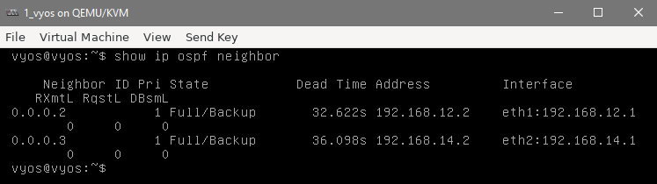

* Complete info

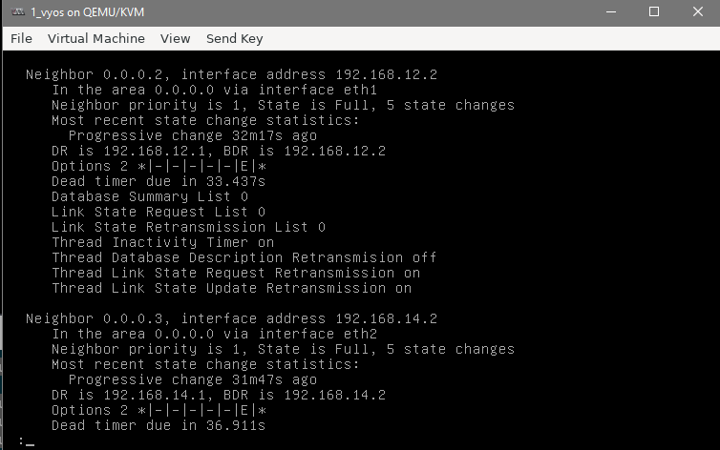

Question 4.c (5 marks all together)

Revise your OSPF configuration of each router so that the traffic between H1 and H2 always goes through the path {H1 <---> R1 <---> R2 <---> R3 <---> H2}. 1) Explain what kind of revision you made on which router. Also, 2) paste the screen capture of traceroute between H1 and H2 to show that the above mentioned path is successfully implemented.

1. To change the link-weights of the path between R1🡨🡪 R2 🡨🡪 R3, I explicitly lowered the costs on those interfaces using the following commands for the each of the routers.

Note that the default cost set by vyos was found to be 10 so I used the minimum possible cost (1) as with the following commands:

1_vyos(R1):

*set interfaces ethernet eth1 ip ospf cost 1*

2_vyos(R2):

*set interfaces ethernet eth1 ip ospf cost 1*

*set interfaces ethernet eth0 ip ospf cost 1*

3_vyos(R2):

*set interfaces ethernet eth1 ip ospf cost 1*

Now, The routers use the length 2 path via R2 rather than the other length 10 path.

1. Traceroute from H1 to H2:

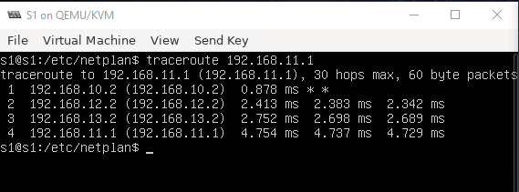

1. Traceroute from H2 to H1:

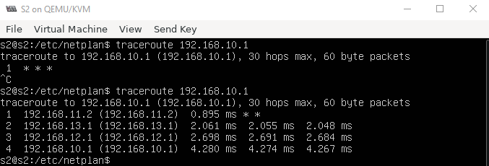

Question 4.d (5 marks)

Shutdown R2, and explain what happens to the routing table of R1 after R2 becomes down.

Routing table of R1 :

**BEFORE** SHUTDOWN of R2

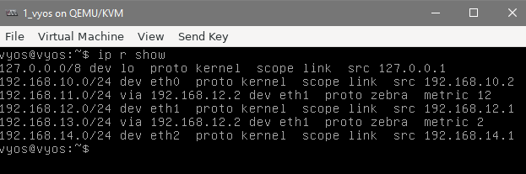



**AFTER** SHUTDOWN of R2

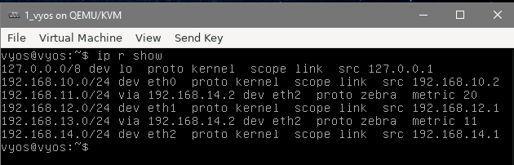



Notice the changes highlighted in the BEFORE AND AFTER screenshots. As R2 was shutdown, R1 now has to route directly to R3 which can be seen on the NIC Ip addrs that are paired with the highlighted subnets. These subnets correspond to LBr2 and LBrB which were previously being accessed via R3.



To further clarify that argument note the changes in the preferred changes corresponding from eth1(connects to R2) to eth2(connect R3).

Question 4.e (5 marks)

Observing the packet capture data at R1, explain what kind of OSPF messages flew from/to R1 after R2 becomes down.

Running the following command on R1 before shutting down R2

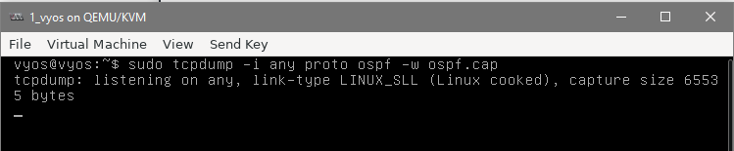

And observing the capture logs:

Using sudo tcpdump -ttttnnr ospf.cap

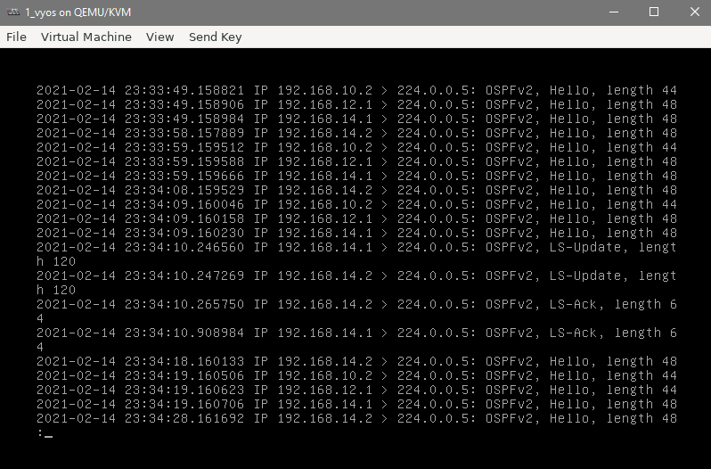



Ignoring the Hello before and after the shutdown (which are just maintenance messages(they keep of verifying the existence of the links))

Note the multicast messages from .14.1 and .14.2 : they are both corresponding to the NICs on LBrC are LS-Update and LS-Ack messages (a pair for both of them).

These are link-state update and acknowledgement messages which update the shortest path database on all the routers after R2 is down.



Done!!