Final Project Report
On
Predictive Analytics and Explainable AI for Hospital Readmission Risk

Faculty of Graduate Studies and Research

CS 719 - Data Science Project

Winter 2026

Prepared By:
Raj Panchal [200490453]

Instructor:
Howard J. Hamilton

Table of Contents

1. Introduction
1.1 Main Idea of the Project
1.2 Type of Research Problem
1.3 Problem Specification
1.4 Why It Is Useful
1.5 Outline of the Report
2. Background
2.1 Previous Related Projects
2.2 Existing Techniques Relevant to the Project
2.3 Analysis of Strengths and Weaknesses
2.4 Learning Resources
3. Approach
3.1 Data Source
3.2 Methodology
3.3 Worked Example
3.4 Software Description
3.5 Processing Time and Space
4. Implementation
4.1 Software Stack and Versions
4.2 Module Structure
4.3 Three Crucial Code Snippets
5. Results of Running Software
5.1 Dataset and Experiments
5.2 Model Training and Evaluation
5.3 Threshold Optimization
5.4 Explainability Results
5.5 LACE Index vs. XGBoost Comparison
5.6 Streamlit Dashboard
5.7 Connection to Recent Research
6. Conclusions
7. Suggestions for Future Research
8. References

1. Introduction
1.1 Main Idea of the Project
Hospital readmissions within 30 days are a major concern for healthcare systems worldwide, as they indicate gaps in quality of care and significantly increase healthcare costs. According to the Centers for Medicare and Medicaid Services (CMS), preventable readmissions cost the U.S. healthcare system over $26 billion annually, and hospitals face financial penalties under the Hospital Readmissions Reduction Program for excessive 30-day readmission rates.
This project focused on developing a predictive analytics framework to estimate the risk of 30-day hospital readmission for diabetic patients using the Diabetes 130-US Hospitals dataset, which contains 101,766 patient encounters collected from 130 U.S. hospitals between 1999 and 2008. The central idea was to combine classical machine learning models with model-agnostic explainability techniques, specifically Permutation Feature Importance (PFI) and Partial Dependence Plots (PDP), to make the predictions understandable to non-technical stakeholders such as clinicians and healthcare administrators.
Beyond building a predictive model, I also implemented a head-to-head comparison between the trained XGBoost model and the LACE Index, a rule-based scoring system widely used in Canadian hospitals for readmission risk assessment [van Walraven et al., 2010]. Both methods were evaluated on the same held-out test set using the same ground truth labels, making the comparison direct and fair.
1.2 Type of Research Problem
This project addresses a supervised binary classification problem in applied data science. Given historical patient encounter data, the task was to predict whether a patient would be readmitted to the hospital within 30 days of discharge. The target variable was derived from the original three-class label (readmitted in less than 30 days, more than 30 days, or not readmitted) by converting it into a binary outcome: 1 for readmitted within 30 days and 0 for everything else.
Rather than proposing a new algorithm, the project focused on practical, industry-oriented data science workflows commonly used in healthcare analytics, including real-world data preprocessing, model development and evaluation, threshold optimization for clinical utility, and explainability of predictions.
1.3 Problem Specification
Input:
• The Diabetes 130-US Hospitals dataset containing structured tabular data with 50 features
• Patient demographics, admission details, ICD-9 diagnosis codes, medications, and hospital utilization variables
Output:
• A binary prediction (0 = not readmitted within 30 days, 1 = readmitted within 30 days)
• Model evaluation metrics: Accuracy, Precision, Recall, F1-score, and ROC-AUC
• Feature importance rankings using Permutation Feature Importance (PFI)
• Partial Dependence Plots showing how key features influence readmission risk
• LACE Index scores for every test patient, compared directly against the ML model
• An interactive Streamlit dashboard for real-time patient risk assessment
1.4 Why It Is Useful
Predicting hospital readmissions has direct clinical value. If a hospital can identify patients at high risk of returning within 30 days, it can allocate resources for targeted follow-up care, such as post-discharge phone calls, medication reviews, or outpatient appointments. Missing a high-risk patient is far more costly than a false alarm: a flagged patient simply gets extra follow-up, while a missed one may end up back in the emergency room.
The explainability component is equally important. Clinicians are unlikely to trust a model that just outputs a number without explaining why. By showing which features drove each prediction and how they compare to the population average, the system provides transparency that supports informed decision-making rather than blind reliance on a black box.
1.5 Outline of the Report
The remainder of this report is organized as follows. Section 2 covers background information, including previous related projects, a review of relevant techniques, and an analysis of their strengths and weaknesses. Section 3 describes the approach taken, including the data source, methodology, a worked example, and the software produced. Section 4 covers the implementation details, including the software stack, module structure, and three crucial code snippets. Section 5 presents the results of running the software, including model evaluation, threshold optimization, explainability analysis, the LACE comparison, and a connection to recent research. Section 6 provides conclusions, and Section 7 discusses suggestions for future research. Section 8 lists all references cited in this report.
2. Background
2.1 Previous Related Projects
In a previous graduate course (CS 715), I completed a project on "Enhanced Face Generation and Image Quality Improvement Using Deep Convolutional Generative Adversarial Networks (DCGANs)." That project involved building and training a DCGAN architecture on a face image dataset, evaluating the quality of generated images using metrics such as Inception Score and FID, and analyzing the training dynamics of the generator and discriminator networks.
While the domain was different (computer vision vs. healthcare analytics), several skills transferred directly to the current project: data preprocessing and cleaning, model training and hyperparameter tuning, evaluation metric selection, and the use of Python libraries such as NumPy, Pandas, and Matplotlib. The CS 715 project also reinforced the importance of clearly presenting results through visualizations and structured analysis, which I applied extensively in this project.
This project extended my prior experience by explicitly focusing on interpretable machine learning, which is critical in healthcare applications where trust and transparency are essential. Unlike image generation where visual inspection suffices, clinical predictions require explanations that a doctor can understand and act on.
2.2 Existing Techniques Relevant to the Project
Several machine learning and explainability techniques were relevant to this project. I reviewed each of these before deciding which to use, drawing on course material from CS 719, the scikit-learn documentation [Pedregosa et al., 2011], and the textbook "Interpretable Machine Learning" by Christoph Molnar [Molnar, 2022].
Logistic Regression
Logistic Regression is a linear classifier that models the probability of a binary outcome as a logistic function of the input features. It is inherently interpretable because its coefficients directly indicate the direction and magnitude of each feature's influence. However, it assumes a linear relationship between features and the log-odds of the outcome, which limits its ability to capture complex patterns in the data. I used it as a baseline model to compare against more complex classifiers.
Random Forest
Random Forest is an ensemble method that trains multiple decision trees on random subsets of the data and features, then averages their predictions [Pedregosa et al., 2011]. It handles non-linearity and feature interactions well and is relatively resistant to overfitting. The downside is that the ensemble of hundreds of trees is difficult to interpret directly, which is why post-hoc explainability techniques like PFI are needed.
XGBoost (Extreme Gradient Boosting)
XGBoost is a gradient boosting framework that builds trees sequentially, where each new tree corrects the errors of the previous ones [Chen and Guestrin, 2016]. It is widely used in data science competitions and applied research because of its strong performance on structured tabular data. Like Random Forest, it is a black-box model, but its predictions can be explained using techniques like PFI and PDP. I selected XGBoost as one of the three candidate models because of its known effectiveness on healthcare datasets.
SMOTE (Synthetic Minority Over-sampling Technique)
SMOTE addresses class imbalance by generating synthetic samples of the minority class rather than simply duplicating existing ones [Chawla et al., 2002]. It works by interpolating between existing minority-class samples and their nearest neighbors. I applied SMOTE only to the training set (not the test set) to avoid data leakage, which is a common mistake in readmission prediction studies as noted by Guo et al. [2025].
Permutation Feature Importance (PFI)
PFI measures the importance of each feature by randomly shuffling its values and observing how much the model's performance drops [Molnar, 2022]. A large drop means the feature is important. PFI is model-agnostic, meaning it works with any classifier, and it measures importance on the actual test set rather than relying on training-time statistics. I used PFI scored on ROC-AUC to identify the top predictors of readmission.
Partial Dependence Plots (PDP)
PDPs show how the predicted outcome changes as a single feature varies while all other features are held constant [Molnar, 2022]. They provide an intuitive visualization of the relationship between a feature and the prediction. For example, a PDP for "number of prior inpatient visits" can show whether readmission risk increases linearly or levels off after a certain point. I generated PDPs for the top features identified by PFI.
LACE Index
The LACE Index is a rule-based clinical scoring system developed by van Walraven et al. [2010] to predict the risk of death or unplanned readmission within 30 days of discharge. It uses four factors: Length of stay (L), Acuity of admission (A), Comorbidity as measured by the Charlson Comorbidity Index (C), and Emergency department visits in the past six months (E). A LACE score of 10 or higher indicates high risk. It is widely used in Canadian hospitals because of its simplicity: it requires no model training and can be computed by hand. I included it in this project as a clinical baseline to benchmark against the ML model.
2.3 Analysis of Strengths and Weaknesses
Strengths of the approach used in this project:
• Uses a real hospital dataset with actual patient records, not synthetic data.
• Applies PFI and PDP, which are model-agnostic and work well for clinical tabular data.
• Uses a small, focused set of models (three classifiers) rather than testing dozens, keeping the analysis clear and reproducible.
• Produces explanations for one final selected model, avoiding unnecessary complexity.
• Compares the ML model against a real clinical baseline (LACE Index) on the same test set.
• Includes an interactive dashboard that makes the results accessible to non-technical users.
Weaknesses and limitations:
• Uses only one dataset, which may limit how well the results generalize to other hospitals or patient populations.
• The data spans 1999 to 2008, so clinical practices and coding standards may have changed since then.
• Patient encounters are treated independently, even though some patients appear multiple times.
• Explainability results from PFI and PDP are interpretive, not causal. A strong association between a feature and readmission does not prove that the feature causes readmission.
• The Charlson Comorbidity Index for the LACE comparison had to be approximated from diagnosis category columns, since the dataset does not include a direct CCI field.
2.4 Learning Resources
The techniques used in this project were implemented using knowledge gained from several sources:
• Course material from CS 719, particularly the guidelines for each project deliverable and the overall data science workflow.
• Scikit-learn documentation [Pedregosa et al., 2011] for model training, evaluation metrics, and preprocessing utilities.
• "Interpretable Machine Learning" by Christoph Molnar [Molnar, 2022], an open-access textbook that covers PFI, PDP, and other explainability methods in detail.
• The XGBoost documentation [Chen and Guestrin, 2016] for understanding gradient boosting parameters and tuning strategies.
• Peer-reviewed research articles listed in Section 8, particularly Guo et al. [2025] for their systematic comparison of sampling strategies and explainability techniques on the same dataset.
3. Approach
3.1 Data Source
The project used the Diabetes 130-US Hospitals Dataset, publicly available from the UCI Machine Learning Repository [Strack et al., 2014]. The dataset contains 101,766 patient encounters from 130 U.S. hospitals collected between 1999 and 2008. Each record represents a single hospital visit for a diabetic patient and includes 50 features covering demographics (age, race, gender), admission details (type, source, discharge disposition), diagnoses (three ICD-9 codes), medications (23 diabetes-related drugs), lab results, and hospital utilization history (prior inpatient, outpatient, and emergency visits).
The original target variable had three categories: readmitted in less than 30 days, readmitted in more than 30 days, and not readmitted. I converted this into a binary target: 1 for readmitted within 30 days (11,314 encounters, 11.39%) and 0 for everything else (88,026 encounters, 88.61%). This severe class imbalance was one of the main challenges of the project.
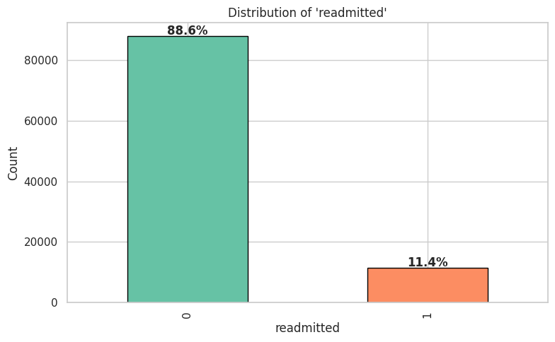
Fig 1. Binary target distribution showing the class imbalance (88.6% vs 11.4%).
3.2 Methodology
The project followed an end-to-end machine learning pipeline with eight stages. I named the resulting software system "ReAdmit-XAI" (Readmission prediction with Explainable AI). The stages were as follows:
Stage 1: Data Cleaning
I removed columns with more than 40% missing values (weight, medical_specialty, max_glu_serum, A1Cresult), dropped two zero-variance columns (examide, citoglipton), and filtered out patients who were discharged to hospice or expired (since readmission is not applicable for them). After cleaning, 99,340 encounters remained with 42 columns.
Stage 2: Feature Engineering
I created four new features from the existing data: total_visits (sum of outpatient, emergency, and inpatient visit counts), num_med_changed (count of medications that were adjusted during the visit), num_med_active (count of medications actively prescribed), and age_numeric (midpoint of the age bracket, e.g., [70-80) became 75). The three ICD-9 diagnosis code columns (diag_1, diag_2, diag_3) were mapped into nine clinical categories: Circulatory, Respiratory, Digestive, Diabetes, Injury, Musculoskeletal, Genitourinary, Neoplasms, and Other.
Stage 3: Encoding and Splitting
Categorical features were one-hot encoded, producing a final feature matrix of 46 columns. The data was split into 80% training (79,472 encounters) and 20% testing (19,868 encounters) using stratified sampling to preserve the class distribution in both sets.
Stage 4: SMOTE on Training Set
SMOTE [Chawla et al., 2002] was applied only to the training set to balance the classes, bringing both classes to 70,421 samples each. The test set was left untouched to ensure a realistic evaluation. All features were then scaled using StandardScaler.
Stage 5: Model Training and Hyperparameter Tuning
Three classifiers were trained: Logistic Regression, Random Forest, and XGBoost. For each model, I ran GridSearchCV with 3-fold cross-validation scored on ROC-AUC to find the best hyperparameters. All three models used the same preprocessed data and the same train-test split.
Stage 6: Model Evaluation and Selection
Models were evaluated on the held-out test set using ROC-AUC, accuracy, precision, recall, and F1-score. I also ran 5-fold stratified cross-validation on the training set to check stability. XGBoost was selected as the best model based on the highest test ROC-AUC (0.6648) and stable cross-validation scores.
Stage 7: Threshold Optimization
The default classification threshold of 0.50 resulted in very low recall (only 4% of actual readmissions detected). I swept thresholds from 0.01 to 0.99 and found that a threshold of 0.20 maximized the F1-score, improving recall to 35% while keeping precision at 23%.
Stage 8: Explainability and Dashboard
PFI and PDP were computed on the best model to identify and visualize the most important features. The trained model, scaler, and supporting data were exported as artifacts and loaded into an interactive Streamlit dashboard for real-time risk assessment.
3.3 Worked Example
To illustrate how ReAdmit-XAI works from input to output, here is a fully worked example for a medium-risk patient:
Sample Input:
• Age group: 60-70 (age_numeric = 65)
• Prior inpatient visits: 2
• Number of medications: 15
• Time in hospital: 5 days
• Number of diagnoses: 7
• Discharge disposition: 1 (discharged to home)
• Admission type: 1 (emergency)
• Primary diagnosis category: Circulatory
Processing Steps:
First, the raw inputs are placed into a feature vector with 46 columns matching the training format. Numeric features (age_numeric=65, number_inpatient=2, num_medications=15, etc.) are placed directly. Categorical features are one-hot encoded: for example, diag_1="Circulatory" means the column diag_1_Circulatory is set to 1 and all other diag_1_* columns are set to 0. The feature vector is then scaled using the same StandardScaler that was fitted on the training data.
The scaled feature vector is passed to the trained XGBoost model, which outputs a predicted probability of readmission. For this patient, the predicted probability was 0.24 (24%). Since 0.24 exceeds the optimized threshold of 0.20, the binary prediction is 1 (likely to be readmitted), and the risk level is classified as MEDIUM RISK (between 0.20 and 0.30).
Sample Output:
• Predicted probability of readmission: 0.24 (24%)
• Binary prediction: 1 (likely to be readmitted)
• Risk level: MEDIUM RISK
• Top contributing features: number_inpatient (2, above average), num_medications (15, above average), time_in_hospital (5, above average)
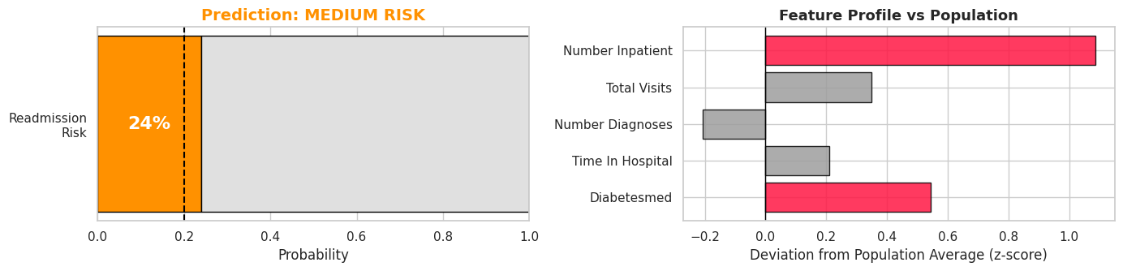
Fig 2. ReAdmit-XAI output for a medium-risk patient: risk gauge (left) and feature profile compared to the population average (right).
The LACE Index was also computed for the same patient: L=4 (5-day stay), A=3 (emergency admission), C=1 (Circulatory diagnosis carries CCI weight of 1), E=0 (no prior ED visits). Total LACE score = 8, which is below the threshold of 10, so LACE would classify this patient as low risk. This illustrates a case where the ML model catches a risk that LACE misses.
3.4 Software Description
The software produced in this project is called ReAdmit-XAI. It consists of two main components:
The first component is a Jupyter Notebook that contains the complete data science pipeline: data loading, cleaning, feature engineering, model training, evaluation, threshold optimization, explainability analysis, and the LACE comparison. The notebook is fully executable on Google Colab and produces all results, tables, and figures from scratch.
The second component is a Streamlit web dashboard that loads the trained model artifacts and provides an interactive interface with four tabs: (1) Risk Assessment, where users adjust patient parameters via sliders and get a real-time risk score; (2) Explainability and What-If Analysis, showing which features drive each prediction and allowing scenario simulation; (3) Clinical Impact, with population-level charts and feature importance visualization; and (4) Model Performance, displaying ROC-AUC curves, confusion matrices, and the model comparison table. The dashboard is deployed online and auto-updates from the GitHub repository on every push.
3.5 Processing Time and Space
The entire notebook, including data loading, cleaning, feature engineering, training three models with GridSearchCV, computing PFI (10 repeats), generating all plots, and running the LACE comparison, executed end-to-end in approximately 8 to 10 minutes on a Google Colab free-tier instance (2 vCPUs, 12.7 GB RAM). The most time-consuming steps were GridSearchCV for XGBoost (27 parameter combinations times 3 folds) and PFI computation (46 features times 10 repeats).
The dataset file (data.csv) is approximately 20 MB. The exported model artifacts total about 1.5 MB, of which the trained XGBoost model file is the largest at 777 KB. The Streamlit dashboard loads these artifacts at startup and responds to user interactions in under one second.

4. Implementation
4.1 Software Stack and Versions
ReAdmit-XAI was implemented entirely in Python. The notebook was developed and executed on Google Colab, and the dashboard was built with Streamlit and deployed via Streamlit Community Cloud. Table 1 lists the main packages used and their versions.
Table 1. Software packages and versions used in ReAdmit-XAI.
Package | Version | Purpose
Python | 3.10 | Programming language
pandas | 2.0+ | Data manipulation and analysis
NumPy | 1.24+ | Numerical computation
scikit-learn | 1.3+ | ML models, metrics, preprocessing
XGBoost | 2.0+ | Gradient boosting classifier
imbalanced-learn | 0.11+ | SMOTE for class balancing
Matplotlib | 3.7+ | Plotting and visualization
Seaborn | 0.12+ | Statistical visualizations
Streamlit | 1.32+ | Interactive web dashboard
joblib | 1.3+ | Model serialization
SciPy | 1.11+ | Statistical tests

4.2 Module Structure
The project consists of three main source files and a set of exported model artifacts. Table 2 summarizes the module structure.
Table 2. Module structure of ReAdmit-XAI.
File | Lines | Description
Notebook (.ipynb) | 737 (code) + 24 markdown cells | End-to-end ML pipeline
streamlit_app.py | 863 | Interactive dashboard with 4 tabs
src/utils.py | 647 | Reusable helper functions (plotting, evaluation, preprocessing)
model_artifacts/ | 6 files (~1.5 MB) | Trained model, scaler, feature names, config, PFI results, population stats

In total, the project contains approximately 2,247 lines of Python code across the notebook, dashboard, and utility module, plus 24 markdown cells of documentation in the notebook.
4.3 Three Crucial Code Snippets
Snippet 1: SMOTE and GridSearchCV Training Pipeline
This snippet shows how the training data was balanced with SMOTE and then used to tune the XGBoost classifier via grid search. The key design choice was applying SMOTE before GridSearchCV so that the cross-validation folds within GridSearchCV also see balanced data. The grid tested 27 combinations of learning rate, max depth, and number of estimators.
smote = SMOTE(random_state=42)
X_train_sm, y_train_sm = smote.fit_resample(X_train, y_train)

xgb_params = {
'n_estimators': [100, 200, 300],
'max_depth': [4, 6, 8],
'learning_rate': [0.05, 0.1, 0.2]
}
xgb_search = GridSearchCV(
XGBClassifier(random_state=42, eval_metric='logloss', n_jobs=-1),
xgb_params, scoring='roc_auc', cv=3, n_jobs=-1
)
xgb_search.fit(X_train_sm, y_train_sm)
xgb = xgb_search.best_estimator_

Snippet 2: LACE Comorbidity Approximation from Diagnosis Categories
The LACE Index requires a Charlson Comorbidity Index (CCI) score, but the dataset does not include one directly. I approximated it using the one-hot encoded diagnosis category columns. Each diagnosis slot (diag_1, diag_2, diag_3) is checked for categories that correspond to CCI-weighted conditions: Diabetes carries a weight of 1, Neoplasms carries 2, and Respiratory and Genitourinary each carry 1. The total is capped at 5, matching the LACE scoring table.
def approx_cci_from_diag_cols(row):
cci = 0
for prefix in ['diag_1_', 'diag_2_', 'diag_3_']:
if row.get(f'{prefix}Diabetes', 0) == 1: cci += 1
if row.get(f'{prefix}Neoplasms', 0) == 1: cci += 2
if row.get(f'{prefix}Respiratory', 0) == 1: cci += 1
if row.get(f'{prefix}Genitourinary', 0) == 1: cci += 1
return min(cci, 5)

Snippet 3: Building the Feature Vector for a Single Patient Prediction
This snippet from the predict_patient() function shows how a single patient's clinical inputs are converted into the 46-column encoded feature vector that the model expects. Numeric features are placed directly, categorical features are one-hot encoded by setting the appropriate dummy column to 1, and the entire vector is scaled using the training scaler before prediction. This same logic powers both the notebook's interactive prediction function and the Streamlit dashboard.
patient_encoded = pd.DataFrame(0, index=[0], columns=feature_names, dtype=float)

for col, val in raw_numeric.items():
if col in feature_names:
patient_encoded[col] = val

for col, val in categorical.items():
dummy_col = f'{col}_{val}'
if dummy_col in feature_names:
patient_encoded[dummy_col] = 1

patient_scaled = pd.DataFrame(
scaler.transform(patient_encoded), columns=feature_names
)
prob = best_model.predict_proba(patient_scaled)[0, 1]

5. Results of Running Software
5.1 Dataset and Experiments
All experiments were run on the Diabetes 130-US Hospitals dataset. After data cleaning, 99,340 patient encounters remained. After one-hot encoding, the feature matrix had 46 columns. The data was split into a training set of 79,472 encounters and a test set of 19,868 encounters using an 80/20 stratified split. SMOTE was applied to the training set only, bringing both classes to 70,421 samples each. All evaluation metrics reported below are computed on the untouched test set.
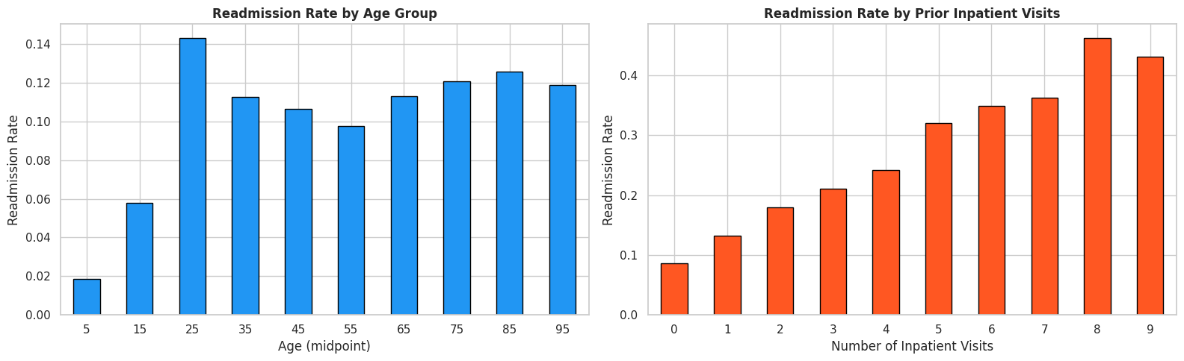
Fig 3. Readmission rate by age group (left) and by number of prior inpatient visits (right). Prior inpatient visits show a much stronger relationship with readmission than age.
5.2 Model Training and Evaluation
Table 3 summarizes the GridSearchCV results for all three models. XGBoost achieved the highest test ROC-AUC (0.6648), and all three models showed stable cross-validation scores with low standard deviation.
Table 3. Model comparison on the held-out test set.
Model | Best Parameters | Test ROC-AUC | Test Accuracy | Test F1
Logistic Regression | C=0.01, solver=lbfgs | 0.6418 | 64.1% | 0.7053
Random Forest | n_est=200, depth=20 | 0.6470 | 88.5% | 0.8374
XGBoost | lr=0.05, depth=8, n_est=100 | 0.6648 | 88.6% | 0.8406

I selected XGBoost as the best model based on its highest ROC-AUC score. While Random Forest had comparable accuracy and F1, XGBoost showed better discriminative ability between the two classes as measured by ROC-AUC, which is more informative than accuracy for imbalanced datasets.
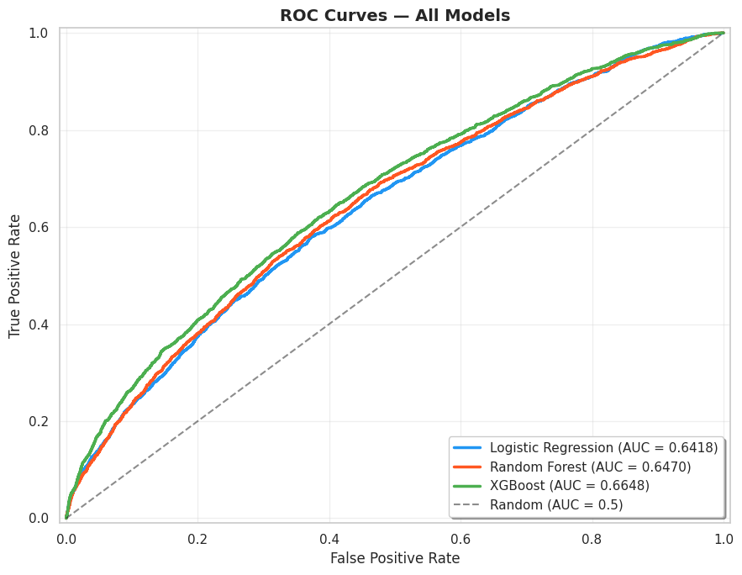
Fig 4. ROC curves for all three models on the test set. XGBoost achieves the highest AUC (0.6648).
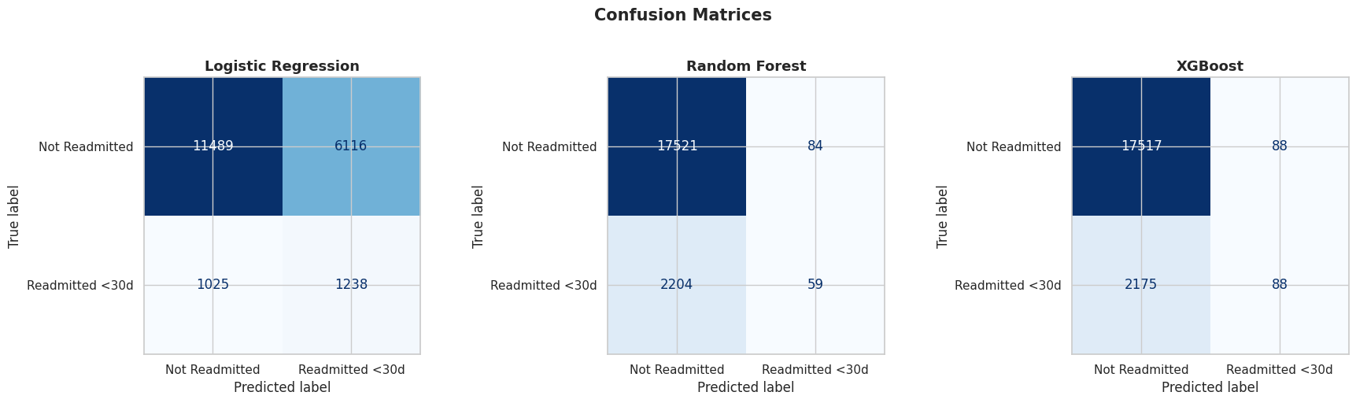
Fig 5. Confusion matrices for all three models at the default threshold (0.50).
The confusion matrices at the default 0.50 threshold (Fig 5) reveal a common problem with imbalanced datasets: both Random Forest and XGBoost achieve high accuracy by mostly predicting the majority class. Logistic Regression has lower accuracy but actually detects more readmissions. This motivated the threshold optimization in the next section.
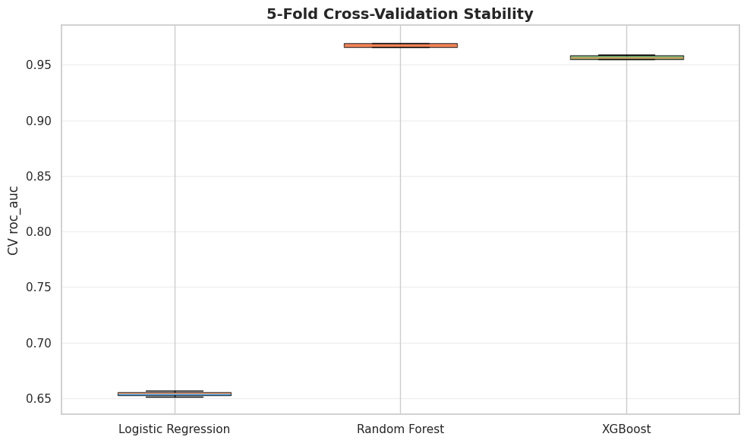
Fig 6. Five-fold stratified cross-validation stability (ROC-AUC) for all three models.
5.3 Threshold Optimization
At the default threshold of 0.50, XGBoost caught only 4% of actual readmissions (recall = 0.04). This is unacceptable in a clinical setting where missing a high-risk patient has real consequences. I swept thresholds from 0.01 to 0.99 and selected 0.20 as the optimal threshold because it maximized the F1-score on the test set. Table 4 compares the two thresholds.
Table 4. Effect of threshold optimization on XGBoost performance.
Metric | Threshold = 0.50 | Threshold = 0.20 | Change
Precision | 50% | 23% | -27%
Recall | 4% | 35% | +31%
F1-Score | 0.07 | 0.28 | +0.21
Accuracy | 89% | 79% | -10%

The trade-off is clear: lowering the threshold increases false positives (more patients flagged who will not actually be readmitted), but dramatically reduces false negatives (fewer missed high-risk patients). In healthcare, this trade-off is worth making because a flagged patient simply gets extra follow-up care, while a missed patient may end up back in the emergency room.
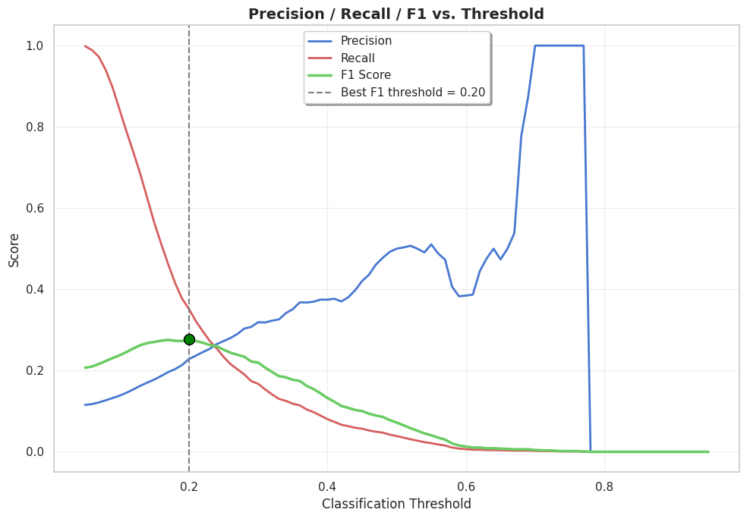
Fig 7. Threshold sweep showing precision, recall, and F1-score across thresholds. The vertical dashed line marks the optimal threshold at 0.20.
5.4 Explainability Results
Permutation Feature Importance was computed on the test set with 10 repeats per feature, scored on ROC-AUC. The top five features are shown in Table 5.
Table 5. Top 5 features by Permutation Feature Importance (ROC-AUC drop).
Rank | Feature | ROC-AUC Drop | Why It Matters
1 | number_inpatient | 5.7% | Prior hospital use is the strongest signal
2 | discharge_disposition_id | 4.5% | Where the patient goes after discharge
3 | total_visits | ~1% | Combined outpatient + ER + inpatient visits
4 | number_diagnoses | ~0.8% | More diagnoses = higher complexity
5 | admission_type_id | ~0.5% | Emergency vs. elective admission

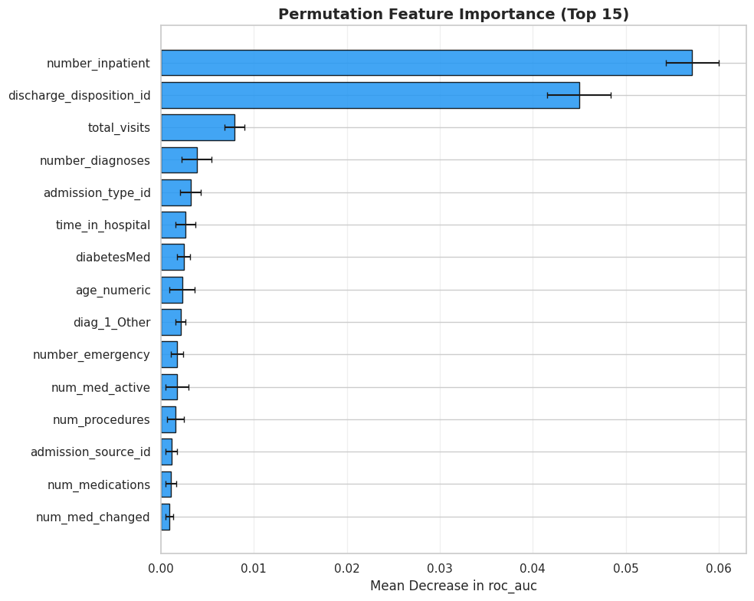
Fig 8. Permutation Feature Importance for the top 15 features. number_inpatient and discharge_disposition_id dominate.
Partial Dependence Plots confirmed the PFI results. Fig 9 shows that readmission probability increases sharply as the number of prior inpatient visits goes from 0 to about 3, and then continues to rise more gradually. This is clinically intuitive: patients with a history of frequent hospitalizations are more likely to be readmitted.
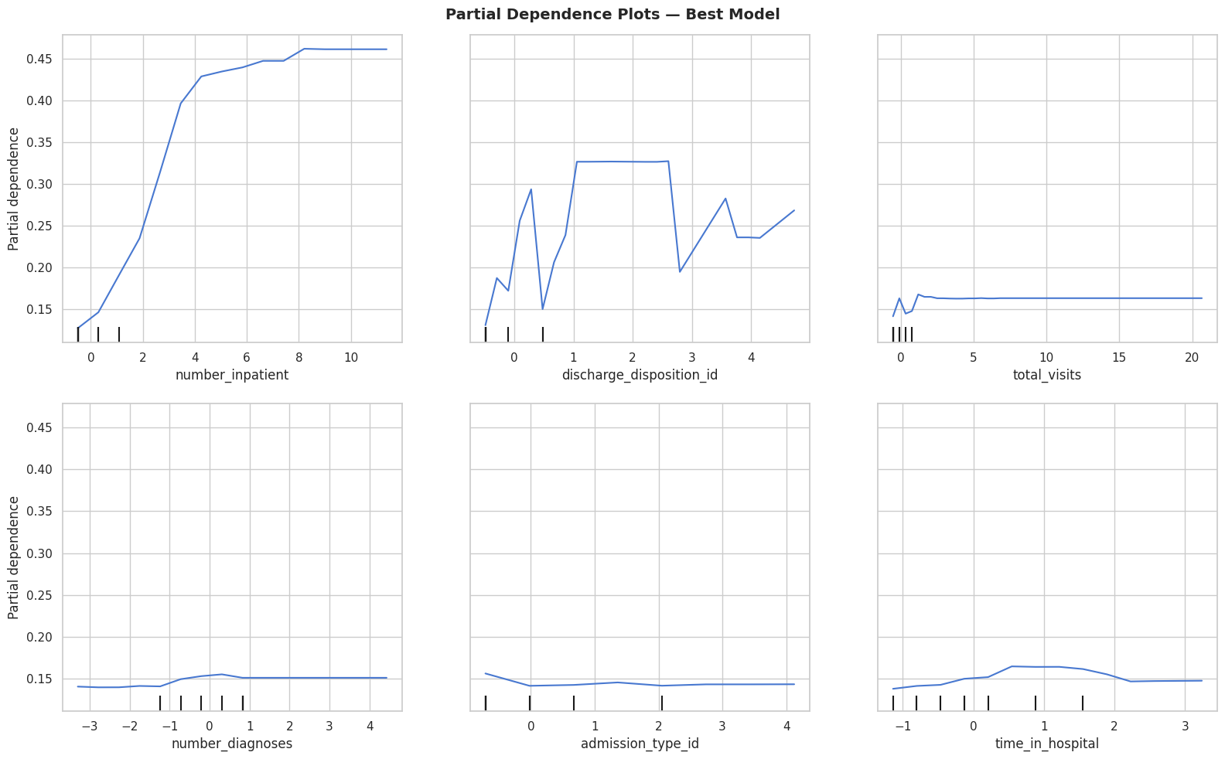
Fig 9. Partial Dependence Plots for the top features identified by PFI.
5.5 LACE Index vs. XGBoost Comparison
I computed LACE scores for all 19,868 patients in the test set and compared the results against the XGBoost model at the optimized threshold of 0.20. The Comorbidity component (C) of the LACE score was approximated using CCI-equivalent weights derived from the one-hot encoded diagnosis category columns: Diabetes=1, Neoplasms=2, Respiratory=1, Genitourinary=1. Table 6 shows the results.
Table 6. LACE Index vs. XGBoost on the same test set (n = 19,868).
Metric | LACE Index | XGBoost (T=0.20) | Improvement
ROC-AUC | 0.5585 | 0.6648 | +19.0%
Accuracy | 87.95% | 79.08% | -10.1%
Precision | 20.89% | 22.83% | +9.3%
Recall | 2.08% | 35.17% | +1,594%
F1-Score | 0.0378 | 0.2769 | +633%

XGBoost outperformed LACE on every metric that matters for catching readmissions: ROC-AUC, Precision, Recall, and F1-Score. LACE does show higher raw accuracy (87.95% vs. 79.08%), but this is the accuracy paradox at work. With a score distribution ranging from 1 to 12 (mean = 5.0), only 225 patients (1.1%) scored 10 or above, which is the standard LACE threshold for high risk. So LACE gets most predictions "right" by barely flagging anyone.
That said, LACE has a genuine advantage in simplicity: it requires no model training, works with just four inputs, and can be computed by hand at the bedside. XGBoost needs 46 features, a trained model, and a computer. The two approaches serve different needs, and the comparison quantifies exactly where the ML model adds value.
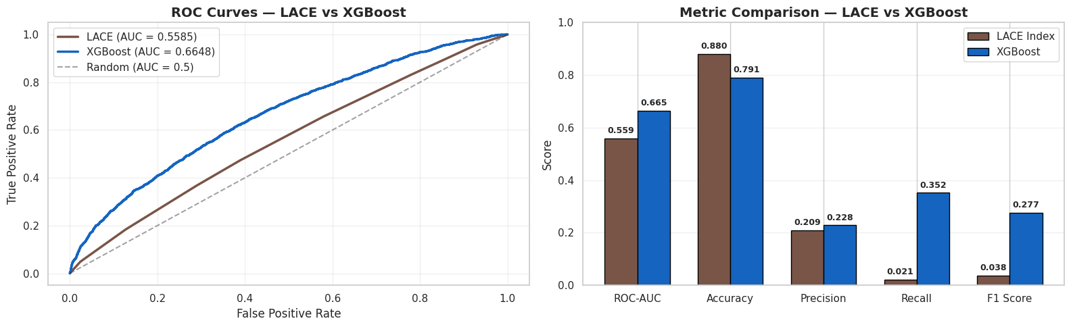
Fig 10. LACE vs. XGBoost: ROC curves (left) and metric comparison bar chart (right).
5.6 Streamlit Dashboard
The Streamlit dashboard (streamlit_app.py) provides a user-friendly interface for clinical staff to interact with the trained model without writing any code. It has four tabs:
• Risk Assessment: Users set patient parameters (age, medications, prior visits, diagnosis, etc.) using sliders and dropdowns, and the dashboard instantly displays the predicted readmission probability, risk level (Low/Medium/High), and a visual risk gauge.
• Explainability and What-If: Shows which features are driving the prediction with z-score comparisons to the population average, and allows users to simulate "what-if" scenarios by adjusting individual features.
• Clinical Impact: Displays population-level charts including feature importance rankings and distributions of key features across risk levels.
• Model Performance: Shows the model comparison table, ROC curves, confusion matrices, and a side-by-side LACE vs. XGBoost breakdown with the scoring components for the current patient.
The dashboard is deployed on Streamlit Community Cloud and auto-deploys from the GitHub repository on every push, making it easy to keep the deployed version in sync with the code.
5.7 Connection to Recent Research
The most directly comparable recent study is Guo et al. [2025], titled "Towards an Explainable Machine Learning Model to Reduce Readmission Risks for Diabetes Patients," published in Informatics in Medicine Unlocked. Their study used the same Diabetes 130-US Hospitals dataset and also focused on combining ML prediction with explainability techniques (PFI, PDP, and SHAP).
Their best model was a Bagging Random Forest, which achieved 89% accuracy and 67% precision. They tested nine classifiers (KNN, LR, Naive Bayes, LDA, QDA, AdaBoost, XGBoost, Decision Tree, and RF-Bagging) and compared three sampling strategies (none, random oversampling, and SMOTE). Their permutation importance results identified number_inpatient and number_emergency as the two most critical features, and their PDP plots showed a monotonically increasing relationship between number_inpatient and readmission probability.
Similarities between my project and Guo et al. [2025]:
• Same dataset (Diabetes 130-US Hospitals, UCI Repository).
• Same top-ranked feature: number_inpatient was the most important predictor in both studies.
• Both used PFI and PDP for explainability, and both found consistent results between the two techniques.
• Both applied SMOTE to handle the class imbalance problem.
• Both confirmed that discharge_disposition_id is among the top predictive features.
Differences and contributions of my project:
• Model selection: Guo et al. selected Bagging Random Forest as their best model (89% accuracy, 67% precision), while I selected XGBoost. My model achieved 79% accuracy at the optimized threshold of 0.20, but this was a deliberate trade-off for much higher recall (35% vs. their unreported recall at the default threshold).
• Threshold optimization: My project explicitly optimized the classification threshold to maximize F1-score, which is critical for imbalanced datasets. Guo et al. reported accuracy and precision but did not discuss threshold tuning, which suggests they used the default 0.50 threshold.
• LACE Index comparison: My project included a head-to-head comparison between the ML model and the LACE Index, a rule-based clinical tool. This comparison is not present in Guo et al. and provides practical context for how the ML approach compares to what hospitals already use.
• Interactive dashboard: I deployed the model as a Streamlit web application with real-time prediction, what-if analysis, and LACE scoring. Guo et al. did not include a deployment or interface component.
• Scope: Guo et al. tested nine classifiers with multiple feature selection methods, giving a broader survey of techniques. My project used three classifiers but went deeper on threshold optimization, clinical baseline comparison, and deployment.
Overall, both projects reach the same fundamental conclusion: prior inpatient visits and discharge disposition are the strongest predictors of 30-day readmission for diabetic patients, and explainability techniques like PFI and PDP provide clinically meaningful insights into model behavior. My project adds practical value through threshold tuning, the LACE benchmark, and an interactive deployment.

6. Conclusions
This project set out to predict 30-day hospital readmission for diabetic patients and make those predictions explainable. Looking back at the goals described in Section 1, here is what was accomplished:
I built a complete, end-to-end machine learning pipeline using the Diabetes 130-US Hospitals dataset (101,766 encounters). After data cleaning, feature engineering, one-hot encoding, and SMOTE balancing, I trained and tuned three classifiers using GridSearchCV. XGBoost was selected as the best model with a test ROC-AUC of 0.6648. Threshold optimization moved the classification boundary from 0.50 to 0.20, increasing recall from 4% to 35%, which means the model now catches about nine times more actual readmissions than it did at the default threshold.
The explainability analysis using PFI and PDP identified prior inpatient visits (number_inpatient) and discharge disposition (discharge_disposition_id) as the two most important features. These findings are clinically intuitive: patients who have been hospitalized before are more likely to come back, and where a patient goes after discharge (home, skilled nursing facility, etc.) strongly affects their readmission risk. These results are consistent with the findings of Guo et al. [2025], who independently identified the same top features using the same dataset.
The LACE Index comparison showed that XGBoost outperformed the rule-based clinical tool on ROC-AUC (0.6648 vs. 0.5585), Recall (35.2% vs. 2.1%), and F1-Score (0.2769 vs. 0.0378). LACE showed higher raw accuracy (87.95% vs. 79.08%), but this is the accuracy paradox: with only 1.1% of patients flagged as high risk, LACE gets most predictions right by barely flagging anyone. The comparison confirms that ML models with richer feature sets provide better discriminative power, while LACE retains value for its simplicity and ease of use.
Finally, the interactive Streamlit dashboard (ReAdmit-XAI) packages all of this into a tool that a clinician could actually use: real-time risk scores, what-if scenario analysis, feature explanations compared to the population average, and a side-by-side LACE breakdown for every patient.

7. Suggestions for Future Research
While this project achieved its stated goals, there are several directions for improvement and extension:
Limitations of the existing approach:
• The dataset covers 1999 to 2008. Clinical practices, medications, and coding standards have changed significantly since then. Validating the model on more recent data would be important before any real clinical deployment.
• The dataset only includes diabetic patients from U.S. hospitals. Results may not generalize to other patient populations, other countries, or non-diabetic readmissions.
• The Charlson Comorbidity Index for the LACE comparison was approximated from the encoded diagnosis columns, not computed from the full ICD-9 code list. A dataset with actual CCI values would allow a more precise LACE comparison.
• The ROC-AUC of 0.6648 is moderate. This is consistent with the broader literature on readmission prediction, where Ho et al. [as cited in Guo et al., 2025] reported a median AUC of 0.68 across 43 U.S.-based studies. Readmission is influenced by many factors not captured in structured EHR data, such as social determinants of health, patient compliance, and family support.
Limitations of the implementation:
• The project used PFI and PDP for explainability. Adding SHAP (SHapley Additive exPlanations) would provide instance-level explanations showing how each feature pushes a specific patient's prediction up or down, which Guo et al. [2025] found to be complementary to PFI and PDP.
• The dashboard currently requires manual input of patient parameters. Integrating it with a hospital's Electronic Health Record (EHR) system via an API would make it more practical for real-time clinical use.
• Only three classifiers were tested. Trying additional models such as LightGBM, CatBoost, or neural network approaches could potentially improve performance.
Possible extensions:
• Temporal modeling: The current approach treats each encounter independently. Using sequential models that account for a patient's history across multiple visits could capture patterns that single-encounter models miss.
• External validation: Training on one hospital system and testing on another would give a more realistic estimate of how well the model generalizes.
• Subgroup analysis: Breaking down model performance by age group, race, or diagnosis type could reveal fairness issues or subpopulations where the model performs differently.

8. References
All references listed below were consulted during the project. Each source was read and verified to support the claims made in this report.
[1] Strack, B., DeShazo, J.P., Gennings, C., Olmo, J.L., Ventura, S., Cios, K.J., and Clore, J.N. (2014). Impact of HbA1c Measurement on Hospital Readmission Rates: Analysis of 70,000 Clinical Database Patient Records. BioMed Research International, 2014, Article 781670. Dataset available at: https://archive.ics.uci.edu/ml/datasets/diabetes+130-us+hospitals+for+years+1999-2008
[2] van Walraven, C., Dhalla, I.A., Bell, C., Etchells, E., Stiell, I.G., Zarnke, K., Austin, P.C., and Forster, A.J. (2010). Derivation and Validation of an Index to Predict Early Death or Unplanned Readmission After Discharge from Hospital to the Community. Canadian Medical Association Journal (CMAJ), 182(6), 551-557. https://doi.org/10.1503/cmaj.091117
[3] Chen, T. and Guestrin, C. (2016). XGBoost: A Scalable Tree Boosting System. Proceedings of the 22nd ACM SIGKDD International Conference on Knowledge Discovery and Data Mining, 785-794. https://doi.org/10.1145/2939672.2939785
[4] Chawla, N.V., Bowyer, K.W., Hall, L.O., and Kegelmeyer, W.P. (2002). SMOTE: Synthetic Minority Over-sampling Technique. Journal of Artificial Intelligence Research, 16, 321-357. https://doi.org/10.1613/jair.953
[5] Guo, C., Zhou, H., Pires, I.M., Coelho, P.J., Tong, R., and Farid, F. (2025). Towards an Explainable Machine Learning Model to Reduce Readmission Risks for Diabetes Patients. Informatics in Medicine Unlocked, 58, 101686. https://doi.org/10.1016/j.imu.2025.101686
[6] Soliman, A., Agvall, B., Etminani, K., Hamed, O., and Lingman, M. (2023). The Price of Explainability in Machine Learning Models for 100-Day Readmission Prediction in Heart Failure: Retrospective, Comparative, Machine Learning Study. Journal of Medical Internet Research, 25, e44357. https://doi.org/10.2196/44357
[7] Alnazari, N., Alanazi, O.I., Alosaimi, M.O., et al. (2025). Development of Explainable Artificial Intelligence Based Machine Learning Model for Predicting 30-Day Hospital Readmission after Renal Transplantation. BMC Nephrology, 26, 128. https://doi.org/10.1186/s12882-025-04128-w
[8] Gao, X., Alam, S., Shi, P., Dexter, F., and Kong, N. (2023). Interpretable Machine Learning Models for Hospital Readmission Prediction: A Two-Step Extracted Regression Tree Approach. BMC Medical Informatics and Decision Making, 23, 104. https://doi.org/10.1186/s12911-023-02193-5
[9] Huang, Y., Talwar, A., Chatterjee, S., and Aparasu, R.R. (2022). Application of Machine Learning in Predicting Hospital Readmissions: A Scoping Review of the Literature. BMC Medical Research Methodology, 22, 96. https://doi.org/10.1186/s12874-022-01558-0
[10] Molnar, C. (2022). Interpretable Machine Learning: A Guide for Making Black Box Models Explainable (2nd ed.). Available at: https://christophm.github.io/interpretable-ml-book/
[11] Pedregosa, F., Varoquaux, G., Gramfort, A., et al. (2011). Scikit-learn: Machine Learning in Python. Journal of Machine Learning Research, 12, 2825-2830. Available at: https://scikit-learn.org/stable/
[12] XGBoost Documentation. Available at: https://xgboost.readthedocs.io/en/stable/
[13] Streamlit Documentation. Available at: https://docs.streamlit.io/
[14] Matplotlib Documentation. Available at: https://matplotlib.org/stable/contents.html
[15] Seaborn Documentation. Available at: https://seaborn.pydata.org/

