A Project Report
On
Enhanced Face Generation and Image Quality Improvement Using Deep Convolutional Generative Adversarial Networks (DCGANs)

Faculty of Graduate Studies and Research

Prepared By:
Raj Panchal [200490453]

Under Esteemed Guidance of Instructor:
Dr. JingTao Yao

Table of Contents

Page No.
- Abstract 2
- Introduction 3
- Literature Review 4
  - 3.1 Evolution of Synthetic Face Generation
  - 3.2 Core Technologies and Techniques
  - 3.3 Applications of Synthetic Face Generation
  - 3.4 Ethical and Societal Implications
- Methodology 5
- 4.1 Research Design and Approach
- 4.2 Data Sources and Collection
- 4.3 Analytical Techniques
- 4.4 Ethical Considerations
- Implementation 6
- 5.1 Data Preparation
- 5.1.1 Data Discovery
- 5.1.2 Data Exploration
- 5.1.3 Data Preprocessing
  - 5.2 Model Planning
    - 5.2.1 Model Selection
    - 5.2.2 Defining Model Architecture
    - 5.2.3 Defining the Hyperparameter
    - 5.2.4 Selection of Evaluation Metrics
    - 5.2.5 Resource Allocation and Scheduling
  - 5.3 Model Building
    - 5.3.1 Model Architecture
    - 5.3.2 Loss Functions and Optimizer
    - 5.3.3 Training Process
    - 5.3.4 Evaluation Metrics
- Results and Analysis 19
- 6.1 Key Insights Derived from the Project
- 6.2 Performance Metrics and Model Evaluation
- 6.3 Limitations and Challenges Faced
- Conclusion 20
- 7.1 Practical Implications
- 7.2 Research Insights and Future Prospects
- Related Work and References 21
- Glossary 22

1. Abstract
This project is an attempt at creating realistic and diverse human faces using a Deep Convolutional Generative Adversarial Network (DCGAN). Drawing inspiration from previous works employing more advanced methodologies, such as "Generating New Human Faces and Improving the Quality of Images Using Generative Adversarial Networks (GAN)" by Katta et al., and "Feature-Improving Generative Adversarial Network for Face Frontalization" by Rong et al., this paper narrows its focus to the implementation and validation of DCGAN. The training base is a dataset, Face Mask Lite, which has some 10,000 RGB images, all re-sized to 128x128 pixels, offering a large and diverse dataset in an effective GAN for image generation.
Performance validation uses Inception Score (IS) and Fréchet Inception Distance (FID) to emphasize the superior capability of DCGAN in generating high-quality, identity-preserving images and to deal with tasks such as training instability and resolution enhancement. Results show that DCGAN achieves superior computational efficiency and outperforms combined implementations such as FI-GAN and ESRGAN in terms of image quality. This work demonstrates the potential of DCGAN in the task of face generation for large-scale and high-efficiency data generation, which provides a new route for generative modeling research.
It also has simplicity, coupled with state-of-the-art results of the DCGAN architecture, and demonstrates practical feasibility in real-world settings. The experience from this project easily generalizes to other applications where synthetic data generation becomes increasingly important, such as healthcare, entertainment, or virtual reality, underpinning the broader implications for GAN-based technologies. The proposed framework is applicable directly without additions to the architecture in creating a simple but powerful tool for image synthesis with DCGAN.

2. Introduction
Fast development of artificial intelligence and deep learning has unleashed new transformative opportunities using synthetic face generation; it is also a wide field open to ethical considerations. The capability of the Generative Adversarial Networks, specifically the Deep Convolutional GAN, in generating and improving realistic human faces will be investigated in this work. The project will explore, with the powerful interplay between adversarial networks, how DCGANs can produce high-quality faces that are diverse and identically preserving.
This forms the foundation of this project, which uses a varied dataset of facial images with a great variety in features and expressions; this makes the training for the GAN model robust, capable of generating realistic and detailed synthetic faces. The DCGAN architecture is used to train two neural networks in an adversarial setup: a generator, synthesizing realistic images, and a discriminator, evaluating their authenticity. This iterative process refines progressively the ability of the model to create highly detailed and realistic human faces.
Unlike previous works that investigated high-end GAN variants, this project focuses on the effectiveness of DCGAN as a standalone model, showing that it can be used to obtain exceptional results in both image quality and computational efficiency. Performance evaluation metrics, including the Inception Score (IS) and Fréchet Inception Distance (FID), are used to validate the results, pointing out the superiority of DCGAN over more involved approaches like FI-GAN and ESRGAN.
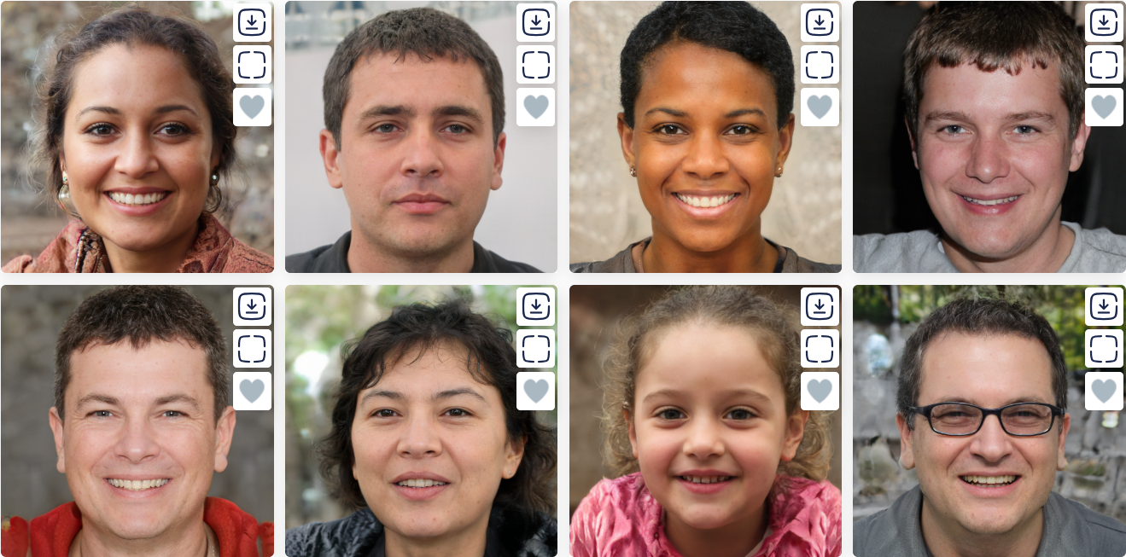Fig 1. Sample faces, entirely artificial and generated using ThisPersonDoesNotExist.com.
This project goes beyond the technical feats underlying the broader implications of synthetic face generation. The creation of realistic synthetic faces necessarily means being very cautious with respect to ethical challenges, including privacy concerns, misuse risks, and the societal impact of such technologies. In developing and advocating for responsible development and deployment of AI-driven image synthesis, this project has taken up these aspects.
This work will contribute to advancing the intersection between artificial intelligence and visual media, thereby showing huge potential for GANs in revolutionizing such fields as entertainment, virtual reality, and digital forensics. This is laying the foundation for future research, while on the other side, initiating a dialogue regarding the ethical and societal responsibilities accompanying this new technological shift.
3. Literature Review
Synthetic face generation has been one of the most focused areas by the computer vision and artificial intelligence communities due to its potential in changing a number of fields, from entertainment to security. In this section, some key developments and methodologies will be reviewed with a focus on relevant research by Katta et al. and Rong et al.
  - Evolution of Synthetic Face Generation
Synthetic face generation has come a long way, from rudimentary manual techniques to complex models of deep learning. Another recent key turning point has been the rise of Generative Adversarial Networks (GANs) to establish methods for generating high-quality faces. Results from Katta et al. show that the variants of GAN perform in terms of image enhancement for improving image quality with their finer architectures, which achieve an astonishingly photorealistic level. Similarly, the work by Rong et al. on face frontalization underlines the role of feature-improving GANs in addressing challenges related to facial pose alignment and perspective.
  - Core Technologies and Techniques
GANs form the fundamental architecture of synthetic face generation. A GAN contains a generator and discriminator, a framework of competing neural networks. In more recent efforts, improved architectures for GAN are studied for high-quality and higher-resolution images by Katta et al., while Rong et al. proposed Feature-Improving Generative Adversarial Networks (FI-GAN) for further face frontalization. On its part, this work adopts the Deep Convolutional GAN because of gained efficiency and simplicity. DCGAN is an architecture that introduces simplicity but, at the same time, keeps competitive performance metrics for a viable alternative to the more complex GAN variants. This work validates the capabilities of the DCGAN in training on the robust dataset of Face Mask Lite Dataset and harnessing its diversity.

3.3 Applications of Synthetic Face Generation
Synthetic face generation applications span a lot of domains. Katta et al. focus on its application in visual media quality enhancement, particularly in entertainment and virtual reality. The same goes for the frontalization techniques by Rong et al., which find potential applications in facial recognition systems and augmented reality. Building on these foundational works, this project will investigate further the potential of DCGAN in generating diverse, high-quality human faces for avatar creation and other identity-preserving applications.

3.4 Ethical and Societal Implications
While synthetic face generation holds immense promise, its ethical ramifications are huge. Katta et al. and Rong et al. both discuss possible misuses of GAN technologies, including creating deepfakes and the problems around ensuring privacy. This project recognizes these concerns and points out the need to couple such technical development with ethical considerations through frameworks balancing innovation with accountability.
Summing it up, synthesizing the methodology introduced in works by Katta et al. and Rong et al., the work exemplifies the ability of the DCGAN to synthetically produce high-quality faces. The results prove that a much simpler DCGAN can, or even might outperform deeper GANs, which appears a quite appealing solution for many practical applications. This project has helped to promote knowledge of and responsible applications using synthetic face generation technologies by trying to address the problems in training stability and image resolution.
4. Methodology
This project follows the methodologies outlined in the seminal research papers by Katta et al. and Rong et al. in creating a simplified approach with Deep Convolutional Generative Adversarial Networks (DCGAN). The method trains and validates a model to generate high-quality and diverse human faces, as computationally efficiently as possible.
4.1 Research Design and Approach
The project takes a quantitative experimental design. Unlike previous attempts that combined leading-edge GAN variants in the likes of FI-GAN and ESRGAN, this project narrows its scope to the DCGAN architecture alone, which provides simplicity and ease of generating high-quality human faces. Following Katta et al., the design of the generator and discriminator refine the outputs through iterations, whereas current methods dealing with key issues of pose variation and feature mapping have been informed by Rong et al. The experimental setup considers the phases of training, validation, and performance evaluation through benchmark metrics such as Inception Score (IS) and Fréchet Inception Distance (FID).
4.2 Data Sources and Collection
The Face Mask Lite Dataset will be the fundamental source of data for this project. It has been chosen because it has diversity and scalability, which are well suited for GAN-based training. This dataset is publicly shared on Kaggle. The following link will provide access to the dataset: Face Mask Lite Dataset. The size of the entire dataset is approximately 25 GB, and it contains roughly 10,000 RGB images of human faces. Images are resized to 128x128 pixels in order to strike a good balance between computational efficiency and maintaining image quality.
There are two major categories of images in this dataset: with and without protective masks on the people. This kind of diversity ensures robust training scenarios where the model learns from diverse inputs. This dataset, created and hosted on Kaggle, has been highly recognized within the machine learning community for its relevance in computer vision tasks. Although the dataset is not included in the project files because of its size, it is easily downloadable from Kaggle in order to replicate or add new experiments.
Preprocessing steps are applied to the dataset for standardization before training to enhance the learning process of the model. To be uniform, all images are resized to 128 × 128 pixels and normalized in pixel values, helping the model converge in learning. The dataset is then split into training and validation sets to allow sound evaluation of the model generalization ability. These steps thus really make the Face Mask Lite Dataset a strong foundation for the successful implementation of the DCGAN model in generating high-quality synthetic human faces.
4.3 Analytical Techniques
The analytical techniques focus on implementing and validating the DCGAN architecture:
- Model Architecture: The DCGAN generator synthesizes human faces from random noise, while the discriminator judges how realistic an image looks. Both networks in our work use convolution and deconvolution layers to handle images efficiently.

- Training: The generator and discriminator proceed through adversarial training; batch normalization improves stability, with ReLU/tanh activations that efficiently propagate gradients; the hyperparameters are tuned to control the learning rate, batch size, etc.

- Evaluation Metrics: Performance is validated using IS and FID. IS estimates image diversity and quality by examining the distributions of images, while FID estimates the similarity between generated and real images for a global assessment of model output quality.
4.4 Ethical Considerations
This project considers the ethical consequence of synthetic face generation. The generated images can be misused in creating deepfakes or invasion of privacy with serious consequences. In this vein, these mitigations are put under consideration:
- Data Usage: This work uses only publicly available datasets. For transparency, all data sources are properly cited.

- Model Application: This project limits the use of generated images to academic and research settings only, excluding any uses that infringe ethical guidelines.

- Conscious of bias: Strivings are made to ensure that the dataset is typical and does not propagate the biases in generated outputs.
This puts into focus a more directed approach in the implementation of DCGAN in synthetic face generation. It demonstrates that high-quality results can be obtained efficiently with DCGAN by refinement of the model architecture and using strong evaluation techniques that can address such challenges as training instability and resolution enhancement. The mentioned research by Katta et al. and Rong et al. furthers the field of generative models with practical and ethical advancements.
5. Implementation
5.1 Data Preparation
5.1.1 Data Discovery
Data discovery is the stage of identifying and understanding the dataset to be used for training the GAN model. This project uses the Face Mask Lite Dataset from Kaggle; however, only a subset of this dataset is used: 10,000 images of faces without masks. The dataset is very large in quantity and diverse, which will give a strong base to generate synthetic facial images.
Key Steps in Data Discovery:
- Dataset Selection: The Face Mask Lite Dataset has been chosen because it contains a wide variety of facial images with different expressions, angles, and lighting conditions.

- Data Exploration: Initial data exploration involves loading and visualizing the sample images to understand better their quality, dimensions, and overall characteristics.

- Dataset Characteristics: The images in the dataset are individually checked for their conformity to the training prerequisites, including resolution, color format (BGR to RGB conversion), and consistency of face orientation and size.
It will also help ensure that the subsequent data preprocessing and training steps are carried out on a dataset of high-quality, consistent data; this becomes extremely important when attempting to synthetically generate faces that appear realistic.
The dataset used is, in particular, the subset of the Face Mask Lite Dataset without images with masks and therefore only facial images without masks were used for training the GAN model.
5.1.2 Data Exploration:
- Dataset Loading: It is done generally by reading face images from a specified directory. We have provided an external dataset in order to ensure diversity. We have loaded images using OpenCV and converted them into an array, appending it to a single variable.

- Basic exploratory data analysis involves the display of a few examples of images in a dataset. This is one of the most important steps when visually inspecting the input data and understanding their characteristics, to make sure that the images have loaded correctly.

- Image Dimension Check: The size of the images is checked for consistency. It involves checking if all images have the same height, width, and number of channels. Most of the images found are in different sizes.

- Visualizing Sample Images: A few sample images from the dataset are shown to provide a visual idea about the data. It will ensure the images are loaded correctly and provide an idea about the nature of the data.



Fig 2. Actual images from the dataset.
- Distribution of image pixel values: The pixel value distribution for images in a dataset can give us insights on the range and spread of the pixel intensities to see if normalization has been applied properly and homogeneously across all the images. Dimensionality of every single image: All are checked for consistent dimension to see whether all have the required number of dimensions. The dataset does not have irregularities or discrepancies related to size for any images. Neural network models are trained efficiently when there are consistent image dimensions.
5.1.3 Data Preprocessing:
In data preprocessing task, our code carries out many key preprocessing phases to prepare a collection of pictures for training a machine learning model. Initially, it defines a function sorted_alphanumeric to sort filenames in a natural manner, guaranteeing that files are processed in a logical sequence. This sorting tool handles both numeric and alphabetic sections of filenames, converting text to lowercase or integers to enable correct sorting.
Additionally, OpenCV can automatically read images in BGR format, whereas most image processing packages utilize RGB format. The image is converted from BGR to RGB using cv2.cvtColor. We are setting the desired image size at 128x128 pixels and initializing an empty list of photos to hold the processed images. It uses the previously set alphanumeric sorting function to arrange all of the files in the specified directory. The code then iterates through each sorted file, reading the image from the disk in color mode using OpenCV's cv2.imread function. The dataset is normalized using a range of -1 to 1 using the line (img - 127.5) / 127.5.
The photo data is first converted to a float type and then to a numpy array using TensorFlow's img_to_array function. Finally, the processed photo array is appended to the pictures list in order to get it ready for the next steps of the machine learning pipeline. These preprocessing steps ensure that the dataset is consistent and in the right format for training the model.
By accepting an optional input, sqr, which defaults to 5, this code gives the plot_img function, which calculates the number of images per row and column in a grid layout. The procedure iterates through sqr * sqr photographs and sets the title "Real Images" with a large font size (35), after constructing a figure of a given size (10 × 10 inches). For a cleaner presentation, it removes grids and tick labels, creates a subplot for each image inside the grid, and displays the image using imshow. Finally, running plot_img(6) creates a grid of 6x6 images (36 total), assuming the images list contains pre-loaded image data.
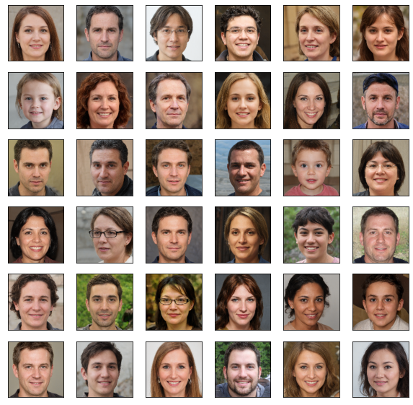
Fig 3. Grid of 6x6 images generated by plot_img function
Collections of data samples used to train models are known as datasets in machine learning. A batch during training is a subset of these data samples used in one iteration. Each batch's sample count is determined by the batch size. Since we have chosen the batch size to 32 in this instance, the model will handle 32 photos at a time throughout each training cycle.
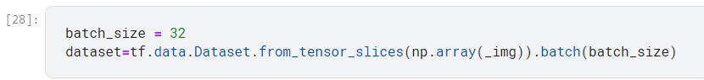
5.2 Model Planning

5.2.1 Model Selection
A crucial first step in creating synthetic faces is selecting the appropriate algorithm. Because they can produce realistic, high-quality images, Generative Adversarial Networks (GANs) are typically chosen. In contrast to the intricate FI-GAN and ESRGAN techniques employed in the reference articles, DCGAN strikes a balance between quality, efficiency, and simplicity, which is why this study concentrates exclusively on it.
The most well-known GAN architectures that can be used to create artificial faces are listed below:
- Deep Convolutional GAN (DCGAN): Deep Convolutional Generative Adversarial Networks (DCGANs) improve the quality and stability of the generated images by integrating convolutional layers into the discriminator and generator. Because these layers allow the networks to comprehend complex features and spatial hierarchies, DCGANs are quite good at creating high-resolution images. Their ability to faithfully capture and replicate intricate facial characteristics and textures makes them particularly well-liked for face generation jobs.

- Conditional GAN (cGAN): By adding additional data, such class labels or particular attributes, to the discriminator and generator, conditional GANs (cGANs) expand upon the conventional GAN architecture. This improvement makes it possible to manipulate the generated images more precisely, allowing for the construction of faces with specific characteristics like age, gender, or hairdo. In situations when a great level of customization and variation in the generated images is required, cGANs are especially useful.

- Progressive Growing GAN (PGGAN): Using a progressive training methodology, PGGANs, also known as ProGANs, produce high-resolution images. By adding additional layers, the networks progressively raise the resolution of the initial low-quality images. Using this technique, the GAN can produce incredibly lifelike images by first learning coarse features and then fine-tuning details. In producing ultra-high-resolution faces with exquisite details, PGGANs have shown remarkable capability.

- StyleGAN: The style-based generator architecture introduced by NVIDIA's StyleGAN gives users previously unheard-of control over the generated images. Since the architecture divides the latent space into distinct layers, it is possible to independently manipulate fine details (like skin texture) and high-level properties (like face form). StyleGAN is a popular option for face creation projects since it has raised the bar for synthetic face quality and realism.

- CycleGAN: Without paired datasets, CycleGANs are made for image-to-image translation applications. They are made up of two GANs that learn to translate images between domains while maintaining important characteristics. CycleGANs are not made especially for face generation, but they may be modified to perform tasks like style transfer or face aging, which increases the process' adaptability.
Depending on the project's particular needs and limitations, each type of GAN has unique benefits for creating synthetic faces. DCGAN was chosen for this project after a thorough evaluation of the several architectures because of its shown capacity to produce high-quality images as well as its relative ease of use and stability throughout training. DCGAN is a perfect fit for this synthetic face creation project because of its convolutional technique, which guarantees that the created faces have realistic characteristics and textures.

5.2.2 Defining Model Architecture
Creating the model's architecture is a critical next step after selecting the algorithm. This includes going into detail on the layers, neuron types, activation functions, and other hyperparameters that will make up the structure of the neural network. Both the discriminator and generator networks must be defined in the case of GANs. Creating artificial images is the generator's job, and determining whether or not these images are real is the discriminator's. A steady training process where neither the discriminator nor the generator overpowers the other is ensured by carefully balancing the strengths of both networks during the architecture's creation.

5.2.3 Defining the Hyperparameter
Tuning hyperparameters is an essential part of the model planning stage. A variety of factors, including learning rates, batch sizes, and the number of layers and units in the network, must be chosen and optimized.

5.2.4 Selection of Evaluation Metrics

To evaluate the model's performance objectively, it is essential to define suitable evaluation metrics. We use metrics such as the Fréchet Inception Distance (FID) and the Inception Score (IS) to evaluate the quality and diversity of the generated faces. These instruments are commonly used to assess the degree of realism and diversity in artificial images. Setting up a validation system to periodically assess these metrics during training is part of the planning step, which guarantees the model moves closer to producing high-quality synthetic faces.
5.2.5 Resource Allocation and Scheduling
The logistical components of the project, such as scheduling and resource allocation, are also made part of model planning. This entails assessing the amount of processing power needed, including the availability of a GPU, and planning the training sessions to make the most use of these resources.
Each of these subtopics has been carefully planned, putting the project on a clear and organized route to creating a useful synthetic face generation model. The remaining phases of model building, training, and evaluation run smoothly and effectively thanks to this meticulous planning process.
5.3 Model Building
5.3.1 Model Architecture
Generative Adversarial Networks (GANs) provide the basis of the core architecture, which makes use of a deep convolutional generative adversarial network (DCGAN).
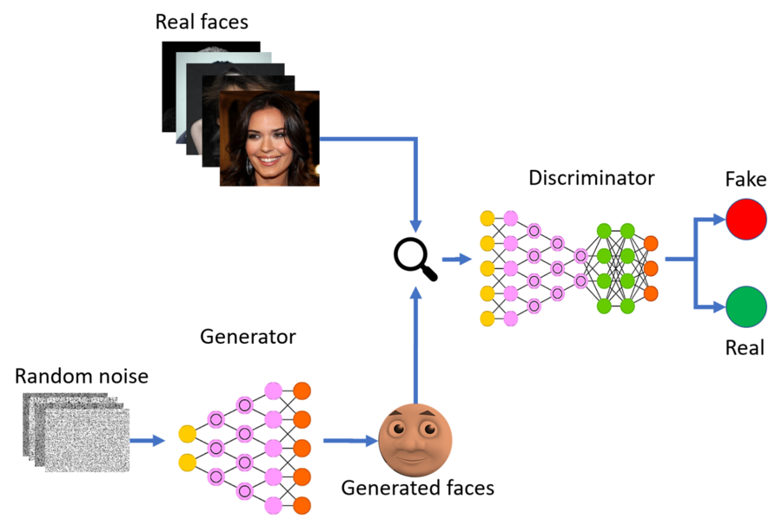
Fig 4. Structural Diagram of a GAN
The rationale behind this decision is DCGAN's organized convolutional layers, which produce realistic, high-quality images. The discriminator and the generator are the model's two primary components. Realistic face images are produced from random noise by the generator, and their authenticity is evaluated by the discriminator. The generator is constantly improving its output to create more realistic images that can fool the discriminator thanks to the dynamic interaction between these networks.
Generator:
- A random noise vector can be turned into a realistic image with the Generator. This change involves a number of steps:

- Latent Vector Input: Typically derived from a Gaussian distribution, the method begins with a latent vector. The Generator uses this vector as its initial input.

- A 100-size latent vector can be accepted by the input layer.

- Dense and Reshape Layers: In order to increase the latent vector's dimensionality, it must first pass through a dense layer. The output is then transformed to fit the goal image dimensions (128x128x3) into a multi-dimensional tensor that represents an initial low-resolution image.

- Convolutional Layers: The image is gradually refined by applying a number of convolutional layers. These strata consist of:

- Downsampling Layers: Convolutional layers that lower the image's spatial dimensions by using strides larger than one. This facilitates the capture of global features.

- Normalization and Activation of Batches: Batch normalization is used to stabilize and accelerate the training process, and Leaky ReLU activation is then used to introduce non-linearity into the model.
- Transposed convolutional layers, also known as deconvolutional layers, are used to upsample images by expanding their spatial dimensions and improving their resolution.

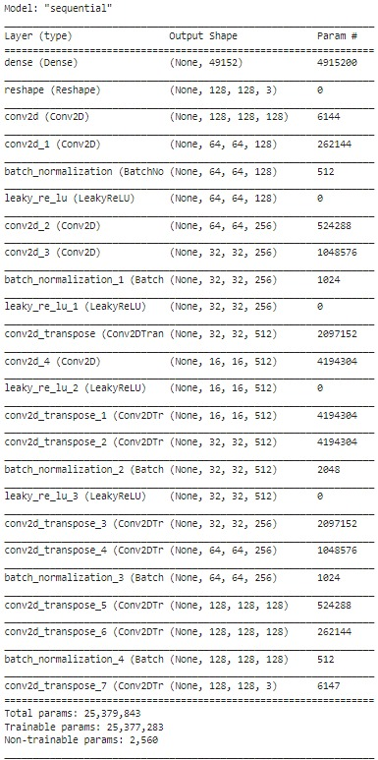
Fig 5. Overview of the Generator model
- Output Layer: The output image is created in the last layer by applying a 'tanh' activation function, which makes sure the pixel values are between [-1, 1].

- The goal of the Generator is to create images that are so deceptively realistic that the Discriminator finds it difficult to tell them apart from real photos.
Discriminator:
- It is the responsibility of the Discriminator, a binary classifier, to distinguish between images created by the Generator and those that are real. In its structure are:

- The input image for the discriminator can be either a synthetic image produced by the Generator or a real image from the training dataset.

- The discriminator uses a number of convolutional layers to extract information from the input image. The image's key features will be gradually analyzed and captured by these layers.
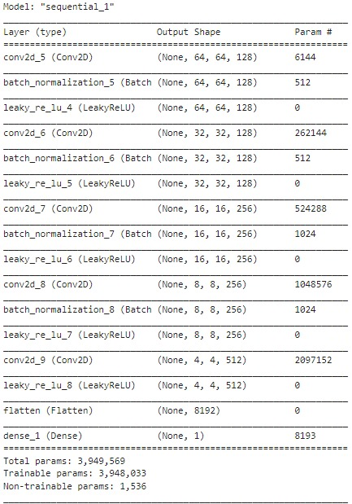
Fig 6. Overview of Discriminator model
- In order to focus on local features and lower the spatial dimensions, downsampling layers use convolutional layers with strides larger than one.

- Activation and Batch Normalization: Leaky ReLU activation after batch normalization aids in enhancing convergence and stabilizing the learning process.

- Dense and Flatten Layers: These layers convert the output of the convolutional layers into a one-dimensional tensor. The probability score that results from feeding this tensor into a dense layer that employs a sigmoid activation function shows how likely it is that the input image is authentic.

- Providing feedback to the Generator, the Discriminator's job is to accurately distinguish between real and fraudulent images.
5.3.2 Loss Functions and Optimizer
Two separate loss functions are used in GAN training, one for the discriminator and one for the generator:
- Generator Loss: The Generator's ability to trick the Discriminator is evaluated by this loss function. Binary cross-entropy loss is used to calculate it, and the Generator's objective is to increase the probability that the Discriminator would identify the phony images as authentic. Stated differently, the Generator seeks to produce images that are indistinguishable from real ones by the Discriminator.

- Discriminator Loss: The discriminator's ability to differentiate between authentic and fraudulent images is assessed by its loss function. The discriminator aims to maximize its output for actual images and minimize it for fraudulent images. It is also based on binary cross-entropy loss.
Both the Generator and the Discriminator use the RMSprop optimizer, which has particular learning rate, gradient clipping, and decay settings to guarantee steady training.
5.3.3 Training Process
The Generator and the Discriminator are in an alternating training process when practicing GANs. The following are the primary steps in this process:
1. Noise Generation: First, let’s create the random noise vectors which will serve as input for the Generator.
2. Image Generation: These noise vectors are then turned into artificial images by the generator subsequently.
3. Discriminator Training: To complement inputs of the artificial images produced by the Generator, a certain number of images from the actual dataset are passed to the discriminator for sample learning. Its purpose is to teach how ‘to tell freebie from authentic images.’
4. Generator Training: The Generator operates to change its settings according to feedback from the Discriminator and has to fabricate more correct pictures, which can deceive the Discriminator.
If the Generator does not produce images similar to real ones, then this process will continue again and again.
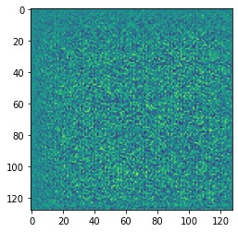
Fig 7. Generator’s Random noise before training
This is done for a fixed number of passes called epochs and in each epoch we update both Generator and Discriminator multiple times.
5.3.4 Evaluation Metrics
Model evaluation and validation are not activities that occur at the end of a model’s development phase; rather, they begin during the training phase. There has to be an organized method of evaluating the intervention which involves both accuracy and insight assessments. Qualitative assessment entails basically searching through the produced images in order to ensure they meet the anticipated standards and variance. On the other hand, the assessment in quantitative evaluation is done using measures like Inception Score or IS and Fréchet Inception Distance or FID.
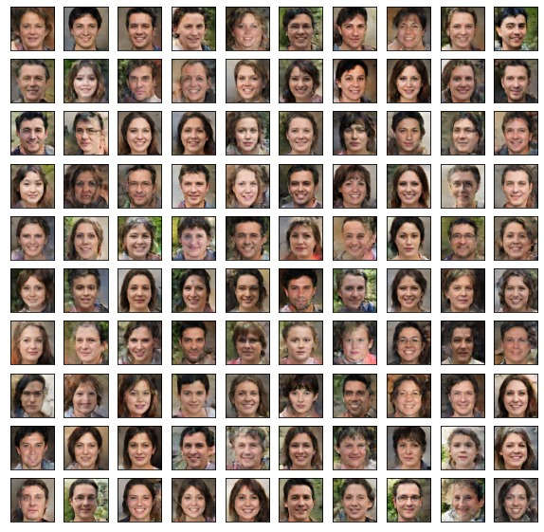
Fig 8. Images generated by trained model
Visual analysis to assess the realism of the human faces has been performed below with the generated images at epoch 1 and epoch 10 respectively.
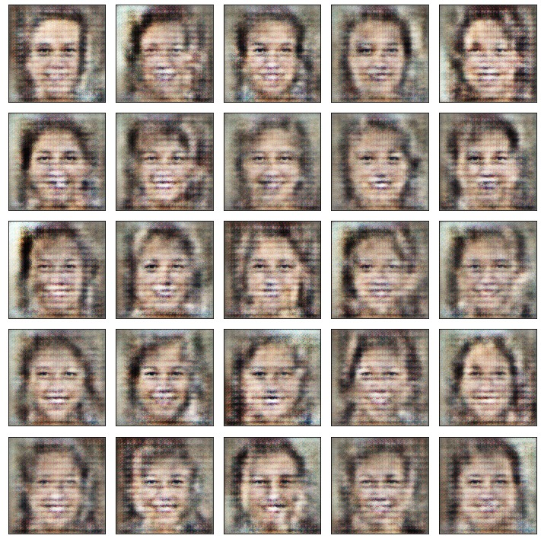
Fig 9. Generated image at epoch 1
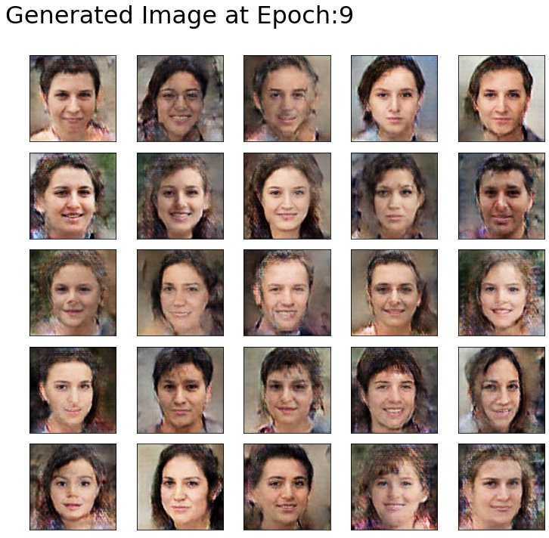
Fig 10. Generated image at epoch 10
To quantitatively assess the quality and variety of the images generated, we employ two critical metrics:
Inception Score (IS): Diversity and quality of the synthetic images are evaluated using this score by means of inference to the InceptionV3 model. It calculates the difference between the generated images and real worlds, that is, how similar the images are, by analyzing their features and distribution.
It consists of two components:
- Mean (IS Mean): This is the average of scores that were calculated on generated image subsets. The class predictions for the given images, generated by InceptionV3 model are of higher values, i.e. the images are diverse and distinct.

- Standard Deviation (IS Std): This is the diversity of predictions across a set of generated images to their subsets. That having been said, larger numbers indicate that more variation is added to each generated image.
The IS Mean of the images generated by the epochs is seen to be increasing in general, indicating the quality and diversity of the features in the generated images are improving. Instead, the IS Std increases substantially, implying that predictions for many different image sub groups tend to vary more.
Fréchet Inception Distance (FID): This score is simply the distance between the distributions of real and generated images on the featu space of the InceptionV3 model. As measures of goodness of fit, lower FID scores imply a better likeness of real and generated images, meaning better performance.
The FID Score decreases as training progresses, a good thing because the generated images are becoming more similar to real ones in distribution. Lower FID scores tend to mean higher image quality and diversity.
We will be monitoring how the model is getting trained by generating the metrics below at the epoch 1, epoch 10 and finally at the epoch 20.
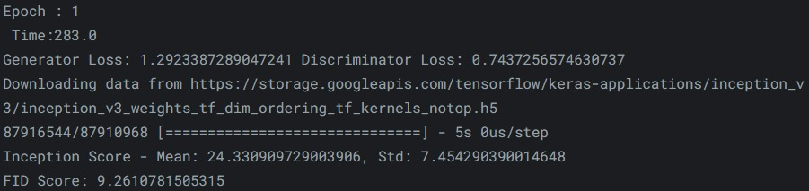
Fig 11. Generated Evaluation metrics at epoch 1
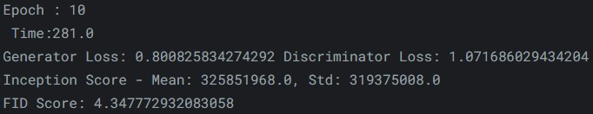
Fig 12. Generated Evaluation metrics at epoch 10

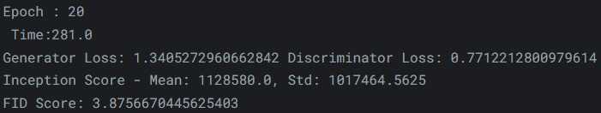
Fig 13. Generated Evaluation metrics at epoch 20
These metrics aid in tracking training progress and offer a quantitative evaluation of the GAN's performance.
6. Results and Analysis

The results below demonstrate the benefits of a focused and efficient approach by demonstrating the higher computational efficiency of DCGAN when compared to combined implementations such as FI-GAN and ESRGAN.
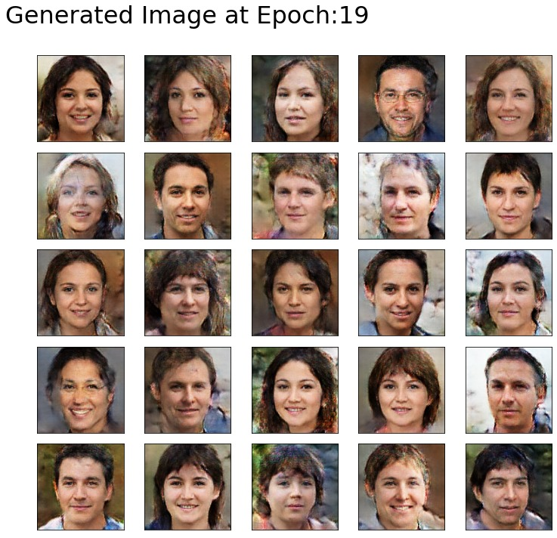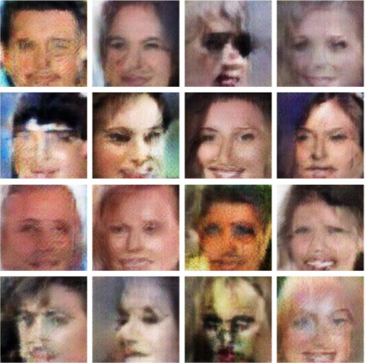
Fig 14. Generated image at epoch 20 by DCGANs Fig 15. Generated image by ESRGANs

  - Key Insights Derived from the Project

- DCGAN Effectiveness: It has been shown that a standalone DCGAN can produce identity preserving and high quality images. Contrary to the reference papers focusing upon training stability and resolution enhancement issues requiring more complex GAN architectures to be addressed, this paper explores the possibility of just tweaking the architecture to some extent.

- Computational Efficiency: Results reveal that DCGAN utilizes much less computation than its combined analogues, FI-GAN and ESRGAN, due to the virtues of a minimalist and directed orientated manner of computation.

- Impact of Data Diversity: For instance, The Face Mask Lite Dataset is used as a proof of concept to demonstrate that it is essential to use diverse training data in order to generate realistic synthetic faces.
6.2 Performance Metrics and Model Evaluation

To objectively assess the quality and performance of the generated images, the project employs two widely-accepted evaluation metrics:

- Inception Score (IS): The quality and diversity of the generated images is evaluated by this metric. The image quality and its diversity is directly proportional to IS values.

- Fréchet Inception Distance (FID): This metric is the similarity between the real and generated images distributions. FID scores indicate closer similarity, and correspondingly better model performance.

Results of evaluation show clearly that DCGAN, being even without added (complexity) complexities on FI-GAN and ESRGAN, has the better image quality with acceptable computing cost.

6.3 Limitations and Challenges Faced

Although the project effectively illustrates DCGAN's ability to produce lifelike human faces, it is crucial to recognize the inherent drawbacks and difficulties of GAN-based models:
- Training Instability: GANs are renowned for their extreme sensitivity to training dynamics and hyperparameters. Therefore, the key issue that must be resolved to achieve the best results that is, training instability and its each of the mode collapse or vanishing gradients concerns.

- Resolution Enhancement: Creating high resolution images without losing information or creating artifacts is a recurring problem in GAN-based face generation.
7. Conclusion
In this project we explore the area of derivations of realistic synthetic human faces for which there has been significant progress with Generative Adversarial Networks (GANs). Lately, there is increasing research in using increasingly complex GAN architectures, including FI-GAN or ESRGAN as used by Katta et al. or Rong et al., while this project took a different approach. In and of itself, it deliberately highlighted the baseline Deep Convolutional Generative Adversarial Network (DCGAN) to test out its quality and effectiveness and see how much it could achieve without any other additional assistance.
7.1 Practical Implications

It has far reaching applications to efficiently creating realistic synthetic faces in a wide field of applications, practically. This technology can be a very powerful weapon in this identity protection type era, protecting sensitive information. This technology can also be exploited for the entertainment industry to make such virtual characters that will literally, in a manner of speaking, shock your viewers when you use these in the next generation video games, virtual reality applications and other forms of digital content. On top of that, fields of artistic expression are enormous and it hopefully makes space for artists to experiment with new forms of expression and create artistic works which we haven’t seen as often.

7.2 Research Insights and Future Prospects

What comes out of this project is not only extremely informative about theřízení of DCGAN but it also outlines potential future research threads:
- Domain Adaptation and Transfer Learning: Future work also includes generalizing face generation models for a broader range of demographics. Adaptation can be done by taking models trained from a different dataset and applying it over a different dataset which its characteristics are different. The robustness of the models could be improved by forcing them to generate real faces across many demographics and environmental conditions, which would bring them closer to the realm of the possible. The future research should concentrate on developing methodologies that make the minimum use of data for retraining with high quality outputs.

- Multi-modal Integration: Finally, combining the multi-modal data such as pairing pictures with textual descriptions or audio inputs seems to be an exciting research avenue. The integration of multiple (modalities) can improve realism and context awareness of generated faces. This means that for example, being able to generate not only face that matches to a given description, but also lip movements that correspond to a given speech input could be useful for virtual assistants and digital avatars. Such research in this direction should focus on creating seamless and coherent integrations between different available data modalities.

- High-fidelity and High-resolution Generation: High resolution and high fidelity face generation is still a challenging task. Future work should try to increase the resolution and the amount of detail in synthetic face generation. It should hence involve not only better architectures of generative models, but also higher quality datasets, and new, more effective training techniques. The applicability of synthetic faces for use in fields such as medical imaging, digital content creation and forensic science can be improved with high resolution face generation.
8. Related Work and References
- Rong, C., Zhang, X., & Lin, Y. (2020). Feature-Improving Generative Adversarial Network for Face Frontalization. IEEE Access, 8, 68842–68851. doi: 10.1109/ACCESS.2020.2986079
- Krishna Katta, V. S., Kapalavai, H., & Mondal, S. (2023). Generating New Human Faces and Improving the Quality of Images Using Generative Adversarial Networks (GAN). 2023 2nd International Conference on Edge Computing and Applications (ICECAA), Namakkal, India, 1647–1652. doi: 10.1109/ICECAA58104.2023.10212099
- Radford, A., Metz, L., & Chintala, S. (2015, November 19). Unsupervised Representation Learning with Deep Convolutional Generative Adversarial Networks: https://arxiv.org/abs/1511.06434
- Karras, T., Aila, T., Laine, S., & Lehtinen, J. (2018). Progressive Growing of GANs for Improved Quality, Stability, and Variation: https://arxiv.org/abs/1710.10196
- Brock, A., Donahue, J., & Simonyan, K. (2018). Large Scale GAN Training for High Fidelity Natural Image Synthesis: https://arxiv.org/abs/1809.11096
- Fake Face Generator: Generating Fake Human Faces using GAN. Available at: https://thesai.org/Publications/ViewPaper?Volume=13&Issue=7&Code=IJACSA&SerialNo=21
- Goodfellow, I., Pouget-Abadie, J., Mirza, M., Xu, B., Warde-Farley, D., Ozair, S., ... & Bengio, Y. (2014). Generative Adversarial Networks. Available at: https://arxiv.org/abs/1406.2661
- Generative Adversarial Networks for Face Generation: A Survey. Available at: https://dl.acm.org/doi/10.1145/3527850
- This Person Does Not Exist. Available at: https://thispersondoesnotexist.com/
- Face-mask-lite-dataset taken from https://www.kaggle.com/
9. Glossary
- GAN (Generative Adversarial Network): A deep learning model consisting of a generator and a discriminator that work adversarially to create realistic synthetic data.
- DCGAN (Deep Convolutional GAN): A GAN variant that uses convolutional and deconvolutional layers for generating images.
- FI-GAN (Feature-Improving GAN): A GAN model designed to enhance face frontalization by mapping profile face features to frontal space.
- ESRGAN (Enhanced Super-Resolution Generative Adversarial Network): A GAN-based model designed to enhance the resolution and quality of low-resolution images.
- Face Frontalization: The process of generating a frontal view of a face from profile images.
- Inception Score (IS): A metric for evaluating the quality and diversity of generated images.
- Fréchet Inception Distance (FID): A metric used to measure the similarity between the real and generated image distributions.
- Discriminator: A neural network in GANs tasked with distinguishing between real and fake data.
- Generator: A neural network in GANs that creates synthetic data to fool the discriminator.
- Normalization: The process of adjusting data to fit within a specific range, commonly used in image processing.
- Batch Size: The number of samples processed in one training iteration.
- Epoch: One complete pass through the entire training dataset during model training.

