**Lab Practical #09:**

Study Packet capture and header analysis by Wireshark (HTTP, TCP, UDP, IP, etc.)

**Practical Assignment #09:**

1. **Explain usage of Wireshark tool.**

* Wireshark is a tool that allows you to capture and examine the data moving through a computer network. Think of a network as a system where devices like computers, smartphones, and servers communicate by sending small units of data called packets. These packets contain information like emails, web page requests, or any other data being exchanged.
* When you use Wireshark, it captures these packets as they travel across the network. It then provides a detailed view of the contents of each packet, showing where it's coming from, where it's going, and what kind of data it contains. This helps users understand how data is flowing through the network, diagnose any issues, or even monitor for potential security threats. Essentially, Wireshark lets you see what's happening behind the scenes in a network, making it a powerful tool for network administrators, security professionals, and anyone interested in understanding network traffic.

1. **Packet capture and header analysis by Wireshark (HTTP, TCP, UDP, IP, etc.**

**HTTP:**

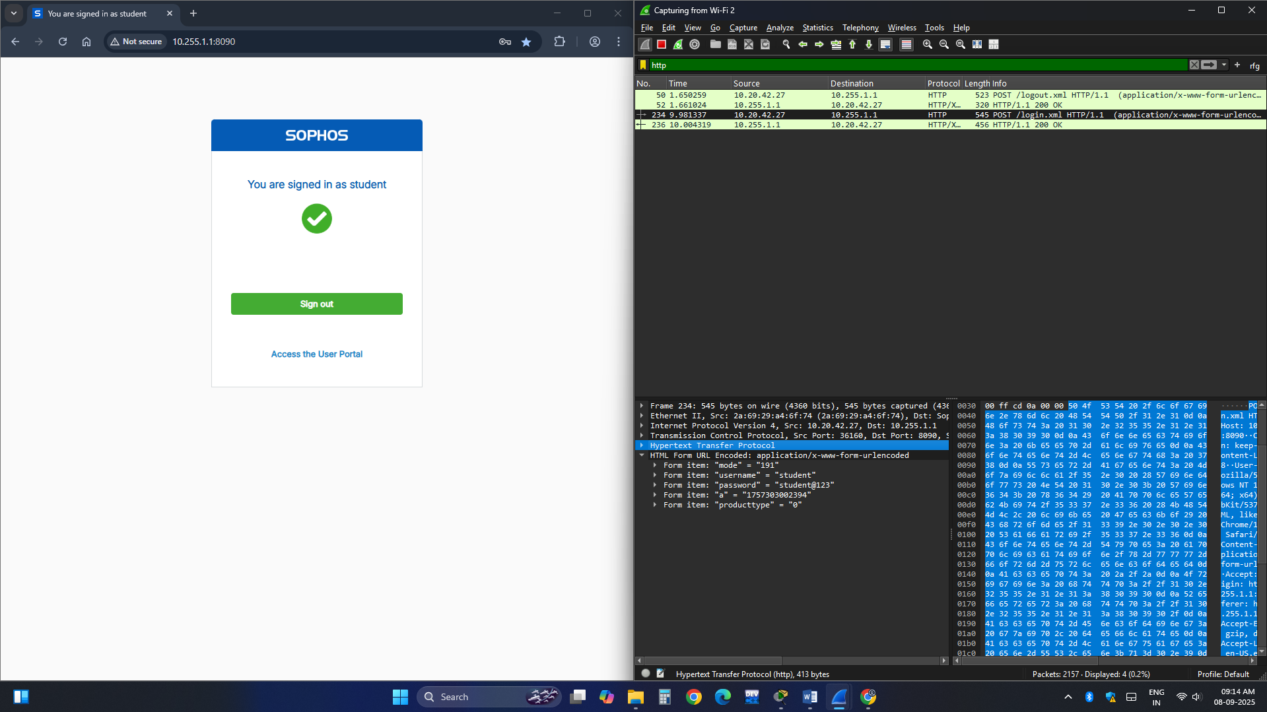

**TCP :**

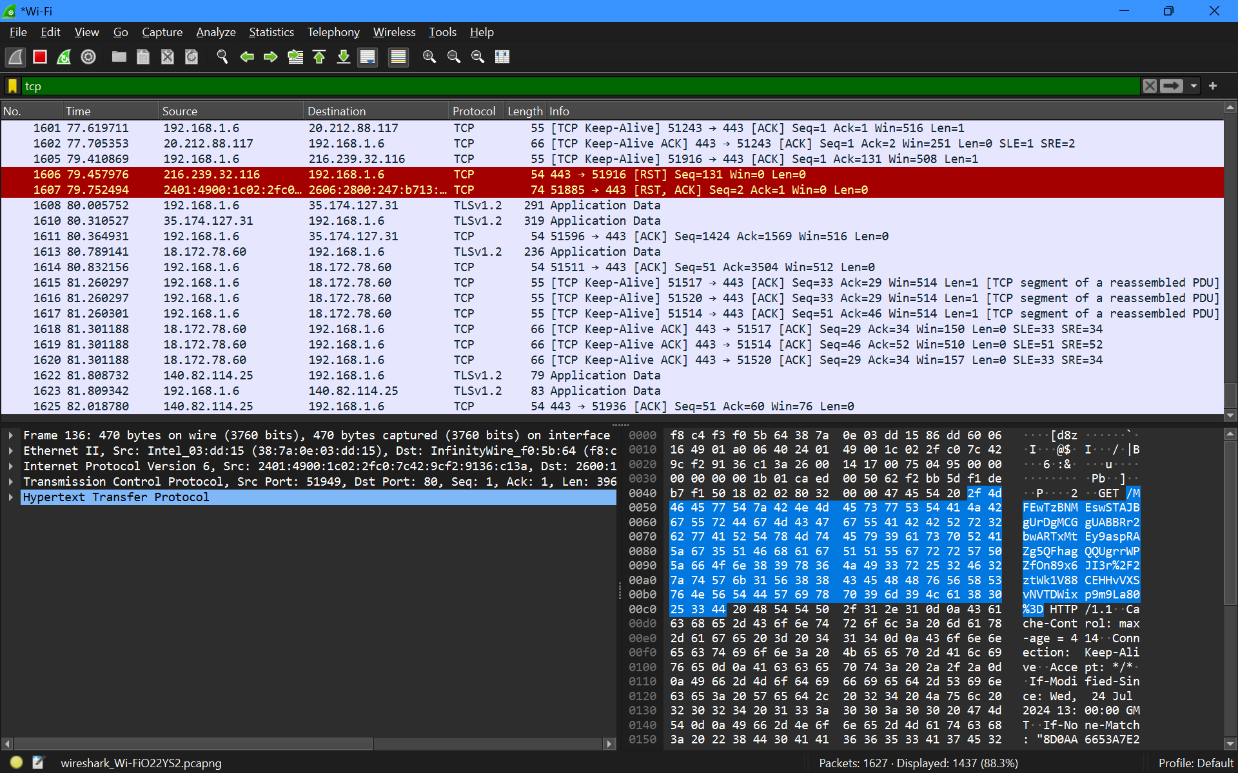

**UDP :**

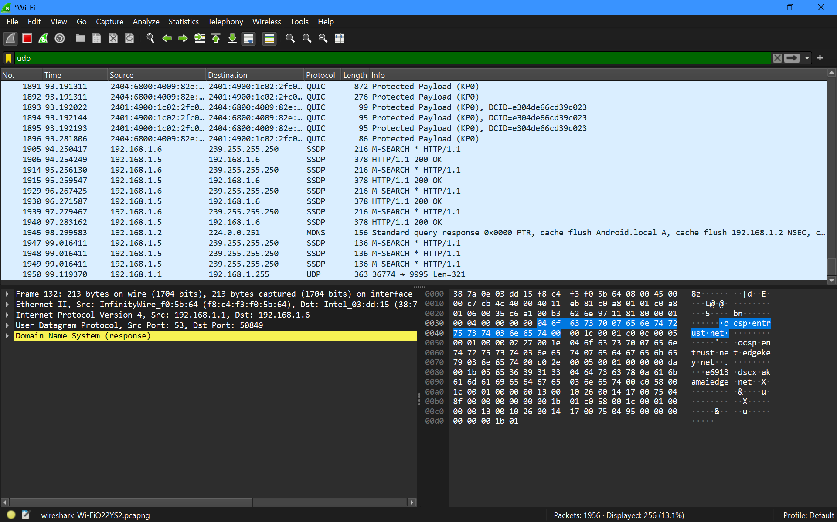

**IP :**

