**Lab Practical #09:**

Study Packet capture and header analysis by Wireshark (HTTP, TCP, UDP, IP, etc.)

**Practical Assignment #09:**

1. **Explain usage of Wireshark tool.**

Wireshark is a network protocol analyzer used to capture and analyze network traffic in real time. It helps in troubleshooting network issues, monitoring performance, detecting security threats, and learning protocol behavior.

1. **Packet capture and header analysis by Wireshark (HTTP, TCP, UDP, IP, etc.)**

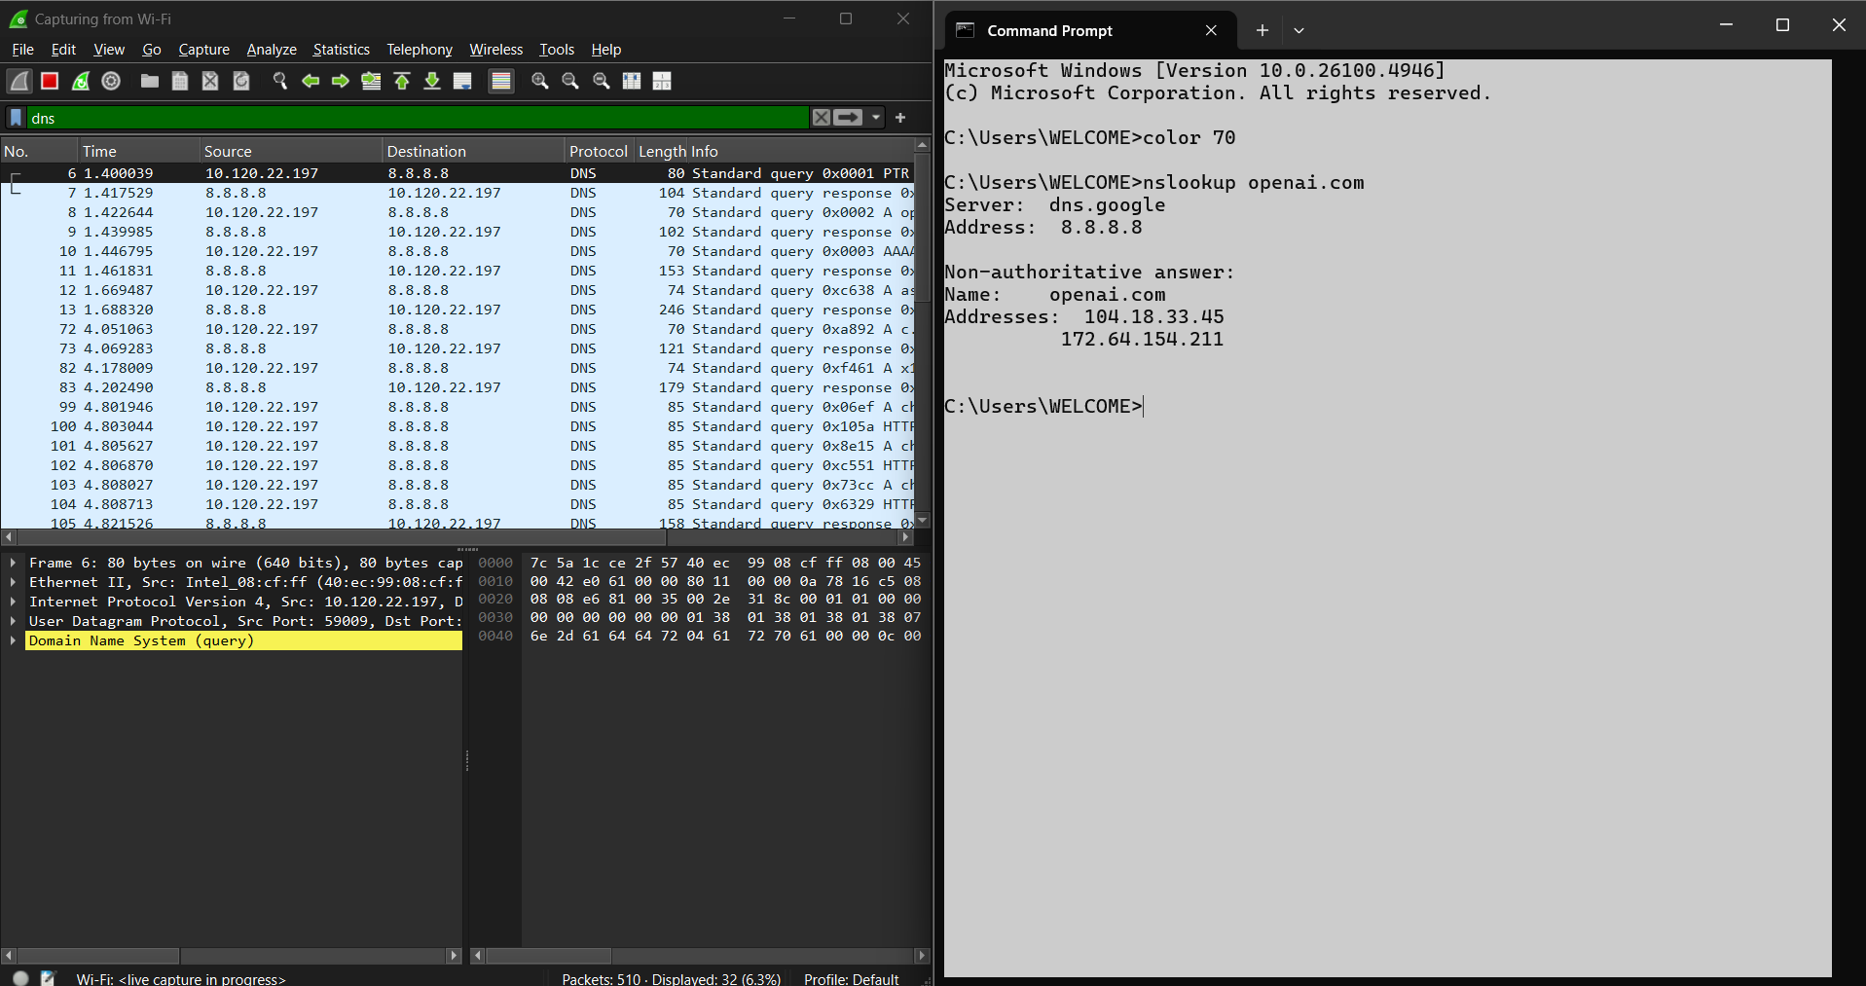

* **ICMP**

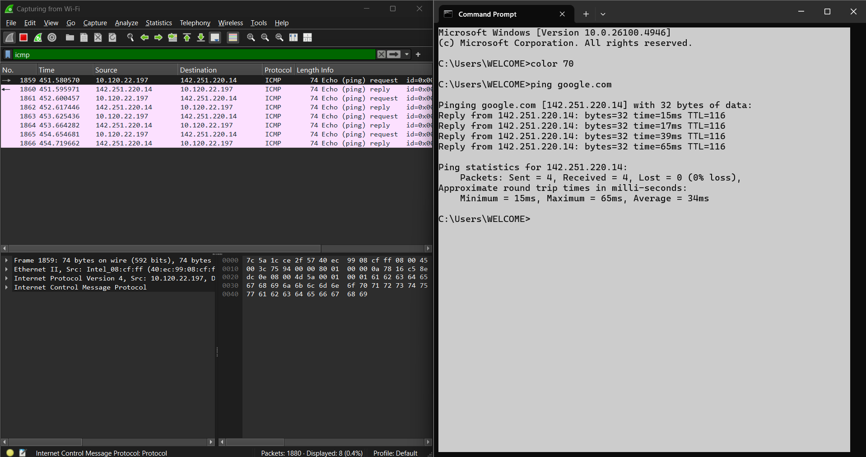

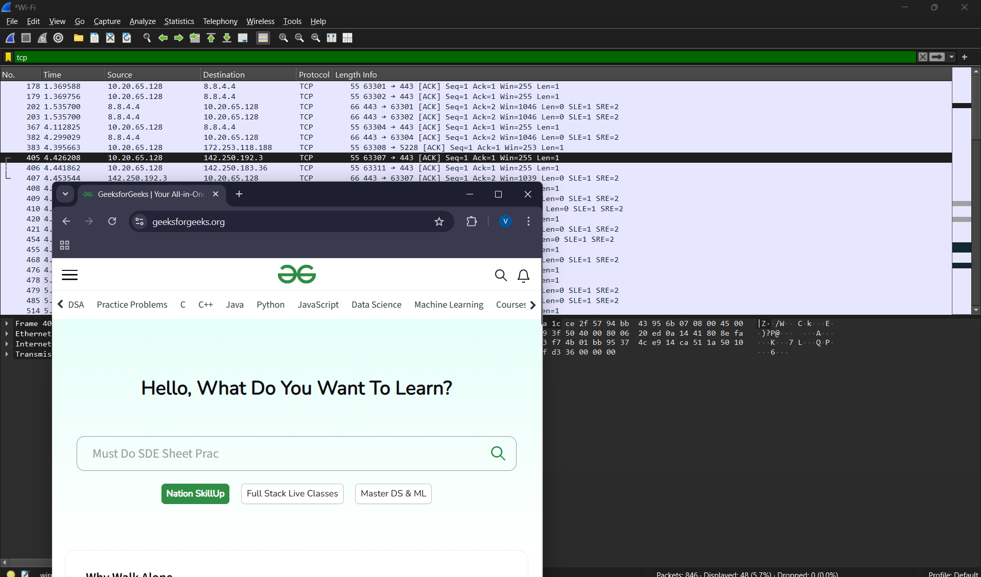

* **TCP**

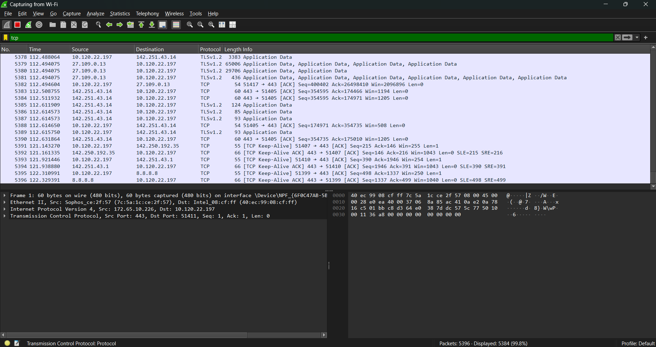

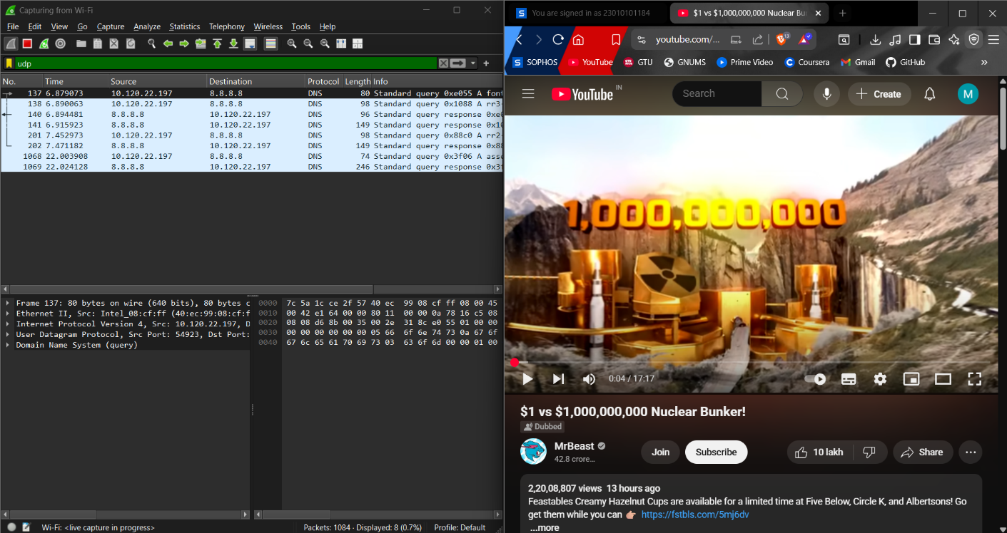

* **UDP**

