# **Git - Practical Exam**

**1. Create one repository for practical and provide the link of it for review.**

[Git Repository](https://github.com/Akash-Rana-25/8009)

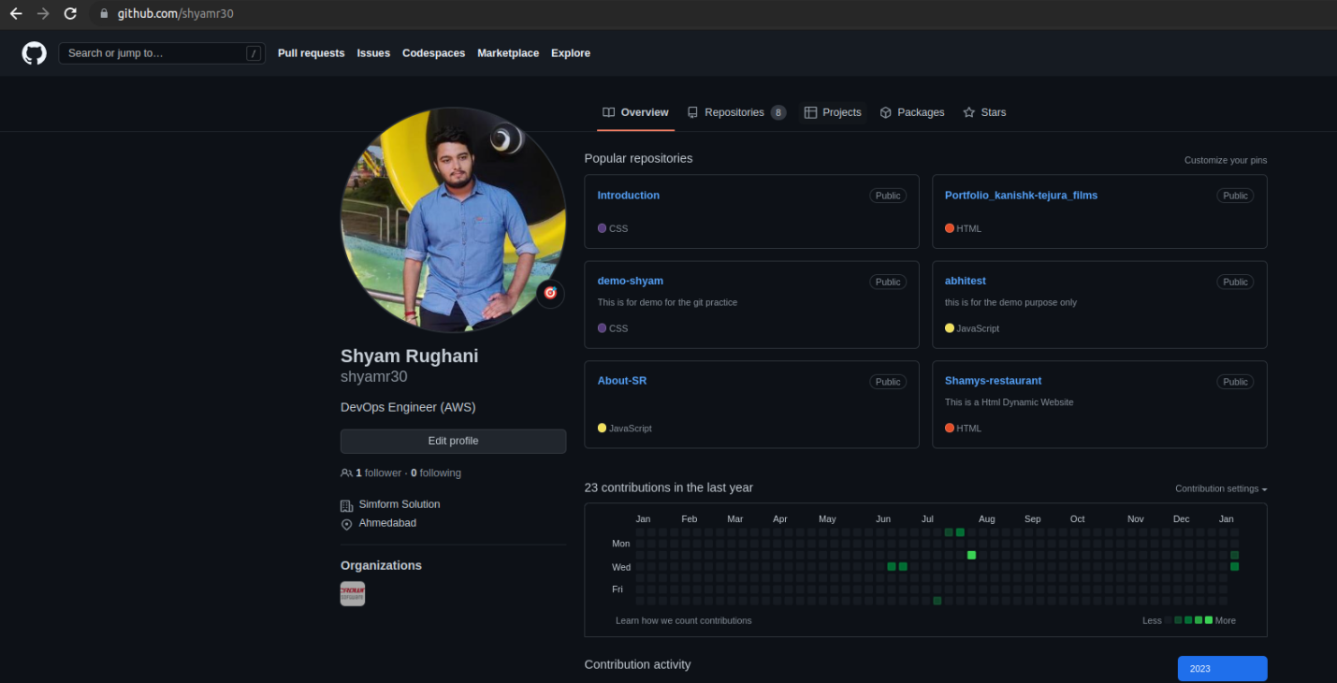

**Branch**

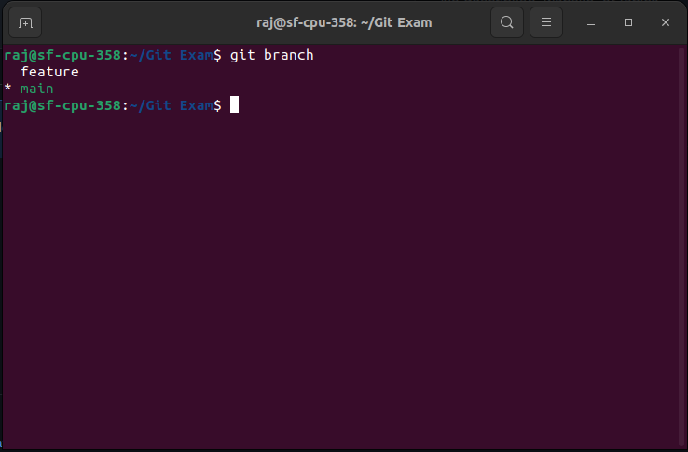

**2.Pull Request**

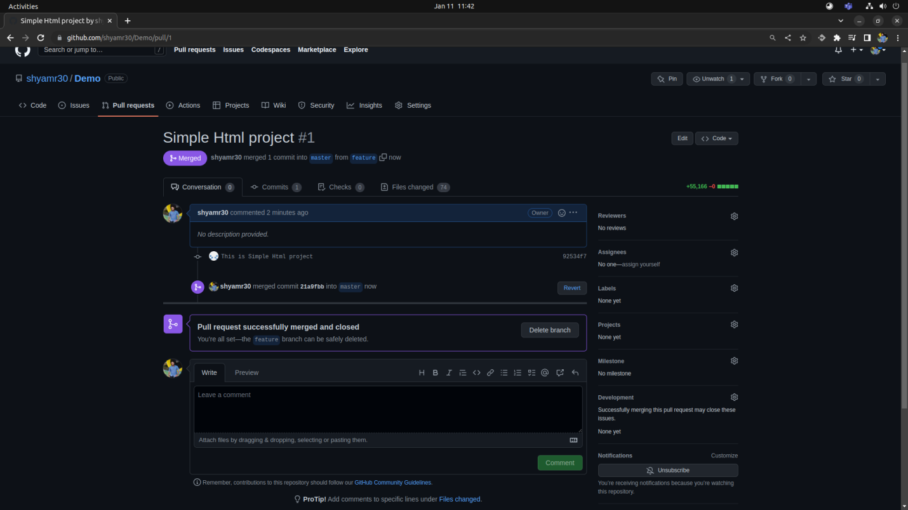

**3.Rebase**

**Commands:**

**$ Git rebase <branch name>**

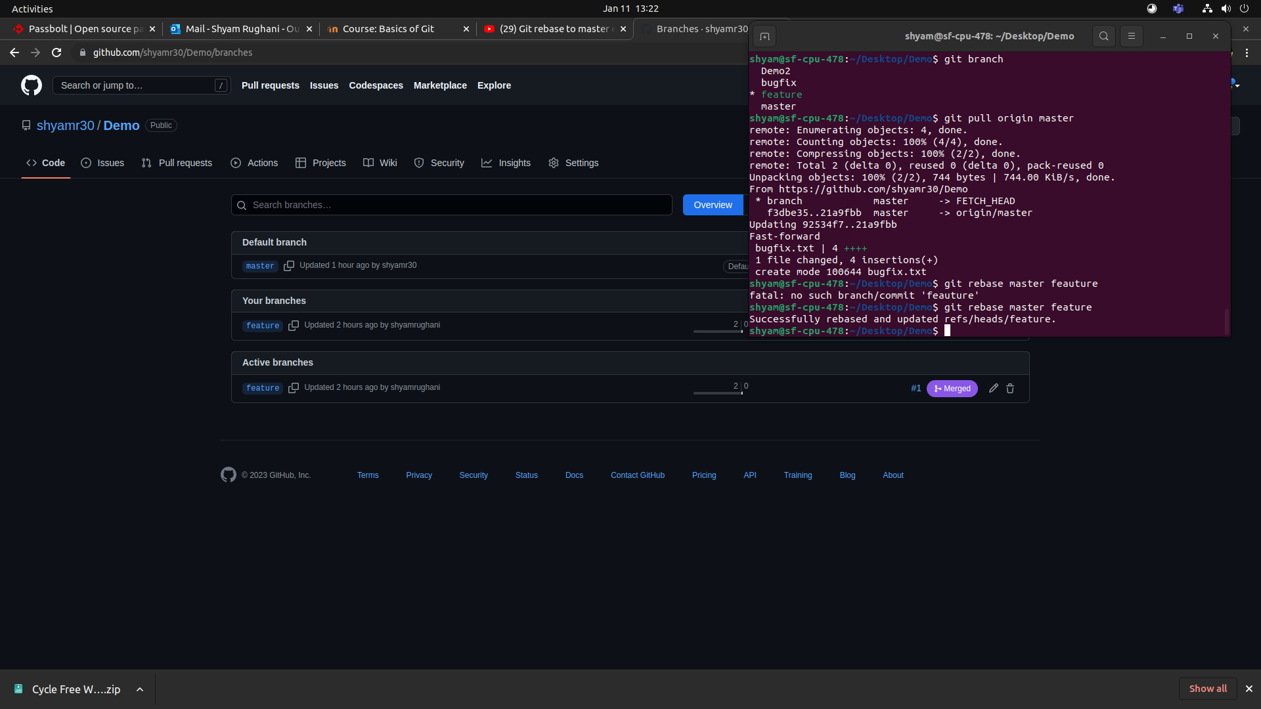

**4. Change commit message**

**Commands:**

**$ Git commit --amend –m ”message ”**

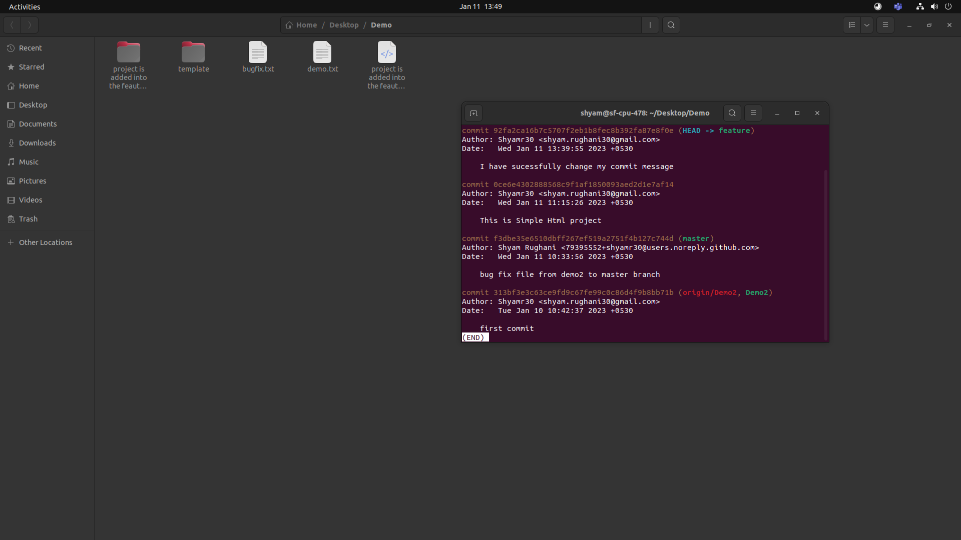

**5. cherry pick**

**Commands:**

**$ Git cherry-pick <commit id>**

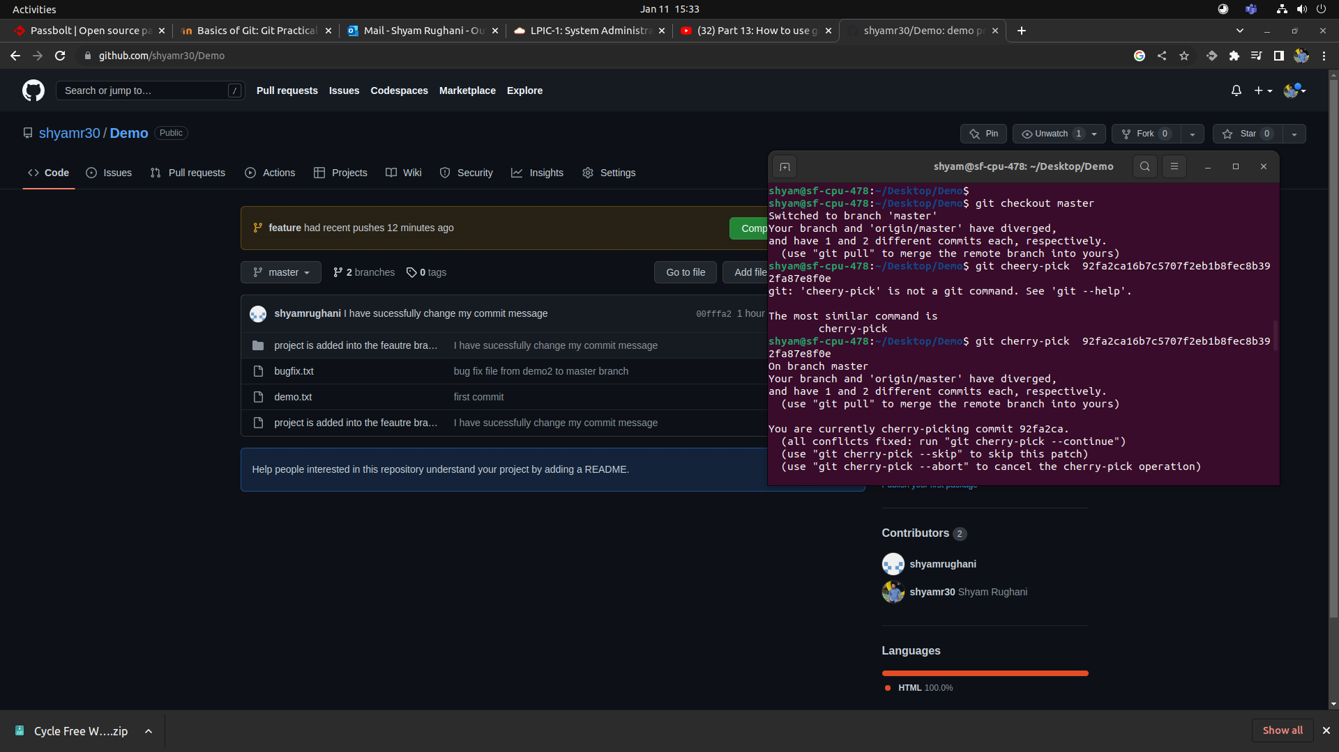

**6. Drop commit**

**Commands:**

**$ Git reset --hard HEAD~1**

