| Experiment No.3 |
| --- |
| Accepting input through Keyboard |
| Date of Performance:26/07/24 |
| Date of Submission:02/08/24 |

**Aim :-** To accept and handle keyboard input in a programming environment

**Objective :-** Develop a simple library management system in Java. The system will allow users (librarians) to input information about new books being added to the library. You need to create a LibraryScanner class that reads and parses different types of input from the user, such as the title of the book, the price of the book, the number of copies available, and the genre of the book

1. Implement a method nextLine() to read a line of input as a String

2. Implement methods nextDouble(), nextInt(), and nextLine() etc. Create a class Book with attributes title, price, copies Available, and genre, rating grades (A-good, B-Ok, C- Bad).

Create a simple demonstration in the main method that prompts the user to enter details for a new book and then displays the entered information.

**Theory:-**

The Scanner class in Java is part of the java.util package and is used for parsing primitive types and strings using regular expressions. It is a simple text scanner which can parse primitive types and strings from any input source such as keyboard input, files, or strings.

Key Concepts and Components

Importing the Scanner Class:

To use the Scanner class, you must import it from the java.util package.

import java.util.Scanner;

Creating a Scanner Object:

A Scanner object needs to be created to read input. The Scanner class provides constructors to specify the input source, such as System.in for standard input (keyboard).

Scanner scanner = new Scanner(System.in);

Reading Different Types of Input:

The Scanner class provides various methods to read different types of input:

nextInt(): Reads an integer.

nextDouble(): Reads a double.

nextLine(): Reads a line of text (string).

next(): Reads the next token (word).

nextBoolean(): Reads a boolean value.

**Code :-**

import java.util.*;

public class Library {

public static void main(String[] args) {

Scanner sc = new Scanner(System.in);

System.out.println("Enter the title of the book:");

String title = sc.nextLine();

System.out.println("Enter the name of the author:");

String name = sc.nextLine();

System.out.println("Enter the genre of the book:");

String genre = sc.nextLine();

System.out.println("Enter the price of the book:");

int price = sc.nextInt();

System.out.println("Enter the rating of the book (e.g., A+, A, B+):");

String rating = sc.nextLine();

System.out.println("Enter the number of copies available:");

int copies = sc.nextInt();

sc.close();

System.out.println("\nBook Information:");

System.out.println("Title: " + title);

System.out.println("Author: " + name);

System.out.println("Genre: " + genre);

System.out.println("Price: " + price);

System.out.println("Rating: " + rating);

System.out.println("Copies Available: " + copies);

}

}

**Output: -**

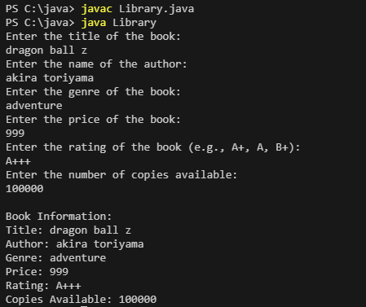

**Conclusion:-**

**next()**: Reads the next token (word) from the input. It does not consume the newline character.

**nextLine()**: Reads the entire line of input including spaces, and consumes the newline character.