**Software Requirements Specification (SRS)**

Ecommerce Shopping Cart

**Introduction**:

The Software Requirements Specification is designed to document and describe the agreement between the customer and the developer regarding the specification of the software product requested. Its primary purpose is to provide a clear and descriptive “statement of user requirements” that can be used as a reference in further development of the software system. This document is broken into a number of sections used to logically separate the software requirements into easily referenced parts. This Software Requirements Specification aims to describe the Functionality, External Interfaces, Attributes and Design Constraints imposed on Implementation of the software system described throughout the rest of the document. Throughout the description of the software system, the language and terminology used should unambiguous and consistent throughout the document.

**Purpose:**

The purpose of this document is to Defining and describing the functions and specifications of the Product E-Commerce System (PECS) is the primary goal of this Software Requirements Specification (SRS). This Software Requirements Specification illustrates, in clear terms, the system’s primary uses and required functionality as specified by our customer.

**Scope :**

This system allows the customers to maintain their cart for add or remove the product over the internet. and payment can do through the varies payment gateway.

**Definitions, acronyms, and abbreviations:**

|  |  |
| --- | --- |
| SRS | Software Requirements Specification |
| DB | Data Base |
| ER | Entity Relationship. |
| HTML | Hypertext markup Language. |
| SQL | Structured Query Language. |
|  |  |

**Functional Requirement:**

This section provides requirement overview of the systems. Various functional modules that can be implemented by the system will be -

**Description**

**Registration**: If customer wants to buy the product then he/she must be registered, unregistered user can’t go to the shopping cart.

**Login:** Customer logins to the system by entering valid user id and password for the shopping.

**Changes to Cart**: Changes to cart means the customer after login or registration can make order or cancel order of the product from the shopping cart.

**Payment:** For customer there are many types of secure billing will be prepaid as debit or credit card, postpaid as after shipping, check or bank draft. The security will provide by the third party like Pay-Pal etc.

**Logout**: After the payment or surf the product the customer will logged out.

**Report Generation**: After all transaction the system can generate the portable document file (.pdf) and then sent one copy to the customer’s Email-address and another one for the system data base to calculate the monthly transaction.

**Login Form**

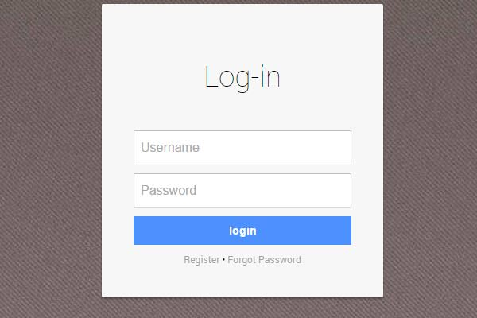

**Registration :**

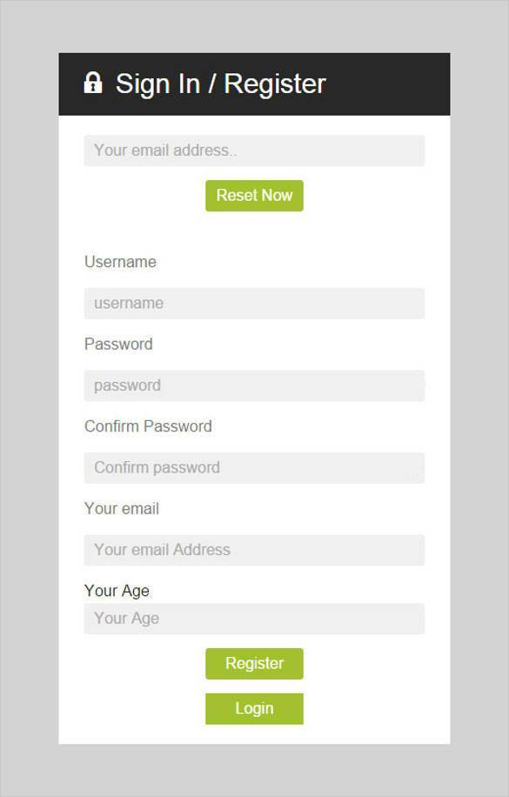

**Other non-Functional Requirements:**

**Security:**

**Reliability:**

**Availability:**

**Maintainability:**

**Portability:**