RULE-BASED INTRADAY FUTURES RETURNS
Return Asymmetry, Robustness and Statistical Validation Across Two Historical Samples
Research working paper · Version 1.0 · October 2026
Raj Phuyal
Independent researcher · Quantitative Finance
October 2026
Status: independent research working paper | Preliminary two-window evidence; not independently validated or peer-reviewed

Abstract
This paper evaluates a rule-based intraday Nasdaq and Euro futures strategy using 242 recorded risk-normalized trade outcomes across 180 dates in 2017–2018 and 2025–2026. The sample produces 149.970R net, mean +0.620R per trade, median −1R and profit factor 2.172. I document instrument and period heterogeneity, date-level aggregation, distributional asymmetry, bootstrap intervals, winner-removal sensitivity, drawdown and cost break-even thresholds. The observed mean is positive under conventional conditional inference, but the data are not a continuous ten-year record, do not independently establish all eligible signals, and lack transaction timestamps, verified historical execution costs and a frozen pre-test strategy specification. I therefore interpret the evidence as a descriptive and conditional statistical baseline, not as proof of a persistent market anomaly. The paper develops a falsifiable program for continuous reconstruction, transaction-cost analysis, regime testing, data-snooping correction and untouched chronological validation.
Keywords: systematic trading; futures; intraday returns; payoff asymmetry; bootstrap; data snooping; backtest overfitting; market regimes; risk-normalized performance.

Research status and interpretation
Scope of this edition. This version consolidates my current research draft but does not establish validated strategy profitability. Historical trades and statistical tests are conditional on the recorded-trade sample; market-data reconstruction, rule-freeze evidence, execution-cost auditing, and an untouched out-of-sample evaluation remain outstanding.
All reported numerical estimates are based on the current combined workbook; the manuscript does not assert continuous performance in the unobserved 2019–2024 interval. Charts and statistics are conditional on the recorded sample. Proposed analyses requiring tick/minute market data are labeled prospective. Older archives containing a 149.470R total are superseded by the revised 149.970R baseline. I present this working paper for scrutiny and further empirical development, not as a completed journal submission.

1. Introduction
Systematic trading research confronts a basic identification problem: profitable historical returns may arise from a real conditional market effect, favorable sampling, discretionary selection or the selection of one rule among many tried. A useful empirical paper must therefore move beyond cumulative profit and characterize the return distribution, data-generating process and strength of its inferential claims. This investigation focuses on the observed performance of an intraday futures framework whose payoff profile combines frequent stop-outs with larger but less frequent winners. The object of interest is not merely the sign of total R, but the credibility and durability of that asymmetry.

2. Research motivation
An R-multiple outcome scales a trade by its initial risk, allowing comparison across instruments with different contract sizes and volatility. It is not a percentage portfolio return: without exposure, position sizing and margin data, annualized Sharpe ratios and account growth cannot be inferred. The project is motivated by the possibility that rules with a negative median can still have positive mean expectancy. Determining whether that structure persists after costs and stringent out-of-sample evaluation is the central economic question.

3. Research questions
The primary question is whether observed mean R is positive and robust to alternative observational units and influential winners. Secondary questions concern cross-instrument and cross-period heterogeneity, dependence among same-day trades, tail risk, costs, volatility regimes and the distinction between a descriptive historical record and genuinely prospective evidence.

4. Formal hypotheses
H1: mean observed trade R exceeds zero. H2: date-level aggregate mean R exceeds zero. H3: positive net R is not solely attributable to the largest few winners. H4: performance differs between instruments and between separated periods. H5: positive expectancy derives from asymmetric payoff magnitudes rather than majority wins. H6 (future): after frozen-rule continuous reconstruction, the net-of-cost strategy retains positive expectancy in an untouched test sample. The first five are conditional exploratory tests; H6 is prospective.

5. Literature review
White (2000) demonstrates the need to adjust inference when the best model is selected from many candidate rules. Sullivan, Timmermann and White (1999) apply bootstrap methods to technical trading rule performance and data snooping. Hansen (2005) develops a superior predictive ability test. Bailey et al. (2017) study backtest overfitting. Moskowitz, Ooi and Pedersen (2012) report time-series momentum in futures and forwards; that medium-horizon result motivates systematic futures research but does not validate the present intraday rule. These sources imply a hierarchy: description, conditional inference, dependence-aware robustness, documented model-selection controls, then untouched chronological validation.

6. Theoretical and conceptual framework
Let X_it denote information available before trade i and θ a pre-specified vector of entry, stop, target and management parameters. The intended strategy maps (X_it, θ) to an eligible signal and a realized outcome R_i. In the existing archive only realized R_i, date, instrument and period are observed; neither the full information set nor the set of eligible-but-untraded signals is available. Accordingly this paper estimates properties of F(R | recorded trade), not unconditional profitability over every possible eligible opportunity.

7. Mathematical strategy definition
For trade i, initial risk C_i = |entry_i − initial_stop_i| × contract multiplier × quantity_i, and realized R_i = realized net or gross P&L_i / C_i, using a consistent convention. The recorded R values are treated as gross strategy outcomes because costs have not been independently validated. With partial exits, R_i is the quantity-weighted sum of exit-leg R multiples. Eligibility should be formalized as S_t(θ)∈{0,1} based on sweep, session, entry and exclusion conditions. A final executable specification must remove subjective judgments from each variable.

8. Exact data methodology
The canonical workbook sheet “All Trades” contains Date, Instrument, R, Period and Outcome. The analysis retains every row with numeric R; instruments are standardized as Nasdaq and Euro; dates are parsed as calendar dates; and the original row index is preserved to maintain supplied within-day ordering. Daily aggregates sum all trade R values on the same date. Monthly and yearly results use the date field. No missing-year observations are filled or interpolated.

9. Sample construction
The combined dataset contains 242 usable records: 101 from 2017–2018 and 141 from 2025–2026. There are 180 unique dates. These are two non-contiguous windows, not a decade of continuous evidence. A separate 2018 row with no recorded R is noted in earlier source materials and excluded from the current numeric baseline. The sample consists of recorded outcomes; the complete historical opportunity universe is unknown.

10. Data-quality protocol
Reconciliation checks require count=242, sum R=149.970, 76 wins, 128 losses and 38 zero outcomes. The analyst should preserve raw row order and use a stable date sort. Date-only observations cannot establish exact intraday entry/exit sequencing; consequently trade-order drawdown is conditional on the supplied order. Any future revision to a trade record should be logged with the old and new values, date, reason and author approval.

11. Trade-level analysis
The arithmetic mean is +0.6197R and median is −1R. The sample standard deviation is approximately 2.228R. Of 242 trades, 76 are positive, 128 negative and 38 break-even. The all-trade positive proportion is 31.4%; excluding break-evens, the win rate is 37.3%. These are distinct denominators and should never be conflated. The best trade is +7.5R and the worst −1R.

12. Daily-level analysis
Aggregating the 242 trades by date yields 180 observed trading days and total +149.970R. The mean across observed trading days is +0.8332R. The daily distribution is not a return on calendar days with no trade; it is conditional on dates with at least one recorded observation. This aggregation reduces the mistaken treatment of same-day trades as independent, but does not by itself remove cross-day serial correlation.

13. Nasdaq analysis
Nasdaq contributes 148 trades and +117.870R, mean +0.796R per trade. Its payoff distribution reflects the multi-leg exit and runner structure in the strategy description. Comparison with Euro must account for different target and management rules; it is not a pure comparison of markets holding strategy design constant.

14. Euro analysis
Euro contributes 94 trades and +32.100R, mean +0.341R per trade. Its reported target is approximately 3R with distinct stop and breakeven rules. Positive average R is observed, but the smaller sample and differing payoff constraints make simple significance rankings potentially misleading.

15. 2017–2018 analysis
The early window has 101 trades, net +52.765R, mean +0.522R, profit factor about 1.879 and maximum sequential drawdown about 10.5R. Its trade-level median and loss clustering matter for assessing the plausibility of subsequent deployment. It cannot be assumed that these trades were recorded under an ex ante frozen rule version without further provenance.

16. 2025–2026 analysis
The later window has 141 trades, net +97.205R, mean +0.689R, profit factor about 2.429 and within-period maximum drawdown about 7R. Although this is temporally later, calling it independent out-of-sample evidence requires proof that the strategy specification was frozen before the sample was examined. The 2026 portion is incomplete as of the research cutoff.

17. Return-distribution analysis
A median of −1R alongside a positive mean reveals right-tail dependence. Skewness is positive, and most observations are at or below zero. The shape reflects risk-management design as well as market opportunity: stops bound many losses while some winning trades produce several R. Formal normality assumptions are questionable, motivating bootstrap and rank-based sensitivity checks.

18. Expectancy decomposition
Write μ = p_W μ_W + p_L μ_L + p_B μ_B. Since zero outcomes contribute nothing, μ = p_W μ_W + p_L μ_L. In this dataset, p_W=76/242, p_L=128/242, p_B=38/242; mean loss is −1R and gross negative R is 128R. Gross positive R is therefore 277.970R and average winner approximately 3.6575R. Hence μ≈(76/242)(3.6575)+(128/242)(−1)=0.6197R. The expectancy arises from winner magnitude, not win frequency.

19. Win/loss asymmetry
The observed payoff ratio, average winner divided by absolute average loser, is about 3.66. This high magnitude ratio can offset a low winning fraction. Yet payoff asymmetry may be fragile to adverse execution at entries and exits, runner fill assumptions and regime changes. Any interpretation should distinguish a design-imposed payoff profile from evidence of an exploitable market anomaly.

20. Profit-factor analysis
Profit factor PF = Σ max(R_i,0) / |Σ min(R_i,0)|. The combined gross positive R is 277.970 and gross negative R is 128.000, yielding PF=2.17164. PF is sensitive to sample composition and can be inflated by omitted trades. It is a useful descriptive ratio but not a probability statement, hypothesis test or substitute for net-of-cost portfolio analysis.

21. Drawdown analysis
The observed maximum sequential peak-to-trough drawdown is approximately 10.5R using supplied row order within each date. Define equity E_k=Σ_{i≤k}R_i and DD_k=E_k−max(0,E_1,…,E_k). The reported maximum drawdown is min_k DD_k. Date-level aggregation yields a separate path with less sensitivity to unknown within-day sequence. Both should be disclosed where intraday timestamps are missing.

22. Sequence-risk analysis
Sequence risk asks how deep a drawdown can become when a given empirical payoff distribution is reordered or resampled. An iid trade bootstrap is informative as a conditional diagnostic, but it does not preserve volatility regimes, serial dependence or endogenous trade frequency. A rigorous extension should use moving-block or stationary bootstrap at the day level, stress altered loss probabilities and winner magnitudes, and disclose the empirical model assumptions.

23. Bootstrap inference
The nonparametric trade bootstrap repeatedly samples 242 trade R values with replacement and computes their mean. Using a fixed seed and 20,000 draws in this manuscript yields the percentile interval shown in the results table. The date-level bootstrap resamples the 180 observed daily aggregates and reports a confidence interval for mean R per active day; this is a different estimand from mean R per trade. Neither bootstrap removes strategy-selection bias.

24. Randomization and sign-flip inference
Under a symmetric zero-centered null, one can randomly multiply outcomes by ±1 and compare the resulting mean with the observed mean. The symmetry assumption is not innocuous here because the strategy distribution is structurally asymmetric and losses are bounded near −1R. A sign-flip p-value should therefore be labeled an assumption-dependent diagnostic rather than an unconditional valid test of zero expectancy. Alternative null construction requires explicit justification.

25. Dependence and same-day clustering
The 242 records occur on 180 dates; within-day trades may share price shocks, trend state and execution constraints. Date clustering can be addressed through date-level aggregation or a cluster bootstrap. Cross-day autocorrelation remains possible and requires an appropriately long observed continuous sample to estimate reliably. Effective sample size should not be assumed equal to 242 independent observations.

26. Winner-concentration analysis
Removing the largest single winner leaves +142.470R. Removing the five largest leaves +118.470R. Removing the ten largest leaves +89.115R across 232 trades, mean +0.384R. The result is therefore not entirely due to one or two unusually profitable observations. Nevertheless, winner removal is an adversarial sensitivity test, not a substitute for corrections for multiple testing or unobserved omitted signals.

27. Parameter sensitivity framework
The next-stage study should perturb Fibonacci entry ratio, ATR lookback and smoothing, stop buffer, minimum stop, breakeven threshold, first target, runner cap and maximum daily attempts. The perturbation grid must be fixed before evaluating a reserved test sample. Performance should be displayed as surfaces or neighborhoods rather than choosing a single best cell. Narrow isolated peaks suggest fragility.

28. Market-regime framework
Proposed ex ante regime variables include realized volatility, ATR percentile, opening range, trend strength, overnight gap, previous-session direction, scheduled macroeconomic announcements, liquidity and day of week. These are not currently included in the trade workbook. Conditional expectancy E[R|Z] should be estimated only after market data and signal timestamps are reconstructed, with careful treatment of multiple comparisons.

29. Transaction-cost analysis
A generic cost stress can be expressed as net R_i = gross R_i − c_i, where c_i is all-in execution cost divided by initial monetary risk. Under a constant cost c per trade, net mean R = 0.6197−c. Thus the break-even average cost is about 0.620R per trade in this observed sample. This is a scenario threshold, not a claim about actual brokerage or market costs; real costs vary by contract, stop width, quantity and fill count.

30. Slippage and execution analysis
The strategy uses intraday orders, partial exits and stop adjustments. A realistic simulator must define bid/ask pricing, limit-order queue assumptions, stop slippage, partial fills, contract multiplier, commissions, exchange fees, rollover conventions and intrabar path ambiguity. Without timestamps and raw market data, none of these effects can be measured from the current R log. Report net results under multiple adverse assumptions once reconstructed.

31. Data-snooping framework
A trading rule selected after inspecting historical outcomes is not a random fixed hypothesis. Conventional confidence intervals condition on the chosen rule and omit the cost of searching over alternative filters, parameters and instruments. Future research must archive the full candidate set and decision chronology. Where feasible, White’s Reality Check or Hansen’s SPA test should be applied to appropriately defined benchmark-relative performance series.

32. Backtest-overfitting framework
Backtest overfitting occurs when a chosen specification captures noise peculiar to the development data. A strong protocol separates rule formation, parameter validation and final chronological test. The probability-of-backtest-overfitting approach can help diagnose selection when many candidate configurations have comparable evaluation records; it cannot be retrofitted convincingly if the search history is unknown.

33. Placebo and falsification tests
Pre-register falsification exercises: shift entry time, use adjacent non-signal sessions, test randomized event alignment, reverse signal direction under a defined null, and compare to simple rules with equivalent trade frequency and risk management. A valid placebo must preserve market structure sufficiently to form a meaningful benchmark. All such analyses are future work, not reported as completed results.

34. Statistical versus economic significance
A small conditional p-value indicates tension with a statistical null, not investability. Economic significance requires net costs, capital utilization, exposure, drawdown tolerance, contract limits, turnover, execution capacity and funding constraints. The R-multiple dataset lacks the monetary position-sizing information required to calculate portfolio returns, annualized Sharpe ratio or investor utility reliably.

35. Threats to validity
Internal validity is limited by unknown eligible-signal coverage, possible discretionary selection, missing intraday sequence, historical rule revisions and absent execution verification. Statistical conclusion validity is limited by dependence, non-normality, selective reporting and research search. External validity is limited by two instruments, sparse non-contiguous windows and partial 2026 coverage. Construct validity depends on the consistency of the initial-risk denominator across partial exits and stop management.

36. Discussion
The most interesting result is the conjunction of negative median, relatively frequent losses and positive mean return. That pattern is consistent with a convex payoff design in which occasional larger winners dominate cumulative R. It does not identify the economic mechanism: market predictability, discretionary filtering and historical selection remain competing explanations. A strong paper should frame these as alternatives to be tested, not as settled causes.

37. Conclusion
The recorded dataset exhibits positive gross risk-normalized returns: +149.970R across 242 trades and +0.620R per trade on average. Positive performance appears in both supplied windows and remains after removing the largest ten winners. These findings justify a deeper empirical study but do not establish an exploitable anomaly. The next evidentiary step is a complete frozen-rule signal reconstruction with costs and untouched chronological validation.

38. Continuous ten-year research design
The proposed study will reconstruct all eligible signals over approximately 2017–2026 with explicit market-data sources, roll conventions, timezone and session rules, signal timestamp, entry/stop/exit fill models and every rule version. The missing 2019–2024 years must be collected rather than interpolated. Development, validation and test partitions should be chronological and defined before inspecting the final test. Multiple-testing corrections and negative-control strategies should accompany the final analysis.

39. Future publication roadmap
Publication 1: current preliminary empirical baseline and reproducibility protocol. Publication 2: complete historical reconstruction with transaction costs and chronological validation. Publication 3: volatility/liquidity regime dependence and conditional payoff asymmetry. Publication 4: market microstructure or execution mechanisms, contingent on tick-level data. These are proposed research directions rather than promised independent publishable findings.

Empirical results and figures
Group | N | Wins | Losses | BE | Net R | Mean R | PF | Max DD
Combined | 242 | 76 | 128 | 38 | 149.97 | 0.62 | 2.172 | -10.5
2017-2018 | 101 | 31 | 60 | 10 | 52.765 | 0.522 | 1.879 | -10.5
2025-2026 | 141 | 45 | 68 | 28 | 97.205 | 0.689 | 2.429 | -7.0

Instrument | N | Wins | Losses | BE | Net R | Mean R | PF
Euro | 94 | 29 | 52 | 13 | 32.1 | 0.341 | 1.617
Nasdaq | 148 | 47 | 76 | 25 | 117.87 | 0.796 | 2.551

Inference | Point estimate | 95% percentile bootstrap interval
Mean per trade | 0.6197R | [0.342, 0.903]R
Mean per active date | 0.8332R | [0.476, 1.205]R

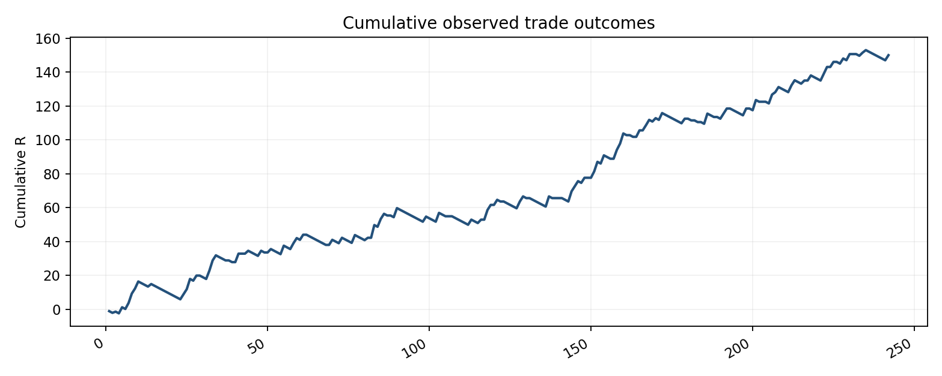
Figure 1. Cumulative R; within-date order follows the source workbook.
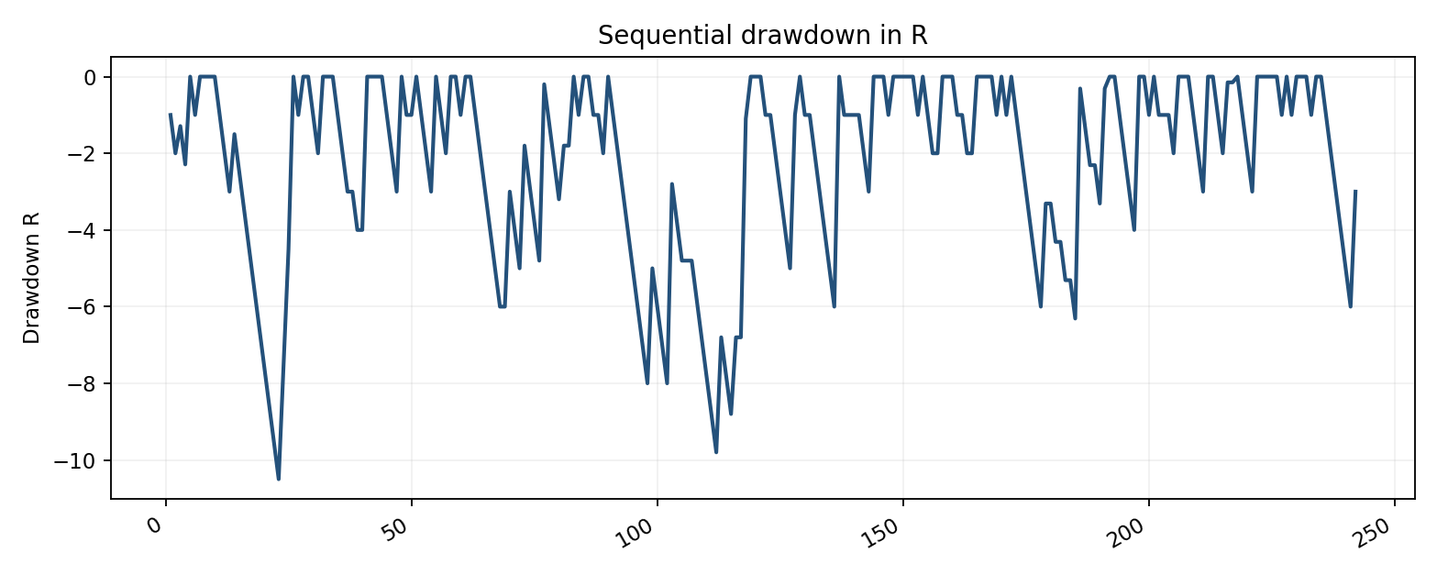
Figure 2. Observed sequential drawdown; order conditional on source rows.
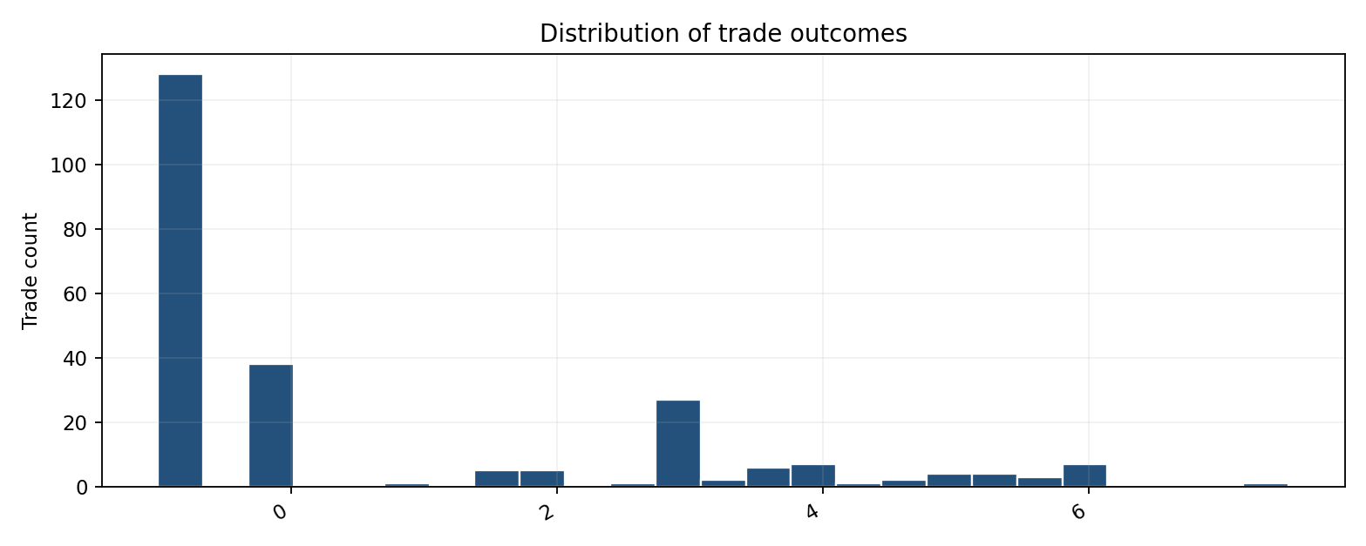
Figure 3. Empirical distribution of R outcomes.
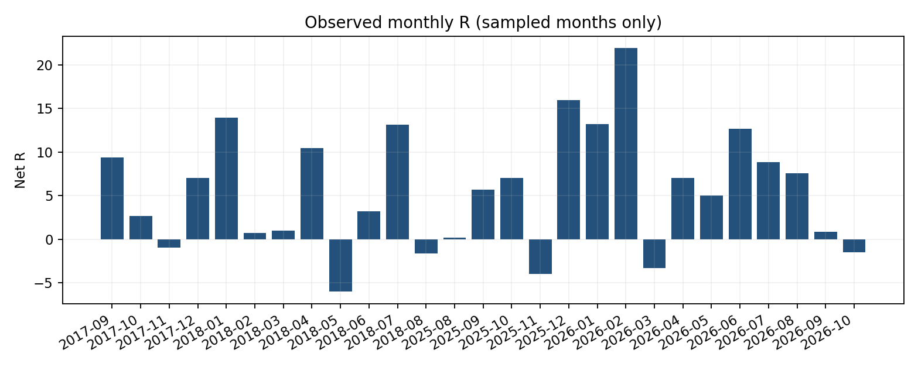
Figure 4. Only observed months are shown; the 2019–2024 gap is not filled.
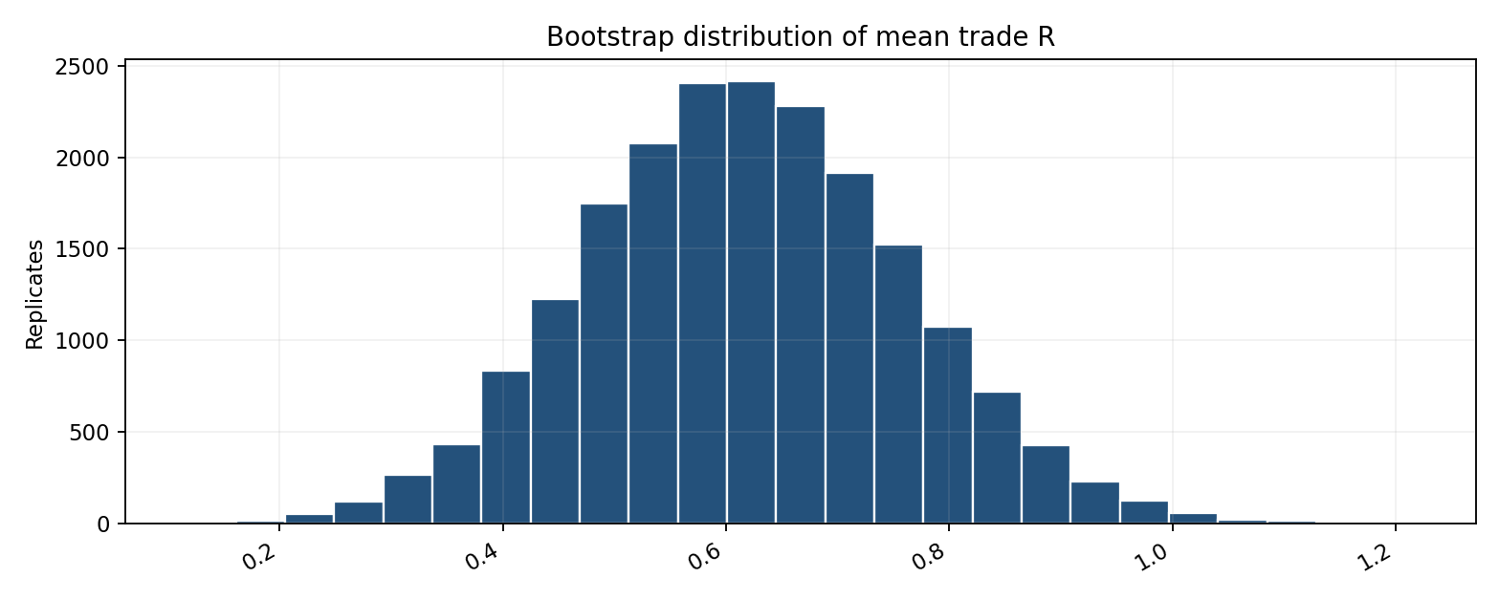
Figure 5. Conditional iid trade bootstrap, 20,000 draws, seed 20261023.

40. Full references
Bailey, D. H., Borwein, J. M., López de Prado, M., & Zhu, Q. J. (2017). The probability of backtest overfitting. Journal of Computational Finance, 20(4). doi:10.21314/JCF.2016.322.
Hansen, P. R. (2005). A test for superior predictive ability. Journal of Business & Economic Statistics, 23(4), 365–380. doi:10.1198/073500105000000063.
Moskowitz, T. J., Ooi, Y. H., & Pedersen, L. H. (2012). Time series momentum. Journal of Financial Economics, 104(2), 228–250. doi:10.1016/j.jfineco.2011.11.003.
Sullivan, R., Timmermann, A., & White, H. (1999). Data-snooping, technical trading rule performance, and the bootstrap. Journal of Finance, 54(5), 1647–1691. doi:10.1111/0022-1082.00163.
White, H. (2000). A reality check for data snooping. Econometrica, 68(5), 1097–1126. doi:10.1111/1468-0262.00152.

Appendix A. Statistical definitions
R multiple: Realized P&L divided by initial trade risk.
Win rate (all trades): Number positive divided by total including zero trades.
Win rate (excluding BE): Positive divided by positive plus negative trades.
Profit factor: Gross positive R / absolute gross negative R.
Drawdown: Cumulative R less running historical maximum including zero baseline.
Bootstrap CI: Quantiles of a stated resampling distribution; conditional on empirical sample.
Date clustering: Non-independence among outcomes occurring on the same trading date.
Cost in R: Execution cost in monetary terms divided by initial monetary risk.

Appendix B. Data dictionary
Variable | Type | Definition | Known limitation
Date | date | Recorded trade date | No intraday timestamp
Instrument | category | Nasdaq or Euro | Contract identifiers absent
R | numeric | Outcome divided by initial risk | Gross/net cost status not independently validated
Period | category | Historical window | 2019–2024 missing
Outcome | category | Win, loss or BE label | Recomputed sign preferred for audit

Appendix C. Reproducibility protocol
- Canonical input: Quant_PhD_Combined_Research_Workbook.xlsx, sheet All Trades.
- Use only numeric R rows and preserve the original row index for within-date order.
- Normalize Instrument labels by stripping whitespace and standardizing capitalization.
- Reconcile N=242 and sum R=149.970 before publishing tables.
- Use a fixed random seed for bootstrap results; disclose draw count and resampling unit.
- Generate all figures from the same canonical analytical dataframe.
- Document every correction in an immutable change log.
- Archive executable code and the data dictionary with the eventual submission.

Appendix D. Publication declarations
Author: Raj Phuyal. Affiliation: independent researcher (confirm current institutional affiliation before submission). Funding: not specified in supplied research archive; author confirmation required. Conflicts of interest: author confirmation required. Data availability: trade-level analytical workbook available in private research archive; public deposit subject to permission and licensing. Code availability: reproducible scripts should be deposited with final manuscript. Ethics: historical financial data only; no human-subject records identified. Originality and concurrent submission status: must be verified by the author before any journal submission.

Appendix E. Final submission checklist
- Reconcile all figures and tables with authoritative 149.970R workbook.
- Confirm exact strategy rule version and rule freeze date.
- Verify data provenance, full eligible signal coverage and missing observations.
- Collect and test missing 2019–2024 historical years before ten-year claims.
- Obtain intraday timestamps and exact contract identifiers.
- Reconstruct net-of-cost fills and realistic slippage.
- Perform HAC or block-bootstrap inference after obtaining adequate continuous data.
- Archive all candidate models and multiple-testing protocol.
- Reserve and evaluate a genuinely untouched chronological test period.
- Confirm funding, conflicts, affiliation, data/code access and journal style.

Appendix F. PhD research positioning
The project bridges computational reproducibility, statistical inference and empirical finance. The author can position the present paper as a pilot that motivates testable questions about payoff asymmetry and model selection, rather than as proof of a trading edge. A research application should emphasize exact rule formalization, transparent negative findings, market-data engineering, dependence-aware statistics and chronological out-of-sample evaluation.

EXTENDED EMPIRICAL AND METHODOLOGICAL SUPPLEMENT
Research expansion dated October 2026. This supplement adds independently recalculated diagnostics from the canonical combined trade workbook. All figures are conditional on recorded outcomes, not a complete signal census. The original manuscript remains intact; this supplement should be integrated section by section in the final editorial pass.

S1. Independent dataset reconciliation
The analytical source is Quant_PhD_Combined_Research_Workbook.xlsx, All Trades sheet. Records with missing numeric R are excluded; rows are sorted chronologically with stable ordering for tied dates. Instrument labels are standardized to uppercase. This supplement independently checks counts, aggregate R, trade distributions, and subgroups. The missing February 2018 unscored record is not imputed.
The source yields N=242 trades, 180 distinct dates, sum=149.970R, mean=0.619711R, sample standard deviation=2.227576R, median=-1.000R. Positive, negative, and zero outcomes number 76, 128, and 38, respectively. The implied average positive outcome is 3.658R and average negative outcome is -1.000R.
A prior archive contains an obsolete total of 149.470R. That value must not be propagated. The present combined workbook is treated as authoritative for the 149.970R baseline, pending raw trade-log audit and independent verification of the source history.

S2. Return asymmetry and economic mechanism
P(W)=0.3140, P(L)=0.5289, and P(B)=0.1570. The decomposition E[R]=P(W)E[R|W]+P(L)E[R|L]+P(B)E[R|B] equals (0.3140 × 3.6575) + (0.5289 × -1.0000) + (0.1570 × 0) = 0.6197R. Thus the positive mean is mathematically attributable to the size of winning trades rather than a majority of winning observations.
At the observed mean win size of 3.658R and average loss magnitude of 1.000R, the conditional break-even win probability among non-zero outcomes is 21.471%. The realized win rate among non-zero outcomes is 37.255%. This threshold ignores fees and assumes the historical conditional payoff sizes remain unchanged.

Quantile profile
Statistic | Value
Minimum | -1.000
5th percentile | -1.000
25th percentile | -1.000
Median | -1.000
75th percentile | 3.000
95th percentile | 5.220
Maximum | 7.500
Skewness | 1.127
Excess kurtosis | -0.076
The distributional measures are descriptive. With a mass at −1R and zero, continuous-distribution assumptions are imperfect. Robust summaries and empirical resampling are therefore important complements to parametric t tests.

S3. Cross-instrument and cross-period factorial view
Window | Market | N | Net R | Mean R | Win share | BE share
2017-2018 | EURO | 42 | 9.100 | 0.217 | 0.310 | 0.048
2017-2018 | NASDAQ | 59 | 43.665 | 0.740 | 0.305 | 0.136
2025-2026 | EURO | 52 | 23.000 | 0.442 | 0.308 | 0.212
2025-2026 | NASDAQ | 89 | 74.205 | 0.834 | 0.326 | 0.191
Instrument and period effects are potentially confounded by different sample sizes, different rule mechanics, and non-identical market opportunities. Subgroup comparisons should be framed as descriptive heterogeneity. A regression with period, instrument, and their interaction can be used as a secondary exploratory model, with date-clustered uncertainty and cautious interpretation given the small number of historical windows.

S4. Inferential diagnostics and their limits
Trade-level one-sample t statistic=4.3278, two-sided p=2.20872e-05; date-aggregated t statistic=4.4224, two-sided p=1.69066e-05. These tests are not corrections for model selection, temporal clustering beyond same-day aggregation, or unobserved eligible signals. The date-level mean is 0.8332R per recorded trading date; it is not the average across all market calendar days.
Using a reproducible random seed (20261023), 12,000 ordinary bootstrap replicates produce percentile 95% intervals for the mean of [0.343, 0.902]R per trade and [0.466, 1.212]R per recorded trading date. The latter resamples complete dates, retaining the aggregation of same-day trades. These intervals are conditional on the selected sample and assume exchangeability at their respective resampling unit.
A sign-flip randomization test is valid as an exact finite-sample procedure under a symmetry/exchangeability null for the signs. A generic zero-mean null alone does not justify sign flipping for asymmetric R outcomes. Because the observed distribution is asymmetric, sign-flip p-values should be reported as sensitivity diagnostics, not as assumption-free proof of positive expectation.

S5. Date-level dependence and serial correlation
Lag (recorded trading dates) | Sample autocorrelation
1 | 0.073
2 | -0.138
3 | -0.023
5 | 0.002
10 | -0.038
The sample autocorrelations above use only consecutive dates that appear in the trade log, not consecutive exchange sessions. Long gaps between recorded trade dates mean these statistics cannot be interpreted as ordinary daily market-time autocorrelations. A full signal calendar and timestamps are necessary to distinguish absence of signals from missing market data. A moving-block bootstrap over complete observed dates can be added as a sensitivity check, but block length should be specified before evaluating the final test sample.

S6. Subperiod performance and sample coverage
Calendar year | Trades | Net R | Mean R
2017 | 26 | 17.985 | 0.692
2018 | 75 | 34.780 | 0.464
2025 | 47 | 24.905 | 0.530
2026 | 94 | 72.300 | 0.769
There are 27 observed calendar months containing at least one recorded trade. A month with no recorded trade must not automatically be interpreted as a zero-return strategy month: without a complete eligible-signal calendar, its status is unknown. Calendar-year totals for 2017, 2018, 2025, and 2026 are partial-year observations.
Observed month | Trades | Net R
2017-09 | 8 | 9.355
2017-10 | 9 | 2.630
2017-11 | 1 | -1.000
2017-12 | 8 | 7.000
2018-01 | 8 | 13.930
2018-02 | 12 | 0.700
2018-03 | 4 | 1.000
2018-04 | 12 | 10.460
2018-05 | 6 | -6.000
2018-06 | 6 | 3.200
2018-07 | 15 | 13.140
2018-08 | 12 | -1.650
2025-08 | 8 | 0.200
2025-09 | 9 | 5.705
2025-10 | 13 | 7.000
2025-11 | 4 | -4.000
2025-12 | 13 | 16.000
2026-01 | 6 | 13.225
2026-02 | 16 | 21.930
2026-03 | 15 | -3.310
2026-04 | 10 | 7.000
2026-05 | 10 | 5.000
2026-06 | 9 | 12.655
2026-07 | 9 | 8.850
2026-08 | 8 | 7.600
2026-09 | 3 | 0.850
2026-10 | 8 | -1.500

S7. Drawdown conventions and path uncertainty
The sequential trade-path peak-to-trough drawdown is -10.500R and the date-close cumulative drawdown is -10.500R. The trade-level drawdown uses workbook order within tied dates; no intraday execution timestamps are available. Therefore the true within-day mark-to-market drawdown cannot be reconstructed. These values should not be equated with account-level dollar drawdown, margin utilization, or a future risk-of-ruin probability.
Reshuffling trades or resampling observed outcomes can illustrate sequence risk under a chosen stochastic model, but it cannot establish the probability of ruin for a strategy whose future distribution, leverage, transaction costs, and dependence are unknown. A formal risk-of-ruin analysis requires a stated capital process and stopping boundary.

S8. Tail-concentration stress tests
Removing the 1 largest positive observations yields 241 trades, 142.470R net and 0.591R mean. The removed winners account for 5.0% of baseline net R (a ratio that may exceed 100% in other datasets).
Removing the 3 largest positive observations yields 239 trades, 130.470R net and 0.546R mean. The removed winners account for 13.0% of baseline net R (a ratio that may exceed 100% in other datasets).
Removing the 5 largest positive observations yields 237 trades, 118.470R net and 0.500R mean. The removed winners account for 21.0% of baseline net R (a ratio that may exceed 100% in other datasets).
Removing the 10 largest positive observations yields 232 trades, 89.115R net and 0.384R mean. The removed winners account for 40.6% of baseline net R (a ratio that may exceed 100% in other datasets).
Removing the 20 largest positive observations yields 222 trades, 38.190R net and 0.172R mean. The removed winners account for 74.5% of baseline net R (a ratio that may exceed 100% in other datasets).
Deletion is a stress test rather than a plausible sampling model: a strategy designed to harvest occasional large wins may be expected to depend on its right tail. The stronger robustness question is whether the tail frequency and magnitude can be replicated in untouched data after accounting for execution.

S9. Execution-cost break-even frontier
Because the archive stores R outcomes without fill-level commissions and slippage, execution sensitivity is reported parametrically rather than as a fabricated historical cost estimate. Let c be the all-in additional cost per trade expressed in initial-risk units, including commissions and net slippage. Then R_net,i=R_gross,i−c and E[R_net]=E[R_gross]−c. If costs vary by trade, replace c with c_i and calculate the realized average.
Hypothetical cost per trade | Adjusted mean R | Adjusted total R
0.000 | 0.620 | 149.970
0.050 | 0.570 | 137.870
0.100 | 0.520 | 125.770
0.200 | 0.420 | 101.570
0.300 | 0.320 | 77.370
0.400 | 0.220 | 53.170
0.500 | 0.120 | 28.970
0.600 | 0.020 | 4.770
Under a constant additive-cost assumption, the observed mean becomes zero at approximately 0.620R cost per trade. This is an algebraic sensitivity threshold, not an estimate of real commissions or slippage. Since Nasdaq and Euro stop distances and exit quantities differ, the proper next step is to reconstruct c_i from contract ticks, position size, partial fills, and historical bid–ask conditions.

S10. Pre-registration and decision log
Before expanding the sample, record the exact strategy version, code hash, contract mapping, roll convention, exchange calendar, data vendor, intraday timestamp handling, signal-eligibility rules, exclusion rules, risk-management rules, and planned statistical tests. Maintain a versioned decision log identifying all rule modifications, including failed alternatives. Pre-register the primary outcome (net R per eligible signal), primary unit (signal or trade), primary comparison, cost model, and confidence-interval procedure.
Partition data chronologically into development, validation, and a sealed final test period. A 2025–2026 period can only be called out of sample if there is contemporaneous evidence that all rules were fixed before its examination. Otherwise label it a later historical sample. Do not reuse the final test period for optimization.

S11. Full historical signal reconstruction specification

Market-data provenance
Record raw data vendor, exchange, futures contract, tick size, trading calendar, session timezone, contract roll dates, and any continuous-contract adjustments. Retain immutable raw extracts.

Signal universe
Enumerate every eligible market event, including non-traded signals and signals rejected by daily risk caps; store exclusion reason, rule version, and decision timestamp.

Order simulation
Specify entry type, order validity, intrabar ambiguity resolution, queue/fill assumptions, spread, fees, partial fills, stop triggers, and exchange close-outs.

Risk normalization
Record initial stop distance, contract multiplier, quantity, and monetary initial risk so that R is reconstructible rather than merely entered as an outcome.

Temporal consistency
Apply the identical code to all historical years; separately report any unavoidable market-structure changes or instrument-definition changes.

Validation audit
Randomly select trade examples from each year for independent manual verification against timestamped market data and execution rules.

S12. Statistical analysis plan for a continuous sample
Primary endpoint: net R per eligible signal under the frozen execution model. Secondary endpoints: date-level net R, conditional expectancy by instrument, drawdown, left-tail risk, win/loss decomposition, and capacity-adjusted economic returns. Primary inference should use dependence-aware confidence intervals and an untouched chronological holdout. All secondary hypotheses should be labeled exploratory or adjusted for multiple testing.
Market-state models should use information available before each entry only. For each candidate covariate (ATR percentile, realized volatility, prior-session range, trend, volume, session timing, scheduled macro announcement), define the lookback and cutoff time. Use time-series cross-validation with purge/embargo where overlapping labels create leakage. Report sample sizes and uncertainty for every regime cell.
Parameter sensitivity should be displayed as response surfaces over a pre-specified neighborhood around the baseline rules. If an apparently favorable setting is chosen after inspecting results, it must return to development status and cannot be presented as validated in the same sample.

S13. Falsification and benchmark design
Pre-specify simple comparators: a session-matched random-entry rule with identical stops and exits; a direction-neutral entry control; a simpler trend/momentum proxy; and the baseline strategy with signal timing deliberately displaced. Each comparator must face the same opportunity calendar and execution model. Random controls should be replicated enough times to estimate their null distribution.
If the strategy outperforms a naive comparator but fails against a risk-matched benchmark, its incremental economic contribution may be limited. If it fails after realistic costs or in the untouched test period, that is a valid and informative empirical result rather than a reason to suppress the study.

S14. Research integrity and submission gate
The current document is a research working paper, not an independently audited trading-performance statement. Before external submission, verify the source data lineage, exact rule equivalence across years, chronological order, all cited bibliographic details, and the status of any prior publication or public dissemination. Figures should identify whether they depict recorded-trade R or investable net account returns. Avoid annualized Sharpe ratios, dollar profits, and capacity claims until capital, calendar, and execution assumptions are specified.
Publication 1 can report the two-window pilot transparently. A stronger follow-on study should prioritize the complete historical signal census and prospective testing, not additional optimization of the currently observed 242 trades.

