Tenant
A tenant in the Power Platform refers to an organization or entity that uses the platform’s services.

Environment Basics
An environment in the context of Dataverse is like a container or workspace where you organize and store your business data.
An environment also allows you to install applications that you build with Power Apps or flows that you create with Power Automate into that environment. You can create one or many environments, depending on your needs.
Each environment is created under a Microsoft Entra ID tenant, and only users within that tenant can access its resources. An environment is also bound to a geographic location, like the United States

1. Resource Access:
- Resources (such as Dataverse databases, connections, flows, etc.) created within an environment are accessible only within that environment.
- However, resources from one environment cannot directly access resources in another environment within the same tenant.

2. Sharing Data Across Different Environments/Region:
Data Integration Tools: Use tools like Azure Data Factory or Power Automate to create data pipelines that can move data between environments in different geographic locations.
APIs and Connectors: Utilize APIs and connectors available in Power Platform to facilitate data sharing. For example, you can create flows in Power Automate that connect to Dataverse databases in both environments.
Cross-Region Replication: If your data needs to be highly available and synchronized in real-time, consider setting up cross-region replication. This can be done using Azure SQL Database or Cosmos DB, which support geo-replication.

1. Data Flows
Purpose: Data Flows are used for data preparation and transformation. They allow you to ingest, cleanse, transform, and load data into Dataverse, Power BI, or Azure Data Lake Storage.
Execution: Data Flows are created using Power Query, which provides a graphical interface for building transformation logic. They run in the cloud and can be scheduled to refresh automatically.

2. Flows
Purpose: Flows, created in Power Automate, are used to automate workflows and business processes. They help in connecting different services and automating repetitive tasks.
Execution: Flows are triggered by events, such as receiving an email, a new file being added to a folder, or a specific time of day.
Usage: Commonly used for automating tasks like sending notifications, updating records, or collecting data from various sources.

Inside Security Roles:
1. Table Privileges:
- These define what tasks a user can perform on specific records within a table.
- Examples include Read, Create, Delete, Write, Assign, Share, Append, and Append To.
- For instance, a salesperson might have Read access to customer records but can also Create new opportunities
2. Miscellaneous Privileges:
These task-based privileges allow users to perform specific non-record tasks.
Examples include publishing articles, activating business rules/process flow, bulk delete, bulk edit, enable or disable user.

3. Privacy-Related Privileges:
These permissions relate specifically to data integration, export, or printing.
Users with these privileges can export to Excel, print records, or use other privacy-related

Business Rule
A business rule refers to a set of logical conditions and actions that are applied to data entry forms or views.
Scope of Business Rule:
- Individual Forms
- All Forms
- Entity

Actions:
- Set column values.
- Clear column values.
- Set column requirement levels.
- Show or hide columns.
- Enable or disable columns.
- Validate data and show error messages.

Calculated Field
A rich conditional support provides branching and multiple conditions. The logical operations include AND and OR operators.
The visual editing capabilities include modern user interface and intellisense in the ACTION section.

Some build-in functions include ADDHOURS, ADDDAYS, ADDWEEKS, ADDMONTHS, ADDYEARS, SUBTRACTHOURS, SUBTRACTDAYS, SUBTRACTWEEKS, SUBTRACTMONTHS, SUBTRACTYEARS, DIFFINDAYS, DIFFINHOURS, DIFFINMINUTES, DIFFINMONTHS, DIFFINWEEKS, DIFFINYEARS, CONCAT, TRIMLEFT, and TRIMRIGHT.

Calculated Field Scope
- Single line of text
- Option Set
- Two Options
- Whole Number
- Decimal Number
- Currency
- Date and Time

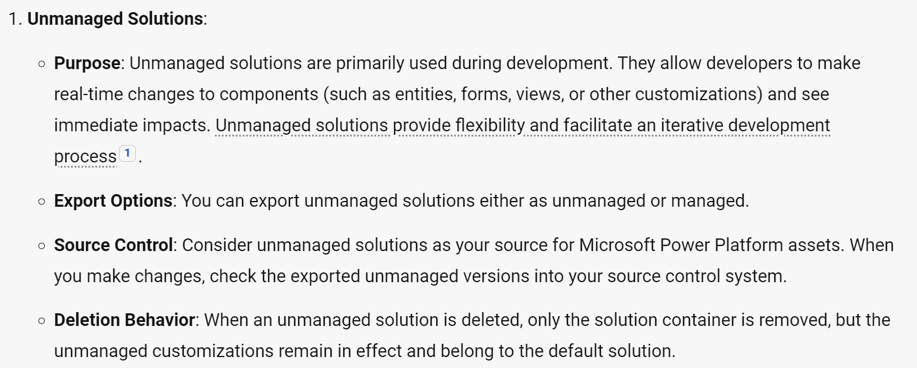
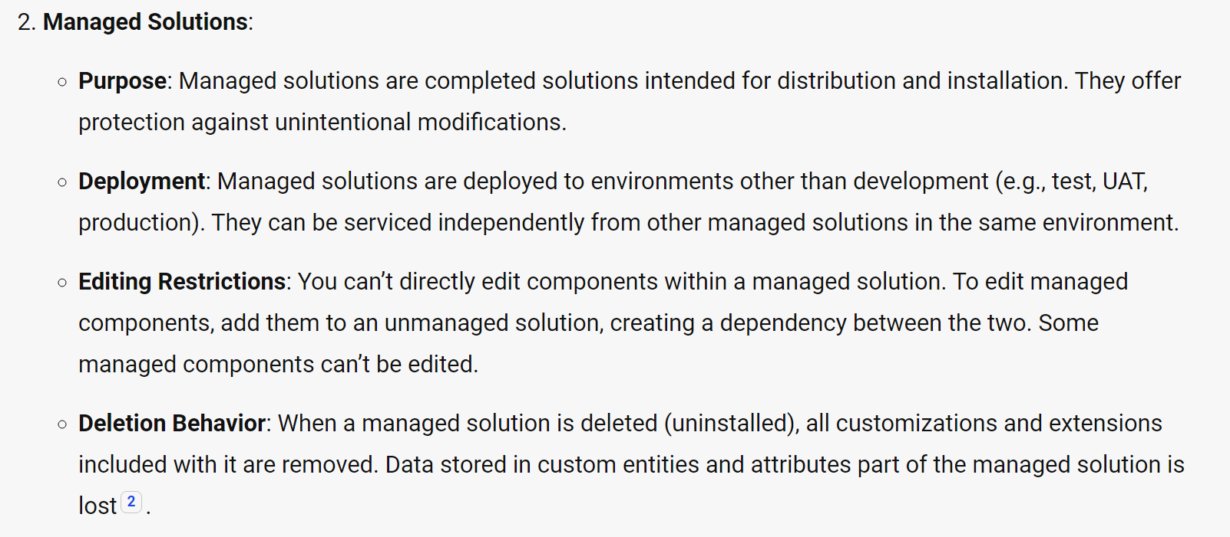

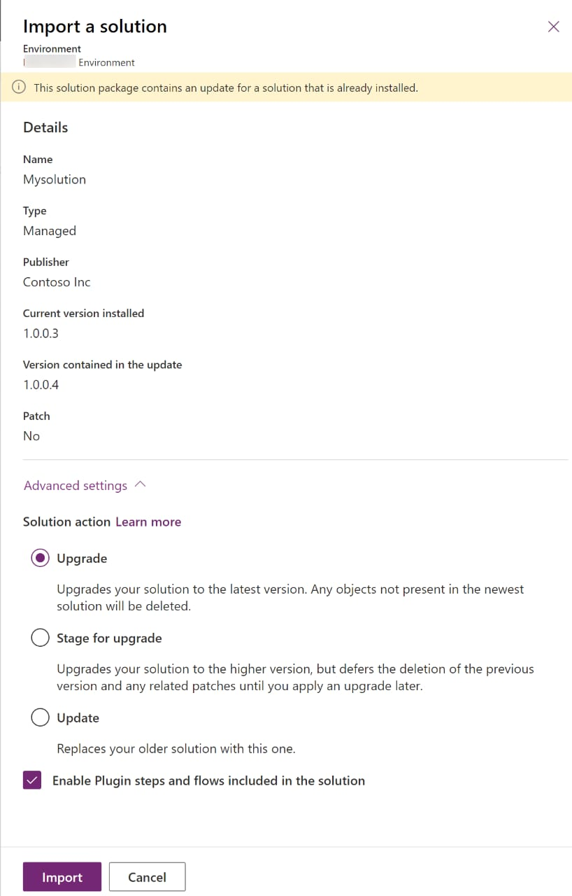
Append and Append To

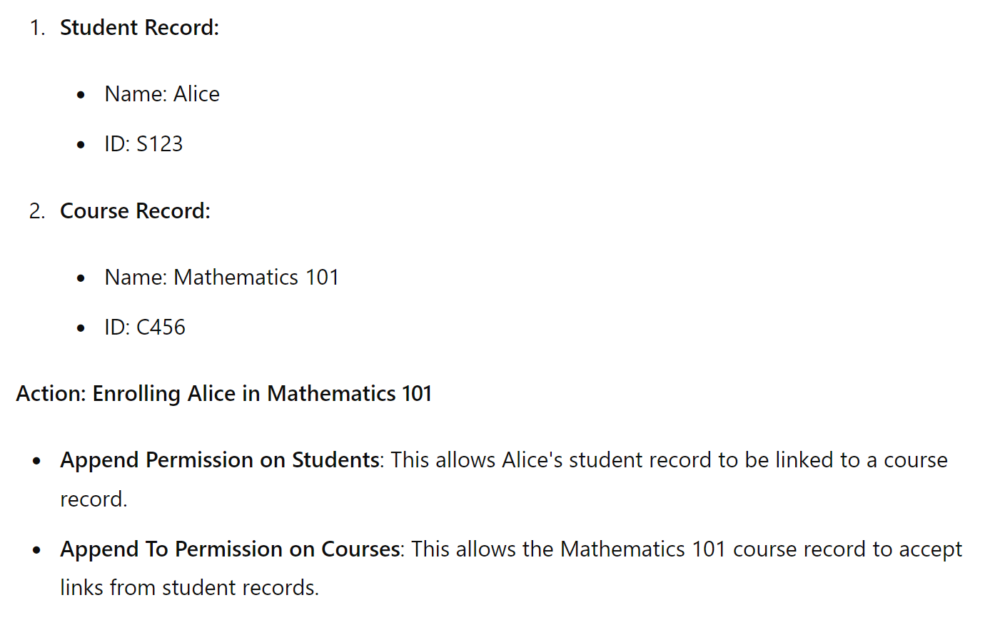
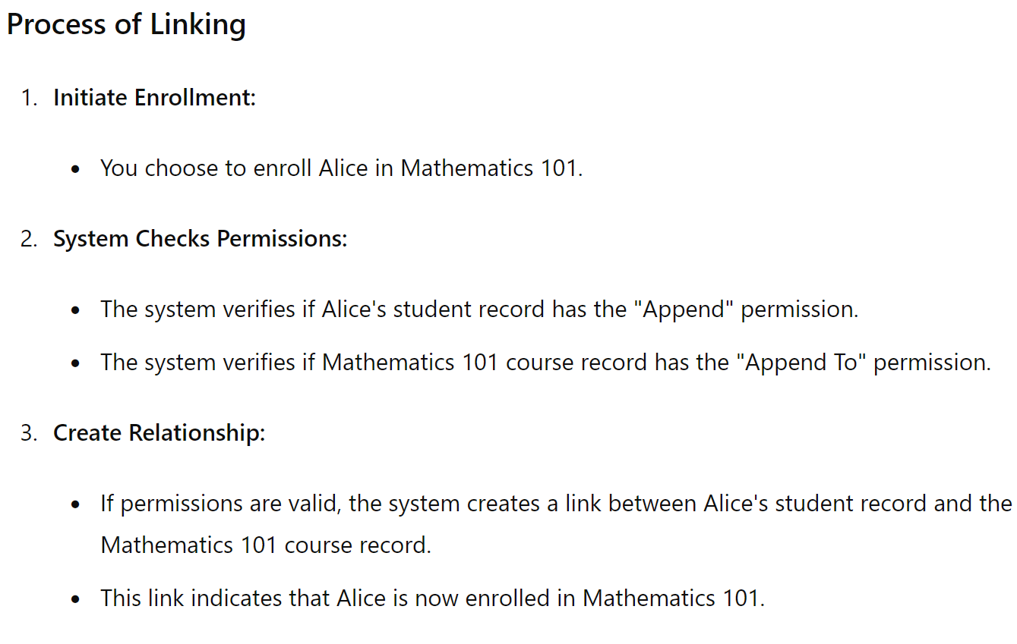
Views
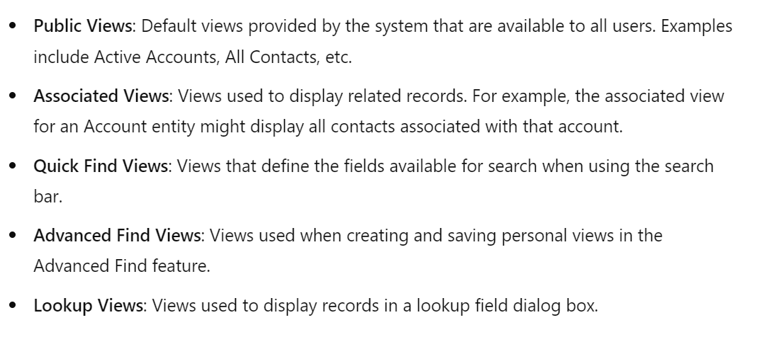

Junction Table
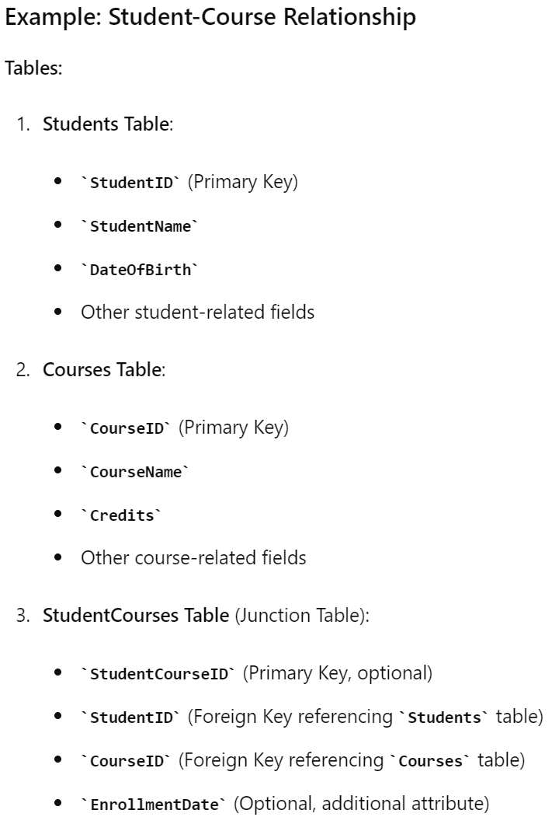
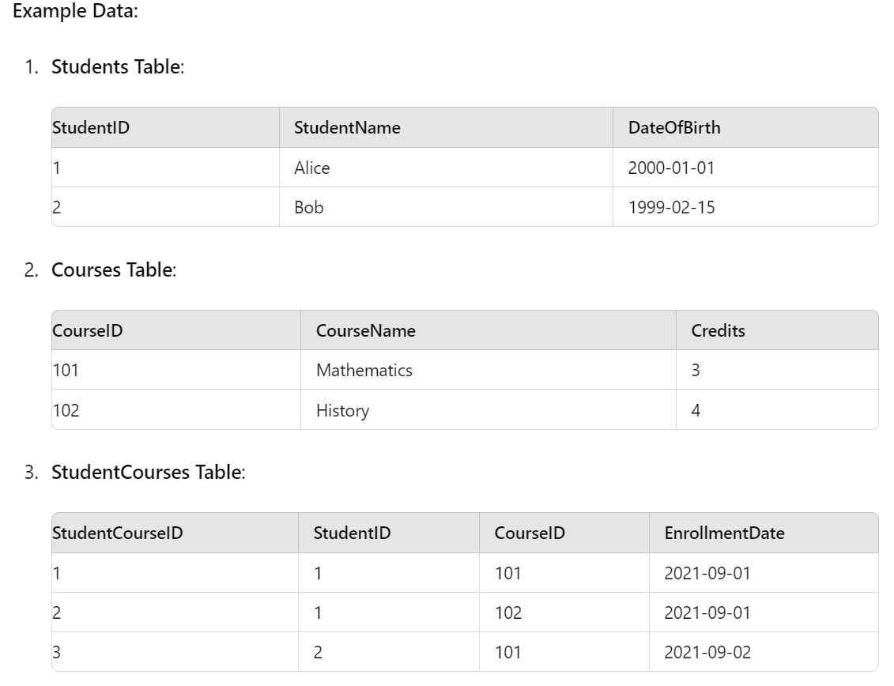

Audit Log
Audit Logs (or Audit Trails) are a specialized subset of logs that focus on recording detailed information about system access and usage, often for compliance, security, and forensic purposes. They provide a chronological record of events that can help track changes, monitor suspicious activities, and ensure accountability.

1. Activity Tables
Definition: Activity tables are special types of tables designed to track and manage actions or events, such as emails, phone calls, appointments, tasks, and other interactions.
Characteristics:
- Unified View: Activities can be aggregated and viewed in a single unified view, which helps users track all interactions related to a record.
- Out-of-the-Box Activities: Common activities like emails, phone calls, and tasks are provided out-of-the-box.
- Custom Activities: You can create custom activity types if the default ones don't meet your requirements.
- Relationships: Activity tables often have special relationships with other tables, enabling you to easily associate activities with records from different tables.
Use Case: Tracking customer interactions, managing to-do lists, scheduling meetings, and logging communications.

2. Standard Tables
Definition: Standard tables are the primary type of table used to store data in a structured format. They can contain custom data fields and are highly configurable.
Characteristics:
- Data Storage: Store various types of data, such as customer information, product details, or transactions.
- Customizable: You can add custom fields, relationships, business rules, workflows, and forms.
- Security: Standard tables can have specific security roles and permissions applied to them.
- Relationships: Can be related to other tables (one-to-one, one-to-many, many-to-one, many-to-many).
Use Case: Storing customer information, product catalogs, sales data, employee records, etc.

3. Elastic Tables
Definition: Elastic tables are designed to handle large volumes of data efficiently and scale dynamically based on usage. They are suitable for scenarios that require high scalability and performance.

Characteristics:
- High Scalability: Automatically scales to handle large volumes of data.
- Performance: Optimized for high-performance data operations.
- Data Partitioning: Data is partitioned to improve performance and manageability.
- Cost-Efficient: Can be more cost-efficient for handling large datasets compared to traditional tables.
Use Case: Storing large-scale datasets like telemetry data, logs, high-frequency transactions, or IoT data.

4. Virtual Tables
Definition: Virtual tables (also known as virtual entities) allow you to integrate external data sources into Dataverse without physically storing the data in the Dataverse database. Data remains in the external source and is accessed on-demand.
Characteristics:
- External Data Integration: Connects to external data sources such as SQL databases, web services, or other systems.
- No Data Duplication: Data is not duplicated; it remains in the external source.
- Real-Time Access: Provides real-time access to external data within Dataverse.
- Custom Providers: You can create custom data providers to connect to various data sources.
Use Case: Displaying data from an external ERP system, integrating with external web services, or accessing data from an external CRM system.

