

Name: - Rajpradeep
Subject:- Database Management System
Roll No.: - 23020570033
Submitted to: - Dr. Kamlesh Kumar Raghuvanshi
Acknowledgement
I would like to take this opportunity to
acknowledge everyone who has helped us in
every stage of this project.

I am deeply indebted to my computer science
Professor, Dr. Kamlesh Kumar Raghuvanshi for
his guidance and suggestions in completing this
practical. The completion of this practical was
possible under his guidance and support.
I am also very thankful to my parents and my
friends who have boosted me up morally with
their continuous support.
At last but not least, I am very thankful to God
almighty for showering his blessings upon me.
I. Create and use the following student-society database schema for a college to answer the given (sample) queries using the standalone SQL editor.
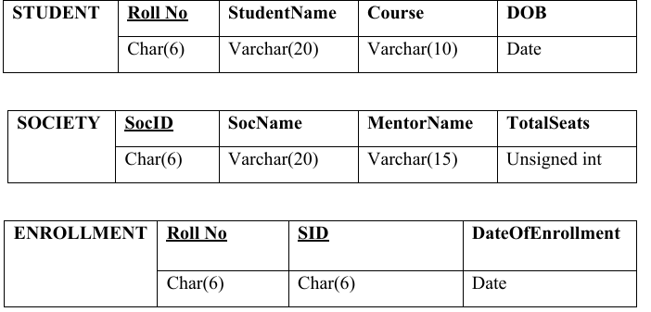
Here Roll no (ENROLLMENT) and SID (ENROLLMENT) are foreign keys.
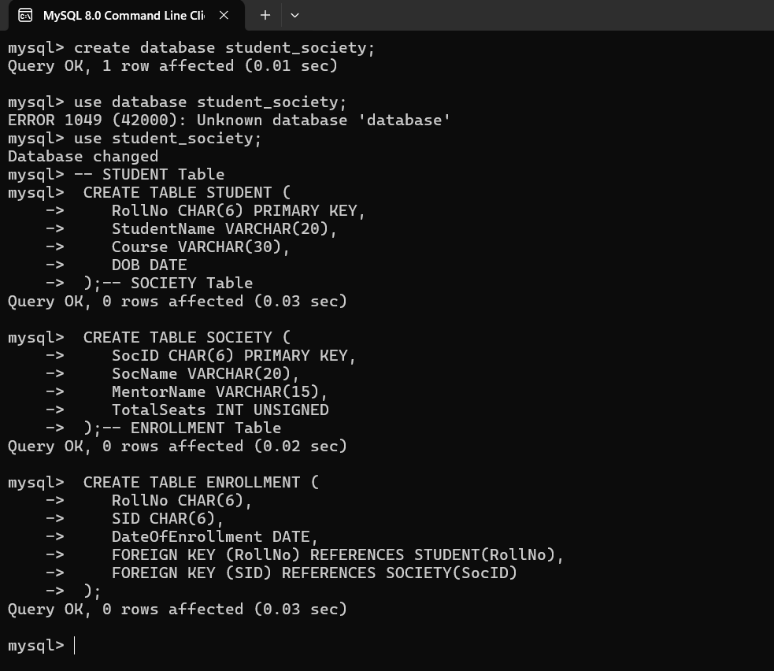

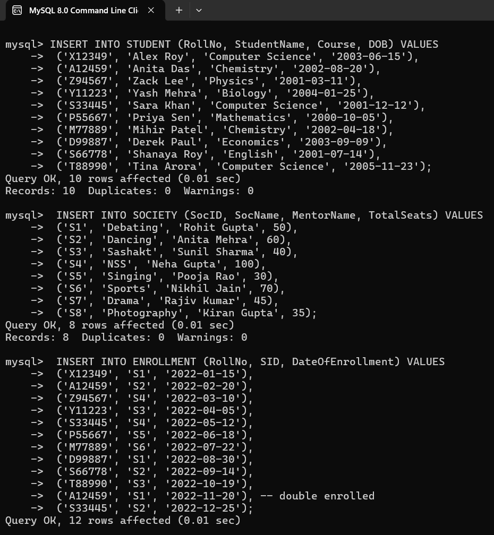
- Retrieve names of students enrolled in any society.
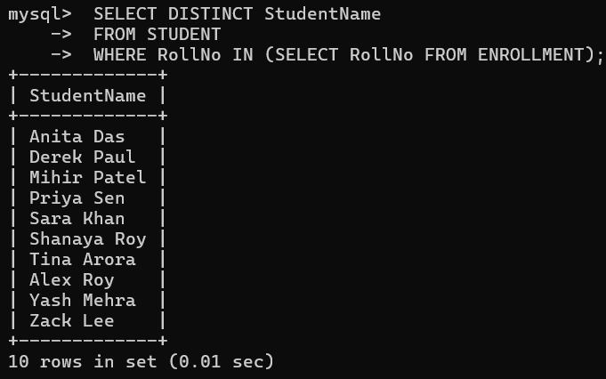
- Retrieve all society names.
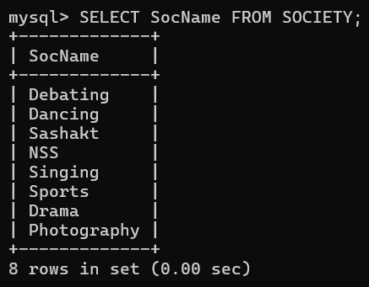
- Retrieve students' names starting with letter ‘A’
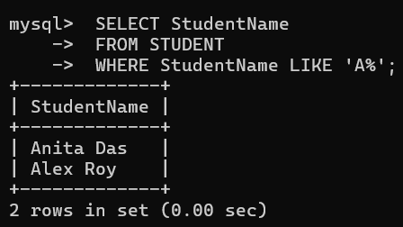
- Retrieve students' details studying in courses ‘computer science’ or ‘chemistry’
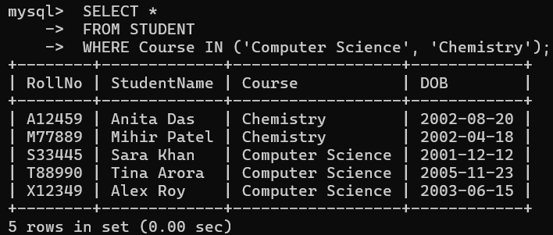
- Retrieve students' names whose roll no either starts with ‘X’ or ‘Z’ and ends with ‘9’
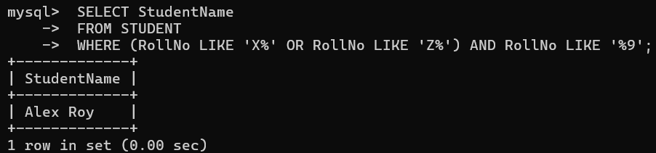
- Find society details with more than N TotalSeats (N input by user, say 40)
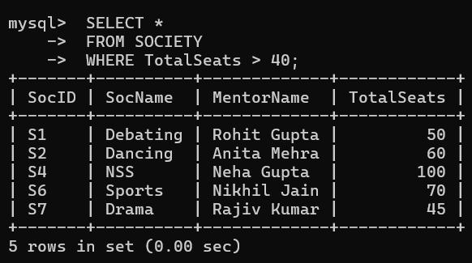
- Update society table for mentor name of a specific society
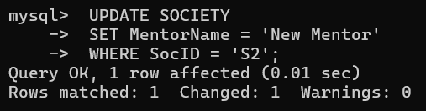
- Find society names in which more than five students have enrolled.
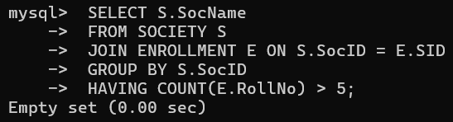
- Find the name of youngest student enrolled in society ‘NSS’
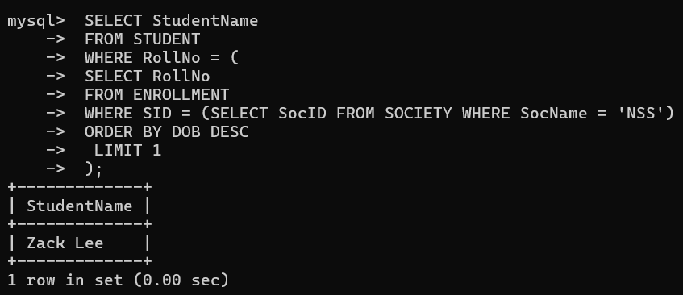
- Find the name of most popular society (on the basis of enrolled students)
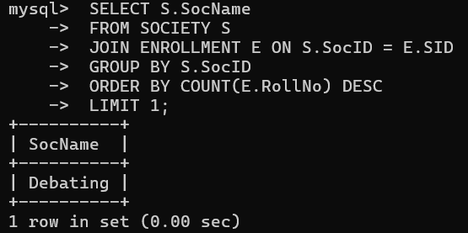
- Find the name of two least popular societies (on the basis of enrolled students)
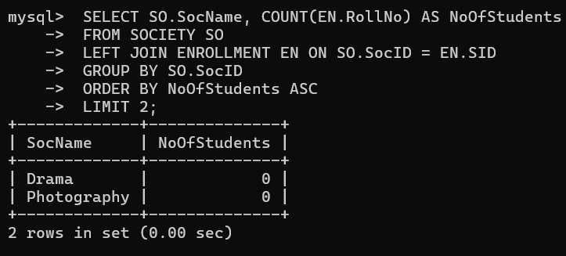
- Find the student names who are not enrolled in any society
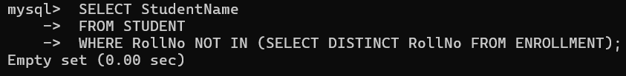
- Find the student names enrolled in at least two societies
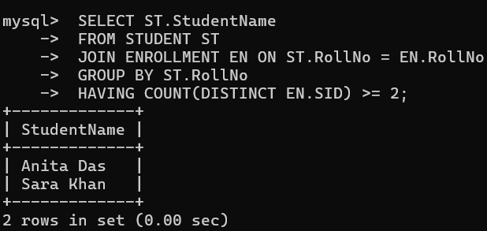
14. Find society names in which maximum students are enrolled
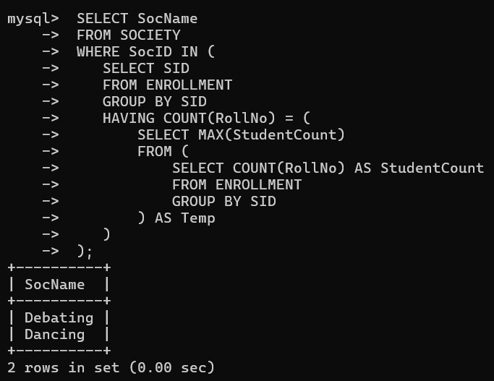
15. Find names of all students who have enrolled in any society and society names in which at least one student has enrolled
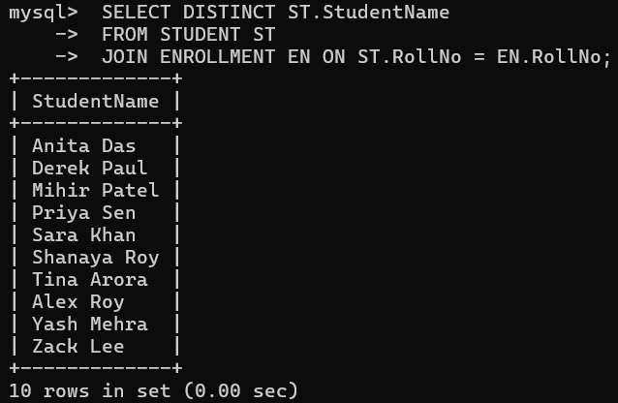
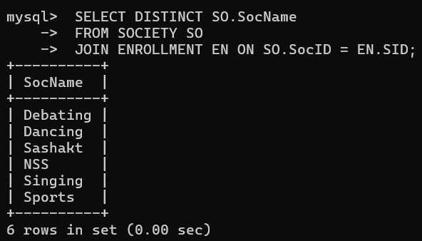
16. Find names of students enrolled in any of the three societies 'Debating', 'Dancing', and 'Sashakt'
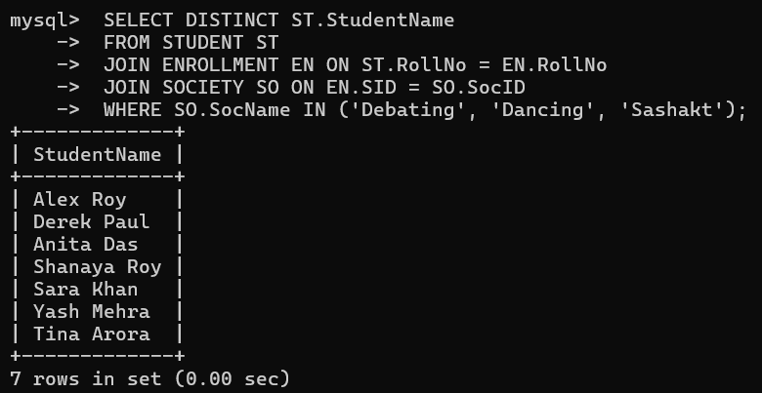
17. Find society names such that its mentor has a name with ‘Gupta’ in it
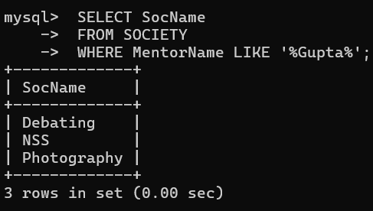
18. Find the society names in which the number of enrolled students is only 10% of its capacity
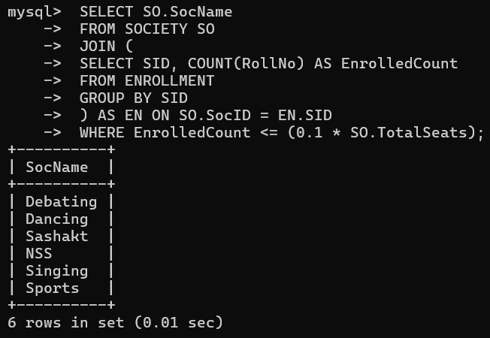
19. Display the vacant seats for each society
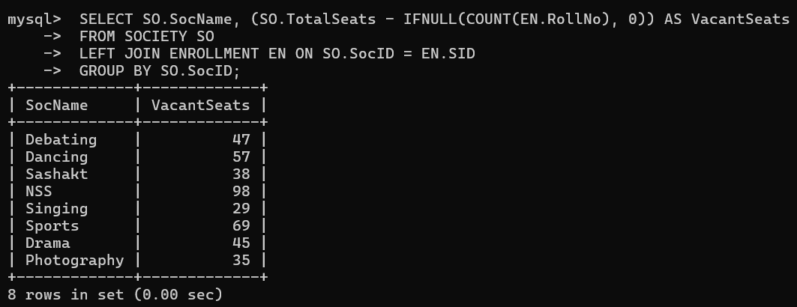
20. Increment Total Seats of each society by 10%
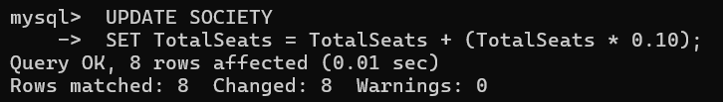
21. Add enrollment fees paid (‘yes’/‘No’) field in the enrollment table.
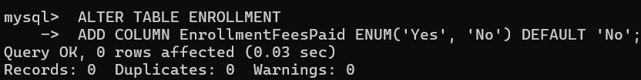
22. Update date of enrollment of society id ‘s1’ to ‘2018-01-15’, ‘s2’ to current date, and ‘s3’ to ‘2018-01-02’.
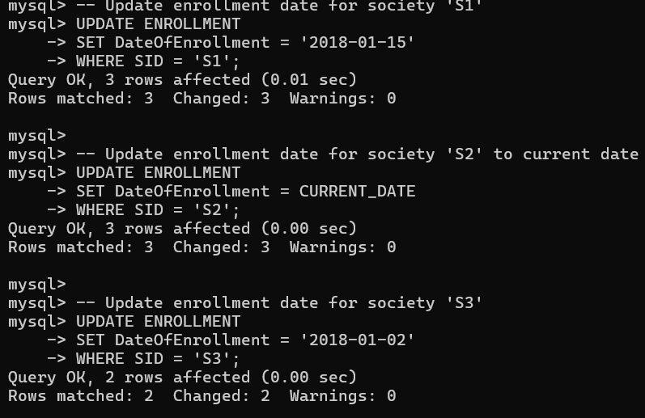
23. Create a view to keep track of society names with the total number of students enrolled in it.
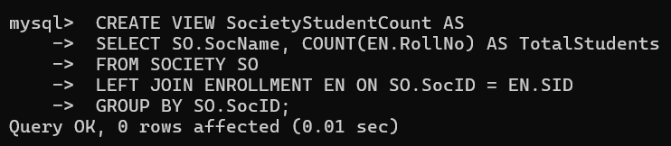
24. Find student names enrolled in all the societies
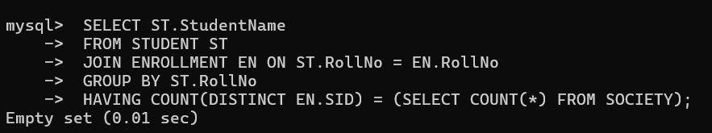
25. Count number of societies with more than 5 students enrolled in it.
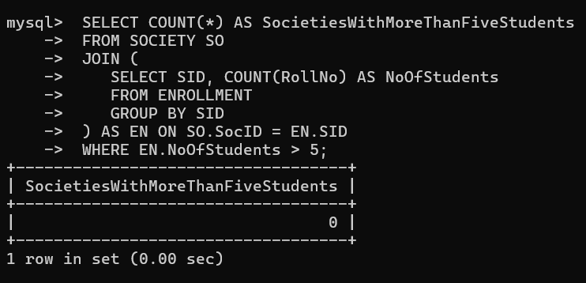
26. Add column Mobile number in student table with default value ‘9999999999’.
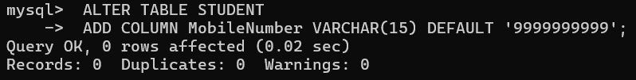
27. Find the total number of students whose age is > 20 years.
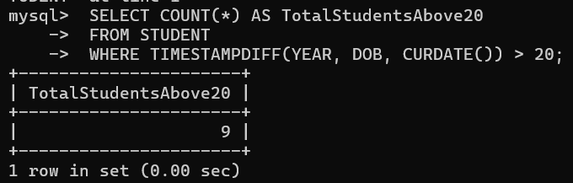
28. Find names of students who are born in 2001 and are enrolled in at least one society.
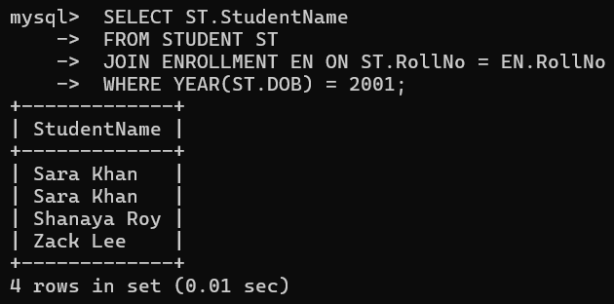
29. Count all societies whose name starts with ‘S’ and ends with ‘t’ and at least 5 students are enrolled in the society.
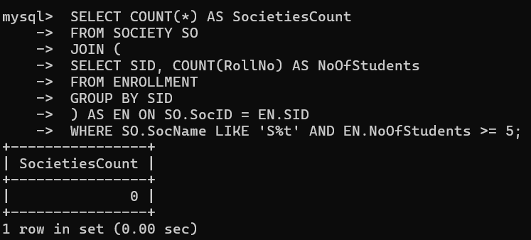
30. Display the following information:
Society name Mentor name Total Capacity Total Enrolled Unfilled Seats
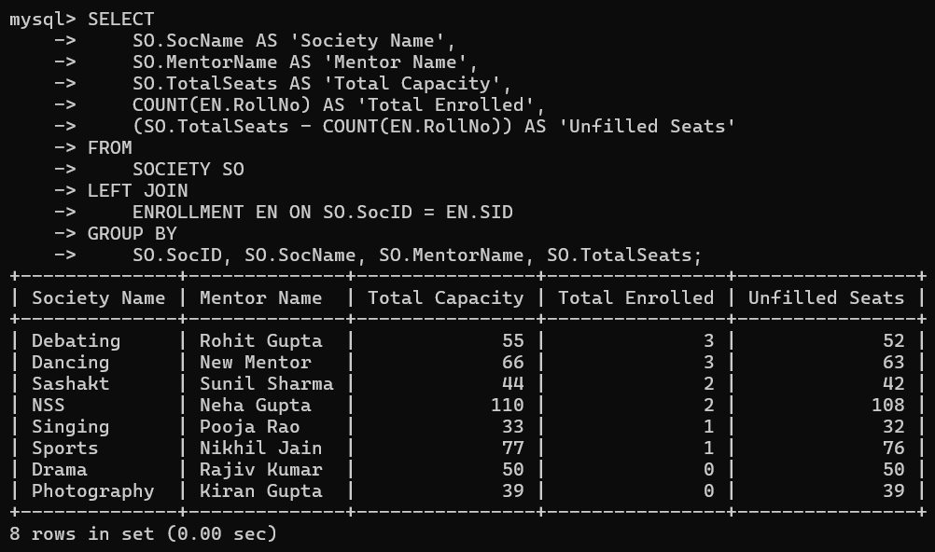
II. Do the following database administration commands: Create user, create role, grant privileges to a role, revoke privileges from a role, create index
