PRACTICAL FILE : GE Statistical Techniques for Quality Control


Name : Kriish Sharma

Course : BSc.(Hons) Computer Science College Roll No. 20231415 Examination Roll No. 23020570016

Index
- Practical 1: Quality Control Analysis Using X-Bar and R-Charts

- Practical 2: Control Limits Calculation for X and R Charts

- Practical 3: Control Chart for Fraction Defective (Same Sample Size)

- Practical 4: Control Chart for Fraction Defective (Different Sample Size)

- Practical 5: Construction of Control Chart for Defects (C-chart)

- Practical 6: Single Sampling Plan Based on Poisson Approximation

Practical 1 : Quality Control Analysis Using X-Bar and R-Charts

Aim:
To analyze the quality of a process using X-Bar and R-Charts and determine whether the process is in statistical control.

Theory:
- Bar and R-Charts are tools used in statistical quality control.

  - The X-Bar Chart monitors the average value of samples and checks if the process mean is stable.

  - The R-Chart monitors the range (variation) of samples to check if process variability is stable.
If all points lie within control limits, the process is considered to be in control.

Steps:

Data Collection:
Collect sample data (for example: 10 samples with 5 readings each).

Calculate the Mean (X-bar):
For each sample, calculate the average using:

X-bar = (Sum of sample values) / (Number of observations in sample)

- Calculate the Range (R):
For each sample, calculate:

Range = Maximum value – Minimum value

- Calculate Control Limits for X-Bar Chart:
Use the formulas:

  - CLx (Central Line) = Average of all sample means

  - UCLx (Upper Control Limit) = X-bar + A2 × R-bar

  - LCLx (Lower Control Limit) = X-bar – A2 × R-bar

- Note: For sample size n = 5, the constant A2 = 0.577.

Calculate Control Limits for R-Chart:
Use the formulas:

  - CLR (Central Line) = R-bar

  - UCLR (Upper Control Limit) = D4 × R-bar

  - LCLR (Lower Control Limit) = D3 × R-bar

- For sample size n = 5: D3 = 0
D4 = 2.114

Plot the Control Charts:
Plot both the X-bar and R charts in Excel using the calculated control limits.

Analysis:

  - Check if any point lies outside control limits.

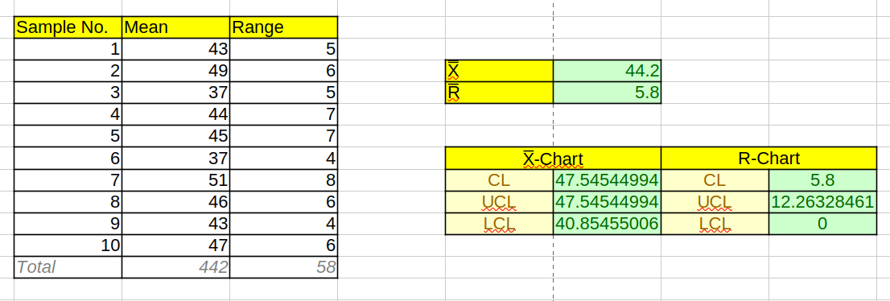
  - If yes, the process is out of control and corrective action is required.

Result:
The X-Bar and R-Charts indicate whether the process is stable. If all points fall within limits, the process is in statistical control.
If any point falls outside the limits, the process is not in control and adjustments are necessary.

Practical 2: Control Limits Calculation for X and R Charts
Aim:

To calculate the control limits for the X-bar (mean) and R (range) charts to monitor the length of bomb bases in production.
Theory:

In statistical process control (SPC), control charts are used to monitor the consistency of processes. The X-bar chart tracks the mean of a sample, while the R-chart monitors the range (the difference between the highest and lowest values) within a sample. The control limits are used to determine if the process is within the acceptable range or if it needs correction.
- For X-bar chart:
The control limits are calculated using:

  - UCL_X = X-bar + A2 * R

  - CL_X = X-bar

  - LCL_X = X-bar - A2 * R

- For R-chart:
The control limits are calculated using:

  - UCL_R = D4 * R

  - CL_R = R

  - LCL_R = D3 * R

Where:

- X-bar is the average of sample means

- R is the average range

- A2, D3, D4 are constants based on the sample size (n = 5 in this case).

Steps:

Input Data:

  - Use the given data for sample means and ranges from the table in the problem.

Calculate the average of the sample means (X-bar):

  - X-bar = (Sum of all sample means) / number of samples

Calculate the average range (R):

  - R = (Sum of all sample ranges) / number of samples

Calculate the control limits for the X-bar chart:

  - Using the constants A2 = 0.58 for n = 5, calculate:

    - UCL_X = X-bar + A2 * R

    - LCL_X = X-bar - A2 * R

Calculate the control limits for the R-chart:

  - Using the constants D3 = 0 and D4 = 2.12 for n = 5, calculate:

    - UCL_R = D4 * R

    - LCL_R = D3 * R = 0

- Check for any sample values outside the control limits and make adjustments if necessary.
- We can see that X-bar values of group number 11 and 17 fall out of control lines so we exclude them

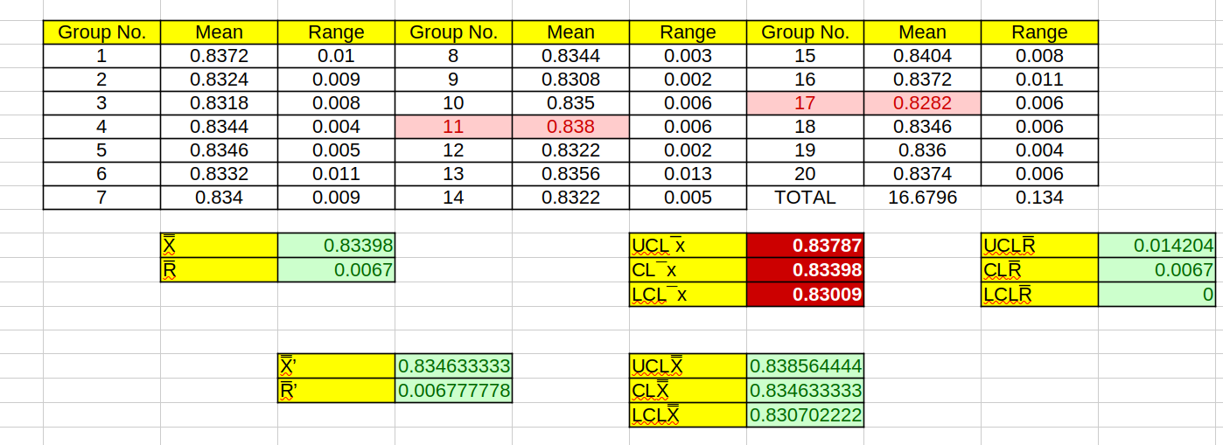
Result:
- The calculated control limits for the X-bar chart:

  - UCL_X = 0.83856

  - LCL_X = 0.8307

- The calculated control limits for the R-chart:

  - UCL_R = 0.014204

  - LCL_R = 0

Practical 3: Control Chart for Fraction Defective (Same Sample Size)
Aim: To draw a control chart for fraction defective and comment on the state of control of the process.

Theory:
Control charts are used in statistical quality control to monitor the consistency and stability of a process. A p-chart (proportion defective chart) is used when the data represents the fraction of defective items in a sample. The p-chart helps in identifying whether the process is in a state of control by comparing the fraction defective against predefined control limits.
In this experiment, we are given the number of defects in 22 lots, each containing 2,000 rubber belts. The fraction defective for each lot is calculated, and control limits are computed using the standard method for p-charts. The resulting control chart helps determine if the process is statistically in control or if corrective actions are needed.

Steps:

Collect the Data:

  - The number of defective items in 22 lots of 2,000 rubber belts are given. For each lot, calculate the fraction defective by dividing the number of defective items by 2,000 (lot size).

Compute the Average Fraction Defective (p̄):

  - Calculate the overall average fraction defective using the formula:
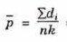
where:

    - ( d_i ) = number of defects in the i-th lot,

    - ( n ) = number of samples (22),

    - ( k ) = sample size (2000).

Calculate the Control Limits:

  - The standard formula for the control limits is:

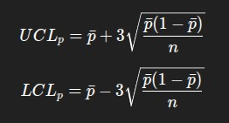

    - Calculate the upper control limit (UCL), lower control limit (LCL), and center line (C.L.), which represents the average fraction defective.

Plot the Control Chart:

  - On the x-axis, plot the sample number (1 to 22). On the y-axis, plot the fraction defective.

  - Draw lines representing the UCL, LCL, and C.L.

Analyze the Chart:

  - Observe if any sample points fall outside the control limits. If so, the process is not in control.

  - Identify any patterns or trends that suggest the process may be out of control.

Comment on the Results:

  - Based on the control chart, determine if the process is in statistical control or not.

  - Identify any sample numbers that fall outside the control limits.

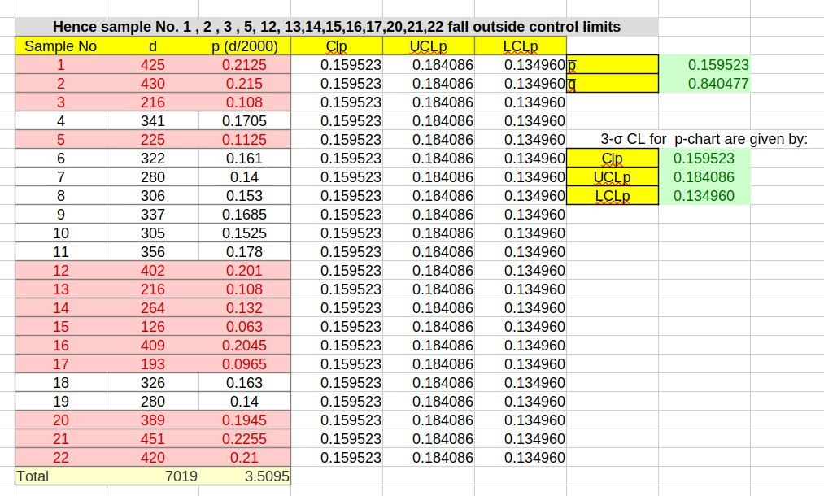

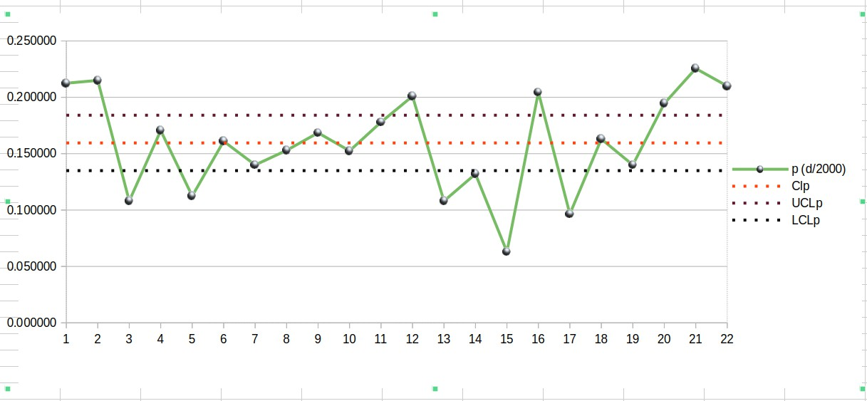
Results:
The control chart for the fraction defective (p-chart) is plotted based on the data provided. Upon reviewing the chart, it is observed that several sample points fall outside the control limits, indicating that the process is not in statistical control. These points suggest that there are deviations in the process that need to be addressed for improvement.

Practical 4: Control Chart for Fraction Defective (Different Sample Size)
Aim:

To draw a control chart for fraction defective and analyze the process for statistical control.

Theory:
Control charts are used to monitor the variation in a process over time and to ensure that the process is in statistical control. The p-chart (proportion defective chart) is used when the sample size varies, and we are monitoring the proportion of defective items in each sample. The formula for calculating the control limits in this case is:
- UCL (Upper Control Limit) = p̄ + 3√(p̄q̄ / nᵢ)

- LCL (Lower Control Limit) = p̄ - 3√(p̄q̄ / nᵢ)

Where:

- p̄ = average proportion defective (d / n for each sample)

- q̄ = 1 - p̄

- nᵢ = sample size for the ith sample

- d = number of defectives in the ith sample

Steps:

Data Collection:
Collect the data for the number of defectives (d) and the sample sizes (nᵢ) for each sample. In this case, you have 10 independent samples with varying sample sizes and corresponding defects.

Calculate p̄ (average proportion defective):
Use the formula p̄ = Σd / Σnᵢ to calculate the average proportion defective across all samples.

Compute Control Limits for Each Sample:
Using the calculated p̄, compute the UCL and LCL for each sample by applying the formulas:

  - UCL = p̄ + 3√(p̄q̄ / nᵢ)

  - LCL = p̄ - 3√(p̄q̄ / nᵢ)

Plot the Control Chart:
Using Excel or any plotting tool, plot the UCL, LCL, and the proportion defective (p) for each sample.

Analyze the Chart:
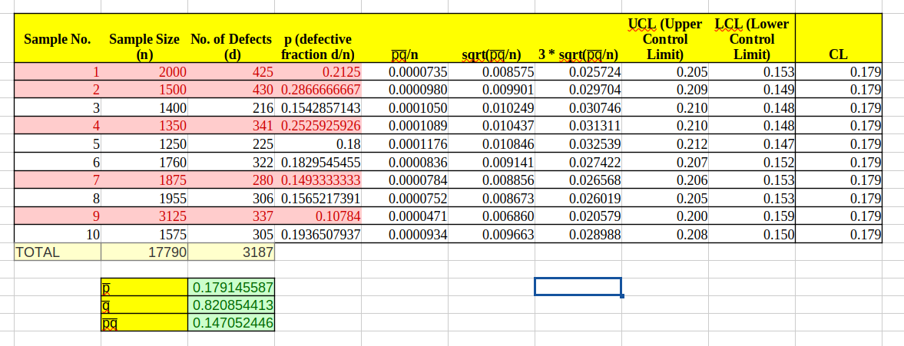
Analyze the chart to identify whether the process is in control. Points outside the control limits suggest that the process is not in statistical control, indicating assignable causes of variation.

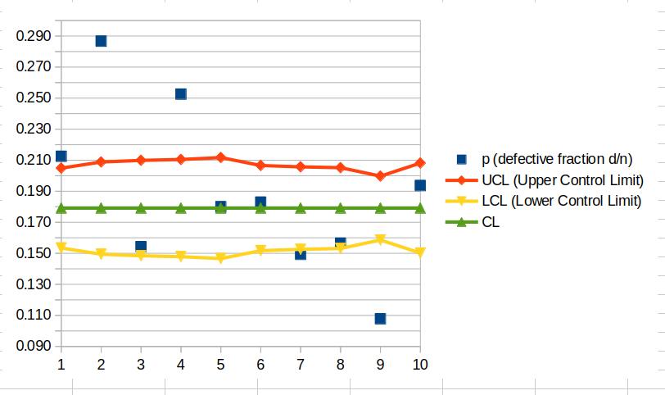
Result:

After plotting the control chart, you will observe that sample points corresponding to samples 1, 2, 4, 7, and 9 are outside the respective control limits. This indicates that the process is not in a state of statistical control and suggests the presence of assignable causes of variation that should be detected and eliminated.

Practical 5 : Construction of Control Chart for Defects (C-chart)

Aim:

To construct a suitable control chart (C-chart) using given data and to determine the control limits for monitoring quality.
Theory:

A control chart is a graphical representation used to monitor how a process varies over time. The C-chart is used when the data involves counting the number of defects or failures in a sample of items. The key components of a C-chart include:
- Central Line (CL): The average number of defects per item.

- Upper Control Limit (UCL): The upper threshold beyond which the process is considered out of control.

- Lower Control Limit (LCL): The lower threshold, indicating the minimum acceptable defect level.

To calculate the control limits:

- The average number of defects per item is calculated.

- Control limits are computed using the average number of defects and the standard deviation of defects per sample.

Steps:
- Data Collection: Obtain the defect count for each sample from the given data.

Calculate Average Defects per Item (CL):

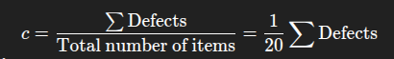

- Calculate Control Limits:

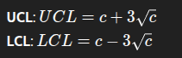

- Identify Out of Control Points: Check for any sample points outside the calculated UCL and LCL. If any points fall outside, remove those samples.

- Recalculate Control Limits: Once out-of-control points are eliminated, recalculate the control limits using the remaining samples.

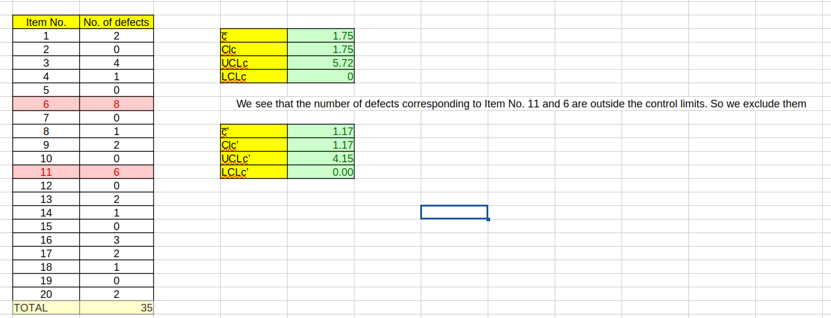
Result:

After completing the calculation and removing out-of-control points, the new control limits can be calculated, providing an updated chart for monitoring future production.

Practical 6: Single Sampling Plan Based on Poisson Approximation

Aim
To compute the Operating Characteristic (OC) curve, Average Total Inspection (ATI), and Average Quality Level (AOQL) of a single sampling plan for a given lot of items, using Poisson approximation to the hyper-geometric distribution.

Theory
In a single sampling plan, a sample of size ( n ) is taken from a lot of size ( N
). The lot is accepted if the number of defective items in the sample is less than or equal to a specified critical value ( c ). If the number of defects exceeds ( c ), the lot is rejected. The Poisson distribution is used for approximating the hyper-geometric distribution in cases where ( N ) is large, and the defect probability ( p ) is small. This is given by the probability of acceptance ( P_a ):
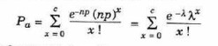
Where:
- ( n ) is the sample size,

- ( p ) is the defect rate,

- ( c ) is the acceptance number,

- ( N ) is the lot size.

The Average Total Inspection (ATI) and Average Quality Level (AOQL) are computed using the following formulas:

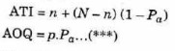

Steps

- Input the given values:

  - Lot size ( N = 2200 )

  - Sample size ( n = 225 )

  - Acceptance number ( c = 14 )

- Use the Poisson distribution formula to compute the probability of acceptance ( P_a ) for various values of defect rate ( p ) (from 0 to 1, with steps like 0.05 or 0.10).

Calculate the ATI and AOQL:

  - For each value of ( p ), compute the ATI and AOQL using the formulas provided.

  - Record the values of ( P_a ), ATI, and AOQL for each defect probability.

Plot the OC Curve:

  - Plot the probability of acceptance ( P_a ) versus the defect probability ( p ).

Plot the ATI Curve:

  - Plot ATI versus defect probability ( p ).

Plot the AOQL Curve:

  - Plot AOQL versus defect probability ( p ).

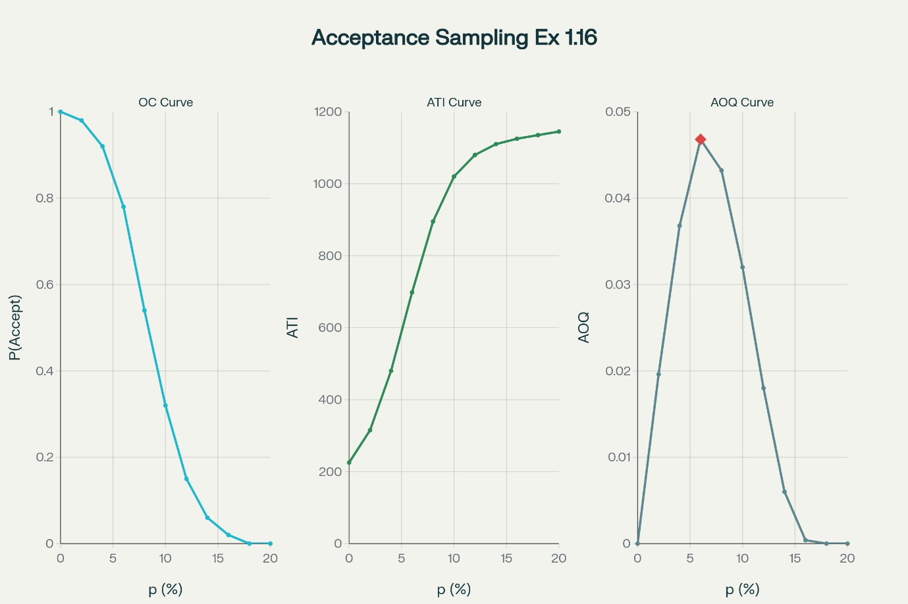
Results

- OC Curve: The graph shows the probability of acceptance ( P_a ) as a function of the defect probability ( p ). This curve helps visualize the performance of the sampling plan with respect to defect rates.

- ATI Curve: The ATI curve shows the average total inspection for different levels of defect probability, indicating how much inspection is required at different quality levels.

- AOQL Curve: The AOQL curve shows the Average Quality Level (AOQL) for different values of defect probability, helping identify the maximum average defect level for which the lot will still be accepted.

