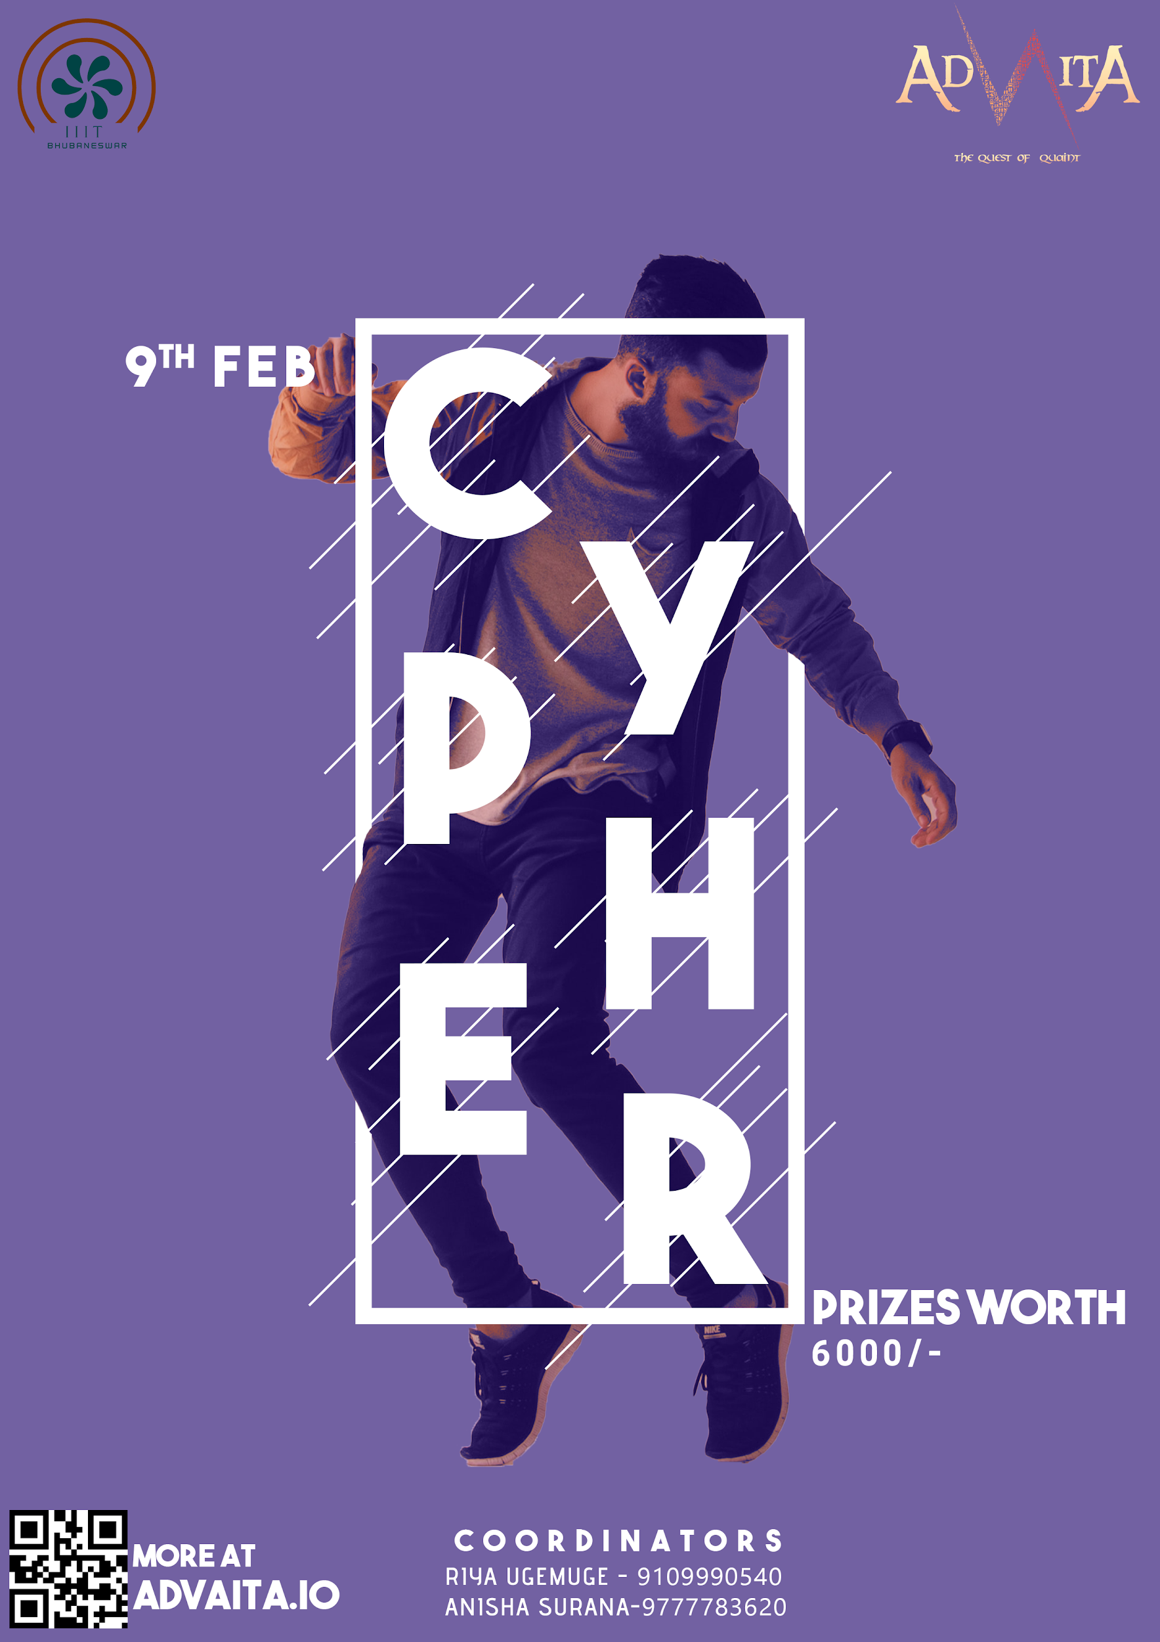

# RULES-

* This is a solo dance battle.
* Time limit is 1 minute for each performer .This may change according to the judges and the number of participants.
* The song would be played spontaneously during the event by the coordinating team. Participants cannot specify the tracks to which they perform.
* Participants may follow any of the following styles : Pumping, Krumping, Break-dance, Tutting, House, Locking, and Western freestyle.
* At a time only one participant is allowed on the stage. On the completion of his/her performance the other participant may enter.
* The order of the performances would be informed prior to the event.
* Total number of rounds is 4 and may change according to the participation.
* The performer is judged on the following criteria:
  + Choreography
  + Stage utilization
  + Energy level
  + Impact on the crowd
  + Ability to overshadow the opponent
* Intentional physical interaction may lead to disqualification.
* Usage of props is not allowed.
* The final decision lies with the judges and the judgment is not questionable.

# EVENT DETAILS:

**DATE:** 9 February, 2020

**VENUE:** A Block, IIIT Bhubaneswar

**ENTRY FEE:** 300/-

# NOTE:

* Prizes worth 6000/- will be given on the spot.
* Every participant must register.