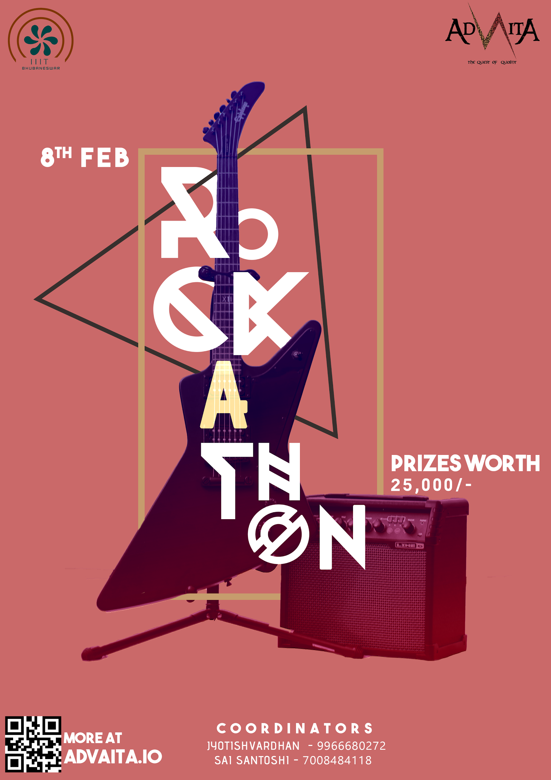

RULES

* A minimum of three members are required to compete as a Band.
* Bands are required to bring their own instruments and musical equipment. (Amplifiers, Mics and a drum kit will be provided by the Organizers)
* Decisions regarding the use of foul language, inappropriate actions or attire will solely depend on the Judge.
* If your Band qualifies for the finale, failure to report for the final round the next day will result in disqualification.
* Failure to report at the venue on time will result in disqualification.
* Any material performed after the time limit will be regarded invalid.
* Any dispute arising due to confusion during the contest shall be resolved only by IIIT Bhubaneswar’s Rockathon Organizing Team and the Judge.
* Failure to abide by these rules and your Band will be removed from the competition.

**EVENT INFORMATION**

>REGISTRATION:-1500/-

>EVENT DATE:-8/2/2020

>VENUE:-MAIN STAGE

**TIME DURATION:-**15 minutes(including sound check)

**JUDGING CRITERIA**:-

1. Synchronization and tightness.(20 points)
2. Stage Presence.(10 points)
3. Vocals.(10 points)
4. Audience Reaction.(10 points)
5. Professionalism.(10 points)
6. Originality.(20 points)
7. Individual Instrument performance.(20 points)

PRIZES WORTH:- 25000/-

AWARD CATEGORIES:-

1.Best Band(Winner and Runner Up)

2.Best Drummer.(Winner)

3.Best Vocalist.(Winner)

4.Best Guitarist.(Winner)

Note:- The number of awards presented may vary on the basis of the participation.