# Web Tools- Assignment 2

By Neerajsing Rajput

Output for Part 3

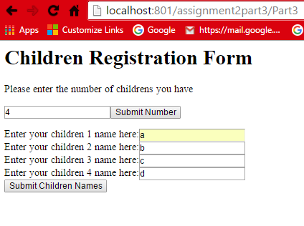

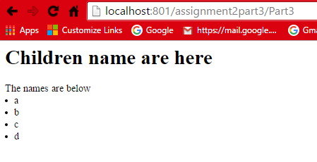

## Part 3

Java Code

import javax.servlet.http.HttpServlet;

import javax.servlet.http.HttpServletRequest;

import javax.servlet.http.HttpServletResponse;

import java.io.IOException;

import java.io.PrintWriter;

import java.util.Enumeration;

import java.util.ArrayList;

import java.util.Map;

import java.util.Set;

import java.util.Iterator;

import javax.servlet.ServletException;

public class Part3 extends HttpServlet {

public void doGet(HttpServletRequest request, HttpServletResponse response) throws ServletException,

IOException {

response.setContentType("text/html");

PrintWriter out = response.getWriter();

String html="<html><head><title>Part6</title>";

html+="<script src=javascripts/ValidationScript.js></script>";

html+="</head><body><form action='Part3' method='post'>";

html+="<h1>Children Registration Form</h1>";

html+="<p>Please enter the number of childrens you have</p>";

html+="<input id='txtNumb' name='txt' type='text'>";

html+= "<button type='button' name='action' onclick='create()' value='submit'/>Submit Number</button>";

html+="<p id='screens'></p><br />";

html+="</form></body></html>";

out.println(html);

out.close();

}

public void doPost(HttpServletRequest request, HttpServletResponse response) throws ServletException,

IOException

{

PrintWriter out=response.getWriter();

response.setContentType("text/html");

out.println("<h1>Children name are here</h1>");

Map parameter=request.getParameterMap();

Set set = parameter.entrySet();

Iterator iterator = set.iterator();

while(iterator.hasNext()){

Map.Entry<String,String[]> entry = (Map.Entry<String,String[]>)iterator.next();

String key=entry.getKey();

if(key.contains("name"))

{

String[] value=entry.getValue();

out.println("The names are below");

if(value.length>1){

for (int i = 0; i < value.length; i++) {

out.println("<li>"+ value[i].toString() + "</li>");

}

}else

out.println("Value is "+value[0].toString()+"<br>");

}

}

out.close();

}

}

**Web.XML**

<web-app>

<servlet>

<servlet-name>Part3</servlet-name>

<servlet-class>Part3</servlet-class>

</servlet>

<servlet-mapping>

<servlet-name>Part3</servlet-name>

<url-pattern>/Part3</url-pattern>

</servlet-mapping>

</web-app>

JavaScript to Create Textbox and submit button.

function create() {

var param = document.getElementById("txtNumb").value;

var s = "";

if (isNaN(param) || param > 1 || param < 100) {

for (var i = 0; i < param; i++) {

s += 'Enter your children ' + (i + 1) + ' name here:<input type="text" name="name" required maxlength="30"><br/>';

document.getElementById("screens").innerHTML = s;

}

s += '<button type="submit" name="action" value="Submit">Submit Children Names</button>';

document.getElementById("screens").innerHTML = s;

} else {

s = "Input not OK";

document.getElementById("screens").innerHTML = s;

}

}

## Part 4:

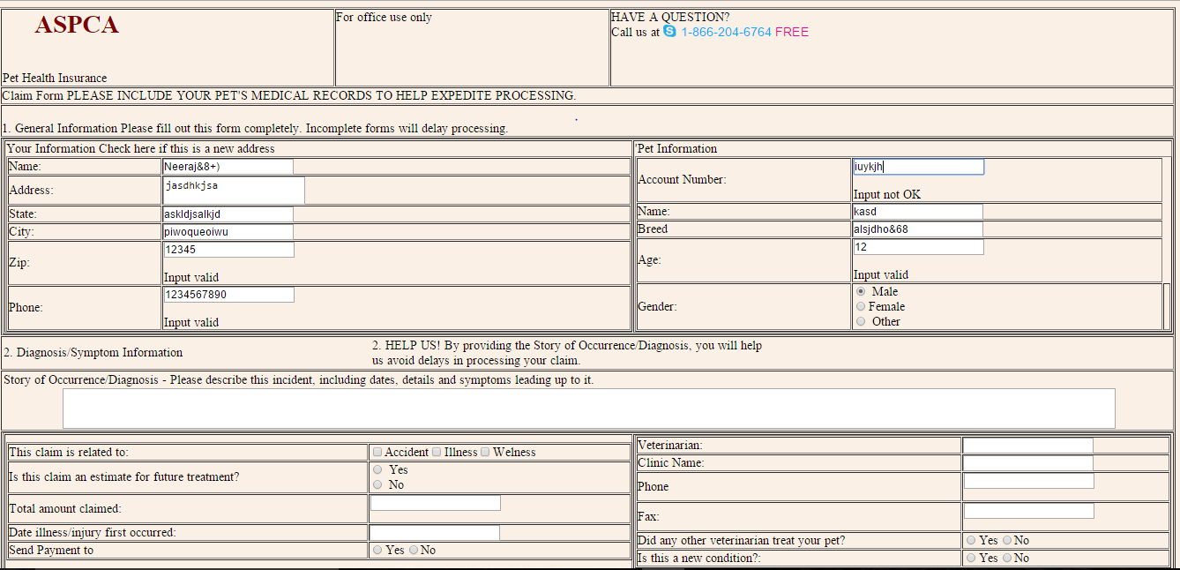

Javascript Message

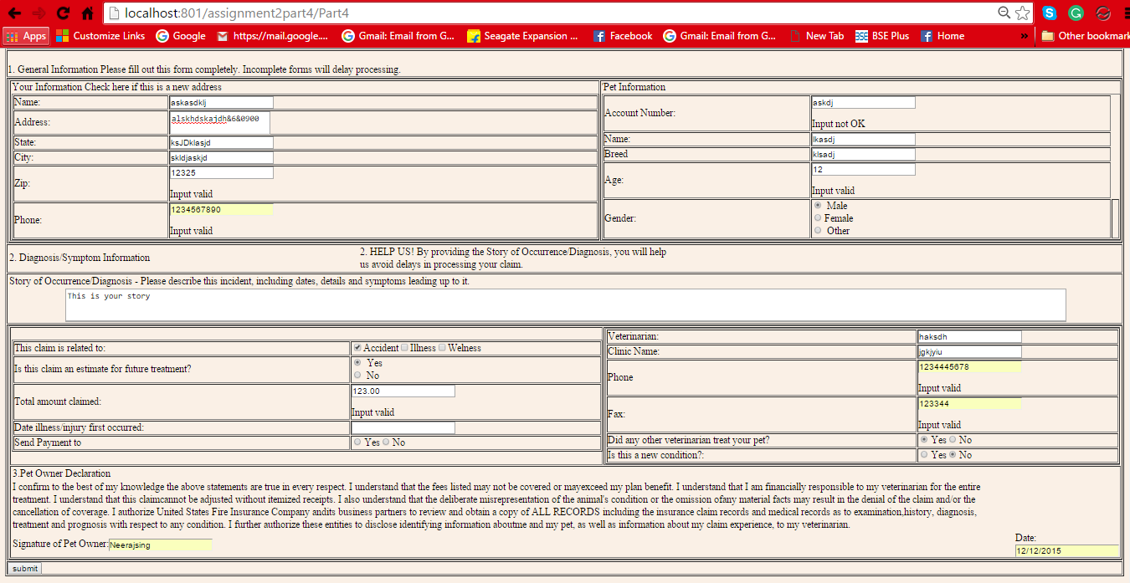

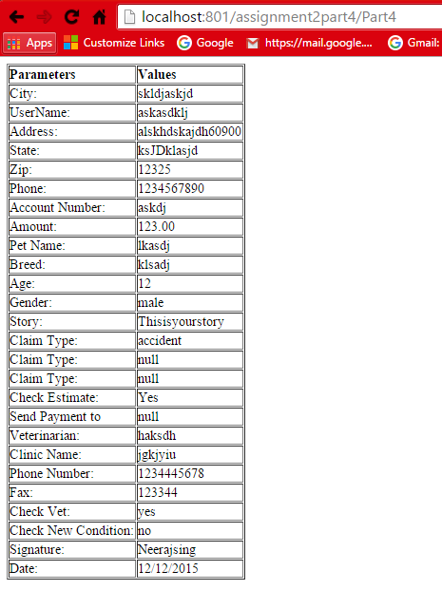

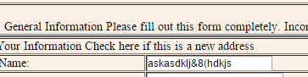



The Name field is sanitized

Java Code

import javax.servlet.http.HttpServlet;

import javax.servlet.http.HttpServletRequest;

import javax.servlet.http.HttpServletResponse;

import javax.servlet.ServletException;

import java.io.IOException;

import java.io.PrintWriter;

import java.util.Enumeration;

public class Part4 extends HttpServlet

{

protected void doGet(HttpServletRequest request,HttpServletResponse response)throws ServletException,IOException

{

PrintWriter out=response.getWriter();

response.setContentType("text/html");

String username="";

String address="";

String state="";

String city="";

String zip="";

String phone="";

String account_number="";

String name="";

String breed="";

String age="";

String male="";

String female="";

String other="";

String amount="";

String textAreaa="";

String dateField="";

String Veterinarian="";

String clinic_name="";

String ph_number="";

String fax_number="";

String Signature="";

String timestamp="";

//Using Html because of buffer overrun problem

String html="<html><head><title>Part6</title><link href=styles/style.css rel=stylesheet type=text/css></link>";

html+="<script src=javascripts/ValidationScript.js></script>";

html+="<script src='javascripts/Datepick/ts_picker.js'></script>";

html+="</head><body><form action='Part4' method='post'>";

html+="<table border='1'>";

html+="<tbody><tr><td valign='top'> <h1> ASPCA</h1><br />Pet Health Insurance </td>";

html+="<td valign='top'> For office use only</td>";

html+="<td valign='top'> HAVE A QUESTION?<br />Call us at 1-866-204-6764</td></tr><tr>";

html+="<td colspan='3'>Claim Form PLEASE INCLUDE YOUR PET'S MEDICAL RECORDS TO HELP EXPEDITE PROCESSING.</td>";

html+="</tr><tr><td colspan='3'>";

html+="<br />1. General Information Please fill out this form completely. Incomplete forms will delay processing.";

html+="</td> </tr><tr>";

html+="<td colspan='3'><table border='1'><tbody><tr><td>Your Information Check here if this is a new address <br />";

html+="<table border='1'><tbody>";

html+="<tr> <td>Name:</td><td><input id='txtName' type='text' name='userName' maxlength='20' value='"+username+"'/></td></tr>";

html+="<tr> <td>Address:</td><td><textarea id='txtAreaAddress' name='Address' rows='2' maxlength='50' cols='20' value='"+address+"'></textarea></td></tr>";

html+="<tr> <td>State:</td><td><input id='txtState' type='text' name='State' value='"+state+"' maxlength='20' /></td></tr>";

html+="<tr> <td>City:</td><td><input id='txtCity' type='text' name='City' value='"+city+"' maxlength='20' /></td></tr>";

html+="<tr> <td>Zip:</td><td><input id='txtZip' type='text' name='Zip' value='"+zip+"' oninput='checkZipCode()' maxlength='5' /><p id='zipError'></p></td></tr>";

html+="<tr> <td>Phone:</td><td><input id='txtPhoneNumber' type='text' name='Phone' oninput='phonenumber()' value='"+phone+"' maxlength='10'/><p id='phoneError'></p></td></tr>";

html+="</tbody></table></td><td valign='top'>'Pet Information<table border='1'><tbody>";

html+="<tr> <td>Account Number:</td><td><input maxlength='200' oninput='accountNumberValidate()' id='txtAccNumber' oninput='accountNumberValidate()' type='text' name='Account_Number' value='"+account_number+"' /><p id='accountNumber'></p></td></tr>";

html+="<tr> <td>Name:</td><td><input id='txtPetName' maxlength='20' type='text' name='Name' value='"+name+"' /></td></tr>";

html+="<tr> <td>Breed</td><td><input id='txtBreed' type='text' name='Breed' value='"+breed+"' /></td></tr>";

html+="<tr> <td>Age:</td><td><input id='txtAge' type='text' maxlength='2' name='Age' value='"+age+"' oninput='checkAge()'/><p id='ageFactor'></p></td></tr>";

html+="<td>Gender:</td><td><input type='radio' name='gender' value='male'> Male<br>";

html+="<input type='radio' name='gender' value='female'>Female<br>";

html+="<input type='radio' name='gender' value='other'> Other</td>";

html+="<td></tr></tbody></table></td></tr></tbody></table></td></tr><tr>";

html+="<td colspan='3'><table><tbody><tr><td>2. Diagnosis/Symptom Information</td><td>";

html+=" 2. HELP US! By providing the Story of Occurrence/Diagnosis, you will help<br />us avoid delays in processing your claim.";

html+="</td></tr></tbody></table></td></tr><tr><td colspan='3'><table><tbody><tr>";

html+="<td>Story of Occurrence/Diagnosis - Please describe this incident, including dates, details and symptoms leading up to it.</td></tr><tr>";

html+="<td><textarea id='TextArea1' maxlength='500' style=\"width:90%; display: block;margin-left: auto;margin-right: auto;\" name='Story' rows='3' cols='60' value='"+textAreaa+"'></textarea></td></tr>";

html+="</tbody></table></td></tr><tr><td colspan='3'><table border='1'><tbody><tr><td><table border='1'><tbody><tr>";

html+="<td>This claim is related to:</td><td><input type='checkbox' name='chkClaimAccident' value='accident'>Accident";

html+="<input type='checkbox' name='chkClaimIllness' value='illness'>Illness";

html+="<input type='checkbox' name='chkClaimWellness' value='wellness'>Welness";

html+="</td></tr>";

html+="<tr><td>Is this claim an estimate for future treatment?</td><td>";

html+="<input type='radio' name='chkEstimate' value='Yes'> Yes<br>";

html+="<input type='radio' name='chkEstimate' value='No'> No<br>";

html+="</td>";

html+="</tr>";

html+="<tr> <td>Total amount claimed:</td><td><input maxlength='10' oninput='amountValidate()' id='txtAmount' type='text' name='Amount' value='"+amount+"' /><p id='AmountError'></p></td></tr>";

html+="<tr>";

html+="<td>Date illness/injury first occurred:</td><td>";

html+="<input id='txtDate' type='text' name='Date' value='"+dateField+"'/>";

//html+="<a href=\"javascript:show_calendar('document.tstest.Date', document.tstest.Date.value);\">";

//html+="<img src='javascripts/Datepick/cal.gif' width='16' height='16' border='0 alt='Click Here to Pick up the timestamp' /></a>";

html+="</td></tr><tr><td>Send Payment to</td><td>";

html+= "<input type='radio' name='chkPayment' value='yes'>Yes";

html+= "<input type='radio' name='chkPayment' value='no'>No</td>";

html+="</tr></tbody></table></td><td><table border='1'><tbody>";

html+= "<tr> <td>Veterinarian:</td><td><input maxlength='20' id='txtVet' type='text' name='Veterinarian' value='"+Veterinarian+"' /></td></tr>";

html+="<tr> <td>Clinic Name:</td><td><input maxlength='20' id='txtClinicName' type='text' name='Clinic Name' value='"+clinic_name+"' /></td></tr>";

html+="<tr> <td>Phone</td><td><input id='txtPhoneNumber1' maxlength='10' type='text' oninput='phonenumber2()' name='Phone Number' value='"+ph_number+"' /><p id='phoneError2'></p></td></tr>";

html+="<tr> <td>Fax:</td><td><input id='txtFax' type='text' name='Fax' oninput='faxValidate()' maxlength='15' value='"+fax_number+"'/><p id='FaxError'></p></td></tr>";

html+="<tr><td>Did any other veterinarian treat your pet?</td><td>";

html+="<input type='radio' name='chkVet' value='yes'>Yes";

html+="<input type='radio' name='chkVet' value='no'>No";

html+="</td></tr>";

html+="<tr><td>Is this a new condition?:</td><td>";

html+="<input type='radio' name='chkNewCond' value='yes'>Yes";

html+="<input type='radio' name='chkNewCond' value='no'>No";

html+="</td></tr></tbody>";

html+="</table></td></tr>";

html+="<tr><td colspan='3'><table> <tr><td>3.Pet Owner Declaration</td></tr><tr><td>";

html+="I confirm to the best of my knowledge the above statements are true in every respect. I understand that the fees listed may not be covered or may"+

"exceed my plan benefit. I understand that I am financially responsible to my veterinarian for the entire treatment. I understand that this claim"+

"cannot be adjusted without itemized receipts. I also understand that the deliberate misrepresentation of the animal's condition or the omission of"+

"any material facts may result in the denial of the claim and/or the cancellation of coverage. I authorize United States Fire Insurance Company and"+

"its business partners to review and obtain a copy of ALL RECORDS including the insurance claim records and medical records as to examination,"+

"history, diagnosis, treatment and prognosis with respect to any condition. I further authorize these entities to disclose identifying information about"+

"me and my pet, as well as information about my claim experience, to my veterinarian.";

html+= "<tr><td>Signature of Pet Owner:<input maxlength='20' id='txtSign' type='text' name='Signature' value='"+Signature+"'/></td><td>";

html+="Date:<input type='Text' name='timestamp' value='"+timestamp+"'>";

html+="</td></tr></table></td></tr></tbody></table></td></tr><tr>";

html+="<td colspan='3'>";

html+="<input id='Submit1' type='submit' value='submit' />";

html+="</td></tr></tbody></table>";

html+="</form></body></html>";

out.println(html);

out.close();

}

public void doPost(HttpServletRequest request, HttpServletResponse response) throws ServletException,

IOException

{

response.setContentType("text/html");

PrintWriter out = response.getWriter();

out.println("<table border='1'>");

out.println("<tr><td><strong>Parameters</strong></td><td><strong>Values</strong></td></tr>");

//Allowed space in Name

String userName=request.getParameter("userName");

userName=userName.replaceAll("[^\\dA-Za-z]",

"");

String state=request.getParameter("State");

state=state.replaceAll("[^A-Za-z]",

"").replaceAll("\\s", "+").trim();

String address=request.getParameter("Address");

address=address.replaceAll("[^\\dA-Za-z]",

"");

String City=request.getParameter("City");

City=City.replaceAll("[^A-Za-z]",

"").replaceAll("\\s", "+").trim();

String Name=request.getParameter("Name");

Name=Name.replaceAll("[^\\dA-Za-z]",

"").replaceAll("\\s", "+").trim();

String Breed=request.getParameter("Breed");

Breed=Breed.replaceAll("[^\\dA-Za-z]",

"").replaceAll("\\s", "+").trim();

String Story=request.getParameter("Story");

Story=Story.replaceAll("[^\\dA-Za-z]",

"");

String ClinicName=request.getParameter("Clinic Name");

ClinicName=ClinicName.replaceAll("[^\\dA-Za-z]",

"").replaceAll("\\s", "+").trim();

String Signature=request.getParameter("Signature");

Signature=Signature.replaceAll("[^\\dA-Za-z]",

"").replaceAll("\\s", "+").trim();

if (userName.equals("")||Signature.equals("")||ClinicName.equals("")||Story.equals("")||Name.equals("")||City.equals("")||state.equals("")||address.equals("")) {

response.sendRedirect("/assignment2part4/error.jsp");

}

out.println("<tr><td>City:</td><td>"+City+"</td></tr>");

out.println("<tr><td>UserName:</td><td>"+userName+"</td></tr>");

out.println("<tr><td>Address:</td><td>"+address+"</td></tr>");

out.println("<tr><td>State:</td><td>"+state+"</td></tr>");

//Done from Client Side

out.println("<tr><td>Zip:</td><td>"+request.getParameter("Zip")+"</td></tr>");

out.println("<tr><td>Phone:</td><td>"+request.getParameter("Phone")+"</td></tr>");

out.println("<tr><td>Account Number:</td><td>"+request.getParameter("Account_Number")+"</td></tr>");

out.println("<tr><td>Amount:</td><td>"+request.getParameter("Amount")+"</td></tr>");

out.println("<tr><td>Pet Name:</td><td>"+Name+"</td></tr>");

out.println("<tr><td>Breed:</td><td>"+Breed+"</td></tr>");

//Client Side

out.println("<tr><td>Age:</td><td>"+request.getParameter("Age")+"</td></tr>");

out.println("<tr><td>Gender:</td><td>"+request.getParameter("gender")+"</td></tr>");

out.println("<tr><td>Story:</td><td>"+Story+"</td></tr>");

out.println("<tr><td>Claim Type:</td><td>"+request.getParameter("chkClaimAccident")+"</td></tr>");

out.println("<tr><td>Claim Type:</td><td>"+request.getParameter("chkClaimIllness")+"</td></tr>");

out.println("<tr><td>Claim Type:</td><td>"+request.getParameter("chkClaimWellness")+"</td></tr>");

out.println("<tr><td>Check Estimate:</td><td>"+request.getParameter("chkEstimate")+"</td></tr>");

out.println("<tr><td>Send Payment to</td><td>"+request.getParameter("chkPayment")+"</td></tr>");

out.println("<tr><td>Veterinarian:</td><td>"+request.getParameter("Veterinarian")+"</td></tr>");

out.println("<tr><td>Clinic Name:</td><td>"+ClinicName+"</td></tr>");

out.println("<tr><td>Phone Number:</td><td>"+request.getParameter("Phone Number")+"</td></tr>");

out.println("<tr><td>Fax:</td><td>"+request.getParameter("Fax")+"</td></tr>");

out.println("<tr><td>Check Vet:</td><td>"+request.getParameter("chkVet")+"</td></tr>");

out.println("<tr><td>Check New Condition:</td><td>"+request.getParameter("chkNewCond")+"</td></tr>");

out.println("<tr><td>Signature:</td><td>"+Signature+"</td></tr>");

out.println("<tr><td>Date:</td><td>"+request.getParameter("timestamp")+"</td></tr>");

out.println("</table>");

out.close();

}

}

Script

Validations.js

function checkZipCode() {

var sZip, text;

// Get the value of the input field with id="numb"

sZip = document.getElementById("txtZip").value;

// If x is Not a Number or less than one or greater than 10

if (/^\d{5}(-\d{4})?$/.test(sZip)) {

text = "Input valid";

} else {

text = "Input not OK";

}

document.getElementById("zipError").innerHTML = text;

}

function phonenumber() {

var inputtxt = document.getElementById("txtPhoneNumber").value;

var text = "";

if (/^\(?([0-9]{3})\)?[-. ]?([0-9]{3})[-. ]?([0-9]{4})$/.test(inputtxt)) {

text = "Input valid";

}

else {

text = "Input not OK";

}

document.getElementById("phoneError").innerHTML = text;

}

function phonenumber2() {

var inputtxt = document.getElementById("txtPhoneNumber1").value;

var text = "";

if (/^\(?([0-9]{3})\)?[-. ]?([0-9]{3})[-. ]?([0-9]{4})$/.test(inputtxt)) {

text = "Input valid";

}

else {

text = "Input not OK";

}

document.getElementById("phoneError2").innerHTML = text;

}

function checkAge() {

var inputtxt = document.getElementById("txtAge").value;

var text = "";

if (/^\d{1,2}$/.test(inputtxt)) {

text = "Input valid";

}

else {

text = "Input not OK";

}

document.getElementById("ageFactor").innerHTML = text;

}

function accountNumberValidate()

{

var inputtxt = document.getElementById("txtAccNumber").value;

var text = "";

if (!isNaN(inputtxt) ) {

text = "Input valid";

}

else {

text = "Input not OK";

}

document.getElementById("accountNumber").innerHTML = text;

}

function amountValidate() {

var inputtxt = document.getElementById("txtAmount").value;

var text = "";

if (!isNaN(inputtxt) && /^[0-9]*\.[0-9]{2}$/.test(inputtxt)) {

text = "Input valid";

}

else {

text = "Input not OK";

}

document.getElementById("AmountError").innerHTML = text;

}

function faxValidate() {

var inputtxt = document.getElementById("txtFax").value;

var text = "";

if (!isNaN(inputtxt)) {

text = "Input valid";

}

else {

text = "Input not OK";

}

document.getElementById("FaxError").innerHTML = text;

}

function validateForm() {

var ageFactor = document.getElementById("ageFactor").innerHTML;

var phoneError2 = document.getElementById("phoneError2").innerHTML;

var phoneError = document.getElementById("phoneError").innerHTML;

var zipError = document.getElementById("zipError").innerHTML;

var accountNumberError = document.getElementById("accountNumber").innerHTML;

var amountError = document.getElementById("AmountError").innerHTML;

var faxError = document.getElementById("FaxError").innerHTML;

if ((ageFactor == "Input not OK") || (phoneError2 == "Input not OK") || (phoneError == "Input not OK") || (zipError == "Input not OK") || (accountNumberError == "Input not OK") || (amountError == "Input not OK") || (faxError == "Input not OK")) {

alert("Please correct the errors on Page");

return false;

}

}

Part 5

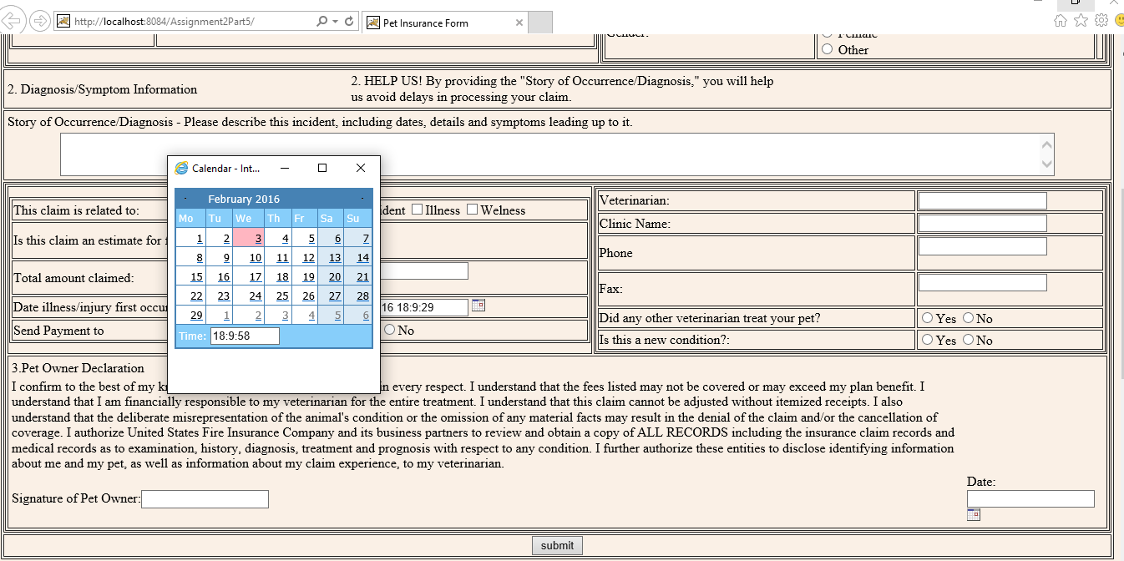

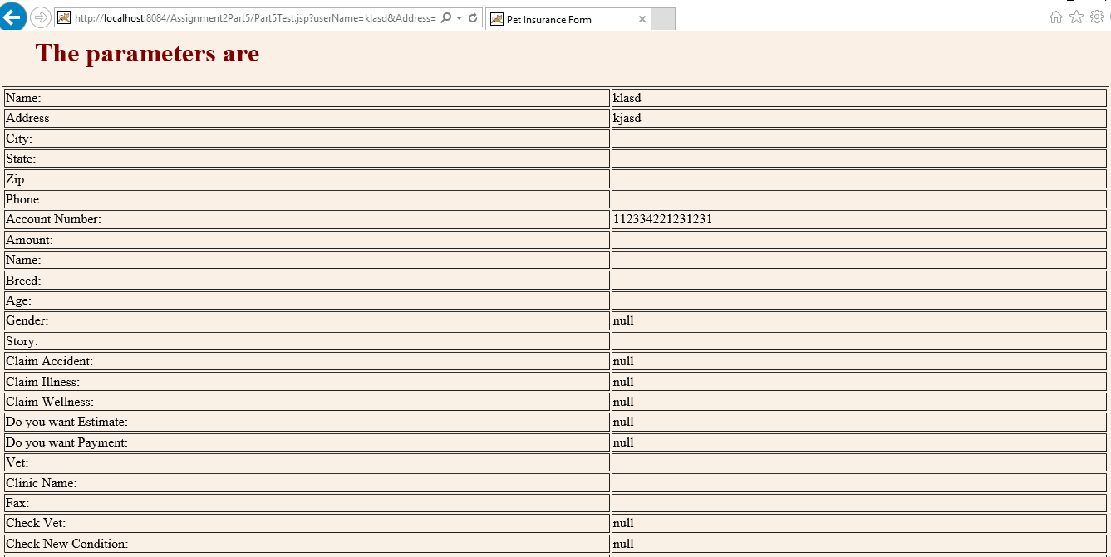

<%--

Document : Part5Test

Created on : Feb 1, 2016, 2:34:08 AM

Author : neera

--%>

<%@page contentType="text/html" pageEncoding="UTF-8"%>

<%@ page import="javax.servlet.http.HttpServlet" %>

<%@ page import="javax.servlet.http.HttpServletRequest" %>

<%@ page import="javax.servlet.http.HttpServletResponse" %>

<%@ page import="javax.servlet.ServletException" %>

<%@ page import="java.io.IOException" %>

<%@ page import="java.io.PrintWriter" %>

<%@ page import="java.util.Enumeration" %>

<!DOCTYPE html>

<html>

<head>

<title>

Pet Insurance Form

</title>

<script src="javascripts/Datepick/ts_picker.js"></script>

<script src="javascripts/ValidationScript.js"></script>

<link href="styles/style.css" rel="stylesheet" />

<meta charset="utf-8" />

</head>

<body>

<FORM name="tstest" METHOD="GET" onsubmit="return validateForm()" ACTION="Part5Test.jsp">

<table border="1">

<tbody>

<tr>

<td valign="top"> <h1> ASPCA</h1><br />Pet Health Insurance </td>

<td valign="top"> For office use only</td>

<td valign="top"> HAVE A QUESTION?<br />Call us at 1-866-204-6764</td>

</tr>

<tr>

<td colspan="3">

Claim Form PLEASE INCLUDE YOUR PET'S MEDICAL RECORDS TO HELP EXPEDITE PROCESSING.

</td>

</tr>

<tr>

<td colspan="3">

<br />

1. General Information Please fill out this form completely. Incomplete forms will delay processing.

</td>

</tr>

<tr>

<td colspan="3">

<table border="1">

<tbody>

<tr>

<td>

Your Information Check here if this is a new address <br />

<table border="1">

<tbody>

<tr> <td>Name:</td><td><input id="txtName" type="text" name="userName" /></td></tr>

<tr> <td>Address:</td><td><textarea id="txtAreaAddress" name="Address" rows="2" cols="20"></textarea></td></tr>

<tr> <td>State:</td><td><input id="txtState" type="text" name="State" /></td></tr>

<tr> <td>City:</td><td><input id="txtCity" type="text" name="City" /></td></tr>

<tr> <td>Zip:</td><td><input id="txtZip" type="text" name="Zip" oninput="checkZipCode()" /><p id="zipError"></p></td></tr>

<tr> <td>Phone:</td><td><input id="txtPhoneNumber" type="text" name="Phone" oninput="phonenumber()" /><p id="phoneError"></p></td></tr>

</tbody>

</table>

</td>

<td valign="top">

Pet Information

<table border="1">

<tbody>

<tr> <td>Account Number:</td><td><input oninput="accountNumberValidate()" id="txtAccNumber" type="text" name="Account_Number" /><p id="accountNumber"></p></td></tr>

<tr> <td>Name:</td><td><input id="txtPetName" type="text" name="Name" /></td></tr>

<tr> <td>Breed</td><td><input id="txtBreed" type="text" name="Breed" /></td></tr>

<tr> <td>Age:</td><td><input id="txtAge" oninput="checkAge()" type="text" name="Age" /><p id="ageFactor"></p></td></tr>

<tr>

<td>Gender:</td>

<td>

<input type="radio" name="gender" value="male"> Male<br>

<input type="radio" name="gender" value="female"> Female<br>

<input type="radio" name="gender" value="other"> Other

<td>

</tr>

</tbody>

</table>

</td>

</tr>

</tbody>

</table>

</td>

</tr>

<tr>

<td colspan="3">

<table>

<tbody>

<tr>

<td>2. Diagnosis/Symptom Information</td>

<td>

2. HELP US! By providing the "Story of Occurrence/Diagnosis," you will help<br />

us avoid delays in processing your claim.

</td>

</tr>

</tbody>

</table>

</td>

</tr>

<tr>

<td colspan="3">

<table>

<tbody>

<tr>

<td>Story of Occurrence/Diagnosis - Please describe this incident, including dates, details and symptoms leading up to it.</td>

</tr>

<tr>

<td valign="middle"><textarea style="width:90%; display: block;margin-left: auto;margin-right: auto;" id="txtStory" rows="3" name="Story" cols="60"></textarea></td>

</tr>

</tbody>

</table>

</td>

</tr>

<tr>

<td colspan="3">

<table border="1">

<tbody>

<tr>

<td>

<table border="1">

<tbody>

<tr>

<td>This claim is related to:</td>

<td>

<input type="checkbox" name="chkClaimAccident" value="accident">Accident

<input type="checkbox" name="chkClaimIllness" value="illness">Illness

<input type="checkbox" name="chkClaimWellness" value="wellness">Welness

</td>

</tr>

<tr>

<td>Is this claim an estimate for future treatment?</td>

<td>

<input type="radio" name="chkEstimate" value="Yes"> Yes<br>

<input type="radio" name="chkEstimate" value="No"> No<br>

</td>

</tr>

<tr> <td>Total amount claimed:</td><td><input id="txtAmount" oninput="amountValidate()" type="text" name="Amount" /><p id="AmountError"></p></td></tr>

<tr>

<td>Date illness/injury first occurred:</td>

<td>

<input id="txtDate" type="text" name="Date" />

<a href="javascript:show_calendar('document.tstest.Date', document.tstest.Date.value);">

<img src="javascripts/Datepick/cal.gif" width="16" height="16" border="0" alt="Click Here to Pick up the timestamp" />

</a>

</td>

</tr>

<tr>

<td>Send Payment to</td>

<td>

<input type="radio" name="chkPayment" value="yes">Yes

<input type="radio" name="chkPayment" value="no">No

</td>

</tr>

</tbody>

</table>

</td>

<td>

<table border="1">

<tbody>

<tr> <td>Veterinarian:</td><td><input id="txtAccNumber" type="text" name="Veterinarian" /></td></tr>

<tr> <td>Clinic Name:</td><td><input id="txtClinicName" type="text" name="Clinic Name" /></td></tr>

<tr> <td>Phone</td><td><input id="txtPhoneNumber1" type="text" name="Phone Number" oninput="phonenumber2()" /><p id="phoneError2"></p></td></tr>

<tr> <td>Fax:</td><td><input id="txtFax" oninput="faxValidate()" type="text" name="Fax" /><p id="FaxError"></p></td></tr>

<tr>

<td>Did any other veterinarian treat your pet?</td>

<td>

<input type="radio" name="chkVet" value="yes">Yes

<input type="radio" name="chkVet" value="no">No

</td>

</tr>

<tr>

<td>Is this a new condition?:</td>

<td>

<input type="radio" name="chkNewCond" value="yes">Yes

<input type="radio" name="chkNewCond" value="no">No

</td>

</tr>

</tbody>

</table>

</td>

</tr>

<tr>

<td colspan="3">

<table>

<tr><td>3.Pet Owner Declaration</td></tr>

<tr>

<td>

I confirm to the best of my knowledge the above statements are true in every respect. I understand that the fees listed may not be covered or may

exceed my plan benefit. I understand that I am financially responsible to my veterinarian for the entire treatment. I understand that this claim

cannot be adjusted without itemized receipts. I also understand that the deliberate misrepresentation of the animal's condition or the omission of

any material facts may result in the denial of the claim and/or the cancellation of coverage. I authorize United States Fire Insurance Company and

its business partners to review and obtain a copy of ALL RECORDS including the insurance claim records and medical records as to examination,

history, diagnosis, treatment and prognosis with respect to any condition. I further authorize these entities to disclose identifying information about

me and my pet, as well as information about my claim experience, to my veterinarian.

</td>

</tr>

<tr>

<td>Signature of Pet Owner:<input id="Text1" type="text" name="Signature" /></td>

<td>

Date:

<input type="Text" name="timestamp" value="">

<a href="javascript:show_calendar('document.tstest.timestamp', document.tstest.timestamp.value);">

<img src="javascripts/Datepick/cal.gif" width="16" height="16" border="0" alt="Click Here to Pick up the timestamp" />

</a>

</td>

</tr>

</table>

</td>

</tr>

</tbody>

</table>

</td>

</tr>

<tr>

<td colspan="3">

<div class="wrapper">

<input id="Submit1" type="submit" value="submit" />

</div>

</td>

</tr>

</tbody>

</table>

</FORM>

<h1>The parameters are</h1>

<%

String userName = request.getParameter("userName");

String state = request.getParameter("State");

String address = request.getParameter("Address");

String City = request.getParameter("City");

String Name = request.getParameter("Name");

String Breed = request.getParameter("Breed");

String Story = request.getParameter("Story");

String ClinicName = request.getParameter("Clinic Name");

String Signature = request.getParameter("Signature");

%>

<table border="1">

<tbody >

<tr><td>Name:</td><td><%= userName %></td></tr>

<tr><td>Address</td><td><%= address %></td></tr>

<tr><td>City:</td><td><%= City %></td></tr>

<tr><td>State:</td><td><%= state %></td></tr>

<tr><td>Zip:</td><td><%= request.getParameter("Zip") %></td></tr>

<tr><td>Phone:</td><td><%= request.getParameter("Phone") %></td></tr>

<tr><td>Account Number:</td><td><%= request.getParameter("Account_Number") %></td></tr>

<tr><td>Amount:</td><td><%= request.getParameter("Amount") %></td></tr>

<tr><td>Name:</td><td><%= Name %></td></tr>

<tr><td>Breed:</td><td><%= Breed %></td></tr>

<tr><td>Age:</td><td><%= request.getParameter("Age") %></td></tr>

<tr><td>Gender:</td><td><%= request.getParameter("gender") %></td></tr>

<tr><td>Story:</td><td><%= Story %></td></tr>

<tr><td>Claim Accident:</td><td><%= request.getParameter("chkClaimAccident") %></td></tr>

<tr><td>Claim Illness:</td><td><%= request.getParameter("chkClaimIllness") %></td></tr>

<tr><td>Claim Wellness:</td><td><%= request.getParameter("chkClaimWellness") %></td></tr>

<tr><td>Do you want Estimate:</td><td><%= request.getParameter("chkEstimate") %></td></tr>

<tr><td>Do you want Payment:</td><td><%= request.getParameter("chkPayment") %></td></tr>

<tr><td>Vet:</td><td><%= request.getParameter("Veterinarian") %></td></tr>

<tr><td>Clinic Name:</td><td><%= ClinicName %></td></tr>

<tr><td>Fax:</td><td><%= request.getParameter("Fax")%></td></tr>

<tr><td>Check Vet:</td><td><%= request.getParameter("chkVet") %></td></tr>

<tr><td>Check New Condition:</td><td><%= request.getParameter("chkNewCond") %></td></tr>

<tr><td>Signature:</td><td><%= Signature %></td></tr>

<tr><td>Date:</td><td><%= request.getParameter("timestamp") %></td></tr>

</tbody>

</table>

</body>

</html>

## Part6

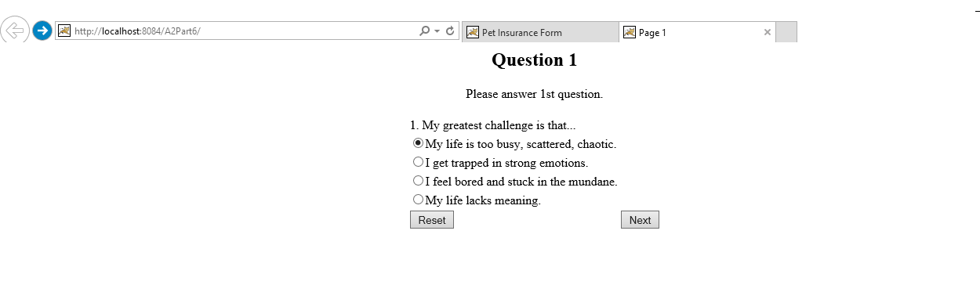

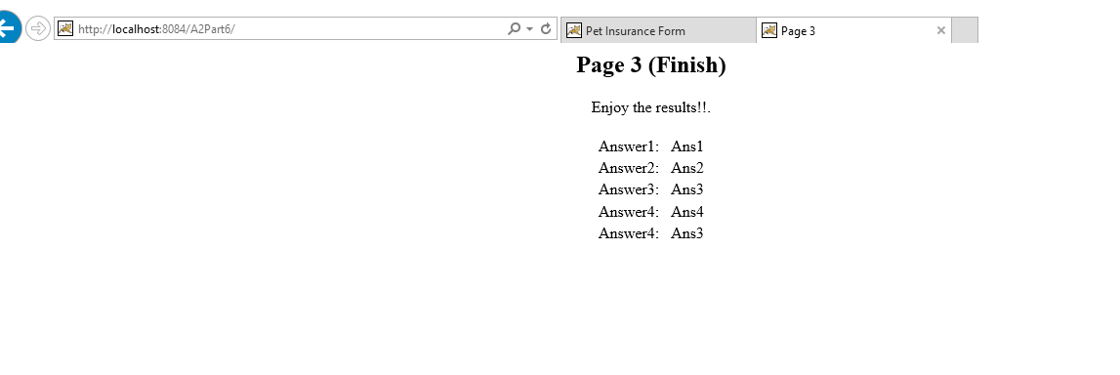

import java.io.IOException;

import java.io.PrintWriter;

import javax.servlet.ServletException;

import javax.servlet.http.HttpServlet;

import javax.servlet.http.HttpServletRequest;

import javax.servlet.http.HttpServletResponse;

public class Part6Quiz extends HttpServlet {

String answer1;

String answer2;

String answer3;

String answer4;

String answer5;

public void doGet(HttpServletRequest request, HttpServletResponse response) throws ServletException, IOException {

sendPage1(response);

}

public void doPost(HttpServletRequest request, HttpServletResponse response) throws ServletException, IOException {

response.setContentType("text/html");

String page = request.getParameter("page");

answer1 = request.getParameter("ans");

answer2 = request.getParameter("ans2");

answer3 = request.getParameter("ans3");

answer4 = request.getParameter("ans4");

answer5 = request.getParameter("ans5");

//PrintWriter out = response.getWriter();

//out.println(answer1);

//out.println(answer2);

//out.println(answer3);

//out.println(answer4);

//out.println(answer5);

if (page == null) {

sendPage1(response);

return;

}

if (page.equals("1")) {

sendPage2(response);

} else if (page.equals("2")) {

sendPage3(response);

} else if (page.equals("3")) {

sendPage4(response);

} else if (page.equals("4")) {

sendPage5(response);

} else if (page.equals("5")) {

displayValues(response);

}

}

void sendPage1(HttpServletResponse response) throws ServletException, IOException {

response.setContentType("text/html");

PrintWriter out = response.getWriter();

out.println("<HTML>");

out.println("<HEAD><TITLE>Page 1</TITLE></HEAD>");

out.println("<BODY>");

out.println("<CENTER>");

out.println("<H2>Question 1</H2>");

out.println("Please answer 1st question.<BR><BR>");

out.println("<FORM METHOD=POST>");

out.println("<INPUT TYPE=HIDDEN NAME=page VALUE=1>");

out.println("<TABLE>");

out.println("<TR>");

out.println("<TD><label for='Question1'/> 1. My greatest challenge is that... &nbsp;</TD></TR>");

out.println("<TR><TD><input type=radio name=ans value=Ans1>My life is too busy, scattered, chaotic.</TD></TR>");

out.println("<TR><TD><input type=\"radio\" name=\"ans\" value=\"Ans2\">I get trapped in strong emotions.</TD></TR>");

out.println("<TR><TD><input type=\"radio\" name=\"ans\" value=\"Ans3\">I feel bored and stuck in the mundane.</TD></TR>");

out.println("<TR><TD><input type=\"radio\" name=\"ans\" value=\"Ans4\">My life lacks meaning.</TD></TR>");

out.println("<TR>");

out.println("<TD><INPUT TYPE=RESET></TD>");

out.println("<TD><INPUT TYPE=SUBMIT VALUE=Next></TD>");

out.println("</TR>");

out.println("</TABLE>");

out.println("</FORM>");

out.println("</CENTER>");

out.println("</BODY>");

out.println("</HTML>");

}

void sendPage2(HttpServletResponse response) throws ServletException, IOException {

response.setContentType("text/html");

PrintWriter out = response.getWriter();

out.println("<HTML>");

out.println("<HEAD><TITLE>Page 2</TITLE></HEAD>");

out.println("<BODY>");

out.println("<CENTER>");

out.println("<H2>Question 2</H2>");

out.println("Please answer 2nd question.<BR><BR>");

out.println("<FORM METHOD=POST>");

out.println("<INPUT TYPE=HIDDEN NAME=page VALUE=2>");

out.println("<TABLE>");

out.println("<TR>");

out.println("<TD><INPUT TYPE=HIDDEN NAME=ans VALUE=\"" + answer1 + "\"></TD>");

out.println("<TD>2. I would best describe the pain in my life right now as a feeling of ... &nbsp;</TD></TR>");

out.println("<TR><TD><input type=radio name=ans2 value=Ans1>negativity and limitation</TD></TR>");

out.println("<TR><TD><input type=\"radio\" name=\"ans2\" value=\"Ans2\">insecurity</TD></TR>");

out.println("<TR><TD><input type=\"radio\" name=\"ans2\" value=\"Ans3\">unhappiness</TD></TR>");

out.println("<TR><TD><input type=\"radio\" name=\"ans2\" value=\"Ans4\">being unfulfilled</TD></TR>");

out.println("<TR>");

out.println("<TD><INPUT TYPE=RESET></TD>");

out.println("<TD><INPUT TYPE=SUBMIT VALUE=Next></TD>");

out.println("</TR>");

out.println("</TABLE>");

out.println("</FORM>");

out.println("</CENTER>");

out.println("</BODY>");

out.println("</HTML>");

}

void sendPage3(HttpServletResponse response) throws ServletException, IOException {

response.setContentType("text/html");

PrintWriter out = response.getWriter();

out.println("<HTML>");

out.println("<HEAD><TITLE>Page 3</TITLE></HEAD>");

out.println("<BODY>");

out.println("<CENTER>");

out.println("<H2>Question 3</H2>");

out.println("Please answer 3rd question.<BR><BR>");

out.println("<FORM METHOD=POST>");

out.println("<INPUT TYPE=HIDDEN NAME=page VALUE=3>");

out.println("<TABLE>");

out.println("<TR>");

out.println("<TD><INPUT TYPE=HIDDEN NAME=ans VALUE=\"" + answer1 + "\"></TD>");

out.println("<TD><INPUT TYPE=HIDDEN NAME=ans2 VALUE=\"" + answer2 + "\"></TD>");

out.println("<TD>3. I am working on ... &nbsp;</TD></TR>");

out.println("<TR><TD><input type=radio name=ans3 value=Ans1>serving others</TD></TR>");

out.println("<TR><TD><input type=\"radio\" name=\"ans3\" value=\"Ans2\">accepting myself</TD></TR>");

out.println("<TR><TD><input type=\"radio\" name=\"ans3\" value=\"Ans3\">expressing myself</TD></TR>");

out.println("<TR><TD><input type=\"radio\" name=\"ans3\" value=\"Ans4\">improving myself</TD></TR>");

out.println("<TR>");

out.println("<TD><INPUT TYPE=RESET></TD>");

out.println("<TD><INPUT TYPE=SUBMIT VALUE=Next></TD>");

out.println("</TR>");

out.println("</TABLE>");

out.println("</FORM>");

out.println("</CENTER>");

out.println("</BODY>");

out.println("</HTML>");

}

void sendPage4(HttpServletResponse response) throws ServletException, IOException {

response.setContentType("text/html");

PrintWriter out = response.getWriter();

out.println("<HTML>");

out.println("<HEAD><TITLE>Page 4</TITLE></HEAD>");

out.println("<BODY>");

out.println("<CENTER>");

out.println("<H2>Question 4</H2>");

out.println("Please answer 4th question.<BR><BR>");

out.println("<FORM METHOD=POST>");

out.println("<INPUT TYPE=HIDDEN NAME=page VALUE=4>");

out.println("<TABLE>");

out.println("<TR>");

out.println("<TD><INPUT TYPE=HIDDEN NAME=ans VALUE=\"" + answer1 + "\"></TD>");

out.println("<TD><INPUT TYPE=HIDDEN NAME=ans2 VALUE=\"" + answer2 + "\"></TD>");

out.println("<TD><INPUT TYPE=HIDDEN NAME=ans3 VALUE=\"" + answer3 + "\"></TD>");

out.println("<TD>4. I usually approach problems and life ... &nbsp;</TD></TR>");

out.println("<TR><TD><input type=radio name=ans4 value=Ans1>intuitively</TD></TR>");

out.println("<TR><TD><input type=\"radio\" name=\"ans4\" value=\"Ans2\">with action</TD></TR>");

out.println("<TR><TD><input type=\"radio\" name=\"ans4\" value=\"Ans3\">intellectually</TD></TR>");

out.println("<TR><TD><input type=\"radio\" name=\"ans4\" value=\"Ans4\">with feelings</TD></TR>");

out.println("<TR>");

out.println("<TD><INPUT TYPE=RESET></TD>");

out.println("<TD><INPUT TYPE=SUBMIT VALUE=Next></TD>");

out.println("</TR>");

out.println("</TABLE>");

out.println("</FORM>");

out.println("</CENTER>");

out.println("</BODY>");

out.println("</HTML>");

}

void sendPage5(HttpServletResponse response) throws ServletException, IOException {

response.setContentType("text/html");

PrintWriter out = response.getWriter();

out.println("<HTML>");

out.println("<HEAD><TITLE>Page 5</TITLE></HEAD>");

out.println("<BODY>");

out.println("<CENTER>");

out.println("<H2>Question 5</H2>");

out.println("Please answer 5th question.<BR><BR>");

out.println("<FORM METHOD=POST>");

out.println("<INPUT TYPE=HIDDEN NAME=page VALUE=5>");

out.println("<TABLE>");

out.println("<TR>");

out.println("<TD><INPUT TYPE=HIDDEN NAME=ans VALUE=\"" + answer1 + "\"></TD>");

out.println("<TD><INPUT TYPE=HIDDEN NAME=ans2 VALUE=\"" + answer2 + "\"></TD>");

out.println("<TD><INPUT TYPE=HIDDEN NAME=ans3 VALUE=\"" + answer3 + "\"></TD>");

out.println("<TD><INPUT TYPE=HIDDEN NAME=ans4 VALUE=\"" + answer4 + "\"></TD>");

out.println("<TD>5. I most value ... &nbsp;</TD></TR>");

out.println("<TR><TD><input type=radio name=ans5 value=Ans1>purpose and contribution</TD></TR>");

out.println("<TR><TD><input type=\"radio\" name=\"ans5\" value=\"Ans2\">peace of mind, order</TD></TR>");

out.println("<TR><TD><input type=\"radio\" name=\"ans5\" value=\"Ans3\">understanding</TD></TR>");

out.println("<TR><TD><input type=\"radio\" name=\"ans5\" value=\"Ans4\">love and connection</TD></TR>");

out.println("<TR>");

out.println("<TD><INPUT TYPE=RESET></TD>");

out.println("<TD><INPUT TYPE=SUBMIT VALUE=Next></TD>");

out.println("</TR>");

out.println("</TABLE>");

out.println("</FORM>");

out.println("</CENTER>");

out.println("</BODY>");

out.println("</HTML>");

}

void displayValues(HttpServletResponse response) throws ServletException, IOException {

response.setContentType("text/html");

PrintWriter out = response.getWriter();

out.println("<HTML>");

out.println("<HEAD><TITLE>Page 3</TITLE></HEAD>");

out.println("<BODY>");

out.println("<CENTER>");

out.println("<H2>Page 3 (Finish)</H2>");

out.println("Enjoy the results!!.<BR><BR>");

out.println("<TABLE>");

out.println("<TR>");

out.println("<TD>Answer1: &nbsp;</TD>");

out.println("<TD>" + answer1 + "</TD>");

out.println("</TR>");

out.println("<TR>");

out.println("<TD>Answer2: &nbsp;</TD>");

out.println("<TD>" + answer2 + "</TD>");

out.println("</TR>");

out.println("<TR>");

out.println("<TD>Answer3: &nbsp;</TD>");

out.println("<TD>" + answer3 + "</TD>");

out.println("</TR>");

out.println("<TR>");

out.println("<TD>Answer4: &nbsp;</TD>");

out.println("<TD>" + answer4 + "</TD>");

out.println("</TR>");

out.println("<TR>");

out.println("<TD>Answer4: &nbsp;</TD>");

out.println("<TD>" + answer5 + "</TD>");

out.println("</TR>");

out.println("</TR></TABLE></CENTER>");

out.println("</BODY></HTML>");

}

}

**WEB.XML**

<?xml version="1.0" encoding="UTF-8"?>

<web-app version="3.1" xmlns="http://xmlns.jcp.org/xml/ns/javaee" xmlns:xsi="http://www.w3.org/2001/XMLSchema-instance" xsi:schemaLocation="http://xmlns.jcp.org/xml/ns/javaee http://xmlns.jcp.org/xml/ns/javaee/web-app_3_1.xsd">

<servlet>

<servlet-name>Part6Quiz</servlet-name>

<servlet-class>Part6Quiz</servlet-class>

</servlet>

<servlet-mapping>

<servlet-name>Part6Quiz</servlet-name>

<url-pattern>/Part6Quiz</url-pattern>

</servlet-mapping>

<session-config>

<session-timeout>

30

</session-timeout>

</session-config>

<welcome-file-list>

<welcome-file>Part6Quiz</welcome-file>

</welcome-file-list>

</web-app>

## Part 7

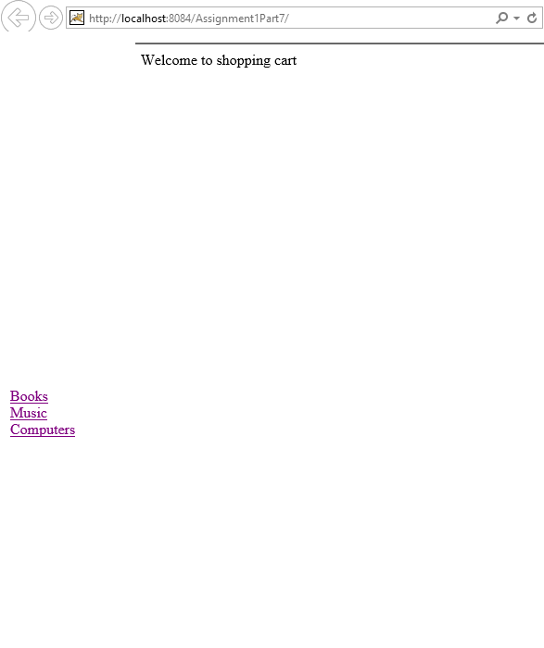

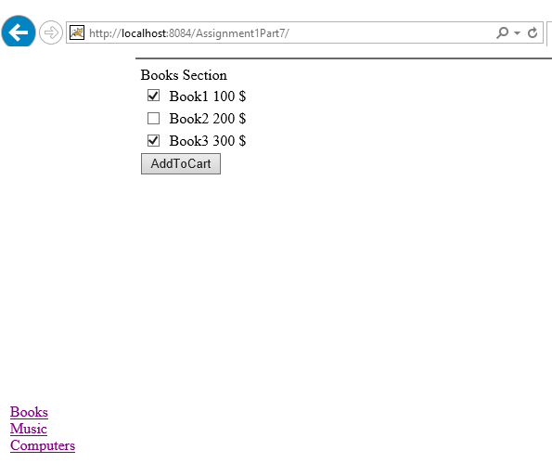

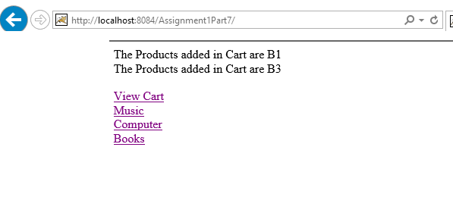

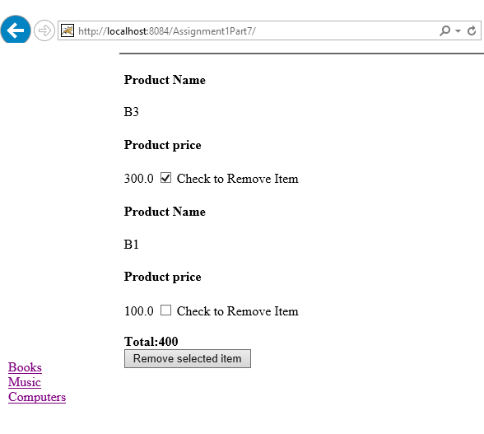

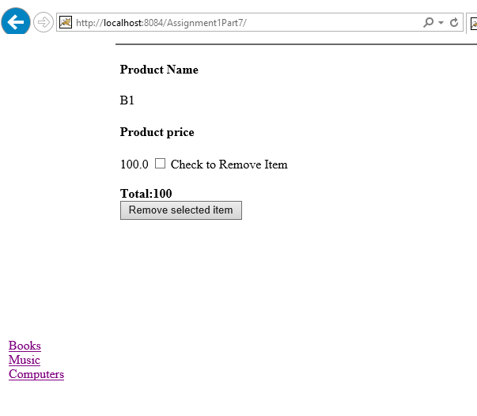

HTML Page

Top of Form

Books Section

|  |  |  |  |
| --- | --- | --- | --- |
|  |  | Book1 | 100 $ |
|  |  | Book2 | 200 $ |
|  |  | Book3 | 300 $ |



Bottom of Form

<html>

<head>

<title>TODO supply a title</title>

<meta charset="UTF-8">

<meta name="viewport" content="width=device-width, initial-scale=1.0">

</head>

<body>

<form name="Books" action="AddToCart">

<div>Books Section</div>

<table>

<tr>

<td><input type="checkbox" name="chkbook" value="B1"/></td>

<td><input type="hidden" name="chkBookHidden" value="20" /></td>

<td>Book1</td>

<td>100 $</td>

</tr>

<tr>

<td><input type="checkbox" name="chkbook" value="B2"/>

</td>

<td><input type="hidden" name="chkBookHidden" value="278" /></td>

<td>Book2</td>

<td>200 $</td>

</tr>

<tr>

<td><input type="checkbox" name="chkbook" value="B3"/>

</td>

<td><input type="hidden" name="chkBookHidden" value="309" /></td>

<td>Book3</td>

<td>300 $</td>

</tr>

</table>

<input type="Submit" name="AddToCart" value="AddToCart"/>

</form>

</body>

</html>

Top of Form

Computer Department

|  |  |  |
| --- | --- | --- |
|  | Lenovo | 500 $ |
|  | HP | 400 $ |
|  | Dell | 300 $ |



Bottom of Form

<!DOCTYPE html>

<!--

To change this license header, choose License Headers in Project Properties.

To change this template file, choose Tools | Templates

and open the template in the editor.

-->

<html>

<head>

<title>Computers Department</title>

<meta charset="UTF-8">

<meta name="viewport" content="width=device-width, initial-scale=1.0">

</head>

<body>

<form name="Comps" action="AddToCart">

<div>Computer Department</div>

<table>

<tr>

<td><input type="checkbox" name="chkcomp" value="C1"/></td>

<td>Lenovo</td>

<td>500 $</td>

</tr>

<tr>

<td><input type="checkbox" name="chkcomp" value="C2"/></td>

<td>HP</td>

<td>400 $</td>

</tr>

<tr>

<td><input type="checkbox" name="chkcomp" value="C3"/></td>

<td>Dell</td>

<td>300 $</td>

</tr>

</table>

<input type="Submit" name="AddToCart" value="AddToCart"/>

</form>

</body>

</html>

Welcome to shopping cart

<!DOCTYPE html>

<!--

To change this license header, choose License Headers in Project Properties.

To change this template file, choose Tools | Templates

and open the template in the editor.

-->

<html>

<head>

<title>Add Items</title>

<meta charset="UTF-8">

<meta name="viewport" content="width=device-width, initial-scale=1.0">

</head>

<body>

<div>Welcome to shopping cart</div>

</body>

</html>

Top of Form

Music Section

|  |  |  |
| --- | --- | --- |
|  | Music1 | 100 |
|  | Music2 | 200 |
|  | Music3 | 300 |



Bottom of Form

<!DOCTYPE html>

<!--

To change this license header, choose License Headers in Project Properties.

To change this template file, choose Tools | Templates

and open the template in the editor.

-->

<html>

<head>

<title>TODO supply a title</title>

<meta charset="UTF-8">

<meta name="viewport" content="width=device-width, initial-scale=1.0">

</head>

<body>

<form name="Music" action="AddToCart">

<div>Music Section</div>

<table>

<tr>

<td><input type="checkbox" name="chkmusic" value="M1"/></td>

<td>Music1</td>

<td>100</td>

</tr>

<tr>

<td><input type="checkbox" name="chkmusic" value="M2"/></td>

<td>Music2</td>

<td>200</td>

</tr>

<tr>

<td><input type="checkbox" name="chkmusic" value="M3"/></td>

<td>Music3</td>

<td>300</td>

</tr>

</table>

<input type="Submit" name="AddToCart" value="AddToCart"/>

<input type='hidden' name='action' value='multiple'/>

</form>

</body>

</html>

|  |  |
| --- | --- |
| Books Music Computers |  |

<!DOCTYPE html>

<!--

To change this license header, choose License Headers in Project Properties.

To change this template file, choose Tools | Templates

and open the template in the editor.

-->

<html>

<head>

<title>TODO supply a title</title>

<meta charset="UTF-8">

<meta name="viewport" content="width=device-width, initial-scale=1.0">

<style>

#wrapper{

width:100%;

height:auto;

margin:0 auto;

border:1px solid blue;

overflow:hidden;

}

#wrapper>div{

display:inline-block;

vertical-align:left;

width:20%;

}

.l{

float:left;

height: auto;

}

.r{

width:100%;

height:100%;

float:right;

}

</style>

</head>

<body>

<table style="width:100%;height:100%">

<tr>

<td width="10%" height="100%"><a href="Books.html" name="i_frameBooks" target="DynamicPage">Books</a><br/>

<a href="Music.html" name="i_frameMusic" target="DynamicPage">Music</a><br/>

<a href="Computers.html" name="i_frameComputers" target="DynamicPage">Computers</a><br/></td>

<td width="90%" height="800px">

<div style="height: 100%; overflow:hidden;">

<iframe src="DynamicPage.html" class="r" name="DynamicPage" frameborder="1" scrolling="yes"></iframe>

</div>

</td>

</tr>

</table>

</body>

</html>

**ViewCart JSP**

<%--

Document : ViewCart

Created on : Feb 2, 2016, 8:37:25 PM

Author : neera

--%>

<%@page contentType="text/html" pageEncoding="UTF-8"%>

<%@ taglib prefix="c" uri="http://java.sun.com/jsp/jstl/core" %>

<%@page import="java.util.Iterator"%>

<%@page import="java.util.HashSet"%>

<%@page import="java.util.List"%>

<%@page import="java.util.ArrayList"%>

<%@page import="Bean.Cart"%>

<%@page import="Bean.Product"%>

<!DOCTYPE html>

<head>

<meta http-equiv="Content-Type" content="text/html; charset=UTF-8">

<title>JSP Page</title>

</head>

<form action="ViewCart">

<%

session = request.getSession();

Cart myCart = new Cart();

myCart = (Cart) session.getAttribute("cart");

int addPrice = 0;

for (Product p : myCart.getCart()) {

addPrice += p.getPrice();

%>

<h4> Product Name </h4><jsp:expression>p.getName()</jsp:expression> <h4> Product price </h4> <jsp:expression>p.getPrice()</jsp:expression>

<input type="checkbox" name="removedProducts" value=<jsp:expression>p.getID()</jsp:expression>>

Check to Remove Item<br/>

<jsp:scriptlet>

}

</jsp:scriptlet>

<br/>

<strong>Total:<jsp:expression>addPrice</jsp:expression></strong>

<br/>

<input type="Submit" name="Submit" value="Remove selected item"/>

</form>

**Add to Cart Servlet**

/*

* To change this license header, choose License Headers in Project Properties.

* To change this template file, choose Tools | Templates

* and open the template in the editor.

*/

import Bean.Cart;

import Bean.Product;

import java.io.IOException;

import java.io.PrintWriter;

import java.util.ArrayList;

import java.util.Iterator;

import java.util.List;

import java.util.Set;

import javax.servlet.ServletException;

import javax.servlet.http.HttpServlet;

import javax.servlet.http.HttpServletRequest;

import javax.servlet.http.HttpServletResponse;

import javax.servlet.http.HttpSession;

/**

*

* @author neera

*/

public class AddToCart extends HttpServlet {

private List<Product> productList;

private Set<Product> myProducts;

public AddToCart() {

// productList = CourseSearchServlet.getCoursesAvailable();

//myCourses = new HashSet<Course>();

}

/**

* Processes requests for both HTTP <code>GET</code> and <code>POST</code>

* methods.

*

* @param request servlet request

* @param response servlet response

* @throws ServletException if a servlet-specific error occurs

* @throws IOException if an I/O error occurs

*/

protected void processRequest(HttpServletRequest request, HttpServletResponse response)

throws ServletException, IOException {

List<Product> listofProduct = new ArrayList<Product>();

listofProduct = getProducts();

Cart cart;

HttpSession session = request.getSession();

if (null != session.getAttribute("cart")) {

cart = new Cart();

cart = (Cart) session.getAttribute("cart");

} else {

cart = new Cart();

}

response.setContentType("text/html;charset=UTF-8");

PrintWriter out = response.getWriter();

/* TODO output your page here. You may use following sample code. */

String[] bookvalues = request.getParameterValues("chkbook");

String[] musicvalues = request.getParameterValues("chkmusic");

String[] compvalues = request.getParameterValues("chkcomp");

if (bookvalues != null) {

for (Product p : listofProduct) {

for (int i = 0; i < bookvalues.length; i++) {

if (p.getID().contains(bookvalues[i])) {

cart.addToCart(p);

session.setAttribute("cart", cart);

out.println("The Products added in Cart are " + bookvalues[i] + "<br/>");

//out.println("<input type='checkbox' name='courseId' value='" + cart.getCart().get(i).getName() + "'/>" + cart.getCart().get(i).getName() + cart.getCart().get(i).getPrice() + "<a href='addCourse.htm?name=" + cart.getCart().get(i).getName() + "&price=" + cart.getCart().get(i).getPrice() + "&action=single'> Add this course</a></h1>");

}

}

}

}

if (compvalues != null) {

for (Product p : listofProduct) {

for (int i = 0; i < compvalues.length; i++) {

if (p.getID().contains(compvalues[i])) {

cart.addToCart(p);

session.setAttribute("cart", cart);

out.println("The Products added in Cart are " + compvalues[i] + "<br/>");

//out.println("<input type='checkbox' name='courseId' value='" + cart.getCart().get(i).getName() + "'/>" + cart.getCart().get(i).getName() + cart.getCart().get(i).getPrice() + "<a href='addCourse.htm?name=" + cart.getCart().get(i).getName() + "&price=" + cart.getCart().get(i).getPrice() + "&action=single'> Add this course</a></h1>");

}

}

}

}

// out.println("<input type='hidden' name='action' value='multiple'/>");

if (musicvalues != null) {

for (Product p : listofProduct) {

for (int i = 0; i < musicvalues.length; i++) {

if (p.getID().contains(musicvalues[i])) {

cart.addToCart(p);

session.setAttribute("cart", cart);

out.println("The Products in Cart are " + musicvalues[i] + "<br/>");

}

}

}

}

out.println("<!DOCTYPE html>");

out.println("<html>");

out.println("<head>");

out.println("<title>Servlet AddToCart</title>");

out.println("<br/><a href='/Assignment1Part7/ViewCart'>View Cart</a>");

out.println("<br/><a href='/Assignment1Part7/Music.html'>Music</a>");

out.println("<br/><a href='/Assignment1Part7/Computers.html'>Computer</a>");

out.println("<br/><a href='/Assignment1Part7/Books.html'>Books</a>");

out.println("</head>");

out.println("<body>");

out.println("");

out.println("</body>");

out.println("</html>");

}

public static List<Product> getProducts() {

List<Product> productList = new ArrayList<Product>();

Product pb1 = new Product();

pb1.setID("B1");

pb1.setName("B1");

pb1.setPrice(100);

Product pb2 = new Product();

pb2.setID("B2");

pb2.setName("B2");

pb2.setPrice(200);

Product pb3 = new Product();

pb3.setID("B3");

pb3.setName("B3");

pb3.setPrice(300);

Product pm1 = new Product();

pm1.setID("M1");

pm1.setName("M1");

pm1.setPrice(100);

Product pm2 = new Product();

pm2.setID("M2");

pm2.setName("M2");

pm2.setPrice(200);

Product pm3 = new Product();

pm3.setID("M3");

pm3.setName("M3");

pm3.setPrice(300);

Product pc1 = new Product();

pc1.setID("C3");

pc1.setName("C3");

pc1.setPrice(500);

Product pc2 = new Product();

pc2.setID("C2");

pc2.setName("C2");

pc2.setPrice(400);

Product pc3 = new Product();

pc3.setID("C3");

pc3.setName("C3");

pc3.setPrice(300);

productList.add(pb1);

productList.add(pb2);

productList.add(pb3);

productList.add(pm1);

productList.add(pm2);

productList.add(pm3);

productList.add(pc1);

productList.add(pc2);

productList.add(pc3);

return productList;

}

// <editor-fold defaultstate="collapsed" desc="HttpServlet methods. Click on the + sign on the left to edit the code.">

/**

* Handles the HTTP <code>GET</code> method.

*

* @param request servlet request

* @param response servlet response

* @throws ServletException if a servlet-specific error occurs

* @throws IOException if an I/O error occurs

*/

@Override

protected void doGet(HttpServletRequest request, HttpServletResponse response)

throws ServletException, IOException {

processRequest(request, response);

}

/**

* Handles the HTTP <code>POST</code> method.

*

* @param request servlet request

* @param response servlet response

* @throws ServletException if a servlet-specific error occurs

* @throws IOException if an I/O error occurs

*/

@Override

protected void doPost(HttpServletRequest request, HttpServletResponse response)

throws ServletException, IOException {

processRequest(request, response);

}

/**

* Returns a short description of the servlet.

*

* @return a String containing servlet description

*/

@Override

public String getServletInfo() {

return "Short description";

}// </editor-fold>

}

**View Cart**

/*

* To change this license header, choose License Headers in Project Properties.

* To change this template file, choose Tools | Templates

* and open the template in the editor.

*/

import Bean.Cart;

import Bean.Product;

import java.io.IOException;

import java.io.PrintWriter;

import java.util.ArrayList;

import java.util.HashSet;

import java.util.List;

import java.util.Set;

import javax.servlet.ServletException;

import javax.servlet.http.HttpServlet;

import javax.servlet.http.HttpServletRequest;

import javax.servlet.http.HttpServletResponse;

import javax.servlet.http.HttpSession;

/**

*

* @author neera

*/

public class ViewCart extends HttpServlet {

/**

* Processes requests for both HTTP <code>GET</code> and <code>POST</code>

* methods.

*

* @param request servlet request

* @param response servlet response

* @throws ServletException if a servlet-specific error occurs

* @throws IOException if an I/O error occurs

*/

private List<Product> productList;

private Cart myCart;

protected void processRequest(HttpServletRequest request, HttpServletResponse response)

throws ServletException, IOException {

HttpSession session = request.getSession();

response.setContentType("text/html;charset=UTF-8");

try (PrintWriter out = response.getWriter()) {

/* TODO output your page here. You may use following sample code. */

String[] removedProducts = request.getParameterValues("removedProducts");

if (removedProducts != null && myCart != null) {

for (int i = 0; i < removedProducts.length; i++) {

for (Product p : myCart.getCart()) {

if (p.getID().equals(removedProducts[i])) {

myCart.removeToCart(p);

}

}

}

}

if (null != session.getAttribute("cart")) {

myCart = new Cart();

myCart = (Cart) session.getAttribute("cart");

} else {

myCart = new Cart();

}

for (Product p : myCart.getCart()) {

out.println(p.getName() + "<span/>" + p.getPrice());

}

session.setAttribute("cart", myCart);

response.sendRedirect("ViewCart.jsp");

} catch (Exception e) {

session.setAttribute("cart", myCart);

response.sendRedirect("ViewCart.jsp");

}

}

// <editor-fold defaultstate="collapsed" desc="HttpServlet methods. Click on the + sign on the left to edit the code.">

/**

* Handles the HTTP <code>GET</code> method.

*

* @param request servlet request

* @param response servlet response

* @throws ServletException if a servlet-specific error occurs

* @throws IOException if an I/O error occurs

*/

@Override

protected void doGet(HttpServletRequest request, HttpServletResponse response)

throws ServletException, IOException {

processRequest(request, response);

}

/**

* Handles the HTTP <code>POST</code> method.

*

* @param request servlet request

* @param response servlet response

* @throws ServletException if a servlet-specific error occurs

* @throws IOException if an I/O error occurs

*/

@Override

protected void doPost(HttpServletRequest request, HttpServletResponse response)

throws ServletException, IOException {

processRequest(request, response);

}

/**

* Returns a short description of the servlet.

*

* @return a String containing servlet description

*/

@Override

public String getServletInfo() {

return "Short description";

}// </editor-fold>

}

**Bean Object**

/*

* To change this license header, choose License Headers in Project Properties.

* To change this template file, choose Tools | Templates

* and open the template in the editor.

*/

package Bean;

import java.util.ArrayList;

import java.util.HashMap;

/**

*

* @author neera

*/

public class Cart {

ArrayList<Product> cart;

public ArrayList<Product> getCart() {

return cart;

}

public void setCart(ArrayList<Product> cart) {

this.cart = cart;

}

public void addToCart(Product p) {

cart.add(p);

}

public void removeToCart(Product p) {

cart.remove(p);

}

public Cart() {

cart = new ArrayList<>();

}

}

/*

* To change this license header, choose License Headers in Project Properties.

* To change this template file, choose Tools | Templates

* and open the template in the editor.

*/

package Bean;

/**

*

* @author neera

*/

public class Product {

private String ID;

private String name;

private double price;

public String getID() {

return ID;

}

public void setID(String ID) {

this.ID = ID;

}

public String getName() {

return name;

}

public void setName(String name) {

this.name = name;

}

public double getPrice() {

return price;

}

public void setPrice(double price) {

this.price = price;

}

}

<?xml version="1.0" encoding="UTF-8"?>

<web-app version="3.1" xmlns="http://xmlns.jcp.org/xml/ns/javaee" xmlns:xsi="http://www.w3.org/2001/XMLSchema-instance" xsi:schemaLocation="http://xmlns.jcp.org/xml/ns/javaee http://xmlns.jcp.org/xml/ns/javaee/web-app_3_1.xsd">

<servlet>

<servlet-name>AddToCart</servlet-name>

<servlet-class>AddToCart</servlet-class>

</servlet>

<servlet>

<servlet-name>ViewCart</servlet-name>

<servlet-class>ViewCart</servlet-class>

</servlet>

<servlet-mapping>

<servlet-name>AddToCart</servlet-name>

<url-pattern>/AddToCart</url-pattern>

</servlet-mapping>

<servlet-mapping>

<servlet-name>ViewCart</servlet-name>

<url-pattern>/ViewCart</url-pattern>

</servlet-mapping>

<session-config>

<session-timeout>

30

</session-timeout>

</session-config>

</web-app>