ROS Network Configuration

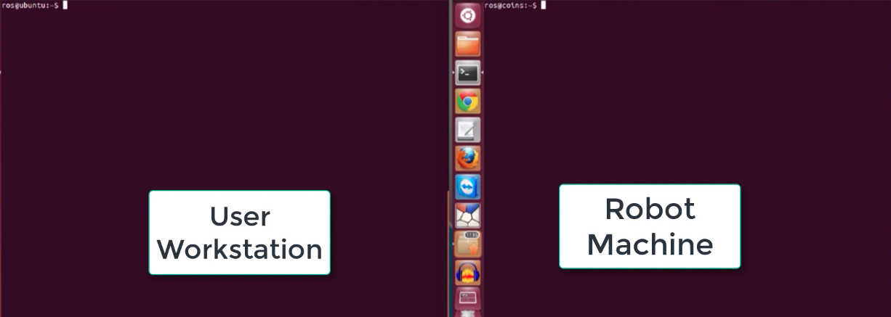
1. Open .bashrc file from both workstation and robot machine
2. in Robot machine
ifconfig to get the host ip address
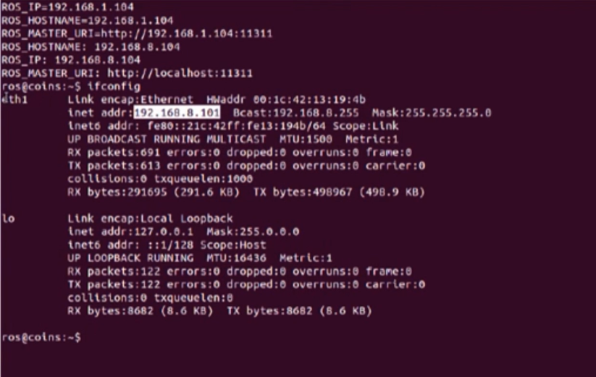
in .bashrc file
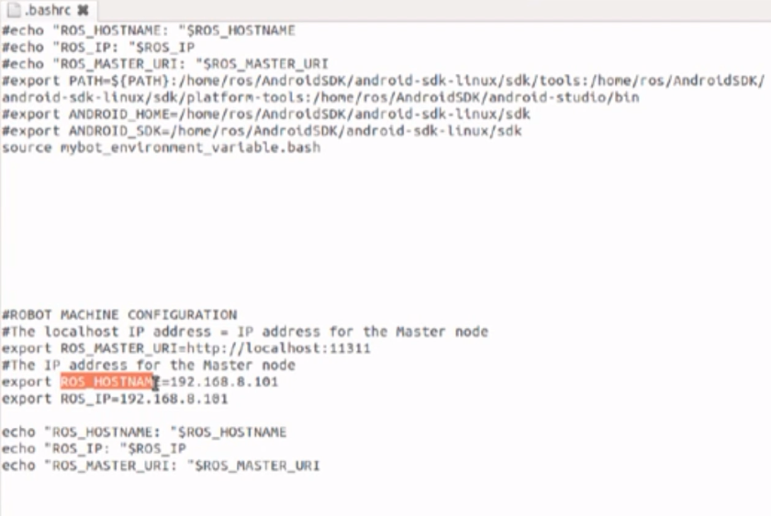
Add the above lines in the .bashrc file indicating the right ROS_HOSTNAME and ROS_IP

3. in the workstation
ifconfig to find the ip address of the workstation
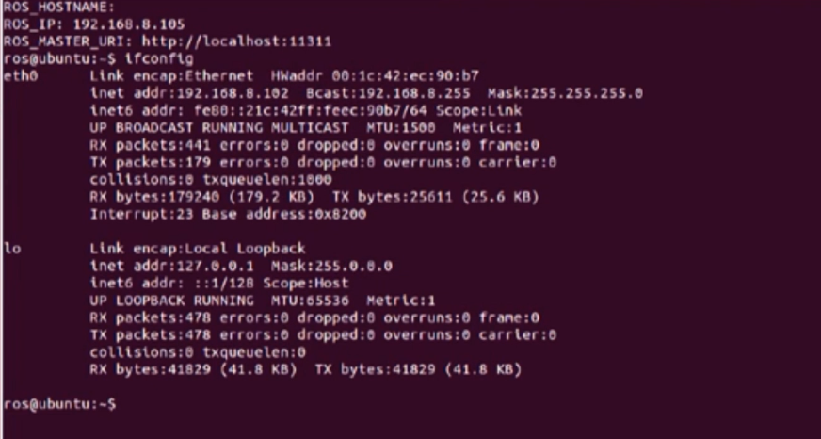

in the .bashrc file edit the ROS_HOSTNAME, ROS_IP env variables
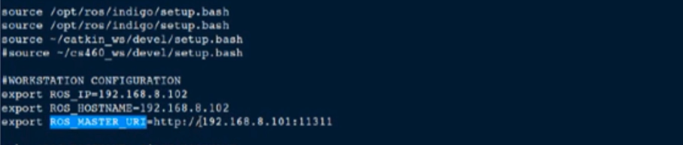
Important configuration is the ROS_MASTER_URI env variable that should point to the robot machine .
In the Robot machine it can be seen that its value is set to the localhost:portnumber

