GEMLAB

AI Customer Experience
& Store-Visit Automation
Project concept • System architecture • Visual workflows • Implementation roadmap

PROJECT GOAL
Help customers get accurate, human-like answers; guide interested buyers toward a GemLab centre or consultation; and use TeleCRM to manage permitted leads and follow-ups. Measure confirmed visits and sales—not just message volume.

Prepared as a discussion document for business and technical stakeholders.

1. Executive summary
GemLab can use an AI customer assistant across its website and an approved WhatsApp channel. The assistant will understand a customer's question, retrieve verified GemLab information, check live business data where needed, and respond in a clear, professional sales-consultant style.
When a customer shows genuine interest, the system can—with the required permission—create or update a lead in TeleCRM, trigger a supported workflow, send an approved WhatsApp template when required, and arrange a store consultation if booking is supported.
THE CORE IDEA
RAG is the verified knowledge desk. The conversation layer turns that evidence into a natural answer. TeleCRM manages supported lead and follow-up actions. Booking, staff check-in or POS data provides evidence of real-world outcomes.

2. What the system should do
Answer accurately | Use approved GemLab policies, FAQs, brochures and product guides. If evidence is missing or conflicting, ask a clarifying question or hand off.
Look up changing facts | Get current price, availability, active offers, store details and appointment slots from an authoritative live system—not from old document text.
Guide the customer | Ask only useful questions, understand product interest and budget where appropriate, and suggest a relevant next step without pressure.
Share approved assets | Send existing product images, brochures and offer details that match the customer's question.
Convert interest into action | Offer a nearby centre or consultation, subject to verified store data and booking capability.
Keep TeleCRM useful | Create/update leads, capture the source and consent status, and trigger only supported workflows and permitted follow-ups.
Measure outcomes | Track qualified leads, booked visits, attended visits and attributed purchases where reliable confirmation data exists.

3. Architecture at a glance
The system has two connected workflows: (A) preparing and retrieving verified knowledge, and (B) handling a live customer conversation and connecting it to TeleCRM.

Flow A — RAG knowledge and answer pipeline
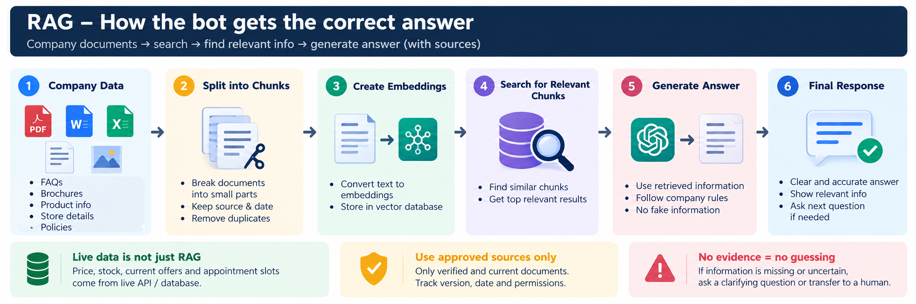
Figure 1. The knowledge workflow: approved documents are cleaned and indexed; each customer question retrieves evidence, passes a verification gate, and is answered or handed off.

Flow B — AI customer bot + TeleCRM
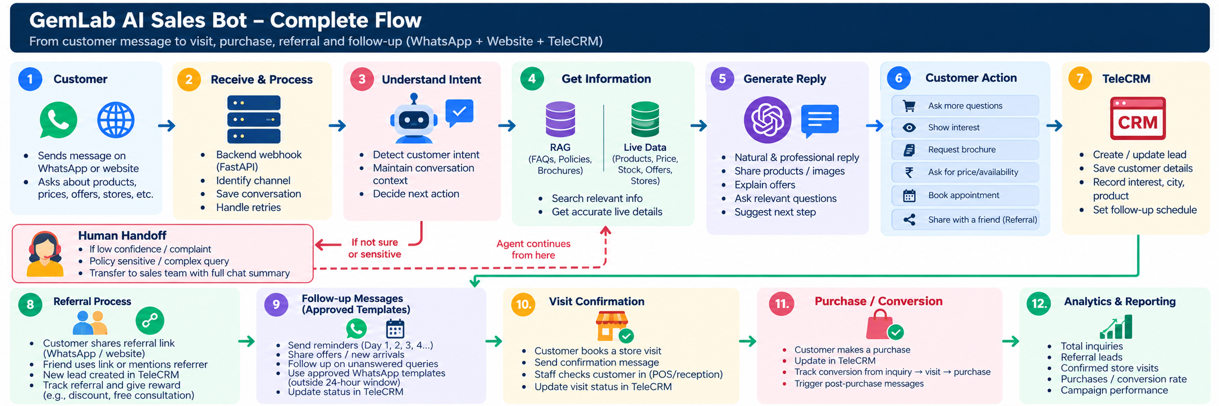
Figure 2. The customer workflow: the assistant responds in the original channel, while TeleCRM actions, template sending and follow-ups depend on verified account capabilities and customer permissions.

4. How a customer conversation works
1. Customer starts: A customer asks a question on the GemLab website or WhatsApp.
2. Understand intent: The backend identifies whether the customer needs product details, pricing, stock, an offer, a brochure, store information, a consultation, order help or a human agent.
3. Retrieve and verify: RAG retrieves approved written information. Live systems are queried for changing facts such as price, stock, current offers or appointment availability.
4. Compose a helpful answer: The AI responds in a warm, concise and professional tone, explains what is known and asks only necessary follow-up questions.
5. Offer the next step: Where relevant, the assistant can share an approved brochure, show verified store details or offer a consultation.
6. Record interest: With the appropriate permission, the system creates or updates the TeleCRM lead using supported functionality.
7. Send permitted follow-up: If a WhatsApp template is required, use an approved template and exact supported variables through the connected sending setup.
8. Confirm the result: A booking record, staff check-in or POS/CRM status update is needed to count an actual visit or purchase.

5. Example: blue sapphire enquiry
Customer | “I’m interested in blue sapphire. Is there a store near me?”
Bot | “I can help with that. Which city or PIN code should I check?”
Customer | Provides city or PIN code.
System | Looks up GemLab’s approved store directory. RAG may retrieve the approved consultation process; store distance and contact details must come from the store directory or another verified source.
Bot | Shares verified centre details and, if supported, offers to arrange a consultation.
TeleCRM | With the customer's permission, creates or updates a lead with product interest, city, source channel and consent status.
Follow-up | If a reminder is appropriate, the supported TeleCRM/WhatsApp setup sends an approved template with validated date, time, centre and other required variables.
Outcome | Booking, attendance and purchase are updated from a booking system, staff confirmation or POS/CRM event.

6. Technology stack (proposed)
The following is a practical starting point, not a claim that these components are already connected or approved.
Customer channels | GemLab website chat; WhatsApp Business Platform/Cloud API through an approved, working provider
Backend | Python + FastAPI for webhooks, orchestration, validation and integrations
Language model | Company-approved Gemini or OpenAI model, selected after quality, cost and privacy review
RAG | LangChain or a lightweight retrieval pipeline; embeddings with ChromaDB for an MVP or PostgreSQL + pgvector for production
Live business data | Existing catalogue/database or approved APIs for current price, stock, offers, store directory and booking slots
Conversation state | PostgreSQL or Redis, based on session and retention requirements
CRM and automation | TeleCRM supported API/workflows; n8n only where it adds a clear integration need
Document processing | PyMuPDF, python-docx and pandas for supported file types
Analytics | PostgreSQL plus Metabase or a company-approved dashboard
Deployment & secrets | Company-approved hosting; API keys in environment variables or a secret manager, never hard-coded

7. TeleCRM and WhatsApp template workflow
- Verify the actual TeleCRM account capabilities first: API access, authentication, lead/contact actions, workflow triggers, scheduling, template selection and delivery-status events.
- Confirm that the WhatsApp Business account/provider is active and that the required message templates are approved and available in the connected sending setup.
- Map template variables exactly as approved. For example, a template may require customer name, consultation date and centre name; the actual placeholder names and order must match the template.
- Before sending, validate consent/permission, phone number format, template availability, required variables and the intended send time.
- Log the response and message ID where available. Handle failures, rate limits, retries and duplicate events safely.
- Do not treat an API success response as proof of delivery; use provider delivery status when available.
- Keep the first release simple: the AI asks for or schedules the reminder through a supported TeleCRM workflow. Avoid creating a separate WhatsApp sender unless the architecture and permissions require it.
IMPORTANT
The exact TeleCRM endpoints, payloads and workflow actions must be checked against GemLab's actual account and documentation. The diagram describes the intended design, not verified API functionality.

8. Knowledge and safety rules
- Policies and FAQs: use only approved, current, versioned documents. Agree which source wins if documents conflict.
- Products and brochures: use approved descriptions and existing assets; do not invent product specifications, photos or claims.
- Price, stock, offers and appointment slots: retrieve from a live, authoritative source.
- Gemstone explanations: avoid guarantees or unsupported claims about outcomes; state only what approved GemLab material supports.
- Customer data: collect and retrieve only information needed for the current purpose and authorized access.
- Low confidence, complaint, sensitive issue or policy exception: clarify or hand off to an authorized person.
- Follow-up: stop when the customer opts out, the purpose is complete, or permission no longer applies.
- Auditability: retain appropriate records of sources, consent, template/message status, failures and human handoffs.

9. Required inputs from GemLab
- Current product catalogue: SKU, gemstone name, grade/specification, price, availability and approved product images.
- Approved gemstone descriptions, FAQs, policies, return/exchange terms and consultation process.
- Brochures and offers, including eligibility, effective dates and expiry dates.
- Store directory: addresses, opening hours, contact details and consultation availability.
- TeleCRM documentation and access confirmation: permitted API actions, authentication, workflow triggers and callbacks.
- WhatsApp account/provider status, template approval, messaging-window rules and consent requirements.
- Website integration permission, existing code/API details and approved deployment environment.
- Booking, staff check-in and POS/CRM outcome source—or a manual staff confirmation process for the MVP.
- Named owners for policy approval, knowledge updates, escalations and sales follow-up.

10. Phased implementation plan
Phase 1 — Knowledge foundation
Collect approved documents and catalogue data; build a read-only RAG prototype; test it against real customer FAQs.
Phase 2 — Conversation MVP
Add website chat or one approved messaging channel, session context, answer guardrails and human handoff.
Phase 3 — TeleCRM leads
Verify API/workflow access; create/update leads and record source, interest and permission.
Phase 4 — Approved templates
Add template selection, variable validation, permitted scheduling, delivery-status handling, opt-out suppression and retry protection.
Phase 5 — Store visit tracking
Connect booking/check-in/POS outcomes or establish a staff confirmation process; create a basic metrics dashboard.
Phase 6 — Controlled pilot
Start with a limited set of FAQs or stores; review answer quality, delivery failures, lead quality and staff feedback before scaling.

11. Success metrics
Customer experience | Response time; answer-quality review; resolution without human support; unresolved-question rate.
Sales pipeline | Qualified leads; consultation bookings; cost per booked visit.
Physical visits | Booked versus attended visits, confirmed by booking records or staff check-in.
Revenue outcomes | Purchases attributed to bot-assisted leads using agreed CRM/POS matching rules.
Messaging health | Template delivery/failure rate, opt-outs, complaints, duplicate sends and human handoffs.

12. Risks and dependencies to resolve early
TeleCRM capability unknown | Verify the available API, workflow actions and account permissions before committing to implementation dates.
WhatsApp access or template restriction | Confirm the account/provider is active and templates are approved before enabling outbound messages.
Incomplete or stale data | Assign an owner and review schedule to product, offer, policy and store information.
No visit-confirmation source | Agree on booking, staff check-in or POS/CRM status before reporting store-visit conversion.
Low-confidence or sensitive answers | Use explicit confidence/exception rules and a reliable human handoff route.
Privacy and security | Restrict data access, protect secrets, minimize collected data and define retention/access policies.

13. A simple explanation for senior management
HOW TO EXPLAIN IT
“We want to build a GemLab AI assistant that answers customer questions using verified company information. When information changes—like price or stock—the system checks a live source instead of guessing. The assistant then helps interested customers find a centre or arrange a consultation. With permission, it records the lead in TeleCRM and uses supported workflows to send approved WhatsApp reminders. Finally, we connect booking, staff check-in or POS data so we can measure real visits and sales. Before development, we will verify TeleCRM access, WhatsApp approvals, data availability and the visit-confirmation process.”

Appendix — illustrative end-to-end logic
- Customer message arrives → validate webhook and identify channel/session.
- Classify intent → retrieve approved RAG evidence and/or query a live business source.
- Check confidence, source freshness and policy constraints.
- If uncertain, sensitive or complaint-related → create human handoff with transcript and relevant evidence.
- Otherwise, compose and send a channel-appropriate response.
- If customer agrees to a visit or follow-up → validate permission and required fields.
- Create/update TeleCRM lead using a verified API/workflow.
- If a WhatsApp template is required → select approved template, validate variables, trigger supported send/schedule action.
- Record message status and any errors; suppress follow-up after opt-out or completion.
- Record booking, confirmed attendance and sale from the relevant source; update metrics.

Document status: Proposed architecture for discussion. Integration details, access permissions and operational processes require confirmation before implementation.

