GEMLAB | PROJECT OVERVIEW

AI Customer Experience & Store-Visit Automation
A simple guide for discussion with senior management.
GOAL: Answer customer questions, turn interest into store visits, and manage leads and follow-ups through TeleCRM.

1. What are we proposing?
Build an AI assistant for GemLab’s website and approved WhatsApp channel. It answers using company information, helps customers explore products, and guides interested buyers toward a consultation or store visit.

2. How it works
The project has two connected parts:
- RAG knowledge: finds the right information in GemLab’s approved documents.
- AI sales bot: talks to the customer, checks live product details, and connects interested customers to TeleCRM.

3. RAG — how the bot finds answers
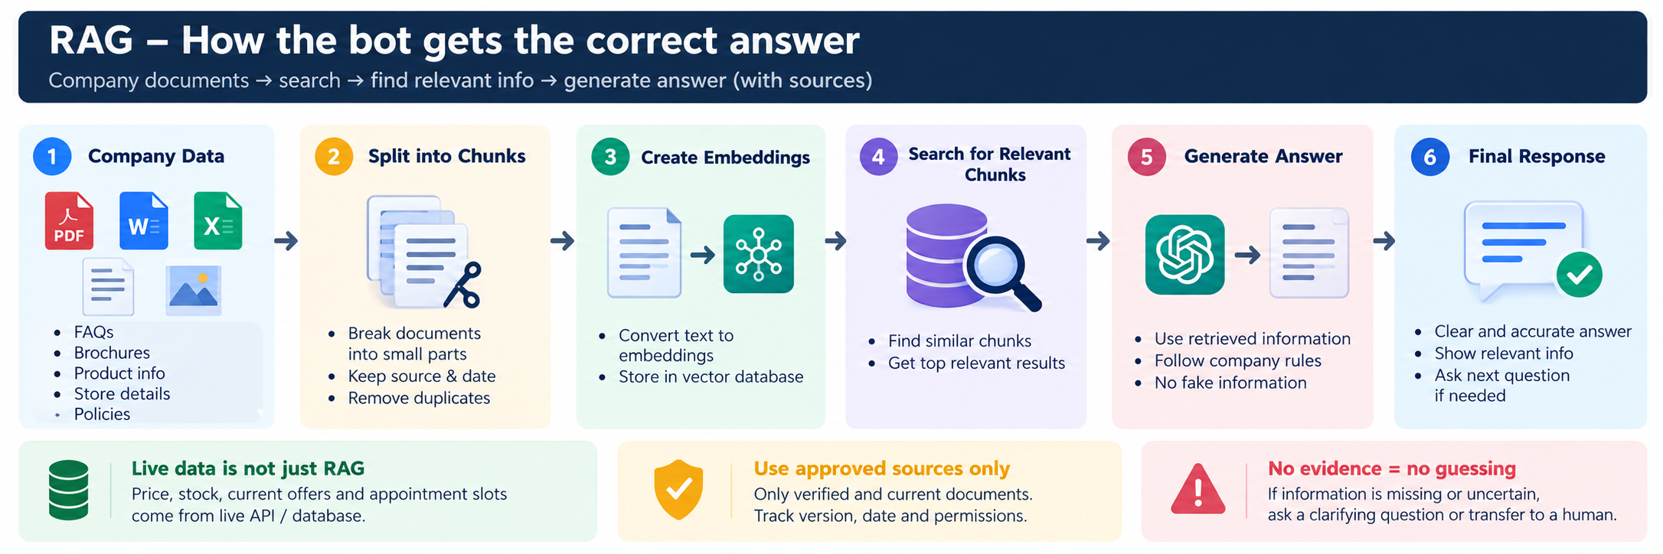
The bot searches approved GemLab information before answering. Current prices, stock and offers must come from live systems.

4. AI sales bot — from message to visit
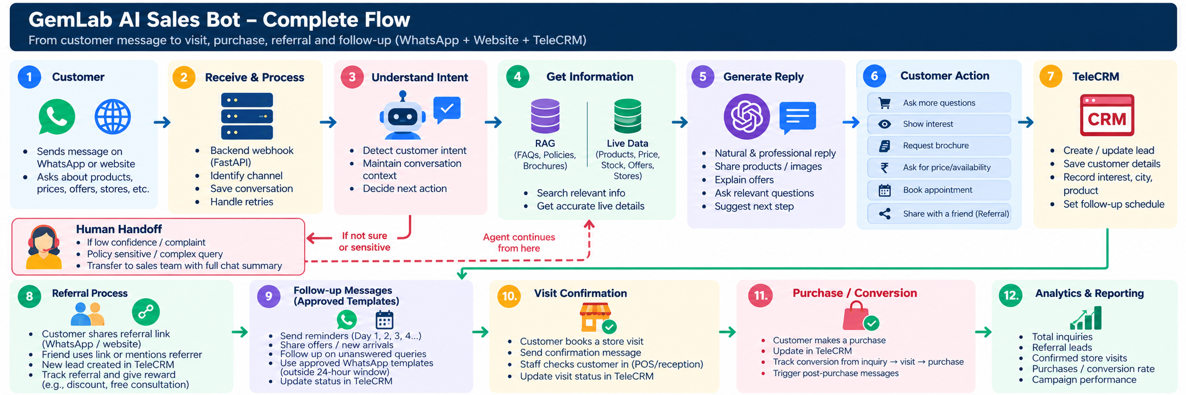
The bot answers questions, shares relevant products or brochures, records interested customers in TeleCRM, supports referrals and follow-ups, and tracks visits and purchases.

5. What the bot can do
- Answer questions about gemstones, products, policies and brochures.
- Ask simple questions to understand the customer’s needs.
- Share approved product images, brochures and offers.
- Suggest a store visit or consultation.
- With permission, create/update a TeleCRM lead and arrange an approved follow-up.
- Support a referral link and track referred leads where the system supports it.

6. Example customer journey
Customer | Asks about blue sapphire and a nearby store.
AI bot | Explains using approved information and asks for city or PIN code.
Store lookup | Checks GemLab’s verified store list and shares suitable details.
TeleCRM | With permission, saves the customer’s interest and contact details.
Follow-up | Uses a supported workflow and approved WhatsApp template if needed.
Outcome | Records a booked visit, confirmed attendance or purchase from a reliable source.

7. Referral process
- Customer shares a GemLab referral link with a friend.
- The friend asks about a product or visits the website.
- The bot answers questions and records the new lead in TeleCRM when permitted.
- GemLab tracks the referral and applies only an approved reward or offer.

8. What we need before building
- Approved product catalogue, FAQs, brochures, policies and offer details.
- Current price/stock source and verified store directory.
- Confirmation of TeleCRM API/workflow access and supported actions.
- Active WhatsApp setup and approved message templates.
- A way to confirm bookings, actual store visits and purchases.

9. Suggested build order
- Prepare and check GemLab’s information.
- Build and test RAG with common customer questions.
- Connect the bot to the website or one approved messaging channel.
- Connect TeleCRM lead updates and approved follow-up workflows.
- Add referral tracking and store-visit confirmation.
- Run a small pilot, review results, then improve.

10. How we measure success
- Qualified customer inquiries and leads.
- Appointments booked and visits actually attended.
- Purchases linked to bot-assisted leads.
- Referral leads and referral conversions.
- Answer quality, response time, failed messages and opt-outs.
Important: TeleCRM API actions, WhatsApp approvals, live data access and visit tracking must be verified before implementation. This document describes the proposed design.

