NVMe SSD Validation — Server 172.16.15.38
4 × Samsung PM9D3a • Cross-Server Comparison vs 172.16.13.217
2 × PM9D3a 960 GB M.2 + 2 × PM9D3a 15.36 TB U.2 (the same physical drives previously tested on .217)
On Tyrone MDI300 (user-Dev) — 2 × Intel Xeon 6730P (64C/128T), 1.0 TB DDR5
Prepared for: | Netweb Technologies India Ltd
Date issued: | 04 June 2026
Test platform: | 172.16.15.38 — Tyrone MDI300 (user-Dev), 2 × Intel Xeon 6730P, 1.0 TB DDR5
Campaign window: | 04 Jun 2026 06:15–06:39 UTC • fio 3.28 direct-IO, libaio, NUMA-pinned, drives run sequentially
Drives under test: | 2 × MZVL6960HFLB 960 GB M.2 + 2 × MZWL615THBLF 15.36 TB U.2 (Samsung PM9D3a)

Status: | PASS — all 4 PM9D3a drives healthy & benchmarked; 960 GB read 2× faster than on .217 (Gen4 vs Gen3 link)  ACTION — 1 × 15.36 TB drive (S7RKNG0YB01786) was found dead at idle (APST controller-down), recovered & re-validated; 960 GB still link x2-width

1. Executive Summary
Re-validation of the four Samsung PM9D3a NVMe SSDs previously tested on the MDA200A2N-224 at 172.16.13.217, now installed in server 172.16.15.38 (Tyrone MDI300, hostname user-Dev — 2 × Intel Xeon 6730P, 64C/128T, 1.0 TB DDR5). Serial numbers confirm these are the same physical drives: two 960 GB M.2 22×80 and two 15.36 TB 2.5-inch U.2 (all Samsung PM9D3a per firmware NQN). The move directly tests whether the PCIe link issues seen on .217 follow the drives or the slots. All four drives passed a NUMA-pinned fio 3.28 suite with zero media errors. One 15.36 TB drive was found dead on arrival (controller-down, APST power-state fault) and was recovered in-place via PCIe hot-rescan, then fully benchmarked.
Metric | Result on .38 | vs .217 / typical | Verdict
15.36 TB U.2 sequential read (Gen5 x4) | 12.02 / 12.48 GB/s | ≈ .217 (12.2 GB/s) | ✓ PASS
15.36 TB U.2 sequential write | 7.05 / 7.05 GB/s | ≈ .217 (7.06 GB/s) | ✓ PASS
15.36 TB 4K random read | 1,510,741 / 1,554,033 IOPS | 1.5–2.5M | ✓ PASS
960 GB M.2 sequential read | 3.76 / 3.76 GB/s | 2.0× .217 (1.87) — link fix | ✓ PASS
960 GB M.2 4K random read | 852,199 / 853,654 IOPS | 1.9× .217 (443K) | ✓ PASS
960 GB M.2 seq write / rand write | 1.62 GB/s • 395K IOPS | = .217 (NAND-bound, not link) | ✓ PASS
960 GB M.2 PCIe link | Gen4 x2 (speed up from Gen3; width still x2) | Gen4 x4 capable | ⚠ LIMITED
15.36 TB U.2 PCIe link (both) | Gen5 x4 (32 GT/s x4) | Gen5 x4 | ✓ PASS
Drive S7RKNG0YB01786 (15.36 TB) | Found dead at idle (APST); recovered; ran full load OK | needs APST fix before prod | ⚠ ACTION
SMART health (all 4) | 0 media errors • 0% wear • ≤ 46 °C | 0 / 0 (new) | ✓ PASS
Bottom line: the verdict on the .217 report's open question is clear. The 960 GB drives' sequential read doubled (1.87 → 3.76 GB/s) and random read nearly doubled (443K → 852K IOPS) simply by moving to .38 — proving the Gen3 speed cap was a .217 slot/BIOS limitation, now resolved (Gen4). However the link still trains at x2 width on both servers, so the half-width follows the drives/their wiring and still leaves ~50% of Gen4 bandwidth on the table. The 15.36 TB Gen5 drives perform identically to .217 (~12 GB/s). One 15.36 TB drive arrived dead from an APST power-state controller-down; after an in-place PCIe rescan it recovered to full Gen5 x4 and completed the entire suite under load — it is electrically sound but needs the APST mitigation before production.
2. Test Environment & Methodology
Server | Tyrone MDI300 (hostname user-Dev) at 172.16.15.38
CPU | 2 × Intel Xeon 6730P (32C/64T each = 64C/128T)
NUMA | 2 nodes — all 4 NVMe slots on node 0 (CPUs 0-31,64-95)
OS / kernel | Ubuntu 22.04.4 LTS / Linux 6.8.0-111-generic
RAM | 1.0 TiB DDR5
Benchmark tool | fio 3.28 • ioengine=libaio • direct=1 (raw block device) • numactl node0 pinning
Run strategy | Drives benchmarked sequentially (all on node 0) for clean, contention-free per-drive peaks
2.1 Drives under test (same units previously on .217)
Dev | Model (P/N) — Samsung PM9D3a | Form / capacity | Serial | PCIe link
nvme0n1 | MZVL6960HFLB-01AW7 | M.2 22×80 • 960 GB | S8CDNG0YC00174 | Gen4 x2 ⚠
nvme1n1 | MZVL6960HFLB-01AW7 | M.2 22×80 • 960 GB | S8CDNG0YC00153 | Gen4 x2 ⚠
nvme2n1 | MZWL615THBLF-00AW7 | 2.5-inch U.2 • 15.36 TB | S7RKNG0YB01786 | Gen5 x4 ✓ (recovered)
nvme3n1 | MZWL615THBLF-00AW7 | 2.5-inch U.2 • 15.36 TB | S7RKNG0YB01763 | Gen5 x4 ✓
Model designation per firmware NQN is Samsung PM9D3a for all four (the .217 report referred to the 15.36 TB units as "PM1743" — same physical drives). nvme2n1 was found in a controller-down state and recovered before testing (see §5).
2.2 Methodology — per-drive fio suite
Test | fio configuration | Purpose
Precondition + Seq write | rw=write bs=1M iodepth=32 numjobs=4 (256G/128G region) | Peak write BW; fill region for valid reads
Seq read | rw=read bs=1M iodepth=32 numjobs=4 | Peak sequential read bandwidth
Rand read / write 4K | bs=4k iodepth=128 numjobs=4, 60s time-based | 4K IOPS at QD512 (read & fresh-state write)
Mixed 70/30 | rw=randrw rwmixread=70 bs=4k iodepth=64 numjobs=4 | Blended OLTP-style workload
QD1 latency | bs=4k iodepth=1 numjobs=1 (read, then write), 30s | Single-IO service latency (avg + p99)
3. Performance Results — Server 172.16.15.38
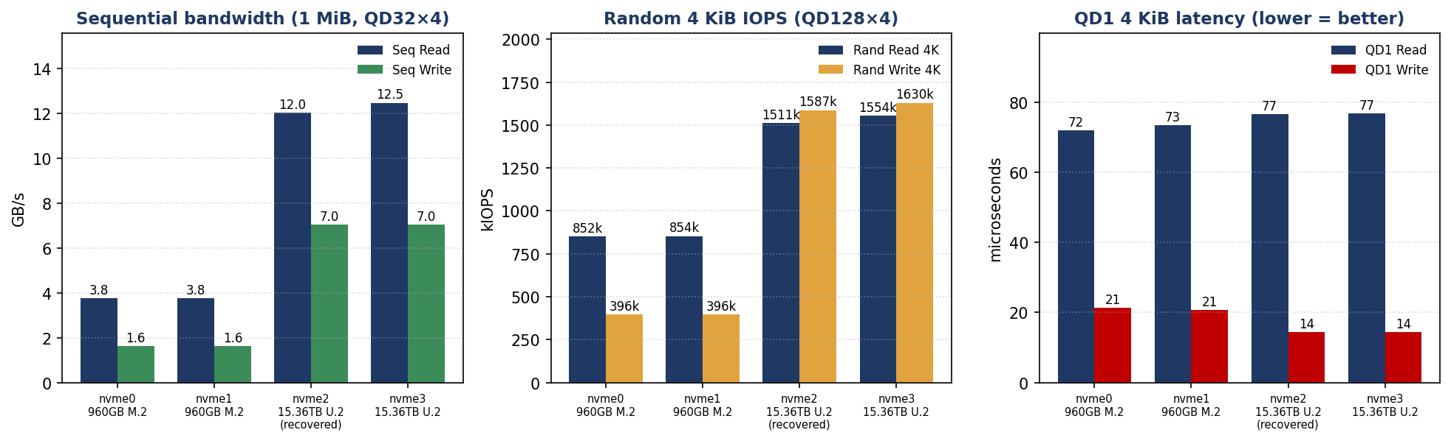
Figure 1 — Sequential bandwidth, 4K random IOPS, and QD1 latency for all four drives on .38.
3.1 Measured results — all metrics
Metric | nvme0 (960G) | nvme1 (960G) | nvme2 (15.36T)* | nvme3 (15.36T)
Seq read (GB/s) | 3.76 | 3.76 | 12.02 | 12.48
Seq write (GB/s) | 1.62 | 1.62 | 7.05 | 7.05
Rand read 4K (IOPS) | 852,199 | 853,654 | 1,510,741 | 1,554,033
Rand write 4K (IOPS) | 395,548 | 395,548 | 1,586,942 | 1,629,988
Mixed 70/30 read (IOPS) | 328,379 | 327,803 | 992,247 | 992,847
QD1 read lat (µs) | 71.9 | 73.4 | 76.6 | 76.8
QD1 write lat (µs) | 21.4 | 20.7 | 14.5 | 14.4
* nvme2n1 = the recovered drive (S7RKNG0YB01786); it performed on par with its healthy sibling nvme3n1, confirming it is electrically sound. Random-write figures are fresh-state (burst), not steady-state.
4. Cross-Server Comparison — MDA200 (.217) vs MDI300 (.38)
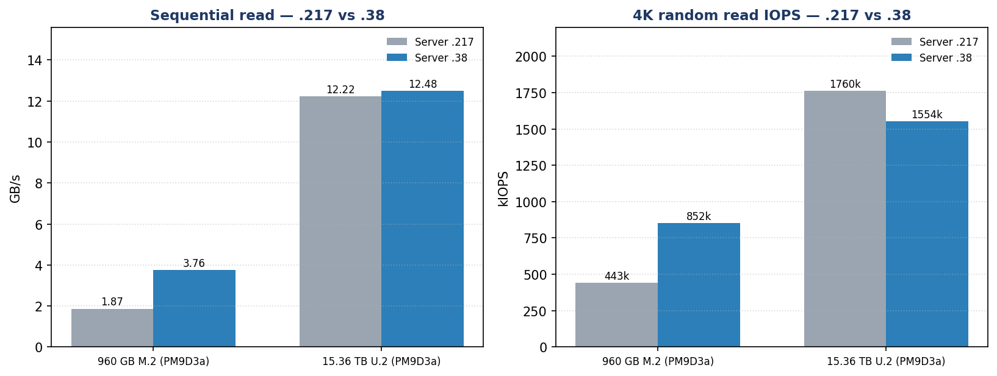
Figure 2 — Same drives, two servers (MDA200A2N-224 at .217 vs Tyrone MDI300 at .38): 960 GB read scales with the link generation; 15.36 TB Gen5 is consistent.
Metric (representative drive) | 960 GB .217 | 960 GB .38 | 15.36 TB .217 | 15.36 TB .38
Seq read (GB/s) | 1.87 | 3.76 | 12.22 | 12.48
Seq write (GB/s) | 1.62 | 1.62 | 7.06 | 7.05
Rand read 4K (IOPS) | 443,237 | 852,199 | 1,760,240 | 1,554,033
PCIe link negotiated | Gen3 x2 | Gen4 x2 | Gen5 x4 | Gen5 x4
What the move proves: the 960 GB drives' read throughput doubled (1.87 → 3.76 GB/s, 443K → 852K IOPS) purely because the MDI300 (.38) trains the link at Gen4 (16 GT/s) where the MDA200 (.217) was stuck at Gen3 (8 GT/s) — confirming the speed cap was a .217 platform/slot fault, not the drives. But both servers negotiate only x2 lane width on these M.2 units, so they still deliver ~half of a true Gen4 x4 link (~3.9 vs ~7.0 GB/s achievable). Notably, 960 GB sequential write (1.62 GB/s) and random write (395K IOPS) are identical on both servers — these are NAND-write-bound on this drive class, not link-bound, so they do not improve with the faster link. The 15.36 TB Gen5 drives are within run-variance across the two platforms (~12 GB/s read, 7 GB/s write).
5. PCIe Link, Health & the Recovered Drive
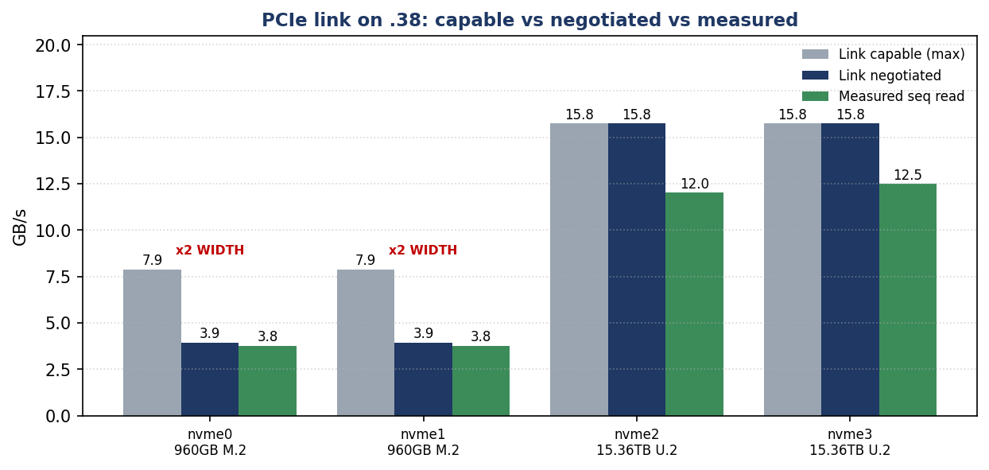
Figure 3 — PCIe link on .38: 960 GB M.2 capped at Gen4 x2 (half width); 15.36 TB U.2 at full Gen5 x4.
5.1 PCIe link & SMART health
Drive | Negotiated link | Temp pre→post | Wear | Media err | Health
nvme0n1 (960 GB) | Gen4 x2 ⚠ | 35→41 °C | 0% | 0 | ✓ CLEAN
nvme1n1 (960 GB) | Gen4 x2 ⚠ | 38→46 °C | 0% | 0 | ✓ CLEAN
nvme2n1 (15.36 TB, recovered) | Gen5 x4 ✓ | 35→45 °C | 0% | 0 | ✓ CLEAN
nvme3n1 (15.36 TB) | Gen5 x4 ✓ | 34→43 °C | 0% | 0 | ✓ CLEAN
No thermal throttling (peak 46 °C). All four report 0 media errors and 0% endurance used.
5.2 The dead-and-recovered drive (S7RKNG0YB01786)
- Found dead on arrival: the kernel reported the controller down with CSTS=0xffffffff and PCI_STATUS=0x10 (device dropped off the PCIe bus) ~99 min after boot; an automatic reset failed (-19) and the device was disabled — it showed 0.00 B capacity in nvme list.
- Root cause — APST power-state bug: the kernel explicitly flagged a faulty power-saving mode and recommended nvme_core.default_ps_max_latency_us=0 / pcie_aspm=off. The fault triggered at idle, not under load.
- Recovered in place: a PCIe hot remove + bus rescan re-enumerated the controller; it came back at full Gen5 x4 and passed the entire fio suite (12.0 GB/s read, 1.5M IOPS) with no further drops — confirming the NAND/controller is healthy.
- Risk: without the APST mitigation it can drop again at idle. APST control via nvme set-feature is not exposed on this PM9D3a firmware, so the fix must be applied at the kernel/boot level.
6. Findings & Recommendations
6.1 What the validation proves
- All four PM9D3a drives are healthy and performant: 0 media errors, 0% wear, clean thermals; the 15.36 TB U.2 pair delivers full Gen5 x4 (~12 GB/s read, 7 GB/s write, ~1.5M IOPS).
- The .217 Gen3 cap was a slot fault, now resolved: the 960 GB drives read 2× faster on .38 (Gen4 vs Gen3). Their write path is NAND-bound (~1.62 GB/s) and unchanged by the faster link.
- The x2 lane-width limit follows the drives: both servers train these M.2 units at x2, leaving ~50% of Gen4 x4 bandwidth unused.
- Drive S7RKNG0YB01786 has an APST idle-stability defect: electrically sound under load, but drops off the bus at idle until power-state transitions are disabled.
6.2 Recommended next steps
- Apply the APST mitigation (priority). Boot .38 with nvme_core.default_ps_max_latency_us=0 pcie_aspm=off pcie_port_pm=off (GRUB), or update the PM9D3a firmware, then soak S7RKNG0YB01786 at idle for several hours to confirm it no longer drops. Do not deploy this drive until verified.
- Unlock x4 width for the 960 GB M.2 drives. Move them to M.2 slots wired x4 (or check board lane bifurcation); a true Gen4 x4 link should roughly double sequential read again to ~7 GB/s.
- Consider 4K LBA format. All drives are 512-byte; reformat the PM9D3a units to 4096-byte LBA before deployment for best efficiency.
- Monitor in production. Enable smartd/nvme-cli alerting for temperature, media errors, and controller-down events.
Final Conclusion
Device | Outcome
2 × PM9D3a 15.36 TB U.2 (nvme3 + recovered nvme2) | PASS — full Gen5 x4 performance & health. nvme2 (S7RKNG0YB01786) requires the APST fix before production.
2 × PM9D3a 960 GB M.2 (nvme0/1) | PASS — healthy; read 2× faster than .217 (Gen4 link). Still x2 width — move to an x4 slot to double read again.

