25G NIC Bonding – Validation & Performance Test Report
Server A (172.16.12.131) ↔ Server B (172.16.13.108)
Prepared by: Shailendra Rajput | Date: 28 May 2026

1. Test Objective
Purpose | Validate and benchmark dual-port 25G NIC performance with and without NIC bonding (link aggregation) between two servers.
Test Focus | Throughput and latency of a single 25G link vs a two-link bond, and comparison of Linux bonding modes.

2. Common Test Environment
Operating System | Ubuntu 22.04.4 LTS
Kernel | 5.15.0 (Server A: -179-generic, Server B: -94-generic)
Test Tools | iperf3 3.9 (throughput), qperf (latency), ethtool, ping
NIC Under Test | Broadcom BCM57414 NetXtreme-E, dual-port 25GbE (driver bnxt_en)
Optics / Cable | SFP28 25G-SR fibre (Cisco-OEM); direct back-to-back (no switch)
Link Tuning | MTU 9000 (jumbo), RX/TX rings 2047, flow control ON, NUMA-pinned iperf3
Topology | Two 25G links per server bonded; direct server-to-server fibre
Test Date | 28 May 2026

3. Server A – System Under Test
Management IP | 172.16.12.131
CPU | AMD EPYC 9124 (2 sockets, 16-core, 64 threads)
Memory | 251 GiB
Role | Kubernetes node (Calico overlay) – production
Management NIC | enp33s0f0 (1 GbE, igb) – not under test
25G NIC 1 | Broadcom BCM57414 @ PCIe 0000:81:00 – x4 link (31.5 Gb/s)
25G NIC 2 | Broadcom BCM57414 @ PCIe 0000:c1:00 – x8 link (63 Gb/s)

4. Server B – System Under Test
Management IP | 172.16.13.108
CPU | AMD EPYC 9745 (2 sockets, 128-core, 512 threads)
Memory | 1.5 TiB
Management NIC | enp84s0f1 (1 GbE, igb) – not under test
25G NIC 1 | Broadcom BCM57414 @ PCIe 0000:61:00 – x8 link (63 Gb/s)
25G NIC 2 | Broadcom BCM57414 @ PCIe 0000:91:00 – x8 link (63 Gb/s)

5. Test Methodology
- Each 25G port was linked back-to-back over fibre and verified at 25 Gb/s with jumbo frames (0% loss at 8972-byte DF ping).
- Baseline measured on a single 25G link (no bond), both directions, with 1 and 8 parallel TCP streams.
- Bond configured via Linux iproute2 (non-persistent) across two 25G ports per server. Modes tested: balance-rr (mode 0) and balance-xor (mode 2, layer3+4 hash).
- Throughput taken from iperf3 sender bitrate; latency from qperf (TCP/UDP) and ICMP ping; TCP retransmissions recorded as a link-quality indicator.

6. Results – Baseline (Single 25G Link, No Bond)
Test Case | Streams | Throughput | Retransmits
Single link A → B | 1 | 16.9 Gbit/s | 0
Single link A → B | 8 | 17.5 Gbit/s | ~14
Single link B → A | 8 | 24.2 Gbit/s | 0
Two links simultaneously (independent) | 8 + 8 | 32.0 Gbit/s (sum) | low
qperf single-stream A→B = 17.3 Gbit/s (confirms iperf3). Clean, near-zero loss with jumbo frames.

7. Results – Bond Mode: balance-rr (mode 0)
Test Case | Streams | Throughput | Retransmits
Bond A → B | 1 | 16.0 Gbit/s | 63
Bond A → B | 8 | 17.4 Gbit/s | 17
Bond B → A | 1 | 19.9 Gbit/s | 41,004
Bond B → A | 8 | 25.5 Gbit/s | 4,373
Round-robin striping causes severe packet reordering (tens of thousands of retransmissions) and no aggregation benefit. Not suitable for TCP.

8. Results – Bond Mode: balance-xor (mode 2, layer3+4)
Test Case | Streams | Throughput | Retransmits
Bond A → B | 1 | 16.9 Gbit/s | 0
Bond A → B | 8 | 18.1 Gbit/s | 7
Bond A → B | 16 | 22.2 Gbit/s | 1
Bond B → A | 8 | 15.2 Gbit/s | 32,212
Bond B → A | 16 | 9.9 Gbit/s | 21,370
A→B aggregates cleanly up to ~22 Gbit/s with many flows. B→A degrades because both of Server A's bonded ports share a single PCIe x4 slot (31.5 Gb/s), causing receive-side packet loss.

9. Latency
Metric | No Bond | Bond (balance-xor)
TCP latency (qperf, one-way) | 18 µs | 24 µs
UDP latency (qperf, one-way) | 19 µs | 22 µs
ICMP round-trip (ping) | 0.45 ms | 0.52 ms

10. Throughput Comparison
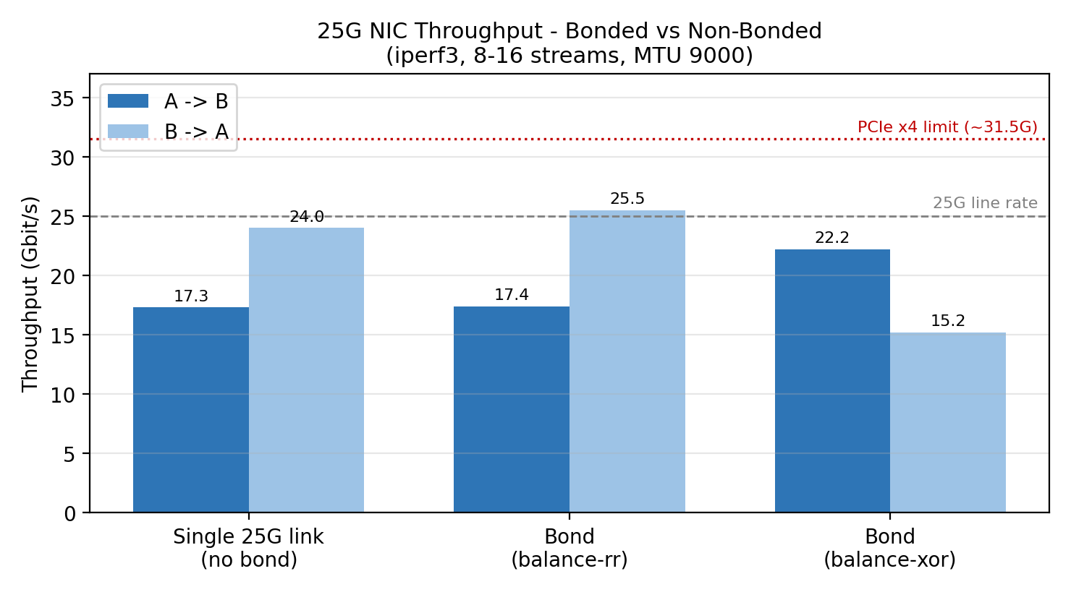
Figure 1 – Peak observed throughput by configuration and direction (iperf3, MTU 9000).

11. Key Findings
- A single 25G link is healthy: ~24 Gbit/s (B→A), ~17 Gbit/s (A→B), ~18 µs latency, near-zero loss with jumbo frames.
- Directional asymmetry: A→B consistently ~17 Gbit/s vs B→A ~24 Gbit/s per link (receive-path / CPU contention on the busy Kubernetes node A).
- Bonding did not cleanly double throughput, due to two host constraints: (a) one of Server A's 25G cards is in a PCIe x4 slot (31.5 Gb/s), and the only stable two-link bond forced both A ports onto that card – capping aggregate ~31G and causing RX loss on B→A; (b) several inter-server fibre links were marginal/unidirectional, forcing a sub-optimal port pairing (RS-FEC off, mixed optics).
- balance-rr (round-robin) is unsuitable for TCP – heavy reordering and tens of thousands of retransmissions with no real gain.
- Repeated bond reconfiguration stressed the bnxt driver and briefly hung Server B's network stack (self-recovered, no reboot).

12. Recommendations
- Move Server A's 25G card from the PCIe x4 slot into an x8 slot (or bond one port per card across two x8 cards) – the single biggest blocker to real 2×25G aggregation.
- Use matching 25G-SR optics on both ends of every link, clean/reseat the LC connectors, and enable RS-FEC (ethtool --set-fec <dev> encoding rs).
- For production bonding, prefer 802.3ad (LACP) via a switch over back-to-back, and persist the configuration in netplan once links are stable.
- Use balance-xor or 802.3ad (flow hashing) for TCP – never balance-rr.
- Expected after the above: ~45–48 Gbit/s multi-flow aggregate on a 2×25G bond.

13. Final Conclusion
NIC Health | Both 25G NICs link at 25 Gb/s; jumbo frames stable, 0% packet loss
Single-Link Performance | PASS – up to ~24 Gbit/s, ~18 µs latency
Bonding (functional) | PASS – bond forms and carries traffic in both modes
Bonding (aggregation) | LIMITED – capped by host PCIe x4 slot and marginal optics (not a NIC fault)
Recommended Mode | balance-xor / 802.3ad (layer3+4); avoid balance-rr
Final Status | PASS WITH PLATFORM LIMITATIONS

14. Document Control
Prepared By | Shailendra Rajput
Date | 28 May 2026
Document | 25G NIC Bonding – Validation & Performance Test Report
Classification | Confidential

