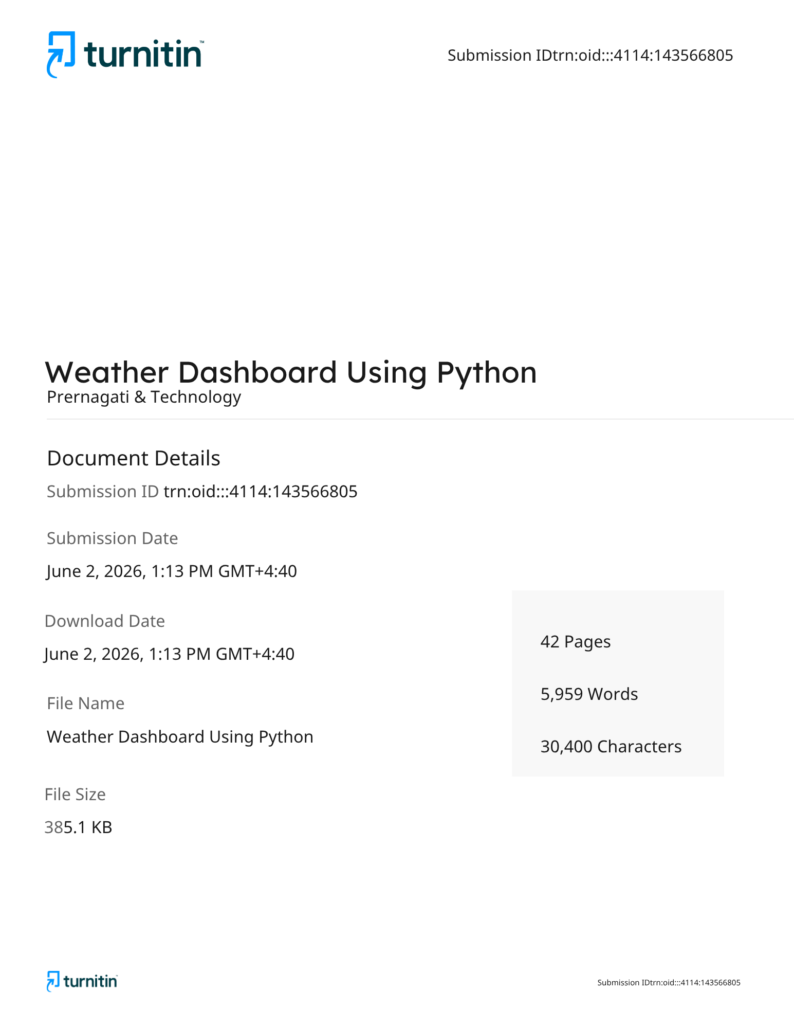
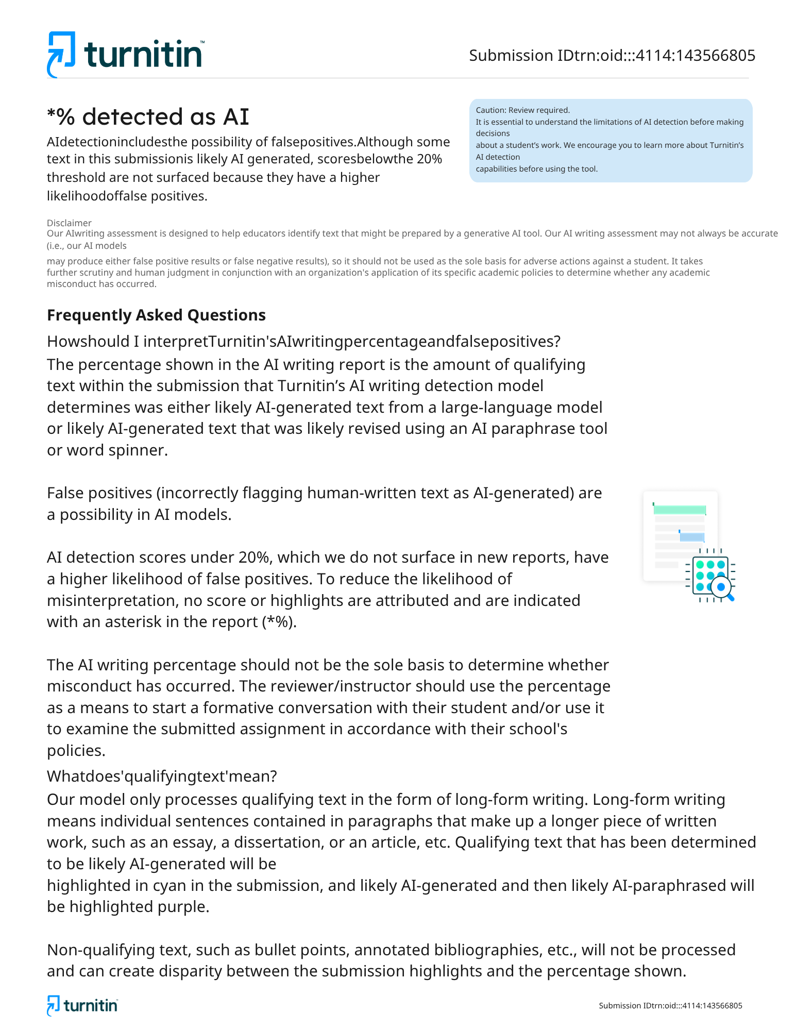

TRAINING REPORT
ON
“…………………….”

SUBMITTED TO SCHOOL OF MANAGEMENT,
BAHRA UNIVERSITY, SHIMLA HILLS FOR THE
DEGREE OF BACHELOR OF BUSINESS ADMINISTRATION
FOR THE SESSION ------------


SUBMITTED BY: SUPERVISED BY:
STUDENT NAME: …………… NAME OF GUIDE: ……………….
ROLL NO. ………………….. WITH DESIGNATION
CLASS. ………

SUBMITTED TO
NAME OF REPORT CORDINATOR WITH DESIGNATION

SCHOOL OF MANAGEMENT
BAHRA UNIVERSITY, SHIMLA HILLS
Year 2026

COMPANY CERTIFICATE

DECLARATION

I …………………, hereby declare that the project report entitled "…………………………
…………………………………" submitted as a part of my Industrial Training/Internship at PGTech Solutions is an original work carried out by me under the guidance and supervision of the organization.
I further declare that this report has not been submitted, either wholly or partly, to any other university, institution, or organization for the award of any degree, diploma, certificate, or any other academic qualification.
The information, data, observations, and knowledge presented in this report have been collected during my training period at PGTech Solutions. Wherever reference has been made to the work of others, appropriate acknowledgment has been given in the References/Bibliography section.
I take full responsibility for the authenticity and originality of the contents of this report.
Student Name: ………………….
Course: ………………….
University/College: ………………………………..
Training Organization: PGTech Solutions
Project Title: …………………………………………
Training Duration: …………………….
Date: …………………
Student's Signature: ___________________________

ACKNOWLEDGEMENT

I would like to express my sincere gratitude to PGTech Solutions for providing me with the opportunity to undergo Industrial Training and gain practical knowledge in the field of Python with Artificial Intelligence (AI) and Machine Learning (ML). This training has been an invaluable learning experience that has enhanced my understanding of Python programming, AI concepts, Machine Learning techniques, and their implementation in real-world applications.
I am deeply thankful to the management of PGTech Solutions for providing a supportive, professional, and motivating workplace where I was able to learn about various concepts such as Python programming fundamentals, data structures, object-oriented programming, data preprocessing, data analysis, machine learning algorithms, model training and evaluation, data visualization, AI applications, project development, and other essential technologies related to Artificial Intelligence and Machine Learning.
I would like to express my heartfelt appreciation to my training mentor, supervisors, and all the staff members at PGTech Solutions for their continuous guidance, encouragement, and valuable suggestions throughout my training period. Their knowledge, patience, and willingness to share practical experiences helped me understand the practical implementation of Python, AI, and Machine Learning concepts while enhancing my technical, analytical, and problem-solving skills.
I am also grateful to my college faculty members and project guide for their constant support, valuable advice, and constructive feedback during the preparation of this project report. Their encouragement motivated me to complete this report successfully and present it in a professional manner.
I sincerely thank my parents and family members for their continuous encouragement, moral support, and motivation throughout my academic journey and training period. Their belief in me has always inspired me to perform my best.
Finally, I would like to thank all those individuals who directly or indirectly contributed to the successful completion of my Industrial Training and this project report. Their support and cooperation have been greatly appreciated.
This project has provided me with practical exposure to Python Programming, Artificial Intelligence, and Machine Learning and has strengthened my technical knowledge, programming skills, analytical thinking, communication skills, teamwork, and understanding of the professional software development environment. I believe the experience and learning gained during this training will be highly beneficial for my future career.

EXECUTIVE SUMMARY
The Industrial Training at PGTech Solutions provided an excellent opportunity to gain practical knowledge and real-world experience in the field of Python Programming, Artificial Intelligence (AI), and Machine Learning (ML). The internship was designed to bridge the gap between academic learning and industry practices by providing hands-on exposure to Python programming, AI concepts, Machine Learning algorithms, data analysis, and real-world project development. During the training period, I actively participated in various technical tasks, worked on practical assignments and projects, observed software development processes, and learned how AI and Machine Learning technologies are applied to solve real-world problems.
This report presents a comprehensive overview of the organization, the responsibilities performed during the internship, the knowledge gained, and the technical as well as professional skills developed throughout the training period. The internship not only enhanced my understanding of Python Programming, Artificial Intelligence, and Machine Learning but also improved my programming abilities, logical thinking, analytical skills, problem-solving capabilities, communication skills, teamwork, and understanding of the software development lifecycle.

1. Overview of the Organization
PGTech Solutions is a professional organization that provides quality services in the fields of Information Technology (IT), Industrial Training, Software Development, Web Development, Mobile Application Development, Python Programming, Artificial Intelligence (AI), Machine Learning (ML), Data Science, Cloud Technologies, Digital Marketing, Graphic Designing, UI/UX Design, and Career Development Programs. The company focuses on providing practical learning experiences, live projects, and industry-oriented training that prepare students and professionals for successful careers.
The organization follows a professional work culture that encourages innovation, teamwork, continuous learning, and skill development. It provides students and interns with opportunities to work on real-world software projects while learning from experienced professionals and industry experts.
The Python with AI & ML Training Department at PGTech Solutions plays an important role in developing programming skills, teaching Artificial Intelligence concepts, implementing Machine Learning algorithms, working with real datasets, building intelligent applications, and providing practical exposure to modern software development technologies.
The company believes that continuous learning and technical innovation are essential for career growth and works toward creating a positive learning environment where students can enhance their programming knowledge, analytical thinking, and problem-solving abilities.

2. Internship Role
During my internship at PGTech Solutions, I worked as a Python with AI & ML Intern and gained practical exposure to Python programming, Artificial Intelligence, and Machine Learning technologies. The internship allowed me to understand how software applications are designed, developed, tested, and implemented using modern programming techniques and AI technologies.
My major responsibilities during the internship included:
- Understanding Python programming fundamentals.
- Learning data structures and object-oriented programming concepts.
- Writing and debugging Python programs.
- Working with Python libraries and modules.
- Understanding data preprocessing and data cleaning techniques.
- Learning data visualization using Python libraries.
- Working with Machine Learning algorithms.
- Building and testing Machine Learning models.
- Understanding supervised and unsupervised learning techniques.
- Learning model evaluation and performance optimization.
- Developing AI-based mini projects.
- Understanding real-world applications of Artificial Intelligence.
- Maintaining project documentation and coding standards.
- Participating in project discussions and team collaboration.
- Learning software development best practices.
The internship provided valuable exposure to real-world software development practices and helped me understand how Python, Artificial Intelligence, and Machine Learning technologies work together to solve practical business problems.

3. Key Learning Outcomes
The internship at PGTech Solutions significantly enhanced my knowledge of Python Programming, Artificial Intelligence, and Machine Learning by providing practical exposure to industry-oriented projects and software development practices.
The major learning outcomes include:
Python Programming
I gained a comprehensive understanding of Python programming concepts, including variables, data types, loops, functions, object-oriented programming, file handling, exception handling, and modules.
Artificial Intelligence
I learned the fundamentals of Artificial Intelligence and understood how intelligent systems are designed to solve real-world problems using data-driven approaches.
Machine Learning
I gained practical knowledge of Machine Learning concepts, including supervised learning, unsupervised learning, classification, regression, clustering, and predictive modeling.
Data Preprocessing
I learned how to collect, clean, transform, and prepare datasets before training Machine Learning models to improve accuracy and performance.
Data Visualization
I understood how to represent data using graphs and charts for better analysis and decision-making through Python visualization libraries
Model Development
I learned how Machine Learning models are trained, tested, evaluated, and optimized using different algorithms and performance metrics.
Project Development
The internship provided hands-on experience in developing Python-based applications and AI-powered projects using real-world datasets and programming techniques.
Software Development Practices
I understood coding standards, debugging techniques, version control concepts, project documentation, and collaborative software development practices.
Problem Solving
The internship improved my logical thinking, analytical abilities, and programming skills by solving coding challenges and implementing practical solutions.
Practical Exposure
The internship provided practical experience beyond classroom learning by allowing me to work on real-time projects involving Python, Artificial Intelligence, and Machine Learning technologies.

4. Skills Acquired During the Internship
The internship helped me develop several technical, interpersonal, and professional skills that will be valuable in my future career.
Technical Skills
- Python Programming.
- Object-Oriented Programming (OOP).
- Data Structures and Algorithms.
- Data Analysis.
- Data Preprocessing.
- Machine Learning Algorithms.
- Artificial Intelligence Concepts.
- Model Training and Evaluation.
- Data Visualization.
- Project Development.
- Debugging and Code Optimization.
- Software Development Fundamentals.
Communication Skills
During the internship, I improved my communication skills by interacting with mentors, trainers, and team members while discussing technical concepts and project requirements.
The internship helped me develop:
- Professional communication.
- Technical documentation.
- Email writing.
- Presentation skills.
- Active listening.
- Team discussions.

Interpersonal Skills
Working in a professional environment improved my interpersonal abilities.
These include:
- Teamwork.
- Collaboration.
- Knowledge sharing.
- Professional behavior.
- Adaptability.
- Positive attitude.

Organizational Skills
The internship improved my ability to organize and manage technical tasks efficiently.
These skills include:
- Time management.
- Project planning.
- Documentation.
- Task prioritization.
- Coding organization.
- Project management.

Problem-Solving Skills
I learned how software developers identify technical challenges and develop practical programming solutions.
Examples include:
- Debugging Python programs.
- Handling coding errors.
- Improving model accuracy.
- Data preprocessing challenges.
- Algorithm optimization.
- Logical problem solving.

Professional Skills
The internship also helped me develop important workplace competencies such as:
- Discipline.
- Responsibility.
- Continuous learning.
- Decision-making.
- Leadership qualities.
- Adaptability.
- Professional ethics.
- Analytical thinking.
- Critical thinking.
- Confidence.

Overall Internship Experience
The Industrial Training at PGTech Solutions was an enriching learning experience that combined theoretical knowledge with practical application. It enhanced my understanding of Python Programming, Artificial Intelligence, Machine Learning, software development practices, and real-world project implementation. Working alongside experienced professionals allowed me to develop confidence, strengthen my programming and analytical skills, improve my communication abilities, and understand the importance of teamwork, innovation, and professional ethics in the IT industry.
The internship has prepared me for future career opportunities by providing practical exposure to Python, Artificial Intelligence, and Machine Learning technologies while helping me build a strong technical foundation for a successful career in software development and emerging technologies.

INDEX
- Introduction to Python
- Python Fundamentals
- Object-Oriented Programming (OOP)
- Python Libraries for AI and Machine Learning
- Data Analysis with NumPy & Pandas
- Data Visualization
- Machine Learning Basics
- Artificial Intelligence Concepts
- Deep Learning & Neural Networks
- AI & ML Projects, Future Scope and Career Opportunities
- Introduction Weather Dashboard Using Python
- Literature Review
- Problem Statement and Objectives
- System Analysis and Requirements
- System Design
- Technologies Used
- Implementation
- Testing
- Results and Output
- Features, Advantages, Limitations and Applications
- Future Enhancements
- Conclusion

Introduction to Python
Python is a high-level, interpreted programming language known for its simple syntax and readability. It is one of the most popular programming languages used for web development, automation, data science, artificial intelligence, and machine learning.
Python was created by Guido van Rossum and released in 1991. Today, it is widely used by companies such as Google, Microsoft, Netflix, Amazon, Meta, and OpenAI.
Features of Python
- Easy to Learn
- Simple Syntax
- Open Source
- Cross Platform
- Object-Oriented
- Large Community Support
- Extensive Libraries
- Fast Development
Applications
- AI & Machine Learning
- Data Science
- Web Development
- Automation
- Game Development
- Desktop Applications
- Cyber Security

2 – Python Fundamentals
Python Fundamentals
Python fundamentals are the building blocks of programming.
Topics Covered
Variables
Variables store data values.
Example:
name = "John"
age = 22
Data Types
- Integer
- Float
- String
- Boolean
- List
- Tuple
- Dictionary
- Set
Operators
- Arithmetic
- Comparison
- Logical
- Assignment
Conditional Statements
- if
- else
- elif
Loops
- for loop
- while loop
Functions
Functions help reuse code.
Example
def add(a,b):
return a+b

3 – Object-Oriented Programming (OOP)
Object-Oriented Programming
OOP organizes programs using objects and classes.
Main Concepts
Class
Blueprint of an object.
Object
Instance of a class.
Encapsulation
Wrapping data and methods together.
Inheritance
One class inherits another class.
Polymorphism
Same function behaves differently.
Abstraction
Hide unnecessary implementation details.
Benefits
- Code Reusability
- Easy Maintenance
- Better Security
- Organized Code

4 – Python Libraries for AI & ML
Python Libraries
Python provides powerful libraries for Artificial Intelligence and Machine Learning.
NumPy
Numerical Computing
Pandas
Data Analysis
Matplotlib
Graphs
Seaborn
Statistical Visualization
Scikit-learn
Machine Learning
TensorFlow
Deep Learning
Keras
Neural Networks
PyTorch
Research & AI Models
OpenCV
Computer Vision
NLTK
Natural Language Processing

5 – Data Analysis with NumPy & Pandas
Data Analysis
Data analysis is the process of collecting, cleaning, and analyzing data.
NumPy Features
- Arrays
- Mathematical Operations
- Matrix Operations
- Random Numbers
Pandas Features
- DataFrames
- Data Cleaning
- Missing Values
- Data Filtering
- Data Sorting
- CSV Reading
- Excel Reading
Importance
- Better Decision Making
- Faster Processing
- Real-world Analysis

Data Visualization
Data Visualization
Visualization helps understand data using charts and graphs.
Libraries
- Matplotlib
- Seaborn
- Plotly
Types of Charts
- Line Chart
- Bar Chart
- Pie Chart
- Histogram
- Scatter Plot
- Heatmap
Benefits
- Easy Analysis
- Better Insights
- Trend Identification
- Business Reports

7 – Machine Learning Basics
Machine Learning
Machine Learning is a branch of Artificial Intelligence where computers learn from data without explicit programming.
Types
Supervised Learning
Uses labeled data.
Examples:
- Spam Detection
- Price Prediction
Unsupervised Learning
Uses unlabeled data.
Examples:
- Customer Segmentation
- Clustering
Reinforcement Learning
Learning by rewards and penalties.
Example:
- Robotics
- Self-driving Cars
ML Workflow
- Data Collection
- Data Cleaning
- Feature Engineering
- Model Training
- Testing
- Prediction

8 – Artificial Intelligence Concepts
Artificial Intelligence
Artificial Intelligence enables machines to simulate human intelligence.
AI Domains
- Expert Systems
- Computer Vision
- Robotics
- Natural Language Processing
- Speech Recognition
Applications
- Chatbots
- Healthcare
- Banking
- Education
- Agriculture
- E-commerce
- Autonomous Vehicles
Advantages
- Automation
- Accuracy
- Speed
- Better Decisions
Challenges
- Data Privacy
- Bias
- Security
- High Cost

9 – Deep Learning & Neural Networks
Deep Learning
Deep Learning is an advanced form of Machine Learning based on Artificial Neural Networks.
Components
- Input Layer
- Hidden Layer
- Output Layer
Popular Frameworks
- TensorFlow
- Keras
- PyTorch
Applications
- Face Recognition
- Voice Assistant
- Medical Diagnosis
- Image Classification
- Self-driving Cars
- Recommendation Systems
Benefits
- High Accuracy
- Automatic Feature Learning
- Large-scale Data Processing

10. AI & ML Projects, Future Scope and Career Opportunities
AI & Machine Learning Future
Artificial Intelligence and Machine Learning are among the fastest-growing technologies worldwide.
Mini Projects
- Face Detection System
- Chatbot
- Weather Prediction
- House Price Prediction
- Handwritten Digit Recognition
- Sentiment Analysis
- Movie Recommendation
- Image Classifier
Career Opportunities
- Python Developer
- AI Engineer
- Machine Learning Engineer
- Data Scientist
- Data Analyst
- NLP Engineer
- Computer Vision Engineer
- Robotics Engineer
- Deep Learning Engineer
- AI Research Scientist
Future Scope
AI and ML are transforming every industry, including healthcare, finance, education, manufacturing, cybersecurity, and entertainment. With continuous advancements in automation, generative AI, and robotics, skilled professionals in Python, AI, and Machine Learning will remain in high demand globally.

CHAPTER 1: INTRODUCTION
1.1 Background
Weather has always been one of the most significant factors influencing human decisions, from agriculture and aviation to daily commuting and tourism. In earlier times, people relied on newspapers, television bulletins, or radio broadcasts to obtain weather updates. With the growth of the internet and the availability of public web services, it has become possible to access weather data programmatically through Application Programming Interfaces (APIs). This shift has enabled developers to build custom applications that fetch live weather data and present it in a form tailored to the user's needs.
The Weather Dashboard Using Python is one such application. It is a real-time weather monitoring tool that allows a user to type in the name of any city and instantly receive up-to-date information about that location's weather conditions, including temperature, humidity, wind speed, and a general description such as “clear sky” or “light rain.”
1.2 Motivation
The motivation behind this project stems from the need for quick and reliable access to weather information without having to navigate through multiple websites or mobile applications that are often cluttered with advertisements. Additionally, as a beginner-level project, the Weather Dashboard offers an excellent opportunity to learn foundational concepts in Python programming, including working with external libraries, handling network requests, processing structured data formats such as JSON, and following secure coding practices such as keeping credentials outside of the source code.
1.3 Project Overview
The application is developed entirely in Python and communicates with a public Weather API over HTTPS. When the user enters a city name, the program constructs a request URL, sends an HTTP GET request using the Requests library, and receives a JSON-formatted response from the server. This response is then parsed to extract relevant fields, and the extracted data is displayed to the user in a clear and organised manner on the console.
The project also demonstrates the use of the python-dotenv package to manage the API key as an environment variable, which is considered a best practice in software development because it prevents sensitive credentials from being exposed in version control systems such as Git.
1.4 Organisation of the Report
This report is organised into twelve chapters. Chapter 1 introduces the project. Chapter 2 reviews existing literature and related work. Chapter 3 defines the problem statement and objectives. Chapter 4 covers system analysis and feasibility study along with hardware and software requirements. Chapter 5 presents the system design, including architecture and data flow diagrams. Chapter 6 details the technologies used. Chapter 7 explains the implementation with code snippets. Chapter 8 describes the testing methodology and test cases. Chapter 9 presents the results and sample outputs. Chapter 10 discusses advantages, limitations, and applications. Chapter 11 outlines future enhancements, and Chapter 12 concludes the report, followed by references and an appendix containing the complete source code.
CHAPTER 2: LITERATURE REVIEW
2.1 Existing Weather Applications
Numerous weather applications exist in the market today, ranging from built-in mobile operating system widgets to dedicated applications such as AccuWeather, The Weather Channel, and Windy. These applications typically provide rich graphical interfaces, multi-day forecasts, radar maps, and severe weather alerts. However, most of these applications are closed-source, bundled with advertisements, and do not expose their underlying data-fetching mechanisms to the user, making them unsuitable for educational purposes.
2.2 API-Based Weather Services
Several organisations provide public Weather APIs that developers can use to build custom applications. These services expose weather data in structured formats such as JSON or XML, along with documentation describing the available endpoints and required parameters. Popular examples include OpenWeatherMap, WeatherAPI, and Visual Crossing. Most of these services follow the REST architectural style, which uses standard HTTP methods to perform actions and returns predictable, well-structured responses that are straightforward to parse programmatically.
2.3 Related Academic Work
A number of student projects and academic tutorials have explored the use of Python for weather-related applications. These typically fall into two categories: command-line based tools similar to the one developed in this project, and GUI-based applications built with frameworks such as Tkinter, PyQt, or web frameworks such as Flask and Django. Command-line tools are generally simpler to develop and are well suited to beginners learning the fundamentals of API integration, while GUI-based tools require additional knowledge of front-end design and event-driven programming.
2.4 Research Gap
While many existing tutorials demonstrate basic API calls, fewer emphasise secure credential management, structured error handling, and modular code organisation. This project attempts to bridge that gap by not only fetching and displaying weather data but also following good software engineering practices such as environment variable management using .env files, exception handling for invalid inputs and network failures, and version control using Git, making it a more complete and industry-relevant learning exercise.
2.5 Comparative Summary
Application | Interface | Open Source | Custom City Search | Ad-Free
AccuWeather App | Graphical (Mobile) | No | Yes | No
Weather.com | Web | No | Yes | No
Windy.com | Web/Map based | No | Limited | No
Weather Dashboard (This Project) | Command Line | Yes | Yes | Yes
Table 2.1: Comparison of Existing Weather Applications with the Proposed System
CHAPTER 3: PROBLEM STATEMENT AND OBJECTIVES
3.1 Problem Statement
People often need accurate and up-to-date weather information before travelling, planning outdoor activities, or making daily decisions. Accessing weather information manually through websites or television bulletins can be time-consuming and is often accompanied by unnecessary advertisements or unrelated content. There is a need for a simple, lightweight application that can provide accurate weather data instantly for any city specified by the user, without requiring a complex interface or installation of a heavy application.
The objective of this project is to develop an automated Weather Dashboard that provides real-time weather information quickly and accurately by integrating a Weather API with a Python application, while also demonstrating good practices in secure credential management and error handling.
3.2 Objectives
- To develop a real-time weather monitoring system using Python.
- To fetch live weather data using a public Weather API.
- To display current weather information for any city entered by the user.
- To learn and demonstrate API integration techniques using the Requests library.
- To understand and implement JSON data processing and parsing.
- To implement environment variable security using a .env file and python-dotenv.
- To provide a simple, user-friendly, and lightweight console-based application.
- To handle invalid inputs and network errors gracefully through exception handling.
3.3 Scope of the Project
The Weather Dashboard can be used in a variety of contexts, including:
- Educational projects for learning API integration
- Travel planning and trip preparation
- General weather monitoring for personal use
- Tourism applications requiring quick weather checks
- Smart city applications as a lightweight data component
- Daily weather forecasting for individuals and small organisations
- Academic learning projects for API and JSON handling
Future enhancements to expand this scope may include graphical interfaces, multi-day weather forecasting, GPS-based automatic location detection, and mobile application development, all of which are discussed further in Chapter 11.
CHAPTER 4: SYSTEM ANALYSIS AND REQUIREMENTS
4.1 Feasibility Study
Before undertaking development, a feasibility study was carried out to assess whether the project could be completed successfully within the available time and resource constraints. The study considered three primary dimensions: technical feasibility, economic feasibility, and operational feasibility.
4.1.1 Technical Feasibility
The project relies on widely available and well-documented technologies, namely Python, the Requests library, and a public Weather API. Python is freely available for Windows, Linux, and macOS, and the required third-party libraries can be installed easily using pip. No specialised hardware is required, and the only external dependency is an active internet connection to communicate with the Weather API. The project was therefore judged to be technically feasible.
4.1.2 Economic Feasibility
All the tools and libraries used in this project, including Python, Visual Studio Code, the Requests library, and python-dotenv, are open-source and free to use. Most public Weather APIs offer a free tier that is more than sufficient for educational and personal use. As a result, the project incurs no significant financial cost, making it highly economically feasible for students and hobbyist developers.
4.1.3 Operational Feasibility
The application has a simple command-line interface that requires the user to only type a city name, making it easy to operate even for users with minimal technical background. The straightforward workflow ensures that the system can be operated with minimal training, confirming its operational feasibility.
4.2 Hardware Requirements
Component | Minimum Requirement
Processor | Intel Core i3 Processor or Above
RAM | Minimum 4 GB
Storage | 10 GB Free Storage
Network | Active Internet Connection
Peripherals | Keyboard and Mouse
Table 4.1: Hardware Requirements
4.3 Software Requirements
Component | Specification
Operating System | Windows 10/11 (or equivalent Linux/macOS)
Programming Language | Python 3.x
IDE / Code Editor | Visual Studio Code
Libraries | Requests, python-dotenv, json (standard library)
API Key | Weather API Key (from chosen weather data provider)
Browser | Internet Browser (Optional, for API documentation)
Version Control | Git
Table 4.2: Software Requirements
4.4 Functional Requirements
- The system shall accept a city name as input from the user.
- The system shall send an HTTP GET request to the Weather API with the specified city.
- The system shall parse the JSON response returned by the API.
- The system shall display temperature, humidity, wind speed, and weather condition.
- The system shall display an appropriate error message for invalid city names.
4.5 Non-Functional Requirements
- Performance: The system should return results within a few seconds under normal network conditions.
- Security: API keys must not be hard-coded and must be stored securely using environment variables.
- Usability: The interface should be simple enough for a first-time user to operate without instructions.
- Reliability: The system should handle network failures and invalid responses gracefully.
- Maintainability: The code should be modular to allow easy extension in the future.
CHAPTER 5: SYSTEM DESIGN
5.1 System Architecture
The Weather Dashboard follows a simple linear architecture in which the user interacts with the Python application, which in turn communicates with the external Weather API over HTTPS. The diagram below illustrates the overall flow of data through the system.
User
|
v
Enter City Name
|
v
Python Application
|
v
HTTP Request (Requests Library)
|
v
Weather API
|
v
JSON Response
|
v
Data Processing
|
v
Display Weather Information
Figure 3.1: System Architecture of Weather Dashboard
5.2 Data Flow Diagram (Level 0)
The Level 0 Data Flow Diagram (DFD) represents the system as a single process that takes a city name as input from the user and produces weather information as output, using the Weather API as an external entity.
+--------+ City Name +---------------------+
| User | ------------------> | Weather Dashboard |
| | <------------------ | System (Process 0) |
+--------+ Weather Details +---------------------+
| ^
Request | | JSON Response
v |
+----------------+
| Weather API |
| (External Ent.)|
+----------------+
Figure 5.1: Data Flow Diagram (Level 0)
5.3 Data Flow Diagram (Level 1)
The Level 1 DFD breaks down the single process into more detailed sub-processes: input validation, API request construction, response parsing, and output formatting.
User -> [1.0 Accept City Input] -> [2.0 Build API Request]
-> [3.0 Send HTTP Request] -> Weather API
Weather API -> [4.0 Receive JSON Response]
-> [5.0 Parse & Extract Data] -> [6.0 Display Output] -> User
Figure 5.2: Data Flow Diagram (Level 1)
5.4 Use Case Diagram (Textual Representation)
The primary actor of the system is the End User, who interacts with the system through a single main use case: “Search Weather by City,” which internally includes the sub use cases “Send API Request,” “Parse JSON Response,” and “Handle Invalid Input.”
+-----------------------------------+
| Weather Dashboard System |
| |
User --> (Search Weather by City) |
| |-- includes --> (Send API Request)
| |-- includes --> (Parse JSON Response)
| |-- extends --> (Handle Invalid City)
+-----------------------------------+
Figure 5.3: Use Case Diagram
5.5 Sequence Diagram (Textual Representation)
User -> App: Enter city name
App -> dotenv: Load API key from .env
App -> WeatherAPI: GET /weather?q=city&appid=API_KEY
WeatherAPI -> App: JSON Response (200 OK)
App -> App: Parse temperature, humidity, wind, condition
App -> User: Display formatted weather report
alt Invalid City
WeatherAPI -> App: 404 Not Found
App -> User: Display error message
end
Figure 5.4: Sequence Diagram for Weather Retrieval
5.6 Module Description
- Input Module: Accepts and validates the city name entered by the user.
- Configuration Module: Loads the API key securely from the .env file using python-dotenv.
- Request Module: Constructs the API endpoint URL and sends the HTTP GET request using Requests.
- Response Handling Module: Checks the HTTP status code and handles errors such as invalid city names.
- Parsing Module: Extracts temperature, humidity, wind speed, and weather description from the JSON response.
- Display Module: Formats and prints the final weather report to the console.
CHAPTER 6: TECHNOLOGIES USED
6.1 Overview
This project makes use of a small but powerful set of technologies, each chosen for its simplicity, wide adoption, and suitability for beginner-to-intermediate level Python development. The table below summarises each technology and its purpose within the system.
Technology | Purpose
Python | Core application development language
Weather API | Provides real-time weather data
Requests Library | Sends HTTP requests to the Weather API
JSON | Data interchange format for API responses
python-dotenv | Manages environment variables and API key security
Git | Version control and source code management
Table 6.1: Technologies Used and Their Purpose
6.2 Python
Python was selected as the primary development language due to its simple syntax, extensive standard library, and strong ecosystem of third-party packages for network communication and data processing. Its readability makes it particularly suitable for beginner-level academic projects.
6.3 Requests Library
The Requests library is a widely used third-party HTTP library for Python that simplifies the process of sending HTTP requests. It abstracts away much of the complexity involved in constructing raw HTTP requests and provides a clean, intuitive interface through methods such as requests.get() and requests.post().
6.4 JSON
JavaScript Object Notation (JSON) is a lightweight, text-based data interchange format that is easy for both humans and machines to read and write. Most modern web APIs, including Weather APIs, return data in JSON format because it maps naturally onto native data structures such as dictionaries and lists in Python.
6.5 python-dotenv
The python-dotenv package allows developers to store configuration values, such as API keys, in a separate .env file rather than hard-coding them directly into the source code. This is considered a security best practice because it prevents sensitive credentials from being accidentally committed to version control systems such as Git and shared publicly.
6.6 Git
Git is a distributed version control system used to track changes to the source code over time. It allows multiple versions of the project to be maintained, facilitates collaboration, and provides a safety net in case changes need to be reverted.
CHAPTER 7: IMPLEMENTATION
7.1 Working of the System
The application follows a well-defined sequence of steps from start to finish:
- The user starts the application from the command line.
- The user enters the desired city name when prompted.
- Python sends an HTTP request to the Weather API using the Requests library.
- The API returns weather information in JSON format.
- The application processes and parses the JSON response.
- Weather details such as temperature, humidity, wind speed, and weather condition are extracted.
- The results are displayed on the screen in a readable format.
- If an invalid city name is entered, the application displays an appropriate error message.
7.2 Environment Setup
Before running the application, the required libraries must be installed. This is done using pip, Python's package manager, as shown below.
pip install requests python-dotenv
Next, a file named .env is created in the project's root directory to securely store the API key, as shown below.
# .env file
WEATHER_API_KEY=your_api_key_here
7.3 Loading the API Key Securely
import os
from dotenv import load_dotenv

# Load environment variables from .env file
load_dotenv()

API_KEY = os.getenv("WEATHER_API_KEY")
BASE_URL = "https://api.openweathermap.org/data/2.5/weather"
7.4 Fetching Weather Data
The core function of the application sends a GET request to the Weather API with the city name and API key as query parameters, then checks the HTTP status code to determine whether the request was successful.
import requests

def get_weather(city):
params = {
"q": city,
"appid": API_KEY,
"units": "metric"
}
response = requests.get(BASE_URL, params=params)

if response.status_code == 200:
return response.json()
else:
return None
7.5 Parsing the JSON Response
Once a valid response is received, the relevant fields are extracted from the nested JSON structure returned by the API.
def parse_weather(data):
city_name = data["name"]
temperature = data["main"]["temp"]
humidity = data["main"]["humidity"]
wind_speed = data["wind"]["speed"]
condition = data["weather"][0]["description"].title()

return {
"city": city_name,
"temperature": temperature,
"humidity": humidity,
"wind_speed": wind_speed,
"condition": condition
}
7.6 Displaying the Output
def display_weather(weather):
print("-" * 30)
print(f"City: {weather['city']}")
print(f"Temperature: {weather['temperature']}\u00b0C")
print(f"Weather: {weather['condition']}")
print(f"Humidity: {weather['humidity']}%")
print(f"Wind Speed: {weather['wind_speed']} m/s")
print("-" * 30)
7.7 Main Program with Error Handling
The main() function ties together all the modules described above and includes exception handling to gracefully manage invalid city names or network failures.
def main():
city = input("Enter city name: ").strip()
try:
data = get_weather(city)
if data is None:
print("Error: City not found. Please check the spelling and try again.")
return
weather = parse_weather(data)
display_weather(weather)
except requests.exceptions.ConnectionError:
print("Error: No internet connection. Please check your network.")
except Exception as e:
print(f"An unexpected error occurred: {e}")

if __name__ == "__main__":
main()
CHAPTER 8: TESTING
8.1 Testing Objectives
Testing was carried out to verify that the Weather Dashboard functions correctly under a range of normal and abnormal conditions, including valid city names, invalid city names, empty input, and loss of network connectivity.
8.2 Types of Testing Performed
8.2.1 Unit Testing
Each function, including get_weather(), parse_weather(), and display_weather(), was tested independently with sample data to confirm that it behaved as expected before integrating it into the complete application.
8.2.2 Integration Testing
After unit testing, the modules were integrated and tested together to ensure that data flowed correctly from the input stage through to the API request, response parsing, and final display stages.
8.2.3 System Testing
The complete application was tested end-to-end by running it as a standalone program and entering a variety of city names, including valid, misspelled, and non-existent cities, to confirm correct overall behaviour.
8.3 Test Cases and Results
Test Case ID | Input | Expected Output | Actual Result
TC01 | Chandigarh | Displays temperature, humidity, wind, condition | Pass
TC02 | London | Displays weather details for London | Pass
TC03 | Xyzabc123 | Displays 'City not found' error message | Pass
TC04 | (empty input) | Prompts user to enter a valid city name | Pass
TC05 | Network disconnected | Displays 'No internet connection' message | Pass
TC06 | delhi (lowercase) | Correctly resolves city regardless of case | Pass
TC07 | New York | Correctly handles multi-word city names | Pass
Table 8.1: Test Cases and Results
8.4 Test Summary
All test cases listed above produced the expected results, confirming that the application correctly handles both normal and edge-case scenarios. The exception handling implemented in the main() function was found to be effective in preventing the application from crashing due to unhandled errors.
CHAPTER 9: RESULTS AND OUTPUT
9.1 Input
The user provides a city name as input. For example:
Enter city name: Chandigarh
9.2 Output
The system displays the city name along with the current temperature, weather condition, humidity, and wind speed, as shown in the sample output below.
------------------------------
City: Chandigarh
Temperature: 30°C
Weather: Clear Sky
Humidity: 55%
Wind Speed: 4.2 m/s
------------------------------
Figure 9.1: Sample Console Output for City Search
9.3 Discussion of Results
The results confirm that the application successfully retrieves and displays accurate, real-time weather information for any valid city name entered by the user. The output format is concise and easy to read, and error messages are clearly communicated when an invalid city name is provided or when the network connection is unavailable. This demonstrates that the system meets all the functional requirements defined in Chapter 4.
CHAPTER 10: FEATURES, ADVANTAGES, LIMITATIONS AND APPLICATIONS
10.1 Features
- Real-time weather updates
- Search weather by city name
- Temperature display
- Humidity information
- Wind speed display
- Weather condition display
- Error handling for invalid cities
- API integration
- Secure API key management using .env
- Lightweight and easy-to-use application
10.2 Advantages
- Provides real-time weather information
- Fast and accurate results
- Easy to use, requiring only a city name as input
- Beginner-friendly project suitable for academic learning
- Demonstrates practical API integration
- Secure API key storage using environment variables
- Supports learning of JSON data handling
- Simple, modular project structure
10.3 Limitations
- Requires an active internet connection to function
- Depends on the availability and uptime of the Weather API
- Displays only current weather conditions, not forecasts
- Requires a valid, registered API key
- Limited to a command-line interface with no graphical display
10.4 Applications
- Educational Institutions, for teaching API integration
- Travel Agencies, for quick weather checks before planning trips
- Tourism Applications, for informing travellers of destination weather
- Personal Weather Monitoring, for everyday use
- Smart City Projects, as a lightweight data-fetching component
- Weather Forecasting Systems, as a foundational building block
- Learning Python API Integration, for students and self-learners
- Student Mini Projects, as a complete beginner-to-intermediate exercise
CHAPTER 11: FUTURE ENHANCEMENTS
While the current implementation of the Weather Dashboard fulfils its core objectives, there are several directions in which the project could be extended to increase its functionality, usability, and reach. These enhancements are outlined below.
- Graphical User Interface (GUI) using Tkinter, to make the application more visually appealing
- Five-day weather forecast, to provide users with predictive weather information
- Automatic location detection, using IP-based or GPS-based geolocation
- Weather icons and animations, to visually represent weather conditions
- Celsius/Fahrenheit conversion, to support users in different regions
- Recent search history, allowing users to quickly revisit previously searched cities
- Voice-enabled weather search, using speech recognition libraries
- Mobile application development, to extend the reach of the application
- Dark mode interface, for improved usability in low-light conditions
- Improved exception handling, to cover a wider range of network and API failure scenarios
Implementing these enhancements would transform the current command-line utility into a more comprehensive weather monitoring platform, suitable for a wider range of users and use cases.
CHAPTER 12: CONCLUSION
The Weather Dashboard Using Python is a simple yet effective application that demonstrates the practical use of Python for real-time API integration. It enables users to access current weather information quickly by entering a city name, without the need to navigate cluttered websites or install heavy applications.
Throughout the development of this project, key programming concepts were applied and reinforced, including sending HTTP requests, processing JSON data, managing environment variables for secure configuration, and implementing exception handling to ensure robust behaviour under a variety of conditions. The modular design of the application, with clearly separated functions for input handling, API communication, data parsing, and output display, makes the codebase easy to understand, maintain, and extend.
This project serves as an excellent beginner-level exercise for students and developers interested in learning API-based application development. It can be further enhanced with advanced features such as graphical interfaces, multi-day weather forecasting, automatic location detection, and mobile support, as discussed in Chapter 11, transforming it from a simple academic exercise into a fully-fledged weather monitoring application.
REFERENCES
[1] Python Software Foundation, “Python 3 Documentation,” Available: https://docs.python.org/3/
[2] Requests Library Documentation, “Requests: HTTP for Humans,” Available: https://docs.python-requests.org/
[3] OpenWeatherMap, “Weather API Documentation,” Available: https://openweathermap.org/api
[4] python-dotenv Documentation, “Managing Environment Variables in Python,” Available: https://pypi.org/project/python-dotenv/
[5] JSON.org, “Introducing JSON,” Available: https://www.json.org/
[6] Git Documentation, “Git - Version Control System,” Available: https://git-scm.com/doc
[7] Real Python, “Python Requests Tutorial,” Available: https://realpython.com/python-requests/
[8] GeeksforGeeks, “Python Weather App Using API,” Available: https://www.geeksforgeeks.org/
APPENDIX A: COMPLETE SOURCE CODE
The complete, consolidated source code for the Weather Dashboard application (main.py) is provided below for reference.
import os
import requests
from dotenv import load_dotenv

# Load environment variables from .env file
load_dotenv()

API_KEY = os.getenv("WEATHER_API_KEY")
BASE_URL = "https://api.openweathermap.org/data/2.5/weather"

def get_weather(city):
params = {"q": city, "appid": API_KEY, "units": "metric"}
response = requests.get(BASE_URL, params=params)
if response.status_code == 200:
return response.json()
return None

def parse_weather(data):
return {
"city": data["name"],
"temperature": data["main"]["temp"],
"humidity": data["main"]["humidity"],
"wind_speed": data["wind"]["speed"],
"condition": data["weather"][0]["description"].title(),
}

def display_weather(weather):
print("-" * 30)
print(f"City: {weather['city']}")
print(f"Temperature: {weather['temperature']}\u00b0C")
print(f"Weather: {weather['condition']}")
print(f"Humidity: {weather['humidity']}%")
print(f"Wind Speed: {weather['wind_speed']} m/s")
print("-" * 30)

def main():
city = input("Enter city name: ").strip()
try:
data = get_weather(city)
if data is None:
print("Error: City not found. Please check spelling.")
return
weather = parse_weather(data)
display_weather(weather)
except requests.exceptions.ConnectionError:
print("Error: No internet connection.")
except Exception as e:
print(f"An unexpected error occurred: {e}")

if __name__ == "__main__":
main()

