**Module – 2 Advance JavaScript**

• What is JavaScript Output method?

**1. Modifying HTML Content:**

* **innerHTML:** This property allows you to directly write content into an HTML element.expand_more It replaces the existing content within that
* **innerText/textContent:** These properties set or get the text content of an element, excluding any HTML tags within it. They offer a lighter-weight alternative to innerHTML for displaying plain text.

**2. Alert Boxes:**

* **window.alert():** This method displays a modal dialog with a message, blocking user interaction with the page until they dismiss it.expand_more It's often used for displaying error messages or important notifications.

**3. Browser Console:**

* **console.log():** This method writes a message to the browser's developer console.expand_more The console is a valuable tool for debugging and inspecting your code's behavior.expand_more It can output various data types, including numbers, strings, objects, and arrays.

**4. Printing (Limited):**

While JavaScript itself cannot directly control printers, you can trigger the browser's print functionality using:

* **window.print():** This method instructs the browser to print the content of the current window.expand_more

**Choosing the Right Output Method:**

* Use innerHTML or innerText/textContent to update the content displayed on your web page.
* Use window.alert() for critical messages that require immediate user attention.
* Use console.log() for debugging and inspecting your code's output during development.
* Use window.print() to initiate browser printing (be cautious of usability implications).

**•** **Que How to used JavaScript Output method?**

1. Modifying HTML Content:

innerHTML:

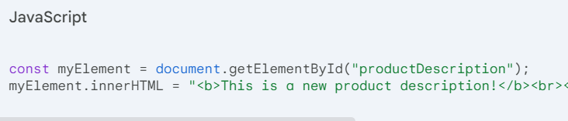

innerText/textContent:

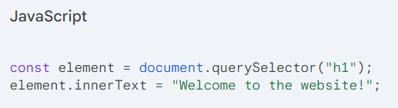

2. Alert Boxes:

window.alert():

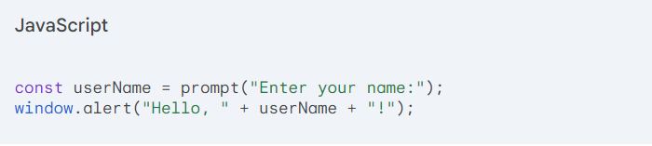

3. Browser Console:

console.log():

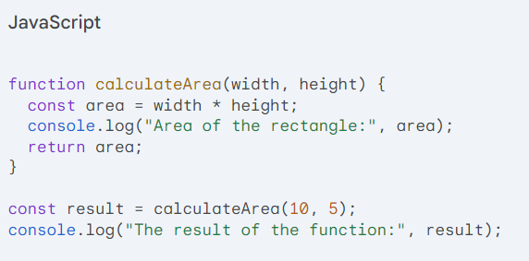

4. Printing (Limited):

window.print():

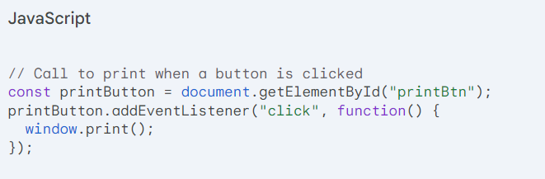

**• Que How to used JavaScript Events to do all examples?**

* 1. Updating Subtotals with Events

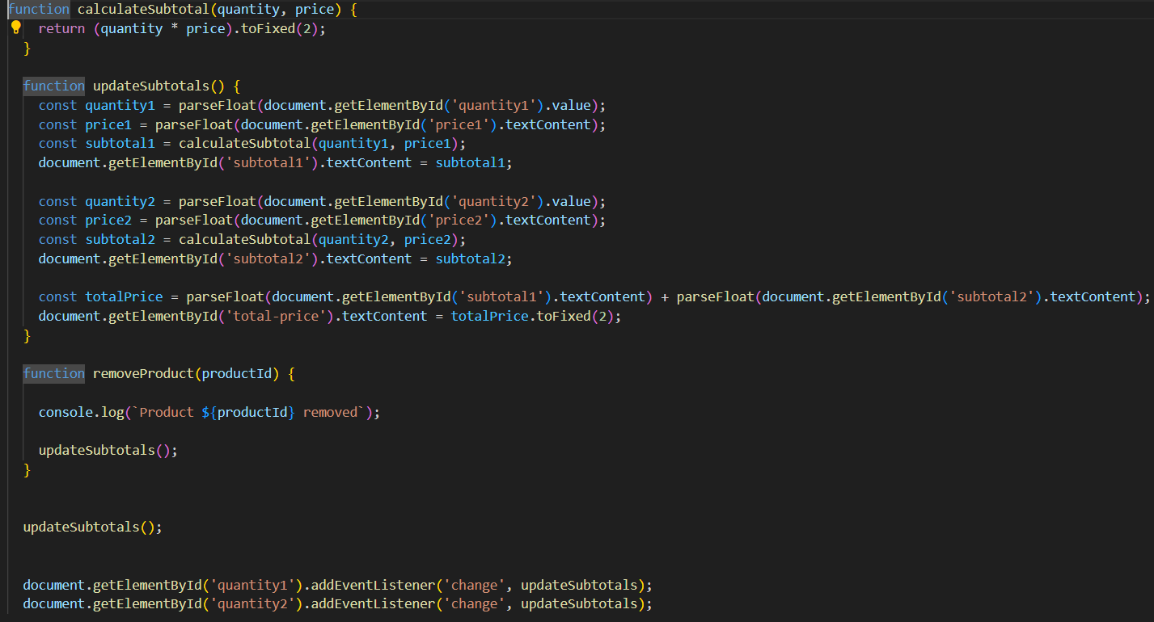

* 1. **User Input Validation with Events:**

