1 . Not able to start loading or Not able to load the unit:-
- Does it have an outbound movement?
If No:- But check if the unit name and license plate are correct as per ROCS system. If they are different, they cannot start loading.
If Yes:- Is it visible on the Unit Information when you double click on the UNIT. If not visible, then they cannot start loading.

Check-out one way the incorrect unit, check-in the unit with the correct name and license plate.

2 . Not able to mark Unit Ready:-
If No:- But check if the unit name and license plate are correct as per ROCS system. If they are different, they cannot mark ready.
If Yes:- Is it visible on the Unit Information when you double click on the UNIT. If not visible, then they cannot mark ready.

Check-out one way the incorrect unit, check-in the unit with the correct name and license plate.
3 . This link is wrong in YOS CC and I can’t check out it:-
Please depart unit in ROCS. Park the unit in Temporary/Dummy location.

If user says they are out of space in Dummy/Temporary screen, Call L3 team.

4 . Not able to checkout one way:- (It is fixed in August 2022 release.)
Is the unit marked as UNIT_EMPTY?
Yes? Please depart unit in ROCS. Park the unit in Temporary/Dummy location.
No? Can you mark it UNIT_EMPTY & try again?

5 . Cannot find the unit on the checkout oneway screen:-. (It is fixed in August 2022 release
Please depart unit in ROCS. Park the unit in Temporary/Dummy location.

6 . Unit Disappeared:- (fixed)
Call L3 Team
7 . Duplicate Unit on the Yard:- (fixed)
Call L3 Team

8 . Units(more than 1) on Parking or Docking disappear:- (fixed)
Cancel the recently created shunter task and refresh the screen.
If it is not resolved still, call L3 team.
9. Different Team Groups to assign in pdsm:-
ROCS production issues:- | TNT_DEV_GLB_ROCS_INFOSYS
Local IT team HL3 location:- | TNT_SPT_EU_NE_Nordics
Database team | TNT_GLB_CLDORCDBAINFOSYS
IBIS Team infosys | TNT_SPT_GLB_ARSSYSMDT_INFOSYS
Infosys L2 team Production | TNT_SPT_GLB_L2SUPP_INFOSYS
Local IT team HL3 location | FXE_SPT_EU_TSITALY
YOS L3 support team | FXE_Dev_EMEA_YOS

10. User reports that he see a Flame icon on the application:-
The issues is due to the internet connection. Assing it to local IT team
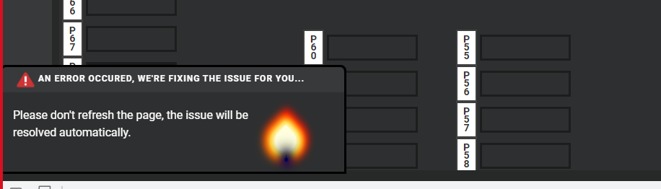

11. Device have ghost touch issues and sometimes glitchy and flashing scanner.
Restart the device and assign to local IT team.
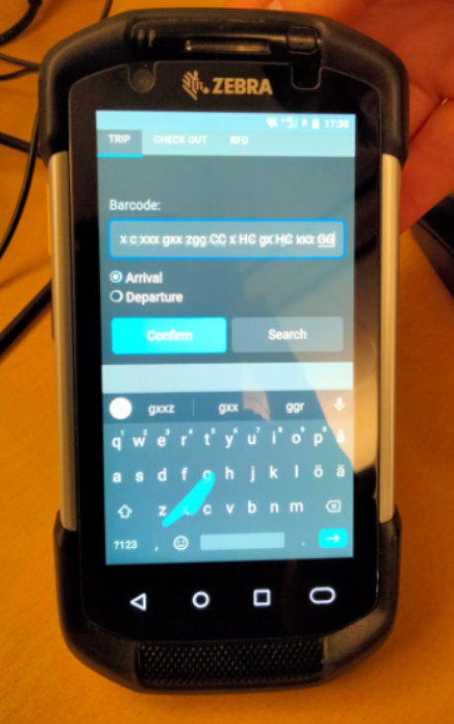

12 . Application is refreshing every 1 hour(Issue fixed).
Assign it to the YOS L3 team
13 I am not able to check-out a unit from the docking door or door(Fixed with the August 2022 release)
Check if it is marked as Ready.
If no,
Ask them to mark it as ready and try again
If yes,
You need to run this script
update yos_schema.asset_site_unit
set check_out_dt=null
where site_tran_id in (select a.site_tran_id from yos_schema.asset_docking_door a
where a.site_tran_id is not null and a.site_tran_id in (select b.site_tran_id from yos_schema.asset_site_unit b
where b.check_out_dt is not null));
14. I am not able to check-out a unit from the parking bay or parking(Fixed with the August 2022 release)
Check if it is marked as Ready.
If no,
Ask them to mark it as ready and try again
If yes,
You need to run this script
update yos_schema.asset_site_unit
set check_out_dt=null
where site_tran_id in (select a.site_tran_id from yos_schema.asset_parking_bay a
where a.site_tran_id is not null and a.site_tran_id in (select b.site_tran_id from yos_schema.asset_site_unit b
where b.check_out_dt is not null));
15. User cannot do check-in oneway unit or cannot do arrival for the same unit(Fixed with the August 2022 release).
Or Unit is on the hub but it is not visible.
update yos_schema.asset_site_unit
set check_out_dt=sysdate-1
where site_tran_id in (select a.site_tran_id from yos_schema.asset_site_unit a
where a.check_out_dt is null and a.site_tran_id not in (select b.site_tran_id from yos_schema.asset_parking_bay b
where b.site_tran_id is not null
union
select c.site_tran_id from yos_schema.asset_docking_door c
where c.site_tran_id is not null));

16. MWW Door scanning not reaching YOS.
When the issue raised, go to Kibana logs and open the filter. Before that get the timestamp, door number. The filter name given below. Check if there was a scan received and it is not getting updated on the Yard. In that case pass the incident to YOS team. If you don’t see scans for that Location and for that Door, then raise this with MWW team to check.

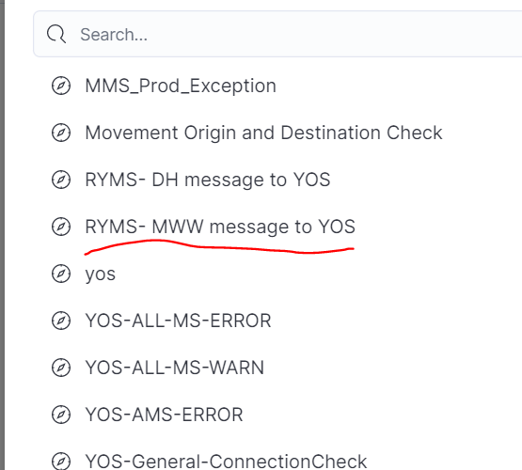

17. YOS Crashed or YOS not accessible.
Sometimes the information in the incident could be misleading. So, check for correct details if it is 404 not found the user is seeing on the application to application crashed.
Application crashed :- User can still access UI. This mean if the user is able to see the Black/grey screen then contact the HL3 team immediately.
YOS not reachable :- YOS should be always available and there no way he will see 404 unless it is an issue with AKAMAI or purple ID or network/internet connection issue.
Is the user says he see a 404 not found message, please raise this with AKAMAI team if there are any 404 error. If not then there is no issue from application. Could be local network.
If the AKAMAI received 404 from AKS, then we need to check from YOS if it is up – generally it is not a case.

AKAMAI team might request for HAR file. Here are the steps to fetch HAR file from the user.
- You need to ask the user to open the developer tools. You can find it here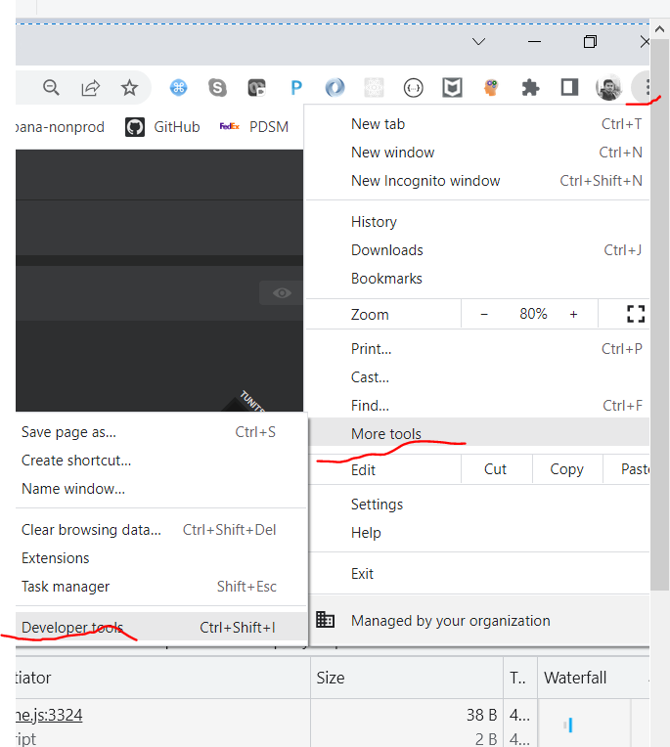
- Then user need to download the HAR file. Here is where you can find it in the developer tools
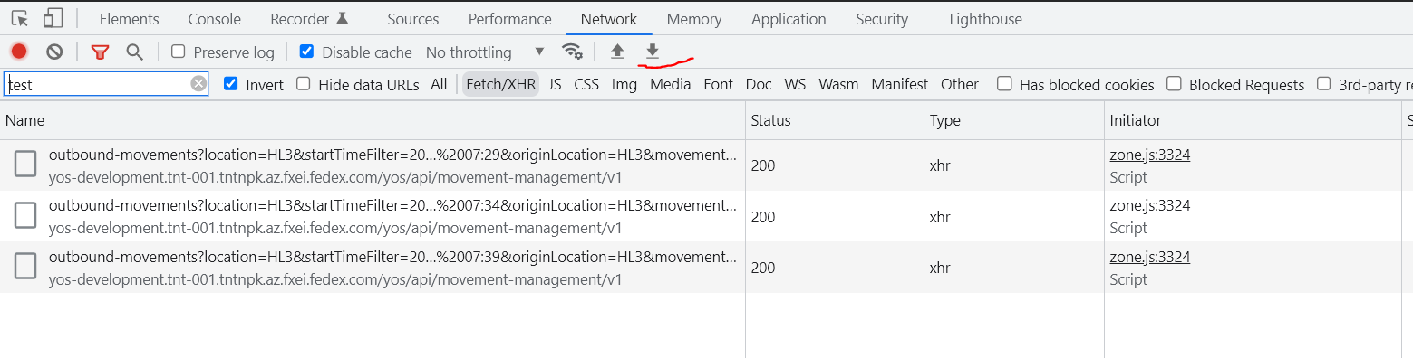
Download it and attach it to the incident and forward that to AKAMAI.
NOTE:- Please make sure you fetch the HAR file when there is a 404 error . If the HAR file is generated when the application is up and running, we cannot use that HAR file
18. Warehouse screen gives 404 error.
Check if the url is correct. Check the type errors, sometimes they use dot(.) instead of – while typing the url.
https://yos-prod.tnt.001.tntpk.az.fxei.fedex.com/yos/api/warehouse-screen/ware-house.html?screenid=2789
check if there is network connection available. Ask them to any website www.fedex.com
if they can open, that link assign that issue to YOS L3 team.

19. Unit Stuck issue
User can remove them from the yard by
1 . right click on the unit
2 . You need to rest unit ready
3 . double click and open the unit information screen.
4. mark unit as empty status.
5. save it
7. make unit ready/empty again.
8. Go to gatekeeper and checkout one way the unit.

User can remove them from the yard by
1. move that unit to a door
2 . Start unloading --> stop unloading --> unit empty
3. Go to gatekeeper and checkout one way the unit.

Grafana
Not yet received the details of Grafana monitoring- the threshold values for heap used, cpu utilization and others that would cause issues for YOS applications.

When multiple webservices/running in cloud, Grafana tool is configured with each of the webservice. YOS application is developed under microservice architecture. Each service have a set of responsibility for doing that and for each of the service we intrigate the Grafana tool. Below are the Grafana Sample screens
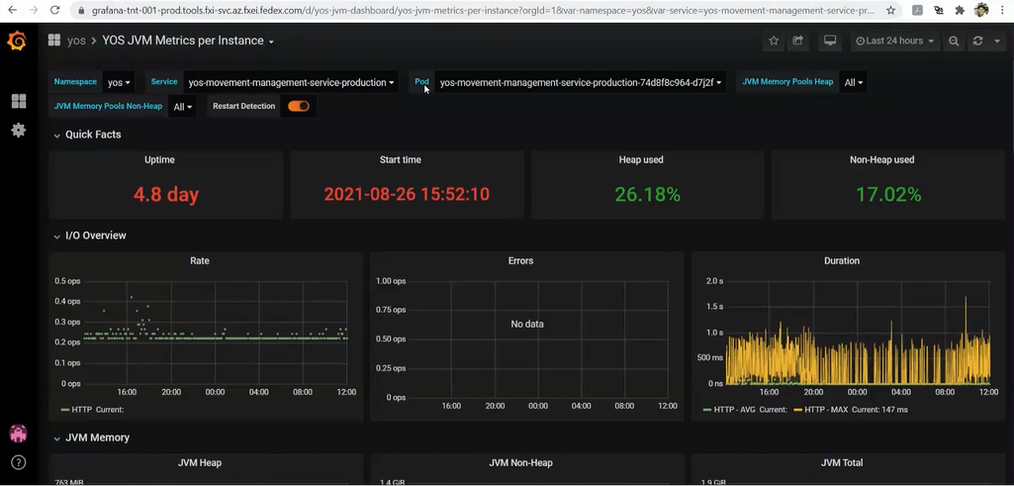

Kibana

Kibana is a proprietary data visualization dashboard software which provides visualization capabilities on top of the content indexed. Users can create bar, line and scatter plots, or pie charts and maps on top of large volumes of data.
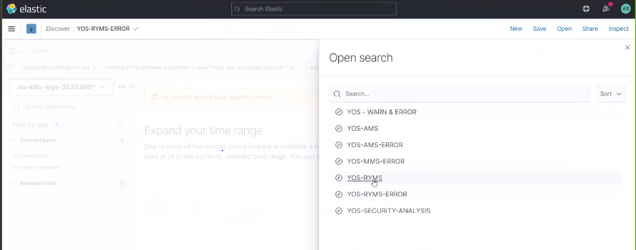
Critical Errors
- Sep 25, 2022 @ 04:00:30.489 rocs-yos-messaging-service-production ERROR Could not refresh JMS Connection for destination 'ECL.TNTCONSDEPART_CREATE_YOS.2' - retrying using FixedBackOff{interval=5000, currentAttempts=3012, maxAttempts=unlimited}. Cause: JMSWMQ0018: Failed to connect to queue manager 'QPDC1GC1' with connection mode 'Clien
Inform IBIS team

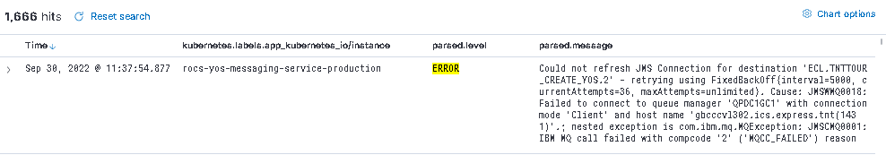

- May 16, 2022 @ 14:06:26.863 yos-warehouse-screen-service-production ERROR HikariPool-1 - Connection is not available, request timed out after 30000ms. – Inform L3 team

