Name: Rathod Raj Dinesh Bhai
Roll No: 82-A
Stream: BCA-5

Case Study: Royal Enfield Bike Rental System

Project Title
Smart Bike Rental Portal for Royal Enfield

Project Overview
The Royal Enfield Bike Rental System is a simple website that helps users rent Royal Enfield bikes. Users can view bikes, register, login, and make bookings. The system also includes an admin panel to manage bikes, users, bookings, and see reports. It makes renting easier for users and management easier for admins.

SDLC Model Used
Waterfall Model

1. Requirement Analysis
Main Goals:
- Allow users to rent bikes online
- Help admin manage bikes, bookings, and users
User Features:
- Register and login
- View available bikes
- Fill rent form and make booking
- View own bookings in dashboard
Admin Features:
- Login to admin dashboard
- Add/Edit/Delete bikes
- View all bookings and change their status (Booked, Collected, Returned)
- View users and their rental history

2. System Design
Database:
- Tables: users, bikes, rentals, payments
- All tables are connected with relationships (e.g., user_id, bike_id)
Technology Used:
- Frontend: HTML, CSS, JavaScript
- Backend: PHP
- Database: MySQL

3. Implementation
- The user can book a bike using a rent form.
- The admin can manage all data using a separate panel.
- Everything is saved and shown using PHP and MySQL.
- Admin dashboard shows booking status, bike availability

4. Testing
- All forms were tested to check correct input.
- Login system tested for both users and admin.
- Booking status and fine calculation tested.

5. Deployment
- Project can run on XAMPP.
- Database file (.sql) is included.
- Files are organized into user, admin, includes, and assets folders.

6. Maintenance
- Easy to add new bikes or features.
- Code is commented and simple to update.

Final Output
- Website helps users book bikes easily.
- Admin can manage everything from dashboard.
- The project is simple, functional, and easy to use.

DFD Diagram (Data Flow Diagram)

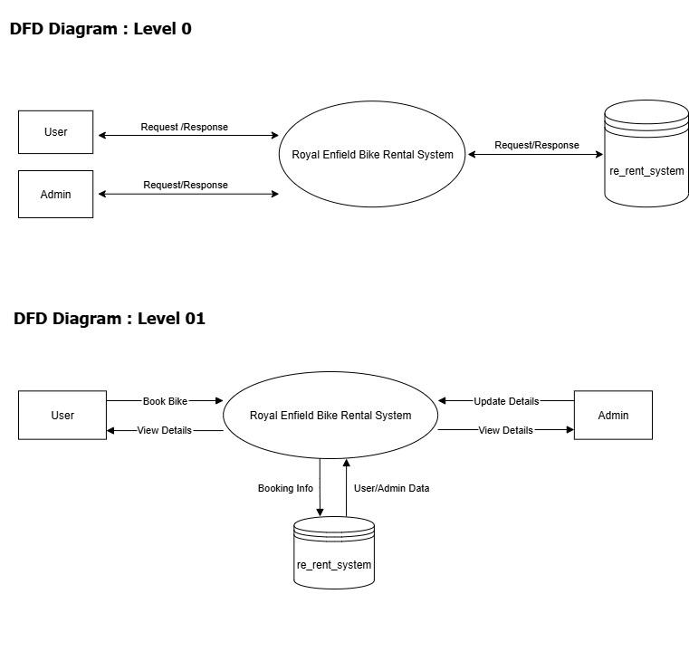

ER Diagram (Entity-Relationship)
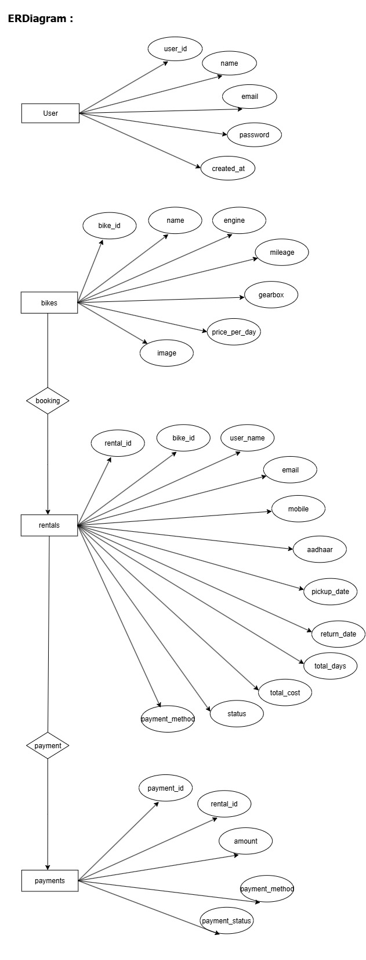

Use Case Diagram

