#Assignment_1

1. Created a freestyle project named ‘Assignment1’

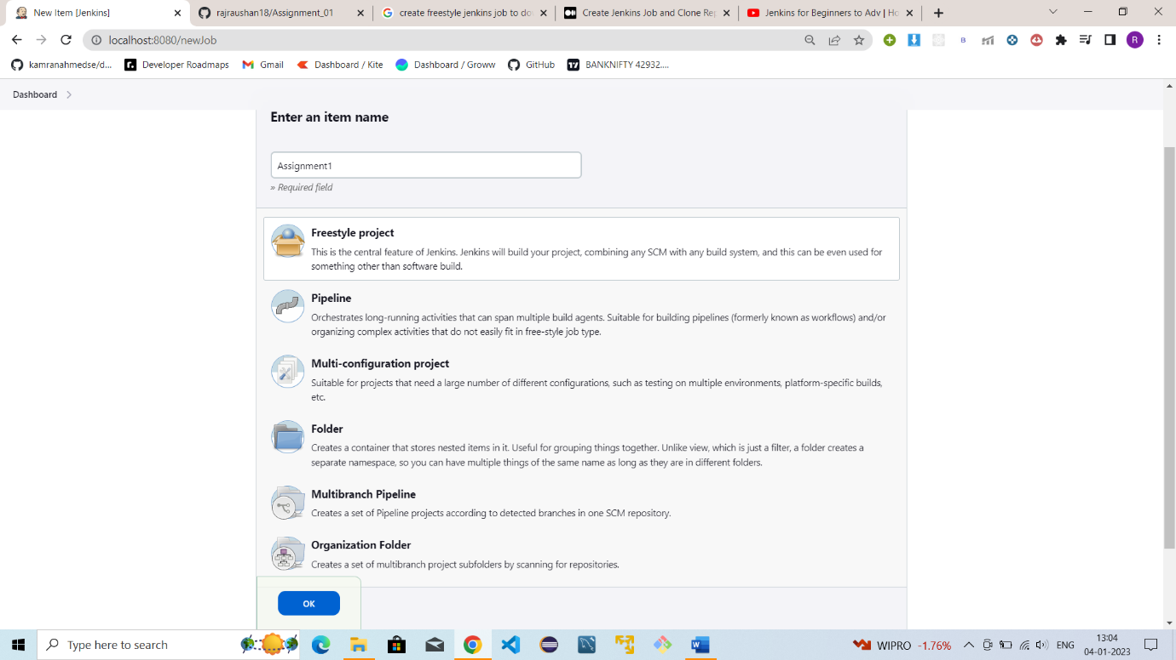

1. Provided the github repository url.

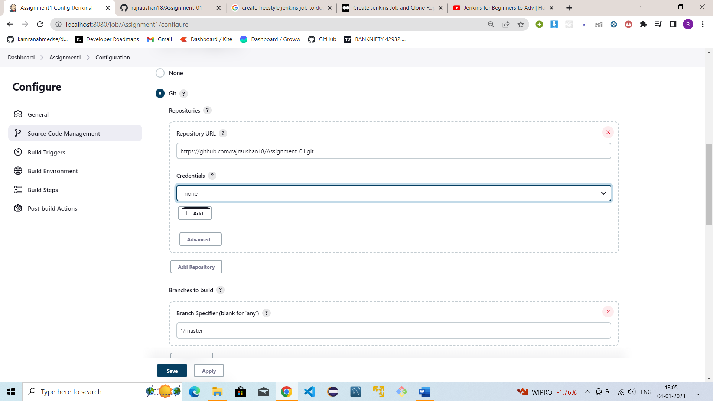

1. The program executed successfully after building and the git repository and got saved on local disk.

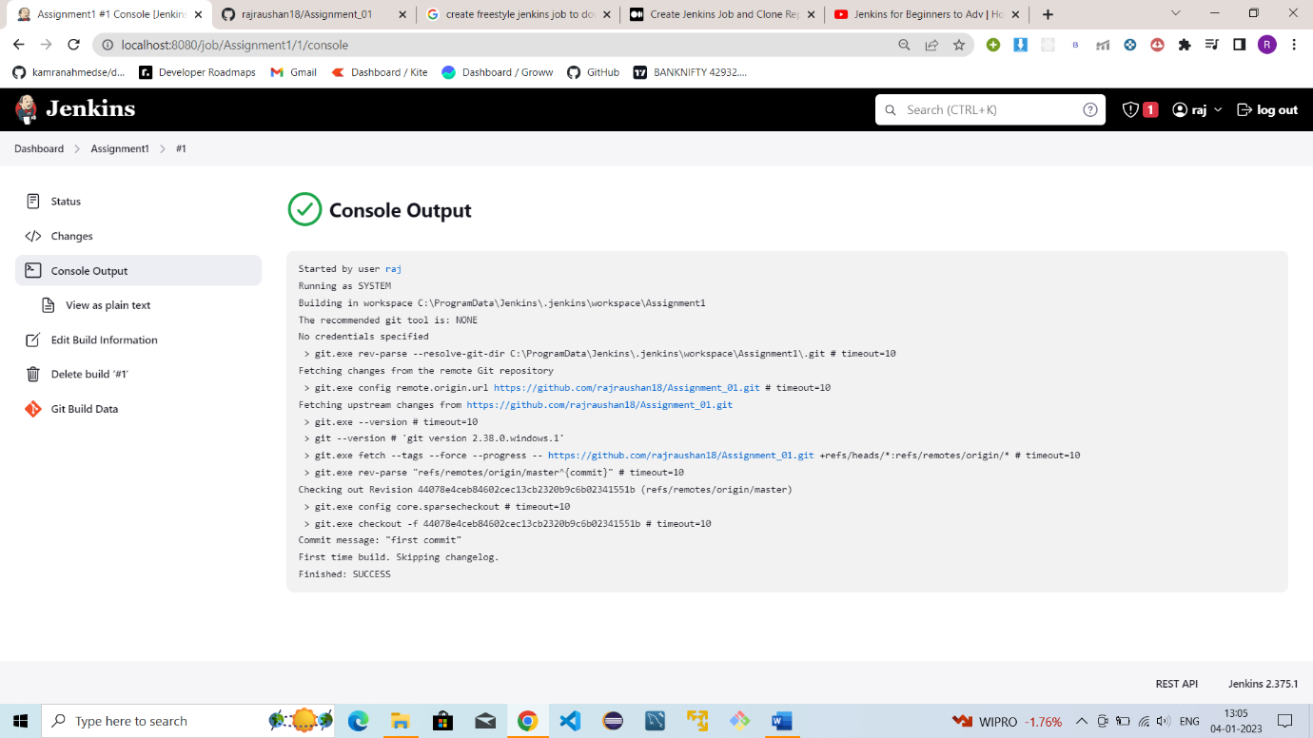

#Assignment_2

1. Createad a jenkins pipeline of a springboot application named ‘Assignment_Frontend_pipeline’

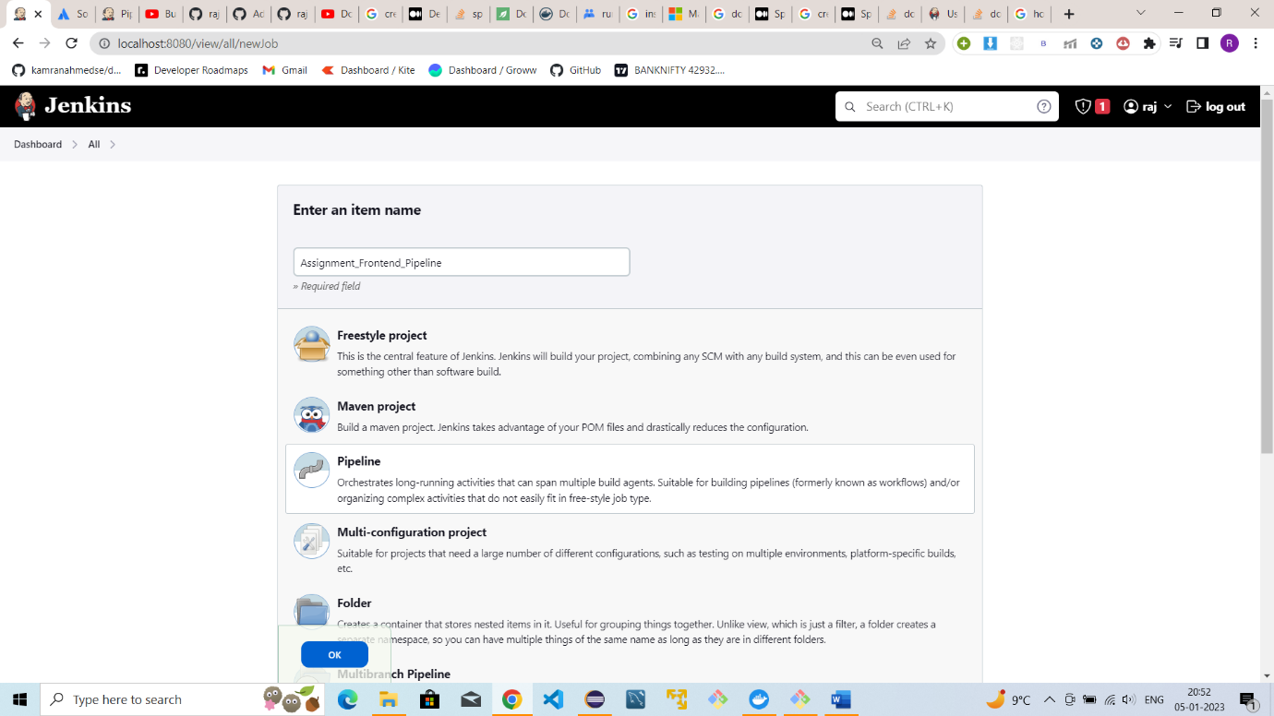

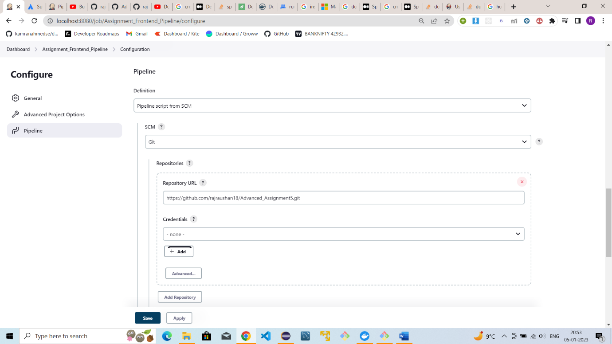

1. Provided the GitHub repo link which includes Jenkins file with all the commands

1. Jenkins file for the frontend pipeline

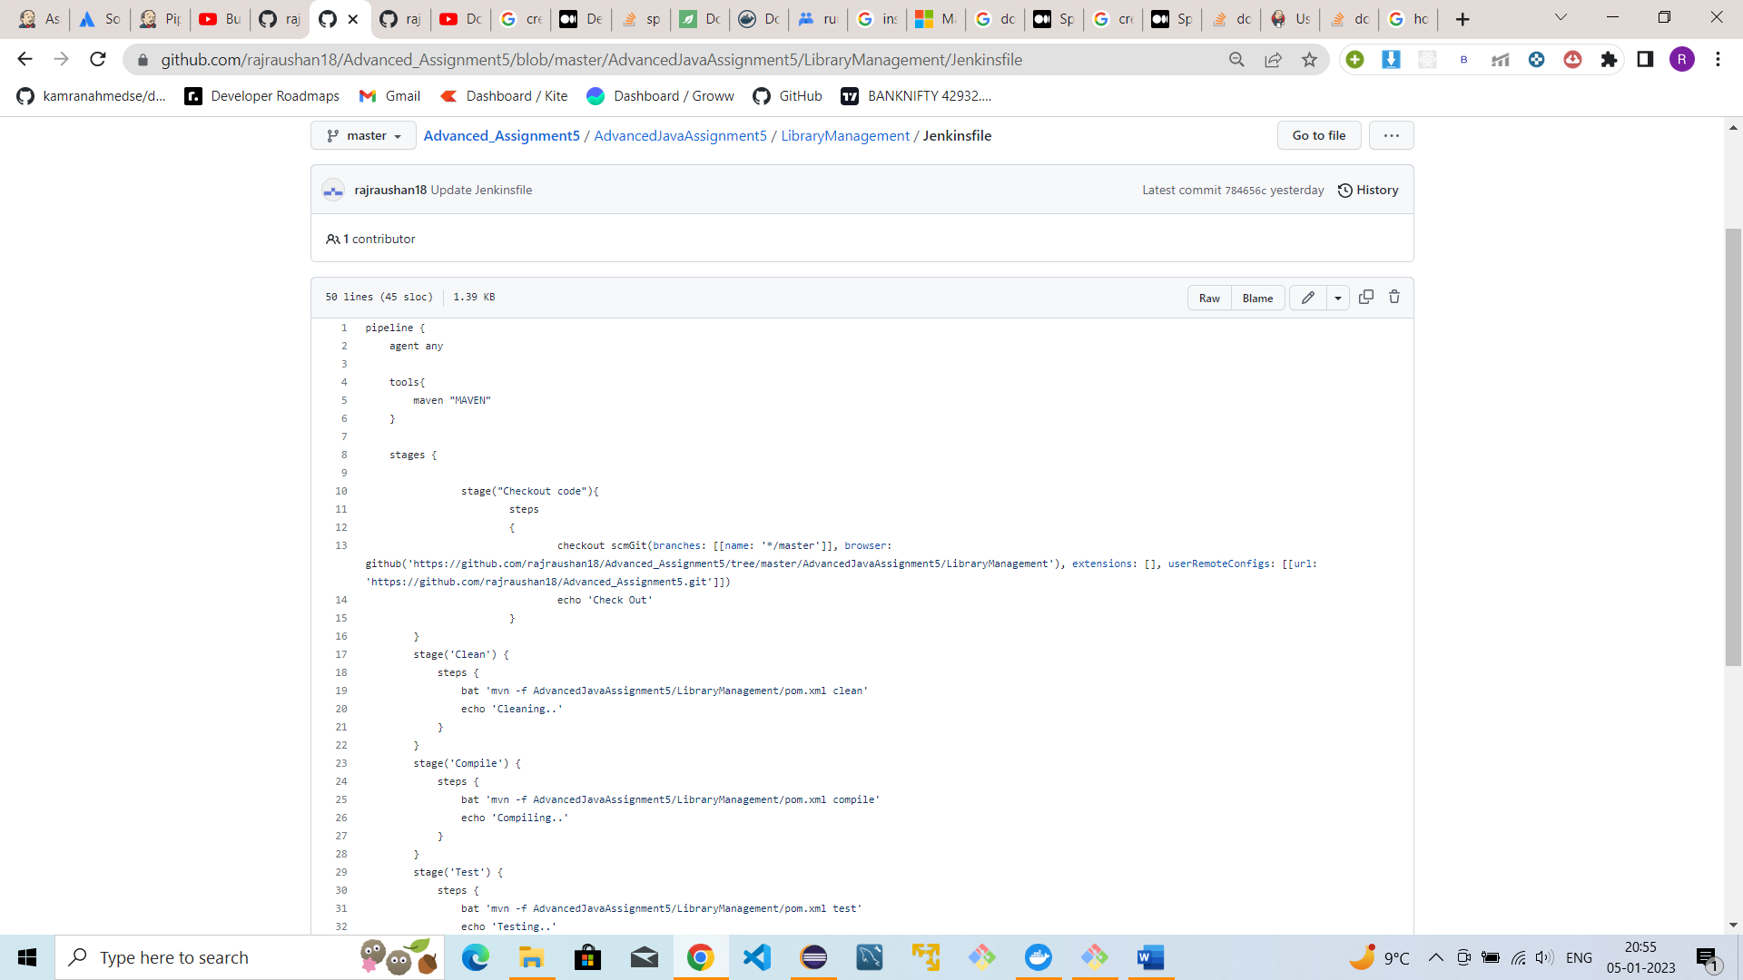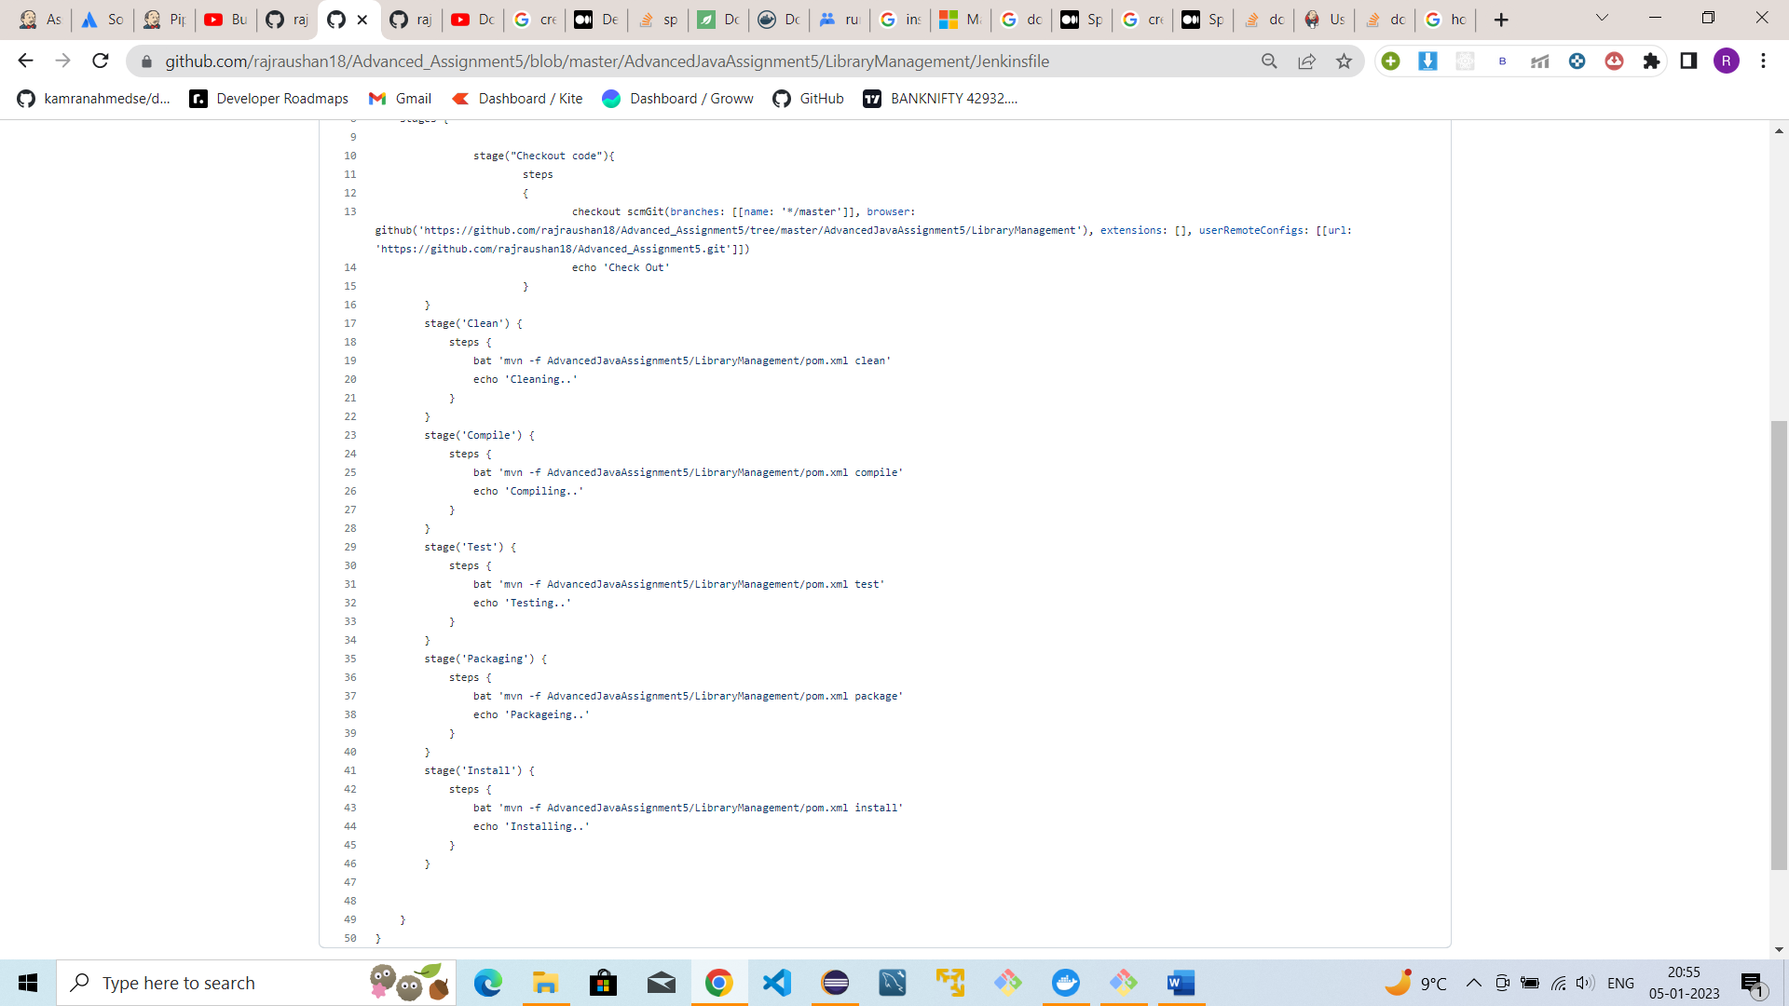

1. Build the pipeline and got executed successfully.

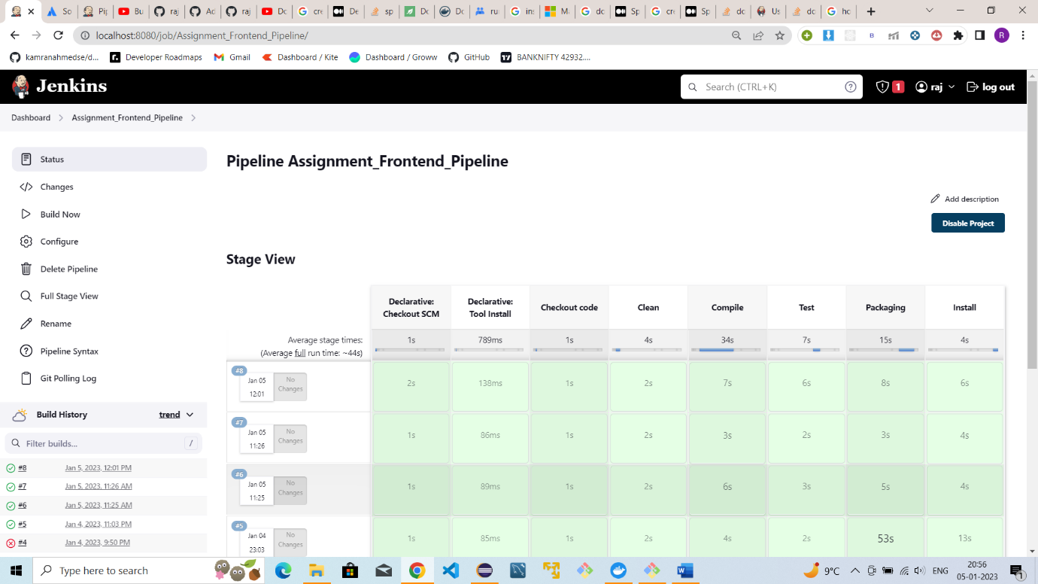

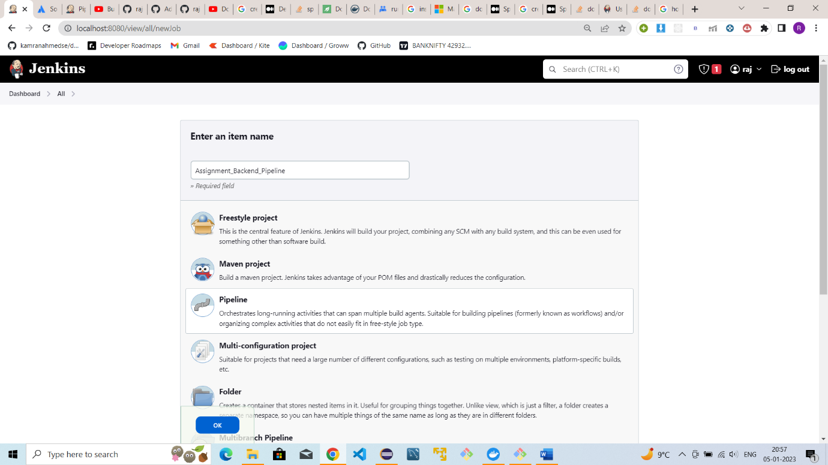

1. Same for the Backend Part of the application.

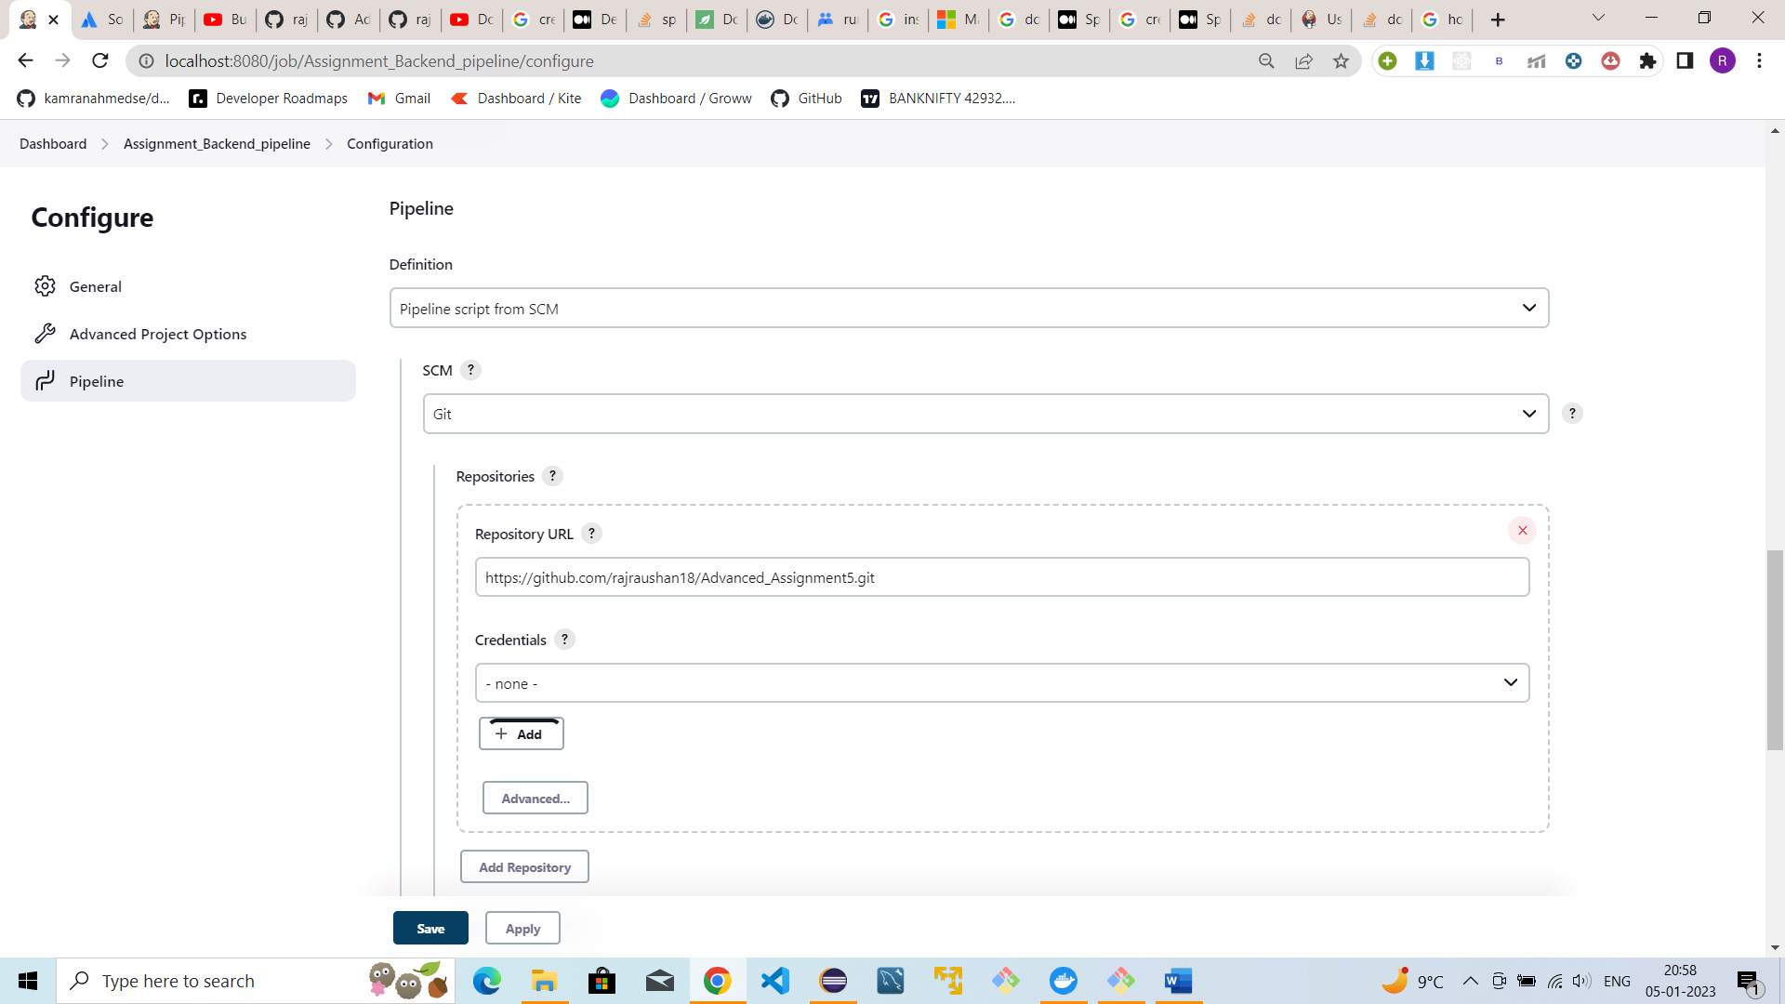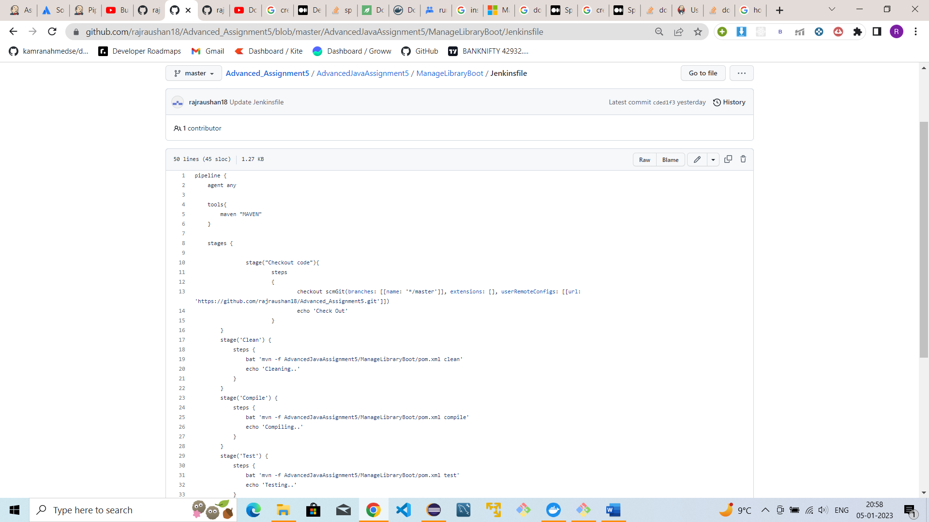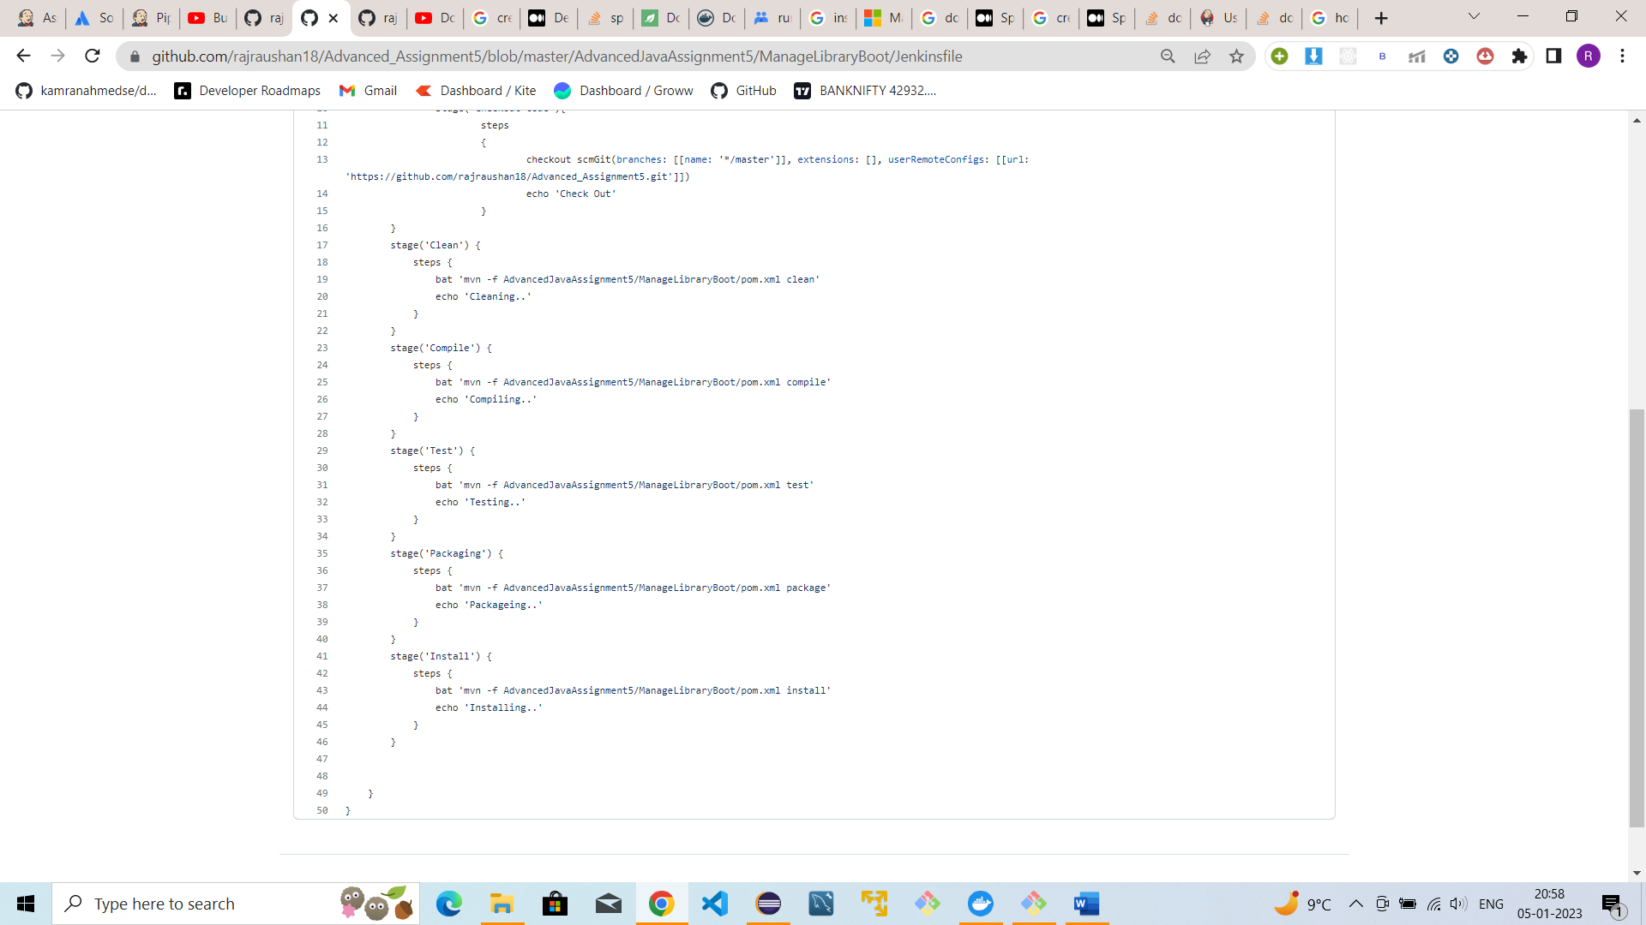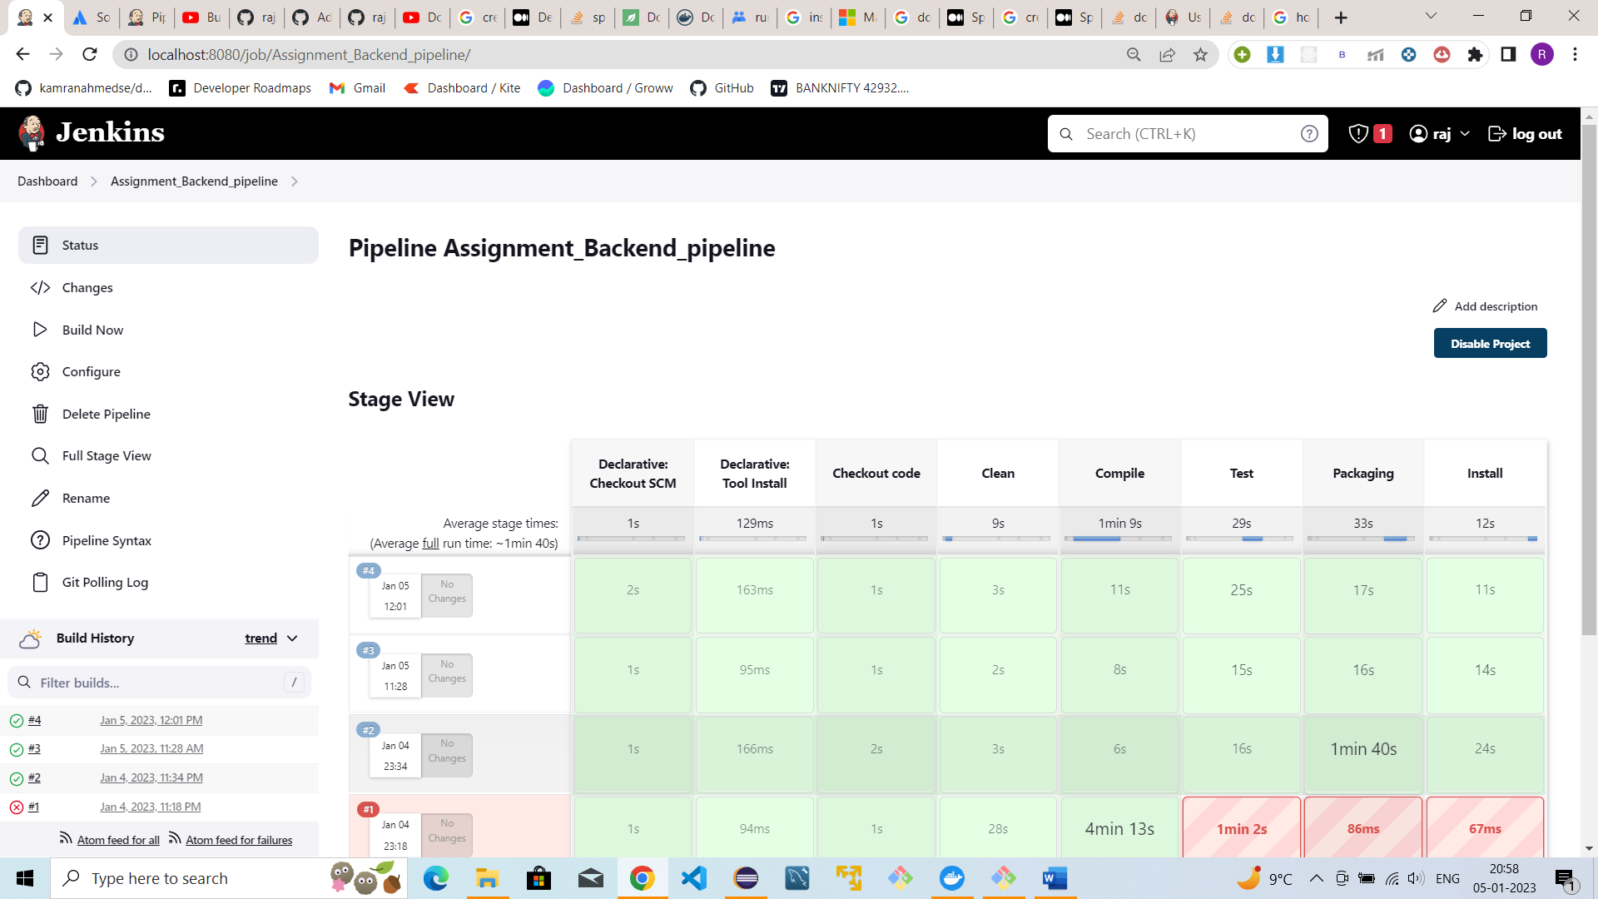

#Assignment_3

1. Created a Jenkins pipeline with name ‘docker-jenkins-integration’

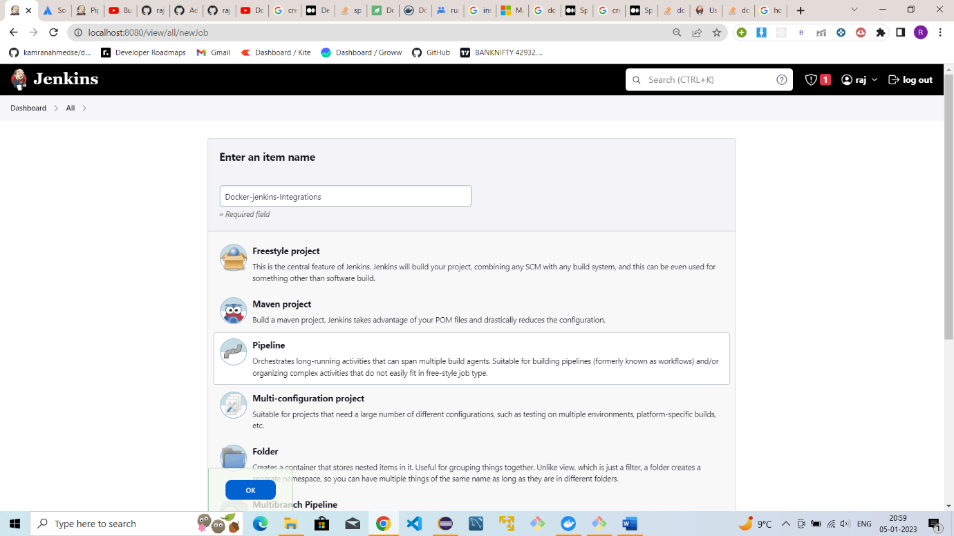

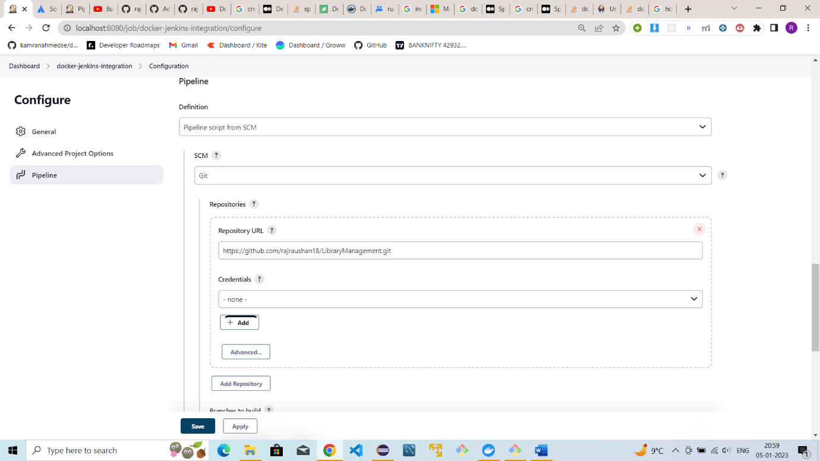

1. Provided the github url here which contains Jenkins with all the commands
2. Jenkins file of the application

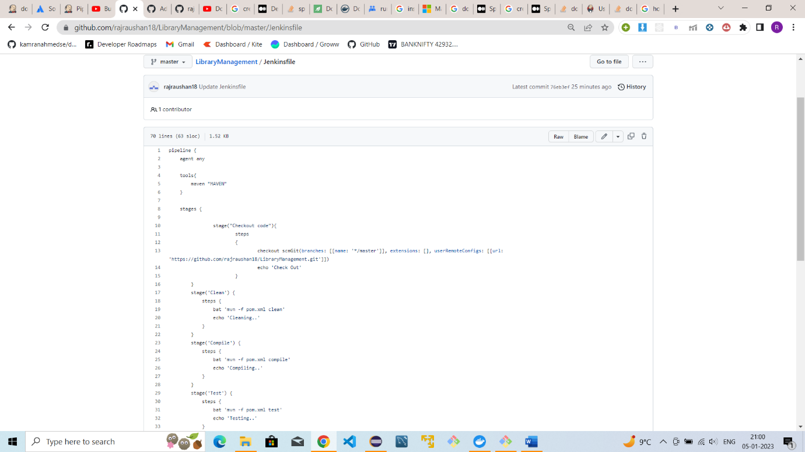

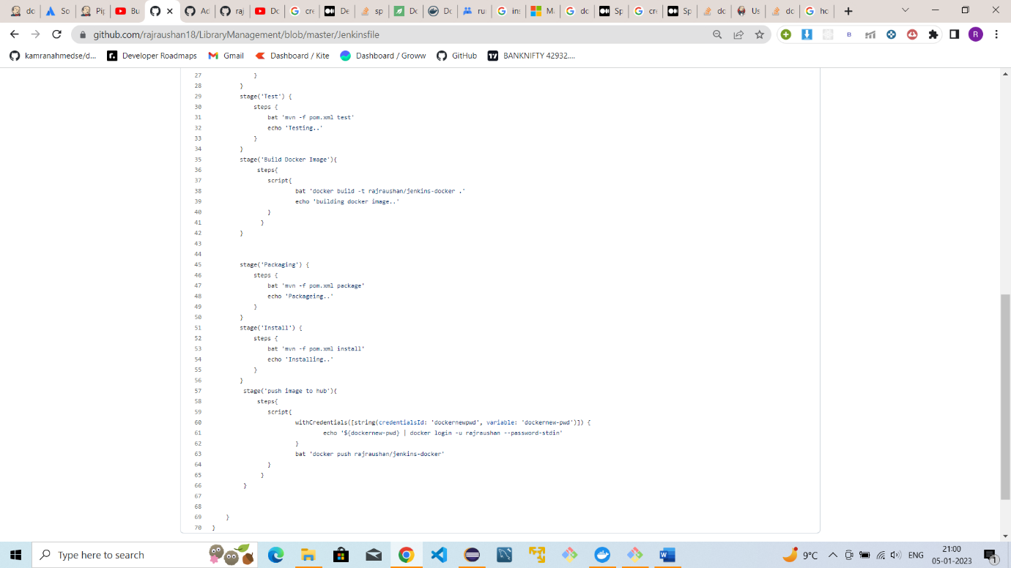

1. Dockerfile with all the commands to build docker using jenkins

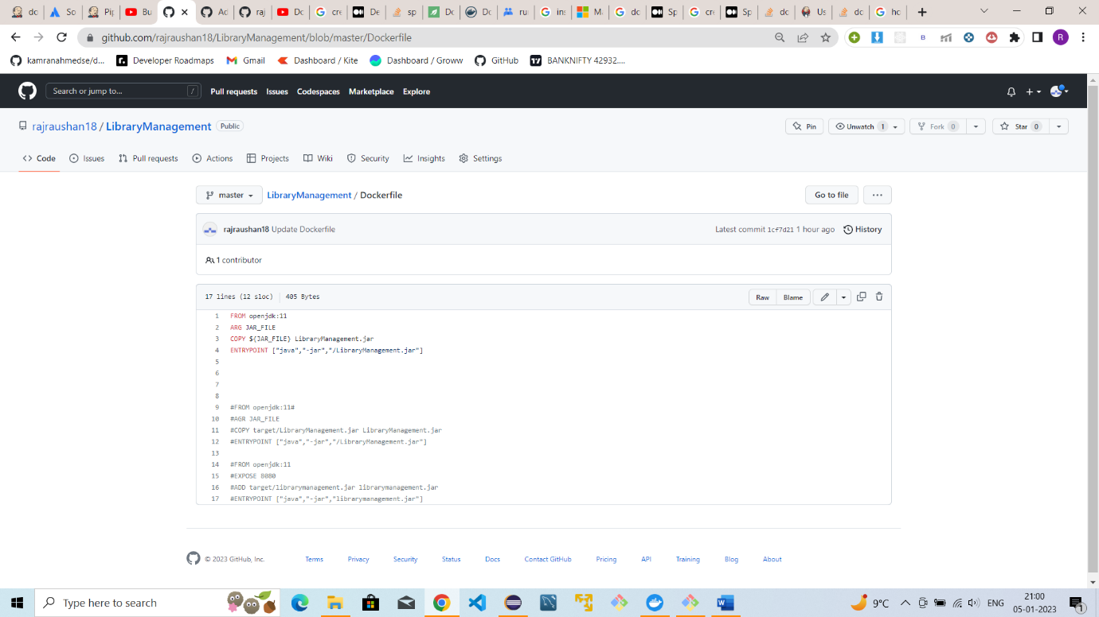

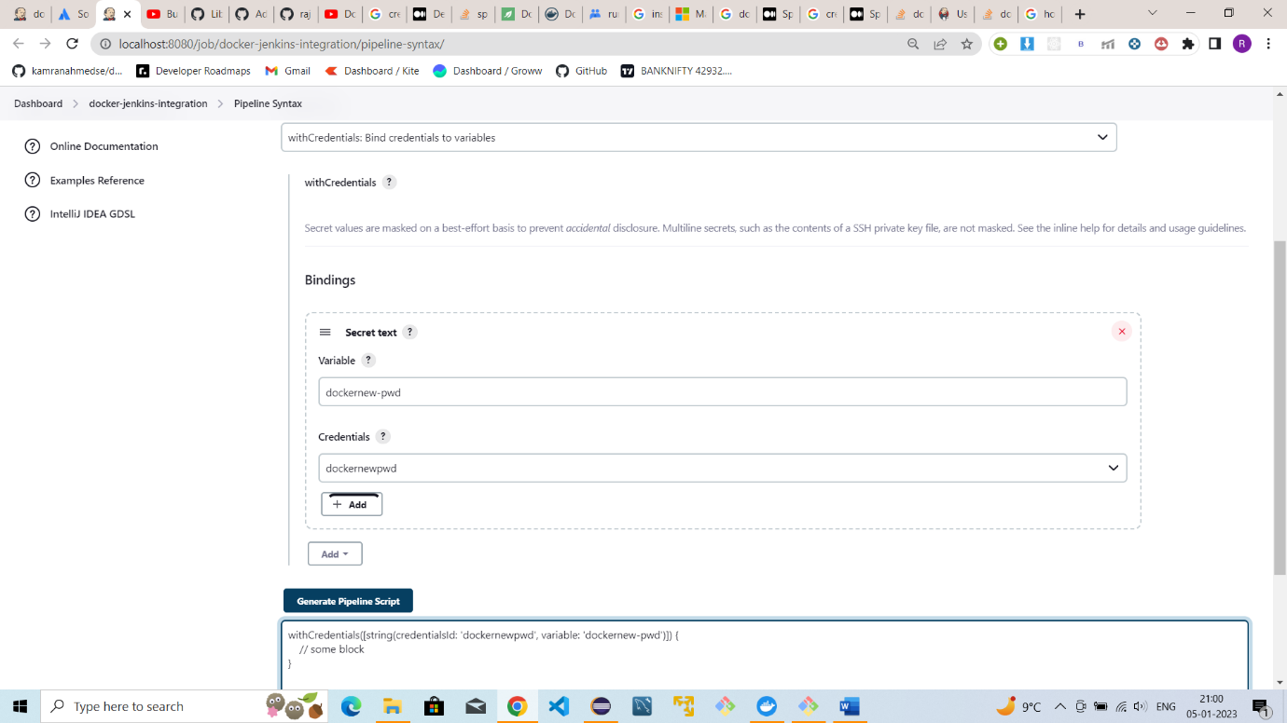

1. Provided the password for the docker hub and saved it using secret text format

1. Build the pipeline and got executed successfully

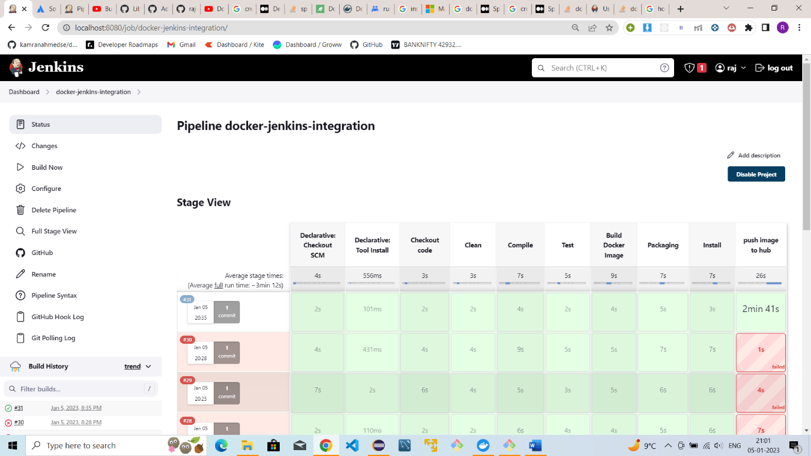

1. 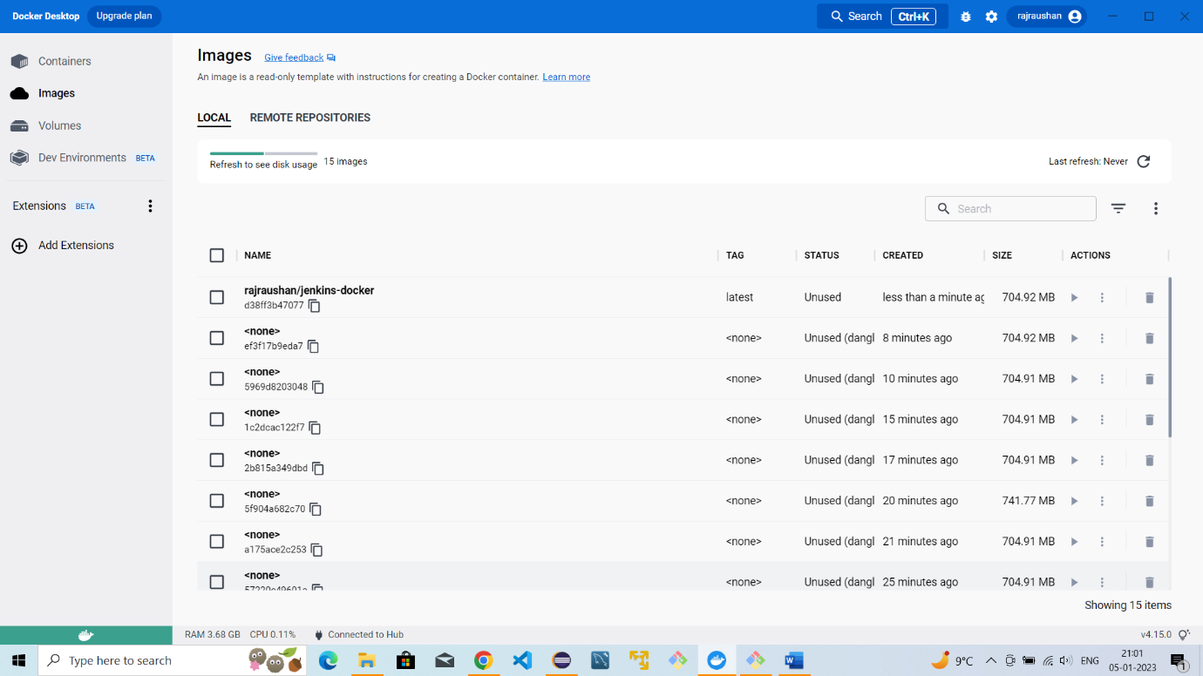Here the ‘Jenkins-docker’ docker image is the latest which got created