AICTE | IBM SkillsBuild Academic Internship
Data Analytics with AI | BharatCares
PROJECT REPORT
House Price Prediction Using Machine Learning
Submitted by
Rajraushan Kumar
Internship ID: IBMUEDA1887
Program: BCA – Data Science & AI
Gopal Narayan Singh University
AICTE | IBM SkillsBuild Data Analytics with AI Internship 2026
Conducted by BharatCares, in association with AICTE and IBM SkillsBuild
Academic Year: 2026

Table of Contents
2. Certificate / Internship Context 3
3. Declaration 4
4. Acknowledgement 5
5. Abstract 6
6. Introduction 7
7. Problem Statement 8
8. Objectives 9
9. Dataset Description 10
9.1 Target Variable 10
9.2 Feature Types 10
10. Tools and Technologies 11
11. Methodology 12
12. Exploratory Data Analysis 13
12.1 Sale Price Distribution 13
12.2 Correlation Heatmap 13
12.3 Overall Quality vs Sale Price 14
12.4 Living Area vs Sale Price 14
13. Data Preprocessing 15
13.1 Numerical Feature Preprocessing 15
13.2 Categorical Feature Preprocessing 15
13.3 ColumnTransformer and Pipeline 15
14. Model Development 16
14.1 Linear Regression 16
14.2 Random Forest Regressor 16
15. Model Evaluation 17
16. Results and Discussion 18
17. Feature Importance 20
18. Model Saving and Verification 21
19. Project Structure 22
20. Limitations 23
21. Future Scope 24
22. Conclusion 25
23. References 26

2. Certificate / Internship Context
This project was undertaken as part of the AICTE | IBM SkillsBuild Academic Internship – Data Analytics with AI, conducted by BharatCares in association with AICTE and IBM. The internship offer letter, issued to the student, confirms the following details of enrolment:
Student Name | Rajraushan Kumar
Internship ID | IBMUEDA1887
Internship Title | IBM SkillsBuild Data Analytics with AI Internship 2026
Conducted By | BharatCares, in association with AICTE and IBM
Duration | 17 August 2026 – 30 September 2026 (6 weeks, Virtual)
University | Gopal Narayan Singh University
Offer Letter Issued By | Chandni Patel, Associate Vice President – People and Culture, BharatCares

As per the internship structure, the program included an orientation session, weekly masterclasses covering data cleaning, exploratory data analysis, predictive analytics, machine learning basics, and AI-driven insights and visualization, followed by project completion and final submission. This report, along with the accompanying Jupyter Notebook, README file, and requirements file, has been prepared to fulfil the final project submission requirement of the internship.

3. Declaration
I, Rajraushan Kumar, a student of BCA – Data Science & AI at Gopal Narayan Singh University, hereby declare that the project titled “House Price Prediction Using Machine Learning”, submitted as part of the AICTE | IBM SkillsBuild Academic Internship – Data Analytics with AI (BharatCares), is an original piece of work carried out by me under the guidance provided during the internship.
I further declare that the analysis, code, results, and findings presented in this report are based on my own work using the Kaggle House Prices: Advanced Regression Techniques dataset, and that this report has not been submitted elsewhere for the award of any other qualification.
Rajraushan Kumar
BCA – Data Science & AI
Gopal Narayan Singh University

4. Acknowledgement
I would like to express my sincere gratitude to AICTE and IBM SkillsBuild for providing the opportunity to undertake the Data Analytics with AI Academic Internship, and to BharatCares for organizing and coordinating the program.
I am thankful to the mentors and subject matter experts who conducted the weekly masterclasses on data cleaning and preprocessing, exploratory data analysis, predictive analytics, machine learning basics, and AI-driven insights, which provided the foundational knowledge required to complete this project.
I also extend my gratitude to Gopal Narayan Singh University for encouraging participation in this industry-focused internship as part of the BCA – Data Science & AI program. Finally, I thank everyone who directly or indirectly supported the successful completion of this project.

5. Abstract
Predicting the sale price of a residential property is a widely studied regression problem in data analytics, with practical applications for buyers, sellers, and real-estate businesses. This project develops and compares two machine learning models — Linear Regression and Random Forest Regressor — to predict house sale prices using the Kaggle “House Prices: Advanced Regression Techniques” dataset, which contains 1,460 residential property records described by 80 explanatory features.
The project workflow includes data loading, missing value analysis, exploratory data analysis, a Scikit-learn preprocessing pipeline (median imputation for numerical features, most-frequent imputation and One-Hot Encoding for categorical features), an 80:20 train-test split, model training, evaluation, and feature importance analysis. Model performance was assessed using Mean Absolute Error (MAE), Root Mean Squared Error (RMSE), and the coefficient of determination (R²).
The Linear Regression model achieved an MAE of $20,485.66, an RMSE of $31,327.80, and an R² of 0.8720 on the test set. The Random Forest Regressor outperformed it, achieving an MAE of $17,465.29, an RMSE of $28,554.98, and an R² of 0.8937. Based on these results, the Random Forest Regressor was selected as the final model and saved using Joblib as models/house_price_prediction_model.pkl for future use. Feature importance analysis identified Overall Quality and Above Ground Living Area as the most influential predictors of sale price.

6. Introduction
House price prediction is one of the most practical applications of data analytics and machine learning in the real-estate domain. The price of a residential property depends on a combination of factors, including its physical characteristics (such as size and quality of construction), location-related attributes, and market conditions. Accurately estimating this price using historical sales data is valuable to home buyers, sellers, real-estate agencies, and financial institutions.
Data analytics plays a central role in this process by enabling systematic exploration of relationships between property features and sale price through statistical summaries and visualizations. Machine learning extends this by building predictive models that can generalize from historical examples to estimate the price of a new, unseen property.
The purpose of this project is to apply an end-to-end data analytics and machine learning workflow — covering data exploration, preprocessing, model training, evaluation, and feature interpretation — to predict house sale prices. The project was carried out as part of the AICTE | IBM SkillsBuild Academic Internship – Data Analytics with AI, in which weekly masterclasses on data cleaning, exploratory data analysis, predictive analytics, and machine learning basics guided the development of this project.

7. Problem Statement
House prices are influenced by numerous property-related factors such as overall build quality, living area, basement area, garage capacity, year of construction, and neighborhood characteristics. Manually estimating a fair sale price by considering all these factors simultaneously is difficult and prone to inconsistency.
The problem addressed in this project is: given a set of numerical and categorical features describing a residential property, predict its sale price (SalePrice) as accurately as possible using supervised regression techniques. This is framed as a supervised machine learning regression problem, where the model learns the relationship between input features and the continuous target variable, SalePrice, from historical sales records.

8. Objectives
- To analyze the house price dataset and understand the relationships between property features and sale price.
- To identify important features that influence house sale price.
- To handle missing values in both numerical and categorical features.
- To perform exploratory data analysis (EDA) using visualizations.
- To prepare the data for machine learning using an appropriate preprocessing pipeline.
- To train regression models — Linear Regression and Random Forest Regressor — for house price prediction.
- To evaluate and compare model performance using MAE, RMSE, and R².
- To analyze feature importance from the trained Random Forest model.
- To save the final trained machine learning model for future use.

9. Dataset Description
The dataset used in this project is the “House Prices: Advanced Regression Techniques” dataset, sourced from Kaggle. It contains records of residential properties along with their sale prices and a wide range of descriptive attributes.
As confirmed in the project notebook, the training dataset (train.csv) consists of 1,460 rows and 81 columns, one of which is the target variable.

9.1 Target Variable
SalePrice — the final sale price of the residential property, in US dollars. This is the continuous variable that the models are trained to predict.

9.2 Feature Types
The dataset's remaining 80 columns are split between numerical and categorical features:
- Numerical features — attributes such as OverallQual, GrLivArea, TotalBsmtSF, 1stFlrSF, GarageCars, GarageArea, LotArea, LotFrontage, YearBuilt, and YearRemodAdd, among others, which describe measurable quantities of the property.
- Categorical features — attributes describing qualitative characteristics of the property, such as zoning classification, neighborhood, house style, basement quality, and sale type, which were identified from the dataset's object-type columns during preprocessing.
Several columns, particularly categorical attributes such as basement and garage quality indicators, and numerical attributes such as LotFrontage, were found to contain missing values, as identified during the missing value analysis step in the notebook. These were addressed in the data preprocessing stage described in Section 13.

10. Tools and Technologies
The following tools and Python libraries, as listed in the project's requirements.txt file, were used to build this project:
Tool / Library | Purpose
Python | Core programming language used for data analysis and machine learning.
Jupyter Notebook | Interactive environment used to develop, run, and document the project step by step.
VS Code | Code editor used for developing and managing the project files.
Pandas | Loading, cleaning, and manipulating the tabular dataset.
NumPy | Numerical operations, including array handling and mathematical computations.
Matplotlib | Creating static visualizations such as histograms, scatter plots, and bar charts.
Seaborn | Statistical data visualization, used for the correlation heatmap, boxplots, and distribution plots.
Scikit-learn | Preprocessing pipeline, model training (Linear Regression, Random Forest Regressor), and evaluation metrics.
Joblib | Saving and loading the trained machine learning model.
OpenPyXL | Supporting library for handling spreadsheet-format data where required.

11. Methodology
The project followed a structured, end-to-end data analytics and machine learning workflow, implemented sequentially in the Jupyter Notebook. The key stages of the methodology were as follows:
- Data Loading — the dataset (train.csv) was loaded using Pandas, and its shape and structure were inspected.
- Data Inspection — column names, data types, and general dataset information were examined using standard Pandas functions.
- Missing Value Analysis — columns containing missing values were identified and quantified.
- Exploratory Data Analysis (EDA) — the distribution of SalePrice, correlations between important numerical features, and relationships between key features and SalePrice were visualized.
- Feature Analysis — numerical and categorical features were separated for targeted preprocessing.
- Train-Test Split — the dataset was split into training (80%) and testing (20%) subsets using a fixed random_state of 42 for reproducibility.
- Numerical Preprocessing — missing numerical values were imputed using the median strategy.
- Categorical Preprocessing — missing categorical values were imputed using the most-frequent strategy.
- One-Hot Encoding — categorical features were converted into numerical form using One-Hot Encoding.
- Model Training — Linear Regression and Random Forest Regressor models were trained on the preprocessed training data.
- Prediction — trained models were used to generate predictions on the held-out test set.
- Evaluation — model predictions were evaluated using MAE, RMSE, and R².
- Feature Importance — feature importances were extracted from the trained Random Forest model.
- Model Saving — the best-performing model was saved to disk using Joblib.
- Model Verification — the saved model was reloaded and verified by generating a prediction on a test sample.

12. Exploratory Data Analysis
Exploratory Data Analysis (EDA) was performed to understand the distribution of the target variable and its relationship with key numerical features before model building. The following visualizations were generated directly from the dataset in the project notebook.

12.1 Sale Price Distribution
The distribution of SalePrice was visualized using a histogram with a kernel density estimate (KDE) overlay. The distribution is right-skewed, with most house prices concentrated between approximately $100,000 and $250,000, and a long tail of higher-priced properties extending beyond $500,000.
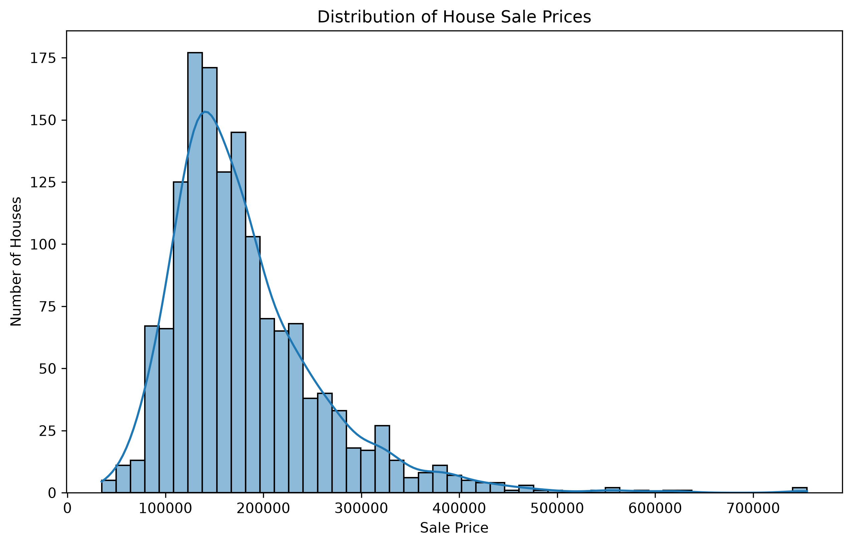
Figure 1: Distribution of house sale prices in the dataset.

12.2 Correlation Heatmap
A correlation heatmap was generated for the important numerical features (OverallQual, GrLivArea, GarageCars, TotalBsmtSF, 1stFlrSF) alongside SalePrice. Overall Quality shows the strongest correlation with SalePrice (0.79), followed by Above Ground Living Area (0.71), Garage Cars (0.64), and Total Basement Area and First Floor Area (0.61 each).
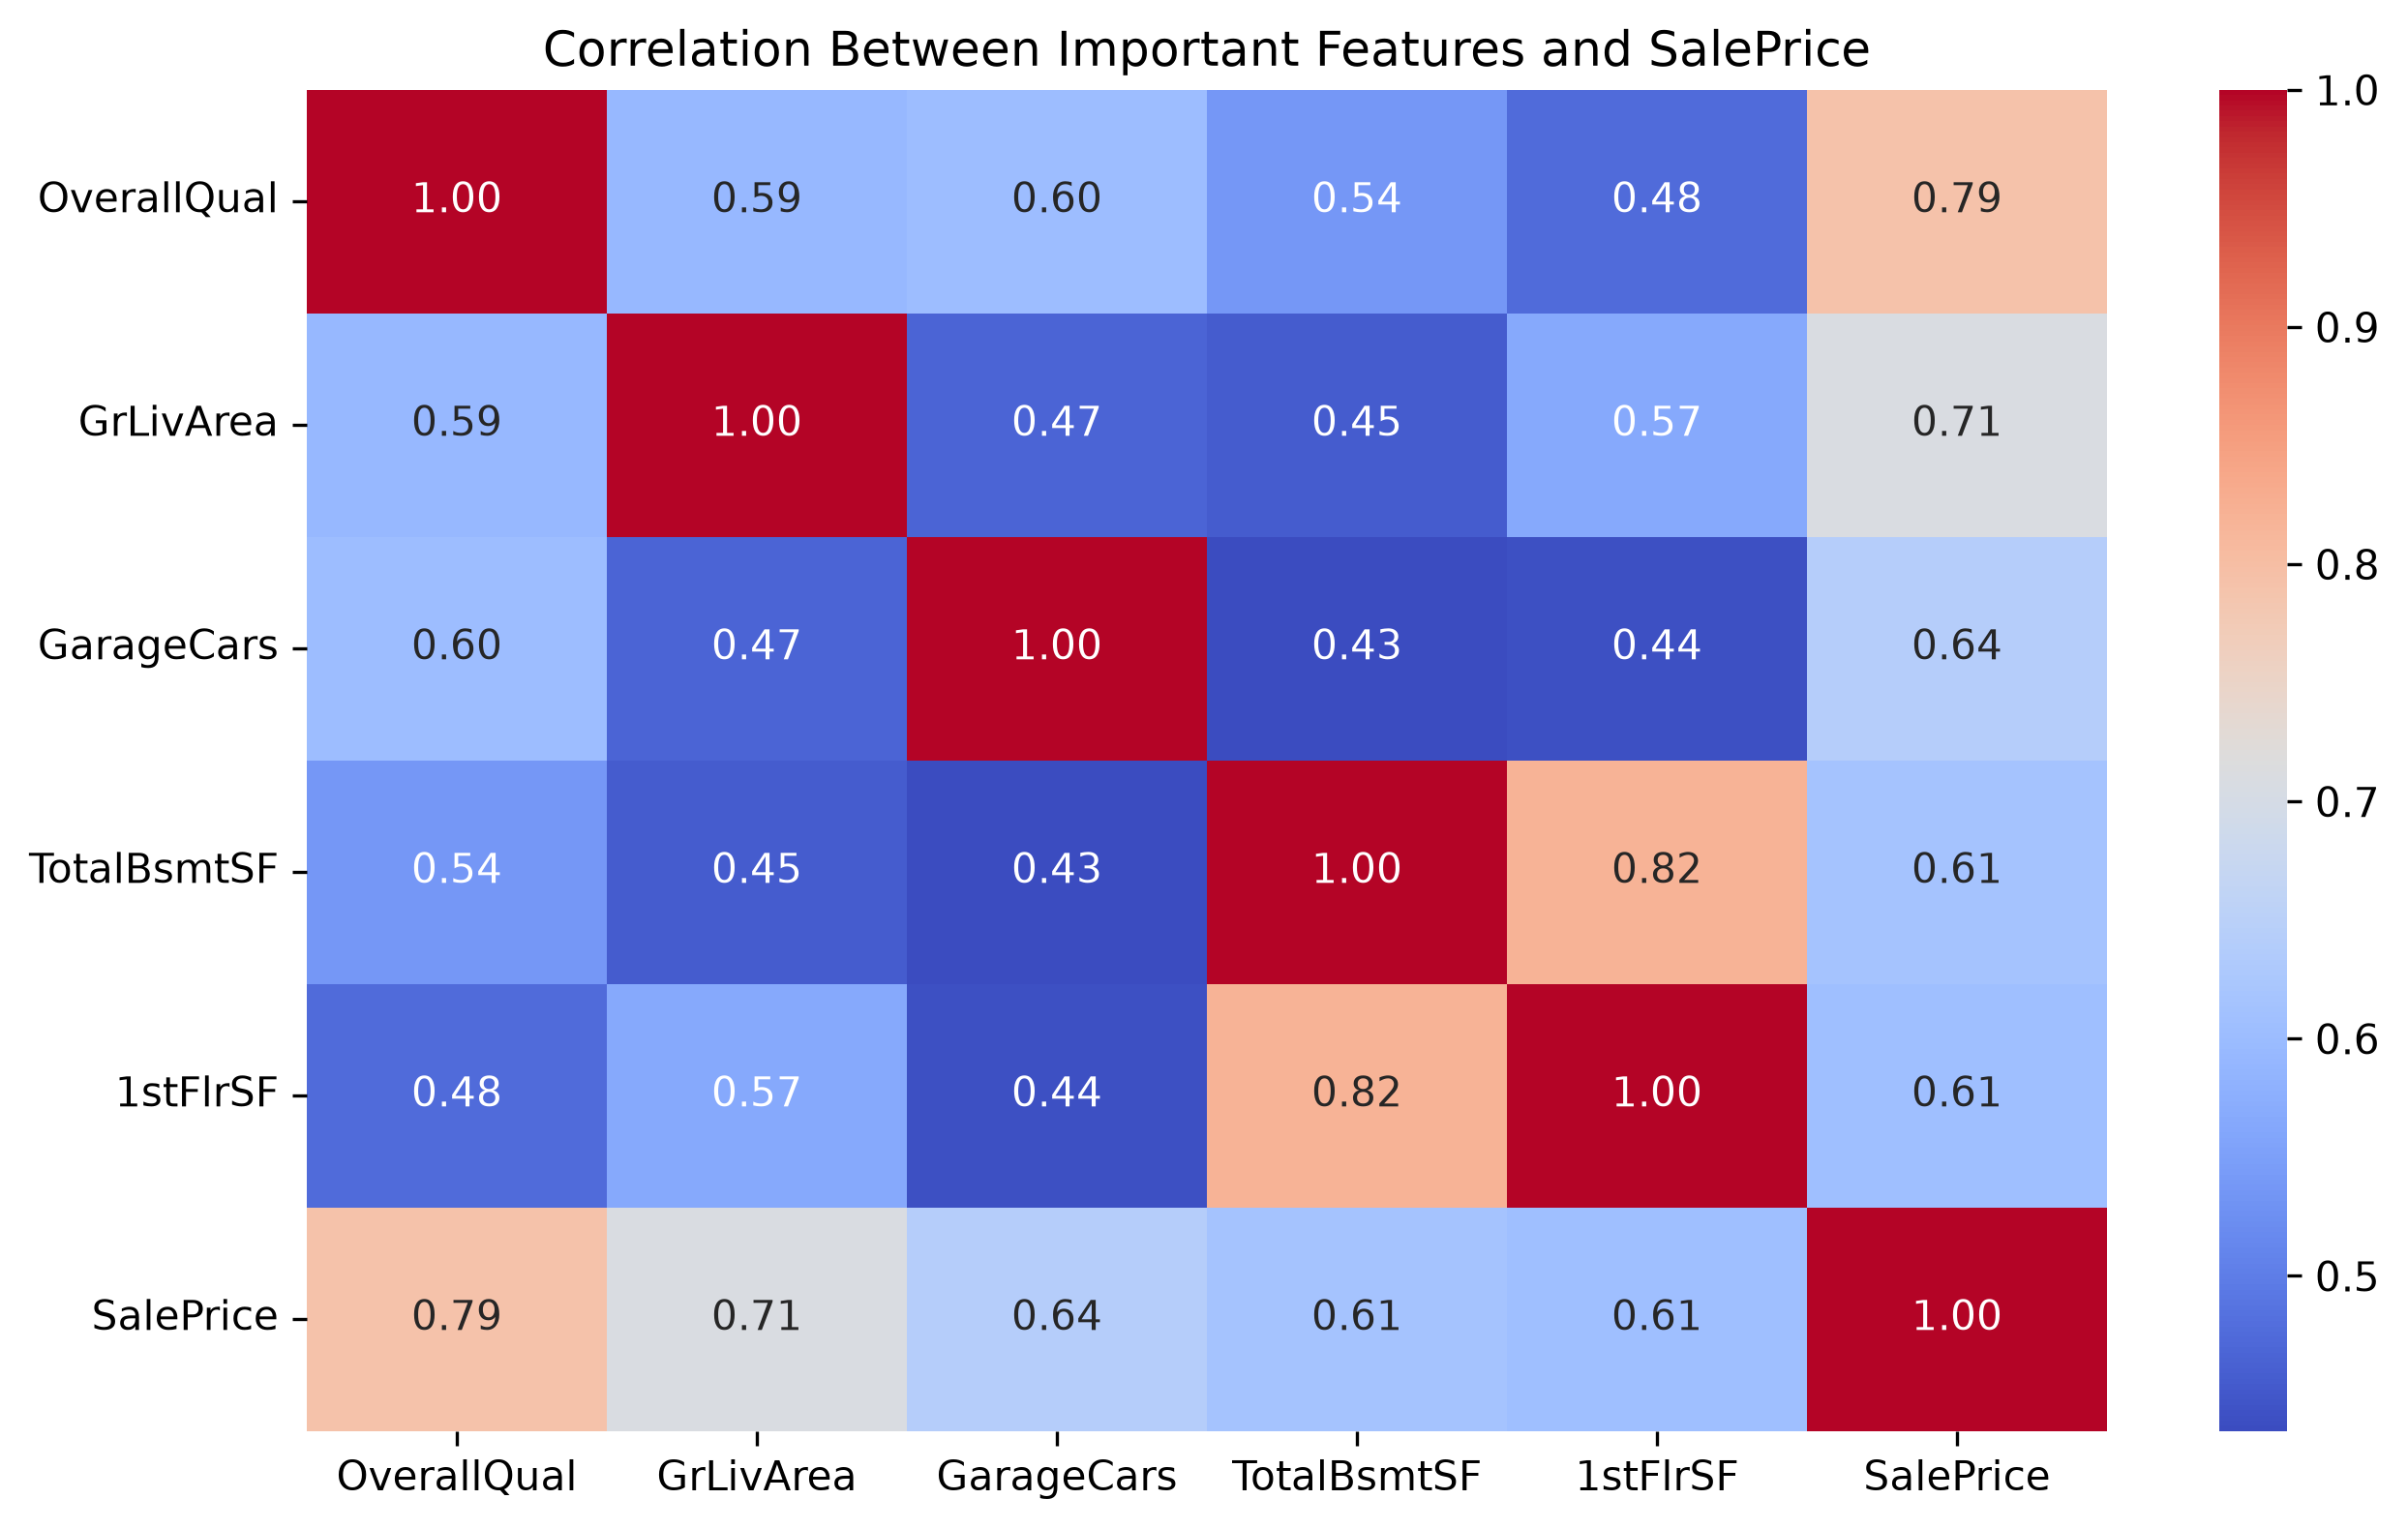
Figure 2: Correlation between key numerical features and SalePrice.

12.3 Overall Quality vs Sale Price
A boxplot of SalePrice grouped by OverallQual (rated on a scale of 1 to 10) shows a clear upward trend: as the overall quality rating increases, the median sale price and its spread both increase substantially, confirming OverallQual as a strong predictor of sale price.
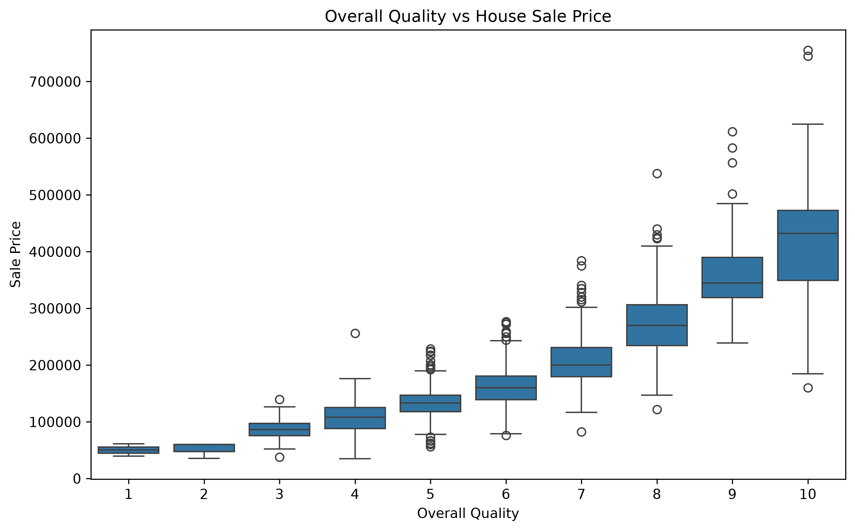
Figure 3: Relationship between overall quality rating and sale price.

12.4 Living Area vs Sale Price
A scatter plot of Above Ground Living Area (GrLivArea) against SalePrice shows a positive relationship — larger living areas are generally associated with higher sale prices — although the relationship shows increasing variance at larger living areas, along with a small number of high-area properties with comparatively lower prices, which appear as outliers in the plot.
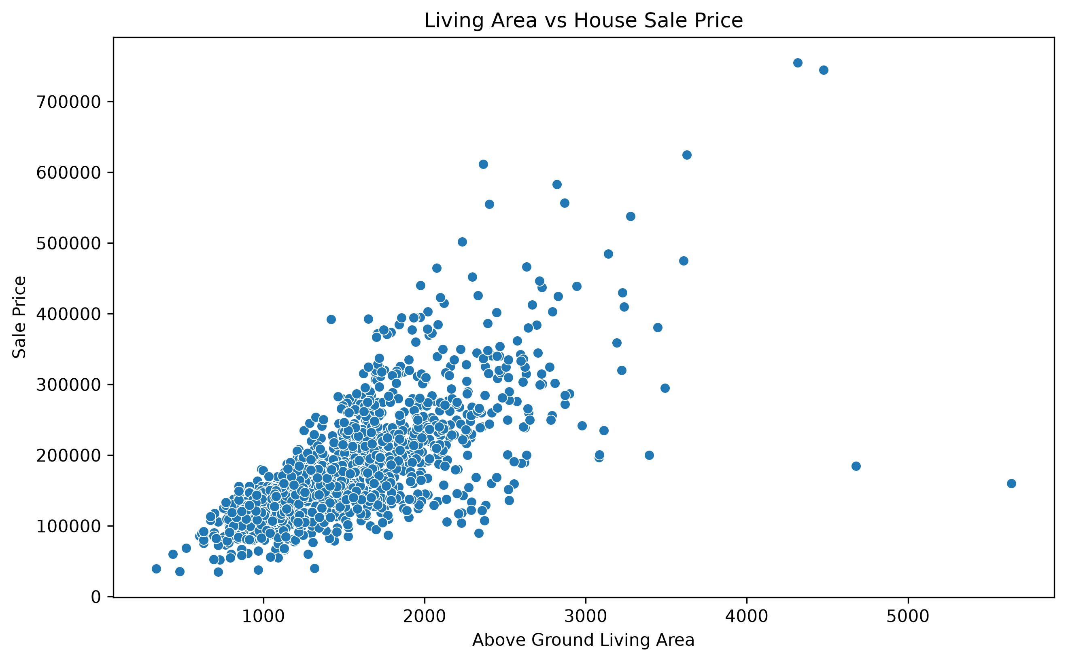
Figure 4: Relationship between above ground living area and sale price.

13. Data Preprocessing
Before model training, the dataset was processed using a Scikit-learn preprocessing pipeline built with ColumnTransformer and Pipeline, ensuring that numerical and categorical features were handled consistently and could be reproduced identically for future predictions.

13.1 Numerical Feature Preprocessing
Missing values in numerical features were imputed using the median strategy (SimpleImputer(strategy="median")). The median was chosen as it is less sensitive to outliers than the mean, which is appropriate for property-related numerical attributes such as lot area and basement area that can contain extreme values.

13.2 Categorical Feature Preprocessing
Missing values in categorical features were imputed using the most-frequent strategy (SimpleImputer(strategy="most_frequent")). Following imputation, categorical features were converted into numerical form using One-Hot Encoding (OneHotEncoder(handle_unknown="ignore")), which creates binary indicator columns for each category while safely handling any categories not seen during training.

13.3 ColumnTransformer and Pipeline
A ColumnTransformer was used to apply the numerical and categorical preprocessing steps to their respective feature subsets in a single, unified transformation step. This preprocessor was then combined with each regression model inside a single Scikit-learn Pipeline object, ensuring that preprocessing and model training were executed consistently for both the Linear Regression and Random Forest Regressor models.

14. Model Development
Two regression models were built and trained, each wrapped in a Scikit-learn Pipeline together with the shared preprocessing steps described in Section 13. The dataset was split into training and testing subsets using an 80:20 ratio with random_state=42.

14.1 Linear Regression
Linear Regression was used as a baseline model. It assumes a linear relationship between the input features and the target variable, SalePrice, and estimates coefficients that minimize the sum of squared errors between predicted and actual values. It was trained using Scikit-learn's LinearRegression() with default parameters.

14.2 Random Forest Regressor
Random Forest Regressor, an ensemble tree-based model, was used as the main predictive model. It builds multiple decision trees on bootstrapped samples of the training data and averages their predictions, which typically improves accuracy and reduces overfitting compared to a single decision tree. The model was configured as follows:
Parameter | Value
n_estimators | 300
random_state | 42
n_jobs | -1

Here, n_estimators=300 specifies that 300 individual decision trees were built in the forest, random_state=42 ensures reproducibility of results, and n_jobs=-1 allows the model to use all available processor cores during training.

15. Model Evaluation
The performance of both regression models was evaluated on the held-out test set (20% of the data) using three standard regression metrics:
- Mean Absolute Error (MAE) — the average absolute difference between predicted and actual sale prices, expressed in dollars.
- Root Mean Squared Error (RMSE) — the square root of the average squared difference between predicted and actual sale prices; it penalizes larger errors more heavily than MAE.
- R² (Coefficient of Determination) — the proportion of variance in the sale price that is explained by the model, ranging from 0 to 1, where values closer to 1 indicate a better fit.
Table 1: Model Performance Comparison
Model | MAE | RMSE | R²
Linear Regression | $20,485.66 | $31,327.80 | 0.8720
Random Forest Regressor | $17,465.29 | $28,554.98 | 0.8937

The Random Forest Regressor outperformed Linear Regression across all three metrics, achieving a lower MAE, a lower RMSE, and a higher R² score. Based on this comparison, the Random Forest Regressor was selected as the final model for this project.

16. Results and Discussion
The final selected model, Random Forest Regressor, achieved the following performance on the test set: MAE of $17,465.29, RMSE of $28,554.98, and R² of 0.8937.
An R² of 0.8937 indicates that approximately 89.4% of the variance in house sale prices in the test set is explained by the model's features. The MAE of $17,465.29 indicates that, on average, the model's predicted sale price differs from the actual sale price by approximately this amount. The RMSE, being larger than the MAE, indicates the presence of some larger prediction errors on specific properties, which is consistent with the wider spread of prediction errors observed for higher-priced houses.
The Actual vs Predicted plot below shows the relationship between the true sale prices and the model's predictions on the test set, with the dashed line representing perfect prediction (where predicted price equals actual price).
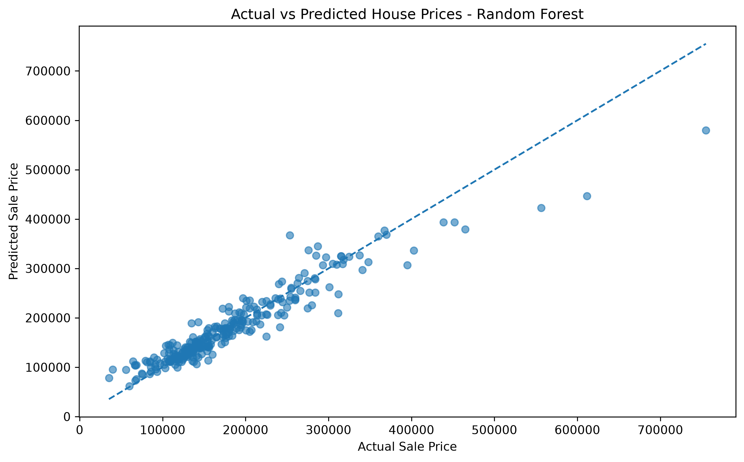
Figure 5: Actual versus predicted house sale prices for the Random Forest model on the test set.
Most points lie close to the diagonal line, indicating generally accurate predictions for the majority of properties, particularly in the lower and mid price ranges. Some deviation is visible for higher-priced properties, where the model tends to underpredict, which is a common characteristic of tree-based models on right-skewed target variables such as SalePrice.
The distribution of prediction errors (actual minus predicted) is shown below. The errors are approximately centered around zero and are more concentrated near zero, with a small number of larger positive and negative errors corresponding to higher-value or atypical properties.
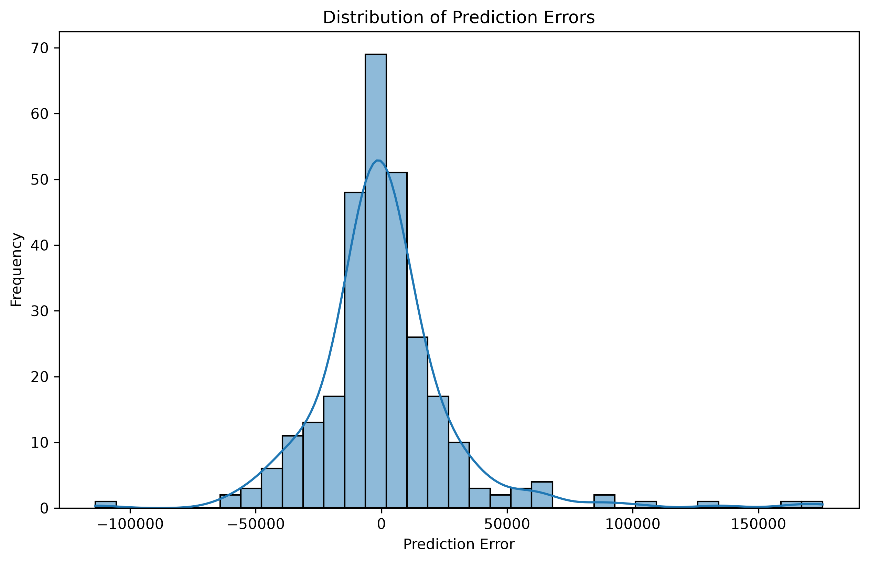
Figure 6: Distribution of prediction errors for the Random Forest model on the test set.
Overall, the results indicate that the Random Forest Regressor provides a reasonably accurate and reliable prediction of house sale prices for this dataset, without exaggerating its real-world accuracy: the model was evaluated only on a held-out test split of the same dataset, and its performance on entirely new, external data has not been assessed.

17. Feature Importance
Feature importance scores were extracted from the trained Random Forest Regressor to understand which features contributed most to its predictions. The top 15 features by importance, as computed directly from the model, are shown below.
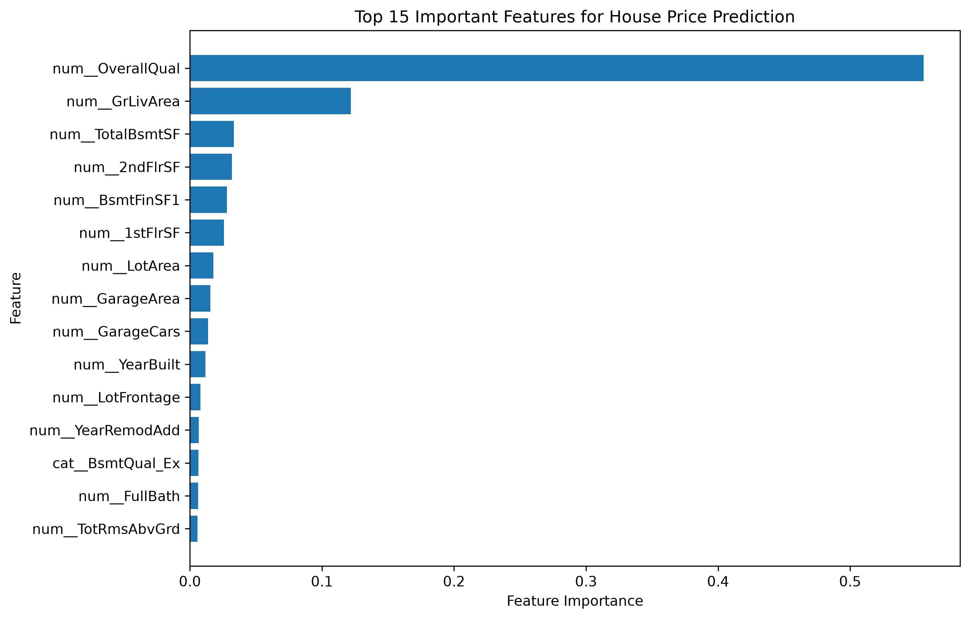
Figure 7: Top 15 important features for house price prediction, as determined by the Random Forest model.
As shown in the figure, num__OverallQual (Overall Quality) is by a clear margin the most important feature in the model, followed by num__GrLivArea (Above Ground Living Area). Other features contributing meaningfully to the model's predictions include TotalBsmtSF, 2ndFlrSF, BsmtFinSF1, 1stFlrSF, LotArea, GarageArea, GarageCars, and YearBuilt, among others shown in the figure.
These findings are consistent with the correlation analysis in Section 12.2, where OverallQual and GrLivArea also showed the strongest correlation with SalePrice, reinforcing that the overall build quality and the size of the living area are the two most influential factors in determining a house's sale price within this dataset.

18. Model Saving and Verification
After confirming that the Random Forest Regressor was the best-performing model based on R² score, it was saved to disk using Joblib so that it could be reused for future predictions without retraining:
models/house_price_prediction_model.pkl
To verify that the saved model was stored correctly, it was reloaded using Joblib and used to generate a prediction on a sample from the test set. The reloaded model produced the same prediction as the original in-memory model, confirming that the model was saved and loaded successfully.

19. Project Structure
The project follows the directory structure below:
House_Price_Prediction_IBM/
├── data/
│ └── train.csv
├── notebooks/
│ └── Rajraushan_House_Price_Prediction_IBM.ipynb
├── models/
│ └── house_price_prediction_model.pkl
├── reports/
│ ├── saleprice_distribution.png
│ ├── correlation_heatmap.png
│ ├── overall_quality_vs_price.png
│ ├── living_area_vs_price.png
│ ├── actual_vs_predicted.png
│ ├── prediction_errors.png
│ └── feature_importance.png
├── requirements.txt
├── README.md
└── .venv/

20. Limitations
- The model's performance is specific to the Kaggle House Prices dataset used in this project and may not generalize directly to housing markets or datasets with different characteristics.
- Evaluation was carried out on a single held-out test split (20% of the data) rather than using cross-validation, so the reported metrics reflect performance on this particular split.
- The current version of the project has not been deployed as an application or web service; the trained model exists only as a saved file for offline use.
- The model could potentially benefit from additional feature engineering, hyperparameter tuning, and treatment of outliers, none of which were performed in the current version of the project.

21. Future Scope
- Hyperparameter tuning of the Random Forest Regressor (e.g., tree depth, number of estimators) to further improve accuracy.
- Applying cross-validation to obtain a more robust estimate of model performance.
- Additional feature engineering, such as creating new derived features from existing ones.
- Outlier treatment for extreme values in features such as living area and lot area.
- Target transformation (e.g., log-transforming SalePrice) to address its right-skewed distribution.
- Testing additional regression algorithms, such as Gradient Boosting or XGBoost, for comparison.
- Deploying the trained model as a web application for interactive use.
- Building an interactive prediction interface that allows users to input property details and receive a predicted sale price.

22. Conclusion
This project successfully implemented an end-to-end machine learning workflow for predicting house sale prices using the Kaggle House Prices: Advanced Regression Techniques dataset. The workflow covered data loading, missing value analysis, exploratory data analysis, a structured preprocessing pipeline for numerical and categorical features, training and comparison of two regression models, detailed evaluation using MAE, RMSE, and R², feature importance analysis, and model persistence.
Between the two models evaluated, the Random Forest Regressor outperformed Linear Regression, achieving an MAE of $17,465.29, an RMSE of $28,554.98, and an R² of 0.8937 on the test set, and was therefore selected and saved as the final model. Feature importance analysis confirmed that Overall Quality and Above Ground Living Area are the most influential predictors of house sale price in this dataset.
This project provided practical, hands-on experience with the complete data analytics and machine learning pipeline, aligning with the objectives of the AICTE | IBM SkillsBuild Academic Internship – Data Analytics with AI, and demonstrates the applicability of machine learning techniques to real-world regression problems such as house price prediction.

23. References
- Kaggle. House Prices: Advanced Regression Techniques Dataset. https://www.kaggle.com/c/house-prices-advanced-regression-techniques
- Python Software Foundation. Python Programming Language. https://www.python.org/
- The Pandas Development Team. Pandas Documentation. https://pandas.pydata.org/docs/
- NumPy Developers. NumPy Documentation. https://numpy.org/doc/
- Matplotlib Development Team. Matplotlib Documentation. https://matplotlib.org/stable/
- Seaborn. Seaborn Statistical Data Visualization Documentation. https://seaborn.pydata.org/
- Scikit-learn Developers. Scikit-learn: Machine Learning in Python. https://scikit-learn.org/stable/
- Joblib Developers. Joblib Documentation. https://joblib.readthedocs.io/
- IBM SkillsBuild / BharatCares. AICTE | IBM SkillsBuild Data Analytics with AI Internship 2026 — Offer Letter and Program Structure.

