Q1)

Q2)

Q3)

Q4)

Q5)

Q6)

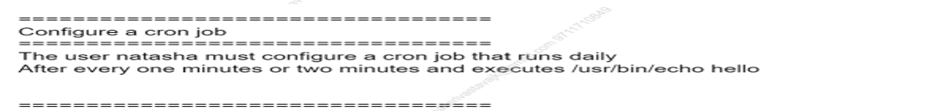

Q7)

Q8)

Q9)

Q10)

Q11)

Q12) 

Q13)

Q14)

Q15)

Q16)

Q17)

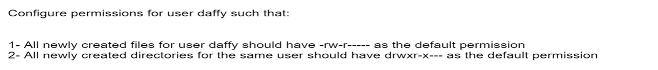

Q18)

Q19)

Q20)

Q21)

Q22)

Q23)

Q24)

