

**SIT TUMKUR, KARNATAKA**

**“Education in Pandemic”**

|  |  |  |
| --- | --- | --- |
| **Team Name** | | |
| **Role** | **Name** | **College Reg. No** |
| Team Leader* | SAHIL RAJ | 1SI20AD022 |
| Member 1* | AKSHATH G | 1SI20AD002 |
| Member 2 | RINKAL RANJAN | 1SI20AD018 |
| Member 3 | GAURI HARSH | 1SI20AD007 |

*Fields should not be empty.

Problem Description

*During this situation of pandemic due to deadly Coronavirus, students are facing difficulties getting education as physical classes are not possible.*

*Although, students are attending online classes, they are not getting the required content and motivation for their studies and interests.*

*The major problems that students are facing nowadays are described below:*

*1.Adaptibility:*

*Students find it difficult to adapt to an online learning environment immediately after traditional classroom learning.*

*2.Technical issues:*

*Many students are not well equipped with a high internet connection that is required for online learning.*

*3.Time management:*

*In many cases students find difficulty in managing their time with online learning. They need a scheduled planner to manage their time in an effective manner.*

*4.Interaction with teachers:*

*Even though online classes are running, students are not getting direct interaction with teachers. Teachers have not yet analysed students of their class which is a major drawback of online classses.*

*5. Centralised study material:*

*Students are not getting notes and documents related to their courses at one place.*

*6.News about events:*

*Many students don’t get to know about different events like recruitment of different clubs and webinars that are organised in the college.*

*7.Proper Guidance:*

*Students don’t just learn from teachers, we learn from seniors and our friends as well. Those students who don’t interact with even friends, are facing stress related issues also.*

Proposed Solution

*To tackle the challenges caused due to this pandemic, our team (SIT_KA_CURIOUSITY) have came up with an idea that focuses on providing education to all, anytime and anywhere.*

*We want to create a website that centralises all the study materials and notes provided by teachers. This website will also contain all the news related to different events so that they will not miss any.*

*Our website would follow the following processes for different problems:*

*1.****Faculty Section****:*

*In this section, teachers, irrespective of their subject of expertise or place of living(any college or state), can provide their resume and our team will provide them platform to teach students available on our platform after proper evaluation.*

*1.****Study materials section****:*

*This section focuses on centralising all the study materials, notes and reference book provided by college at one place regardless of branch or year of the course of any student.*

*2.****QnA section****:*

*This section will help students to interact with teachers, seniors or their batch mates. This will help students to clear their doubts regarding any concept, in which they are facing problem.*

*3.****Clubs section****:*

*This section will provide information about different clubs existing in SIT. Students don’t know about different clubs that are present in the college. Clubs helps students to perform activities in which they are interested and getting better at the same. Clubs also helps students to explore what they want to do and how to do. So, it is important for them to get proper information at one place.*

*4.* ***News section****:*

*This section will provide information about different events and webinars that are organised in the college. This will keep students updated and they won’t miss any event.*

*5.****Tips Section****:*

*In this section students will get tips on different topics from expert seniors so that students can improve their skills.*

*6.* ***Fun Section****:*

*Here students can find problems and games that keep them busy in this pandemic and also makes them stress free.*

*7.* ***Contact Us****:*

*We love criticism, we want our platform to get better over time. In this section people can contact with our team members and they can all add any queries and suggestions, so that this platform improves and we can reach even higher number of people and serve their needs.*

*8.****Find Your Mentor****:*

*Here, seniors who are interested in sharing their knowledge in their respective field of expertise can interact with eager learner. Seniors can provide required information and students can directly interact with them. It will help both of them to sharpen their skills.*

*We also have few more ideas that may be implemented in two days or may not be implemented like adding a funtionalities like video conferencing, etc.*

*This website will provide them a every information about their course studies and it would be fun place too, students can interact, learn and motivate at the same place.*

*Even if they will miss out their class due to some technical issues, they can get all the required information at one place.*

***Our Goal****:*

*We always want to solve real world problems in a fun oriented aproach.*

Technology Stack

|  |  |
| --- | --- |
| Python | We will use python as object-oriented programming for creating the app. |
| Flask | We will use flask for creating web -based application. |
| HTML | We will use HTML for creating webpages. |
| CSS | For styling of our web-site we will be using CSS. |
| VS-CODE | We will use Vs-Code as IDE. |
| SQL | We will use SQL for creating databases for creating QnA section. |
| Java-Script | We will use little bit of JS also. |
| Heroku | We will use Heroku platform to deploy our website. |
| Git and Git-hub | We will use git-hub to create repositories and all members will be able to access the code. |

Use Case Scenario

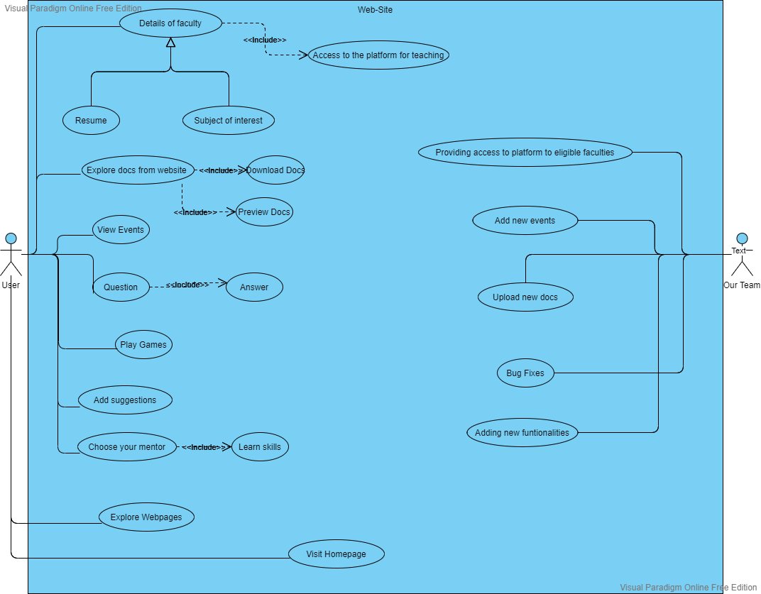

Contact Details

Team Leader: Sahil Raj

Email : rajsahilcoder@gmail.com

Phone : 9693438548

Member1 Name: Akshath G

Email : akshathg4268@gmail.com

Phone : 8748948411

Member2 Name: Rinkal Ranjan

Email : rinkalranjan2468@gmail.com

Phone : 9113467072

Member3 Name: Gauri Harsh

Email : gauri3235@gmail.com

Phone : 8917826372

*Fields should not be empty.