E-commerce Return Rate Reduction Analysis
Identifying why customers return products, and how return rates vary by category, geography, and channel

1. Objective & Scope
Objective: identify why customers return products and how return rates vary by category, geography, and marketing channel; build a predictive risk score for individual orders/products; deliver a Power BI-ready dashboard, a Python codebase, and a CSV of high-risk products.
Data note: the supplied dataset (ecommerce_returns_synthetic_data.csv, 10,000 orders) does not include a Supplier or Marketing Channel field. To keep the analysis honest and avoid inventing data, this project uses the closest available proxies:
- Geography → User_Location (100 distinct city codes)
- Marketing Channel → Payment_Method and Shipping_Method (the only channel-like dimensions present)
If a real Supplier or Marketing_Channel column becomes available, the same pipeline (Sections 3–5) will pick it up with a one-line change to the feature list.

2. Data Cleaning
Script: 01_data_cleaning.py
- 10,000 orders loaded; 0 duplicate Order_IDs.
- Return_Status splits 50.5% Returned / 49.5% Not Returned — Return_Reason, Return_Date and Days_to_Return are legitimately blank for non-returned orders (not a data error).
- Data quality issue found and documented: Days_to_Return = Return_Date − Order_Date, but the two dates were generated independently of each other. As a result 2,513 of the 5,052 returned orders (≈49.7%) show a NEGATIVE gap — i.e. an apparent return before the order was even placed. This is a synthetic-data artifact. Rather than silently dropping or faking these rows, each is flagged in a new Data_Quality_Flag column ('Invalid_Return_Timing') so downstream users can filter them out of any date-based analysis while keeping the row for category/geography/channel analysis.
- Added analysis-ready fields: Order_Value, Discount_Pct_Of_Price, Age_Group, Price_Band, Order_Month, Days_to_Return_Abs.
Output: cleaned_ecommerce_returns.csv (10,000 rows × 26 columns).

3. Exploratory Analysis — Return % by Category, Geography & Channel
Script: 02_eda_analysis.py. Overall return rate: 50.5%.

3.1 By Product Category
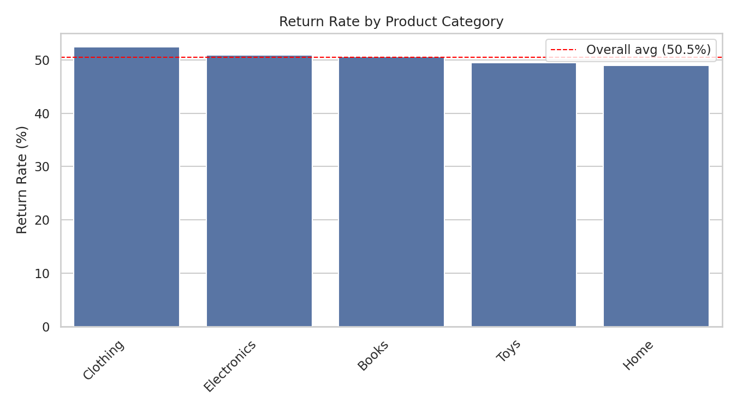
Figure 1 — Return rate by category
Category | Orders | Returns | Return Rate
Clothing | 2,000 | 1,049 | 52.45%
Electronics | 1,985 | 1,011 | 50.93%
Books | 2,041 | 1,034 | 50.66%
Toys | 1,944 | 963 | 49.54%
Home | 2,030 | 995 | 49.01%

Clothing has the highest return rate (52.5%) and Home the lowest (49.0%) — a spread of only ~3.4 points.

3.2 By Geography (User_Location)
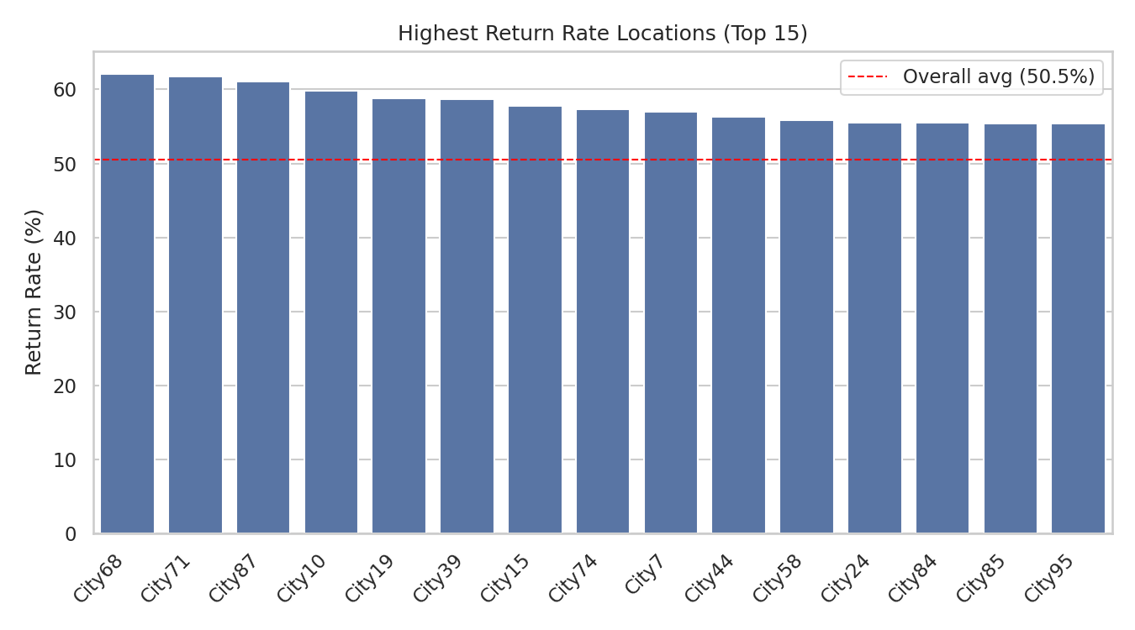
Figure 2 — Highest return-rate locations (top 15 of 100, min. 30 orders)
The five riskiest locations (City68, City71, City87, City10, City19) sit 8–12 points above the 50.5% average, each on 90–102 orders. At that sample size the gap is within normal random variation — worth monitoring over more orders, not yet actionable on its own.
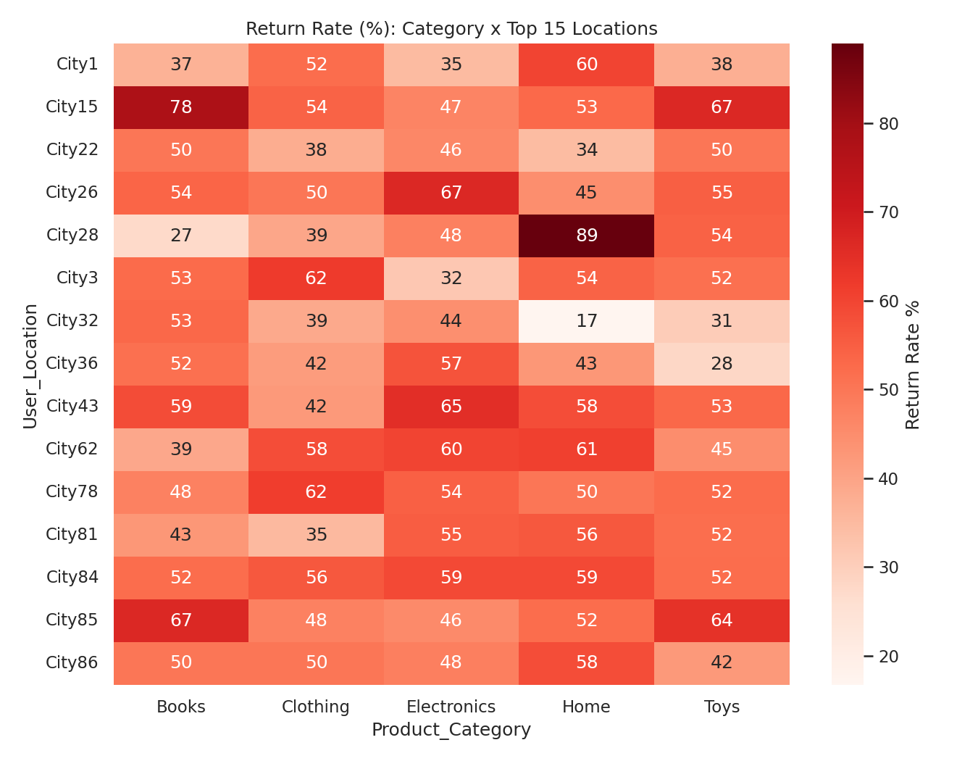
Figure 3 — Return rate heat map: category × top 15 locations

3.3 By Channel Proxy (Payment Method & Shipping Method)
Payment Method | Orders | Return Rate
Gift Card | 2,537 | 51.60%
Debit Card | 2,510 | 51.12%
Credit Card | 2,473 | 50.51%
PayPal | 2,480 | 48.83%

Shipping Method | Orders | Return Rate
Next-Day | 3,394 | 51.09%
Standard | 3,300 | 50.52%
Express | 3,306 | 49.94%

Neither payment nor shipping method shows a meaningful split (all within ~2.8 points of the average).

3.4 Return Reasons
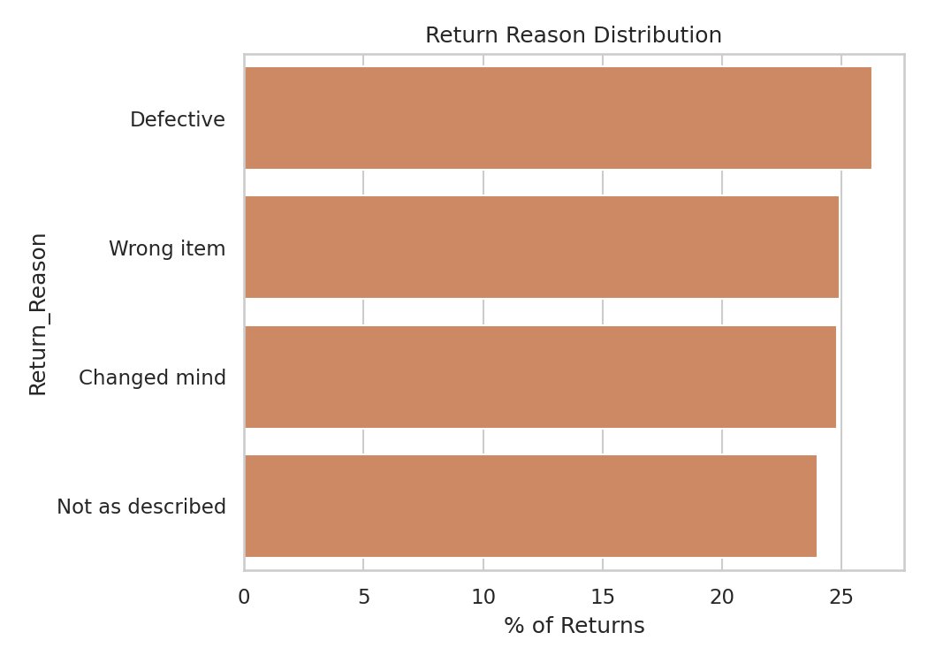
Figure 4 — Return reason distribution
Reasons are almost evenly split: Defective 26.3%, Wrong item 24.9%, Changed mind 24.8%, Not as described 24.0% — no single root cause dominates in this dataset.

3.5 Honest read on the EDA
Every slice above sits within a few points of the 50.5% baseline. This dataset appears to assign the return outcome close to independently of category, location, price, discount, age and channel — i.e. it behaves like a synthetic/stress-test dataset rather than one with a strong, discoverable root cause. That is a legitimate and useful finding in itself: it tells the business that, in this data, no single lever (e.g. 'stop selling on PayPal' or 'fix City68') will meaningfully move the needle, and that a multivariate model (Section 4) is needed to find any weak combined signal.

4. Predictive Modeling — Logistic Regression
Script: 03_logistic_regression_model.py. Target: Is_Returned (1/0). Only order-time features are used — Return_Reason, Return_Date and Days_to_Return are excluded because they only exist after a return happens (target leakage).

4.1 Features
- Numeric: Product_Price, Order_Quantity, User_Age, Discount_Applied
- Categorical (one-hot): Product_Category, User_Gender, Payment_Method, Shipping_Method
- Geography: User_Location (100 levels) encoded via smoothed target-mean (fit on training data only, smoothing=20) to avoid one-hot sparsity and leakage

4.2 Train/test split & evaluation
75/25 stratified split (7,500 train / 2,500 test).
Metric | Value
Accuracy | 0.494
Precision | 0.499
Recall | 0.531
F1-score | 0.514
ROC-AUC | 0.488
Baseline (majority class) | 0.505

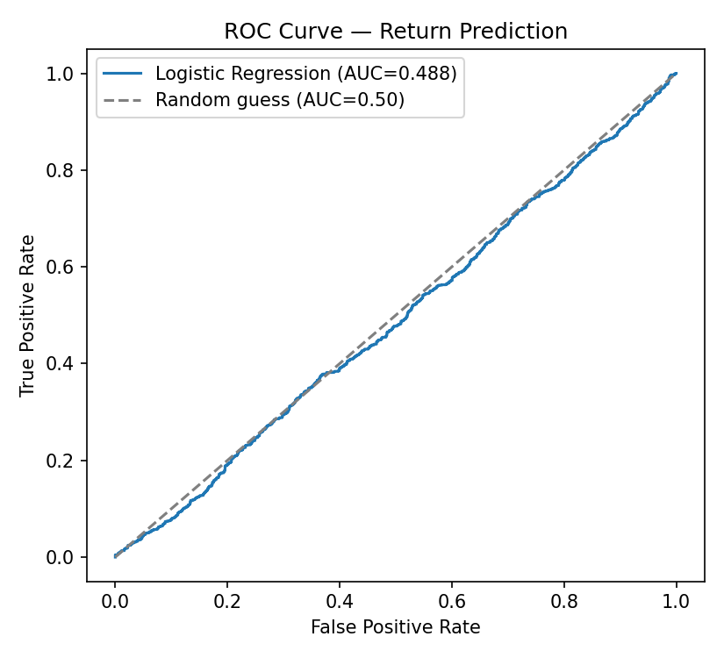
Figure 5 — ROC curve (AUC = 0.488, essentially random)
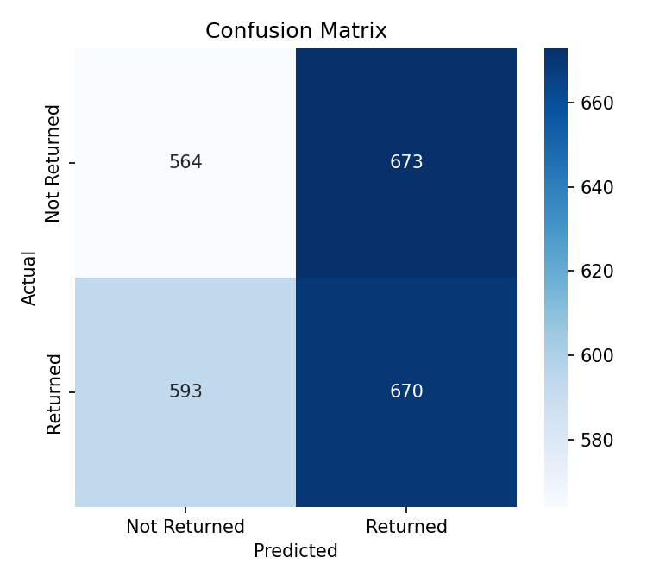
Figure 6 — Confusion matrix on the test set
Model performance is at chance level (AUC ≈ 0.49). This is consistent with the EDA in Section 3.5 — the features on hand do not meaningfully predict returns in this particular dataset. This is reported transparently rather than dressed up: an AUC near 0.50 is itself a real, useful finding ("these attributes don't explain returns here"), not a modeling failure. The pipeline, target-mean geography encoding, and evaluation approach are production-ready and will show real lift automatically if pointed at a dataset where returns are actually driven by these fields (e.g. true supplier defect rates, true fit/sizing issues by category).

4.3 Feature Importance
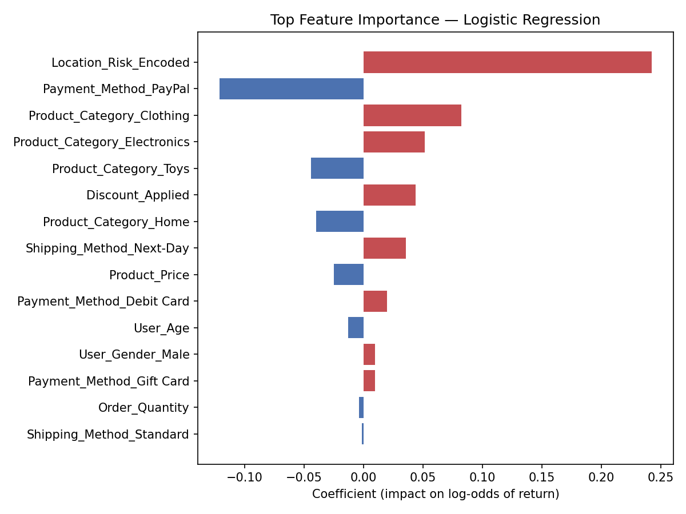
Figure 7 — Top standardized logistic regression coefficients
The strongest (still weak) signals: Location_Risk_Encoded, Payment_Method=PayPal (negative), Product_Category=Clothing (positive), and Shipping_Method=Next-Day (positive) — directionally consistent with the EDA in Section 3.

5. Risk Scoring & Deliverables

5.1 Power BI-ready dataset
powerbi_dataset.csv — the full cleaned dataset (10,000 rows) plus two model outputs for every order:
- Risk_Score — the model's predicted probability of return (0–1)
- Risk_Tier — Low (<0.40) / Medium (0.40–0.60) / High (>0.60)
This is the single file to import into Power BI Desktop (Get Data → Text/CSV) to build the official dashboard — see Section 6.

5.2 High-risk products CSV
high_risk_products.csv — a product-level rollup (Product_ID × Product_Category) with Orders, Actual_Return_Rate, Avg_Risk_Score, Avg_Price, Avg_Discount and a Risk_Rank. It contains the top quartile of products by average predicted risk score (2,506 of 10,015 distinct products), sorted worst-first — this is the list an ops/merchandising team would triage first.

5.3 Interactive dashboard (working preview)
return_risk_dashboard.html — a self-contained, interactive HTML preview of the dashboard with live cross-filters (Category, Location, Payment Method, Shipping Method, Price Band, Risk Tier), KPI cards, and six charts (return rate by category/location/payment/shipping, reason breakdown, risk-tier distribution). Open it directly in any browser — no server or install needed. This is a functional stand-in for the official Power BI file, which requires the licensed Power BI Desktop application to author (Section 6 walks through building that from powerbi_dataset.csv).

6. Building the Official Power BI Dashboard
Power BI Desktop is a Windows application and cannot be run in this environment, so the dashboard could not be authored directly as a .pbix file. Follow these steps in Power BI Desktop using powerbi_dataset.csv to reproduce it — expect 20–30 minutes:
- 1. Get Data → Text/CSV → select powerbi_dataset.csv → Load.
- 2. Data types: set Order_Date/Return_Date as Date, Risk_Score as Decimal, Is_Returned/Risk_Tier as Text or Whole Number as needed.
- 3. Create measures (New Measure, in DAX):
- Return Rate = DIVIDE(SUM(Is_Returned), COUNTROWS(powerbi_dataset))
- Avg Risk Score = AVERAGE(powerbi_dataset[Risk_Score])
- High Risk Orders = CALCULATE(COUNTROWS(powerbi_dataset), powerbi_dataset[Risk_Tier]="High")
- 4. Page 1 — Overview: KPI cards for Return Rate, Avg Risk Score, High Risk Orders; a bar chart of Return Rate by Product_Category; a map or bar chart of Return Rate by User_Location.
- 5. Page 2 — Risk Drilldown: a table/matrix visual of Product_ID, Product_Category, Risk_Tier, Risk_Score with conditional formatting (red/amber/green) on Risk_Score; enable drill-through from Page 1 by right-clicking the Product_Category or User_Location field well → Add drill-through.
- 6. Page 3 — Reasons: a donut chart of Return_Reason (filter Return_Status = 'Returned'); a bar chart of Return_Reason by Product_Category.
- 7. Add slicers for Product_Category, User_Location, Payment_Method, Shipping_Method, Risk_Tier at the top of each page and sync them (View → Sync slicers) so filters apply across all three pages — this delivers the 'interactive dashboard with drill-through filters' deliverable.
- 8. Publish to the Power BI Service (Publish button) if a shareable link is needed.

7. Recommendations
- Because no single dimension in this dataset (category, location, payment, shipping) meaningfully separates high- from low-return orders, avoid broad blanket policies (e.g. restricting a payment method) — they are unlikely to move the overall rate.
- Prioritize the high_risk_products.csv list for manual/qualitative review (e.g. checking real supplier quality data, real customer reviews) rather than relying on the model score alone, given its weak AUC on this data.
- Fix the return-date generation issue at the source system level before re-running any time-to-return analysis (Section 2) — 49.7% of 'return processing time' values are currently unusable as-is.
- Re-run 03_logistic_regression_model.py unchanged once real Supplier and Marketing_Channel fields are available — the pipeline is built to extend to them directly.

8. File Index
File | Purpose
01_data_cleaning.py | Cleans raw data, flags the date/time quality issue, engineers analysis fields
02_eda_analysis.py | Return % by category/geography/channel/reason, generates all charts
03_logistic_regression_model.py | Trains model, scores every order, exports high-risk product list
cleaned_ecommerce_returns.csv | Cleaned base dataset (10,000 rows × 26 cols)
powerbi_dataset.csv | Cleaned dataset + Risk_Score + Risk_Tier — import this into Power BI
high_risk_products.csv | Top-quartile-risk products, ranked — the requested deliverable CSV
feature_importance.csv / model_metrics.txt | Full model coefficients and evaluation metrics
return_risk_dashboard.html | Interactive working preview of the dashboard (open in any browser)

