NSW HSC Software Engineering
Year 12 | 2022 NESA Syllabus

Software Automation
Complete Study Notes — Band 6 Depth
Algorithms in Machine Learning · Programming for Automation · Significance and Impact of ML and AI
Version 3 | Enhanced for Clarity, Depth and HSC Exam Readiness
This v3 edition retains the full Band 6 content from v2 and adds: richer explanations with stronger analogies; additional Australian and international case studies; an enriched bias section with named real-world examples (including the Algorithmic Justice League and Twitter's image-cropping algorithm); updated employment statistics from the World Economic Forum; and explicit links to Australia's AI Ethics Framework. All additions are drawn strictly from current course-relevant source material.

Syllabus Outcomes Addressed
SE-12-01 justifies methods used to plan, develop and engineer software solutions
SE-12-02 applies structural elements to develop programming code
SE-12-03 analyses how current hardware, software and emerging technologies influence the development of software engineering solutions
SE-12-04 evaluates practices to safely and securely collect, use and store data
SE-12-05 explains the social, ethical and legal implications of software engineering on the individual, society and the environment
SE-12-06 justifies the selection and use of tools and resources to design, develop, manage and evaluate software
SE-12-07 designs, develops and implements safe and secure programming solutions
SE-12-08 tests and evaluates language structures to refine code
SE-12-09 applies methods to manage and document the development of a software project

Section 1: Algorithms in Machine Learning
This section develops foundational knowledge of machine learning theory, exploring how ML enables automation, the nature of ML training models, key algorithms and their applications, and the tools software engineers use to design and analyse ML systems.

Dot Point 1 — Investigate how machine learning (ML) supports automation through the use of DevOps, robotic process automation (RPA) and business process automation (BPA)
Background: What is Automation in Software Engineering?
Automation in software engineering refers to the use of technology to perform processes that would otherwise require manual human effort, with minimal or no human intervention at runtime. Machine learning extends the reach of automation by enabling systems to handle variability, uncertainty and complexity in data — tasks that simple rule-based scripts cannot address. ML-powered automation can learn from new data over time, adapting its behaviour without being explicitly reprogrammed.
A key distinction worth understanding from the start: in a traditional (rule-based) program, a developer writes explicit instructions for every possible scenario — "if X then do Y." In an ML-powered automation system, the developer instead provides the machine with many examples of data and desired outcomes, and the system works out the rules itself. This is what makes ML-powered automation so much more powerful for complex, real-world problems.
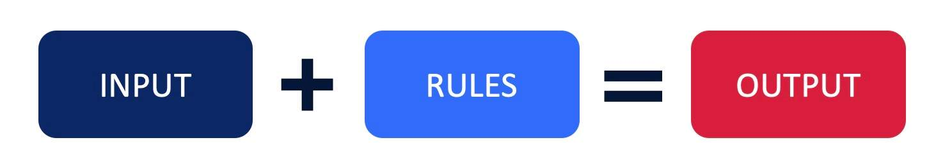
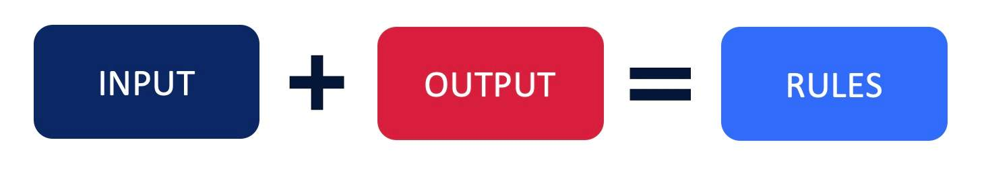
DevOps and MLOps
DevOps | A set of cultural, organisational and technical practices that combine software Development (Dev) and IT Operations (Ops) to shorten the development lifecycle, enable continuous integration and continuous delivery (CI/CD), and produce high-quality software reliably at scale.
Continuous Integration (CI):
Developers frequently merge code into a shared repository, where it is automatically built and tested to catch problems early.
Continuous Delivery (CD):
After CI, code that passes tests is automatically prepared for release, so it’s always ready to deploy.
✅ In short:
- CI = test code continuously
- CD = keep code ready to release

MLOps | The application of DevOps principles specifically to machine learning systems: the automated process of designing, training and deploying ML models. MLOps bridges the gap between data scientists (who build ML models) and operational teams (who deploy and support them in production).
MLOps is the automated process of designing, training and deploying machine learning models. It borrows many of the same principles and practices used in DevOps, bringing together the teams involved in developing machine learning models and the operational teams involved in deploying and supporting the models in production.
MLOps is structured around three overlapping stages that form a continuous cycle:
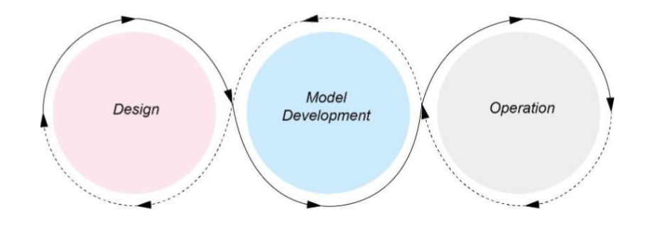
Design Stage | Model Development Stage | Operations Stage
Define the business problem to be solved | Data wrangling: cleaning, transforming and normalising raw data | Deploy the trained model to a production environment
Refactor the business problem into a machine learning problem | Feature engineering: selecting and creating the most useful input variables for the model | Support ongoing operations and respond to usage patterns
Define success metrics (e.g. accuracy, F1-score, RMSE) | Model training: fitting the chosen algorithm to the training dataset | Monitor model performance and detect degradation (model drift)
Research available data sources and assess data quality | Model testing and validation: evaluating performance on a held-out test dataset | Retrain or retune the model when performance falls below defined thresholds

Robotic Process Automation (RPA)
RPA | A form of software automation in which software 'robots' (bots) are configured to mimic the actions of a human user interacting with digital systems — such as logging into applications, reading and entering data, copying records between systems, and generating reports. RPA operates at the user-interface level.

RPA is best suited to high-volume, repetitive, rule-based tasks using structured data. When ML is integrated with RPA, bots gain the ability to handle unstructured data (e.g. extracting information from scanned PDFs using optical character recognition) and make data-driven decisions based on predicted outcomes, extending automation beyond purely scripted workflows.
- Real-world example: A bank configures RPA bots to process loan applications: the bot logs into the document system, extracts applicant data from uploaded files, validates it against the customer database, pre-fills the application form and forwards completed applications to a credit officer. Tasks that previously required several hours of manual data entry are completed in seconds.

Business Process Automation (BPA)
BPA | The use of technology to automate complex, multi-step business processes that span multiple systems, departments and decision points. Unlike RPA, which automates individual tasks at the UI level, BPA automates entire end-to-end workflows through back-end integration with APIs and databases.

When ML is embedded within BPA, the system can make intelligent decisions at each workflow stage, handle exceptions, adapt to new scenarios and continuously improve through operational feedback. This enables organisations to automate processes that require context-aware judgement, not just rule-following.
- Real-world example: A retail supply chain uses ML-powered BPA to automate the entire process from demand forecasting (predicting what products to order) through purchase order generation, supplier communication, logistics scheduling and inventory update — with no manual intervention at any stage unless an exception threshold is breached.

 | RPA | BPA
Scope | Automates individual, repetitive, rule-based tasks | Automates entire end-to-end business workflows
Integration | Operates at the user interface level, mimicking human actions | Integrates with back-end systems through APIs and databases
Data type | Best suited to structured, predictable data | Can manage complex logic, decisions, exceptions and branching
Span | Does not inherently span multiple departments or systems | Designed to coordinate multiple systems and stakeholders
Example | Copying records between two internal databases | End-to-end supply chain management from order to delivery

📌 Exam Tip
When a question asks you to explain how ML supports automation, you must address all three: DevOps/MLOps, RPA and BPA. Use specific terminology for each (e.g. CI/CD pipeline for DevOps; UI-level bots for RPA; end-to-end workflow integration for BPA). A Band 6 response will also explain how ML enhances each approach beyond simple rule-based automation.

Exam Ready Paragraphs
Machine learning (ML) supports automation in software development and operations most prominently through MLOps, which is the automated process of designing, training, and deploying ML models within a DevOps pipeline. MLOps extends traditional DevOps principles by uniting development teams and operational teams across three stages: Design, which involves defining the business problem, establishing success metrics, and researching available data; Model Development, which encompasses data wrangling, feature engineering, model training, and validation; and Operations, which covers model deployment, ongoing support, and continuous monitoring of model performance. By integrating ML-powered tools into the DevOps pipeline, organisations can automate security testing, code scanning, and vulnerability detection, enabling rapid feedback loops and reducing the risk of exploitable weaknesses entering production. ML algorithms further enhance DevOps by performing anomaly detection across system logs and network traffic, allowing the pipeline to self-correct and flag deviations without manual intervention. This continuous, automated quality assurance cycle significantly improves both software reliability and deployment velocity.
ML also strengthens automation across Robotic Process Automation (RPA) and Business Process Automation (BPA). In RPA environments, ML algorithms continuously monitor bot behaviour in real time, detecting anomalies or deviations from normal operation that may indicate a security threat or process failure; this allows the system to respond to incidents faster than any manual oversight model could achieve. ML can further optimise RPA bot performance by analysing interaction data to identify inefficiencies and recommend enhancements to task execution. In BPA workflows, ML supports automation through predictive analysis, identifying vulnerabilities in business processes before they are exploited and automating risk mitigation in response. Automated compliance monitoring, enabled by ML, ensures that BPA processes continuously satisfy regulatory requirements without human intervention. Together, ML-driven RPA and BPA reduce operational cost, increase process accuracy, and enable organisations to scale automation confidently while maintaining security and compliance standards.

Exam Tip: If the question provides a stimulus or scenario (such as the QuidantCon proposal format seen in the 2025 HSC), you must anchor each paragraph to the scenario. Name the specific slide or feature being discussed, then explain how ML supports that automation mechanism using the terminology above — do not write generically.

Dot Point 2 — Distinguish between artificial intelligence (AI) and ML
Definitions
Artificial Intelligence (AI) | The broad field of computer science concerned with building systems capable of performing tasks that would normally require human intelligence, such as reasoning, language understanding, perception, problem-solving and decision-making.
https://www.youtube.com/watch?v=5mHxO2JpCR0
Machine Learning (ML) | A specific subset of AI in which a system is trained to learn patterns from data and improve its performance on a task over time, without being explicitly reprogrammed. The system identifies statistical patterns in training data and applies those patterns to new, unseen data.
https://youtu.be/ob_p9qARjJo?si=o32DeYMifhELvj7a
The relationship between AI and ML is hierarchical: all machine learning is a form of artificial intelligence, but not all artificial intelligence involves machine learning. For example, a rule-based expert system that uses hard-coded if-then logic is AI but not ML; a neural network that learns to recognise images from labelled examples is both AI and ML.
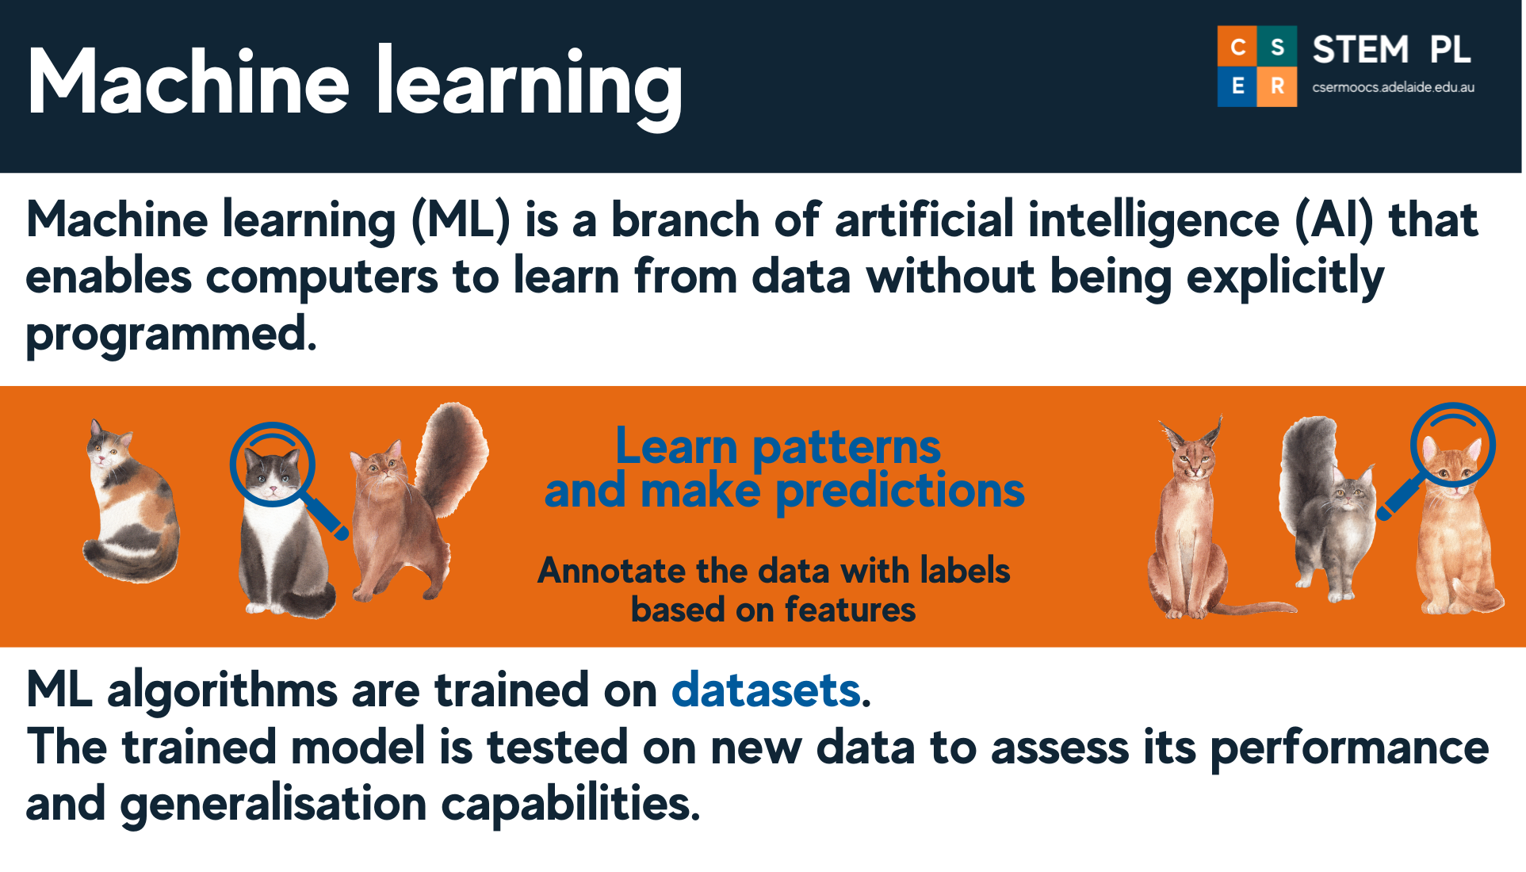
🔍 The AI Hierarchy — Clarifying the Nested Relationship
Understanding the full hierarchy helps you answer "distinguish" questions with precision. Think of it as nested subsets:
- Artificial Intelligence (AI) — the broadest category. Any technique enabling a machine to exhibit intelligent behaviour. Includes rule-based systems, search algorithms, AND machine learning.
- Machine Learning (ML) — a subset of AI. The system learns patterns from data rather than following explicit rules. Performance generally improves with more data.
- Deep Learning (DL) — a subset of ML. Uses neural networks with multiple ('deep') layers to learn complex, non-linear patterns. Especially powerful for images, audio and text.
- Generative AI — a subset of deep learning. Focused on creating new content (text, images, audio, code) by learning patterns from training data. Examples: ChatGPT, DALL-E, Stable Diffusion.
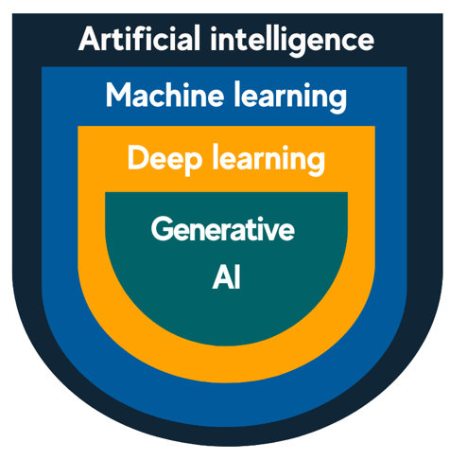
Analogy: AI is like the sport of athletics. ML is like running. Deep learning is like sprinting. Generative AI is like the 100-metre sprint — a specific, highly specialised form at the core of current excitement.

 | Artificial Intelligence (AI) | Machine Learning (ML)
Scope | Broad field: any technique enabling machines to exhibit intelligent behaviour | A specific technique within AI: learns from data rather than following explicit rules
Rules | Can use hard-coded rules, logic, knowledge bases or search algorithms | Uses statistical algorithms trained on datasets to find patterns
Data effect | Performance does not necessarily improve with more data | Performance generally improves as more representative training data is provided
Learning | May not involve any learning from experience | Learning from experience (data) is the defining characteristic
Example (AI, not ML) | Rule-based chatbot following a scripted decision tree | —
Example (both) | Any neural network or ML model | Spam filter that learns from patterns in labelled emails

⚠️ Common Student Mistake
Students frequently write that ML is the same as AI, or treat AI as if it exclusively means ML. Always clarify: AI is the broad category; ML is one approach within it. In the HSC, distinguishing them requires you to name the key difference — ML systems learn from data; AI systems may not. A strong response also notes that deep learning and generative AI are further nested subsets.

Dot Point 3 — Explore models of training ML — supervised, unsupervised, semi-supervised, reinforcement learning
Overview
The way a machine learning model is trained determines what kinds of problems it can solve and what data it requires. The four main training models differ in how labelled the training data is and what the source of the learning signal is. A useful way to think about it: supervised learning is like studying with an answer key; unsupervised learning is like reading without one; semi-supervised is like having an answer key for only a few questions; reinforcement learning is like learning a game by playing it.

Supervised Learning
Supervised Learning | A training model in which the dataset consists of input–output pairs, where each input is paired with a known, correct output label. The model learns a mapping from inputs to outputs by minimising prediction error against the known labels.

- Why it works: The model adjusts its internal parameters iteratively, comparing its predictions to the ground-truth labels and reducing the difference (error) through optimisation techniques such as gradient descent.
- Use cases: Classification (e.g. fraud detection, email spam filtering, image recognition) and regression (e.g. house price prediction, sales forecasting).
- Real-world example: A spam filter is trained on thousands of emails labelled 'spam' or 'not spam'. The model learns which features (certain words, sender patterns, link density) correlate with spam, then classifies incoming emails automatically. New emails — never seen during training — are classified based on the learned patterns.
- Limitation: Requires a large, accurately labelled dataset. Labelling is expensive and time-consuming; incorrect labels degrade model quality.
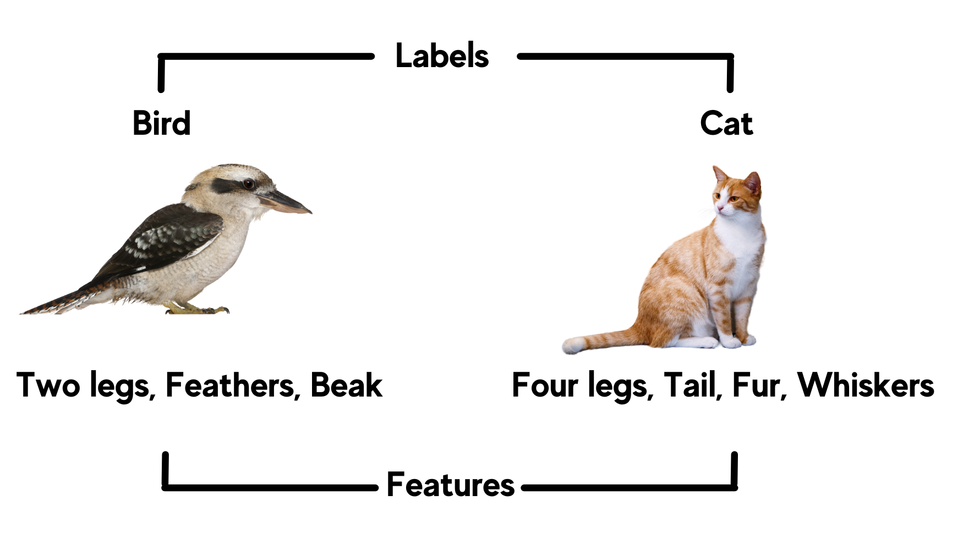
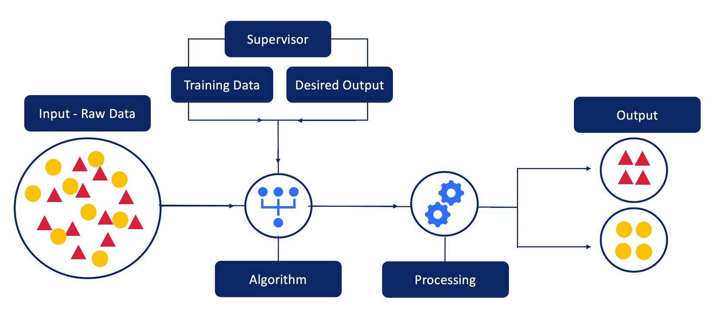

Unsupervised Learning
Unsupervised Learning | A training model in which the data contains only inputs with no corresponding output labels. The model must discover hidden structure, natural groupings or patterns within the data autonomously, without any predefined categories.

- Why it works: Algorithms such as k-means clustering measure similarity between data points and group them into clusters based on distance or density, without being told what the groups should be.
- Use cases: Customer division, abnormality detection, market basket analysis.
- Real-world example: An e-commerce platform analyses purchase histories across millions of customers with no predefined categories. The unsupervised model identifies natural clusters: bargain hunters, premium product buyers, seasonal shoppers. The business uses these subdivisions to tailor marketing campaigns to each group.
- Limitation: Results can be difficult to interpret because the model defines its own categories. There is no ground truth against which to measure accuracy.
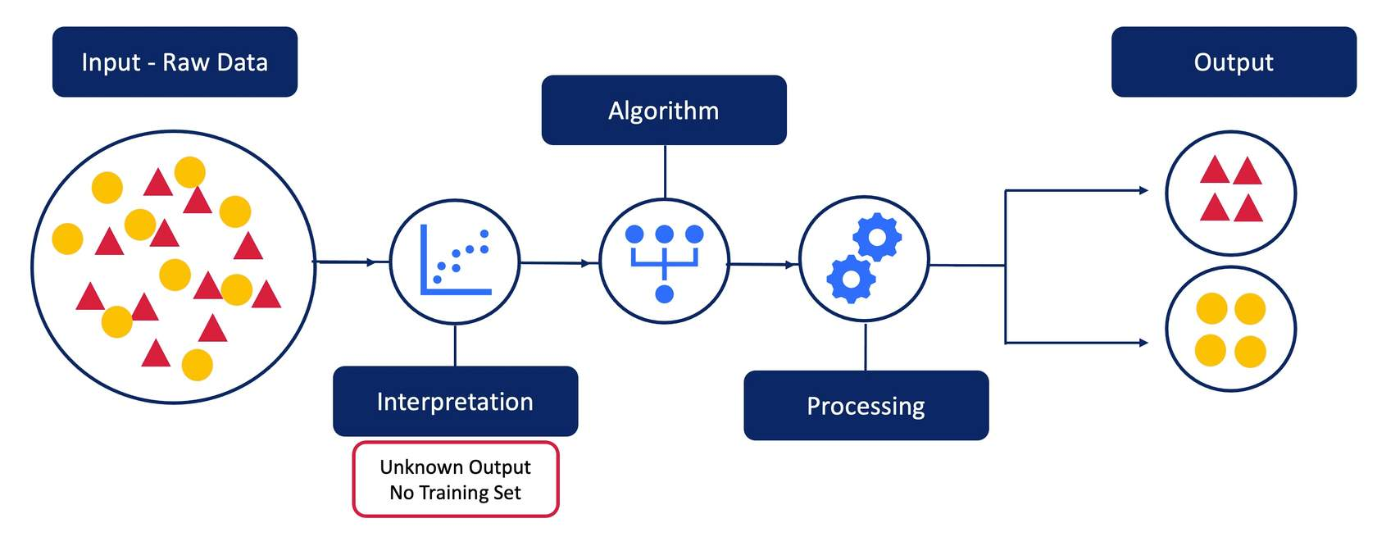
Semi-Supervised Learning
Semi-Supervised Learning | A training model that combines a small quantity of labelled data with a large quantity of unlabelled data. It uses the structure in the abundant unlabelled data to improve the model's learning beyond what the small labelled set alone would permit.

- Why it matters: Expert labelling is expensive and slow. In many domains (medical imaging, audio transcription, satellite imagery) it is practical to collect millions of unlabelled examples but label only a small fraction. Semi-supervised learning bridges the gap.
- Real-world example: A medical imaging system is trained on 500 X-rays labelled by radiologists alongside 50,000 unlabelled X-ray images. The model uses the geometric and structural patterns learned from unlabelled images to improve its detection of abnormalities, reducing the volume of costly expert annotation required.
Supervised Learning VS Semi-Supervised Learning (v3.0)
- Think of supervised learning as an AI with a personal trainer: a radiologist labels every single X-ray, telling the machine exactly what’s healthy and what’s not. It’s highly accurate, but it's "expensive" because a human has to do all the heavy lifting first. Semi-supervised learning is the shortcut. The AI studies a small batch of expert-labelled scans to learn the basics, then tackles thousands of unlabelled ones on its own. It looks for clusters and patterns—basically learning the "normal" anatomy of a human chest—and assigns itself "pseudo-labels" for the unlabelled scans it feels confident about.
- This "self-study" makes the system smarter because it isn't just memorizing answers; it’s learning to understand the "shape" of the data. By seeing thousands of variations in anatomy, the AI learns to ignore "noise"—like a weirdly shaped rib or a different camera angle—and focus on the actual disease.
- The Risk: If the model's first few "guesses" are wrong and it adds them to its training set, it can essentially "hallucinate" and become confidently incorrect. This is why the initial labelled data (the Supervised part) must be extremely high quality.
💡 Just in Case, Note: Self-Supervised Learning (v3 Addition)
You may encounter the term self-supervised learning in reading or extended-response questions. It is a variation of the semi-supervised idea — instead of humans providing any labels, the model generates its own labels from the structure of the data. A well-known technique is Masked Language Modelling, where the algorithm hides random words in a sentence and trains itself to predict the missing word from context. This underlies many modern large language models (e.g. ChatGPT). For HSC purposes: self-supervised learning is sometimes treated as a subset of unsupervised learning, but it is worth knowing the distinction for extended responses.

Reinforcement Learning
Reinforcement Learning | A training model in which an agent learns by interacting with an environment. At each step the agent selects an action, observes the new state of the environment and receives a reward (positive or negative). Over many iterations the agent learns a policy — a strategy for choosing actions that maximises cumulative reward.

- Why it differs: Unlike supervised learning, there is no labelled dataset. The learning signal comes entirely from the reward function. Unlike unsupervised learning, there is a clear objective: maximise cumulative reward.
- Use cases: Game-playing AI, robotic control, autonomous vehicles, dynamic pricing and resource scheduling.
- Real-world example: DeepMind's AlphaGo learns to play the board game Go by playing millions of games against itself. Actions leading to winning outcomes receive positive rewards; losing outcomes receive negative rewards. Through this process, the agent develops an expert-level playing strategy without any human-provided labelled data.

Training Model | Data Required | Learning Signal | Best For
Supervised | Labelled input–output pairs | Prediction error vs. known labels | Classification and regression tasks
Unsupervised | Unlabelled inputs only | Internal data structure (similarity/density) | Clustering, anomaly detection, pattern discovery
Semi-supervised | Small labelled + large unlabelled | Combined: labels + data structure | When labelling is expensive, but data is abundant
Reinforcement | No dataset; environment interaction | Reward signal from the environment | Sequential decision-making and control tasks

📌 Exam Tip
Scenario-based questions will describe a situation and ask you to identify the most appropriate training model. Apply this logic: Is labelled data available? If yes → supervised. No labels at all? → unsupervised. Some labels with lots of unlabelled data? → semi-supervised. Is the task sequential decision-making in an environment? → reinforcement learning. Always justify your choice by naming the key characteristic of the model and linking it to the scenario.
In the following video, Types of Machine Learning: Supervised and Unsupervised, two PhD students in machine learning explain the difference between these two approaches.
https://youtu.be/wy-m6sd1BOA
https://www.youtube.com/watch?v=xr5LeWKbVnY
https://vimeo.com/884306944/cbc2795268?fl=pl&fe=cm

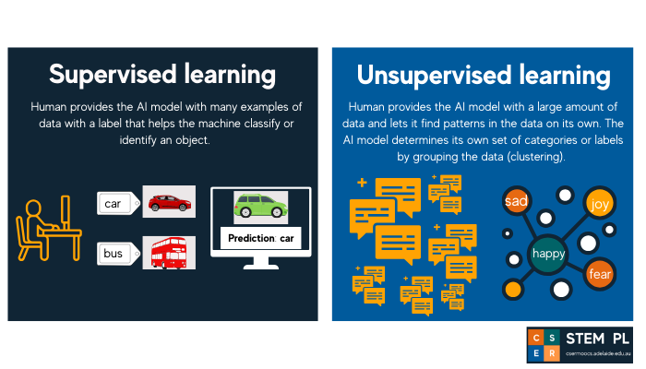
Dot Point 4 — Investigate common applications of key ML algorithms — data analysis and forecasting, virtual personal assistants, image recognition
Data Analysis and Forecasting
ML algorithms are widely applied to analyse large datasets and predict future values. Regression algorithms model the statistical relationship between input features and a numeric target, enabling organisations to forecast outcomes such as energy demand, financial returns, product sales and equipment failure times. These predictions inform strategic decisions in logistics, inventory management, risk assessment and financial planning.
- Real-world example: A supermarket chain trains a linear regression model on three years of weekly sales data, promotional calendars and weather records. The trained model forecasts the quantity of perishable goods to order each week, reducing spoilage waste and preventing stock shortages simultaneously. The model is retrained monthly as new data becomes available (MLOps — Operations stage).
- Key algorithms used: Linear regression, polynomial regression, decision trees, gradient boosting (XGBoost), recurrent neural networks (time-series forecasting).

Virtual Personal Assistants (VPAs)
Virtual personal assistants such as Apple Siri, Amazon Alexa and Google Assistant use multiple ML models in a pipeline to process natural language input and provide intelligent responses. Speech recognition models (trained on labelled audio data — supervised learning) convert spoken input to text; natural language processing (NLP) models interpret the meaning of the text query; and response generation or action models determine the appropriate output.
🔍 How a VPA Pipeline Works — Step by Step (v3 Addition)
Consider the command: "Set an alarm for 7 am tomorrow." Here is what happens inside a VPA:
- An acoustic model (supervised learning, trained on millions of labelled audio recordings) converts the spoken audio to text.
- An NLP intent-recognition model identifies the action: "set alarm" and the parameters: time = 07:00, date = tomorrow.
- The assistant calls the appropriate system API (e.g. the device's clock system) with those parameters.
- The system uses supervised learning trained on millions of similar requests to achieve high accuracy across diverse speakers, accents and contexts.

This pipeline illustrates how multiple supervised learning models work together in sequence — each model's output becomes the next model's input. Understanding this pipeline is valuable for extended-response questions on VPA architecture.

Image Recognition
Image recognition systems use neural networks — specifically convolutional neural networks (CNNs) — to identify objects, people, scenes or features within digital images or video. During training (supervised learning), the model is exposed to millions of labelled images and learns hierarchical feature representations: lower layers detect simple edges and colour gradients; higher layers combine these into complex object representations. Once trained, the model can classify new images with high accuracy.
- Social media: Platforms deploy facial recognition models that automatically suggest tags when a user uploads a photograph, matching detected faces against a database of known profiles.
- Healthcare: CNN-based models analyse medical images such as X-rays and MRI scans to detect potential tumours or lesions, assisting radiologists by flagging areas warranting closer examination. In Australia, a system developed by the Centre for Eye Research Australia (CERA) detects diabetic eye disease with over 93% accuracy in primary care settings.
- Agriculture (Leafsnap): An app that uses computer vision to identify tree species from photos of leaves — detecting leaf shapes and providing botanical classifications. This demonstrates supervised image classification applied to environmental science.
- Manufacturing: Visual inspection systems use image recognition to identify defective products on a production line in real time, replacing time-consuming manual inspection.
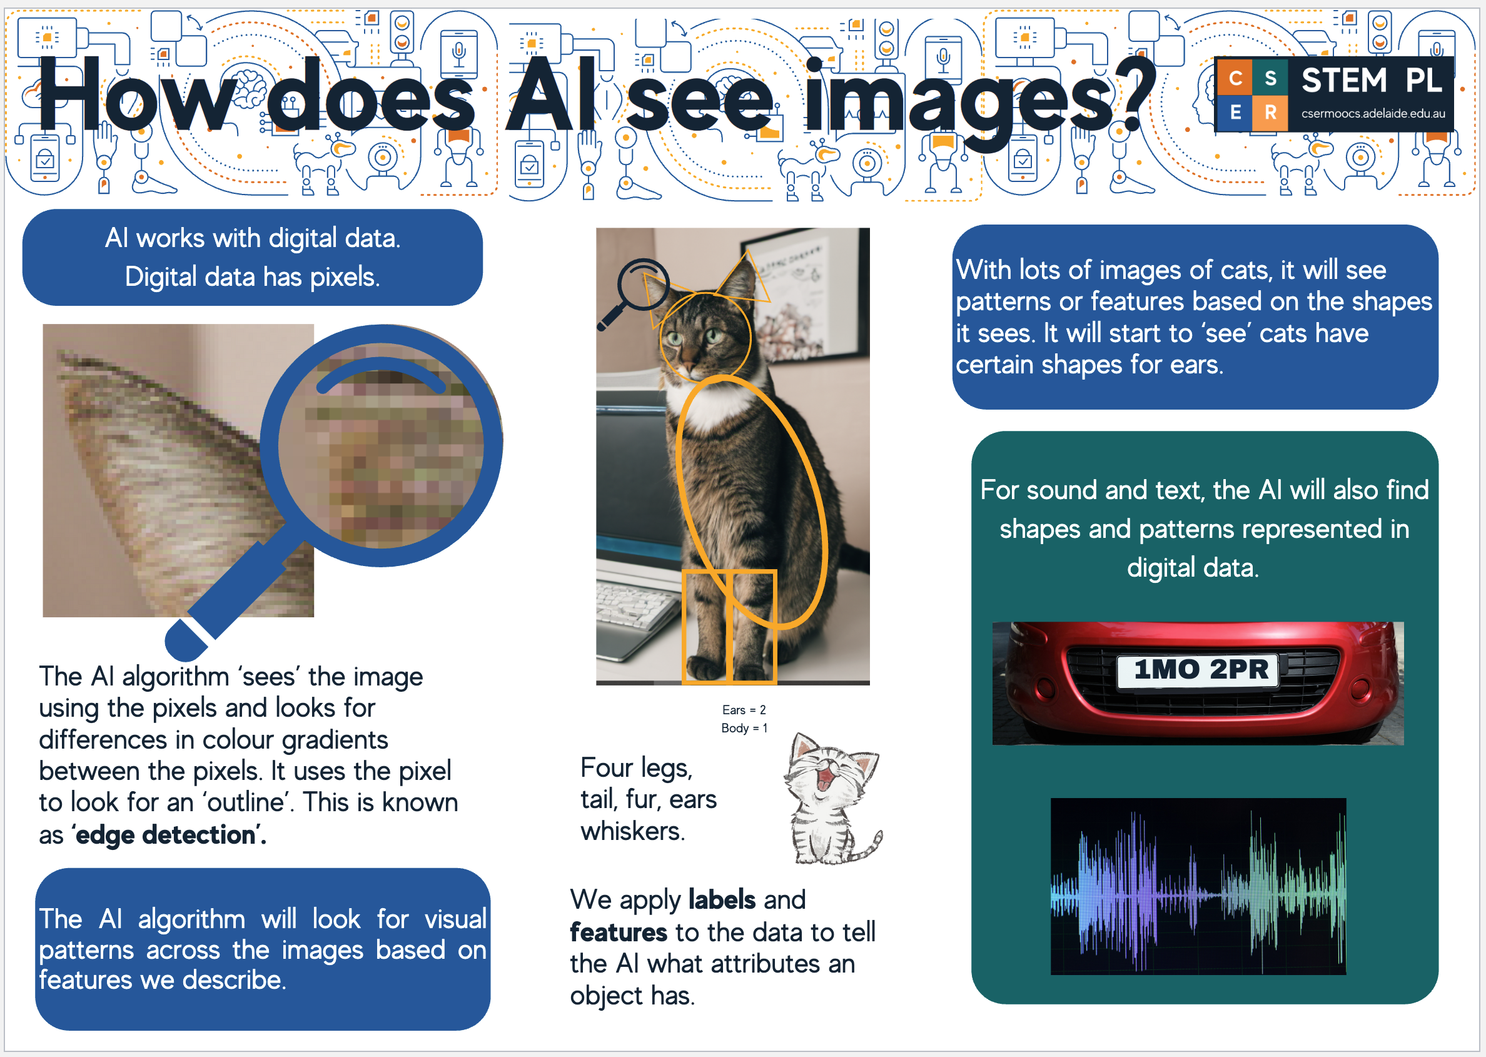
Dot Point 5 — Research models used by software engineers to design and analyse ML — decision trees, neural networks
Decision Trees
Decision Tree | - A decision tree is a diagram that represents all possible combinations of decisions and their resulting actions. Branches are shown to describe the eventual action depending on the condition at the time. Each decision path will lead to either another decision or a final action.  - A supervised ML model that represents a sequence of hierarchical if-then-else decisions. Starting from the root node (the most informative feature), the data is split into branches based on feature values until a leaf node is reached, which represents the final prediction or classification.

Software engineers use decision tree diagrams to visualise the logic of a classification or regression model before implementation, making them valuable tools at the design and analysis stage. The tree structure makes the reasoning behind any individual prediction fully traceable: the prediction for any input can be explained by identifying which path through the tree was taken.
- Advantage: Highly interpretable and explainable to non-technical stakeholders. Supports both classification and regression. No feature scaling required.
- Disadvantage: Prone to overfitting (memorising training data rather than generalising) when the tree grows too deep. Can be unstable when small changes to training data produce very different tree structures.
- Real-world example: A bank uses a decision tree to assess loan eligibility. The root node splits on annual income; one branch then splits on credit score; a further branch splits on existing debt-to-income ratio. Each leaf node results in a classification of 'Approved', 'Pending review' or 'Declined'. The clear, traceable logic supports regulatory compliance requirements for explainable credit decisions.

The following decision tree shows the rules in controlling the temperature system within a ‘smart’ house.
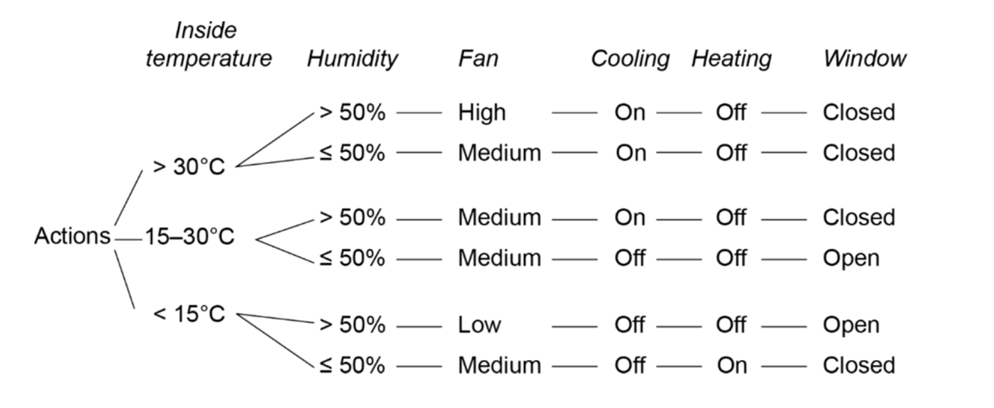

The following diagram shows another way to represent a decision tree.
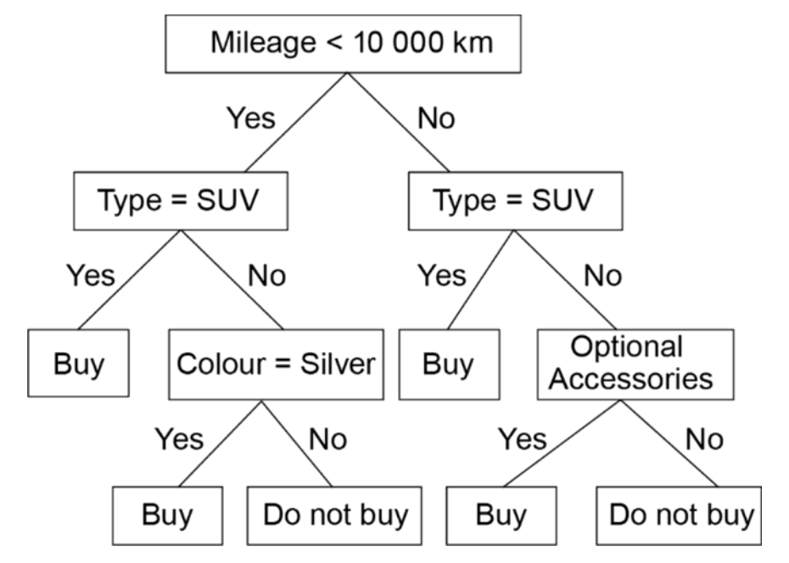
Neural Networks
Neural Network | A computational model inspired by the biological neural networks of the human brain. It consists of layers of interconnected nodes (artificial neurones) that process numerical inputs through weighted connections, applying mathematical activation functions to produce outputs. Neural networks can model highly complex, non-linear relationships in data.
https://youtu.be/bfmFfD2RIcg?si=XLoVWP-RRqWXeJ1t
🔍 Why "Deep" Learning? (v3 Clarification)
The term deep learning simply refers to a neural network with multiple hidden layers — the word "deep" means depth of layers, not depth of intelligence. A network with one hidden layer is a "shallow" network. A network with five, ten, or hundreds of hidden layers is "deep." Each additional layer enables the model to learn increasingly abstract and complex representations of the data. This is why deep learning is especially powerful for complex inputs like images, speech and text, where patterns operate at multiple levels of abstraction (e.g. an image has pixels → edges → shapes → objects).
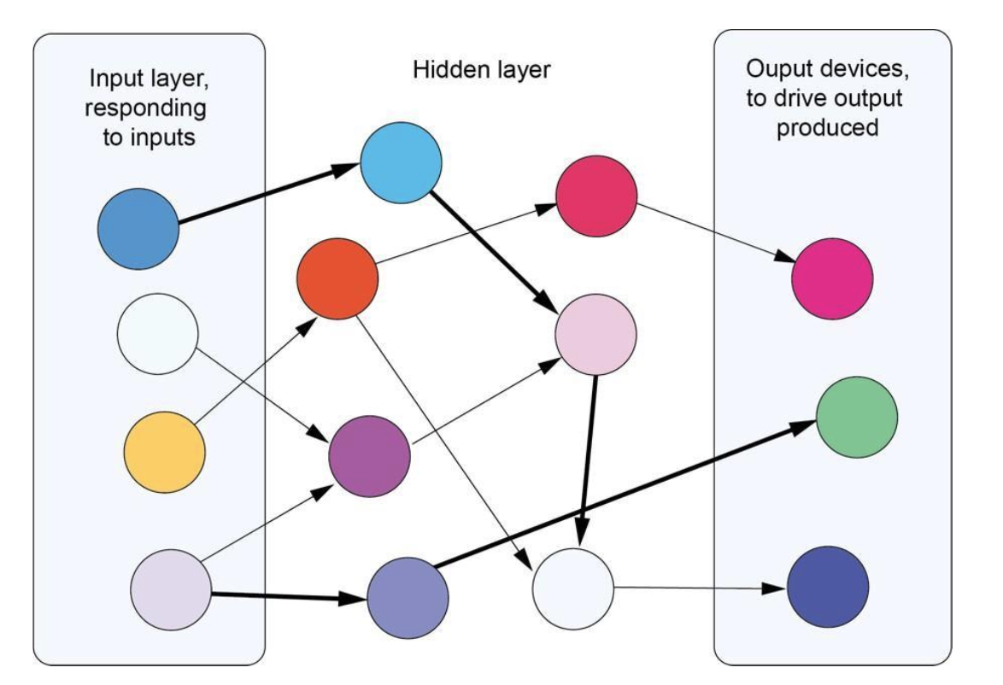
A standard feedforward neural network consists of three types of layers:
- Input layer: Receives the raw feature data. The number of nodes equals the number of input features. No computation occurs here; data is simply passed to the first hidden layer.
- Hidden layers: Each node receives weighted inputs from the previous layer, sums them, adds a bias term, and applies an activation function (such as ReLU — Rectified Linear Unit, or sigmoid). One or more hidden layers enable the network to learn non-linear representations of the data.
- Output layer: Produces the final prediction. For binary classification: one node with a sigmoid activation (outputs probability between 0 and 1). For multi-class classification: one node per class. For regression: one node with no activation.
https://www.youtube.com/watch?v=aircAruvnKk
Training Cycle
During the training cycle, the internal weight and bias (threshold) values of each node are determined. The system is exposed to a series of inputs with known outputs (labels). The process uses backpropagation with gradient descent: the model makes a prediction, calculates the error (loss), propagates the error backward through the network and adjusts each weight proportionally to its contribution to the error. This iterative process is repeated across many training iterations (epochs). Regular exposure to the training cycle results in improved accuracy and better pattern matching.
https://youtu.be/IHZwWFHWa-w?si=LNppXDUO6XsafF61
💡 Analogy for Backpropagation (v3 Addition)
Imagine you are throwing darts at a target blindfolded. After each throw, someone tells you how far you missed and in which direction. You adjust your throwing angle slightly. Over hundreds of throws, your adjustments get smaller and more precise as you converge on the bullseye. Backpropagation is the process of calculating how much each weight in the network contributed to the error and adjusting it accordingly. Gradient descent is the mathematical method that tells you which direction and how much to adjust. Each complete pass through all the training data is one epoch.

Execution Cycle
The execution cycle follows the training cycle. Once training is complete, the internal weights are fixed. For a new, unseen input, the signal propagates forward through the network: each node applies its learned weight and activation function to produce a final output. The connections with the strongest weights carry a greater priority in determining the final output. The execution cycle uses the internal values developed during training to produce predictions without any further learning.

 | Decision Tree | Neural Network
Interpretability | High: prediction logic is visible and traceable | Low: internal representations are not easily explained ('black box')
Best data type | Smaller, structured tabular datasets | Complex, high-dimensional data: images, audio, text
Training speed | Fast on small to medium datasets | Requires substantial training data and computational resources
Overfitting risk | Prone to overfitting without pruning or depth limits | Prone to overfitting without regularisation (dropout, L2)
Explainability | Rules can be extracted and explained to stakeholders | Requires tools like SHAP values to interpret predictions
Example uses | Loan eligibility, medical diagnosis decision trees | Image recognition, speech recognition, NLP

📌 Exam Tip
When asked to describe the training cycle and execution cycle of a neural network, treat them as two distinct, sequential phases. Training adjusts the weights using labelled data and backpropagation. Execution uses fixed weights to produce predictions. A Band 6 response will name specific elements: nodes, weights, biases, activation functions, backpropagation, epochs.

Dot Point 6 — Describe types of algorithms associated with ML — linear regression, logistic regression, K-nearest neighbour
Linear Regression
Linear Regression | A supervised learning algorithm used to predict a continuous numeric output value from one or more input features. The algorithm fits a straight line (line of best fit) through training data that minimises the total squared differences between predicted and actual values. The equation takes the form y = mx + c (or y = β₀ + β₁x₁ + … for multiple features).

Linear Regression focuses on the relationship between variables to predict a specific, continuous numerical value.
- The Goal: To find the "Line of Best Fit" that minimizes the distance (residuals) between the actual data points and the predicted line.
- The Equation: Students should recognize y = mx + c
  - y: Dependent variable (what we want to predict).
  - x: Independent variable (the input feature).
  - m: Gradient (weight/slope).
  - c: Y-intercept (bias).
- Key Characteristics:
  - Linearity: Assumes that if the input increases, the output changes at a constant rate.
  - Sensitivity: Highly affected by outliers, which can "pull" the line away from the majority of the data.
- HSC Example: Predicting the exact download speed of a network based on the distance from the router.
https://www.youtube.com/watch?v=qxo8p8PtFeA
Logistic Regression
Logistic Regression | Despite the name, logistic regression is a classification algorithm, not a regression algorithm. It predicts the probability that an input belongs to a particular category by applying a sigmoid (logistic) function to a linear combination of input features, producing an output value between 0 and 1. A threshold (commonly 0.5) converts the probability to a discrete class label. Also supervised learning.

Despite the name, this is a classification algorithm. It is used when the output is categorical (e.g., Yes/No, Pass/Fail).
- The Mechanism: Instead of a straight line, it uses the Sigmoid Function to create an "S-shaped" curve.
- The Output: It calculates a probability between 0 and 1.
  - If the result is > 0.5, it classifies as 1 (True/Yes).
  - If the result is < 0.5, it classifies as 0 (False/No).
- Key Characteristics:
  - Decision Boundary: It creates a clear "cut-off" point for classification.
  - Robustness: Unlike linear regression, it is less influenced by extreme outliers because the output is capped between 0 and 1.
- HSC Example: Determining if a data packet is "corrupted" or "clean" based on error-bit frequency.
⚠️ Common Mistake
Students confuse logistic regression with linear regression. Remember: logistic regression is always used for CLASSIFICATION. The output is a probability, not a numeric value on a continuous scale. The word "regression" in the name refers to the mathematical technique used internally, not the type of task.

K-Nearest Neighbour (KNN)
K-Nearest Neighbour (KNN) | An instance-based supervised learning algorithm used for both classification and regression. For a new input, the algorithm calculates the distance (typically Euclidean distance) to all points in the training dataset, identifies the k closest training examples (the k nearest neighbours) and assigns: the majority class label of those neighbours (for classification) or their average value (for regression) as the prediction.

KNN is a versatile algorithm used for classification (most common) or regression. It relies on the idea that "similar things exist in close proximity."
- How it Works:
  - A new data point is placed on a graph.
  - The algorithm looks at the k closest existing data points (neighbours).
  - Classification: It takes a "majority vote." If k=3 and two neighbours are "Blue" and one is "Red," the new point is classified as "Blue."
- Key Characteristics:
  - Distance Metrics: Usually uses Euclidean distance (straight-line distance) to find neighbours.
  - Choosing 'k': * If k is too small (e.g., k=1), the model is sensitive to noise.
    - If k is too large, it may include points from other categories.
  - Computationally Expensive: Because it doesn't "learn" a model but instead compares new data to every existing point, it can be slow with massive datasets.
- HSC Example: Classifying a fruit as an "Apple" or "Orange" based on its weight and diameter by comparing it to known examples.

Algorithm | Task Type | Output | Key Feature
Linear regression | Regression | Continuous numeric value | Line of best fit; assumes linear relationship
Polynomial regression | Regression | Continuous numeric value | Extends linear regression to curved relationships
Logistic regression | Classification | Probability (0 to 1) → class label | Sigmoid function; binary classification
K-nearest neighbour | Classification or regression | Majority class or average of k neighbours | Distance-based; no explicit training phase
Decision tree | Classification or regression | Leaf-node class or value | Hierarchical if-then-else splits; interpretable
Neural network | Classification, regression, generation | Layer-dependent activation output | Layered nodes with learned weights; backpropagation

⚠️ Common Student Mistakes
- Treating AI and ML as synonyms: always state that ML is a subset of AI, and explain the distinguishing feature (learning from data vs. explicit rules).
- Confusing logistic regression with regression: logistic regression is a CLASSIFICATION algorithm. Its output is a probability converted to a class label, not a numeric value on a continuous scale.
- Failing to name all three MLOps stages or confusing them with DevOps stages generally: Design, Model Development and Operations are the specific MLOps stages.
- Describing training and execution cycles as the same process: training adjusts weights using backpropagation on labelled data; execution uses fixed weights to generate predictions.
- Choosing the wrong training model for a scenario: always identify whether the data is labelled, partially labelled or unlabelled, and whether the task involves sequential decision-making.

Section 2: Programming for Automation

Regression Algorithms in Machine Learning — Compare and Contrast

Syllabus Reference: SE-12 — Programming for Automation

Exam-Ready Paragraph
Linear regression, polynomial regression, and logistic regression are all supervised machine learning algorithms that are trained on labelled data, yet they differ fundamentally in the types of problems they solve and the nature of their output.
Linear regression models the relationship between one or more input features and a continuous output variable by fitting a straight line through the training data, making it appropriate for predicting numeric values such as house prices or temperature readings where a proportional, linear relationship can be assumed. Polynomial regression extends this approach by fitting a curved line using higher-degree polynomial equations, enabling the model to capture non-linear relationships in the data — for example, predicting engine wear over time, where the rate of degradation accelerates rather than increases at a constant rate. Both linear and polynomial regression therefore belong to the same category of regression tasks: they predict values across a continuous numeric range.
Logistic regression, despite its name, operates fundamentally differently; rather than predicting a continuous value, it is used for classification problems and outputs a probability between 0 and 1, which is then mapped to a discrete category. A common application is binary classification, such as predicting whether a patient's test result is positive or negative.
Consequently, the choice between these algorithms depends entirely on the nature of the problem: if the target variable is a continuous number, linear or polynomial regression is appropriate, with polynomial selected when the data exhibits a curved trend; if the target is a categorical outcome, logistic regression is the correct tool.

Comparison Table
Feature | Linear Regression | Polynomial Regression | Logistic Regression
Task type | Regression | Regression | Classification
Output type | Continuous numeric value | Continuous numeric value | Probability mapped to a discrete class (e.g. 0 or 1)
Relationship modelled | Straight-line (linear) relationship between input and output | Curved (non-linear) relationship using higher-degree polynomial equations | Non-linear relationship mapped through a sigmoid function to a probability
Line/curve of best fit | Straight line | Curved polynomial curve | S-shaped sigmoid curve
Training data required | Labelled (supervised) | Labelled (supervised) | Labelled (supervised)
When to use | Data follows a consistent, proportional trend | Data follows a curved or accelerating trend | Output is a category, not a number
Real-world example | Predicting a student's exam score from hours studied | Predicting engine wear rate over time | Classifying an email as spam or not spam
Python library | sklearn.linear_model.LinearRegression | sklearn.preprocessing.PolynomialFeatures + LinearRegression | sklearn.linear_model.LogisticRegression
Common error | Applying to curved data, producing poor fit (underfitting) | Overfitting if polynomial degree is too high | Misidentifying it as a regression tool — it is a classifier
HSC syllabus category | Regression algorithm — predicts continuous values | Regression algorithm — predicts continuous values | Classification algorithm — predicts a category

Exam Tip: A frequent error is assuming logistic regression predicts a number because the word "regression" appears in its name. In the HSC, always clarify that logistic regression is a classification algorithm. The NESA Course Specifications explicitly state: linear and polynomial regression predict values in a continuous range, whereas logistic regression is used for classification problems. Stating this distinction clearly in any compare/contrast response is the difference between a Band 4 and Band 6 answer.

This section requires students to design, develop and apply ML models in Python using object-oriented programming (OOP). Students are expected to understand and use established ML frameworks; they are NOT required to implement the mathematical algorithms from first principles.

Key Python Libraries
- NumPy: A fundamental library for numerical computation. Provides multi-dimensional arrays (ndarray) and mathematical functions. ML models require data formatted as NumPy arrays.
- Scikit-learn (sklearn): A production-ready ML library implementing linear regression, polynomial regression, logistic regression, KNN, decision trees and many other algorithms. Core OOP pattern: instantiate a model object, call fit() to train, call predict() to generate predictions.
- TensorFlow / Keras: A deep learning library for building, training and deploying neural networks. Keras provides a high-level OOP API: models are objects; layers are objects; training is performed through the fit() method.
- OOP connection: In all these libraries, each algorithm is implemented as a class. Students instantiate an object of that class, call methods (fit(), predict(), compile()) and access attributes (e.g. model.coef, model.intercept). The model object encapsulates all internal state through the principle of encapsulation.

Dot Point 7 — Design, develop and apply ML regression models using an OOP to predict numeric values — linear regression, polynomial regression, logistic regression
Linear Regression — Implementation
Linear regression predicts a continuous output from one or more numeric input features. The Scikit-learn LinearRegression class implements ordinary least squares regression. After fitting, the model can predict values for inputs both within and outside the training range (interpolation and extrapolation).

💻 Linear Regression using NumPy and Scikit-learn
# Import required libraries
import numpy as np
from sklearn.linear_model import LinearRegression

# -----------------------------
# 1. Prepare Training Data
# -----------------------------
# x = input feature(s)
# Note: sklearn requires a 2D array for features → shape (n_samples, n_features)
x = np.array([[2], [4], [6], [8], [10], [12], [14], [16]])

# y = target output labels
y = np.array([1, 3, 5, 7, 9, 11, 13, 15])

# -----------------------------
# 2. Create Model (OOP Concept)
# -----------------------------
# LinearRegression → CLASS
# model → INSTANCE (object of the class)
model = LinearRegression()

# -----------------------------
# 3. Train the Model
# -----------------------------
# fit() finds the best-fit line: y = mx + c
# Internally:
# - Calculates slope (m)
# - Calculates intercept (c)
# - Minimises squared error between predictions and actual values
model.fit(x, y)

# -----------------------------
# 4. Inspect Learned Parameters
# -----------------------------
# coef_ → slope(s) (m)
# intercept_ → y-intercept (c)
print("Slope (m):", model.coef_) # Expected: [1.]
print("Intercept (c):", model.intercept_) # Expected: -1.0

# -----------------------------
# 5. Make Predictions (Known Value)
# -----------------------------
# Predict using a value from the training set
y_pred_known = model.predict([[4]])
print("Prediction for x = 4:", y_pred_known) # Expected: [3.]

# -----------------------------
# 6. Make Predictions (New Value / Interpolation)
# -----------------------------
# Predict using a value NOT seen during training
y_pred_new = model.predict([[4.5]])
print("Prediction for x = 4.5:", y_pred_new) # Expected: [3.5]

# -----------------------------
# 7. Evaluate Model Performance
# -----------------------------
# score() returns R² (coefficient of determination)
# R² = 1.0 → perfect fit
r2_score = model.score(x, y)
print("R² score:", r2_score) # Expected: 1.0
``

📖 Why This Demonstrates OOP
- LinearRegression is a CLASS defined in the sklearn library.
- model is an OBJECT (instance) of that class.
- fit() and predict() are METHODS called on the object.
- coef_ and intercept_ are ATTRIBUTES that store the model's learned state.
- The internal mathematical state (slope, intercept) is encapsulated within the object and is not directly accessible except through defined methods and attributes.

Polynomial Regression — Implementation
Polynomial regression models non-linear (curved) relationships between input and output. It extends linear regression by transforming the input features into polynomial terms (e.g. x, x², x³) using the PolynomialFeatures transformer, then fitting a standard linear model to the transformed data. Internally the mathematics remains linear — it is the feature transformation that introduces curvature.

💻 Polynomial Regression using Scikit-learn
import numpy as np
from sklearn.linear_model import LinearRegression
from sklearn.preprocessing import PolynomialFeatures

# ============================================================
# 1) Training data (quadratic relationship): y = x²
# ============================================================
# x must be a 2D array for scikit-learn: shape (n_samples, n_features)
# Here: 6 samples, 1 feature each
x = np.array([[1], [2], [3], [4], [5], [6]])

# y is typically 1D: shape (n_samples,)
y = np.array([1, 4, 9, 16, 25, 36])

# ============================================================
# 2) Feature engineering: create polynomial features
# ============================================================
# PolynomialFeatures is a TRANSFORMER class:
# - fit() learns how many output features will be produced (and stores metadata)
# - transform() applies the mapping to new data
#
# degree=2 means we generate: [x, x²] (and optionally a constant/bias term)
# include_bias=False avoids adding a column of ones.
# (LinearRegression already has an intercept term by default.)
poly = PolynomialFeatures(degree=2, include_bias=False)

# fit_transform() does:
# - fit() -> "learn" the transformation shape
# - transform() -> apply it to x
#
# Result: x_poly has 2 columns: [x, x²]
# Example: [[3]] becomes [[3, 9]]
x_poly = poly.fit_transform(x)

# ============================================================
# 3) Train a linear model on the transformed features
# ============================================================
# Even though the relationship is curved in original x,
# it becomes LINEAR in the expanded feature space:
# y = a*(x) + b*(x²) + c
model = LinearRegression()
model.fit(x_poly, y)

# ============================================================
# 4) Predict on new inputs (IMPORTANT: transform first!)
# ============================================================
# NEVER feed raw x into a model trained on x_poly.
# You must apply the SAME polynomial transformation to new data.
x_new = np.array([[7]])
x_new_poly = poly.transform(x_new)

prediction = model.predict(x_new_poly)
print("Prediction for x = 7:", prediction) # Expected: [49.]

# ============================================================
# 5) Evaluate model fit
# ============================================================
# R² score: 1.0 means perfect fit (for this exact quadratic dataset)
r2 = model.score(x_poly, y)
print("R² score:", r2) # Expected: 1.0

# ============================================================
# 6) (Optional) Inspect the learned equation
# ============================================================
# model.coef_ corresponds to coefficients for [x, x²] in this order
# model.intercept_ is the constant term (c)
print("Coefficients [for x, x²]:", model.coef_)
print("Intercept:", model.intercept_)

# If you want to display the equation clearly:
a, b = model.coef_ # a for x, b for x²
c = model.intercept_
print(f"Learned model: y = ({a:.3f})*x + ({b:.3f})*x² + ({c:.3f})")

⚠️ Critical Design Note
The same new input MUST be passed through poly.transform() before being fed to model.predict(). Forgetting this step is the most common implementation error. The PolynomialFeatures object (poly) and the LinearRegression object (model) are two separate objects working in a pipeline — each must receive its expected input format.

Logistic Regression — Implementation
Logistic regression is used for binary classification. The model predicts the probability that a given input belongs to class 1 (positive class). The predict() method applies a threshold of 0.5 to convert the probability to a class label (0 or 1). The predict_proba() method returns the raw probability values, which is useful when the cost of false positives and false negatives differs.

💻 Logistic Regression using Scikit-learn
import numpy as np
from sklearn.linear_model import LogisticRegression

# ============================================================
# 1) Training data (binary classification)
# ============================================================
# Feature: hours studied (x)
# Label: pass/fail (y) where 1 = pass, 0 = fail
#
# IMPORTANT:
# scikit-learn expects X to be 2D: (n_samples, n_features)
# - Here we have 8 samples and 1 feature per sample
X = np.array([[1], [2], [3], [4], [5], [6], [7], [8]])

# y is 1D: (n_samples,)
y = np.array([0, 0, 0, 0, 1, 1, 1, 1])

# ============================================================
# 2) Create (instantiate) the classifier model
# ============================================================
# LogisticRegression is a CLASS (blueprint).
# model is an INSTANCE (object created from that class).
#
# Logistic Regression learns a linear decision boundary:
# z = w*x + b
# and converts it to a probability using the sigmoid:
# p(pass) = 1 / (1 + e^(-z))
#
# Note: LogisticRegression uses regularisation by default (L2).
# For tiny toy datasets, that can slightly affect “perfect fit”.
model = LogisticRegression()
model.fit(X, y) # fit() = training

# ============================================================
# 3) Predict the class label for new input
# ============================================================
# Predicting a class label means returning either 0 (fail) or 1 (pass).
# In binary classification, sklearn typically uses a 0.5 threshold:
# if p(pass) >= 0.5 -> predict 1
# else -> predict 0
new_student = np.array([[5.5]])

class_prediction = model.predict(new_student)
print("Class prediction (0=fail, 1=pass):", class_prediction)

# ============================================================
# 4) Predict class probabilities (more informative)
# ============================================================
# predict_proba returns probabilities for each class in model.classes_
# For this dataset, model.classes_ should be [0, 1]
# Output format: [[p(class 0), p(class 1)]]
probabilities = model.predict_proba(new_student)
print("Class labels order:", model.classes_)
print("Probabilities [fail, pass]:", probabilities)

# ============================================================
# 5) Evaluate performance on training data
# ============================================================
# score() for classifiers = accuracy by default
# accuracy = (number correct) / (total)
training_accuracy = model.score(X, y)
print("Training accuracy:", training_accuracy)

# ============================================================
# 6) (Optional but great for teaching) Inspect the learned boundary
# ============================================================
# coef_ is w (weight/slope), intercept_ is b (bias/intercept)
w = model.coef_[0][0]
b = model.intercept_[0]
print("Weight (w):", w)
print("Intercept (b):", b)

# Decision boundary occurs when p(pass)=0.5, which corresponds to z = 0:
# w*x + b = 0 -> x = -b / w
decision_boundary = -b / w
print("Decision boundary (p=0.5) at hours studied ≈", decision_boundary)

📌 Exam Tip
In code-based exam questions, always explain: (1) what the class represents (the algorithm), (2) what fit() does (trains the model on data), (3) what predict() does (applies the trained model to new inputs), and (4) what the OOP structure means (encapsulation of model state, abstraction of internal complexity). Marks are awarded for connecting the code to concepts, not just describing what lines do.

Dot Point 8 — Apply neural network models using an OOP to make predictions
Neural Networks in Python — Keras/TensorFlow
Keras (running on TensorFlow) provides a clean OOP API for constructing, training and deploying neural networks. The Sequential model is the most common architecture for straightforward feedforward networks: layers are stacked in order, and data flows from input to output through each layer in sequence.
Students are not required to implement backpropagation manually. However, students must be able to explain what each part of the code does, how it maps to neural network theory (training cycle, execution cycle), and how OOP principles are demonstrated.

💻 Neural Network for Regression using Keras (TensorFlow)
import numpy as np
from tensorflow import keras
from tensorflow.keras import layers

# ============================================================
# 1) Training data (toy example)
# ============================================================
# Features (X): [house_size_sqm, num_bedrooms]
# Target (y): price_in_thousands (e.g., 300 means $300,000)
#
# Keras expects:
# - X as a 2D array of shape (n_samples, n_features)
# - y as a 1D array of shape (n_samples,) or 2D (n_samples, 1)
X_train = np.array([
[50, 2], [80, 3], [100, 4], [120, 5],
[60, 2], [90, 3], [110, 4]
], dtype=np.float32)

y_train = np.array([300, 450, 560, 700, 340, 490, 630], dtype=np.float32)

# ============================================================
# 2) Model definition (OOP concepts)
# ============================================================
# Sequential is a CLASS; model is an INSTANCE (object).
# Dense layers are objects (instances) created and passed into the model.
#
# Regression output:
# - single neuron (Dense(1))
# - NO activation function on output (linear output)
# because we want any real-valued prediction (not restricted to 0..1).
model = keras.Sequential(
[
layers.Dense(64, activation="relu", input_shape=(2,)), # hidden layer 1
layers.Dense(32, activation="relu"), # hidden layer 2
layers.Dense(1) # output layer
],
name="house_price_regression_model"
)

# Optional: show the architecture early (great for lessons)
model.summary()

# ============================================================
# 3) Compile (configure training)
# ============================================================
# Optimiser: Adam (adaptive gradient descent)
# Loss: Mean Squared Error (MSE) - standard for regression
# Metric: Mean Absolute Error (MAE) - easier to interpret in “$ thousands”
model.compile(
optimizer="adam",
loss="mean_squared_error",
metrics=["mean_absolute_error"]
)

# ============================================================
# 4) Train (fit) the model
# ============================================================
# Training cycle:
# forward pass -> compute loss -> backpropagation -> update weights
#
# epochs=200 means 200 passes over the training data.
# verbose=0 hides logs (use 1 for live progress in class)
history = model.fit(
X_train, y_train,
epochs=200,
verbose=0
)

# ============================================================
# 5) Predict (execution / inference cycle)
# ============================================================
# predict() uses the fixed learned weights to output a value
# for a new, unseen input.
new_house = np.array([[75, 3]], dtype=np.float32)

pred_thousands = model.predict(new_house, verbose=0)[0, 0]
print(f"Predicted price: ${pred_thousands:,.0f},000")

The OOP principles demonstrated: the Sequential model and each Dense layer are objects; the model encapsulates all internal state (weights and biases for each node); fit() and predict() are methods that abstract the complexity of backpropagation and forward propagation respectively; the user interacts with the model through a clean interface without needing to know the internal mathematical implementation.

Neural Network for Classification
💻 Neural Network for Binary Classification using Keras
import numpy as np
from tensorflow import keras
from tensorflow.keras import layers

# ============================================================
# 1) Training data (toy example)
# ============================================================
# Features: [age, glucose_level]
# Label: diabetes risk (1 = high risk, 0 = low risk)
#
# NOTE:
# - This dataset is tiny (6 samples), purely for demonstration.
# - In real ML, you would need far more data, careful preprocessing,
# and separate validation/test sets.
X_train = np.array([
[25, 85],
[45, 140],
[35, 95],
[60, 180],
[28, 78],
[52, 160],
], dtype=np.float32)

y_train = np.array([0, 1, 0, 1, 0, 1], dtype=np.float32)

# ============================================================
# 2) Define the neural network (architecture)
# ============================================================
# Sequential = layers stacked in order
# Dense = fully-connected layer
#
# input_shape=(2,) means: each sample has 2 features
# relu = non-linear activation function (allows learning complex patterns)
# sigmoid = outputs a probability (0 to 1) for binary classification
model = keras.Sequential(
[
layers.Dense(16, activation="relu", input_shape=(2,)),
layers.Dense(8, activation="relu"),
layers.Dense(1, activation="sigmoid"),
],
name="diabetes_risk_demo_model",
)

# (Optional but useful) Print the model structure
model.summary()

# ============================================================
# 3) Compile the model (choose training settings)
# ============================================================
# optimizer='adam' : adjusts weights efficiently
# loss='binary_crossentropy': standard for binary classification
# metrics=['accuracy'] : tracks % correct (simple metric)
model.compile(
optimizer="adam",
loss="binary_crossentropy",
metrics=["accuracy"],
)

# ============================================================
# 4) Train the model (learning via backpropagation)
# ============================================================
# epochs=100 means the model sees the whole dataset 100 times.
# verbose=0 hides output; set verbose=1 to see progress.
history = model.fit(X_train, y_train, epochs=100, verbose=0)

# ============================================================
# 5) Predict risk probability for a new patient
# ============================================================
new_patient = np.array([[48, 155]], dtype=np.float32)

# predict() returns a 2D array of shape (n_samples, 1)
risk_probability = model.predict(new_patient, verbose=0)[0, 0]

print(f"Diabetes risk probability: {risk_probability:.2%}")

# ============================================================
# 6) Convert probability -> class label using a threshold
# ============================================================
# Default threshold is often 0.5, but in real applications you
# would choose a threshold based on the cost of false positives/negatives.
classification = "High risk" if risk_probability > 0.5 else "Low risk"
print(f"Classification: {classification}")

⚠️ Common Student Mistakes
- Using predict() before fit(): the model has not been trained yet. Always call fit() first.
- Forgetting poly.transform() before model.predict() in polynomial regression: the new input must be transformed through the same polynomial feature transformer used during training.
- Conflating the training cycle with the execution cycle: training adjusts weights through backpropagation; execution uses fixed weights to produce predictions. They are distinct phases.
- Not naming OOP concepts explicitly in exam responses: state that the model is an OBJECT, fit() and predict() are METHODS, and the internal weights are ATTRIBUTES encapsulated by the class.
- Using the wrong activation function: regression output layers use no activation (or linear); binary classification output layers use sigmoid; multi-class output layers use softmax.

Section 3: Significance and Impact of ML and AI
This section examines the broader consequences of deploying ML and AI-driven automation, exploring its impact on individuals, society and the environment; the way human behaviour shapes ML development; and the critical issue of bias in ML and AI systems.

Dot Point 9 — Assess the impact of automation on the individual, society and the environment
Safety of Workers
ML-powered robots and autonomous systems can perform tasks in environments that present unacceptable risks to human workers: extreme temperatures, toxic chemical exposure, confined spaces, heights and radiation. Automation displaces humans from these hazardous roles, reducing workplace injuries and fatalities. In mining, autonomous drilling and haulage vehicles operate continuously without exposing workers to underground conditions. In nuclear facilities, remotely operated ML-guided robots handle radioactive materials.
- Benefit: Significant reduction in workplace injury rates and occupational disease in high-risk sectors. Machines can operate at higher precision and without fatigue-related error.
- Concern: The displacement of workers from manual roles creates social and economic disruption. Workers in these roles may lack the technical skills needed to transition into the new roles automation creates, without targeted support and retraining programmes.

📋 Case Study: BHP and CSIRO — AI-Powered Predictive Mining Safety (Australia)
Challenge: Australia's mining sector faces significant safety risks from underground rock bursts and equipment failures.
Solution: CSIRO and BHP developed a domain-specific AI foundation model trained on seismic data, drone imagery, and equipment telemetry. Using edge computing and reinforcement learning, the system predicts underground hazards in real time.
Outcomes measured: 24% reduction in injury incidents — 36% decrease in equipment downtime — over 6,000 hazards proactively identified and resolved before causing harm — improved worker confidence and safety compliance.
HSC link: This is a direct example of automation benefiting worker safety and production efficiency. The model demonstrates MLOps (continuous retraining as new sensor data arrives) and reinforcement learning in a real-world deployment.

People with Disability
ML and AI-powered assistive technologies significantly expand the independence and social participation of people with disability. Applications include real-time speech-to-text (for users with hearing impairment), text-to-speech and predictive communication tools (for users with speech or motor impairments), computer vision-based navigation aids (for users with visual impairment), and smart home devices controlled by voice or gaze.
🔍 Specific Assistive Technology Examples (v3 Addition)
- Microsoft Seeing AI: Uses computer vision to provide real-time audio descriptions of the visual world — reading text in images, describing scenes, identifying people — for users with visual impairment.
- Google Lookout: Similar CV-based app providing spoken descriptions of surroundings, reading printed text, and identifying objects; allows users to navigate public spaces independently.
- Voice-controlled smart home devices (Siri, Alexa, Google Assistant): Use NLP to allow users with motor impairments to control home appliances, access information and communicate without physical interaction.
- Predictive communication tools (e.g. SwiftKey with word prediction): Use ML to learn an individual user's vocabulary and communication patterns, significantly reducing the effort required to compose messages for users with motor or cognitive disabilities.

- Benefit: Increased independence, access to employment and education, and improved quality of life for individuals whose disability previously created barriers to participation.
- Concern: If training data does not adequately represent people with disability (in terms of speech patterns, interaction styles or physical characteristics), AI systems may perform poorly for the very users they are designed to assist, reinforcing exclusion rather than reducing it. This is a specific form of dataset source bias (see Dot Point 11).

The Nature and Skills Required for Employment
The widespread adoption of ML-driven automation is fundamentally reshaping labour market demand. Routine, rule-based tasks in sectors including data entry, customer service, clerical processing, logistics coordination and financial processing are increasingly automated. Simultaneously, demand grows for workers with skills in software engineering, data science, ML model development, AI system governance and human–machine collaboration.
📊 Employment Statistics — World Economic Forum (v3 Addition)
A report by the World Economic Forum on the Future of Jobs found:
- Machines will replace some roles — particularly those involving repetitive, structured tasks — but will also create 133 million new roles globally.
- In 2023, across 12 industries, 34% of tasks were completed by machines.
- Task automation by 2027 is expected to vary from 35% of reasoning and decision-making tasks to 65% of information and data processing tasks.
- New roles in demand include: data science, ML engineering, AI governance, digital transformation, and human–AI collaboration management.

Implication for exam responses: When assessing employment impacts, avoid stating simply "AI will take all jobs." The evidence supports a more nuanced argument: AI displaces some roles while creating others, and the key concern is the speed of that transition and the support available for retraining.

- Impact on individuals: Workers in displaced roles face the need to retrain, often without financial or institutional support. The speed of automation may outpace the capacity of education and workforce development systems to respond.
- Impact on society: Education systems must evolve to prioritise computational thinking, digital literacy and adaptability. Governments and employers face pressure to invest in reskilling programmes at scale.

Production Efficiency, Waste and the Environment
ML-driven automation can significantly improve resource efficiency and reduce environmental impact: predictive maintenance models identify equipment faults before failure, reducing energy waste; precision agriculture systems optimise irrigation, fertiliser application and pest control; manufacturing quality control systems reduce defect rates and raw material waste.
- Environmental benefit: Reduced resource consumption, lower carbon emissions per unit of production, and decreased waste across manufacturing, agriculture and logistics. SwarmFarm Robotics (Queensland) uses autonomous robots to target weeds precisely, reducing herbicide use by up to 95% and fuel emissions by 35%.
- Environmental concern: Training large, complex neural networks requires substantial computational resources and electrical energy. The carbon footprint of training a single large language model can be equivalent to the lifetime emissions of several passenger vehicles. The manufacture, energy consumption and eventual disposal of the hardware infrastructure supporting AI systems represent additional environmental costs that must be weighed against efficiency gains.

The Economy and Distribution of Wealth
Automation increases aggregate productivity, enabling economic growth and reducing the unit cost of goods and services. However, the distribution of these gains is not automatic or equitable. If productivity gains accrue primarily to the owners of capital (corporations and shareholders) while workers bear the costs of displacement, automation exacerbates existing economic inequalities.
- Concentration risk: Industries and regions with high concentrations of automatable routine employment face disproportionate disruption. This includes manufacturing regions and service-sector employment in developing economies.
- Opportunity: The creation of new industries, products and services enabled by ML and AI may generate employment and economic value that offsets displacement, provided the skills transition is managed effectively.

Benefits of Automation | Concerns and Risks of Automation
Reduces worker exposure to dangerous conditions | Displaces workers from routine and manual roles
Increases independence for people with disability | Poorly trained AI may exclude and disadvantage marginalised users
Improves production efficiency and reduces material waste | Training large ML models has a high energy and carbon cost
Enables economic growth and lower consumer prices | Economic gains may concentrate among capital owners
Creates new high-skill employment in technology sectors | Mid-skill clerical and manual roles face the greatest displacement
Enables precision agriculture and environmental optimisation | Hardware lifecycle and e-waste pose environmental challenges

📌 Exam Tip
Questions that use the verb ASSESS require a balanced argument: present both benefits and concerns with evidence and examples, then form a justified conclusion. Do not list only positives or only negatives. Address the impact across all three dimensions: individual, society and environment. A Band 6 response names at least three of the five specific impact areas from the syllabus and includes a specific real-world example for each.

Dot Point 10 — Explore by implementation how patterns in human behaviour influence ML and AI software development
Why Human Behaviour Matters in ML Development
Machine learning models are trained on data generated by human beings and are deployed in social and cultural contexts. The patterns of human behaviour encoded in training data directly shape what the model learns, and the context of deployment determines whether model outputs are appropriate, ethical and effective. Software engineers must therefore consider the full spectrum of human behavioural patterns — psychological, physiological, cultural and values-based — when designing, training and deploying ML systems.

Psychological Responses
Human psychological tendencies such as cognitive biases, emotional reactions and motivational patterns are reflected in the data ML models are trained on. Recommendation algorithms trained on click and viewing data learn to exploit psychological vulnerabilities: negativity bias (humans attend more readily to alarming or emotionally provocative content), social proof (trending content attracts more engagement), and loss aversion (fear of missing out drives compulsive usage). If not explicitly countered, ML systems can amplify these tendencies, contributing to misinformation spread, addictive usage patterns and social polarisation.
- Design implication: Software engineers must evaluate whether the reward function or objective of an ML system reinforces psychologically harmful patterns in user behaviour. Optimising purely for engagement metrics, without consideration of user wellbeing, is an ethically irresponsible design choice.
- Example: A social media platform's content recommendation model was optimised for time-on-platform. Because emotionally arousing and outrage-inducing content drove higher engagement, the model learned to recommend increasingly extreme content, amplifying political polarisation. Responsible redesign requires incorporating wellbeing and diversity of exposure as explicit objectives in the reward function.

Patterns Related to Acute Stress Response
Human physiological and behavioural responses to acute stress — including accelerated heart rate, impaired decision-making, altered communication patterns and heightened error rates — affect the quality and representativeness of data collected in high-stakes environments such as healthcare, emergency services, financial trading and aviation.
- Challenge: ML systems trained on data from normal operating conditions may misclassify or fail to recognise stress-induced anomalies, because the statistical distribution of data under stress differs from the training distribution.
- Design implication: Training data for high-stakes ML systems must include examples of stress-induced behavioural and physiological states, and the model's objectives must distinguish stress-induced patterns from pathological ones. Human oversight mechanisms should be retained for decisions made during high-stress scenarios.
- Example: A patient monitoring system using ML to detect cardiac abnormalities must account for stress-related tachycardia, which may superficially resemble pathological arrhythmia. Misclassification could trigger false alarms that increase patient anxiety or, more dangerously, cause genuine emergencies to be dismissed as stress artefacts.

Cultural Protocols
Patterns of communication, interaction, hierarchy, privacy and decision-making vary significantly across cultural contexts. ML systems trained predominantly on data from one cultural context — typically English-language, Western, urban and socioeconomically advantaged — may perform poorly or produce inappropriate, offensive or harmful outputs when deployed in different cultural environments.
- Design implication: Culturally sensitive ML development requires collecting diverse, representative training data with input from the communities affected. Data sovereignty frameworks, including those established by Indigenous communities under the CARE Principles (Collective benefit, Authority to control, Responsibility, Ethics), must be respected during data collection and model training.
- Example: NLP models trained on English-language corpora perform significantly better for English-speaking users than for speakers of low-resource languages. A virtual health assistant deployed in remote Indigenous communities without culturally appropriate training data and community consultation may fail to understand locally relevant health concepts, communication norms or culturally specific descriptions of symptoms.
🌏 Australian Context — Indigenous Language Preservation (v3 Addition)
The Living First Language Platform uses NLP and AI to support Indigenous communities in Australia to preserve, revitalise and teach their languages. This is a positive example of culturally informed ML development: the system was built with community consultation and for community benefit, respecting data sovereignty principles. It illustrates that ML deployed with genuine cultural sensitivity can become a tool for preserving cultural heritage, rather than erasing it. This example demonstrates how cultural protocols directly shape software engineering decisions — from data collection consent through to interface design and language model training.

Belief Systems
Individual and community belief systems — religious, philosophical and values-based — influence what kinds of automated decisions are considered acceptable, appropriate or desirable. Some communities may object on ethical or religious grounds to algorithmic decision-making in domains such as healthcare, family law, financial advice or religious practice.
- Design implication: Software engineers developing ML systems for diverse user populations must conduct stakeholder consultation to understand the values and belief systems of affected communities. Systems should incorporate opt-out mechanisms, configurable consent controls and alternative non-automated pathways where automated decision-making may conflict with users' deeply held values.

Dot Point 11 — Investigate the effect of human and dataset source bias in the development of ML and AI solutions
Why Bias is a Critical Concern in ML
A biased ML model produces systematically inaccurate or unfair predictions for specific groups, demographics or contexts. Because ML systems are increasingly deployed in high-stakes domains — including hiring, credit scoring, healthcare diagnosis, criminal justice risk assessment and university admissions — biased models can perpetuate, amplify and institutionalise existing social inequalities at scale. Software engineers have both a professional and ethical responsibility to identify, measure and mitigate bias throughout the ML development lifecycle.

Human Bias
Human Bias | Bias that originates in the decisions, assumptions, priorities or blind spots of the software engineers, data scientists, domain experts or organisations involved in building the ML system. Human bias can enter the system at any stage: problem framing, data collection, feature selection, annotation, model evaluation and deployment decisions.

- Problem framing bias: Defining the ML problem in a way that reflects the priorities or assumptions of a dominant group. Example: designing a recruitment algorithm to identify candidates who are a "culture fit" when the existing culture is homogeneous implicitly encodes discriminatory preferences into the objective function.
- Feature selection bias: Choosing input features that serve as proxies for protected characteristics. Postcode is a well-documented proxy for race and socioeconomic status; including it in a credit-scoring model can produce racially disparate outcomes even without race being an explicit input.
- Annotation bias: When human labellers bring their own cultural assumptions to the task of labelling training data. Example: labellers assessing whether a text comment is "toxic" may apply standards that reflect their own cultural context, producing labels that penalise dialect features of minority language communities.
- Confirmation bias in evaluation: Testing a model only on scenarios where it is expected to perform well, without systematically evaluating performance across the full range of user demographics and edge cases.

📋 Real-World Example: YouTube Left-Handed Upload Bias (v3 Addition)
A clear and instructive example of unconscious human bias in technology design: Google engineers were confused to find that approximately 5–10% of users were uploading videos to YouTube upside-down. After investigation, they discovered the cause: left-handed users were holding their phones differently from right-handed users, and the software had been designed and tested exclusively with right-handed interaction in mind.
No developer intended to discriminate against left-handed users. The bias entered the system through a homogeneous testing population — no one on the design team thought to include left-handed users in testing. This illustrates that human bias does not require malicious intent; it can arise from a simple failure to consider the full diversity of users. Mitigation: use diverse testing groups that represent the full range of users who will interact with the system.

Dataset Source Bias
Dataset Source Bias | Bias that arises when the training dataset is not representative of the real-world population the model will encounter in deployment. If the data systematically overrepresents or underrepresents certain groups, regions, languages, time periods or scenarios, the model will learn biased patterns and produce unfair or inaccurate outputs for underrepresented groups.

- Historical bias: Training data that reflects past discriminatory practices encodes those inequities into the model. Recidivism prediction tools trained on historical criminal justice data may perpetuate racial disparities that originated in discriminatory policing and sentencing practices.
- Sampling bias: Data collected from a non-representative sample. Facial recognition models trained predominantly on lighter-skinned faces demonstrate significantly higher error rates for darker-skinned individuals — with serious consequences in law enforcement.
- Temporal bias (model drift): Training data collected at a specific point in time may not reflect current conditions. A credit risk model trained on pre-pandemic data will not reflect post-pandemic employment patterns.
- Measurement bias: Systematic errors or inconsistencies in how data was collected — for example, medical diagnostic data gathered using instruments calibrated differently across hospitals.

📋 Named Case Study: Facial Recognition and Algorithmic Bias — Gender Shades (v3 Addition)
Researcher: Joy Buolamwini, MIT Media Lab; founder of the Algorithmic Justice League (AJL).
Finding (Gender Shades study): Commercial facial recognition systems from major technology companies were found to have substantially higher misclassification error rates for darker-skinned individuals, particularly darker-skinned women, compared to lighter-skinned individuals. Some systems showed error rates over 34% for darker-skinned women versus under 1% for lighter-skinned men.
Cause (dataset source bias — sampling bias): Training datasets were composed predominantly of lighter-skinned faces, reflecting the demographics of early publicly available image databases. The model's internal feature representations were optimised for the overrepresented group.
Consequence: When these systems were deployed in law enforcement for suspect identification, the sampling bias directly increased the risk of false accusations for people from already marginalised communities — a severe and discriminatory real-world harm.
Response: The AJL's research caused Microsoft, IBM and Amazon to update their facial recognition products. This demonstrates that individual researchers and advocates can have direct influence on how powerful ML technologies are designed and deployed.
Mitigation applied: Actively curate balanced, demographically representative datasets; evaluate model performance separately across demographic subgroups using fairness metrics such as equalised odds.

📋 Named Case Study: Twitter Image-Cropping Algorithm (v3 Addition)
Platform: Twitter (now X), 2021.
Bias observed: Users noticed that Twitter's automated image-cropping algorithm (used to generate preview thumbnails) consistently favoured white faces over black faces. When an image contained both a black and a white face, the cropped preview almost always focused on the white face.
Cause (dataset source bias — saliency detection): The algorithm used a technique called saliency detection to identify the most visually prominent feature to centre in the preview. The model had learned — from its training data — to treat lighter-coloured features as more "salient." This was not an intentional design choice but an unintended consequence of the training data distribution.
Response: Twitter investigated, confirmed the bias, apologised publicly, and disabled the automatic cropping feature — returning control over image display to users. They committed to further research to address the root cause.
HSC link: This example is directly relevant to both dataset source bias (the model learned skewed saliency from biased training data) and the design implication of bias mitigation: audit model outputs across demographic groups before deployment.

🏛️ Australia's AI Ethics Framework (v3 Addition)
The Australian Government's Ethics Framework for Artificial Intelligence (Department of Industry, Science and Resources) sets out principles for the responsible development and use of AI. Key principles include:
- Net benefit: AI should generate net benefits for individuals, communities and society.
- Do no harm: AI must not unreasonably harm people, communities or the environment.
- Privacy protection and security: AI must safeguard personal privacy and data security.
- Fairness: AI must be inclusive, not unfairly discriminate, and consider the full range of users.
- Transparency and explainability: People should be able to understand how AI-driven decisions are made.
- Contestability: People affected by AI decisions should be able to challenge those decisions.
- Accountability: Those responsible for AI must be identifiable and answerable for outcomes.

HSC link: When asked to discuss ethical implications of ML/AI in extended responses, explicitly naming and applying specific principles from this framework demonstrates Band 6 depth. Link each principle to a specific issue raised in the question (e.g. fairness → bias; transparency → explainability of decision trees vs. neural networks).

Bias Type | Origin | Example | Mitigation
Human (problem framing) | Developer's objective definition | Recruitment algorithm optimising for "culture fit" in a homogeneous organisation | Involve diverse stakeholders; audit objective function for proxy discrimination
Human (feature selection) | Developer's choice of inputs | Using postcode in a credit model (racial proxy) | Remove features correlated with protected characteristics; apply fairness constraints
Human (annotation) | Labellers' cultural assumptions | Toxicity classifier penalising African American Vernacular English | Use diverse labeller pools; audit inter-annotator agreement across demographics
Dataset (historical) | Discriminatory historical data | Recidivism tools trained on racially biased criminal justice records | Re-examine historical data for embedded inequity; apply re-weighting or re-sampling
Dataset (sampling) | Non-representative data collection | Facial recognition model (Gender Shades) with low accuracy on darker-skinned faces | Actively curate balanced, demographically representative datasets
Dataset (temporal/drift) | Data collected at a different time | Pre-pandemic credit model failing post-pandemic applicants | Monitor production performance; schedule regular model retraining with current data

⚠️ Common Student Mistakes
- Treating bias as only a data problem: bias also originates in problem framing, feature selection, annotation and evaluation choices by developers.
- Addressing the impact of automation only in terms of job loss: HSC responses require coverage of all five impact areas: safety, disability, employment skills, environment, and economy/wealth.
- Failing to link cultural protocols or belief systems to a concrete design implication: always state what the software engineer should DO differently as a result.
- Confusing historical bias with temporal bias: historical bias encodes past discrimination; temporal bias reflects the fact that statistical distributions shift over time (model drift).
- Discussing bias without naming a mitigation strategy: examiners expect students to demonstrate understanding of how bias can be reduced, not just identified.
- Not naming specific examples: vague statements like "the data could be biased" earn few marks. Name the type of bias, name the mechanism, and name a real case (e.g. Gender Shades, Twitter image-cropping).

📌 Exam Tip
A Band 6 response on bias will: (1) distinguish human bias from dataset source bias with precise definitions; (2) provide a specific, realistic example for each — name the domain, the specific bias type, and the real-world consequence; (3) explain the consequence of the bias in that context; and (4) propose at least two mitigation strategies with justification. Reference to Australia's AI Ethics Framework principles (fairness, accountability, transparency) will demonstrate exceptional depth.

Section 4: Model HSC Exam Responses
The following model responses demonstrate Band 6 depth, precise use of HSC terminology, structured argumentation and relevant examples. Each response addresses the specific verb used in the question (distinguish, explain, assess, investigate).

Model Response 1 (6 marks)
Exam Question
Distinguish between artificial intelligence (AI) and machine learning (ML), and explain how ML supports automation through the use of DevOps, robotic process automation (RPA) and business process automation (BPA). (6 marks)

Band 6 Model Response
Artificial intelligence is the broad field of computer science encompassing any technique that enables machines to perform tasks ordinarily requiring human intelligence, such as reasoning, perception and decision-making. Machine learning is a specific subset of AI in which a system learns patterns from data and improves its performance on a task without being explicitly reprogrammed for each new scenario. The critical distinction is that ML systems learn from data; AI systems may rely on hard-coded rules or logic without any learning. A rule-based expert system demonstrates AI without ML; a neural network trained on labelled images demonstrates both. It is also worth noting that deep learning (neural networks with multiple hidden layers) and generative AI (systems that create new content) are further nested subsets within ML — illustrating the hierarchical nature of the field. ML supports automation through three complementary approaches. DevOps, when extended to ML systems, becomes MLOps: the automated process of designing, training and deploying ML models in a continuous cycle, connecting the teams who develop models with those who operate them in production. This enables organisations to continuously update and improve models as new data becomes available, rather than treating deployment as a one-off event. Robotic process automation uses ML-enhanced bots to automate individual, repetitive tasks at the user-interface level: a bot might extract data from scanned invoices using an ML-based optical character recognition model, validate it against a database and trigger a payment workflow, all without human intervention. Business process automation, by contrast, automates entire end-to-end workflows across multiple systems and departments. An ML-powered BPA system for a hospital might automate the full patient journey from admission form processing through diagnostic recommendation, bed allocation, medication dispensing and discharge scheduling, with the ML component enabling intelligent routing of non-standard cases rather than simply following a rigid rule tree. Together, MLOps ensures models are continuously developed and improved; RPA deploys those models to automate task-level execution; and BPA integrates them into organisation-wide workflow automation. ML is the enabling technology that extends each approach beyond the limitations of purely rule-based scripting.

Model Response 2 (6 marks)
Exam Question
Assess the impact of the increasing use of automation on the individual, society and the environment. In your response, refer to at least THREE specific impacts from the syllabus. (6 marks)

Band 6 Model Response
The increasing deployment of ML-driven automation produces significant impacts across individual, societal and environmental dimensions, generating both substantial benefits and serious concerns that require active management by engineers, policymakers and organisations. At the individual level, automation substantially improves worker safety in hazardous industries. ML-powered autonomous systems now perform drilling, chemical handling and inspection tasks in environments where injury risk is unacceptably high. In Australia, a collaboration between CSIRO and BHP produced an AI system for predictive mining safety that achieved a 24% reduction in injury incidents and resolved over 6,000 hazards proactively — a concrete demonstration of automation's safety benefit. However, this coexists with significant disruption: workers in routine manual and clerical roles face displacement as tasks are automated. According to the World Economic Forum, while AI will displace some roles, it will also create 133 million new roles globally — but the transition demands new technical skills that require substantial investment in retraining, and the burden of this transition falls disproportionately on workers with the fewest resources to do so. For people with disability, ML-powered assistive technologies — including Microsoft Seeing AI, Google Lookout, and voice-controlled devices — have meaningfully expanded independence and access to employment and education. However, if training data underrepresents users with disability, the systems may perform poorly for those they are intended to assist, compounding exclusion through dataset source bias. Environmentally, predictive maintenance and precision agriculture models reduce waste and resource consumption; Queensland-based SwarmFarm Robotics uses autonomous AI-guided robots to reduce herbicide use by up to 95%. This benefit must be weighed against the substantial energy cost of training large ML models, which can equal the lifetime emissions of several passenger vehicles. Overall, the impact of automation is neither uniformly beneficial nor harmful. Its consequences are distributed unevenly across the workforce and society, and its environmental sustainability depends critically on how the energy demands of AI infrastructure are managed. Responsible software engineering requires that these broader consequences be considered as design constraints, not externalities.

Model Response 3 (4 marks)
Exam Question
Explain the effect of dataset source bias in the development of ML and AI solutions. Refer to a specific example in your response. (4 marks)

Band 6 Model Response
Dataset source bias occurs when the training data used to develop an ML model does not adequately represent the full population the model will encounter in deployment. Because ML models learn statistical patterns from training data, a non-representative dataset causes the model to learn skewed patterns that reflect the overrepresented group rather than the true underlying population. The consequence is that the model produces systematically inaccurate or unfair outputs for underrepresented groups, even when average performance on training data appears acceptable. A well-documented example is the "Gender Shades" study by researcher Joy Buolamwini of the MIT Media Lab. Multiple commercial facial recognition systems were found to have misclassification error rates exceeding 34% for darker-skinned women, compared to under 1% for lighter-skinned men. This arose because training datasets were composed predominantly of lighter-skinned faces, reflecting the demographics of early publicly available image databases. The model's internal feature representations were optimised for the overrepresented group. When these systems were deployed in law enforcement, the sampling bias directly increased the risk of false accusations for people from already marginalised communities — a severe real-world harm. To mitigate dataset source bias, software engineers must: actively audit training datasets for demographic representativeness; evaluate model performance separately across demographic subgroups using fairness metrics such as equalised odds; and implement continuous monitoring in production to detect performance degradation that may indicate the training distribution no longer represents the deployment population. Australia's AI Ethics Framework additionally requires that AI systems be fair and not unfairly discriminate — a principle that directly mandates these mitigation strategies.

Model Response 4 (4 marks)
Exam Question
Describe the training cycle and execution cycle of a neural network. In your response, explain the role of weights and backpropagation. (4 marks)

Band 6 Model Response
A neural network consists of interconnected layers of nodes (artificial neurones), where each connection between nodes is assigned a numerical weight that determines the strength of that connection's contribution to the next layer's output. During the training cycle, the network is exposed to a series of labelled training examples. For each input, the network produces a prediction through a forward pass: data flows from the input layer through hidden layers to the output layer (the number of hidden layers defines the "depth" in deep learning), with each node applying its current weights and an activation function to its inputs. The prediction is compared against the known label, and a loss function quantifies the error. Backpropagation then propagates this error signal backward through the network: the gradient of the loss with respect to each weight is calculated, and the weights are adjusted in the direction that reduces the error using an optimisation algorithm such as gradient descent. This forward–backward process is repeated across many training iterations (epochs). Regular exposure to the training cycle results in progressively improved accuracy and pattern-matching capability as the weights converge on values that minimise prediction error across the training dataset. In the execution cycle, training is complete and the weights are fixed. A new, unseen input is passed forward through the network using the trained weights; no further weight adjustment occurs. The connections with the strongest trained weights carry greater priority in determining the final output. The execution cycle applies the knowledge encoded in the weight values during training to generate predictions for new data, without any further learning.

Section 5: Quick Reference

Syllabus Dot Point Coverage Map
# | Syllabus Dot Point | Section
1 | Investigate how ML supports automation through DevOps, RPA and BPA | 1 — Dot Point 1
2 | Distinguish between AI and ML | 1 — Dot Point 2
3 | Explore models of training ML (supervised, unsupervised, semi-supervised, reinforcement) | 1 — Dot Point 3
4 | Investigate common applications: data analysis/forecasting, VPAs, image recognition | 1 — Dot Point 4
5 | Research models: decision trees, neural networks (training and execution cycles) | 1 — Dot Point 5
6 | Describe algorithms: linear regression, logistic regression, K-nearest neighbour | 1 — Dot Point 6
7 | Design/develop/apply ML regression models using OOP (linear, polynomial, logistic) | 2 — Dot Point 7
8 | Apply neural network models using OOP to make predictions | 2 — Dot Point 8
9 | Assess impact of automation: safety, disability, employment, environment, economy | 3 — Dot Point 9
10 | Explore how human behaviour influences ML/AI: psychology, stress, culture, beliefs | 3 — Dot Point 10
11 | Investigate human and dataset source bias in ML/AI development | 3 — Dot Point 11

Key Vocabulary — Alphabetical
Term | Definition
Annotation bias | Bias introduced when human labellers apply their own cultural assumptions or language preferences to the task of labelling training data.
Artificial Intelligence (AI) | The broad field of computer science concerned with building systems capable of performing tasks requiring human intelligence. Includes ML, deep learning, generative AI and rule-based systems.
Backpropagation | The process used during neural network training to propagate prediction error backward through the network and adjust weights proportionally to each weight's contribution to the error.
BPA (Business Process Automation) | Automation of entire end-to-end business workflows across multiple systems and departments through back-end integration.
Dataset source bias | Bias arising from training data that is not representative of the real-world deployment population, causing the model to perform poorly for underrepresented groups.
Decision tree | A supervised ML model using hierarchical if-then-else feature splits to produce a classification or regression output; highly interpretable.
Deep learning | A subset of machine learning that uses neural networks with multiple ('deep') hidden layers to learn complex, non-linear patterns. Especially effective for images, audio and text.
DevOps / MLOps | DevOps: practices combining development and operations for CI/CD. MLOps: extension to ML systems — the automated process of designing, training and deploying ML models.
Execution cycle | The phase where a trained neural network uses its fixed, learned weights to generate predictions for new inputs without any further learning.
Feature engineering | The process of selecting, transforming or creating input variables from raw data to maximise the information available to an ML model.
Generative AI | A subset of deep learning focused on creating new content (text, images, audio, code) by learning patterns from training data. Examples: ChatGPT, DALL-E.
Historical bias | A form of dataset source bias in which training data reflects past discriminatory practices, encoding those inequities into the model.
Human bias | Bias originating in developer decisions during problem framing, feature selection, annotation, evaluation or deployment.
K-nearest neighbour (KNN) | An instance-based algorithm that classifies or predicts based on the majority class or average value of the k closest training examples by distance.
Linear regression | Supervised algorithm that predicts a continuous output by fitting a line of best fit to minimise squared prediction error.
Logistic regression | A classification algorithm (not regression) that predicts the probability of class membership using a sigmoid function, then thresholds to a class label.
Machine Learning (ML) | A subset of AI in which systems learn patterns from data to improve performance on a task without being explicitly reprogrammed.
Model drift | Degradation in model performance over time because the statistical distribution of production data diverges from the training data distribution.
Neural network | A layered computational model of interconnected nodes with learned weights; training uses backpropagation; execution uses fixed weights.
Polynomial regression | Extends linear regression to model non-linear relationships by transforming input features into polynomial terms before fitting.
Reinforcement learning | A training model where an agent learns a policy by receiving rewards/penalties from environment interactions; no fixed dataset.
RPA (Robotic Process Automation) | Automation of individual, repetitive, rule-based tasks at the user-interface level using software bots.
Sampling bias | A form of dataset source bias in which the training data was collected from a non-representative sample of the target population.
Semi-supervised learning | Training on a small quantity of labelled data combined with a large quantity of unlabelled data.
Supervised learning | Training on labelled input–output pairs; the model learns a mapping from inputs to known outputs.
Training cycle | The phase where a neural network's internal weights and biases are adjusted through repeated forward passes, loss calculation and backpropagation.
Unsupervised learning | Training on unlabelled data; the model discovers hidden structure, clusters or patterns without predefined categories.

End of Software Automation Study Notes — NSW HSC Software Engineering 11–12 (2022 Syllabus)
Version 3 | Band 6 Preparation | Enhanced with real-world examples, Australian case studies, and AI Ethics Framework references

