**Tests for function**

1. Function Name: handle_user_input(user_input, state_options):

**Test 1**: Option is from 1 to 5 but user enters 10.

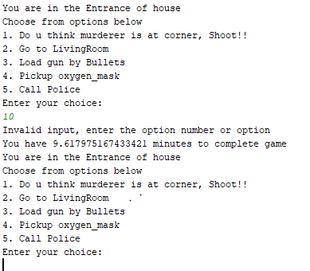

**Test 2:** User enters any random String.

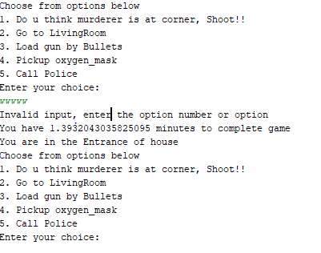

**Test 3:** User enter floats

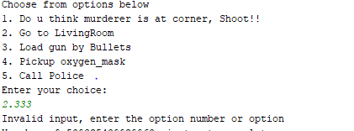

**Test4:** Correct int option

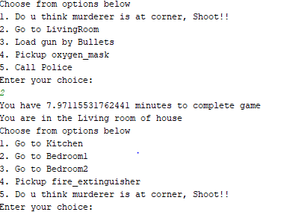

**Test5:** Correct String Option

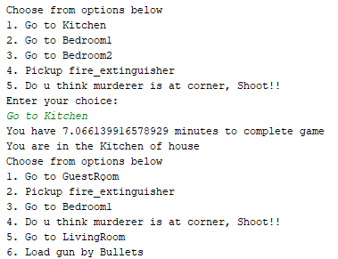

1. Function Name: show_game_directions():

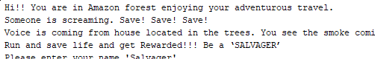

1. Function Name: decrement_bullets()

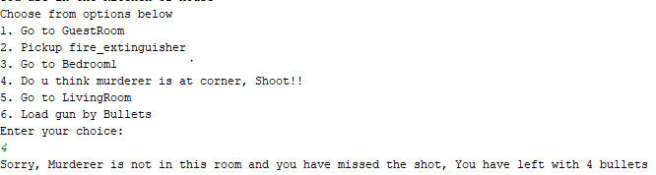

1. Function Name: increment_bullets()

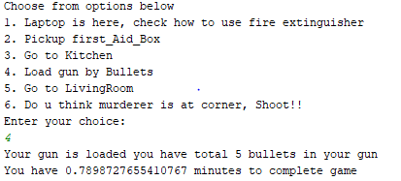

1. Function Name: reward_calculator()

