IT-261 CN 23IT106

Practical 6

Aim:

A growing enterprise, RouteTech Inc., requires a scalable routing solution to support its dynamic network topology.  
Task:   
1) Implement Dynamic Routing Protocol RIP in the following configurations:

* RIP (classful routing).
* RIPv2 (classless routing with CIDR).

2) Test the configuration and troubleshoot routing issues.

Output:

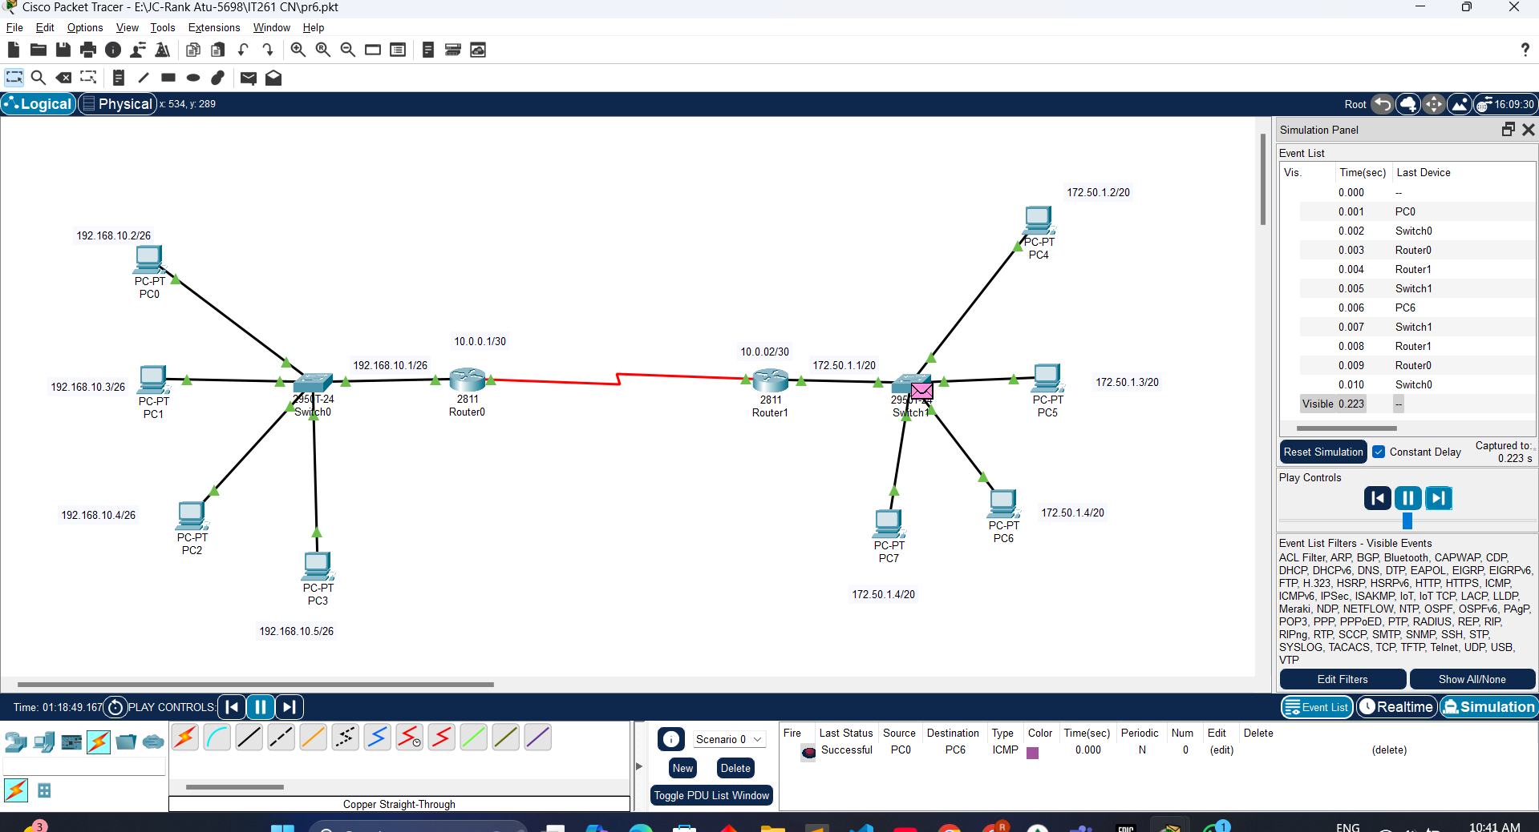

Conclusion

In implementing RIP and RIPv2 for RouteTech Inc., RIP (classful) provided basic dynamic routing but lacked support for CIDR and VLSM, making it less scalable. RIPv2, on the other hand, improved scalability by supporting classless routing with CIDR, offering better flexibility and address utilization. After configuring both protocols, testing showed RIPv2's ability to handle RouteTech’s growing network topology more efficiently. Troubleshooting revealed that RIPv2's ability to propagate subnet information resolved issues that RIP could not handle. In conclusion, RIPv2 is the more suitable choice for the company's evolving needs.