Design and Simulation of a Series-Parallel Hybrid Electric Vehicle (HEV) Using MATLAB Simulink and Stateflow
KPIT Apex Lab
COEP Technological University, Pune, India
Members
Raj Sawala  MIS: 612407149  Email: sawalar24.extc@coeptech.ac.in  Dept: ExTC  COEP Technological University | Amaan Mulla  MIS: __________________  Email: __________________  Dept: __________________  COEP Technological University | Karan Patil  MIS: __________________  Email: __________________  Dept: __________________  COEP Technological University
Mentor: Padma Dwivedi

Abstract
This project presents a MATLAB Simulink and Stateflow model of a series-parallel Hybrid Electric Vehicle (HEV). The model combines a pack-level battery equivalent-circuit model, generator control, motor control, a Simscape physical plant, and an energy-management control subsystem. The control subsystem selects drive cycles, computes driver torque request from vehicle-speed feedback, chooses operating mode through a Stateflow chart, and allocates engine, motor, and generator torque through a dynamic torque-split MATLAB Function.
The physical plant contains Simscape drivetrain elements including ideal torque sources, inertias, gears, a disc friction clutch, Magic Formula tire, vehicle body, brake actuation, and engine-speed sensing. The battery subsystem uses a discrete-time pack-level 1RC equivalent-circuit update using dt, SOC_new, and V_RC_new feedback through Unit Delay blocks. The motor control subsystem applies speed-based torque limiting, SOC derating, regenerative braking protection, and slew-rate limiting. Generator control translates generator torque and engine-speed feedback into generator power/current using the efficiency input eta with current clamping.
The documentation is intentionally written as a maintainable engineering report: each subsystem is described by purpose, interfaces, design logic, extracted code, parameters, expected behavior, scope outputs, assumptions, and known limitations. This makes the model easier to understand, review, modify, and extend.
Keywords
Hybrid Electric Vehicle, HEV, Series-Parallel Powertrain, Simulink, Stateflow, Simscape, Battery ECM, Energy Management System, Torque Split, Regenerative Braking

Nomenclature
Abbreviation | Meaning
HEV | Hybrid Electric Vehicle
EMS | Energy Management System
ECM | Equivalent Circuit Model
SOC | State of Charge
OCV | Open Circuit Voltage
RC | Resistor-Capacitor network
PI | Proportional-Integral controller
P-only | Proportional-only controller
LUT | Look-Up Table
ICE | Internal Combustion Engine
PS | Physical Signal
RPM | Revolutions per minute
Nm | Newton metre

I. INTRODUCTION
The objective of this project is to build and simulate a series-parallel HEV architecture. The model is not only a static block diagram; it represents closed-loop interaction between driver demand, energy-management decisions, battery state, generator charging, motor torque limiting, and the Simscape physical driveline.
The model is split into five major top-level subsystems: Battery, Generator_control, Motor_control, Physical Plant, and control. These subsystems exchange torque, speed, SOC, voltage, current, grade, clutch command, and braking signals. The most important documentation requirement is therefore not only to describe each block, but to describe the exact signal interfaces and how each subsystem affects the others.
Important documentation choice
The report records actual model details visible in the SLX package. Where a parameter is only a workspace symbol, such as C_nom, R1, C1, I_max_charge, T_gen_max, or dt, it is marked as an external workspace parameter rather than assigned an invented value.

1.1 Project objectives
- Model a series-parallel HEV powertrain with engine, motor, generator, clutch, gears, wheels, tire, and vehicle body.
- Implement a Stateflow-based EMS to switch between standby, regenerative braking, series, parallel, and series-parallel operating modes.
- Compute torque demand from vehicle-speed tracking and road-grade scenario selection.
- Represent the battery using a pack-level 1RC equivalent-circuit model with SOC dynamics and terminal-voltage calculation.
- Protect the motor through SOC derating, regeneration blocking at high SOC, speed-based torque limits, and slew-rate limiting.
- Provide scopes for torque, speed, power, battery, and generator/engine monitoring.

1.2 Report coverage
The report covers model architecture, exact subsystem ports, subsystem design notes, MATLAB Function code, Stateflow EMS transitions, parameter tables, scope documentation, limitations, and suggested verification checks. Screenshots from the provided PDF are inserted where available, and placeholders are included for additional screenshots and scope graphs that can be pasted later.

II. SYSTEM ARCHITECTURE
At the top level, the model uses the control subsystem as the supervisory controller. In the current SLX file it receives actual vehicle speed, battery SOC, and engine speed; the drive-cycle selection is handled inside the control subsystem using the ds_select constant/manual selection path and the dc_ts{1}...dc_ts{6} workspace signals. It outputs torque commands and actuator commands to the physical plant, motor control, generator control, and scopes. The Battery subsystem provides SOC and voltage feedback. Motor_control and Generator_control act as actuator-level conditioning layers between control commands and electrical/powertrain behavior.
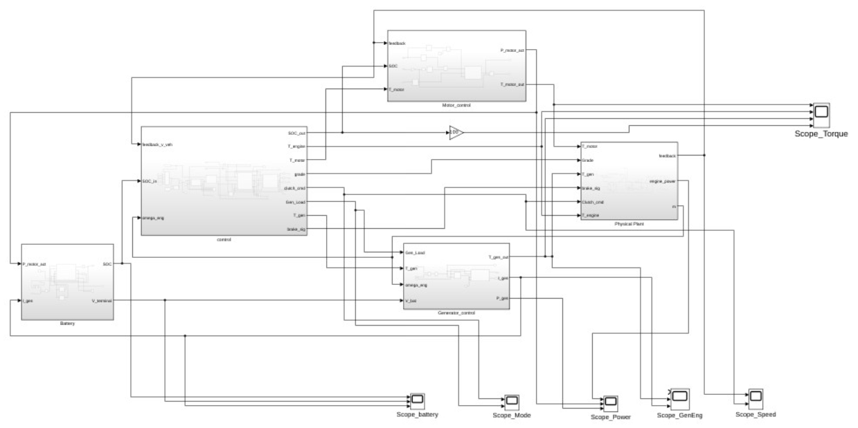
Figure 2.1 Top-level HEV model architecture from the uploaded screenshot PDF.

2.1 Top-level subsystem roles
Top-level subsystem | Role in the model
Battery | Pack-level battery equivalent-circuit subsystem. It estimates SOC and terminal voltage from motor power and generator charging current.
Generator_control | Converts generator torque/loading command and engine speed into actual generator torque, power, and charging current.
Motor_control | Applies speed, SOC, regenerative braking, and slew-rate limits to motor torque; computes actual motor power.
Physical Plant | Simscape driveline and vehicle dynamics plant. It converts torque/brake/grade commands into vehicle-speed and engine-speed feedback.
control | Energy-management system. It selects drive cycle, computes driver torque demand, chooses HEV mode in Stateflow, and calculates torque split.

2.2 High-level signal flow
- An internal drive-cycle selector uses ds_select/manual selection logic to select one of six workspace drive-cycle signals dc_ts{k}.
- DriverPI compares selected reference speed with feedback_v_veh and generates T_req and brake_sig.
- generate_terrain_scenario passes T_req and assigns road grade based on the internally selected Terrain_Mode value.
- The Stateflow EMS chart uses vehicle speed, torque demand, SOC, grade, and high-torque threshold to decide the active HEV mode.
- Torque_Split_Dynamic computes T_engine, T_motor, and T_gen according to EMS commands.
- Motor_control limits the motor torque and computes P_motor_act for the Battery subsystem.
- Generator_control saturates generator torque and computes I_gen for battery charging.
- Physical Plant receives the torque/brake/grade commands and returns vehicle speed, engine speed, and engine power.

Figure 2.2 Current top-level HEV Simulink model screenshot.
This screenshot replaces the earlier low-resolution export and shows the current signal routing, subsystems, and scopes.

III. SUBSYSTEM INTERFACES
The following tables list the actual subsystem ports observed in the SLX package. This section is important because HEV models become difficult to debug when torque, SOC, voltage, current, and command signals are mixed up.

3.1 control interface
Port | Input name | Unit / type | Description
1 | feedback_v_veh | km/h | Actual vehicle speed feedback from Physical Plant.
2 | SOC_in | % | Battery SOC signal after top-level 100x gain.
3 | omega_eng | rpm | Engine speed feedback from Physical Plant.

Port | Output name | Unit / type | Description
1 | SOC_out | % | Pass-through/monitoring SOC output.
2 | T_engine | Nm | Engine torque command.
3 | T_motor | Nm | Motor torque command before Motor_control limiting.
4 | grade | % | Selected road grade.
5 | clutch_cmd | 0/1 | Clutch command from EMS chart.
6 | Gen_Load | 0/1 | Generator loading command from EMS chart.
7 | T_gen | Nm | Generator torque command.
8 | brake_sig | 0-1 | Brake signal from DriverPI.

3.2 Battery interface
Port | Input name | Unit / type | Description
1 | P_motor_act | W (model signal) | Actual motor electrical power demand from Motor_control; divided by battery terminal voltage to estimate motor current.
2 | I_gen | A | Generator charging current from Generator_control.

Port | Output name | Unit / type | Description
1 | SOC | fraction, 0-1 | Battery state of charge from the discrete BatteryECM update and Unit Delay feedback path. A 100x gain at top-level converts this to percent for control.
2 | V_terminal | V | Pack terminal voltage after OCV, R0 and RC voltage drop scaling.

3.3 Generator_control interface
Port | Input name | Unit / type | Description
1 | Gen_Load | 0/1 | EMS command enabling generator loading.
2 | T_gen | Nm | Generator torque command from torque split calculator.
3 | omega_eng | rpm (model signal) | Engine speed feedback from Physical Plant / engine sensor.
4 | V_bat | V | Battery terminal voltage.

Port | Output name | Unit / type | Description
1 | T_gen_out | Nm | Actual/saturated generator torque sent to Physical Plant and scopes.
2 | I_gen | A | Charging current sent to Battery and scopes.
3 | P_gen | model power units | Generator power output computed in MATLAB Function.

3.4 Motor_control interface
Port | Input name | Unit / type | Description
1 | feedback | km/h or speed feedback signal | Vehicle speed feedback from plant. A gain of 3.4722 generates omega_motor for motor power calculation.
2 | SOC | % | SOC after top-level 100x gain.
3 | T_motor | Nm | Motor torque command from control.

Port | Output name | Unit / type | Description
1 | P_motor_act | W / model power units | Actual motor power computed from limited torque and speed.
2 | T_motor_out | Nm | SOC-, speed- and slew-limited motor torque sent to plant and scope.

3.5 Physical Plant interface
Port | Input name | Unit / type | Description
1 | T_motor | Nm | Motor torque applied through ideal torque source and motor gear.
2 | Grade | % | Road grade command converted to road angle.
3 | Clutch_cmd | 0/1 | Clutch engagement command.
4 | T_gen | Nm | Generator loading torque.
5 | brake_sig | 0-1 | Brake command from DriverPI.
6 | T_engine | Nm | Engine torque command.

Port | Output name | Unit / type | Description
1 | feedback | km/h | Vehicle speed feedback from Vehicle Body V output through PS-Simulink converter and 3.6 gain.
2 | engine_power | W / model power units | Engine mechanical power from torque-speed sensor subsystem.
3 | m | rpm / engine-speed feedback signal | Filtered engine-speed output from the engine sensor subsystem. It is routed at top level into omega_eng inputs of control and Generator_control.

Port-count note
In the live SLX package, Physical Plant has 6 inputs and 3 outputs: feedback, omega, and engine_power. If an older note says 6 inputs and 2 outputs, that appears outdated for this uploaded model.

IV. BATTERY MODEL
The Battery subsystem represents the energy source/sink of the HEV model. It receives actual motor power demand and generator charging current, estimates the net battery current, integrates SOC, and computes terminal voltage using a pack-level 1RC equivalent-circuit model.
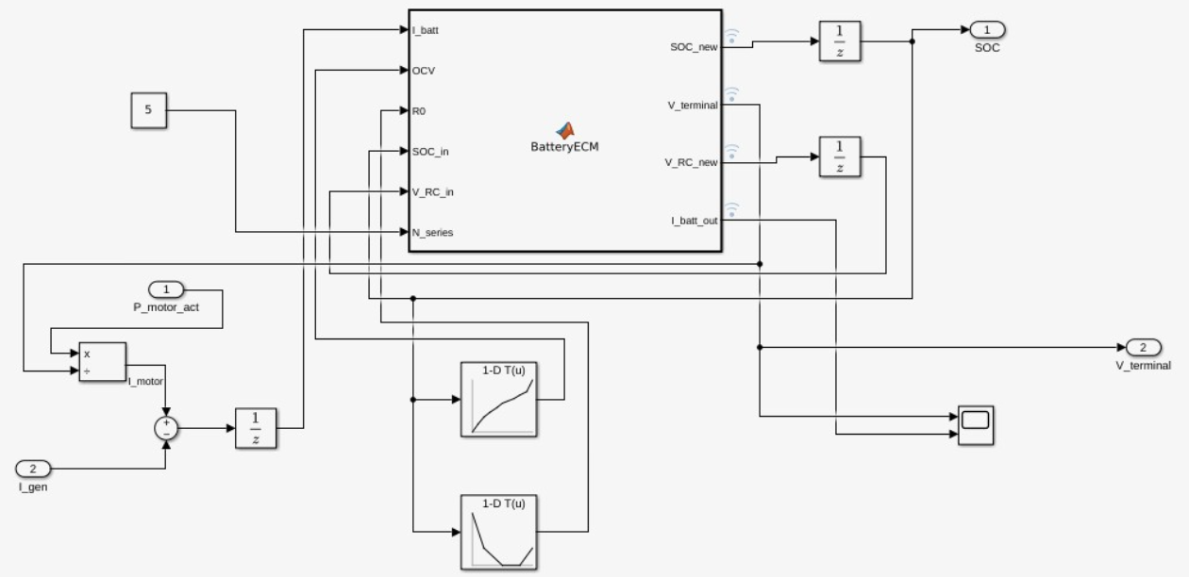
Figure 4.1 Battery subsystem screenshot.

4.1 Battery design overview
The battery model is based on a 1RC equivalent circuit. The open-circuit voltage and ohmic resistance are obtained from SOC-based lookup tables. In the current SLX file, the MATLAB Function performs a discrete-time SOC and RC-voltage update using the dt input. SOC_new and V_RC_new are fed back through Unit Delay blocks, so the function directly computes the next states rather than outputting continuous derivatives.
Battery block / parameter | Value visible in model | Purpose
SOC memory / Unit Delay initial condition | SOC_init (workspace symbol) | Initial SOC is provided from workspace. In the included Drive Cycle 2 result, SOC starts near 90%.
RC voltage memory / Unit Delay initial condition | V_RC_init (workspace symbol) | Initial RC polarization voltage used by the discrete 1RC battery update.
N_series constant | 5 | Scales cell-level OCV/R0/V_RC to pack level.
OCV lookup | SOC -> cell voltage | Provides cell open-circuit voltage curve.
R0 lookup | SOC -> ohmic resistance | Provides SOC-dependent internal resistance.
Unit Delay3 sample time | 0.01 s | Breaks direct feedthrough/current path and supports simulation stability.
BatteryECM time step | dt input | Used for Coulomb counting and RC exponential update.

4.2 Battery mathematical formulation
The implemented equations are:
dSOC = -I_batt * dt / (C_nom * 3600)
SOC_new = max(0, min(1, SOC_in + dSOC))
alpha = exp(-dt/(R1*C1))
V_RC_new = alpha*V_RC_in + R1*(1-alpha)*I_batt
OCV_pack = OCV * N_series
R0_pack_drop = I_batt * R0 * N_series
V_RC_pack = V_RC_new * N_series
V_terminal = OCV_pack - R0_pack_drop - V_RC_pack
V_terminal is clamped between 2.5*N_series and 4.3*N_series.
Pack scaling
The uploaded model passes N_series = 5 to the BatteryECM function. This makes the terminal-voltage clamp 12.5 V to 21.5 V. For a full-size HEV, this is a simplified low-voltage pack representation unless the workspace/model is later re-parameterized.

4.3 Battery MATLAB Function code
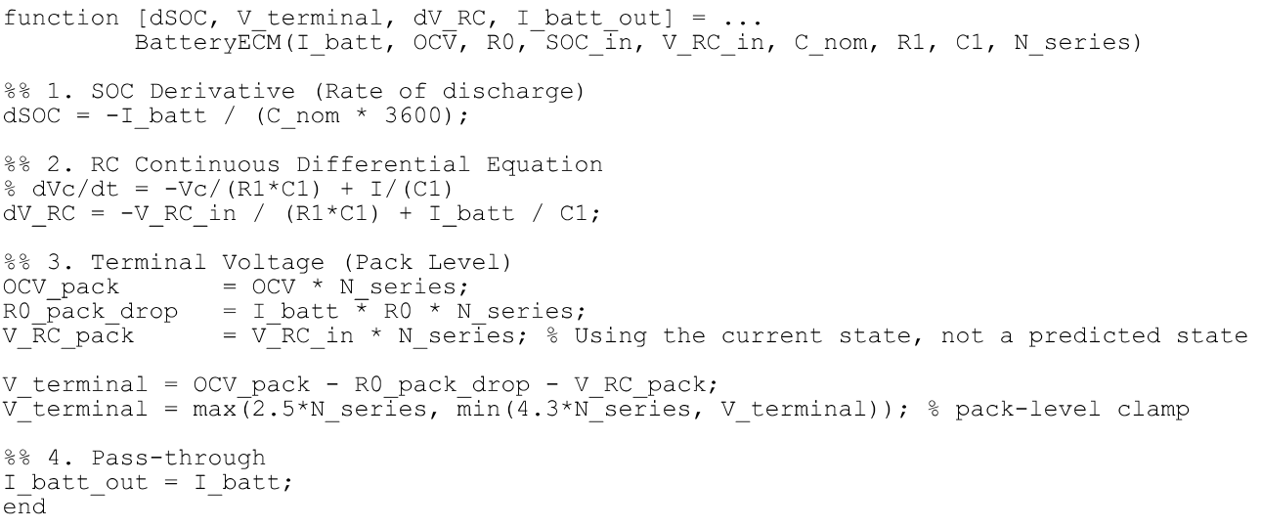
Figure 4.2 BatteryECM code screenshot from PDF.
Listing 4.1 BatteryECM MATLAB Function extracted from the SLX package.
function [SOC_new, V_terminal, V_RC_new, I_batt_out] = ...
BatteryECM(I_batt, OCV, R0, SOC_in, V_RC_in, dt, C_nom, R1, C1, N_series)

%% 1. SOC integration (Coulomb counting)
dSOC = -I_batt * dt / (C_nom * 3600);
SOC_new = SOC_in + dSOC;
SOC_new = max(0, min(1, SOC_new));

%% 2. RC pair dynamics at cell level
alpha = exp(-dt/(R1*C1));
V_RC_new = alpha*V_RC_in + R1*(1-alpha)*I_batt;

%% 3. Terminal voltage at pack level
OCV_pack = OCV * N_series;
R0_pack_drop = I_batt * R0 * N_series;
V_RC_pack = V_RC_new * N_series;

V_terminal = OCV_pack - R0_pack_drop - V_RC_pack;
V_terminal = max(2.5*N_series, min(4.3*N_series, V_terminal));

%% 4. Pass-through
I_batt_out = I_batt;
end

V. GENERATOR CONTROL
Generator_control acts as the conditioning layer between the EMS generator torque command and the battery charging current. It multiplies the generator command by Gen_Load, applies a saturation block, and computes generator power/current through a MATLAB Function.
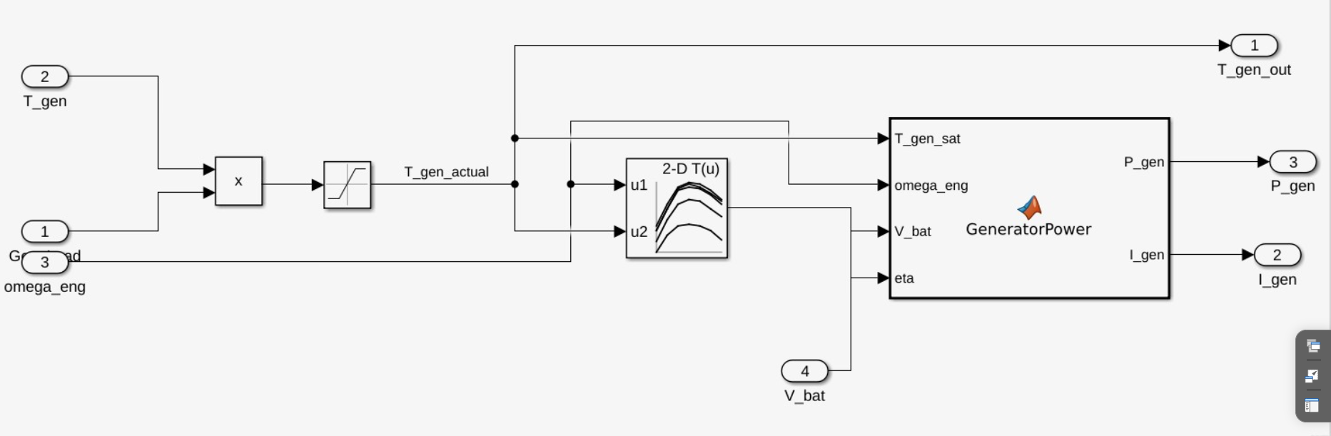
Figure 5.1 Generator_control subsystem screenshot.

5.1 Generator control signal path
- Gen_Load and T_gen are multiplied so that generator torque is active only when the EMS enables generator loading.
- The product is saturated using lower limit 0 and upper limit T_gen_max.
- T_gen_out is sent back to the plant and to scopes as actual/saturated generator torque.
- GeneratorPower receives T_gen_sat, omega_eng, V_bat, and eta, then outputs P_gen and I_gen.
- I_gen is clamped to I_max_charge and constrained to be non-negative.

5.2 Generator lookup table and implementation note
Item | Extracted value | Engineering meaning
2-D LUT breakpoints dimension 1 | [0;50;100;150;200;250;300] | Speed/torque-map axis as implemented. Connected to omega_eng in the subsystem.
2-D LUT breakpoints dimension 2 | [0;20;40;60;80] | Second map axis. Connected to T_gen_actual in the subsystem.
2-D LUT table | 7 x 5 matrix, values approx. 0.60 to 0.92 | Represents an efficiency-like map.
Actual connection status | LUT output is connected to the eta input of GeneratorPower. | The current GeneratorPower function multiplies generator torque and engine speed by eta before current calculation.
Implementation update note
The current Generator_control screenshot and SLX function signature show eta connected to GeneratorPower. The current GeneratorPower code computes P_gen = T_gen_sat * omega_eng * eta, then divides by safe battery voltage and clamps I_gen to I_max_charge.

5.3 Generator MATLAB Function code
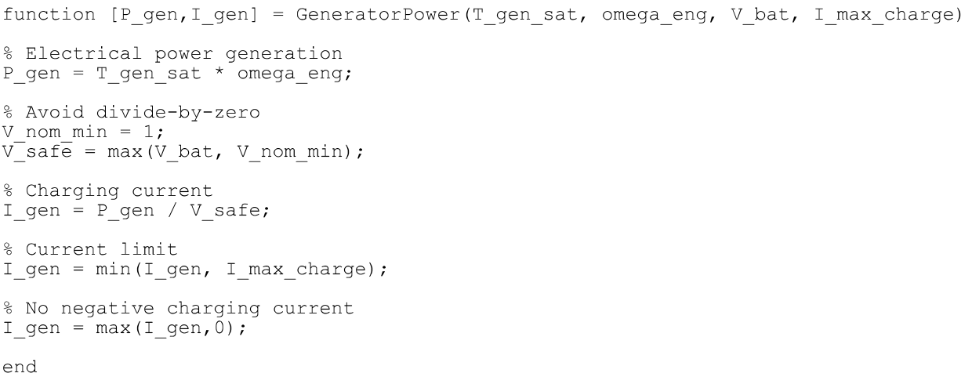
Figure 5.2 GeneratorPower code screenshot from PDF.
Listing 5.1 GeneratorPower MATLAB Function extracted from the SLX package.
function [P_gen,I_gen] = GeneratorPower(T_gen_sat, omega_eng, V_bat, eta, I_max_charge)

% Electrical power generation
P_gen = T_gen_sat * omega_eng * eta;

% Avoid divide-by-zero
V_nom_min = 1;
V_safe = max(V_bat, V_nom_min);

% Charging current
I_gen = P_gen / V_safe;

% Current limit
I_gen = min(I_gen, I_max_charge);

% No negative charging current
I_gen = max(I_gen,0);
end

VI. MOTOR CONTROL
Motor_control receives the torque command from the EMS and applies practical limits before sending motor torque to the physical plant. It also estimates actual motor power for the battery model.
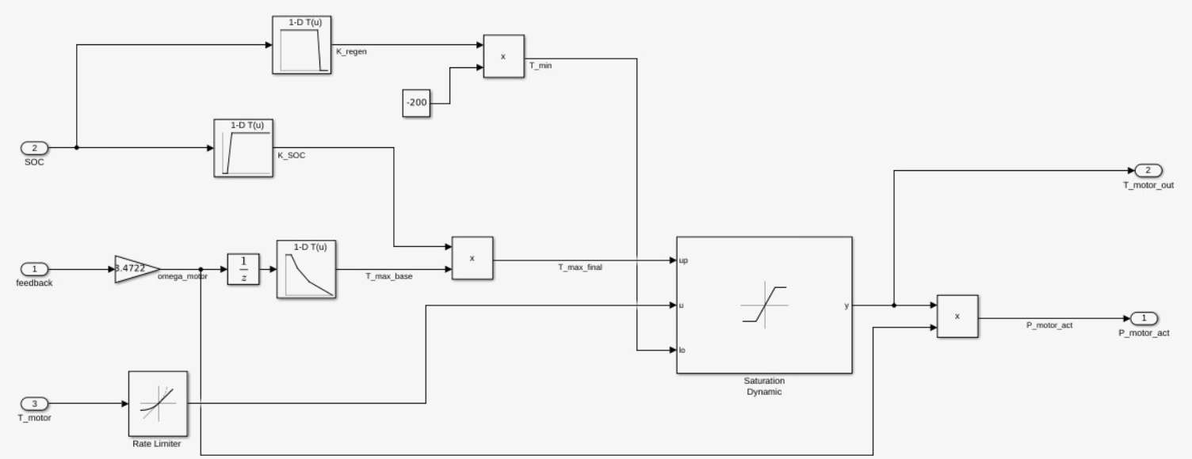
Figure 6.1 Motor_control subsystem screenshot.

6.1 Motor-control protective behavior
- Speed-based torque limiting reduces maximum motor torque as motor speed increases.
- K_SOC derates positive motor torque at low SOC. In the uploaded table, motor assistance is zero below 10% SOC and reaches full permission by 20% SOC.
- K_regen derates regenerative braking at high SOC. Regeneration remains allowed up to 80% SOC and is blocked by 85% SOC.
- A dynamic saturation block limits the requested torque between the computed upper and lower torque limits.
- The Rate Limiter uses rising slew limit 500 and falling slew limit -500, with inherited sample time.
Motor parameter / LUT | Breakpoints | Table values | Purpose
T_max_base LUT | [0;50;100;200;400] | [250;250;200;150;100] | Speed-based base motor torque limit.
K_SOC LUT | [0;0.1;0.2;1] | [0;0;1;1] | Low-SOC motor-assist derating.
K_regen LUT | [0;0.8;0.85;1] | [1;1;0;0] | High-SOC regenerative braking blocking.
T_min constant | -200 | - | Lower motor torque limit before K_regen scaling.
Feedback gain | 3.4722 | - | Generates omega_motor from feedback signal for motor power calculation.
Rate limiter | Rising 500, falling -500 | - | Limits torque-command slew rate.
Motor-control subsystem screenshot has been inserted above. Lookup-table numeric breakpoints and table values are documented in the table; separate block-dialog screenshots may be added later if required by the evaluator.

VII. PHYSICAL PLANT
The Physical Plant subsystem is the Simscape driveline model. It converts engine, motor, generator, brake, clutch, and grade commands into vehicle motion and engine-speed feedback. It is the most physically detailed part of the model.
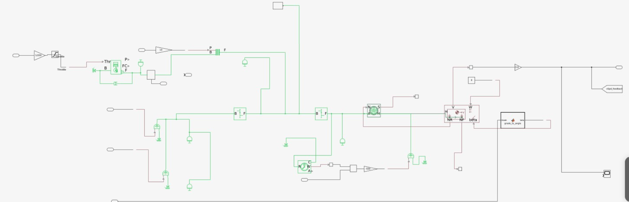
Figure 7.1 Physical Plant subsystem screenshot.
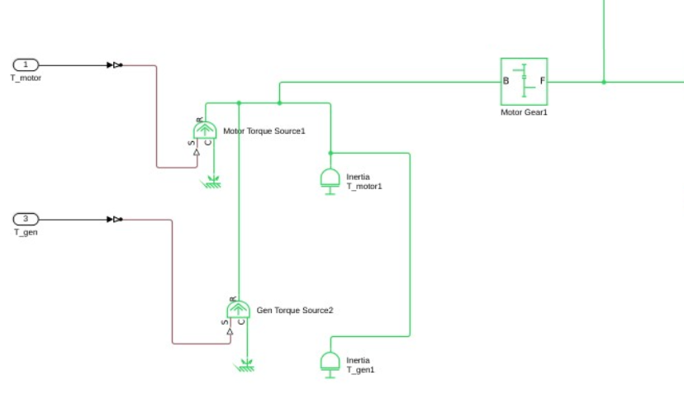
Figure 7.1(b) Physical Plant zoomed view of the motor/generator torque-source and motor-gear section.

7.1 Mechanical topology
The topology visible in the uploaded screenshot and SLX XML can be summarized as follows: engine torque is applied through an engine subsystem and engine shaft inertia; a clutch controls mechanical coupling to the driveline; motor and generator torque sources are connected through their own inertias; the motor path uses a Motor Gear; the driveline reaches the Final Drive gear, wheel inertia, Magic Formula tire, and Vehicle Body. Vehicle speed and engine speed are sensed and returned to the controller.
Plant component | Block type / library source | Visible parameter values | Purpose
Generic Engine | Simscape Driveline Generic Engine | Initial velocity 800 rpm; redline speed 5000 rpm; inertia model off in block; engine shaft inertia added separately | Engine-side mechanical source/behavior.
Engine Shaft Inertia | Rotational Inertia | 0.25 kg*m^2 | Dedicated shaft inertia for engine dynamics.
Disc Friction Clutch | Simscape Driveline Clutch | r_eff = 130 mm; piston area = 0.001 m^2; mu_static = 0.35 | Engages/disengages engine mechanical path.
Motor Torque Source | Ideal Torque Source | Input from T_motor | Applies commanded motor torque.
Generator Torque Source | Ideal Torque Source | Input from T_gen | Applies generator loading torque.
Motor Gear1 | Simple Gear | ratio = 2; efficiency = 0.8 | Motor/driveline gearing.
Final Drive gear1 | Simple Gear | ratio = 2; efficiency = 0.8 | Final driveline gear reduction.
Tire (Magic Formula)1 | Magic Formula Tire | p_tire = 250e3 Pa; damping = 1000 N*s/m | Tire-road longitudinal force.
Vehicle Body1 | Vehicle Body | mass = 1200 kg; area = 3 m^2; Cd = 0.4; rho = 1.18 | Vehicle longitudinal dynamics.

7.2 Engine/sensor subsystem design
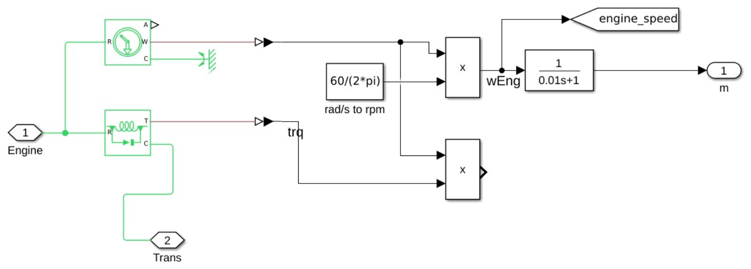
Figure 7.2 Engine sensor subsystem screenshot.
The engine-speed sensing subsystem uses an Ideal Rotational Motion Sensor and conversion from rad/s to rpm using 60/(2*pi). Engine torque and angular velocity are also multiplied to generate engine power. A first-order transfer function 1/(0.01s+1) is used on the engine-speed output path, giving a filtered omega_engine signal for feedback.
Rationale for this plant style
The model uses a Simulink-computed torque command with ideal torque sources and dedicated inertias. This is appropriate for a student-level HEV control project because it keeps the EMS and torque split logic visible and tunable, instead of hiding engine behavior inside a combustion-calibrated block requiring detailed engine maps.

7.3 Grade conversion code
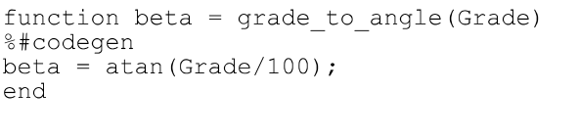
Figure 7.3 grade_to_angle code screenshot from PDF.
Listing 7.1 grade_to_angle MATLAB Function extracted from the SLX package.
function beta = grade_to_angle(Grade)
%#codegen
beta = atan(Grade/100);
end
Additional physical-plant close-up screenshots inserted below: engine/clutch path, brake actuator path, and tire/vehicle-body/grade path.
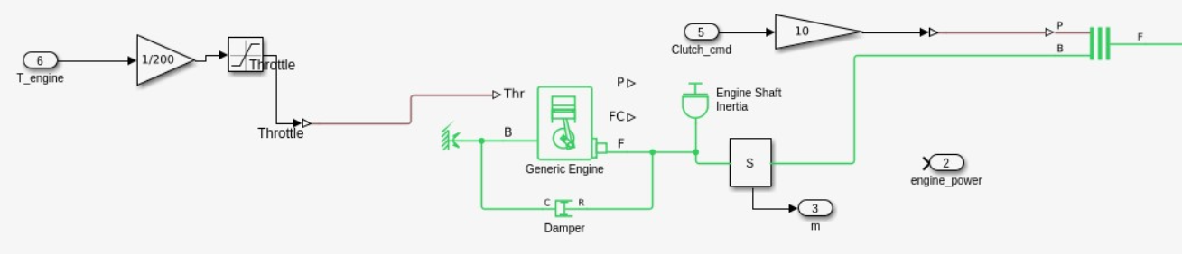
Figure 7.4 Physical Plant close-up: engine, throttle, clutch command and engine shaft path.
Shows the torque command input, throttle conversion, Generic Engine, shaft inertia, clutch command path and engine_power output.
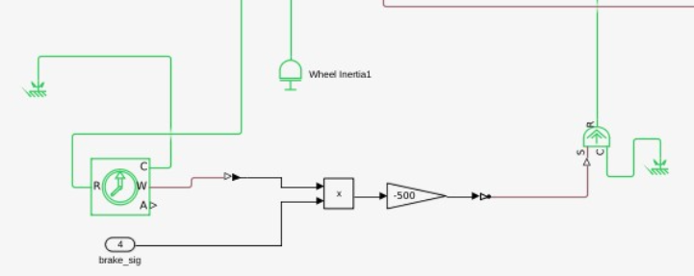
Figure 7.5 Physical Plant close-up: brake actuator and wheel-side braking path.
Shows brake_sig path, braking torque conversion and connection to the wheel/driveline side.
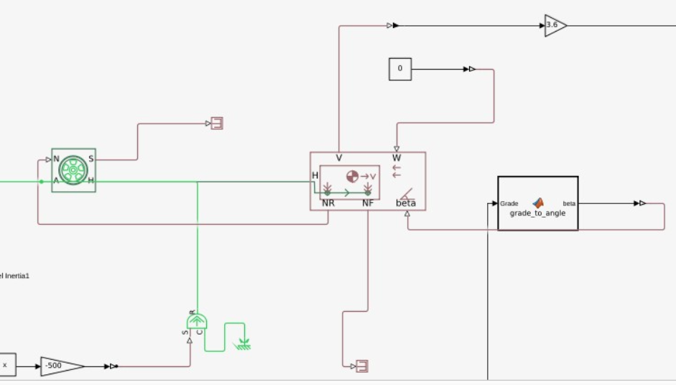
Figure 7.6 Physical Plant close-up: tire, vehicle body, grade conversion and speed feedback path.
Shows Magic Formula Tire, Vehicle Body, grade_to_angle block and 3.6 gain used for speed feedback.

VIII. ENERGY MANAGEMENT CONTROL
The control subsystem acts as the EMS. It selects the drive cycle, computes torque demand, assigns road grade, selects HEV operating mode using Stateflow, and calculates engine/motor/generator torque commands.
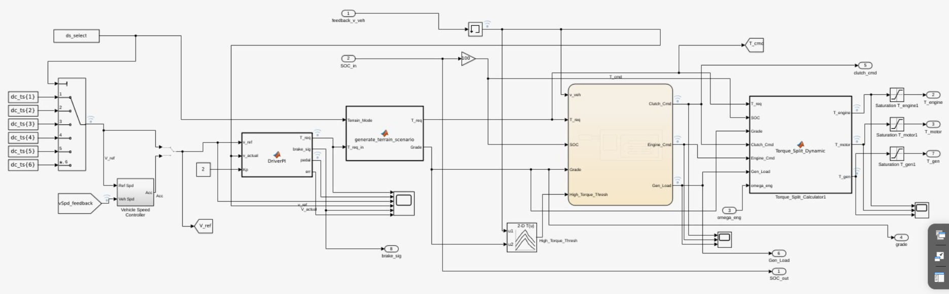
Figure 8.1 control subsystem screenshot.

8.1 Drive-cycle selection
The control subsystem contains six From Workspace drive-cycle signals, dc_ts{1} to dc_ts{6}, selected through the internal drive-cycle selection path. In the current SLX file the top-level control subsystem no longer exposes Terrain_mode as an external input port; selection is handled inside control using ds_select/manual selection logic. Several From Workspace blocks use the workspace sample time dt, so dc_ts and dt must be available before simulation.
Terrain_Mode | Drive-cycle source | Grade assigned by generate_terrain_scenario
1 | dc_ts{1} | 0% flat road
2 | dc_ts{2} | 1% slight road grade
3 | dc_ts{3} | 8% steep uphill road
4 | dc_ts{4} | 0% flat road
5 | dc_ts{5} | 1% slight road grade
6 | dc_ts{6} | 8% steep uphill road
otherwise | none | T_req=0, Grade=0 fail-safe

8.2 DriverPI current control law
In the current SLX file, DriverPI is now a true PI-style speed controller with proportional gain Kp, integral gain Ki, and time step dt. The function accumulates error using int_err = int_err + err*dt, applies anti-windup limiting when Ki is non-zero, saturates pedal command to [-1,1], generates T_req from positive pedal demand, generates brake_sig from negative pedal demand, and smooths T_req using a low-pass filter with alpha = 0.02.
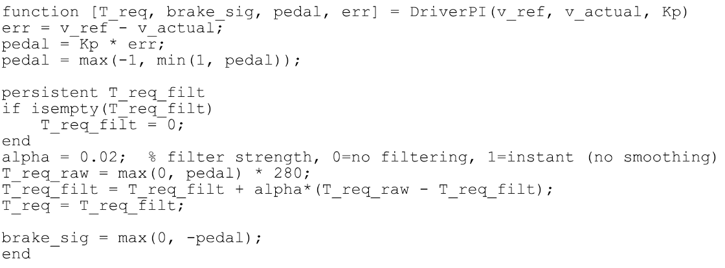
Figure 8.2 DriverPI code screenshot from PDF.
Listing 8.1 DriverPI MATLAB Function extracted from the SLX package.
function [T_req, brake_sig, pedal, err] = DriverPI(v_ref, v_actual, Kp, Ki, dt)
% 1. Initialize memory
persistent int_err T_req_filt
if isempty(int_err)
int_err = 0;
T_req_filt = 0;
end

% 2. Error calculation
err = v_ref - v_actual;

% 3. Proper time-based integration
int_err = int_err + (err * dt);

% 4. Anti-windup
if Ki ~= 0
int_limit = 1 / abs(Ki);
int_err = max(-int_limit, min(int_limit, int_err));
end

% 5. PI control law
pedal_unsat = (Kp * err) + (Ki * int_err);
pedal = max(-1, min(1, pedal_unsat));

% 6. Torque and braking commands
T_req_raw = max(0, pedal) * 280;
brake_sig = max(0, -pedal);

% 7. Low-pass filter for T_req
alpha = 0.02;
T_req_filt = T_req_filt + alpha * (T_req_raw - T_req_filt);
T_req = T_req_filt;
end

8.3 Terrain/grade scenario function
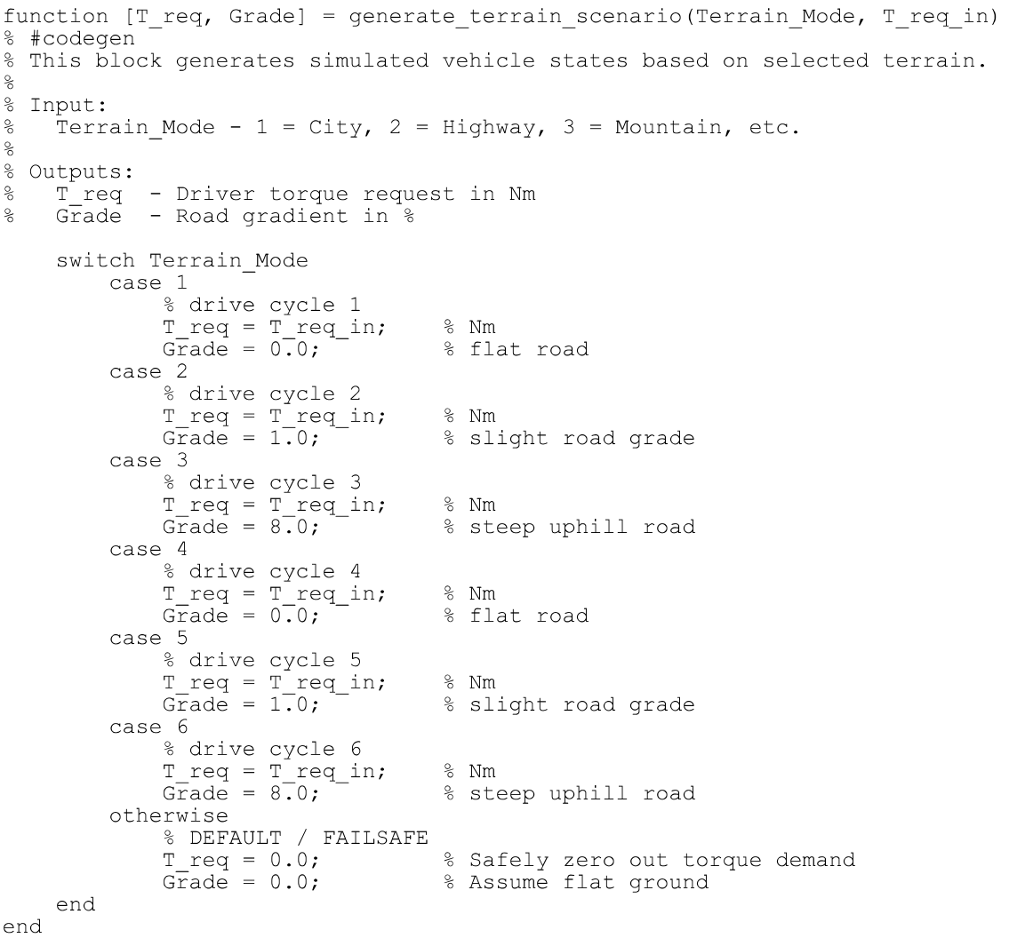
Figure 8.3 generate_terrain_scenario code screenshot from PDF.
Listing 8.2 generate_terrain_scenario MATLAB Function extracted from the SLX package.
function [T_req, Grade] = generate_terrain_scenario(Terrain_Mode, T_req_in)
% #codegen
% This block generates simulated vehicle states based on selected terrain.
%
% Input:
% Terrain_Mode - 1 = City, 2 = Highway, 3 = Mountain, etc.
%
% Outputs:
% T_req - Driver torque request in Nm
% Grade - Road gradient in %

switch Terrain_Mode
case 1
% drive cycle 1
T_req = T_req_in; % Nm
Grade = 0.0; % flat road
case 2
% drive cycle 2
T_req = T_req_in; % Nm
Grade = 1.0; % slight road grade
case 3
% drive cycle 3
T_req = T_req_in; % Nm
Grade = 8.0; % steep uphill road
case 4
% drive cycle 4
T_req = T_req_in; % Nm
Grade = 0.0; % flat road
case 5
% drive cycle 5
T_req = T_req_in; % Nm
Grade = 1.0; % slight road grade
case 6
% drive cycle 6
T_req = T_req_in; % Nm
Grade = 8.0; % steep uphill road
otherwise
% DEFAULT / FAILSAFE
T_req = 0.0; % Safely zero out torque demand
Grade = 0.0; % Assume flat ground
end
end

8.4 High torque threshold lookup
The control subsystem contains a 2-D lookup table for High_Torque_Thresh. The breakpoints and table values visible in the SLX XML are shown below. This threshold is used in the Stateflow EMS transition into series-parallel mode when grade and torque demand are high.
Axis / table | Extracted value
Breakpoints dimension 1 | [0;20;40;60;70;80;100;120]
Breakpoints dimension 2 | [0 5 10]
Table | [100 80 60; 120 100 80; 140 120 100; 155 135 115; 145 125 105; 130 110 90; 115 95 75; 95 80 65]

8.5 EMS Stateflow mode-selection chart
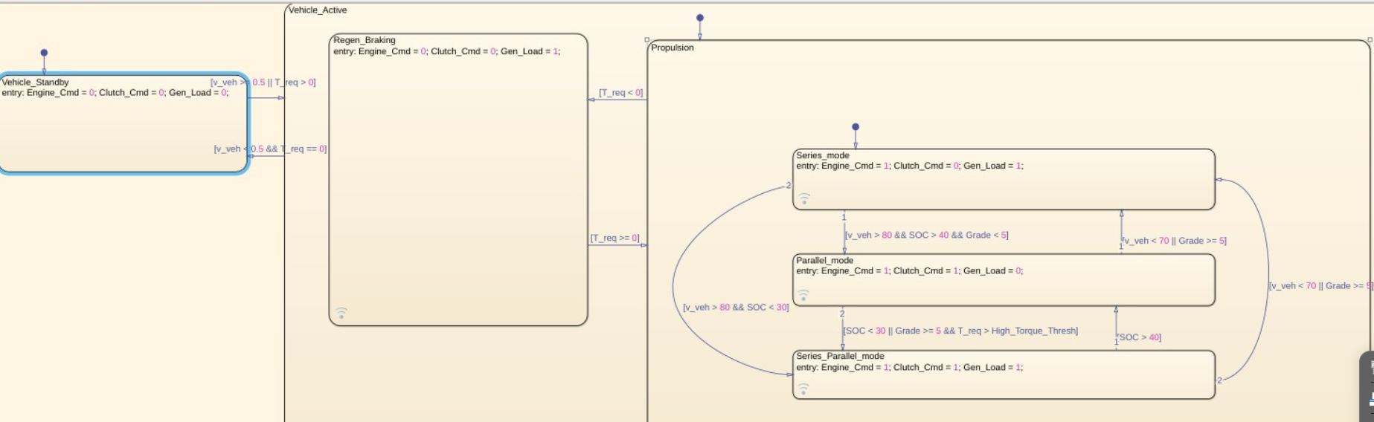
Figure 8.4 EMS Stateflow chart screenshot.
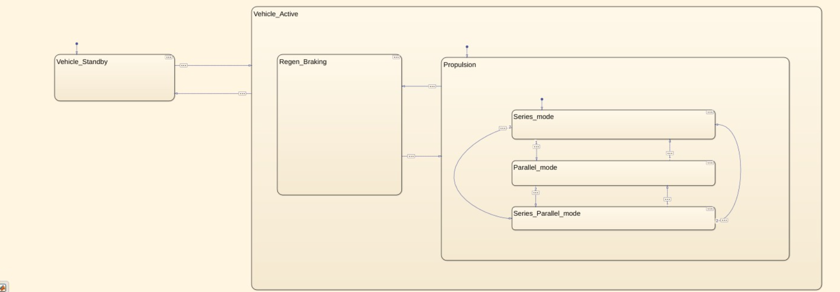
Figure 8.4(b) Alternate EMS Stateflow overview showing the same state hierarchy with a cleaner zoomed layout.
The EMS chart contains the top states Vehicle_Standby and Vehicle_Active. Inside Vehicle_Active, the model separates Regen_Braking and Propulsion. Inside Propulsion, three operating modes are implemented: Series_mode, Parallel_mode, and Series_Parallel_mode.
State ID | State | Entry action / description
51 | Vehicle_Active | Vehicle_Active
57 | Regen_Braking | Regen_Braking; entry: Engine_Cmd = 0; Clutch_Cmd = 0; Gen_Load = 1;
59 | Propulsion | Propulsion
66 | Series_mode | Series_mode; entry: Engine_Cmd = 1; Clutch_Cmd = 0; Gen_Load = 1;
67 | Parallel_mode | Parallel_mode; entry: Engine_Cmd = 1; Clutch_Cmd = 1; Gen_Load = 0;
68 | Series_Parallel_mode | Series_Parallel_mode; entry: Engine_Cmd = 1; Clutch_Cmd = 1; Gen_Load = 1;
50 | Vehicle_Standby | Vehicle_Standby; entry: Engine_Cmd = 0; Clutch_Cmd = 0; Gen_Load = 0;

8.6 EMS transition conditions
Transition ID | Source | Destination | Condition
124 | Default/Initial | Series_mode | (default transition)
81 | Series_Parallel_mode | Series_mode | [v_veh < 70 || Grade >= 5]
76 | Series_mode | Series_Parallel_mode | [v_veh > 80 && SOC < 30]
75 | Series_mode | Parallel_mode | [v_veh > 80 && SOC > 40 && Grade < 5]
78 | Parallel_mode | Series_mode | [v_veh < 70 || Grade >= 5]
79 | Parallel_mode | Series_Parallel_mode | [SOC < 30 || Grade >= 5 && T_req > High_Torque_Thresh]
80 | Series_Parallel_mode | Parallel_mode | [SOC > 40]
85 | Default/Initial | Propulsion | (default transition)
87 | Propulsion | Regen_Braking | [T_req < 0]
88 | Regen_Braking | Propulsion | [T_req >= 0]
92 | Default/Initial | Vehicle_Standby | (default transition)
53 | Vehicle_Standby | Vehicle_Active | [v_veh >= 0.5 || T_req > 0]
56 | Vehicle_Active | Vehicle_Standby | [v_veh < 0.5 && T_req == 0]
Transition precedence note
The condition [SOC < 30 || Grade >= 5 && T_req > High_Torque_Thresh] follows MATLAB/Stateflow logical precedence, where && binds tighter than ||. In plain words: SOC below 30 triggers series-parallel, or high grade plus high torque triggers it.

8.7 Torque_Split_Dynamic logic
Torque_Split_Dynamic converts EMS commands into actual torque requests for engine, motor, and generator. It uses command combinations from the Stateflow chart. The function also includes vehicle mass, wheel radius, grade force calculation, SOC weighting, and final torque clamping.
EMS command combination | Mode interpreted by code | Torque allocation behavior
Engine_Cmd=0, Clutch_Cmd=0, Gen_Load=1 | Standby or regenerative braking | If T_req<0, motor torque is negative and scaled by eta_motor; otherwise motor torque is zero.
Engine_Cmd=1, Clutch_Cmd=0, Gen_Load=1 | Series mode | Motor provides propulsion torque up to T_motor_max. Engine runs near T_engine_opt plus SOC correction and drives generator.
Engine_Cmd=1, Clutch_Cmd=1, Gen_Load=0 | Parallel mode | Engine torque is based on SOC weighting; motor fills remaining torque and grade compensation. Generator torque is zero.
Engine_Cmd=1, Clutch_Cmd=1, Gen_Load=1 | Series-parallel mode | Engine holds T_engine_opt. Surplus goes to generator or deficit is supplied by motor.
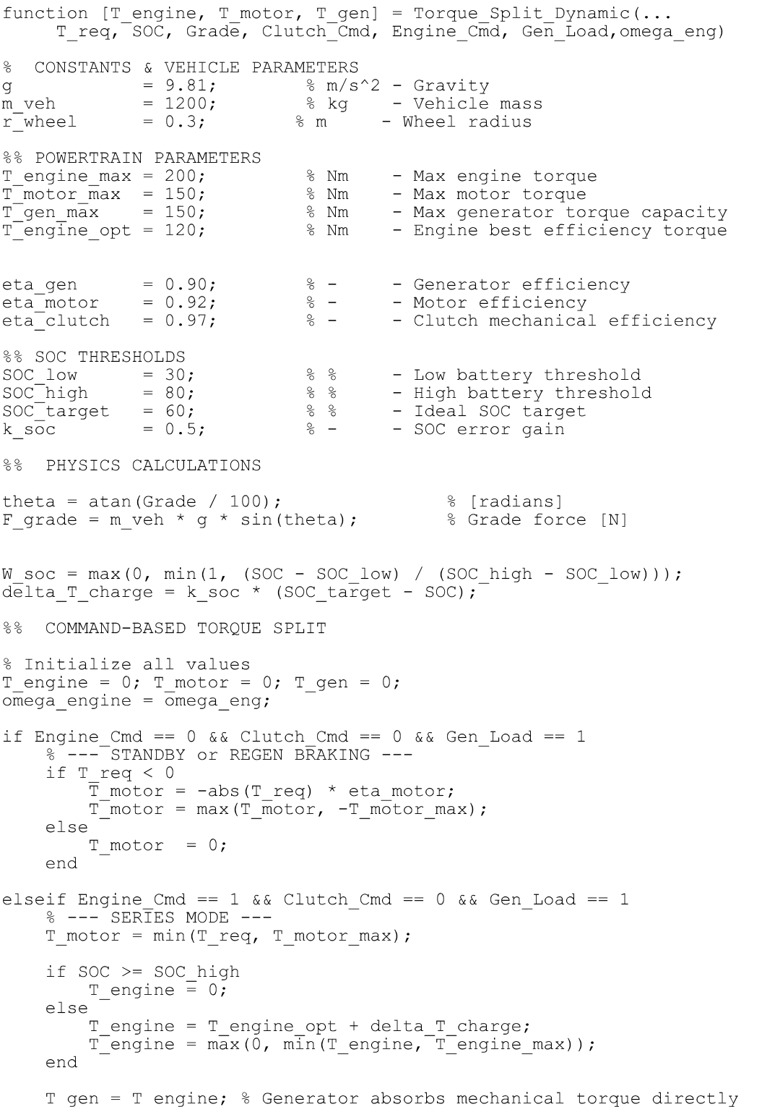
Figure 8.5 Torque_Split_Dynamic code screenshot, part 1.
Listing 8.3 Torque_Split_Dynamic MATLAB Function extracted from the SLX package.
function [T_engine, T_motor, T_gen] = Torque_Split_Dynamic(...
T_req, SOC, Grade, Clutch_Cmd, Engine_Cmd, Gen_Load,omega_eng)

% CONSTANTS & VEHICLE PARAMETERS
g = 9.81; % m/s^2 - Gravity
m_veh = 1200; % kg - Vehicle mass
r_wheel = 0.3; % m - Wheel radius

%% POWERTRAIN PARAMETERS
T_engine_max = 200; % Nm - Max engine torque
T_motor_max = 150; % Nm - Max motor torque
T_gen_max = 150; % Nm - Max generator torque capacity
T_engine_opt = 120; % Nm - Engine best efficiency torque

eta_gen = 0.90; % - - Generator efficiency
eta_motor = 0.92; % - - Motor efficiency
eta_clutch = 0.97; % - - Clutch mechanical efficiency

%% SOC THRESHOLDS
SOC_low = 30; % % - Low battery threshold
SOC_high = 80; % % - High battery threshold
SOC_target = 60; % % - Ideal SOC target
k_soc = 0.5; % - - SOC error gain

%% PHYSICS CALCULATIONS

theta = atan(Grade / 100); % [radians]
F_grade = m_veh * g * sin(theta); % Grade force [N]

W_soc = max(0, min(1, (SOC - SOC_low) / (SOC_high - SOC_low)));
delta_T_charge = k_soc * (SOC_target - SOC);

%% COMMAND-BASED TORQUE SPLIT

% Initialize all values
T_engine = 0; T_motor = 0; T_gen = 0;
omega_engine = omega_eng;

if Engine_Cmd == 0 && Clutch_Cmd == 0 && Gen_Load == 1
% --- STANDBY or REGEN BRAKING ---
if T_req < 0
T_motor = -abs(T_req) * eta_motor;
T_motor = max(T_motor, -T_motor_max);
else
T_motor = 0;
end

elseif Engine_Cmd == 1 && Clutch_Cmd == 0 && Gen_Load == 1
% --- SERIES MODE ---
T_motor = min(T_req, T_motor_max);

if SOC >= SOC_high
T_engine = 0;
else
T_engine = T_engine_opt + delta_T_charge;
T_engine = max(0, min(T_engine, T_engine_max));
end

T_gen = T_engine; % Generator absorbs mechanical torque directly

elseif Engine_Cmd == 1 && Clutch_Cmd == 1 && Gen_Load == 0
% --- PARALLEL MODE ---
T_grade_motor = F_grade * r_wheel;

T_engine = (1 - W_soc) * T_engine_max;
T_engine = min(T_engine, T_req);

T_motor = (T_req - (T_engine * eta_clutch)) + T_grade_motor;
T_motor = max(0, min(T_motor, T_motor_max));
T_gen = 0;

elseif Engine_Cmd == 1 && Clutch_Cmd == 1 && Gen_Load == 1
% --- SERIES-PARALLEL MODE ---
T_engine = T_engine_opt;

if T_engine >= T_req
% Engine has surplus. Calculate torque gap and route to generator.
T_surplus = T_engine - T_req;
T_gen = T_surplus;
T_motor = 0;
else
% Engine has deficit. Motor must assist.
T_motor = min(T_req - T_engine, T_motor_max);
T_gen = 0;
end
end

T_engine = max(0, min(T_engine, T_engine_max));
T_motor = max(-T_motor_max, min(T_motor, T_motor_max));

% BUG 4 FIXED: Clamped to T_gen_max instead of T_engine_max
T_gen = max(0, min(T_gen, T_gen_max));

end
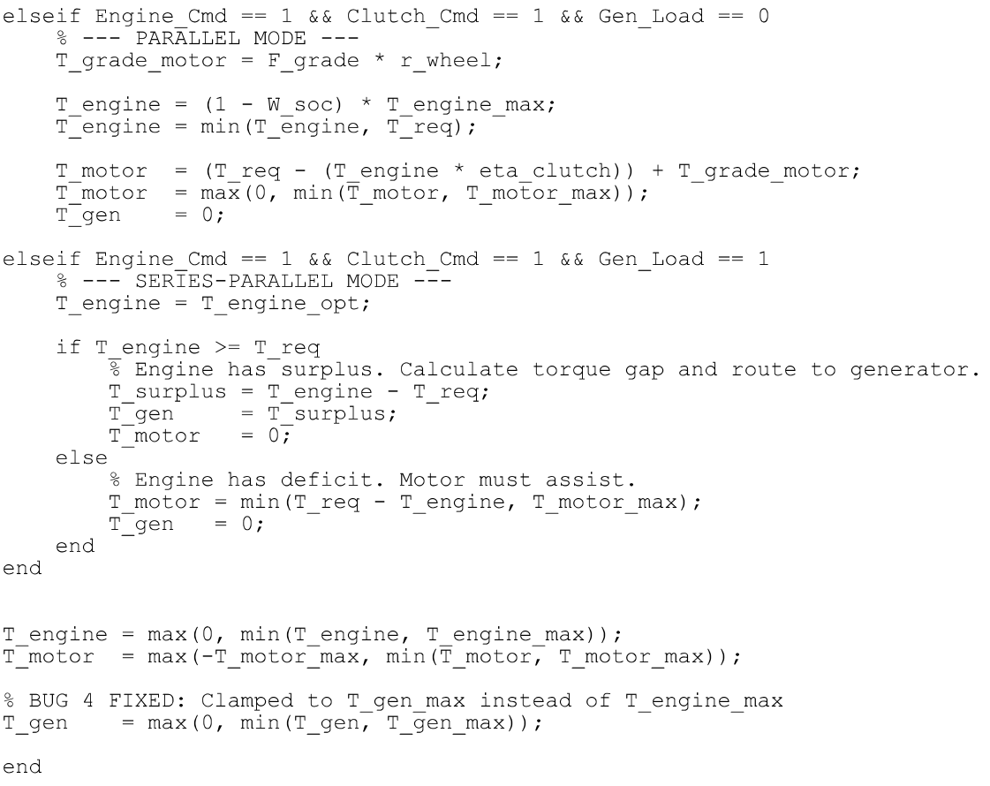
Figure 8.6 Torque_Split_Dynamic code screenshot, part 2.

IX. SCOPES AND RESULT DOCUMENTATION
The uploaded model contains several top-level scopes. The scope signal labels were extracted from the Scope GraphicalSettings saved in the SLX XML. These scopes are essential for presenting simulation results in the final report.
Result-screenshot note: all scope plots inserted in this section correspond to Drive Cycle 2. The plots should therefore be interpreted as the model response under the second drive-cycle/terrain selection.

Scope name | No. of inputs | Signals connected | Recommended result interpretation
Scope_Torque | 4 | T_motor_out, T_engine, T_gen, SOC_out | Shows torque split and SOC trend together. Use it to verify mode decisions and torque allocation.
Scope_Speed | 2 | Physical Plant/feedback, control/Clutch_Cmd | Shows vehicle speed response and clutch engagement timing.
Scope_Power | 3 | Physical Plant/P, Motor_control/P_motor_act, Generator_control/P_gen | Shows mechanical/electrical power exchange among engine, motor, and generator.
Scope_GenEng | 3 | Physical Plant/wEng, T_gen, Generator_control/I_gen | Shows engine speed, generator torque, and charging current.
Scope_battery | 3 | Battery/SOC, Battery/V_terminal, Generator_control/I_gen | Shows SOC, terminal voltage, and generator charging current.
Scope_Mode | 2 | control/Clutch_Cmd, control/Gen_Load | Shows clutch engagement command and generator-load command during Drive Cycle 2.

9.1 Scope_Torque expected graph notes
In series mode, motor torque should track propulsion demand while engine/generator torque supports charging. In parallel mode, engine torque should increase and motor torque should assist only as required. In regenerative braking, motor torque may become negative if T_req is negative and SOC protection permits regeneration.
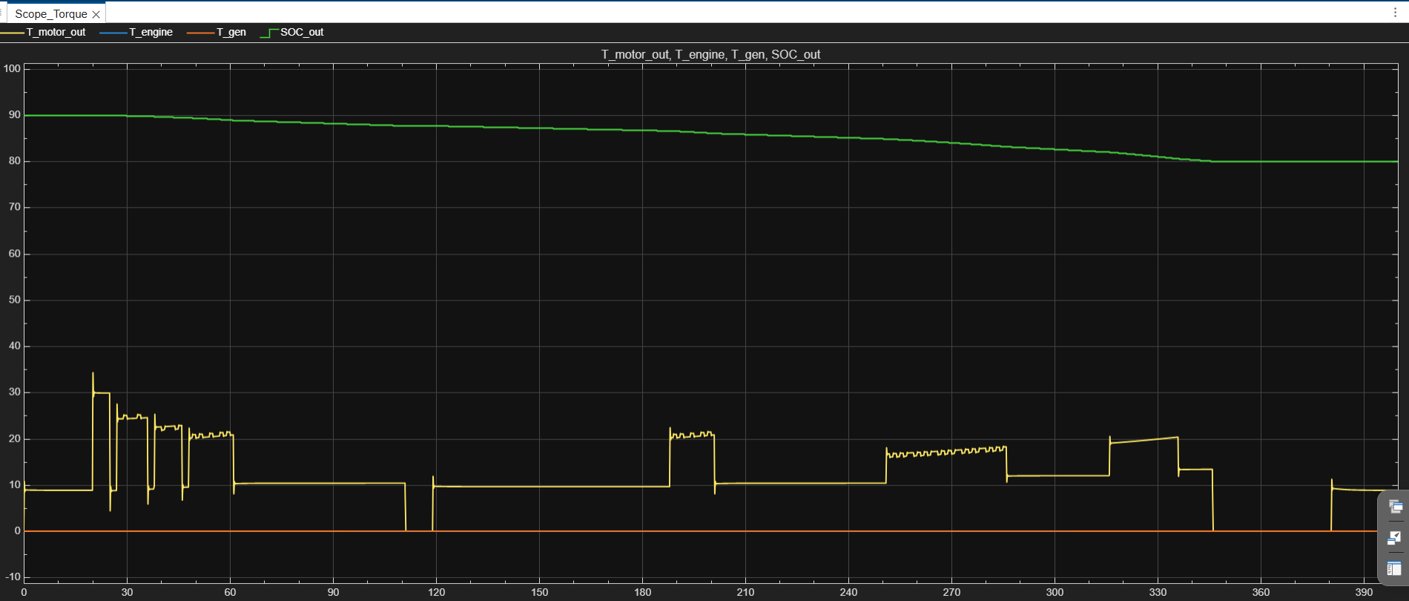
Figure 9.1 Scope_Torque output for Drive Cycle 2.
Channels: T_motor_out, T_engine, T_gen and SOC_out.

9.2 Scope_Speed expected graph notes
The speed scope should show the actual vehicle-speed feedback. It can be compared against the selected drive-cycle reference inside control. Clutch_Cmd can be overlaid to show how mode transitions affect driveline engagement.
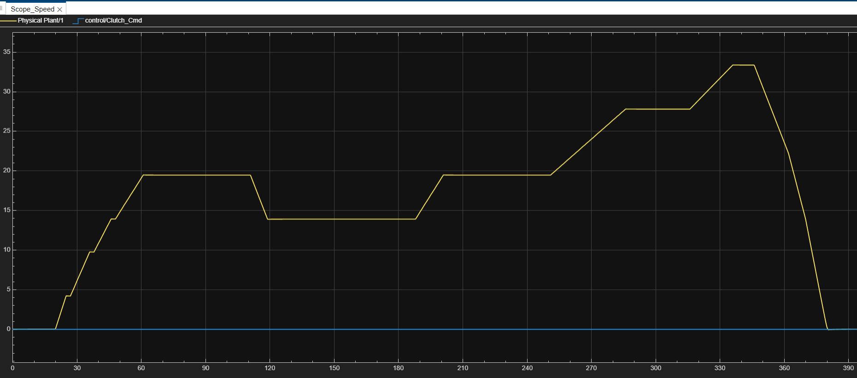
Figure 9.2 Scope_Speed output for Drive Cycle 2.
Channels: actual vehicle-speed feedback and clutch command.

9.3 Scope_Power expected graph notes
The power scope helps confirm energy flow. During propulsion, motor power should generally be positive when the motor assists. During generator charging, Generator_control/P_gen should rise with generator torque and engine speed. Engine power should correspond to engine torque and speed behavior in the plant sensor subsystem.
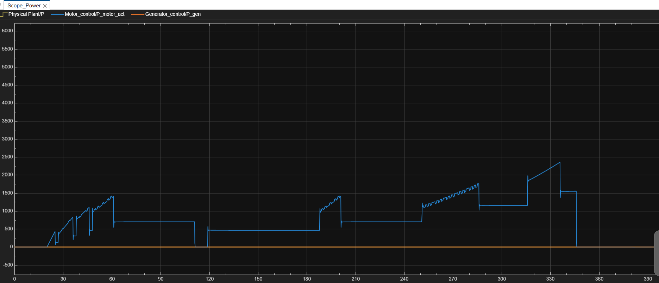
Figure 9.3 Scope_Power output for Drive Cycle 2.
Channels: engine power, motor actual power and generator power.

9.4 Scope_GenEng and Scope_battery expected graph notes
Scope_GenEng is useful for checking generator charging logic. Scope_battery is useful for checking whether SOC and V_terminal stay within limits. If SOC rises while I_gen is positive and motor power is low, the battery/generator path is behaving as expected. If V_terminal clips at the clamp limit, the pack parameters should be reviewed.
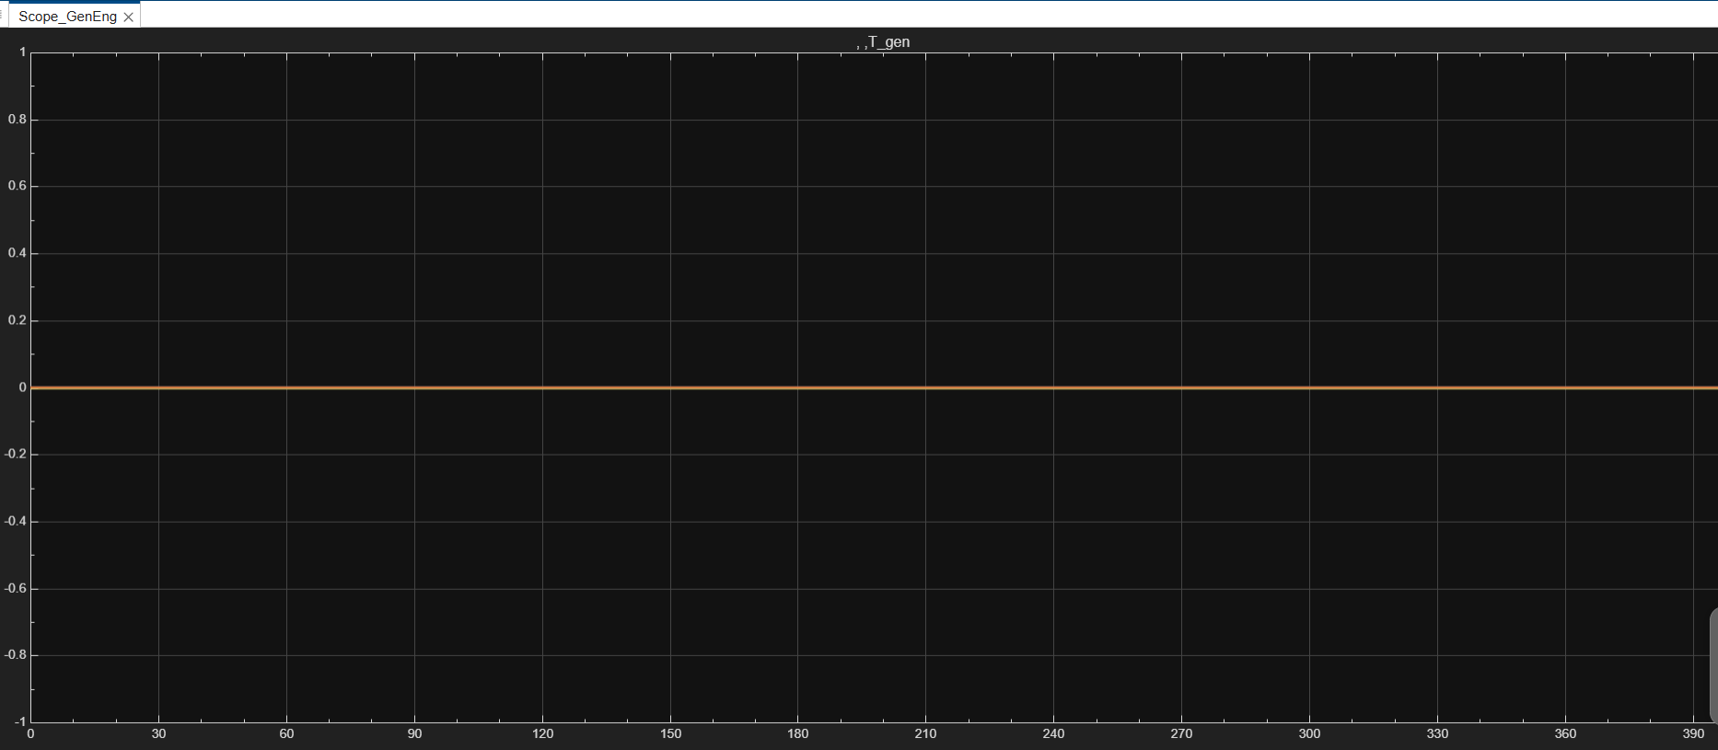
Figure 9.4 Scope_GenEng output for Drive Cycle 2.
Channels: engine speed, generator torque and generator current; the shown run indicates generator torque/current remain nearly zero.
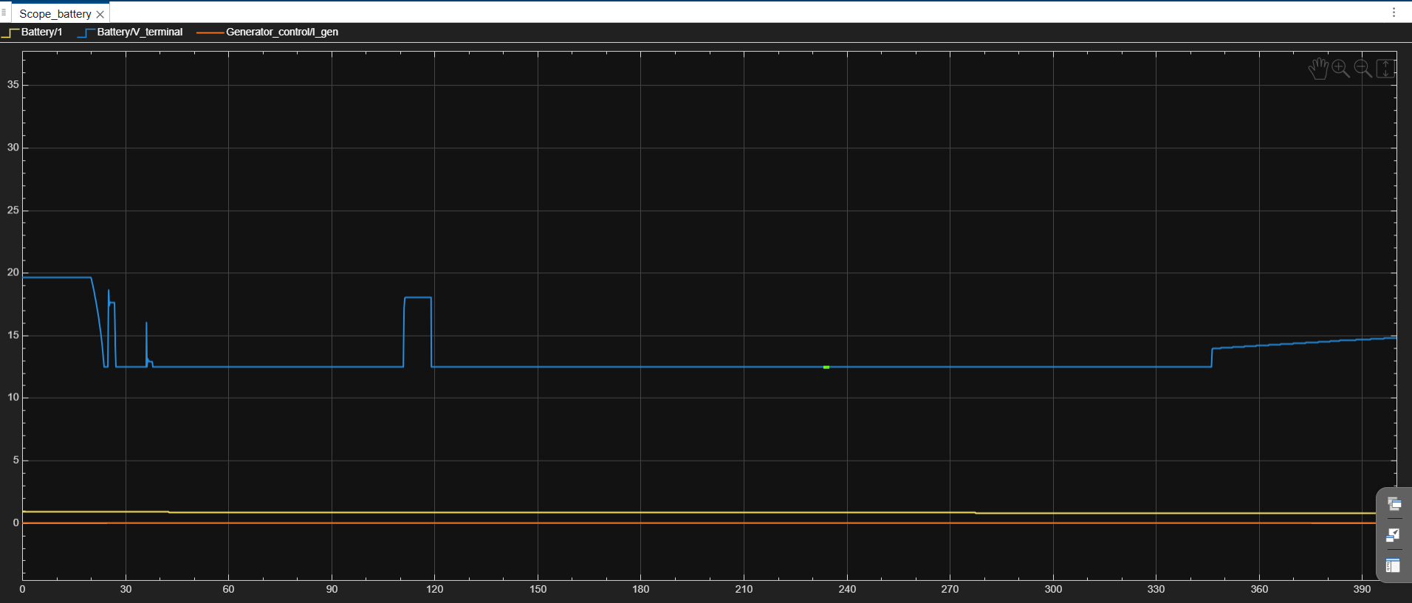
Figure 9.5 Scope_battery output for Drive Cycle 2.
Channels: SOC, V_terminal and I_gen.
9.5 Additional Drive Cycle 2 diagnostic scopes
The following additional scope captures are included because they directly support controller verification for the same Drive Cycle 2 simulation run.
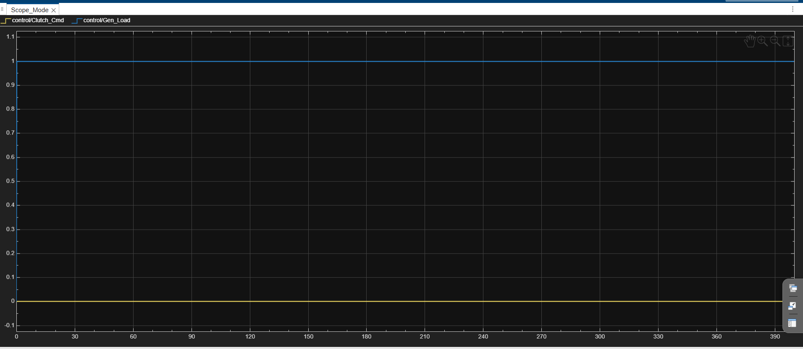
Figure 9.6 Scope_Mode output for Drive Cycle 2: Clutch_Cmd and Gen_Load commands.
The plot shows generator loading enabled and clutch command inactive for the shown drive-cycle run.
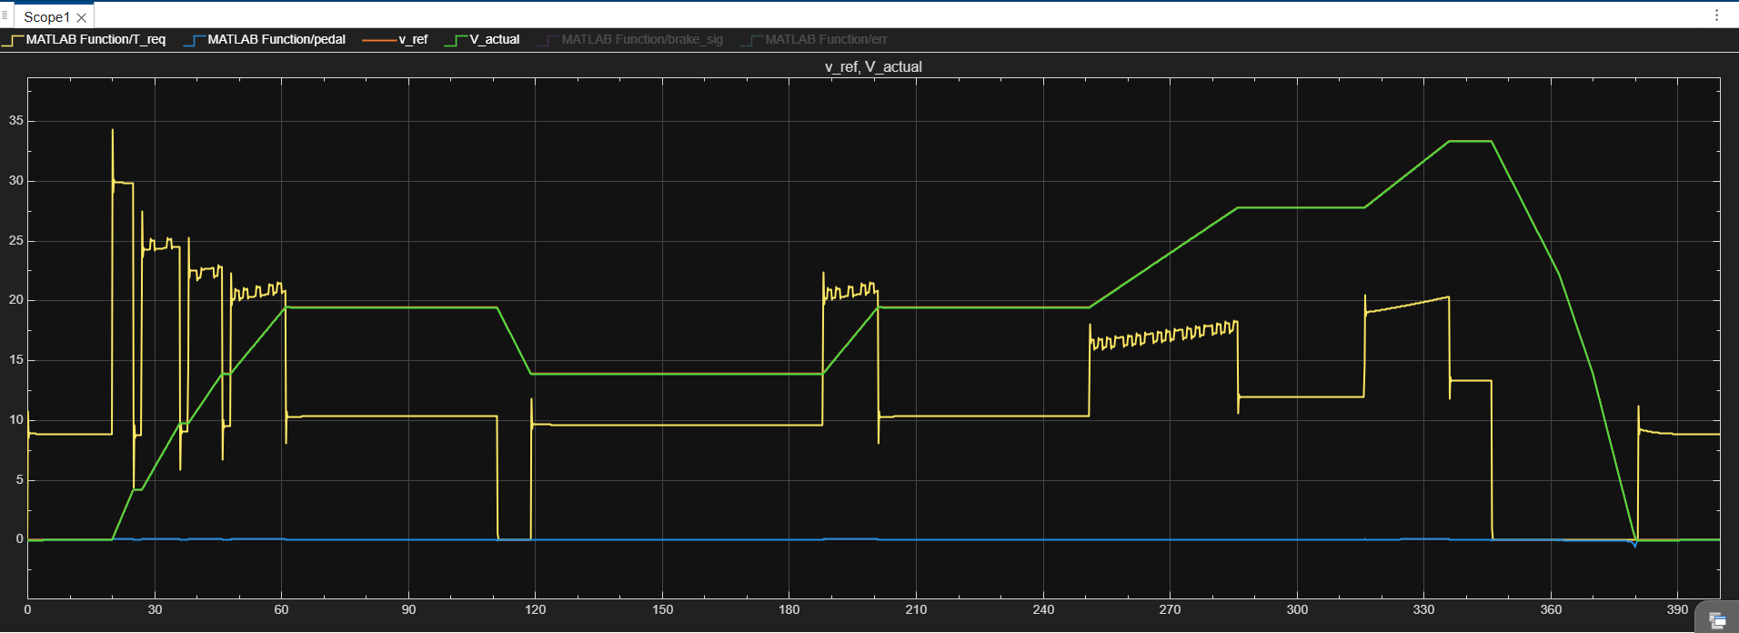
Figure 9.7 DriverPI/internal speed-tracking scope for Drive Cycle 2.
This plot compares v_ref and V_actual and also shows the filtered T_req response generated by the driver controller.
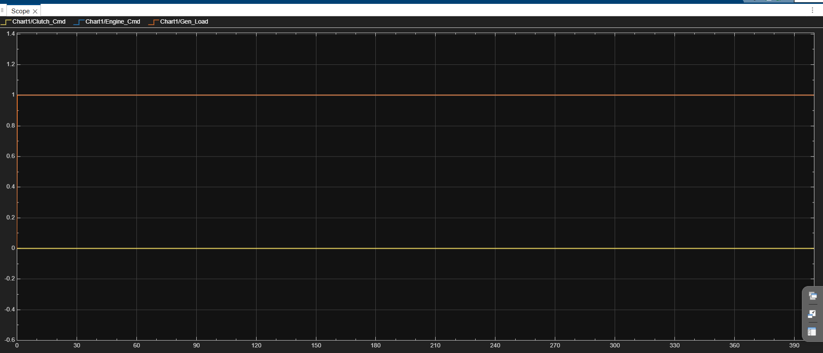
Figure 9.8 EMS chart command scope for Drive Cycle 2.
Shows Clutch_Cmd, Engine_Cmd and Gen_Load command levels produced by the mode-selection chart.
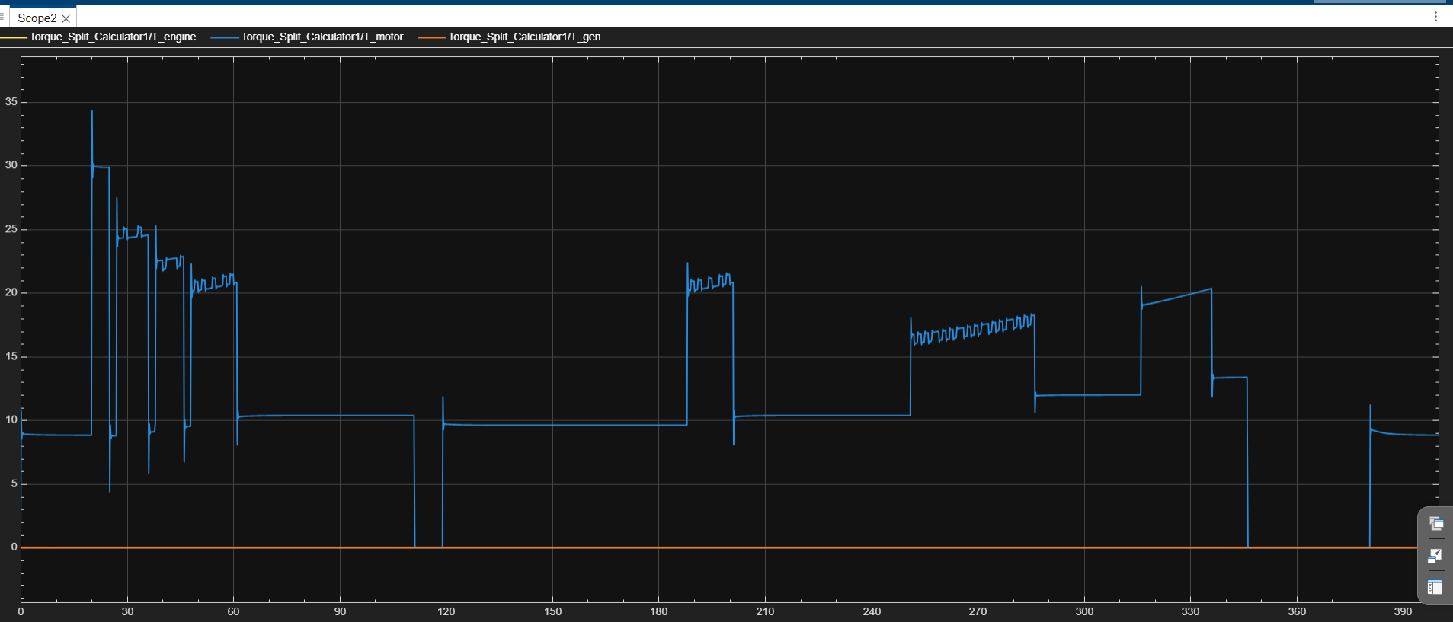
Figure 9.9 Torque split calculator output scope for Drive Cycle 2.
Shows the internal T_engine, T_motor and T_gen torque commands before/around final output routing.

X. PARAMETER REFERENCE
This table lists tunable constants and key parameters visible in the current uploaded file. Some values are numeric and directly embedded in blocks or code. Others are external workspace symbols and must be defined in the MATLAB base workspace, model workspace, or initialization script before simulation.
Parameter | Current value | Unit | Source in model | Comment
Kp | 2 | - | control/Constant -> DriverPI input | Proportional speed-error gain used by the current PI driver controller.
DriverPI alpha | 0.02 | - | control/MATLAB Function script | Low-pass smoothing factor for T_req filter.
DriverPI torque scale | 280 | Nm | control/MATLAB Function script | T_req_raw = max(0,pedal)*280.
N_series | 5 | cells in series | Battery/Constant -> BatteryECM input | Pack-level voltage scaling. Clamp range becomes 12.5 V to 21.5 V.
SOC initial condition | SOC_init (external symbol); Drive Cycle 2 run begins near 90% | fraction | Battery/Unit Delay initial condition | Initial SOC is workspace-defined in the current SLX; do not document it as a fixed 0.6 unless SOC_init is set to 0.6.
OCV lookup BP | [0,0.1,...,1] | SOC fraction | Battery/1-D Lookup Table | SOC breakpoints for cell OCV curve.
OCV lookup table | [3,3.2,3.35,3.45,3.55,3.65,3.72,3.78,3.85,3.93,4.2] | V/cell | Battery/1-D Lookup Table | Cell OCV values.
R0 lookup BP | [0,0.2,0.5,0.8,1] | SOC fraction | Battery/1-D Lookup Table1 | SOC breakpoints for internal resistance.
R0 lookup table | [0.08,0.06,0.05,0.05,0.06] | ohm/cell | Battery/1-D Lookup Table1 | Ohmic resistance values used in pack voltage drop.
C_nom | external symbol | Ah | BatteryECM MATLAB Function parameter | Referenced by code but numeric value is not embedded in the SLX XML/package.
R1 | external symbol | ohm | BatteryECM MATLAB Function parameter | Referenced by code but numeric value is not embedded in the SLX XML/package.
C1 | external symbol | F | BatteryECM MATLAB Function parameter | Referenced by code but numeric value is not embedded in the SLX XML/package.
I_max_charge | external symbol | A | GeneratorPower MATLAB Function parameter | Current clamp parameter; numeric value not embedded in the SLX XML/package.
T_gen_max | external symbol in Generator_control saturation; 150 in Torque_Split code | Nm | Generator_control/Saturation + Torque_Split_Dynamic | Workspace limit is symbolic in Generator_control, while Torque_Split_Dynamic uses 150 Nm internally.
T_engine_max | 200 | Nm | Torque_Split_Dynamic code | Maximum engine torque inside torque split calculator.
T_motor_max | 150 | Nm | Torque_Split_Dynamic code | Maximum motor torque inside torque split calculator.
T_engine_opt | 120 | Nm | Torque_Split_Dynamic code | Engine operating target used in series and series-parallel modes.
SOC_low | 30 | % | Torque_Split_Dynamic code | Low SOC threshold.
Ki | 0.05 | - | control/Constant2 -> DriverPI input | Integral gain used in current DriverPI function.
DriverPI dt | 0.01 | s | control/Constant3 -> DriverPI input | Time step used for DriverPI error integration.
Battery SOC_init | external symbol | fraction | Battery/Unit Delay initial condition | Workspace-defined initial SOC for discrete BatteryECM feedback path.
Battery V_RC_init | external symbol | V/cell equivalent | Battery/Unit Delay1 initial condition | Workspace-defined initial RC voltage state.
Parameter | Current value | Unit | Source in model | Comment
SOC_high | 80 | % | Torque_Split_Dynamic code | High SOC threshold.
SOC_target | 60 | % | Torque_Split_Dynamic code | Target SOC for charging torque correction.
k_soc | 0.5 | - | Torque_Split_Dynamic code | Gain for SOC-target charging torque correction.
eta_gen | 0.90 | - | Torque_Split_Dynamic code | Declared generator efficiency; not directly used elsewhere in the shown torque split equations.
eta_motor | 0.92 | - | Torque_Split_Dynamic code | Used for regenerative motor torque scaling.
eta_clutch | 0.97 | - | Torque_Split_Dynamic code | Used in parallel-mode torque allocation.
Vehicle mass | 1200 | kg | Physical Plant Vehicle Body; Torque_Split_Dynamic code | Used in plant and grade force calculation.
Wheel radius | 0.3 | m | Torque_Split_Dynamic code | Used for grade compensation torque. Tire block separately uses Magic Formula parameters.
Motor Gear ratio | 2 | - | Physical Plant/Motor Gear1 | Simple gear block ratio.
Final Drive ratio | 2 | - | Physical Plant/Final Drive gear1 | Simple gear block ratio.
Gear efficiency parameter | 0.8 | - | Physical Plant/Motor Gear1 and Final Drive gear1 | Simple gear efficiency parameter; friction model is set to off.
Engine shaft inertia | 0.25 | kg*m^2 | Physical Plant/Engine Shaft Inertia | Dedicated engine shaft inertia.
Driveline inertia | 0.01 | kg*m^2 | Physical Plant/Driveline_Inertia1 | Driveline inertia block.
Motor torque-source inertia | 0.01 | kg*m^2 | Physical Plant/Inertia T_motor1 | Motor shaft inertia.
Generator torque-source inertia | 0.01 | kg*m^2 | Physical Plant/Inertia T_gen1 | Generator shaft inertia.
Wheel inertia | 0.01 | kg*m^2 | Physical Plant/Wheel Inertia1 | Wheel rotational inertia block.
Vehicle frontal area | 3 | m^2 | Physical Plant/Vehicle Body1 | Aerodynamic drag area.
Vehicle Cd | 0.4 | - | Physical Plant/Vehicle Body1 | Aerodynamic drag coefficient.
Parameter | Current value | Unit | Source in model | Comment
Air density | 1.18 | kg/m^3 | Physical Plant/Vehicle Body1 | Vehicle body air density parameter.
Tire pressure | 250e3 | Pa | Physical Plant/Tire (Magic Formula)1 | Magic Formula tire pressure.
Tire damping | 1000 | N*s/m | Physical Plant/Tire (Magic Formula)1 | Tire damping parameter.
Clutch effective radius | 130 | mm | Physical Plant/Disc Friction Clutch1 | Clutch effective friction radius.
Clutch piston area | 0.001 | m^2 | Physical Plant/Disc Friction Clutch1 | Hydraulic piston area.
Clutch static friction coefficient | 0.35 | - | Physical Plant/Disc Friction Clutch1 | Fixed static coefficient.
Brake gain | -500 | - | Physical Plant/Gain | Converts brake signal to physical braking input direction.
Clutch command scaling | 1/200 then saturation [0,1] | - | Physical Plant/Gain1 + Saturation | Scales command into clutch actuation domain.
Grade-to-angle | atan(Grade/100) | rad | Physical Plant/MATLAB Function3 | Road grade conversion for vehicle body road angle input.

10.1 External workspace parameters requiring confirmation
Symbol | Where used | Why it must be confirmed
C_nom | BatteryECM MATLAB Function | Affects SOC rate directly. Wrong value changes battery depletion/charging speed.
R1, C1 | BatteryECM MATLAB Function | Affects RC voltage dynamics and terminal-voltage transient response.
I_max_charge | GeneratorPower MATLAB Function | Limits generator charging current.
T_gen_max | Generator_control Saturation block | Limits actual generator torque.
dt | BatteryECM, DriverPI, and From Workspace sample times | Affects battery state update, PI integration, and drive-cycle sampling.
dc_ts{1}...dc_ts{6} | control drive-cycle From Workspace blocks | Provide speed reference signals for terrain modes.
SOC_init | Battery Unit Delay initial condition | Sets initial SOC; current report should not assume a fixed value unless this workspace variable is known.
V_RC_init | Battery Unit Delay1 initial condition | Sets initial RC network voltage state for the 1RC battery model.

XI. LIMITATIONS AND ASSUMPTIONS
Area | Limitation / assumption
External workspace parameters | Several symbols are referenced but not numerically stored in the SLX package: C_nom, R1, C1, I_max_charge, T_gen_max, dt, SOC_init, V_RC_init, and dc_ts{1}...dc_ts{6}.
Generator efficiency application | The latest SLX shows the efficiency lookup output connected to the eta input of GeneratorPower, and the function multiplies by eta. Remaining validation should focus on map calibration and speed-unit consistency.
DriverPI implementation | The latest SLX implements PI behavior with Kp, Ki, dt, anti-windup, and low-pass filtered T_req. The gains still need tuning against the selected drive cycle.
Speed units in power calculation | omega_eng appears labelled as rpm in the model. Mechanical power in physical watts requires angular speed in rad/s; therefore P_gen and engine power should be interpreted carefully unless speed units are confirmed.
Torque limit inconsistency | Torque_Split_Dynamic clamps engine/motor/generator to 200/150/150 Nm, while output Saturation blocks in control use 250/200/200 or similar limits. The final command is affected by both sets of limits.
Simplified road grade | generate_terrain_scenario assigns fixed grade values based on Terrain_Mode: 0%, 1%, or 8%. It does not model continuously varying road slope unless extended.
Battery pack scale | N_series=5 creates a low-voltage pack representation. This is acceptable for control demonstration but not a realistic full HEV pack unless intentionally scaled.
Physical plant simplifications | Ideal torque sources simplify engine, motor, and generator behavior. Thermal effects, detailed combustion maps, inverter dynamics, and battery thermal limits are not fully modeled.
Stateflow hysteresis | The EMS uses thresholds such as SOC 30/40 and speed 70/80, which provide some separation. Additional time hysteresis/debounce could further reduce mode chatter.
Validation scope | The model structure is documented from the uploaded SLX and PDF screenshots. Numerical simulation correctness should still be validated inside MATLAB/Simulink with the required workspace variables loaded.

XII. VERIFICATION AND FUTURE WORK

12.1 Simulation verification checklist

Model audit note: This final pass was checked against HEV_2_7_26_copy.slx. The major corrections made in this document are: control now has 3 top-level inputs, BatteryECM is discrete-time with dt, GeneratorPower uses eta, and DriverPI includes Ki, dt, anti-windup, and filtered T_req.
Check area | What to verify
Workspace setup | Confirm C_nom, R1, C1, I_max_charge, T_gen_max, dt, SOC_init, V_RC_init, and dc_ts{1}...dc_ts{6} exist before simulation.
Interface correctness | Verify the top-level ports match the tables in Chapter 3.
SOC units | Confirm control receives SOC in percent while Battery internally integrates SOC as 0-1 fraction.
Speed feedback | Confirm Physical Plant feedback is in km/h and is routed to control and Motor_control correctly.
Generator current | Check I_gen never exceeds I_max_charge and remains non-negative.
Motor derating | Test SOC below 10-20% and above 80-85% to verify K_SOC and K_regen behavior.
Mode selection | Test city, highway, mountain, braking, high SOC, low SOC, and high grade cases.
Torque split | Check T_engine, T_motor, and T_gen in each Stateflow mode against the logic table.
Plant response | Check vehicle speed changes smoothly and no algebraic loop or solver errors occur.
Scope export | Export scope plots with legends and units for final submission.

12.2 Suggested future improvements
- Verify the generator efficiency map over a wider operating range and confirm whether omega_eng entering GeneratorPower is in rpm or rad/s before interpreting P_gen as physical watts.
- Tune Kp, Ki, dt, and the T_req filter alpha for better drive-cycle tracking and reduced oscillations in torque request.
- Move hardcoded constants from Torque_Split_Dynamic into a single initialization script or model workspace for traceability.
- Use realistic HEV battery pack N_series and capacity values, with clear sourcing.
- Add mode hysteresis with timers to reduce Stateflow transition chatter.
- Add signal logging to Simulation Data Inspector and export standard result plots automatically.
- Validate physical plant against expected acceleration, gradeability, and energy consumption values.

12.3 Conclusion
The uploaded model forms a complete student-level HEV simulation architecture with battery, generator, motor, physical plant, and EMS/control subsystems. The model is especially useful for demonstrating how Stateflow mode logic interacts with torque split, motor limits, generator charging, and vehicle dynamics. The latest model revision has improved implementation consistency by using eta in GeneratorPower and by changing DriverPI from P-only behavior to PI behavior with anti-windup. Remaining improvement areas are parameter traceability, physical unit consistency, drive-cycle calibration, and validation against expected HEV performance values.

REFERENCES
[1] MathWorks, Simulink documentation for model-based design, MATLAB Function blocks, and simulation workflows.
[2] MathWorks, Simscape Driveline documentation for rotational mechanical networks, gears, tires, and vehicle bodies.
[3] MathWorks, Stateflow documentation for state machines and control logic in Simulink models.
[4] IEEE, IEEE Conference Template and authoring guidelines for technical papers.

APPENDIX A: EXTRACTED MATLAB FUNCTION CODE

A.1 BatteryECM
function [SOC_new, V_terminal, V_RC_new, I_batt_out] = ...
BatteryECM(I_batt, OCV, R0, SOC_in, V_RC_in, dt, C_nom, R1, C1, N_series)

%% 1. SOC integration (Coulomb counting)
dSOC = -I_batt * dt / (C_nom * 3600);
SOC_new = SOC_in + dSOC;
SOC_new = max(0, min(1, SOC_new));

%% 2. RC pair dynamics at cell level
alpha = exp(-dt/(R1*C1));
V_RC_new = alpha*V_RC_in + R1*(1-alpha)*I_batt;

%% 3. Terminal voltage at pack level
OCV_pack = OCV * N_series;
R0_pack_drop = I_batt * R0 * N_series;
V_RC_pack = V_RC_new * N_series;

V_terminal = OCV_pack - R0_pack_drop - V_RC_pack;
V_terminal = max(2.5*N_series, min(4.3*N_series, V_terminal));

%% 4. Pass-through
I_batt_out = I_batt;
end

A.2 GeneratorPower
function [P_gen,I_gen] = GeneratorPower(T_gen_sat, omega_eng, V_bat, eta, I_max_charge)

% Electrical power generation
P_gen = T_gen_sat * omega_eng * eta;

% Avoid divide-by-zero
V_nom_min = 1;
V_safe = max(V_bat, V_nom_min);

% Charging current
I_gen = P_gen / V_safe;

% Current limit
I_gen = min(I_gen, I_max_charge);

% No negative charging current
I_gen = max(I_gen,0);
end

A.3 DriverPI
function [T_req, brake_sig, pedal, err] = DriverPI(v_ref, v_actual, Kp, Ki, dt)
% 1. Initialize memory
persistent int_err T_req_filt
if isempty(int_err)
int_err = 0;
T_req_filt = 0;
end

% 2. Error calculation
err = v_ref - v_actual;

% 3. Proper time-based integration
int_err = int_err + (err * dt);

% 4. Anti-windup
if Ki ~= 0
int_limit = 1 / abs(Ki);
int_err = max(-int_limit, min(int_limit, int_err));
end

% 5. PI control law
pedal_unsat = (Kp * err) + (Ki * int_err);
pedal = max(-1, min(1, pedal_unsat));

% 6. Torque and braking commands
T_req_raw = max(0, pedal) * 280;
brake_sig = max(0, -pedal);

% 7. Low-pass filter for T_req
alpha = 0.02;
T_req_filt = T_req_filt + alpha * (T_req_raw - T_req_filt);
T_req = T_req_filt;
end

A.4 generate_terrain_scenario
function [T_req, Grade] = generate_terrain_scenario(Terrain_Mode, T_req_in)
% #codegen
% This block generates simulated vehicle states based on selected terrain.
%
% Input:
% Terrain_Mode - 1 = City, 2 = Highway, 3 = Mountain, etc.
%
% Outputs:
% T_req - Driver torque request in Nm
% Grade - Road gradient in %

switch Terrain_Mode
case 1
% drive cycle 1
T_req = T_req_in; % Nm
Grade = 0.0; % flat road
case 2
% drive cycle 2
T_req = T_req_in; % Nm
Grade = 1.0; % slight road grade
case 3
% drive cycle 3
T_req = T_req_in; % Nm
Grade = 8.0; % steep uphill road
case 4
% drive cycle 4
T_req = T_req_in; % Nm
Grade = 0.0; % flat road
case 5
% drive cycle 5
T_req = T_req_in; % Nm
Grade = 1.0; % slight road grade
case 6
% drive cycle 6
T_req = T_req_in; % Nm
Grade = 8.0; % steep uphill road
otherwise
% DEFAULT / FAILSAFE
T_req = 0.0; % Safely zero out torque demand
Grade = 0.0; % Assume flat ground
end
end

A.5 grade_to_angle
function beta = grade_to_angle(Grade)
%#codegen
beta = atan(Grade/100);
end

A.6 Torque_Split_Dynamic
function [T_engine, T_motor, T_gen] = Torque_Split_Dynamic(...
T_req, SOC, Grade, Clutch_Cmd, Engine_Cmd, Gen_Load,omega_eng)

% CONSTANTS & VEHICLE PARAMETERS
g = 9.81; % m/s^2 - Gravity
m_veh = 1200; % kg - Vehicle mass
r_wheel = 0.3; % m - Wheel radius

%% POWERTRAIN PARAMETERS
T_engine_max = 200; % Nm - Max engine torque
T_motor_max = 150; % Nm - Max motor torque
T_gen_max = 150; % Nm - Max generator torque capacity
T_engine_opt = 120; % Nm - Engine best efficiency torque

eta_gen = 0.90; % - - Generator efficiency
eta_motor = 0.92; % - - Motor efficiency
eta_clutch = 0.97; % - - Clutch mechanical efficiency

%% SOC THRESHOLDS
SOC_low = 30; % % - Low battery threshold
SOC_high = 80; % % - High battery threshold
SOC_target = 60; % % - Ideal SOC target
k_soc = 0.5; % - - SOC error gain

%% PHYSICS CALCULATIONS

theta = atan(Grade / 100); % [radians]
F_grade = m_veh * g * sin(theta); % Grade force [N]

W_soc = max(0, min(1, (SOC - SOC_low) / (SOC_high - SOC_low)));
delta_T_charge = k_soc * (SOC_target - SOC);

%% COMMAND-BASED TORQUE SPLIT

% Initialize all values
T_engine = 0; T_motor = 0; T_gen = 0;
omega_engine = omega_eng;

if Engine_Cmd == 0 && Clutch_Cmd == 0 && Gen_Load == 1
% --- STANDBY or REGEN BRAKING ---
if T_req < 0
T_motor = -abs(T_req) * eta_motor;
T_motor = max(T_motor, -T_motor_max);
else
T_motor = 0;
end

elseif Engine_Cmd == 1 && Clutch_Cmd == 0 && Gen_Load == 1
% --- SERIES MODE ---
T_motor = min(T_req, T_motor_max);

if SOC >= SOC_high
T_engine = 0;
else
T_engine = T_engine_opt + delta_T_charge;
T_engine = max(0, min(T_engine, T_engine_max));
end

T_gen = T_engine; % Generator absorbs mechanical torque directly

elseif Engine_Cmd == 1 && Clutch_Cmd == 1 && Gen_Load == 0
% --- PARALLEL MODE ---
T_grade_motor = F_grade * r_wheel;

T_engine = (1 - W_soc) * T_engine_max;
T_engine = min(T_engine, T_req);

T_motor = (T_req - (T_engine * eta_clutch)) + T_grade_motor;
T_motor = max(0, min(T_motor, T_motor_max));
T_gen = 0;

elseif Engine_Cmd == 1 && Clutch_Cmd == 1 && Gen_Load == 1
% --- SERIES-PARALLEL MODE ---
T_engine = T_engine_opt;

if T_engine >= T_req
% Engine has surplus. Calculate torque gap and route to generator.
T_surplus = T_engine - T_req;
T_gen = T_surplus;
T_motor = 0;
else
% Engine has deficit. Motor must assist.
T_motor = min(T_req - T_engine, T_motor_max);
T_gen = 0;
end
end

T_engine = max(0, min(T_engine, T_engine_max));
T_motor = max(-T_motor_max, min(T_motor, T_motor_max));

% BUG 4 FIXED: Clamped to T_gen_max instead of T_engine_max
T_gen = max(0, min(T_gen, T_gen_max));

end

APPENDIX B: MODEL INVENTORY TABLES
The following inventories were extracted from the SLX XML files. They are included so that future users do not have to reverse-engineer block names from the Simulink model.

B.1 Top-level model inventory
SID | Block type | Block name
112 | SubSystem | Battery
233 | Gain | Gain
185 | SubSystem | Generator_control
140 | SubSystem | Motor_control
18 | SubSystem | Physical Plant
242 | Scope | Scope_GenEng
241 | Scope | Scope_Mode
229 | Scope | Scope_Power
227 | Scope | Scope_Speed
228 | Scope | Scope_Torque
240 | Scope | Scope_battery
418 | SubSystem | control

B.2 Battery subsystem inventory
SID | Block type | Block name
169 | Inport | P_motor_act
124 | Inport | I_gen
125 | Lookup_n-D | 1-D Lookup Table
126 | Lookup_n-D | 1-D Lookup Table1
386 | Constant | Constant
121 | Product | Divide
115 | SubSystem | MATLAB Function
128 | Scope | Scope
127 | Sum | Sum
116 | UnitDelay | Unit Delay
117 | UnitDelay | Unit Delay1
161 | UnitDelay | Unit Delay3
129 | Outport | SOC
132 | Outport | V_terminal

B.3 Generator_control subsystem inventory
SID | Block type | Block name
187 | Inport | Gen_Load
186 | Inport | T_gen
188 | Inport | omega_eng
189 | Inport | V_bat
74 | Lookup_n-D | 2-D Lookup Table
75 | SubSystem | MATLAB Function
70 | Product | Product
73 | Saturate | Saturation
190 | Outport | T_gen_out
191 | Outport | I_gen
231 | Outport | P_gen

B.4 Motor_control subsystem inventory
SID | Block type | Block name
145 | Inport | feedback
144 | Inport | SOC
143 | Inport | T_motor
147 | Lookup_n-D | 1-D Lookup Table
148 | Lookup_n-D | 1-D Lookup Table1
150 | Lookup_n-D | 1-D Lookup Table2
152 | Constant | Constant
245 | Gain | Gain
149 | Product | Product
151 | Product | Product1
156 | Product | Product2
153 | RateLimiter | Rate Limiter
154 | Reference | Saturation Dynamic
246 | UnitDelay | Unit Delay
160 | Outport | P_motor_act
158 | Outport | T_motor_out

B.5 Physical Plant inventory
SID | Block type | Block name
54 | Inport | T_motor
56 | Inport | Grade
55 | Inport | T_gen
255 | Inport | brake_sig
387 | Inport | Clutch_cmd
388 | Inport | T_engine
21 | Constant | Constant1
474 | Reference | Damper
390 | Reference | Disc Friction Clutch1
23 | Reference | Driveline_Inertia1
475 | Reference | Engine Shaft Inertia
25 | Reference | Final Drive gear1
256 | Gain | Gain
392 | Gain | Gain2
26 | Gain | Gain3
393 | Gain | Gain4
27 | Reference | Gen Torque Source2
476 | Reference | Generic Engine
472 | Goto | Goto
252 | Reference | Ideal Rotational Motion Sensor
261 | Reference | Ideal Torque Source
29 | Reference | Inertia T_gen1
30 | Reference | Inertia T_motor1
31 | SubSystem | MATLAB Function3
477 | Reference | MRRef Engine Housing
260 | Reference | Mechanical Rotational Reference
263 | Reference | Mechanical Rotational Reference1
33 | Reference | Mechanical Rotational Reference4
34 | Reference | Mechanical Rotational Reference5
35 | Reference | Motor Gear1
36 | Reference | Motor Torque Source1
66 | Reference | PS Terminator
37 | Reference | PS Terminator1
253 | Reference | PS-Simulink Converter
39 | Reference | PS-Simulink Converter3
254 | Product | Product
396 | Saturate | Saturation
49 | Scope | Scope
478 | SubSystem | Sensor
258 | Reference | Simulink-PS Converter
414 | Reference | Simulink-PS Converter1
40 | Reference | Simulink-PS Converter10
41 | Reference | Simulink-PS Converter11
42 | Reference | Simulink-PS Converter6
43 | Reference | Simulink-PS Converter7
415 | Reference | Simulink-PS Converter9
45 | Reference | Solver Configuration1
46 | Reference | Tire (Magic Formula)1
47 | Reference | Vehicle Body1
48 | Reference | Wheel Inertia1
57 | Outport | feedback
417 | Outport | engine_power
495 | Outport | m
Inventory continued on next page.
SID | Block type | Block name
31::1 | Inport | Grade
31::32 | Demux | Demux
31::31 | S-Function | SFunction
31::33 | Terminator | Terminator
31::5 | Outport | beta
Inventory continued on next page.
SID | Block type | Block name
480 | Goto | Goto3
481 | Reference | Ideal Rotational Motion Sensor
482 | Reference | Ideal Torque Sensor
483 | Reference | Mechanical Rotational Reference
484 | Reference | PS-Simulink Converter
485 | Reference | PS-Simulink Converter1
486 | Product | Product
487 | Product | Product1
488 | Reference | Transfer Fcn (with initial outputs)
489 | Constant | rad/s to rpm
490 | PMIOPort | Engine
491 | PMIOPort | Trans
492 | Outport | m

B.6 control subsystem inventory
SID | Block type | Block name
419 | Inport | feedback_v_veh
420 | Inport | SOC_in
421 | Inport | omega_eng
422 | Lookup_n-D | 2-D Lookup Table3
423 | SubSystem | Chart1
424 | Constant | Constant
425 | Constant | Constant1
496 | Constant | Constant2
497 | Constant | Constant3
426 | From | From
427 | FromWorkspace | From Workspace
428 | FromWorkspace | From Workspace1
429 | FromWorkspace | From Workspace2
430 | FromWorkspace | From Workspace3
431 | FromWorkspace | From Workspace4
432 | FromWorkspace | From Workspace5
433 | Gain | Gain1
434 | Goto | Goto
435 | Goto | Goto1
436 | SubSystem | MATLAB Function
437 | SubSystem | MATLAB Function2
438 | ManualSwitch | Manual Switch
439 | Memory | Memory
440 | MultiPortSwitch | Multiport Switch
441 | Saturate | Saturation T_engine1
442 | Saturate | Saturation T_gen1
443 | Saturate | Saturation T_motor1
444 | Scope | Scope
445 | Scope | Scope1
446 | Scope | Scope2
447 | SubSystem | Torque_Split_Calculator1
448 | SubSystem | Vehicle Speed Controller
464 | Outport | SOC_out
465 | Outport | T_engine
466 | Outport | T_motor
467 | Outport | grade
468 | Outport | clutch_cmd
469 | Outport | Gen_Load
470 | Outport | T_gen
471 | Outport | brake_sig
Inventory continued on next page.
SID | Block type | Block name
449 | Inport | Ref Spd
450 | Inport | Veh Spd
451 | TransferFcn | 20Hz Lowpass Filter
452 | Scope | Accel Ctrl
453 | Gain | Gain
454 | Goto | Goto
455 | Gain | Ki
456 | Gain | Kp
457 | Saturate | Limit Acc
458 | Saturate | Limit Brk
459 | Integrator | Limits [-5,5]
460 | Mux | Mux
461 | Sum | Sum
462 | Sum | Sum1
463 | Outport | Acc

Appendix C. Screenshot Index from Uploaded PDF
Source | Content used in this report
PDF page 1 | Top-level architecture
PDF page 2 | Battery subsystem
PDF page 3 | BatteryECM code
PDF page 4 | Generator_control subsystem
PDF page 5 | GeneratorPower code
PDF page 6 | Motor_control subsystem
PDF page 7 | Physical Plant subsystem
PDF page 8 | grade_to_angle code
PDF page 9 | Engine sensor subsystem
PDF page 10 | control subsystem
PDF page 11 | Stateflow EMS chart
PDF page 12 | DriverPI code
PDF page 13 | generate_terrain_scenario code
PDF page 14 | Torque_Split_Dynamic code part 1
PDF page 15 | Torque_Split_Dynamic code part 2

Final top-level HEV model screenshot used for submission.
This final image shows the model state after the provided screenshot set and documents the top-level subsystem wiring and scopes.

