Requirement for window installation
Window 10 or 11 = Operating system
Anaconda distribution
First install MSVC compiler

Implementation
We need to create a conda environment Using Anaconda to create dedicated environments is always the best way to not mess up your python installation
conda create -n textattack python=3.8
conda activate textattack
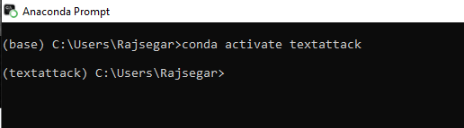
And install a On Windows the installation of TextAttack cannot build the library pycld2 automatically, so you need to install it from unofficial windows binaries.
https://pypi.org/project/pycld2/#files
https://www.cgohlke.com/
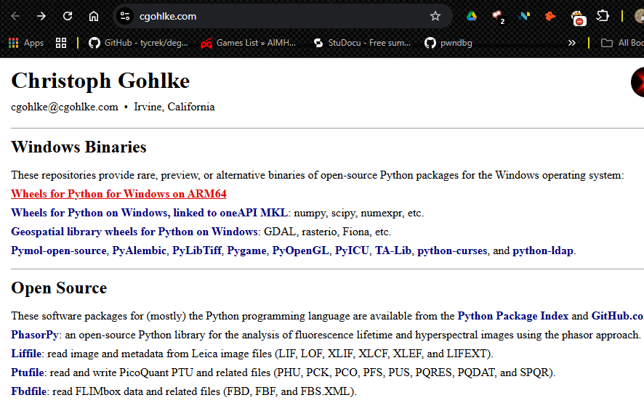

This step we are going to performance in the windows

Installation for Textattack (end-to-end overview of training, evaluating, and attacking a model using TextAttack.)

Now you can proceed to install the TextAttack library
Pip install textattack
pip install textattack[tensorflow]
After the this library I confirm the while textattack
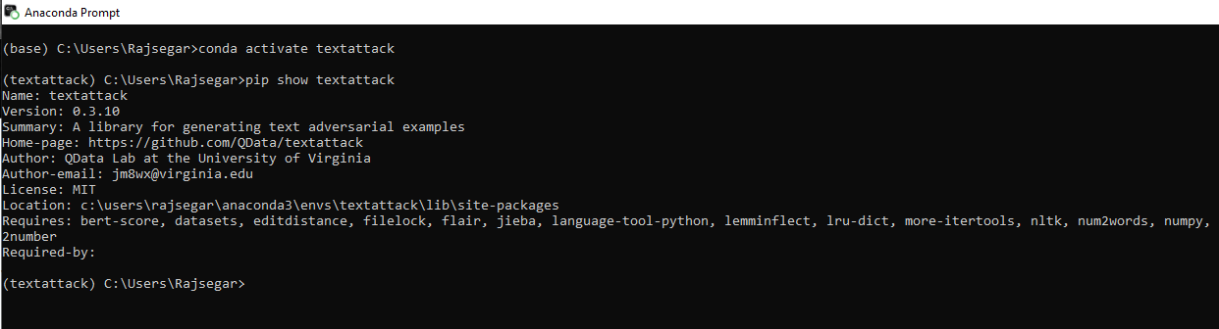

Pip show textattack

After that we have to install a CUDA Acceleration. Install both TensorFlow and PyTorch with CUDA support if you have an NVIDIA GPU. I recommend using the most recent CUDA version that maintains compatibility with both frameworks. According to the official TensorFlow and PyTorch documentation, newer releases such as CUDA 11.2 or 11.3 are not supported by both. The compatible version is CUDA 11.0, and you follow this guide for installation.
https://docs.nvidia.com/cuda/archive/11.0/cuda-installation-guide-microsoft-windows/index.html
After confirming that CUDA 11.0 is installed correctly by running the nvcc -V command, proceed with the setup.
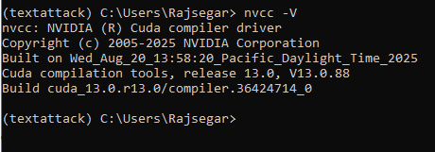

Training
textattack peek-dataset --dataset-from-huggingface rotten_tomatoes
Here train a model using TextAttack, which integrates directly with the Transformers and Datasets libraries to fine-tune any pre-trained Transformer model on datasets from the Hugging Face Datasets hub.
In this example, here use the Rotten Tomatoes Movie Review dataset. It is relatively small and demonstrates the key features of the textattack train command. We can inspect the dataset using the textattack peek-dataset command.

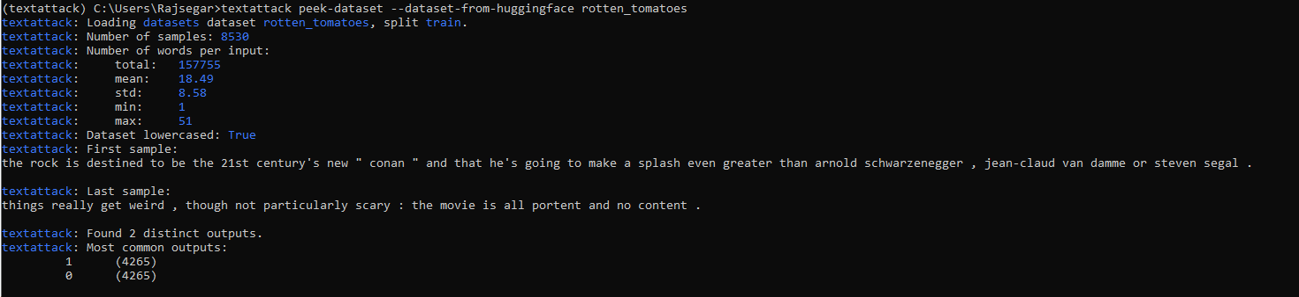

textattack train --model-name-or-path distilbert-base-uncased --dataset rotten_tomatoes --model-num-labels 2 --model-max-length 64 --per-device-train-batch-size 128 --num-epochs 1
The dataset looks good! It’s lowercased already, so we’ll make sure our model is uncased. The longest input is 51 words, so we can cap our maximum sequence length (--model-max-length) at 64.
uncased https://huggingface.co/transformers/model_doc/distilbert.html since it’s a relatively small model, and a good example of how we integrate with transformers.

This command =
textattack train \ # Train a model with TextAttack
--model distilbert-base-uncased \ # Using distilbert, uncased version, from `transformers`
--dataset rotten_tomatoes \ # On the Rotten Tomatoes dataset
--model-num-labels 3 \ # That has 2 labels
--model-max-length 64 \ # With a maximum sequence length of 64
--per-device-train-batch-size 128 \ # And batch size of 128
--num-epochs 3 \ # For 3 epochs

Now let’s run it (please remember to use GPU if you have access):
textattack train --model-name-or-path distilbert-base-uncased --dataset rotten_tomatoes --model-num-labels 2 --model-max-length 64 --per-device-train-batch-size 128 --num-epochs 1
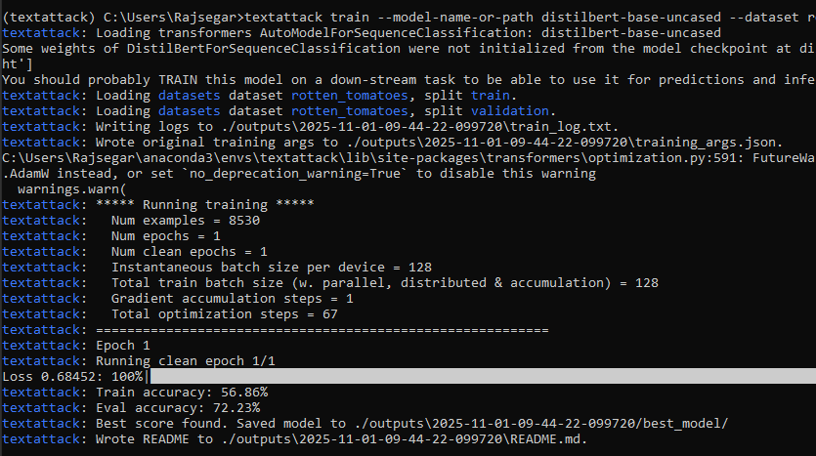

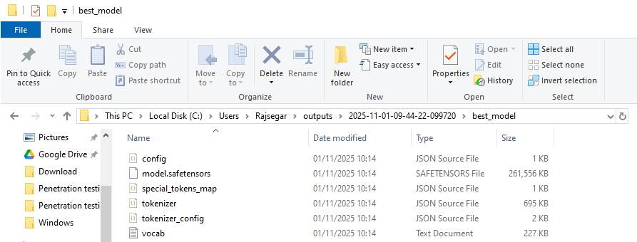

Finally I training the data and it create a output.
The distilbert-base-cased model is successfully fine-tuned for 1 epochs. Next, evaluate its performance using the textattack eval command. Specify the path to the fine-tuned model via the --model argument, along with the desired number of evaluation samples. The textattack eval utility automatically loads the evaluation dataset used during training for consistent benchmarking.

Summary
- Accuracy steadily improved across epochs for both train and eval sets.
- Loss consistently decreased, indicating effective learning.
- The model was re-saved each epoch due to continuous improvement in evaluation performance.

Evaluation
We successfully fine-tuned distilbert-base-cased for 3 epochs. Now let’s evaluate it using textattack eval. This is as simple as providing the path to the pretrained model (that you just obtain from running the above command!) to --model, along with the number of evaluation samples. textattack eval will automatically load the evaluation data from training:

textattack eval --num-examples 1000 --model ./outputs\2025-11-01-09-44-22-099720/best_model/ --dataset-from-huggingface rotten_tomatoes --dataset-split test
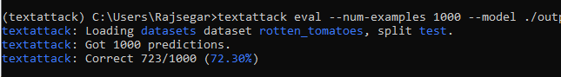

Awesome – Able to train a model up to 72.30% accuracy on the test dataset – with only a single command!

Attack

Finally, let’s attack our pre-trained model. We can do this the same way as before (by providing the path to the pretrained model to --model). For our attack, let’s use the “TextFooler” attack recipe, from the paper “Is BERT Really Robust? A Strong Baseline for Natural Language Attack on Text Classification and Entailment” (Jin et al, 2019). We can do this by passing --recipe textfooler to textattack attack.

Warning: We’re printing out 100 examples and, if the attack succeeds, their perturbations. The output of this command is going to be quite long!

textattack attack --recipe textfooler --num-examples 100 --model ./outputs\2025-11-01-09-44-22-099720/best_model/ --dataset-from-huggingface rotten_tomatoes --dataset-split test

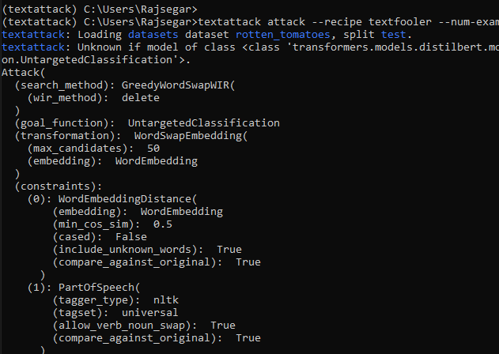

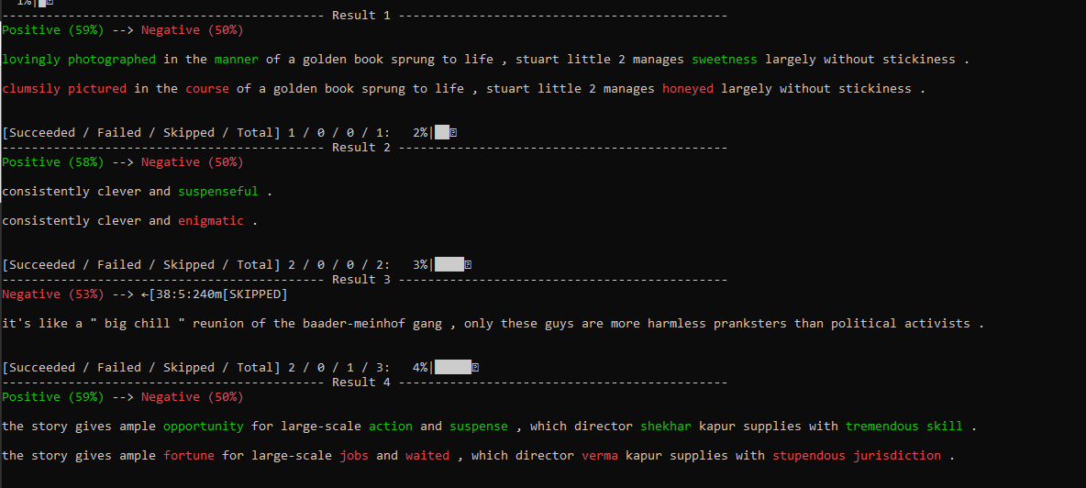
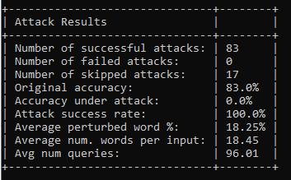

The adversarial evaluation using TextAttack has been successfully completed. The fine-tuned distilbert-base-cased model was subjected to 100 evaluation samples, achieving an original accuracy of 83% and an attack success rate of 100%. A total of 83 successful adversarial attacks were generated, with no failures and 17 skipped samples. The model’s accuracy under attack dropped to 0%, indicating full susceptibility to adversarial perturbations. On average, 18.25% of words were modified per sample, with an average of 18.45 words per input and 96.01 queries per attack.

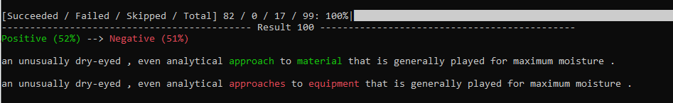

TextFooler for a BERT-based sentiment classifier. Swapping out ”approach to material” with synonym ”approaches to equipment” completely changes the model’s prediction, even though the underlying meaning of the text has not changed.
Positive 52%
Negative 51%

Bonus
There are many powerful functions in TextAttack, we can use through command lines. Here is a list of examples as bonus for your learning.

textattack attack --recipe deepwordbug --model lstm-mr --num-examples 2 --log-summary-to-json attack_summary.json

Deepwordbug = DeepWordBug is a character/word-level adversarial method that perturbs text (character swaps, insertions, deletions or token substitutions) to try to flip the model’s prediction while keeping the text readable.

We will be able to see an attack_summary.json written to the current directory with a machine-readable summary of results
.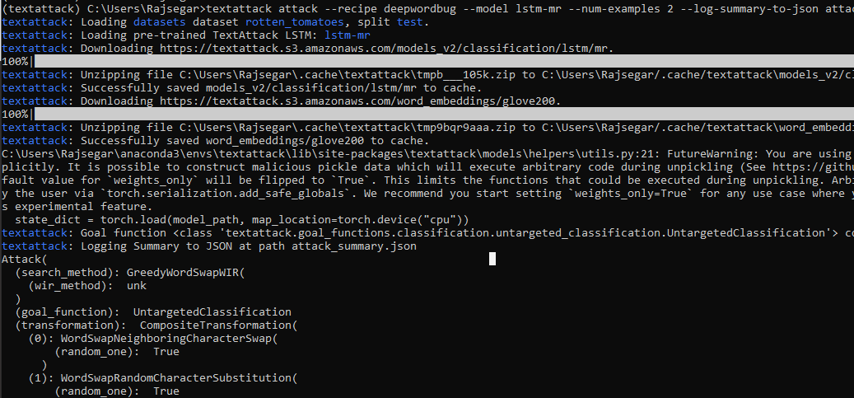
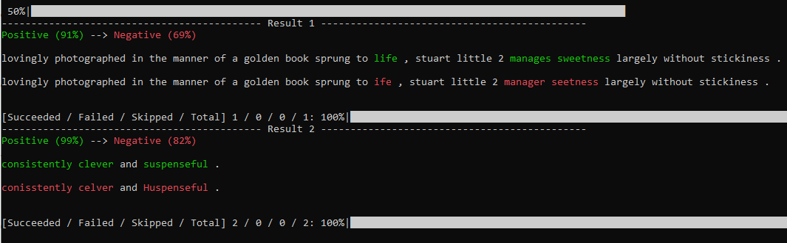

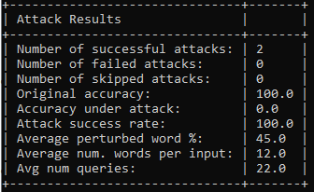

textattack attack --model lstm-mr --recipe deepwordbug --num-examples 2 --attack-n --enable-advance-metrics
