
DEPARTMENT OF

COMPUTER

SCIENCE &

ENGINEERING

Experiment 5
Student Name: Raj Gupta UID: 23BAI70387
Branch: BE CSE AIML Section/Group: 23AIT-KRG G2
Semester: 6th Date of Performance: 18 Feb 2026
Subject Name: Full Stack Subject Code: 23CSH-382

- Title: Application Testing & Debugging

- Aim:
To optimize the performance of the EcoTrack React application using memoization techniques and code splitting, and to enhance the user interface using enterprise-grade Material UI components.

- Objective:
After completing this experiment and its follow-up tasks, the student will be able to:
    - Understand the purpose of automated testing in frontend applications
    - Write unit tests for JavaScript utility functions using Jest
    - Use different Jest matchers to validate expected outputs and behaviors
    - Test React components using React Testing Library
    - Verify UI rendering by querying elements from the DOM
    - Implement asynchronous testing using findBy and waitFor methods
    - Apply mocking to simulate API or external data responses in tests
    - Perform snapshot testing to detect unintended UI changes
    - Debug failing tests and application logic using browser Developer
Tools and breakpoints
    - Analyze application behavior and errors systematically rather than manual checking.

- Implementation/Code:
  - logSlice.jsx:
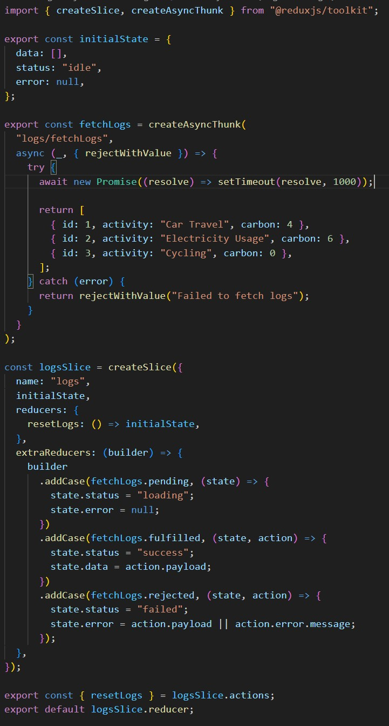
Logs.jsx:
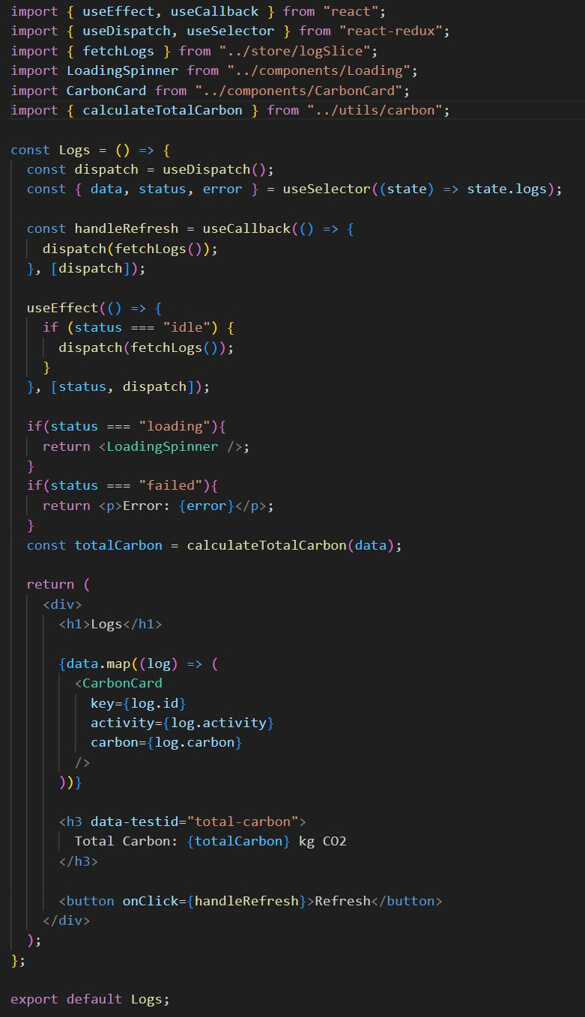

CarbonCards.jsx:
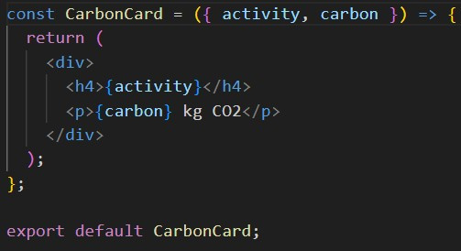
  - Loading.jsx:
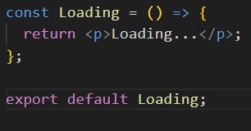
  - NotFound.jsx:
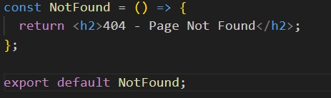
  - Store.jsx:
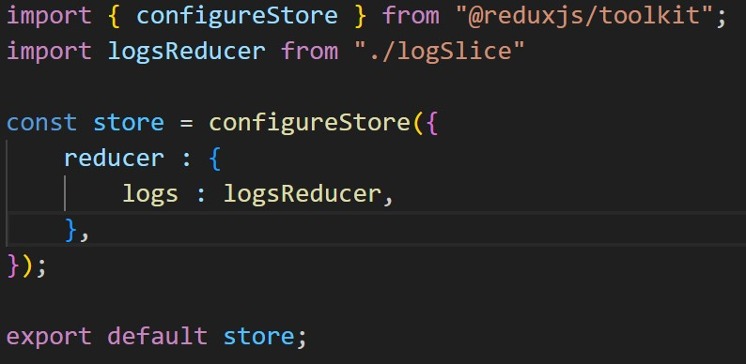
AuthContext.jsx:
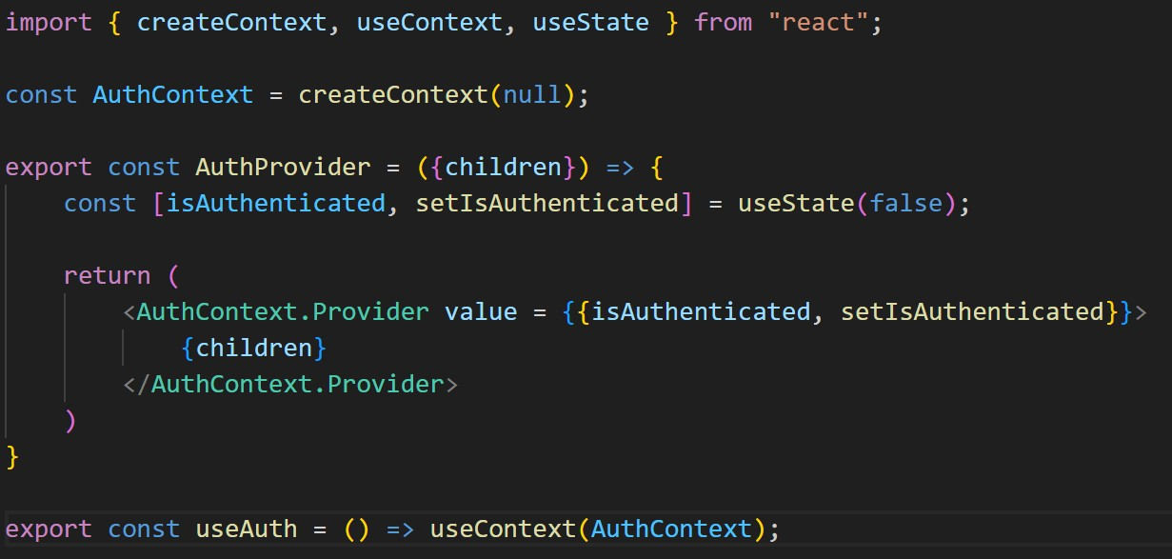

  - ProtectedRoute.jsx:
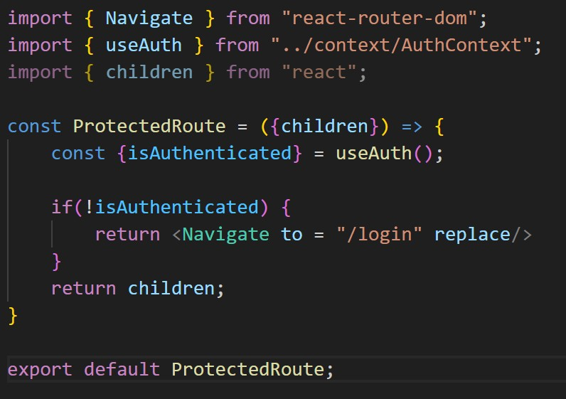

Login.jsx:
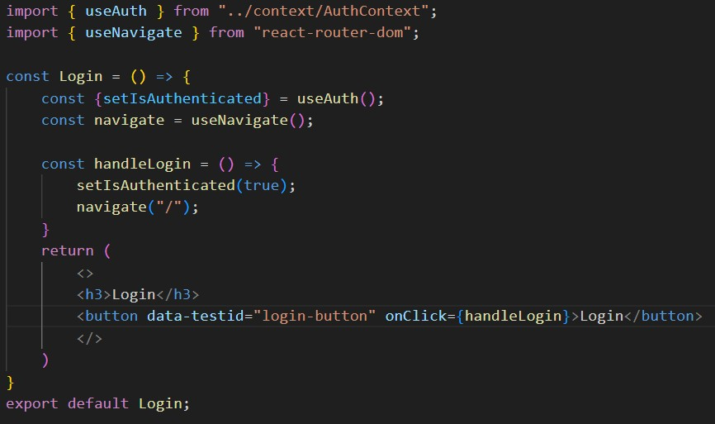
  - Logout.jsx:
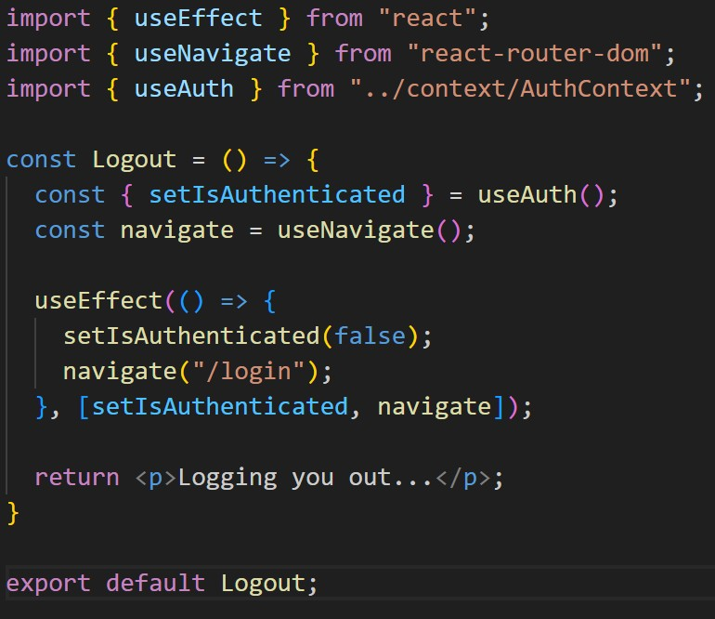
DashboardSettings, DashboardSummary, DashboardAnalytics:
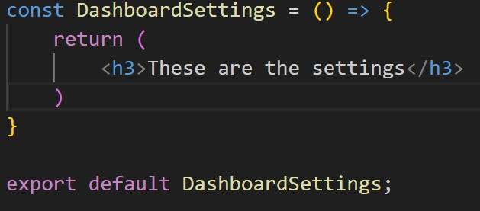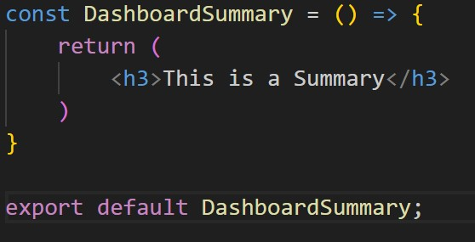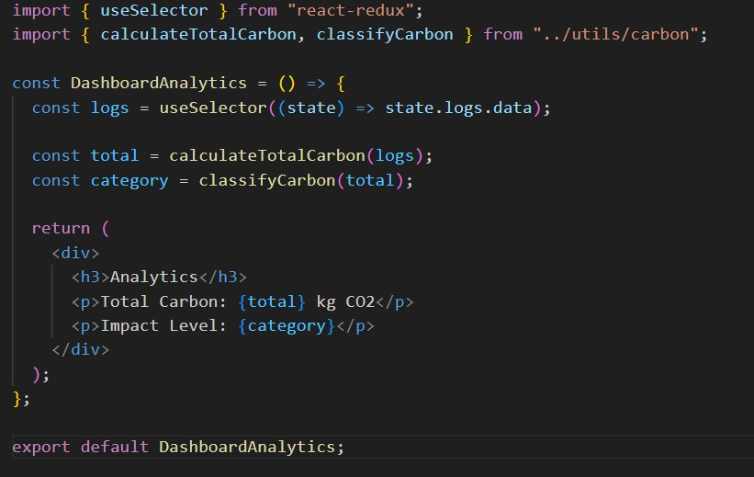
  - DashboardLayout.jsx:
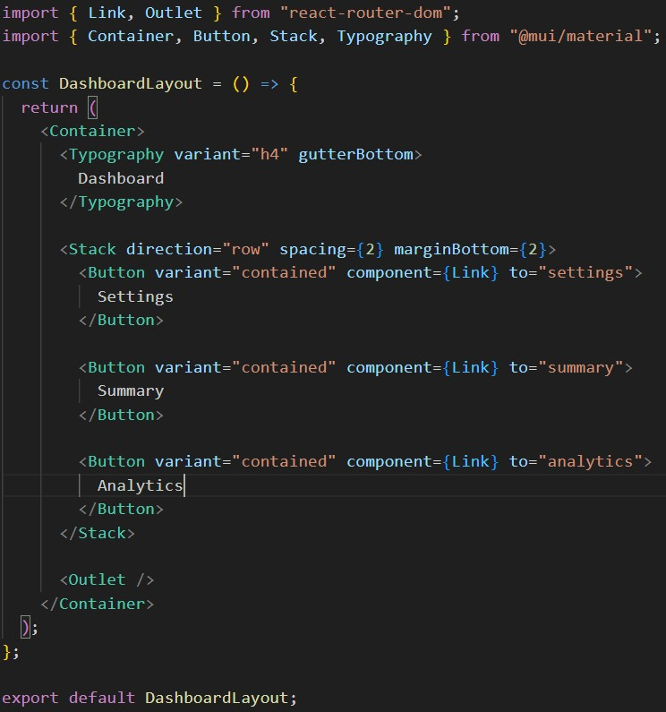
Header.jsx:
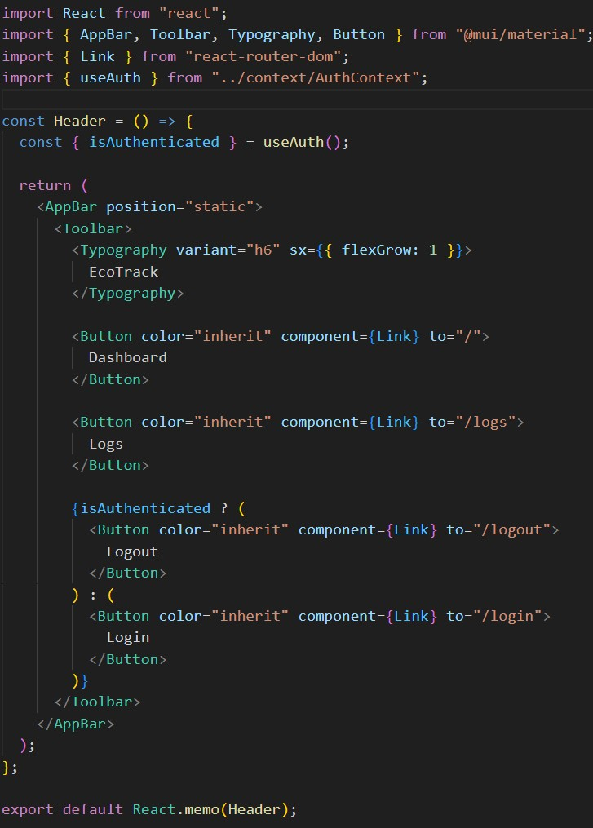

App.jsx:
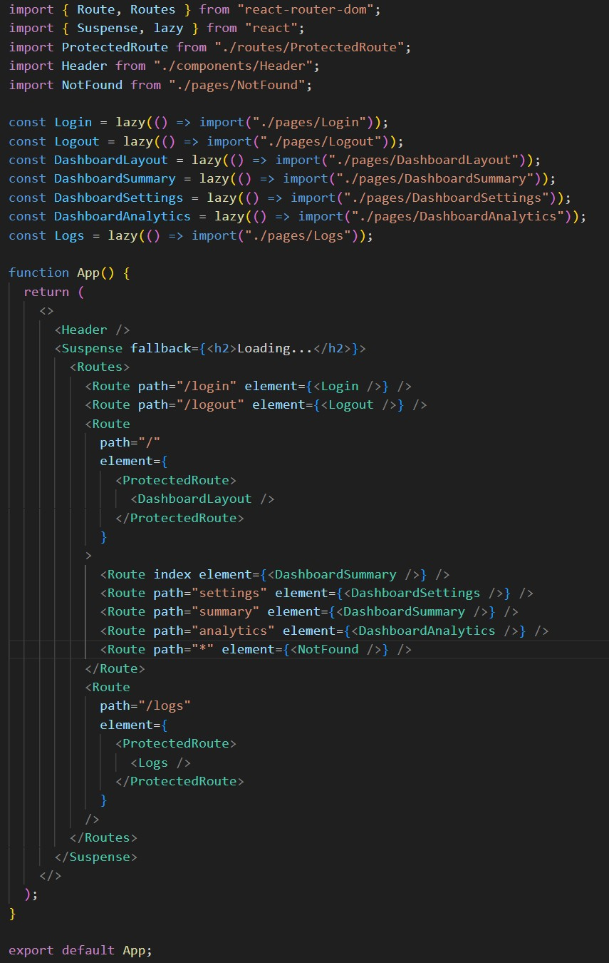

- Output

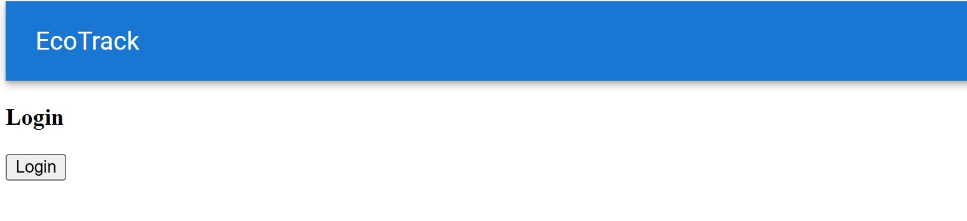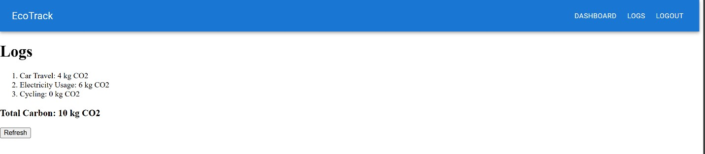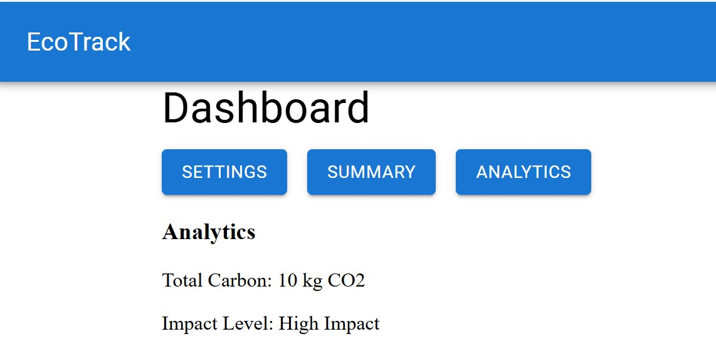

- Learning Outcome
    - We learnt about React Apps and how to create them.
    - We learnt about redux and it’s components.
    - We learnt about the use of thunks and Slices.
    - We learnt about Authentication and index pages
    - We learnt about React testing library and its components.
    - We learnt about the use and implementation of snapshot testing.

