TODO:

Install and setup Django

Install and setup Vue

Include Font Awesome

Set up base template

Create Django app and models for pproducts

Create simple front page (latest products)

View a product

create virtual environment - py 3.7.4

pip install virtualenv

in terminal:

>>virtualenv environment_3_7_4

>>ls

>>source environment_3_7_4/Scripts/activate

this is for windows

python backend, js frontend

>> pip install django

>> pip install djoser (auth, token)

>> pip install pillow

>> pip install stripe

for the django part of proj

>>django-admin startproject hobbithole

>>ls

environment_3_7_4 hobbithole todo.txt

(environment_3_7_4)

>>cd hobbithole

(environment_3_7_4)

>>ls

hobbithole manage.py

(environment_3_7_4)

Now look in the hobbithole folder created, edit the settings.py

here default INSTALLED_APPS there, you need to add a few more

Next add cors allowed url - localhost

then in urls.py addd djoser

now to initialise DB

>>python manage.py make migrations

when opening again you need to navigate to hobbithole

##IMP: missing comma at the end gave corsheaders not found error in settings

--ERROR still for corsheaders

>>pip install django-cors-headers

resolved

>>python manage.py make migrations

unknown "make:

---In urls.py use curved brackts instead of braces

new error: CORS_ALLOWED_ORIGINS should be a sequence of strings.

was using braces should be []

>>python manage.py makemigrations

Now this worked :)

>>python manage.py migrate

now db table is created, first name last name email, etc

to create a super user

>>python manage.py createsuperuser

give name, email, pswd bilbo baggins is hobbithole

--to start dev server

>>python manage.py runserver

open url http://127.0.0.1:8000/ in browser, page not found with

admin/

api/v1

api/v1

add /admin to url, login using pswd, you will see only 1 user

as per tutorial to be run in cmd

npm install -g @vue/cli

not working as nodejs not INSTALLED

tried open new terminal >>pip install vue

NEXT STEP: install nodejs and try, tutorial 12:26

NOTE: dev server runnig "Quit the server with CTRL-BREAK."

use ctrl+c

16/04

installed nodejs from site

restarted cmd '

>>npm -v

>>node -v

now trying: in cmd

>>npm install -g @vue/cli

>>vue create hobbithole_vue

select manually, choose using space router, vue, css preproc, babel - remove linter

use 3.x preview

history mode yes

Saas scs preprocessor

dedeicated yes, save no

first chg dir to vue you created i.e. hobbithole_vue

next >> npm install axios

talk t obackend

>> npm install bulma

>> npm run serve -->to check it works start dev server

open the localhost link you got, your frontend vue app!!

*****INSTALL AND SETUP VUE IS DONE**** (Djanga installed earlier)

***to include font awesome for icons***

add link href in index.html https://cdnjs.com/libraries/font-awesome

***TO SETUP BASE TEMPLATE**

open the Vue app file and remove default stuff from style tag

#app {

font-family: Avenir, Helvetica, Arial, sans-serif;

-webkit-font-smoothing: antialiased;

-moz-osx-font-smoothing: grayscale;

text-align: center;

color: #2c3e50;

}

#nav {

padding: 30px;

a {

font-weight: bold;

color: #2c3e50;

&.router-link-exact-active {

color: #42b983;

}

}

}

remove nav bar <div id="nav">

<router-link to="/">Home</router-link> |

<router-link to="/about">About</router-link>

</div>

make a new div id wrapper

in vscode search for vue syntax and install extension

In folder structure under views, check Home, remove default structure

For the mobile menu part add in app

Mke it possible to click

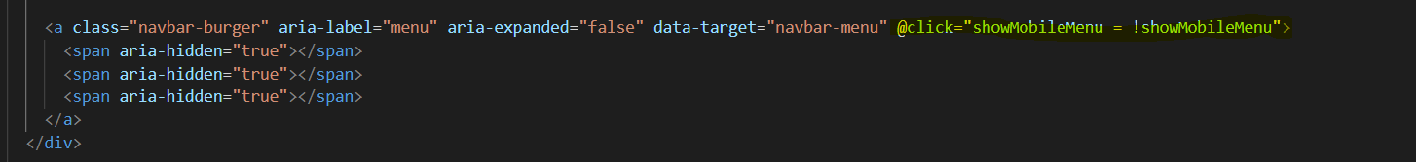

Bind the class

CREATE THE DJANGO APP AND PRODUCTS:

vscode

>>python manage.py startapp product

In folder structure check “product”

Models.py Is where we describe what kind of info we will have in DB

Comments added in models.py

ERROR: unable to import Django.db, tried pip install

Because we need to install inside venv we’re using

Ctrl shift p – select interpreter and use your venv, then do pip install, working now.

<https://stackoverflow.com/questions/58388355/unable-to-import-django-httppylintimport-error#:~:text=There%20are%20two%20ways%20to,it%20using%20python%20%2Dm%20pip%20.&text=The%20other%20option%20is%20to,have%20selected%20in%20VS%20Code>.

Django needs to know about this product, so add it in INSTALLED_APPS. Save it then use

>>python manage.py makemigrations

To actually create it in DB

>>python manage.py migrate

ERROR:

Comma was missing. FIXED

Add products structure with functions, thumbnail, etc

Make migrations, migrate, runserver

Added insettings, now go to urls

Tell Django what doc root is

**CREATE DJANGO APP AND MODELS IS COMPLETE**

**CREATE SERIALIZER AND VIEWS FOR PRODUCTS**

Get objects from DB in JSON

Right lick products and create serializer.py

Next go to views.py

36:35 pause

New urls.py file in product

Import this in the original urls.py (better to have separate urls.py and then import

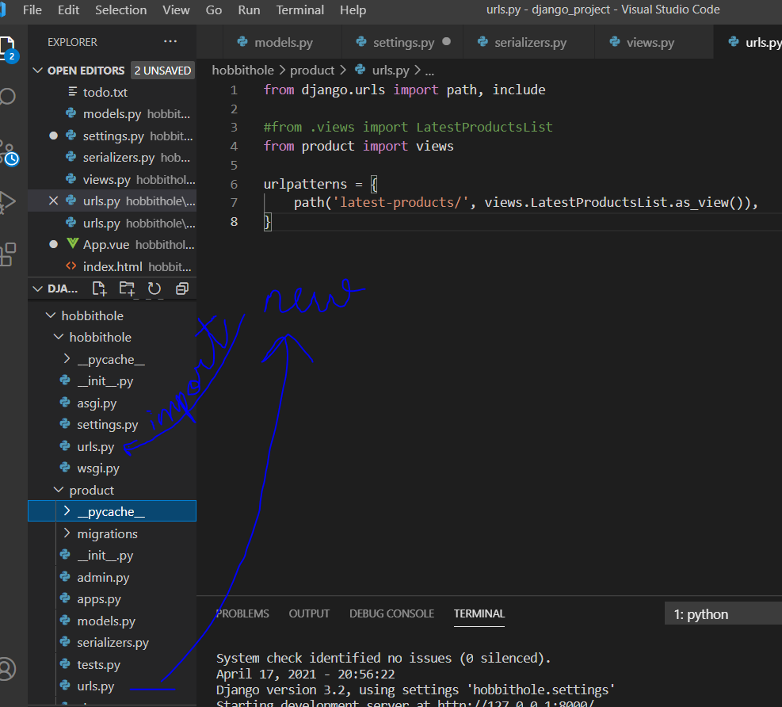

Importing it….

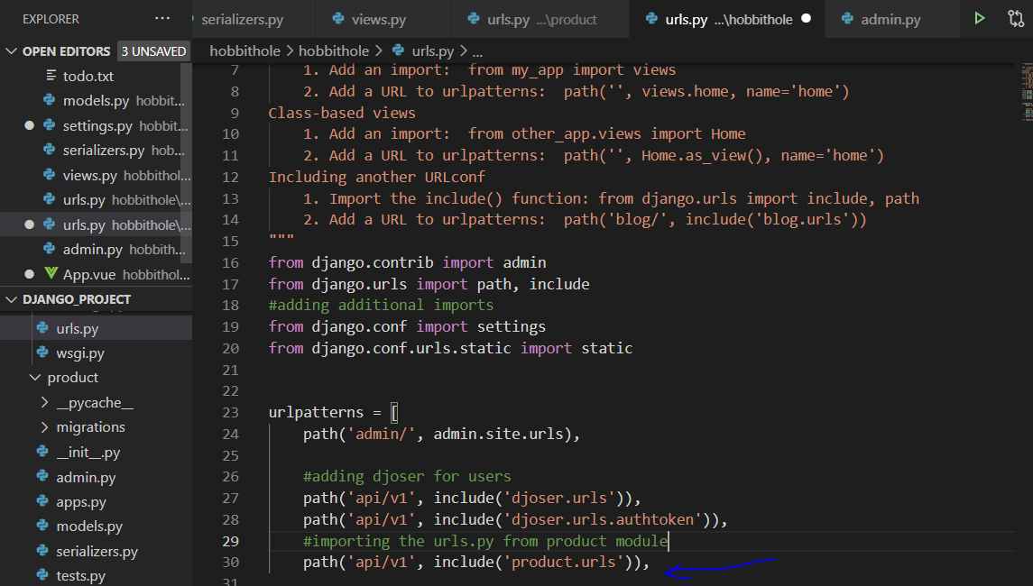

Go to admin.py in product

ERROR: while loading admin pg in browser

ISSUE:

Use square brackets not braces.

Not in admin py

Then open url/admin > add category

Added under New and Old category

ERROR:

latest-products page not opening, comma was missing

Added comma, still not resolved. PENDING

In Home added code :

Here actual list of products not returned yet, we need to get those from backend.

Added:

.get here doesn’t have full url, give base url in the main.js file using axios.

Also one style tag to remove spaces besides images

In main.js adding axios base url

45:30 stopped. Check why latest-products url not working.

ISSUE: in product, serializers is a tuple, remove braces

ISSUE: urls in model corrected to 8000

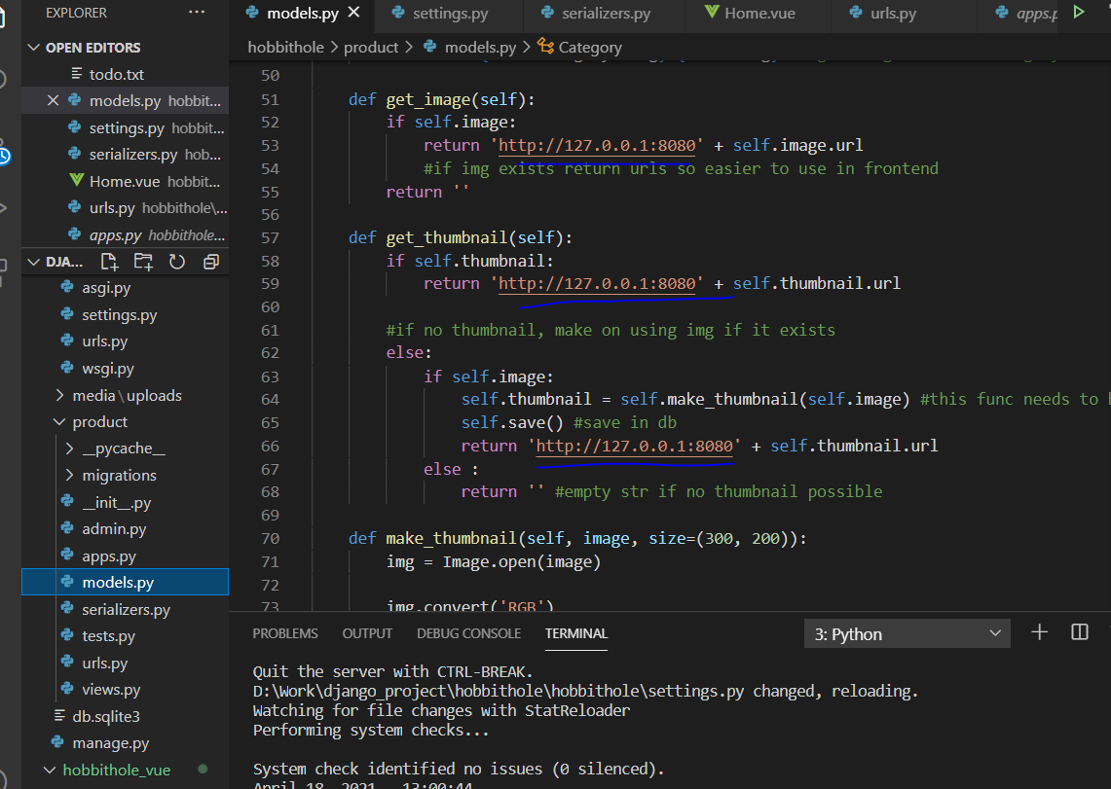

<http://localhost:8080/> is for frontend vue, open cmd again (if closed)

navigate to hobbithole_vue

>>npm run serve

<<python manage.py startapp product1 🡪 mistake

Another folder for product1 created

This is working

Not working – to be resolved for latest products.

Moving ahead.

in product views^

In urls of product below

Now in Vue we need to create page

Create Product.vue under views under hobbithole_vue

Now add this page under router so we can visit it.

55:49 paused going back to see where axios was installed

In the vue path we install axios i.e hobbithole_vue

SLASH / was missing, know how urls work.

Backend working

Trying this url:

<http://127.0.0.1:8000/api/v1/products/old/homage-to-california/>

found spelling mistake, corrected.

Then got raise http404 not defined, so need to import it

Now getting proper 404

Another slash missing: causing product details page to not load, corrected

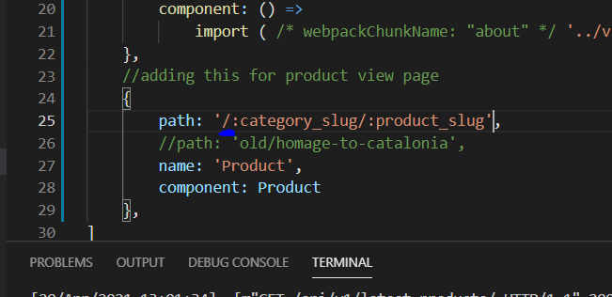

**Setup Vuex**

Under vue module, store> index.js

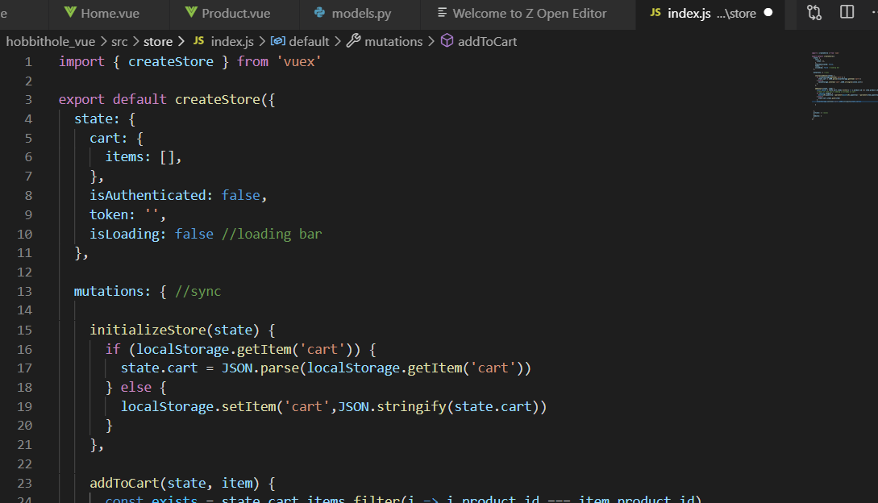

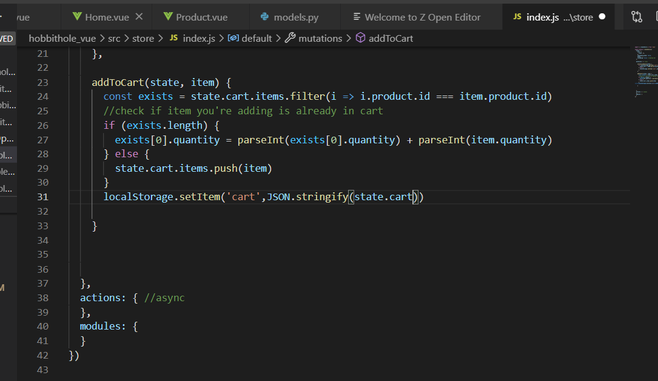

>> Initialise store in App.vue

Under script tag

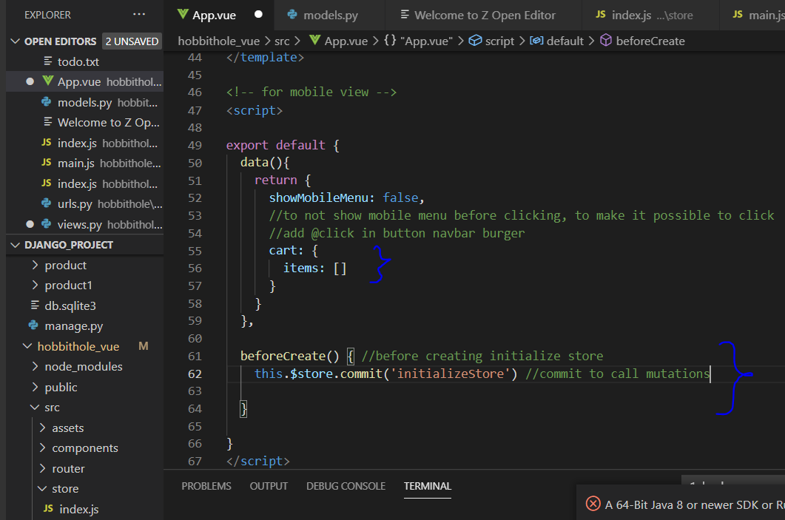

To display length of cart, make a variable

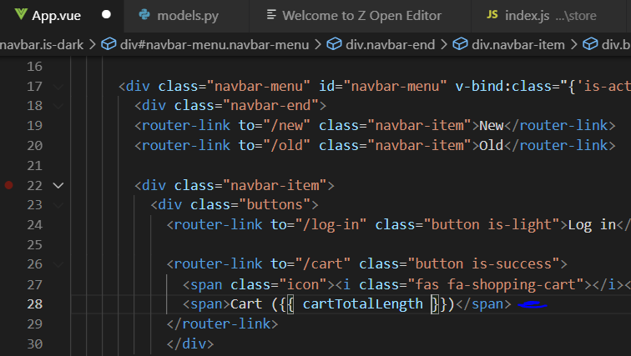

To display such computed variables, have a computed part in script

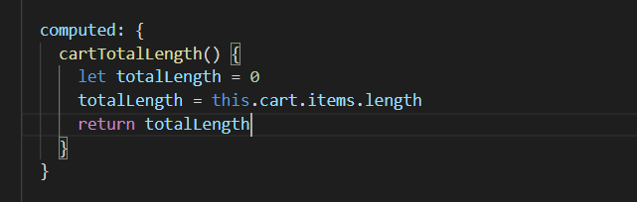

>> make it possible to add to cart (call store) (refer video from 0:57:0

Error as frontend url had changed, added in allowed origins

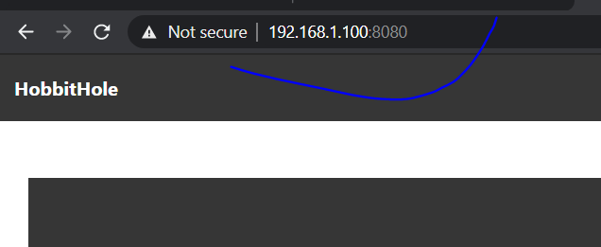

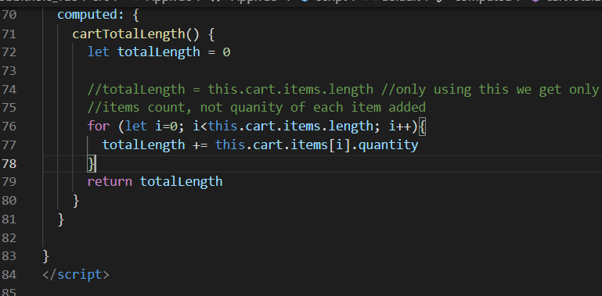

Proper code above to get cart length and add each quantity.

>> to have a message when adding to cart

In cmd >>npm install bulma-toast

Add below in product.vue

import {toast} from 'bulma-toast'

in addtocart function add a toast func, this will have the msg

//"bulma-toast": "^2.3.0",

**To add loading bar between pages**

Store> index

        setIsLoading(state, status) {

          state.isLoading = status

        }

In Product.vue

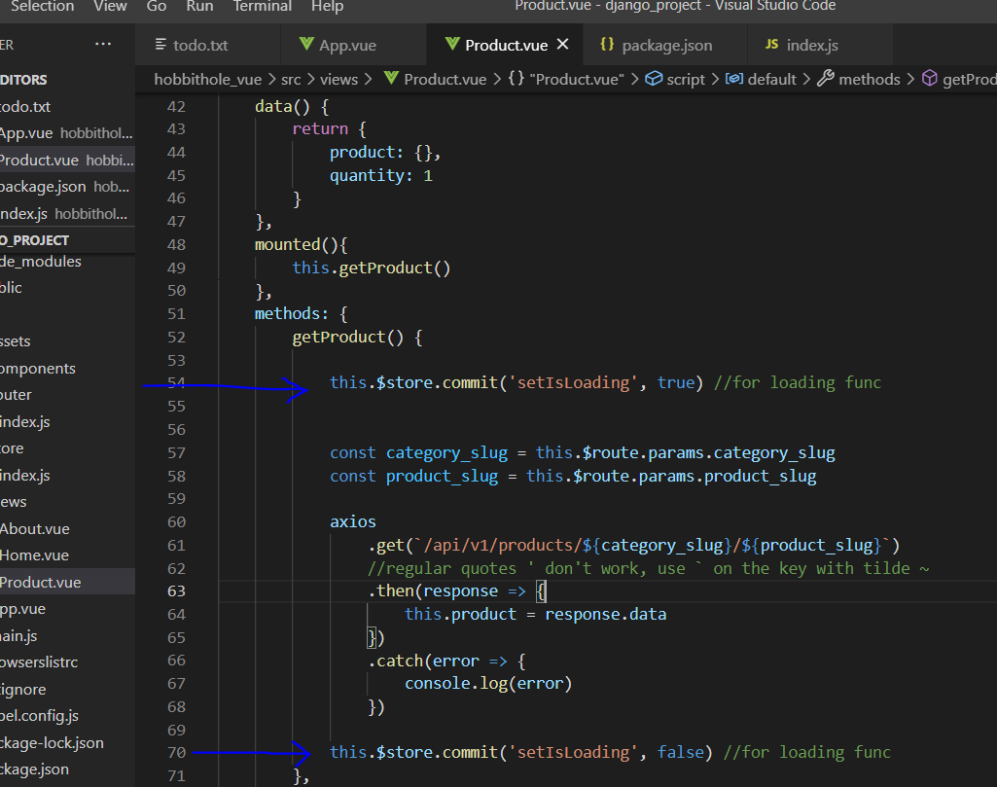

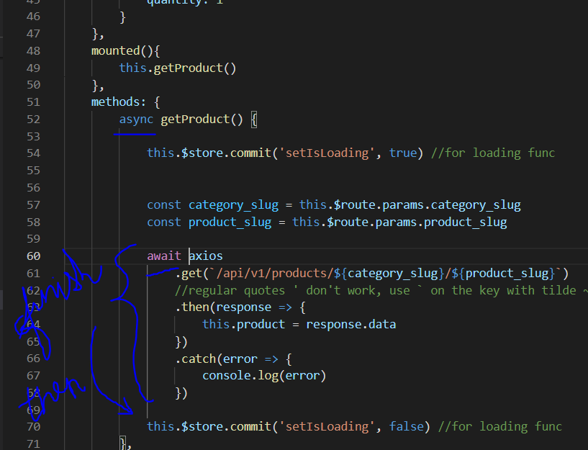

Now add loading bar to display, in App.vue

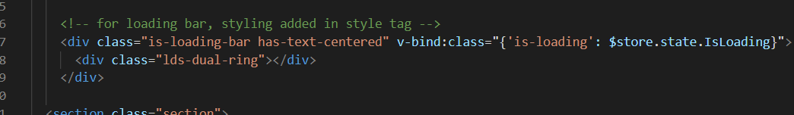

1:09:00 – 22nd May

Set Name to Each page (on tab)

Product.vue add:

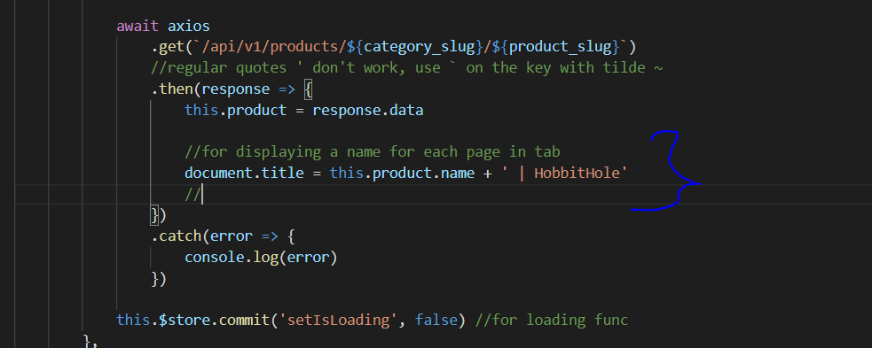

For home page you can add in Home.vue

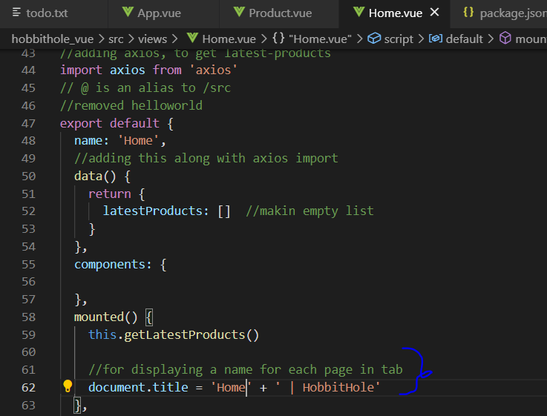

Result:

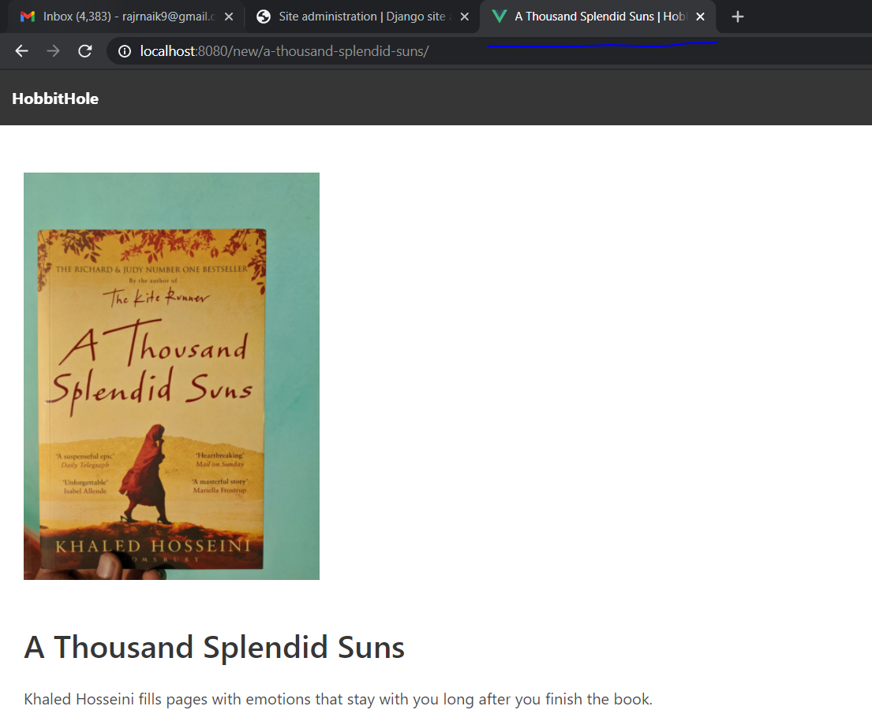

Adding categories menu i.e allow to view products by category. (Menus already there, make them clickable)

1. Django views, add new class.
2. Serializer class in serializers.py
3. In urls import this

Backend done

To display this category page create new pg in Vue. Category.vue

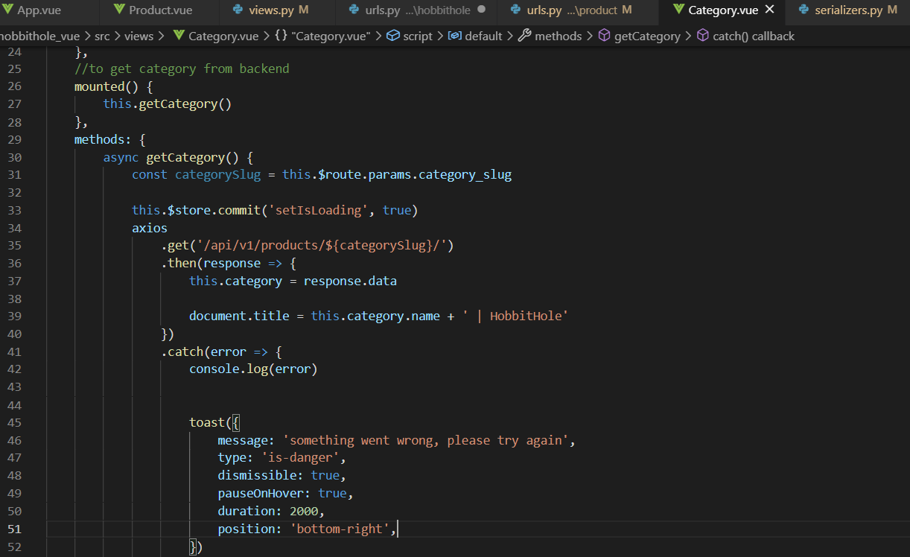

Next in router add:

Import the category.vue path

import Category from '../views/Category.vue'

under routes:

{

        path: '/:category_slug',

        //path: 'old/',

        name: 'Category',

        component: Category

    }

Under product views import Category

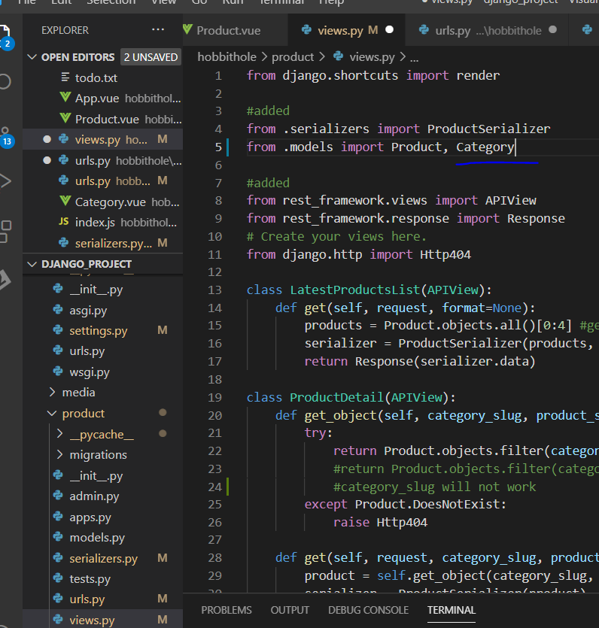

Also

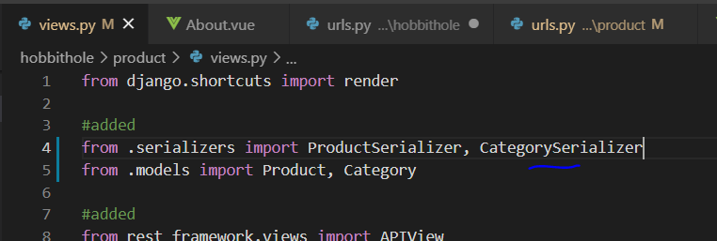

**For reusable code use components:**

**Make ProductBox under components**

To use this code on any page, e.g. on home page add

<ProductBox

        v-for="product in latestProducts"

        v-bind:key="product.id"

        v-bind:product="product" />

import ProductBox from '@/components/ProductBox'

under export default add below:

components: {

    ProductBox

  },

Similar code added on Category.vue page

<ProductBox

                v-for="product in category.products"

                v-bind:key="product.id"

                v-bind:product="product" />

**Problem:** When clicking on New, page loads up but clicking on Old category, it is not refreshed

Need to go back to home page and load up old again.

Under category.vue add

//to check for change in url, refresh

    watch: {

        $route(to, from) {

            if (to.name === 'Category') {

                this.getCategory()

            }

        }

    },

**TO ADD SEARCH**

Views.py add:

from rest_framework.decorators import api_view

from django.db.models import Q

@api_view(['POST'])

def search(request):

    query = request.data.get('query', '')

    if query:

        products = Product.objects.filter(Q(name__icontains=query) | Q(description__icontains=query))

        serializer - ProductSerializer(products, many=True)

        return Response(serializer.data)

    else:

        return Response({"products": []})

in APP.vue

        <!-- Search Bar-->

        <div class="navbar-start">

          <div class="navbar-item">

            <form method="get" action="/search">

              <div class="field has-addons">

                <div class="control">

                  <input type="text" class="input" placeholder="How can we help?" name="query">

                </div>

                <div class="control">

                  <button class="button is-success">

                    <span class="icon">

                    <i class="fas fa-search"></i>

                    </span>

                  </button>

                </div>

              </div>

            </form>

          </div>

        </div>

        <!-- Search Bar-->

The /search here needs to be created.

Cont from 1:24

Create a search vue Search.vue, use product box component to display

    mounted() {

        document.title = 'Search | HobbithHole'

        let uri = window.location.search.substring(1)

        let params = new URLSearchParams(uri)

        if (params.get('query')) {

            this.query = params.get('query')

            this.performSearch()

        }

    },

    methods: {

        performSearch() {}

    }

Now add it router index.js to test (import statement n add to routes list below)

Now query term should be displayed when searching:

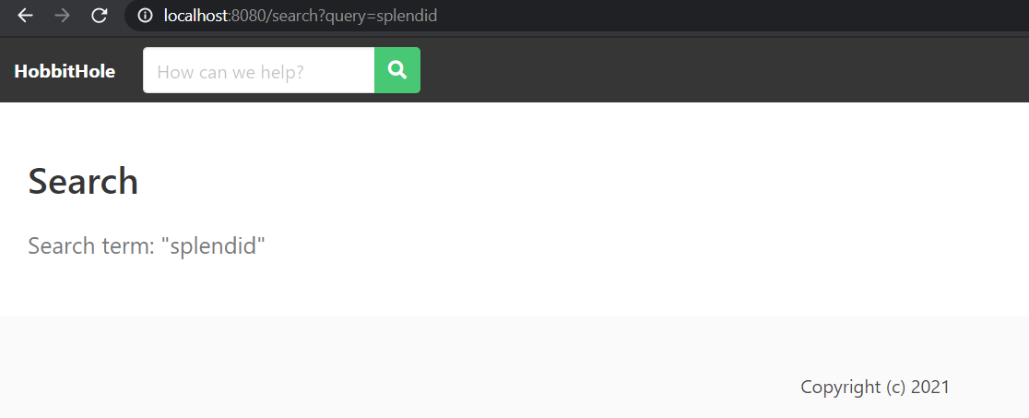

Define the performSearch func

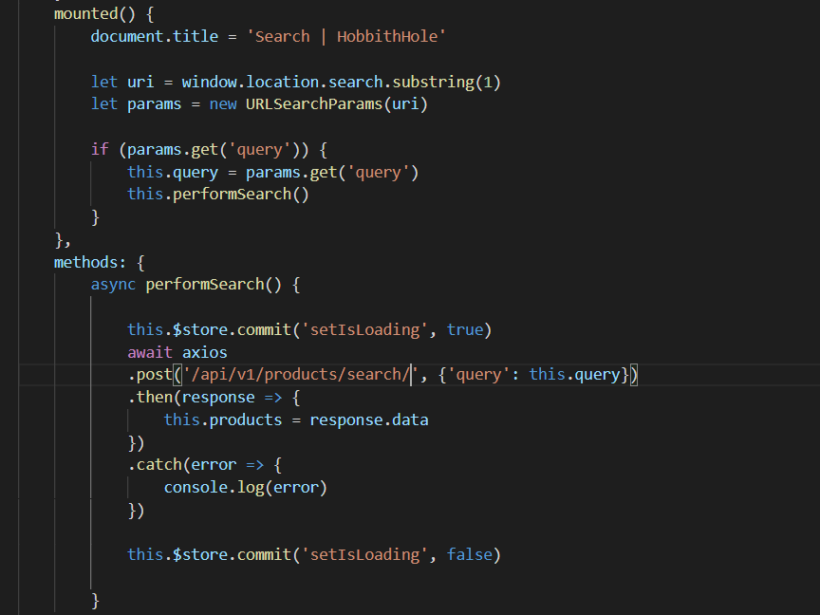

Search should be working

Errors corrected: post uri needs slash at end

**Adding Cart Page:**

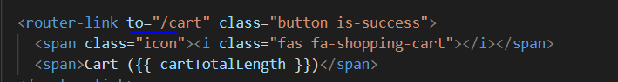

Create Cart.vue

Add link in router and import Cart.vue

In Cart.vue every product has to be displayed, use reusable code. Create component CartItem (import this in Cart.vue)