**Task :** Drag and Drop

**Task Description :** Implement a drag-and-drop functionality for images only. The user should be able to drag an image/s from the device and drop it into another section. Ensuring smooth interactivity during the drag-and-drop process.

Technology :- React.js, Tailwind CSS

**Task Output Screenshot :**

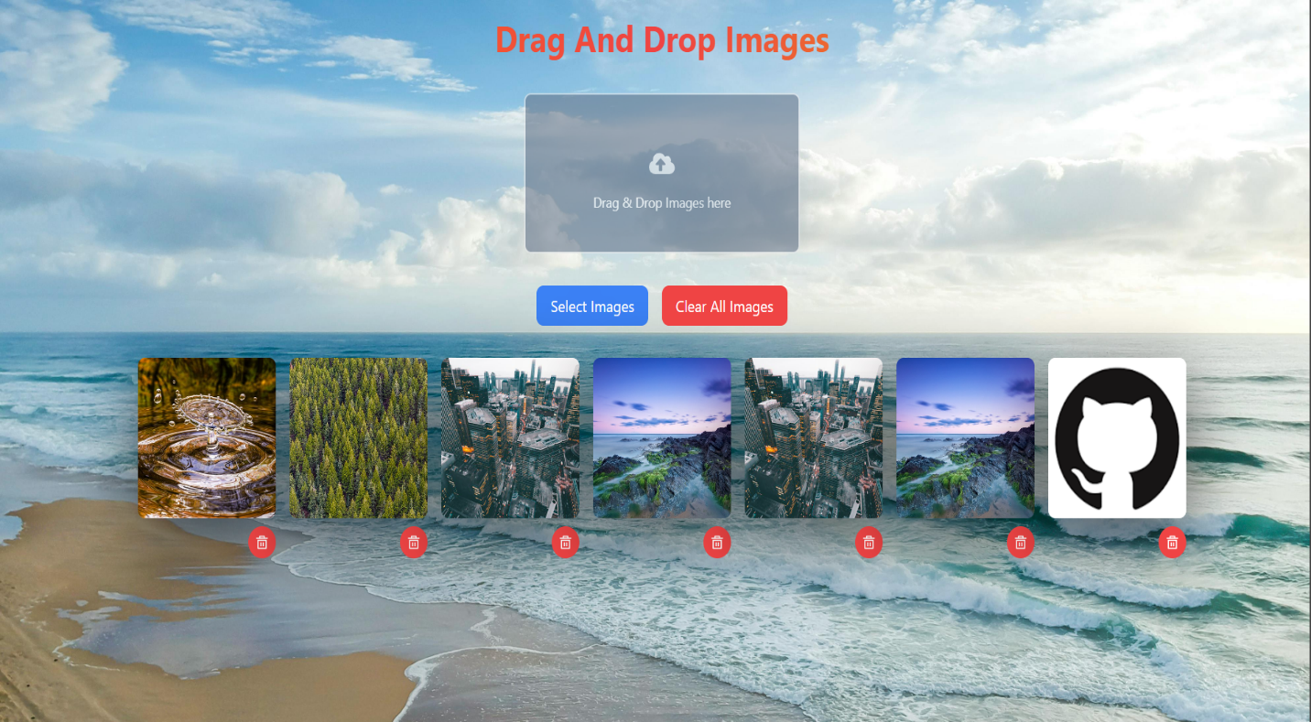

**Widget/Algorithm used in task :**

For implementing the drag-and-drop functionality, the following approaches and tools were used:

1. Drag-and-Drop API :

* The project utilized the native HTML5 Drag-and-Drop API to handle drag-and-drop interactions efficiently. This API allows tracking drag events (e.g., dragstart, dragover and drag) to move elements within the application.

1. State Management :

* React’s useState hook was used to manage the selected files’ state dynamically, ensuring smooth UI updates whenever files are dragged or dropped.

1. File Validation Logic :

* A custom validation algorithm was implemented to ensure that only image files are accepted. If non-image files are dropped, an error message is shown to the user.

1. Dynamic Rendering :

* After validating the dropped files, they were rendered dynamically in a specified section of the webpage using React’s declarative rendering approach.

1. Styling :

* Tailwind CSS was used to style the drag-and-drop area, providing hover and focus effects for better user experience.