**Task : React Hooks Form**

**Task Description :** Create custom component for the input using the same library with all kind of validations. Validating user inputs such as name, email, password, confirm password and role selection. Displaying error messages dynamically for invalid inputs.

Technology :- React.js, Tailwind CSS

**Task Output Screenshot :**

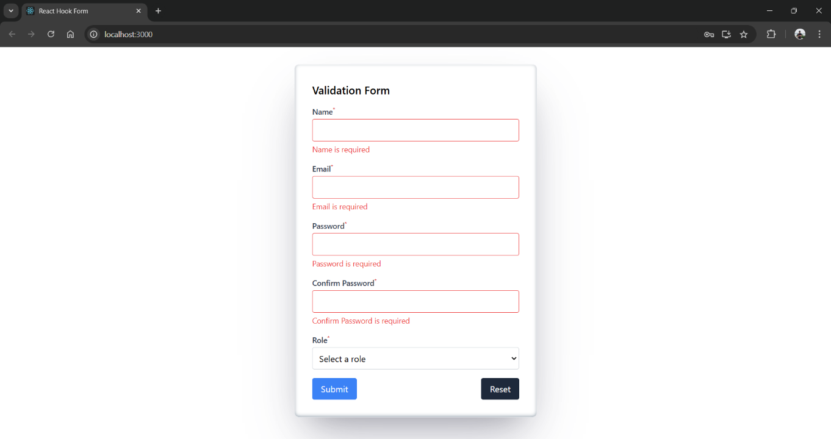

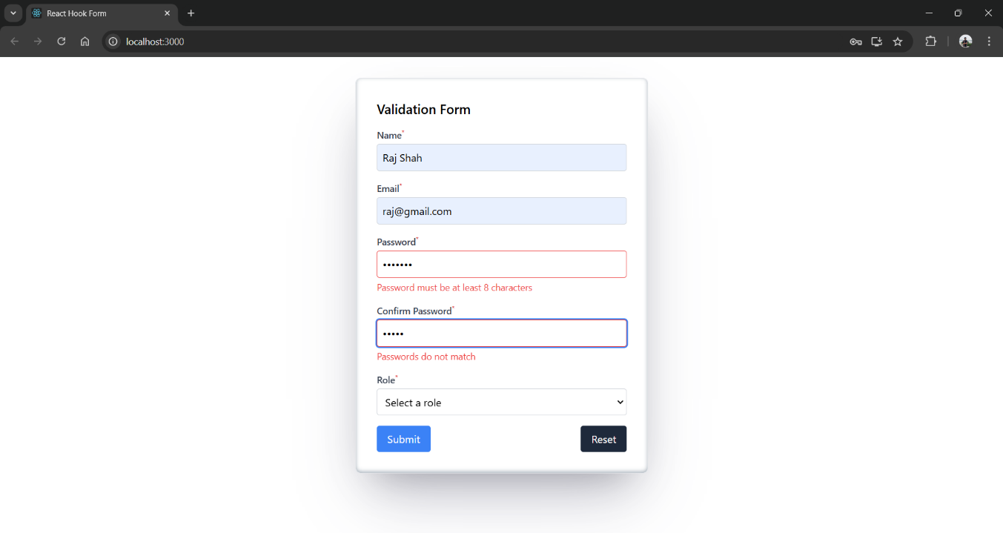

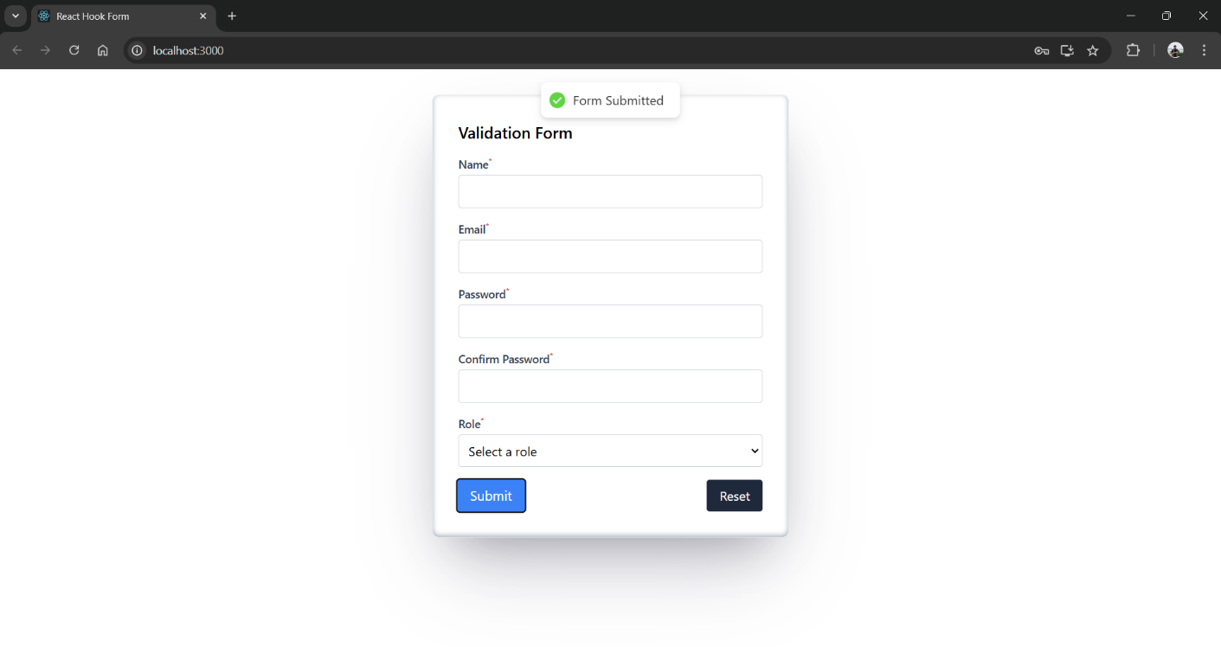

**Widget/Algorithm used in task :**

**Widgets :**

1. Input Fields :

* Used for entering text values such as Name, Email, Password.

1. Dropdown (Select) :

* Used for selecting a role (e.g., Admin, User).

1. Button :

* Used for form submission and resetting.

**Algorithms and Libraries :**

1. React Hook Form :

* For managing form state, validation and dynamic error handling.

1. Validation Rules :

* Required Validation : Ensures fields are not empty.
* Pattern Matching : Validates email using regex.
* Custom Rules : Ensures passwords match.

1. React Hot Toast :

* For showing success notifications after successful submission.