**Task :** Tic Tac Toe

**Task Description :** Build a 2-player “Tic Tac Toe” game. The game should display a 3x3 grid where players alternately place their symbols (X or O). Implement a logic to determine the winner or detect a draw.

Technology :- React.js, Tailwind CSS

**Task Output Screenshot :**

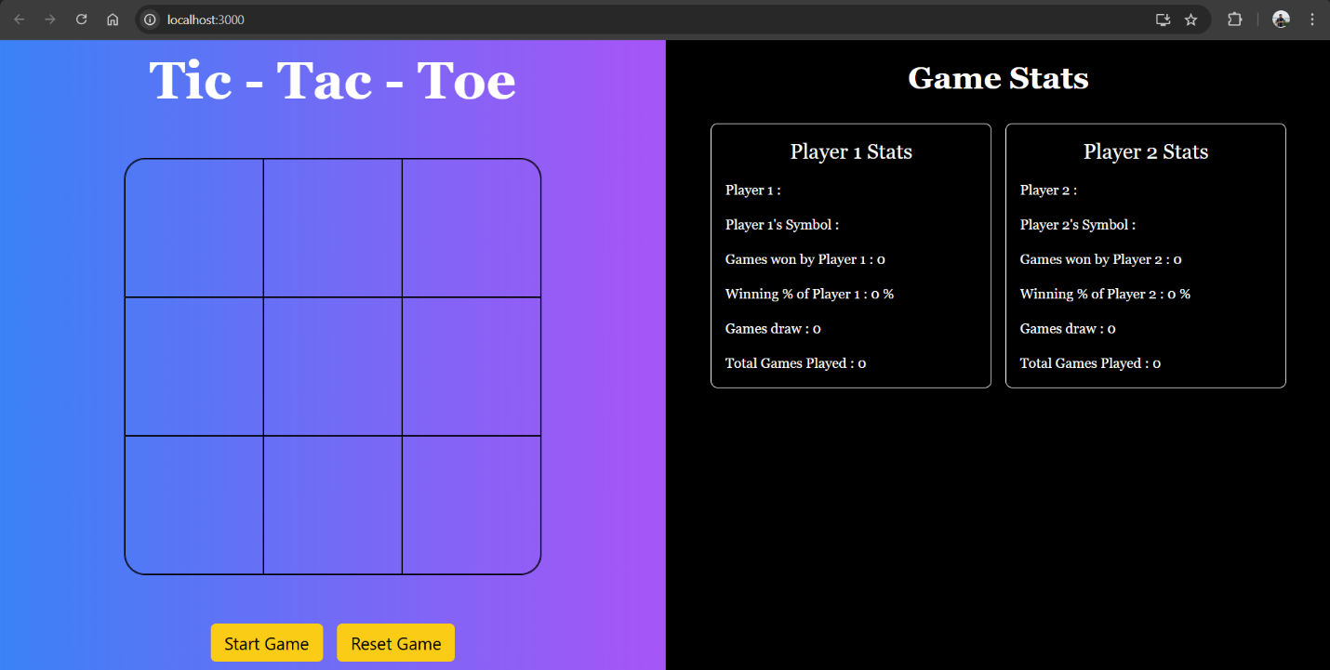

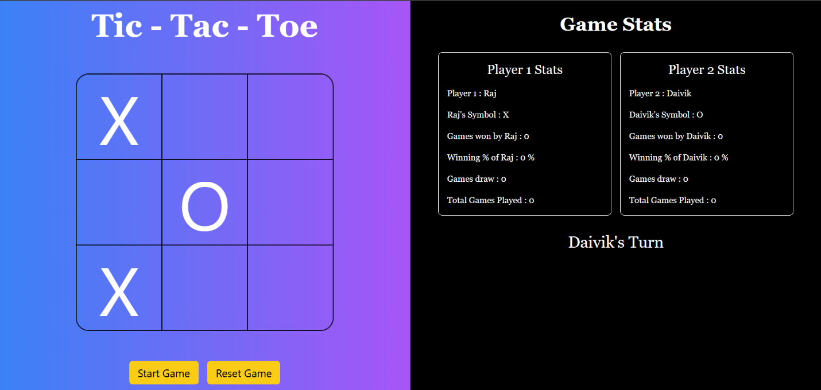

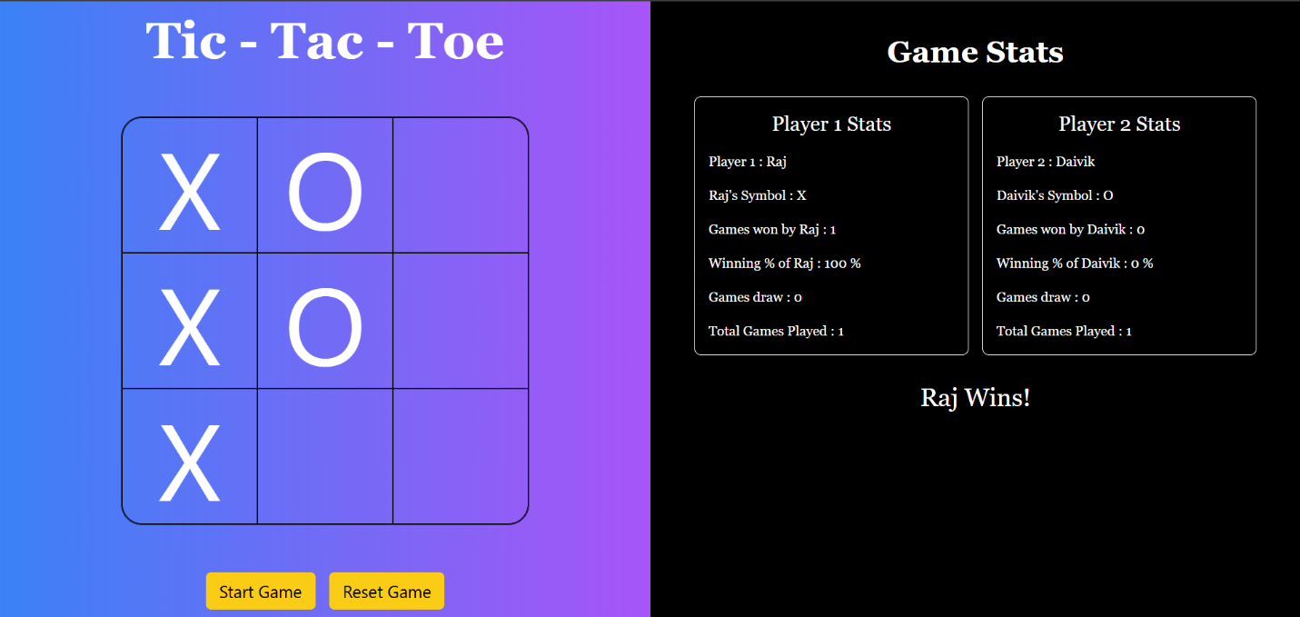

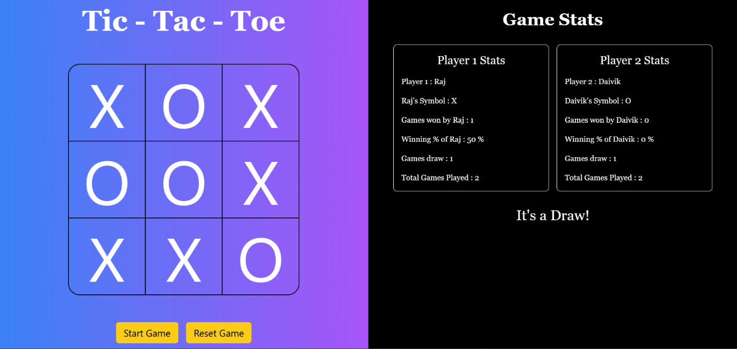

**Widget/Algorithm used in task :**

1. React State for Game Management :

* Used useState to track the game board, current player and game status.

1. Winning Logic :

* Checked all possible winning combinations (rows, columns, diagonal) after each move.

1. Dynamic Rendering :

* Updated the grid dynamically using React’s map method.

1. Conditional Rendering :

* Displayed game status (winner/draw) based on the game’s state.

1. CSS for Styling :

* Styled the grid and added hover effects for better interactivity.

1. Restart Functionality :

* Used a button to reset the game state to the initial condition.

1. Confetti on win :

* Shows a confetti blast when a winner is declared.