**REPORT**

**Project 1: Comparison-based Sorting Algorithms**

**Submitted By**

1. Raj Shah (ID # 801205036)

2. Parth Patel, (ID#  801212088)

**Code Repository Overview**

In this project, we have **created input from random function in python.There are three main files which are starting point for Program Files names are main.py ( Random Array) , mainSorted.py (Sorted Array) , mainReverse.py (reverse sorted array)** . Each of files will create different sample sized files ranging from 1,000 to 60,000.

So for example,  **main.py will generate array** containing 10,000 samples in random order and **main.py will call 5 function imports** which will sort Input array and give the time taken in milliseconds.

Please check the **README** file to get source code execution instruction and i/o specification.

**Project Structure :**

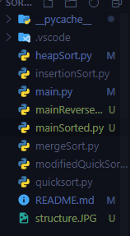

**Data Structure**

In this project we use python as our programming language. To implement the sorting algorithms, in most of the cases we used a array of size same as sampledata test. We don’t use any library function in implementing the algorithms of this project. We prepared several python scripts to test the execution time of our implemented algorithms.

**Complexity Analysis**

For **Insertion sort** the running time of different formatted input files are as follows:

1. Sorted inputs (best case): $T\left(n\right)=θ\left(n\right)$
2. Reversely sorted inputs (worst case): $T\left(n\right)=θ\left(n^{2}\right)$
3. Random inputs (average case): $T\left(n\right)=θ\left(n^{2}\right)$

For **Merge sort** the running time of different formatted input files are as follows:

1. Sorted inputs: $T\left(n\right)=O\left(nlogn\right)$
2. Reversely sorted inputs: $T\left(n\right)=O\left(nlogn\right)$
3. Random inputs: $T\left(n\right)=O\left(nlogn\right)$

For **Heapsort** the running time of different formatted input files are as follows:

1. Sorted inputs: $T\left(n\right)=O\left(nlogn\right)$
2. Reversely sorted inputs: $T\left(n\right)=O\left(nlogn\right)$
3. Random inputs: $T\left(n\right)=O\left(nlogn\right)$

For **In-place quicksort** the running time of different formatted input files are as follows:

1. Sorted inputs (worst case): $T\left(n\right)=O\left(n^{2}\right)$
2. Reversely sorted inputs (worst case): $T\left(n\right)=O\left(n^{2}\right)$
3. Random inputs (average case): $T\left(n\right)=O\left(nlogn\right)$

For **Modified quicksort** the running time of different formatted input files are as follows:

1. Sorted inputs: $T\left(n\right)=O\left(nlogn\right)$
2. Reversely sorted inputs: $T\left(n\right)=O\left(nlogn\right)$
3. Random inputs: $T\left(n\right)=O\left(nlogn\right)$

**Results**

**Random data(unsorted):**

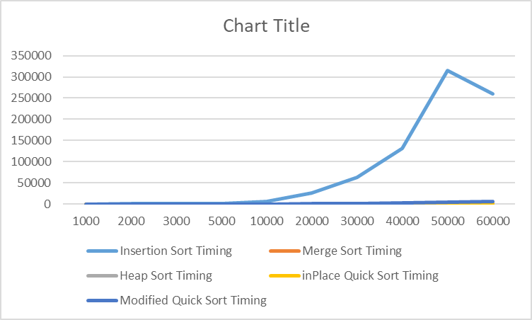

Insertion Sort Timing :

[121.9930648803711, 297.00684547424316, 880.000114440918, 1638.995885848999, 6577.994585037231,

26594.9809551239, 63078.937292099, 130860.46147346497, 314660.1912975311, 259416.87440872192]

Merge sort Timing :

[17.99774169921875, 19.99640464782715, 28.003931045532227, 36.00502014160156, 84.00487899780273,

162.0025634765625, 261.9976997375488, 353.99913787841797, 450.000524520874, 561.030387878418]

Heapsort Timing :

[7.055759429931641, 17.04859733581543, 21.006345748901367, 41.004180908203125, 91.00103378295898,

201.93743705749512, 595.9982872009277, 1205.014944076538, 854.0024757385254, 1000.0002384185791]

In-Place Quicksort Timing :

[4.996061325073242,11.004924774169922,12.999296188354492, 18.00227165222168, 42.99783706665039,

94.00296211242676, 134.0012550354004, 231.0347557067871, 239.00079727172852, 591.008186340332]

Modified quicksort Timing :

[5.003690719604492,16.000032424926758,22.000551223754883,52.99878120422363,176.00417137145996,722.996711730957,1600.996732711792,2887.9692554473877,4360.9983921051025,6260.988712310791]

**[2]Sorted data:**

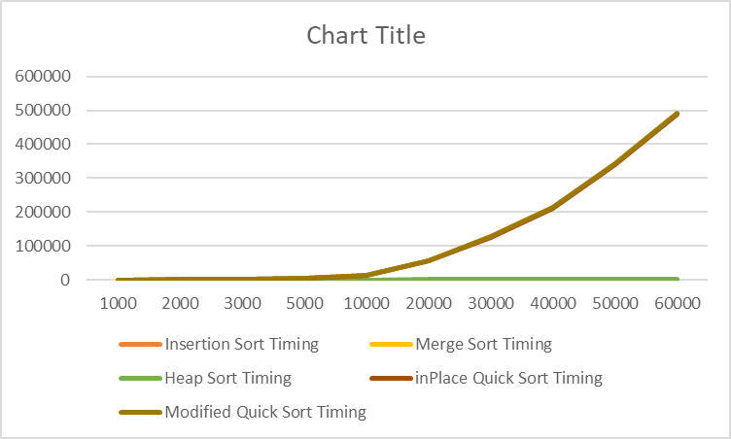

Insertion Sort Timing :

[0.0, 1.0020732879638672, 0.0, 2.0172595977783203, 3.0159950256347656 6.999969482421875, 10.001420974731445, 10.027408599853516,15.043973922729492, 21.99554443359375]

Merge sort Timing :

[4.996776580810547, 15.00248908996582, 29.000043869018555, 30.982017517089844 60.96625328063965,123.86918067932129, 215.99674224853516,285.9675884246826,341.95566177368164, 456.024169921875]

Heapsort Timing :

[11.001825332641602,27.001142501831055,36.99827194213867, 73.00281524658203, 169.9998378753662,

402.9829502105713, 508.9995861053467, 717.0071601867676, 853.9958000183105, 1159.428358078003]

In-Place Quicksort Timing :

[188.00020217895508, 978.996992111206, 1344.0313339233398, 4027.99916267395, 13016.411304473877,

54444.00119781494, 125225.1501083374, 210117.05875396729, 337838.9916419983, 486028.78427505493]

Modified quicksort Timing :

[6.006717681884766, 11.003732681274414, 20.969152450561523, 33.03718566894531,120.03397941589355, 406.0351848602295, 1170.0026988983154, 1484.0011596679688, 3423.007011413574, 4113.03448677063]

**[3]Reverse Sorted data:**



Insertion Sort Timing :

[133.99958610534668, 656.9981575012207, 1437.002420425415, 4026.9994735717773,16232.070446014404,72323.18019866943, 162794.16847229004,312062.44349479675,471556.4212799072, 585642.1818733215]

Merge sort Timing :

[3.998279571533203,17.002105712890625,17.996549606323242, 37.99772262573242, 68.9995288848877, 195.00041007995605, 249.96018409729004,364.00294303894043,437.02006340026855, 467.95129776000977]

Heapsort Timing :

[10.000228881835938, 14.01209831237793, 28.00464630126953, 52.00052261352539, 132.06839561462402, 269.0014839172363, 386.99960708618164, 548.9969253540039, 722.9986190795898, 722.0017910003662]

In-Place Quicksort Timing :

[113.9991283416748,450.99854469299316,1006.9968700408936,2826.9999027252197,11238.833904266357,48383.84437561035,107699.40948486328,180644.06895637512,314159.6176624298, 327561.9509220123]]

Modified quicksort Timing :

[5.0067175621884766,13.06839561462402,21.002420425415,34.99674224853516,130.44349479675,429.0351848602295, 1182.1026988983121,1484.0011596679688,3521.00052261352539, 4195. 00119781494]

**Test platform:**

* Processor: Intel(R) Xeon(R) CPU E5-2620 2.00GHz (12 Core)
* Windows 10
* Python 3.6.2

**Code**

* + - 1. Code for insertion_sort.py

def insertionSort(array):

for x in range(1,len(array)):

key=array[x]

y=x-1

while y>=0 and array[y]>key:

array[y+1]=array[y]

y=y-1

array[y+1]=key

# Use This Print to verify while invoking from main file

#print(array)

# Use for Indiviual Analysis and Code Correctness

#array=[2,1,6,9,10,11,60,14,15,22,8,88,40,24,36,75,888,14]

#InsertSort(array)

#print(array)

2.Code for merge_sort.py

def mergeSort(array):

if len(array) > 1:

mid = len(array)//2

L = array[:mid]

R = array[mid:]

mergeSort(L)

mergeSort(R)

i = j = k = 0

while i < len(L) and j < len(R):

if L[i] < R[j]:

array[k] = L[i]

i += 1

else:

array[k] = R[j]

j += 1

k += 1

while i < len(L):

array[k] = L[i]

i += 1

k += 1

while j < len(R):

array[k] = R[j]

j += 1

k += 1

return array

#array = [2,1,6,9,10,11,60,14,15,22,8,88,40,24,36,75,888,14]

#mergeSort(array)

#printList(array)

3.Code for heapsort.py

def heapify(arr, n, i):

largest = i # Initialize largest as root

l = 2 * i + 1 # left = 2*i + 1

r = 2 * i + 2 # right = 2*i + 2

# See if left child of root exists and is

# greater than root

if l < n and arr[largest] < arr[l]:

largest = l

# See if right child of root exists and is

# greater than root

if r < n and arr[largest] < arr[r]:

largest = r

# Change root, if needed

if largest != i:

arr[i], arr[largest] = arr[largest], arr[i] # swap

# Heapify the root.

heapify(arr, n, largest)

# The main function to sort an array of given size

def heapSort(arr):

n = len(arr)

# Build a maxheap.

for i in range(n//2 - 1, -1, -1):

heapify(arr, n, i)

# One by one extract elements

for i in range(n-1, 0, -1):

arr[i], arr[0] = arr[0], arr[i] # swap

heapify(arr, i, 0)

return arr

#arr = [12, 11, 13, 5, 6, 7]

#heapSort(arr)

4.Code for inplace_quicksort.py

def partition(arr, low, high):

i = (low-1)

pivot = arr[high]

for j in range(low, high):

if arr[j] <= pivot:

i = i+1

arr[i], arr[j] = arr[j], arr[i]

arr[i+1], arr[high] = arr[high], arr[i+1]

return (i+1)

def quickSort(arr, low, high):

if len(arr) == 1:

return arr

if low < high:

# pi is partitioning index, arr[p] is now

# at right place

pi = partition(arr, low, high)

quickSort(arr, low, pi-1)

quickSort(arr, pi+1, high)

5.Code for modified_quicksort.py

medianC = 0

def median(a, b, c):

if ( a - b) * (c - a) >= 0:

return a

elif (b - a) * (c - b) >= 0:

return b

else:

return c

def partition_median(array, smallValArr, highValArr):

small = array[smallValArr]

high = array[highValArr - 1]

length = highValArr - smallValArr

middle = array[smallValArr + length // 2]

pivot = median(small, high, middle)

pivotindex = array.index(pivot)

array[pivotindex] = array[smallValArr]

array[smallValArr] = pivot

i = smallValArr + 1

for j in range(smallValArr + 1, highValArr):

if array[j] < pivot:

temp = array[j]

array[j] = array[i]

array[i] = temp

i += 1

highEndVal = array[smallValArr]

array[smallValArr] = array[i - 1]

array[i - 1] = highEndVal

return i - 1

def quicksort_median(array, smallIndex, highIndex):

global medianC

if smallIndex+ 10 <= highIndex:

newpivotindex = partition_median(array, smallIndex, highIndex)

medianC += (highIndex - smallIndex - 1)

quicksort_median(array, smallIndex, newpivotindex)

quicksort_median(array, newpivotindex + 1, highIndex)

else:

insertion_sortt(array,smallIndex,highIndex)

def insertion_sortt(array,a,b):

for i in range(a, b):

j = i

while j > 0 and array[j] < array[j-1]:

array[j],array[j-1]=array[j-1],array[j]

j = j - 1

def mquick_sort(inputArr):

quicksort_median(inputArr, 0, len(inputArr))

return inputArr