**Aim:**

To display first 9 images of four datasets CIFAR10, CIFAR100, MNIST, Fashion MNIST

**Observations:**

1. CIFAR10

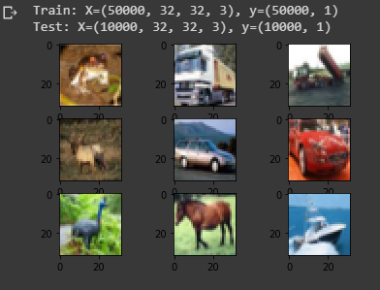

1. CIFAR100

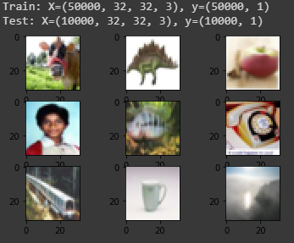

1. MNIST

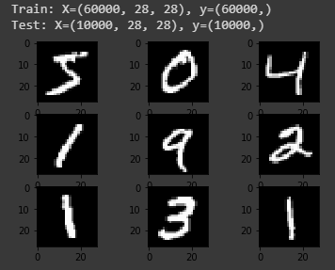

1. Fashion MNIST

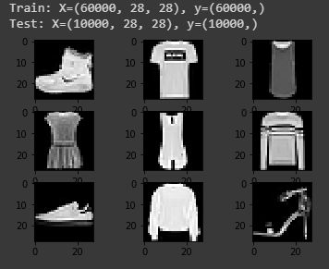

**Conclusion:**

We successfully displayed images of these 4 datasets.

**Colab Sheet Link:** <https://colab.research.google.com/drive/14_kVcgINLfMWSKusWUhF2pmSJTjFe4uG>