**Aim:**

How to get images from Image net.

**Observations:**

Images are downloaded. Two directories are created to store these images. The images used are of cats and dogs. After the images are saved in the folder, a dataframe is created. Similar dataframe is created for test. The images are passed through a generator function for both train and validation sets. A Sequential model is created with 6 layers. The 6 layers are conv2D, flatten, dense, relu, dense, sigmoid. The model is then evaluated and a roc_auc_score is generated. The output is predicted.



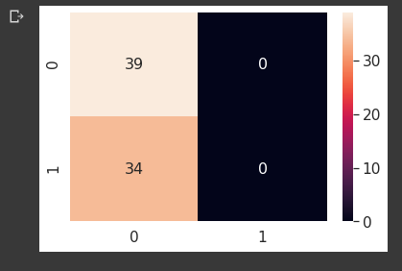

**Conclusion:**

39 observations have been correctly predicted by the model. On the other hand, 34 observations have been misclassified.

**Colab Sheet Link:** <https://colab.research.google.com/drive/1y3RiRvtGqGWDYHdE9_wfh0HI6ayEHl9r>