E-commerce Customer Retention and Activation

Introduction:

• Customer satisfaction has emerged as one of the most important factors that guarantee the success of online store; it has been posited as a key stimulant of purchase, repurchase intentions and customer loyalty.

• A comprehensive review of the literature, theories and models have been carried out to propose the models for customer activation and customer retention.

• Five major factors that contributed to the success of an e-commerce store have been identified as: service quality, system quality, information quality, trust and net benefit.

• The research furthermore investigated the factors that influence the online customers repeat purchase intention. The combination of both utilitarian value and hedonistic values are needed to affect the repeat purchase intention (loyalty) positively. The data is collected from the Indian online shoppers.

• Results indicate the e-retail success factors, which are very much critical for customer satisfaction.

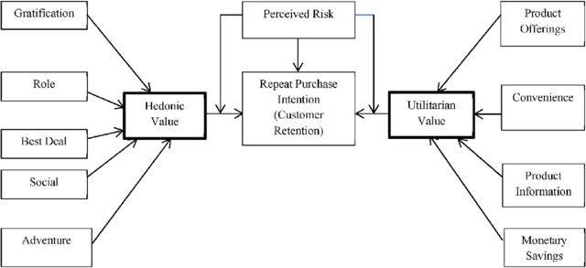

Dataset:

* The data is collected from the Indian online shoppers which has such data as age, gender, how long customers shop online, payment mode, access mode, page loading time, value for money and other data.
* Results indicate the e-retail success factors, which are very much critical for customer satisfaction.

Exploratory Data Analysis:

In this dataset I have performed the below analysis (after null value removal)

* **Univarient Analysis:** Uni means ‘one’ which is simplest form of analyzing data. Analyzing each variables separately.
* **Multivarient Analysis**: Analysis is made with more than one data.
* **Correlation:** It is the measure of relationship between two variables
* **Outliers:** outliers are values within a dataset that vary greatly from the others—they're either much larger, or significantly smaller. Outliers may indicate variabilities in a measurement, experimental errors, or a novelty.
* **Skewness:** Measure of symmetric or asymmetric distribution.

VALUE FOR MONEY:

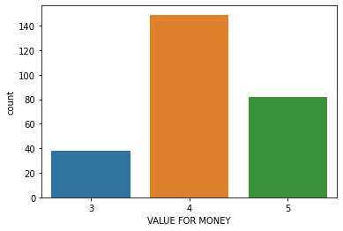

Here mostly all customers agree that the product bought are Value for money.

RECOMMENDED WEBSITE

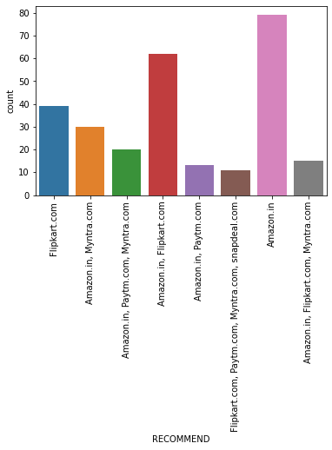

It is seen that mostly amazon is used and recommended website, followed by Flipkart and Myntra

Correlation:

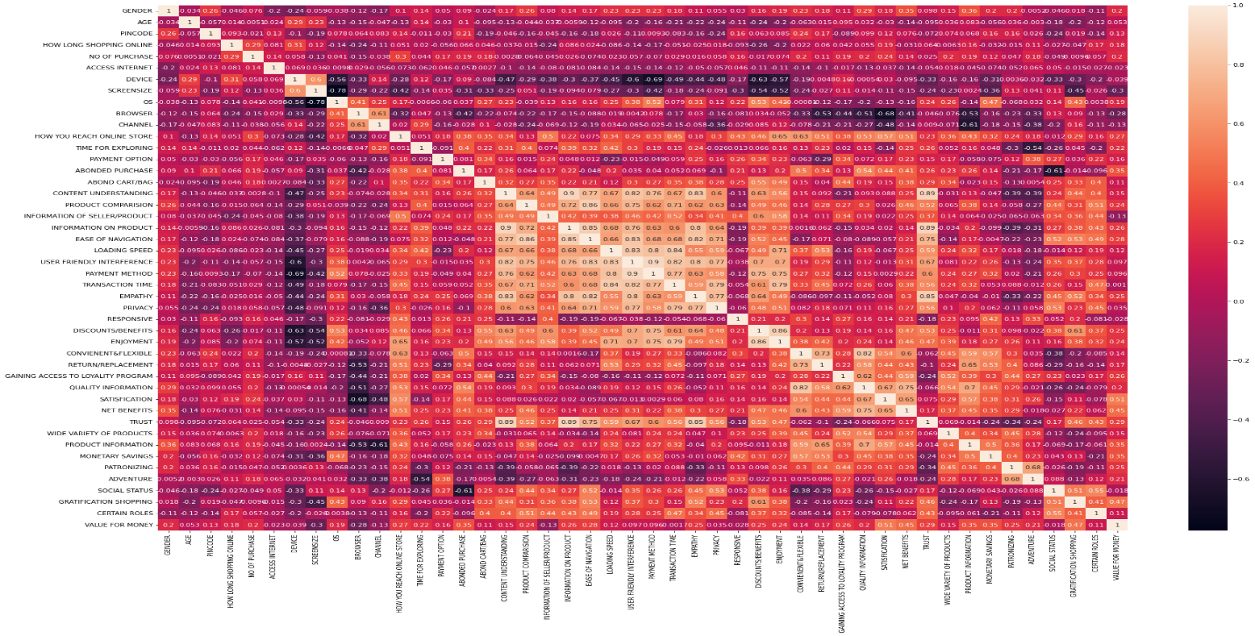

Key Observations:

Here we can find that 'OS' and 'SCREEN SIZE' column is highly correlated with each other.

Mostly all data have positive correlation with 'VALUE FOR MONEY'

This observation says that customers are more interested in faster delivery and ease of access product details over other factors which also makes the customers to purchase again from the same vendor.

Conclusion:

Based on the data we can conclude that with ease of internet facility most of customers trust ecommerce sites because they have good price, product offers, easy return policy, ease usage of website.

Customers also recommend few sites to their friends based on the value of the website.