System and method for registering and analysis of real time attendance and response tracking for enhanced learning

AUTHORS: Nikhil Sharma, Haris Ahmed, Mohd. Azharuddin, Mohd. Nauman
MENTOR: Dr. Amit Pundir, Dr. Geetika Jain Saxena, Mr. Dharamendra Mahato, Mr. Rajshekhar Mukherjee

Within the ambit of this paper we shall design an alternate attendance and response record system that utilizes Wi-Fi and essentially turns traditional attendance taking methodology an obsolete affair. The proposed system shall employ: Arduino hardware, IDE software, Wi-Fi module, mobile interface, camera, GPS module, and personal computer and MATLAB software. We shall devise the system such that it predicts a student’s regularity, interests and skills.

The student only requires an android powered smart phone to connect with the system. Unlike traditional attendance methods, the system automatically takes attendance, stores it on to a server and sends it to the recipient with complete analysis of his regularity for different classes. The response record system would then, use data analytics to predict a student’s skill and interests by analyzing data collected from quizzes and other events.

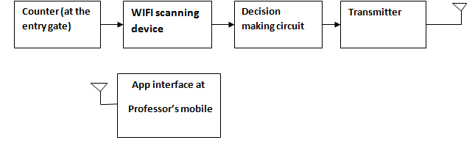
Figure 1: Basic block diagram

When a student enters in a class, the camera at the top of door will help in counting the number of students entering by using face recognition and at the same time receiver will receive the name of Wi-Fi (MAC address of mobile). Then all the scanned names with counting of students of respective class will be sent to web server and there all the scanned names (MAC addresses) will be checked according to the different routers (receivers) after this attendance will be taken. Attendance of each and every student will be updated on application interface provided to students and professors. If number of counted students is equal to the number of Wi-Fi devices then attendance is registered but, if these don’t match then there is some error. This problem can occur if there is a technical problem or student doesn’t have Wi-Fi device switched on or a student carries multiple devices inside a class. Finally, there is a flexibility provided in the professor’s application so that he/she can change attendance manually.

As the previous section suggested, to be able to remove the problem of proxies we require an automated counting method. In this project, we use image processing to count the number of students entering the class. The Wi-Fi based system independently takes the attendance and then, matches it with the result of image processing employing a camera placed near the entrance of the class. If the match is successful this means there isn’t any discrepancy in the attendance. However, if there isn’t a match then, the system intimates the professor about potential proxy attendances that would need a manual counting/correction.
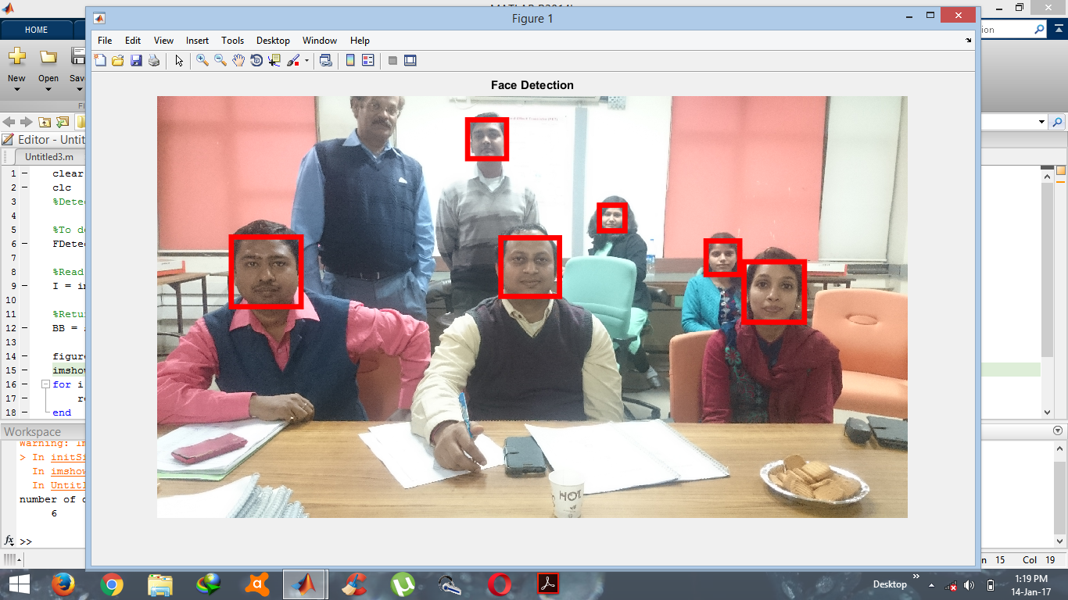
Figure 2: Sample result for counting using Matlab
The Attendance record system would require an android application that would act as an interface between the hardware and the user i.e. students or teachers. The proposed android application would include a login page from where either a student or a teacher might log into the application by filling up their credentials. The following options would be available to a teacher/ student:
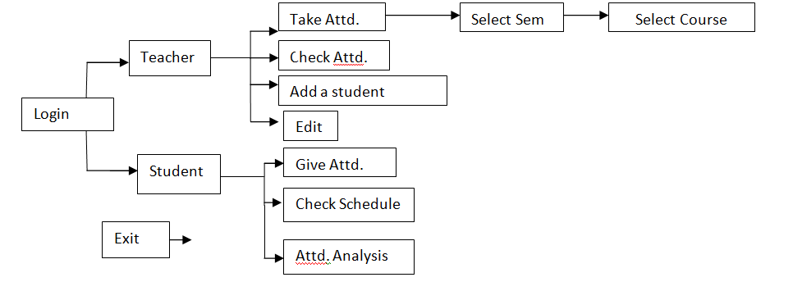Figure 3: Android application block diagram
The device once functional would be beneficial for students and teachers across educational institutions. It would significantly save precious time of teachers invested on taking attendance. Thus, the productivity of class would increase.

The system would further be improvised such that it suitably predicts a student’s regularity, interests and skills.
REFERENCES
[1] International Journal of Advent Research in Computer and Electronics (IJARCE) Vol. 2, No. 4, April 2015 E-ISSN 2348-5523“The WI-FI Based Attendance Tracker”,SuryawanshiAboli R. , SawantTejashri P. , RaskarMadhuri B. RaykarSuvarna C. , RangdalMukesh.
[2] “E-Attendance System (EAS) using WI-FI” ,Muhammad FaizMokhtar, Che Wan ShamsulBahriC.W.Ahmad and KhirulnizamAbdRahman ,Faculty of Information Science and Technology, KolejUniversiti Islam Antarabangsa Selangor, MALAYSIA

.

