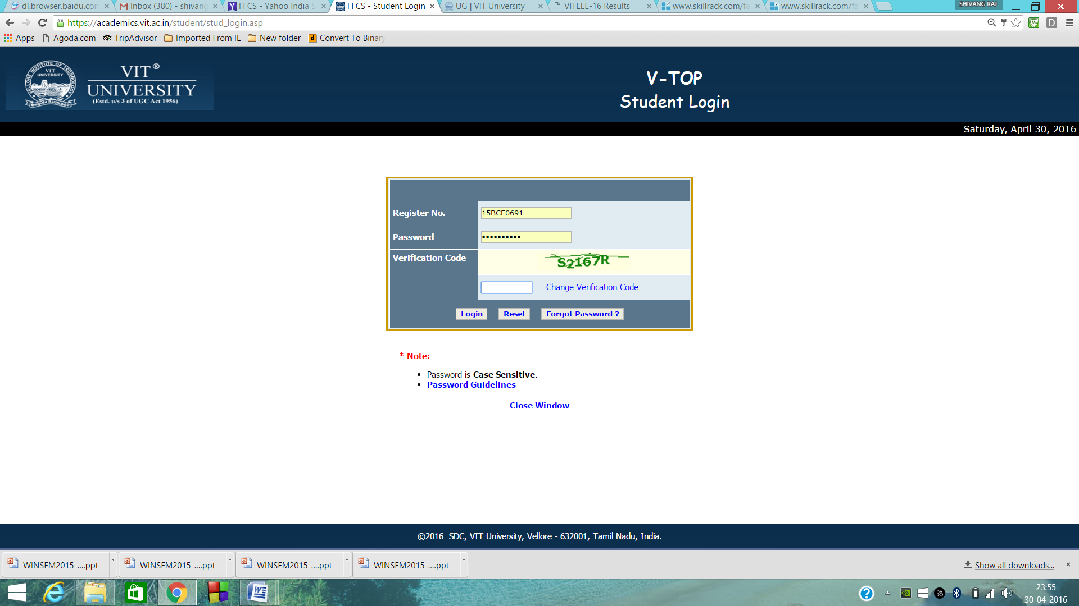

**Name**:- SHIVANG RAJ

**Registration No**.:- 15BCE0691

**Title**:- BASE CONVERSION USING STACKS

**Course Name:-** Data Structures & Algorithms

**Course Code**:- CSE2003

**Semester**:- Winter 2015-2016

**Index**

Topic Page No.

|  |  |
| --- | --- |
| **Problem Statement** | 1 |
| **Software used** | 1 |
| **Functions used** | 1 |
| **List of Errors encountered while coding the project** | 2 |
| **Key or challenging logic in the project** | 3 |
| **Elaborated Sample Input and Output** | 3-4 |

**Problem Statement:-**

**Base conversion of numbers having bases in range (1-62) to any base in range (1-62) using data structure “stacks”.**

**Software used:-**

**Code :: Blocks V13.12**

*A free , open source C, C++ and Fortran IDE for windows ,Linux and Mac OS X*

**Dev C++**

**Functions:-**

**push() :- pushes elements at the top of the stack.**

**pop():- pops out elements at the top of the stack from the stack.**

**any_base_to_decimal() :- converts any base number to decimal base number. We do take an input number as character and an input base as parameters in this function which would convert that character number to an integer of base 10 , keeping the error conditions like the value of each and every character of input number should be less than the base of the input number in counter.**

**decimal_to_any_base() :- converts decimal base number to any base number. The number which is already been converted to base 10 integer is taken input for this function along with the output base and with the use of push and pop function and using the concept of stacks the number is finally converted to the number of output base.**

**1.**

**List of Errors encountered while coding the project:-**

**C:\Users\USER\Documents\PROJECT.cpp|70|error: '::main' must return 'int'|**

**C:\Users\USER\Documents\ PROJECT.cpp||In function 'int any_base_to_decimal(int*, int)':|**

**C:\Users\USER\Documents\ PROJECT.cpp|12|error: cannot convert 'int*' to 'const char*' for argument '1' to 'size_t strlen(const char*)'|**

**C:\Users\USER\Documents\ PROJECT.cpp||In function 'int main()':|**

**C:\Users\USER\Documents\ PROJECT.cpp|85|error: cannot convert ‘char*’ to ‘int*’ for argument ‘1’ to ‘int any_base_to_decimal(int*, int)’|**

**C:\Users\USER\Documents\ PROJECT.cpp||In function ‘char pop(int*, int*)’😐**

**C:\Users\USER\Documents\ PROJECT.cpp|64|error: array must be initialized with a brace-enclosed nitialize|**

**Some of the logical errors encountered :**

**At the time if we ask for the input number, the value of each and every character of that number should be less than the base of the input number otherwise the code should throw error.**

**2.**

**Key or challenging logic in the project:-**

**As I was converting base in range (1-62) I had to encounter the alphabets in such a way that code wouldn’t seem to be longer as in first shot someone would go for assigning some value to all the alphabets with the corresponding number. But the logic I have implemented in the code is :**

**char op[120]=”0123456789ABCDEFGHIJKLMNOPQRSTUVWXYZabcdefghijklmnopqrstuvwxyz”;**

**value = stack1[*top];**

**that would return the alphabet or decimals depending upon the number is getting popped out of stack.**

**Elaborated Sample Input and Output:-**

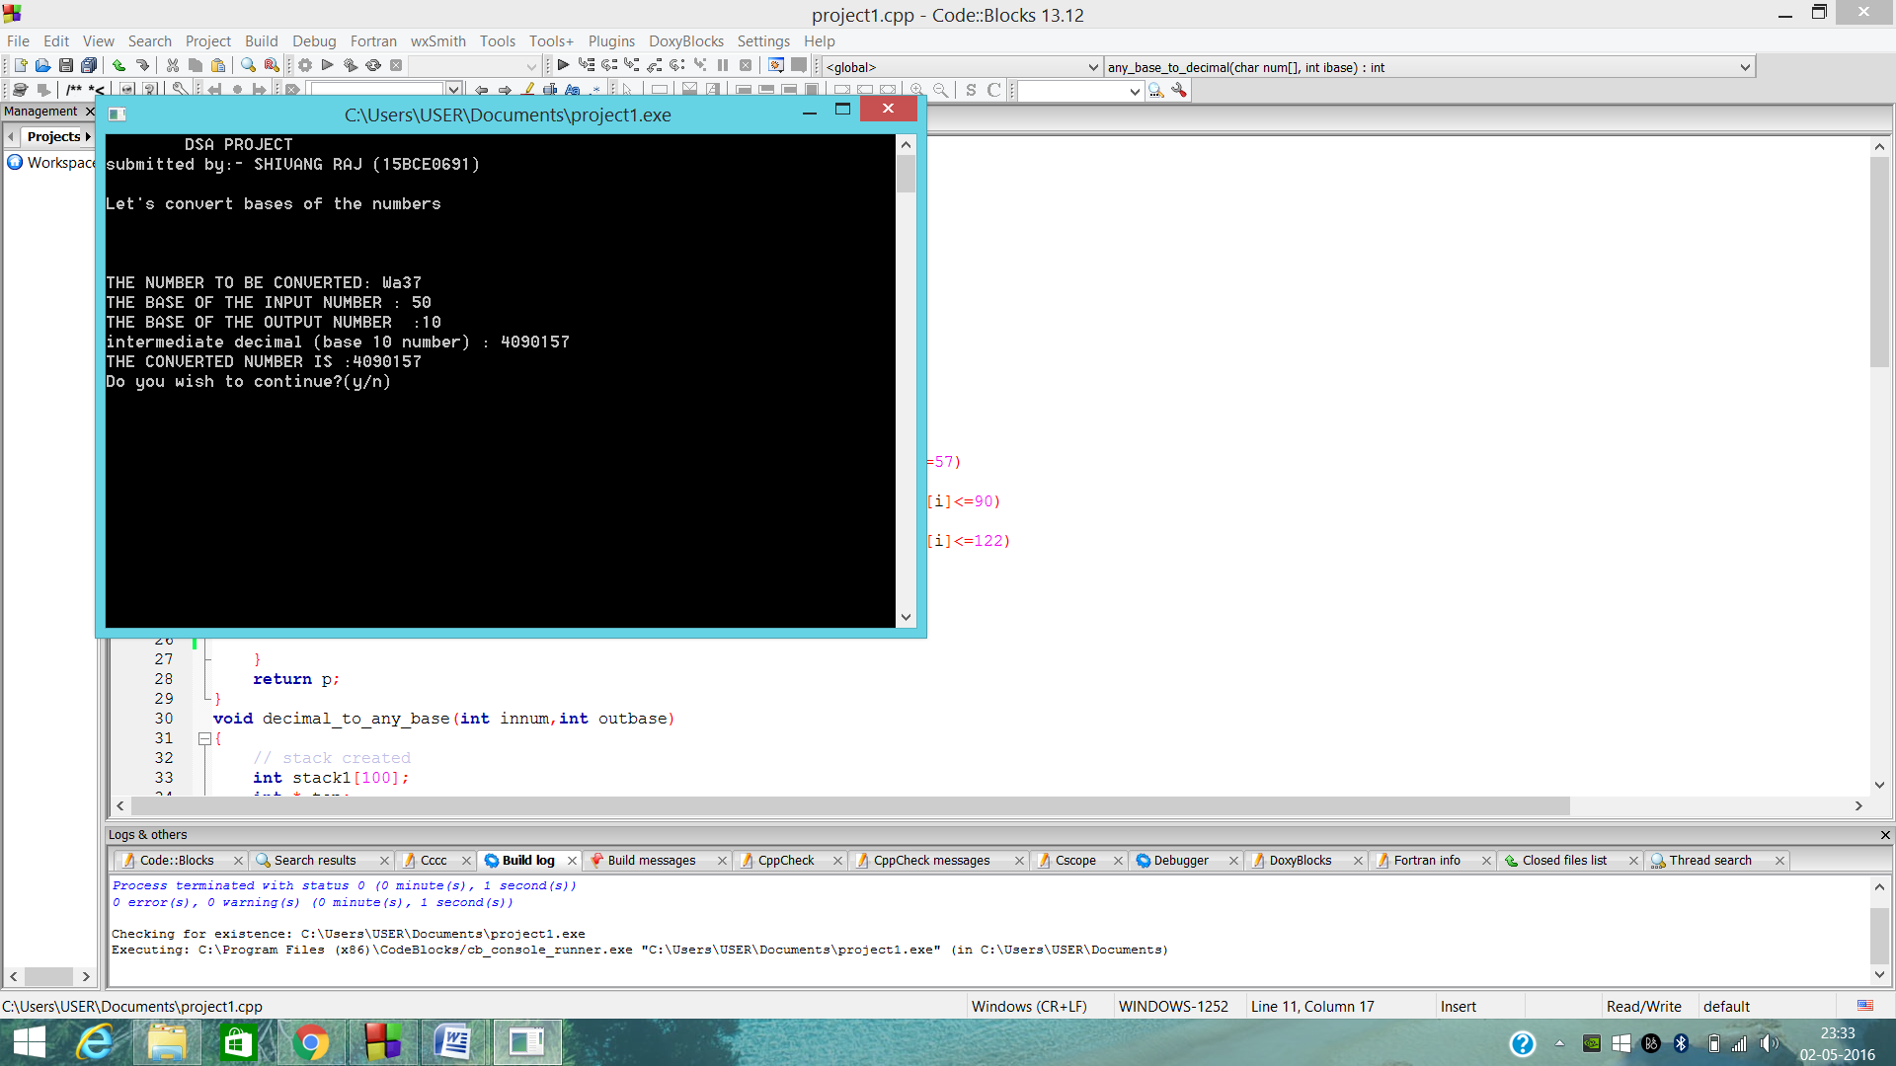

**3.**

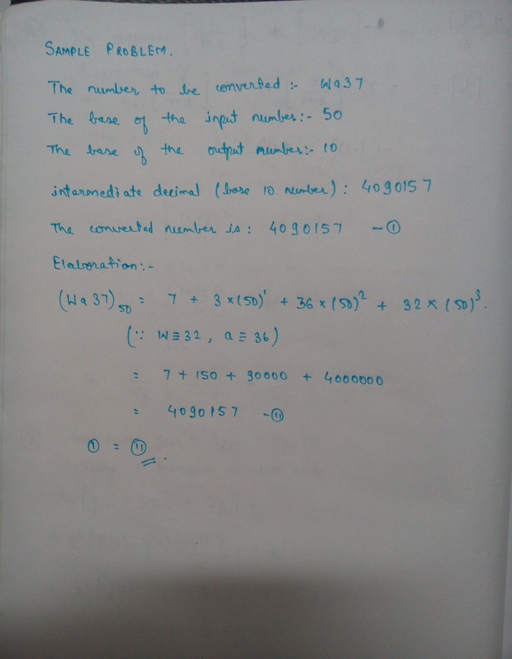

**4.**