Agro

E-Commerce

Module: **Buyer**

**Home Screen**

English हिंदी मराठी

Search…

**Home Products About Us My Orders  ** 

On Home Screen when Visitor Click on **Home** then this window will be shown

**Advertisement & Offers Slider**

Categories

**SEEDS FERTILIZERS PESTISIDES TOOLS&EQUIP. FRUITS&VEG. GROCERIES**

On Home Screen when Visitor Click on any **Category** then related all products window will be shown

Top Selling Products

**RICE BANANA COTTON SUGARCANE GVAVAS GROUNDNUT**

Seasonal Products On Home Screen when Visitor Click on any **Product** then related all products window will be shown

**BANANA MANGO COCONUT SUGARCANE GVAVAS WATERMELON**

© Copyright **Gaya Soft E-Commerce**. All Rights Reserved

|  |  |  |  |  |
| --- | --- | --- | --- | --- |
| **ABOUT** | **SOCIAL** | **POLICY** | **Mail Us** | **Registered Office Address** |
| Contact | Facebook | Return & Refund Policy | Gaya soft E-Commerce Pvt. Ltd. | Gaya Soft E-Commerce Pvt. Ltd. |
| About Us | Twitter | Cancellation Policy | Flat No. 9, 3 Floor, | Flat No. 9, 3 Floor, |
|  | LinkedIn | Shipping & Delivery Policy | 'Upendra C housing Society', | 'Upendra C housing Society', |
|  |  |  |  |  |
|  | YouTube |  | Opp Nisarg Hotel, Erandavana,  Road Nal Stop, | Opp Nisarg Hotel, Erandavana,  Road Nal Stop, |
|  |  |  | 411004 Pune – Maharashtra. | 411004 Pune – Maharashtra. |

English हिंदी मराठी

Search…

**Home Products About Us My Orders  ** 

On **Products** tab mouse over effect shows the below window

**PESTICIDE**

Bactericides

Bio-Pesticides

Fungicides

Herbicides

Insecticides

Larvicides

Nematicides

Organic Pesticides

Repellent

Rodenticides

Virucides

Weedicides

**SEEDS**

Horticulture Crop Seeds

Asvgandha Seeds

Cash Crop Seeds

Flower Seeds

**FERTILIZER**

Biological Fertilizer

Booster Fertilizer

Micro-Nutrient Fertilizer

Nano-Fertilizer

Nutrient Fertilizer

Organic Fertilizer

Plant Nutrient Fertilizer

Water Soluble Fertilizer

**TOOLS & EQUIPMENT**

Farm Tools & Equipment’s

Irrigation Tools & Equipment’

Nursery Tools & Equipment’s

If we move mouse on any **Category** its shows **Sub-Category** and it also shows further **Products** as bellows:

**Groceries**

Grains

Flours

Dals & Pulses

Organic Staples

Edible Oil & Ghee

Masala & Spices

Dry Fruits

Grains

Arborio Rice

Basmati Rice

Black Rice

Bomba Rice

Brown Rice

Jasmine Rice

Logn Grain White Rice

Parboiled Rice

Stcky Rice

Sushi Rice

Rice

Wheat

Rice

Sorghum

Corn

Oats

Barley

Amaranth

Rye

Millet

**Basmati Rice**

When Visitor Click on Any Product then they can see the same products from different Sellers

English हिंदी मराठी

Search…

**Home Products About Us My Orders  ** 

CATEGORIES >> GROCERIES >> GRAINS >> RICE >> **BASMATI RICE**

**Sort by Popularity**

At left Side of the screen some **filtes** are provide

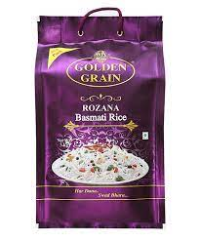

Get 30% Offer

Get 25% Offer

Get 20% Offer

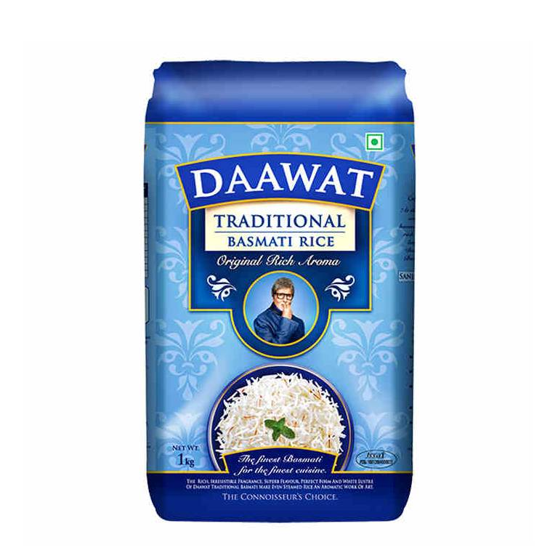

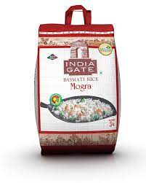

Category

Seeds (15)

Fertilizers (10)

Fruits & Vegitable (8)

Grocery (12)

Tools & Equipment (7)

Top Selling



Dawat

Basmati Rice 

Rozana

MRP – ~~Rs 100~~ **Rs 70**

Basmati Rice 

Rozana

MRP – ~~Rs 100~~ **Rs 75**

Basmati Rice 

Rozana

MRP – ~~Rs 100~~ **Rs 80**

Rozana

India Gate

**3.2**





**3.5**

**3.8**

Others

Price

1Kg - Rs 70.00

1Kg - Rs 75.00

1Kg - Rs 80.00

Rs 51 to Rs 100 (6)



Rs 101 to Rs 200 (8)

Rs 201 to Rs 500 (8)

More than Rs 501 (102)

Discount

Here Visitor can add any product in cart and wishlist

If Visitor Wants to add product in cart or wishlist he/she must login at their profile and if don’t have register then first need to register themselves on portal

Upto 5% (4)

Here Visitor can Add Quantity of products one or more

5% - 10% (6)

10% - 15% (5)

15% - 25% (2)

More than 25% (13)

**Related Products** Here Visitor can see also related products and their Information









1Kg - Rs 79.00

1Kg - Rs 89.00

1Kg - Rs 99.00

1Kg - Rs 79.00

English हिंदी मराठी

Search…

**Home Products About Us My Orders  ** 

CATEGORIES >> GROCERIES >> GRAINS >> RICE >> BASMATI RICE >> **DAAWAT BASMATI RICE-5KG**

Get 30% Offer

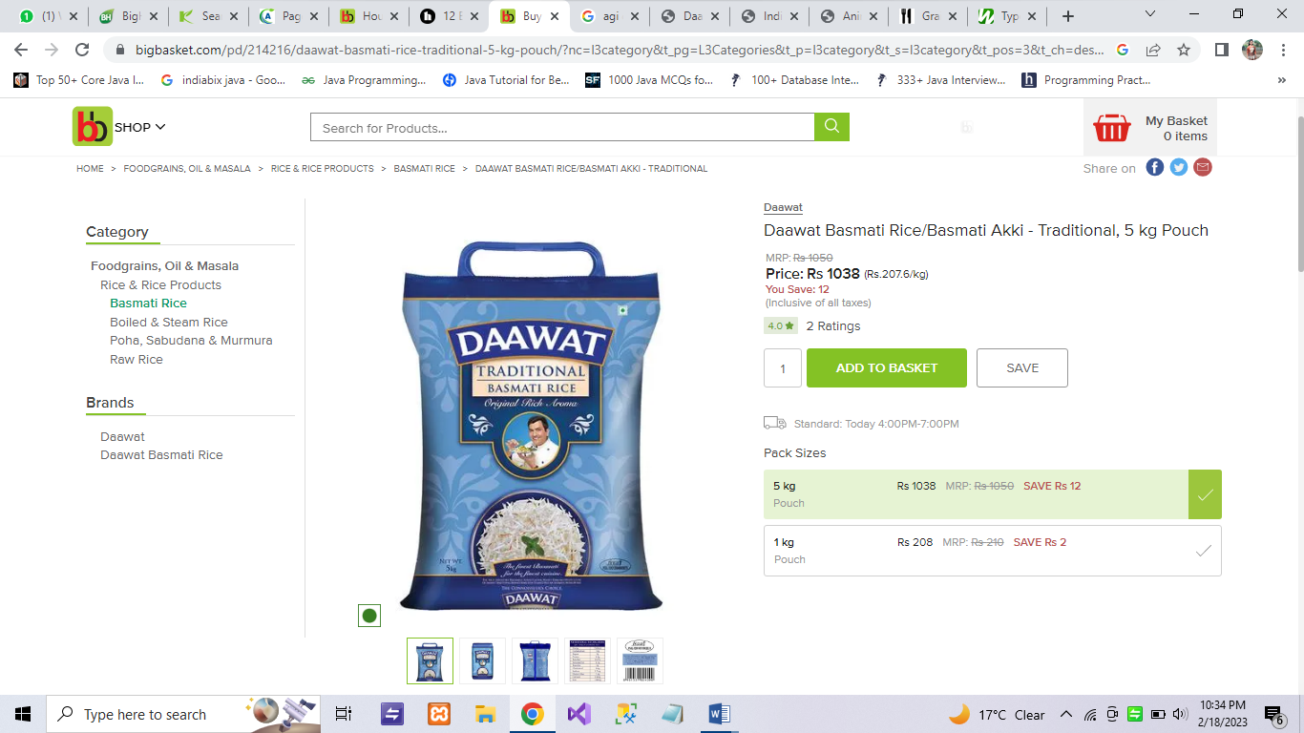

DAAWAT BASMATI RICE-5KG

**3.2**

**Basmati Rice**

Mfg. By: **Daawat**

In Stock Available: **Yes** / No

By Insert PIN and click on Check we can Check Delivery Availability

Non Expirable Product: Yes / **No**

Exp. Date: 1 year from mfg

Is Returnable Product? **Yes** / No

Is Seasonable Product? Yes / **No**

MRP – ~~Rs 100~~ **Rs 70**

Shipping Charges: **Rs 50.00**

**424206**

**Check**

Check Pin:



**Add to Cart c**

**Qnt. 1**

Share On:  **Chat bubble**

Here Click on **Logo** buyer can Share Product by link or message

**Description:**

* The extra-long grain and Non-Sticky texture make this rice ideal for all types of Biryani.
* Fortune brings to you the most special basmati rice- biryani special.
* On cooking it becomes exceptionally long fluffy and full of flavor.
* The result is an irresistible serving that delight everyone’s heart through its appearance and taste.
* After cooking rice elongate over 2 times and become flavorful and taste.
* Pristine white grains.

**3.2**

Ratings & Review:

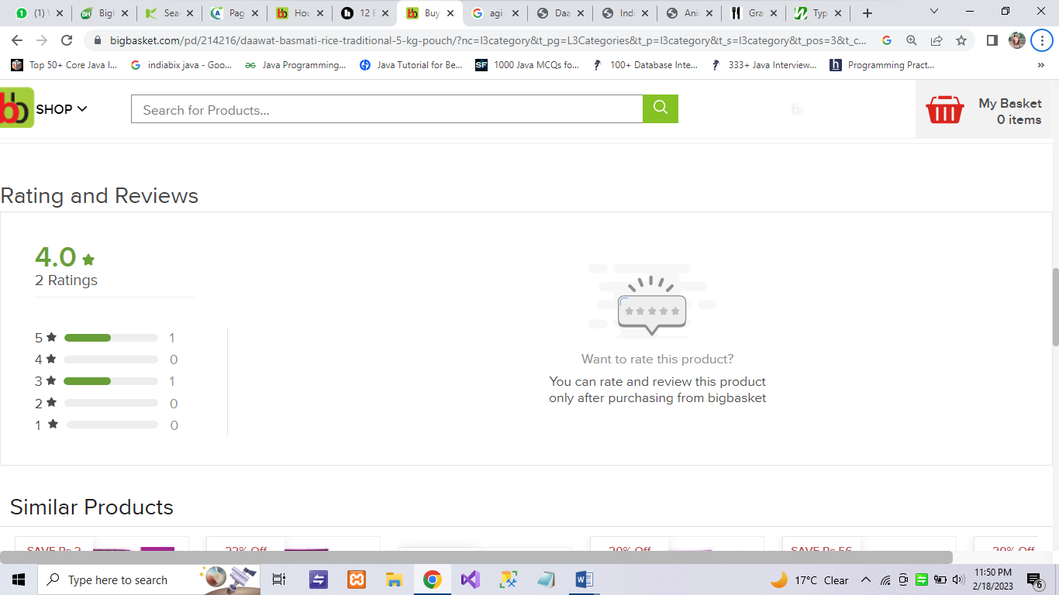

#### 

**WELCOME TO AGRO E-COMMERCE**

Forget Password? Show Password

OR

By continuing, you agree to Agro E-Commerce’s

**Terms of Service, Privacy Policy**

Not on Agro E-Commerce yet? **Sign up**

E-mail

Password

**Login**

Continue with **Facebook**

Continue with **Google**

**WELCOME TO AGRO E-COMMERCE**

**User Registration**

Full Name:

Email Id:

Password:

Confirm Password:

Mobile No:

**Register**

**WELCOME TO AGRO E-COMMERCE**

Forget Password? Show Password

OR

By continuing, you agree to Agro E-Commerce’s

**Terms of Service, Privacy Policy**

Not on Agro E-Commerce yet? **Sign up**

sagarkoli219@gmail.com

Skoli@219

**Login**

Continue with **Facebook**

Continue with **Google**

**WELCOME TO AGRO E-COMMERCE**

**Forgot Password**

Please Enter Your Email for Reset Password Request

E-mail

**Reset Password**

**WELCOME TO AGRO E-COMMERCE**

**Reset Password**

Please Enter New Password

New Password

Confirm Password

**Reset & Login**

English हिंदी मराठी

Search…

**Home Products About Us Wallet   ** 

**(3) (2) (3) Profile**

**Advertisement & Offers Slider**

Categories

**SEEDS FERTILIZERS PESTISIDES TOOLS&EQUIP. FRUITS&VEG. GROCERIES**

Top Selling Products

**RICE BANANA COTTON SUGARCANE GVAVAS GROUNDNUT**

Seasonal Products

**BANANA MANGO COCONUT SUGARCANE GVAVAS WATERMELON**

|  |  |  |  |  |
| --- | --- | --- | --- | --- |
| **ABOUT** | **SOCIAL** | **POLICY** | **Mail Us** | **Registered Office Address** |
| Contact | Facebook | Return & Refund Policy | Gaya soft E-Commerce Pvt. Ltd. | Gaya Soft E-Commerce Pvt. Ltd. |
| About Us | Twitter | Cancellation Policy | Flat No. 9, 3 Floor, | Flat No. 9, 3 Floor, |
|  | LinkedIn | Shipping & Delivery Policy | 'Upendra C housing Society', | 'Upendra C housing Society', |
|  |  |  |  |  |
|  | YouTube |  | Opp Nisarg Hotel, Erandavana,  Road Nal Stop, | Opp Nisarg Hotel, Erandavana,  Road Nal Stop, |
|  |  |  | 411004 Pune – Maharashtra. | 411004 Pune – Maharashtra. |

© Copyright **Gaya Soft E-Commerce**. All Rights Reserved

English हिंदी मराठी

Search…

**Home Products About Us Wallet   ** 

**(3) (2) (3) Profile**

HOME >> **MY WISHLIST**

**My Wish-List**



**1**

**2**

**3**



Basmati Rice

Rozana

MRP – ~~Rs 100~~ **Rs 80/kg**

**In Stock**

**Add to Cart**



Basmati Rice

Rozana

MRP – ~~Rs 100~~ **Rs 75/kg**

**Out of Stock**

**Notify Me**



Basmati Rice

Rozana

MRP – ~~Rs 100~~ **Rs 70/kg**

**In Stock**

**Add to Cart**

English हिंदी मराठी

Search…

**Home Products About Us Wallet   ** 

**(3) (2) (3) Profile**

**Continue to Shopping**

HOME >> **MY CART**

**My Cart**



**Product Image Details Quantity Total**

**1**

**2**

**Cart Total**

**Sub Total: Rs 510**

**SGST: Rs 20**

**CGST: Rs 20**

**Shipping Charges: Rs 50**

**Coupon Code:** Apply Coupon

**Total: Rs 600**

Add items worth Rs 120 more to get 100 points

Basmati Rice 2kg

Rozana

MRP – ~~Rs 100~~ **Rs 80/kg**

**In Stock**



**Rs 160**

**1**

Basmati Rice 5Kg

Rozana

MRP – ~~Rs 100~~ **Rs 70/kg**

**In Stock**



**Rs 350**

**1**

**CONTINUE SHOPPING**

**PROCEED TO CKECKOUT**

English हिंदी मराठी

Search…

**Home Products About Us Wallet   ** 

**(3) (2) (3) Profile**

HOME >> MY CART >> ORDER DETAILS >> **SHIPPING ADDRESS**

**My Address Gallery**



**Place Address Details**

* **1 Home** Sagar Ashok Koli Edit 

12-A, Meera Nagar, New Prakasha Road

Shahada, Maharashrta, 425410

8551810587

* **2 Office** Sagar Ashok Koli Edit 

3rd Floor, Upendra building, Pandurang

Colony, Erandawane, Pune, Maharashtra, 411034

8551810587

* **3 Other**  **Add New Address**

**PLACE ORDER**

English हिंदी मराठी

Search…

**Home Products About Us Wallet   ** 

**(3) (2) (3) Profile**

HOME >> MY CART >> ORDER DETAILS >> SHIPPING ADDRESS >> **EDIT ADDRESS**

**WELCOME TO AGRO E-COMMERCE**

**Edit Address**

Full Name:

Address:

Landmark:

Country:

State:

City:

Pin Code:

Address Type:

Mobile No:

Alternate No:

Email:

Gender: Male Female Other

DOB: 

Near New Petrol Pump

12-A, New Prakasha Road,Shahada

Sagar Ashok Koli

India 

Maharashtra 

Nandurbar 

sagarkoli219@gmail.com

8551810587

425410

Home 

8551810587

23/08/1994

**PLACE ORDER**

English हिंदी मराठी

Search…

**Home Products About Us Wallet   ** 

**(3) (3) (2) Profile**

HOME >> MY CART >> ORDER DETAILS >> SHIPPING ADDRESS >> **ADD NEW ADDRESS**

When we Click on **Add New Address** Following window Appears

**WELCOME TO AGRO E-COMMERCE**

**Add New Address**

Full Name:

Address:

Landmark:

Country:

State:

City:

Pin Code:

Address Type:

Mobile No:

Alternate No:

Email:

Gender: Male Female Other

DOB: 









**SAVE & PLACE ORDER**

English हिंदी मराठी

Search…

**Home Products About Us Wallet   ** 

**(3) (2) (3) Profile**

HOME >> MY CART >> ORDER DETAILS >> SHIPPING ADDRESS >> **PAYMENT**

**Continue to Shopping**

**Order Details**

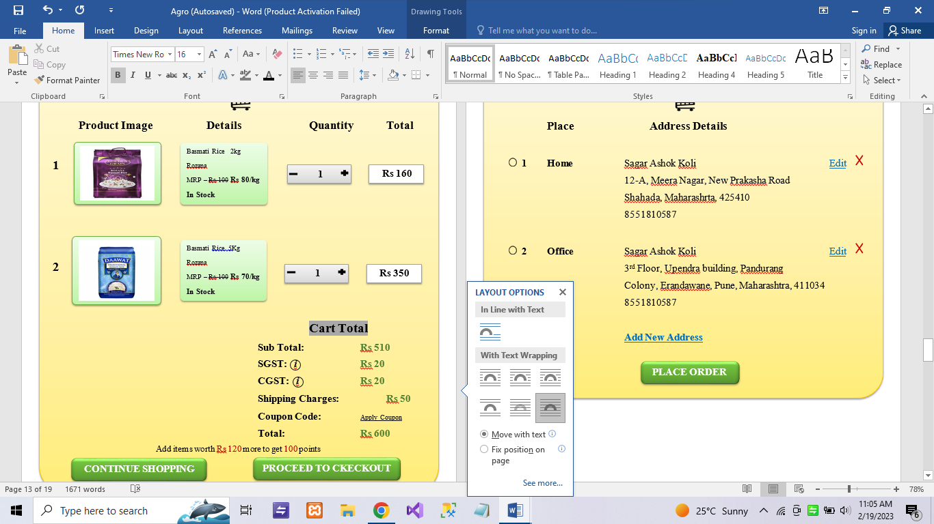

**Payment Options**

* Credit / Debit Card
* Cash On Delivery
* Digital Currency
* UPI
* Payment from My Wallet / Coupons

**ADD CARD DETAILS**

**CANCEL**

English हिंदी मराठी

Search…

**Home Products About Us Wallet   ** 

**(3) (2) (3) Profile**

HOME >> MY CART >> ORDER DETAILS >> SHIPPING ADDRESS >> PAYMENT **>> COUPONS**

Sub Total Rs 510

CGST Rs 20

SGST Rs 20

UGST -

IGST -

Coupon Code (worth Rs 10 off)

Shipping Charges Rs 50

Total Rs 590

KLIHGF

**CANCEL**

**ADD CARD DETAILS**

Card Holder Name*

Card No*

Exp. Year* CVV*

**PROCEED**

**CANCEL**

**Enter OTP**

**CANCEL**

**CONFIRM OTP & PLACED ORDER**

**ORDER CONFIRMATION**

Your order is Successfully Placed…!!!

**OK**

On Click **OK** order Invoice Send on Buyers Email Id

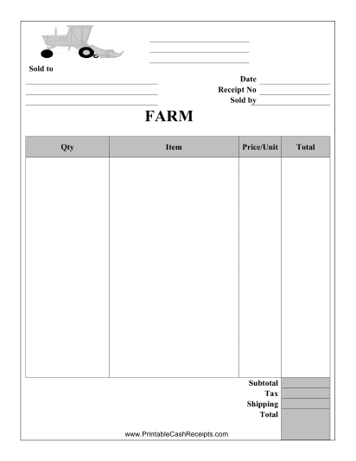

**PRINT**

English हिंदी मराठी

Search…

**Home Products About Us Wallet   ** 

**(3) (2) (3) Profile**

HOME >> MY PROFILE **>> UPDATE PROFILE**

**Update Profile**

Full Name:

Address:

Landmark:

Country:

State:

City:

Pin Code:

Address Type:

Mobile No:

Alternate No:

Email:

Gender: Male Female Other

DOB: 

**My Profile**

My Orders

My Wallet

Notifications

Logout

**Update Profile**

Change Password

Sagar Ashok Koli

sagarkoli219@gmail.com

8551810587

--Select-- 

--Select-- 

--Select-- 

--Select-- 

23/08/1994

**UPDATE**

English हिंदी मराठी

Search…

**Home Products About Us Wallet   ** 

**(3) (2) (3) Profile**

HOME >> MY PROFILE >> MY ORDERS>> **REMAINING ORDERS**

**Continue to Shopping**

My Profile

**My Orders**

My Wallet

Notifications

Logout

**Remaining Orders**

Orders History

**Note: You can Cancel the order only before Dispatching**

**Remaining Orders**

**No OrderId Order Details Prod Qnt. Delivery Add. Status Order Date Delivery Date Total**

1 ORD001 Basmati Daawat 12-A, Meera Nagar,

Rice 5Kg 1 Shahada,425410 **In-Transit 17-02-2023 22-02-2023 Rs 550**

Basmati Rozana

Rice 2Kg 1

2 ORD001 Basmati Daawat 12-A, Meera Nagar,

Rice 5Kg 1 Shahada,425410 **Dispatched 17-02-2023 22-02-2023 Rs 900**

Basmati Rozana

Rice 2Kg 1

3 ORD001 Basmati Daawat 12-A, Meera Nagar,

Rice 5Kg 1 Shahada,425410 **Picked up 17-02-2023 22-02-2023 Rs 650**

Basmati Rozana

Rice 2Kg 2

4 ORD001 Basmati Daawat 12-A, Meera Nagar,

Rice 5Kg 1 Shahada,425410 **Placed 17-02-2023 22-02-2023 Rs 910**

Basmati Rozana

Rice 2Kg 1

**Cancel**

**Track**

**Track**

**Cancel**

**Track**

**Cancel**

**Track**

**Cancel**

English हिंदी मराठी

Search…

**Home Products About Us Wallet   ** 

**(3) (2) (3) Profile**

HOME >> MY PROFILE >> MY ORDERS>>REMAINING ORDERS >> **TRACKING ORDER**

My Profile

**My Orders**

My Wallet

Notifications

Logout

**Remaining Orders**

Orders History

**Tracking Details**

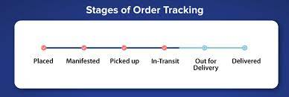

English हिंदी मराठी

Search…

**Home Products About Us Wallet   ** 

**(3) (2) (3) Profile**

HOME >> MY PROFILE >> MY ORDERS>>REMAINING ORDER >> **CANCEL ORDER**

My Profile

**My Orders**

My Wallet

Notifications

Logout

**Remaining Orders**

Orders History

**Note: You can Cancel the order only before Dispatching**

Product Details: Basmati Rozana Rice 2Kg

Reason:



Longer Deliveries.

No mention of a delivery date.

Unexpected Shipping costs.

High Shipping costs.

Over-purchasing.

Loss of interest or need.

Refund request send to Seller

**Feedback & Rating**

**Refund**

**Cancelled Order Details**

**No Order Id Order Details Prod Qnt. Delivery Add. Status PayMode Order Date Delivery Date Total Replace Reason**

1 ORD001 Basmati Daawat 12-A, Meera Nagar, Longer Deliveries

Rice 5Kg 1 Shahada,425410 **In-Transit COD 17-02-2023 22-02-2023 Rs 550**

Basmati Rozana

Rice 2Kg 1

2 ORD001 Basmati Daawat 12-A, Meera Nagar, Product was

Rice 5Kg 2 Shahada,425410 **In-Transit Wallet 17-02-2023 22-02-2023 Rs 910** damaged

Basmati Rozana **Rs. 860 Refund**

Rice 2Kg 1

English हिंदी मराठी

Search…

**Home Products About Us Wallet   ** 

**(3) (2) (3) Profile**

HOME >> MY PROFILE >> MY ORDERS>>ORDER HISTORY >> **FEEDBACK & RATING**

My Profile

**My Orders**

My Wallet

Notifications

Logout

Remaining Orders

Track Order

**Orders History**

Feedback:

Rating In Stars:

Write Here…

**Save**

+

English हिंदी मराठी

Search…

**Home Products About Us Wallet   ** 

**(3) (2) (3) Profile**

HOME >> MY PROFILE >> MY ORDERS>> **ORDER HISTORY**

My Profile

**My Orders**

My Wallet

Notifications

Logout

Remaining Orders

**Orders History**

**Note: You can Cancel the order only before Dispatching**

**Continue to Shopping**

**Order Details**

**No Order Id Order Details Prod Qnt. Delivery Add. Status PayMdOrder Date Delivery Date Total Return Ord Status**

1 ORD001 Basmati Daawat 12-A, Meera Nagar,

Rice 5Kg 1 Shahada,425410 **Delivered 17-02-2023 22-02-2023 Rs 550**

Basmati Rozana **COD**

Rice 2Kg 1

1 ORD002 Basmati Daawat 12-A, Meera Nagar,

Rice 5Kg 1 Shahada,425410 **Dispatched 17-02-2023 22-02-2023 Rs 550**

Basmati Rozana **Debit Card**

Rice 2Kg 1

1 ORD003 Basmati Daawat 12-A, Meera Nagar,

Rice 5Kg 1 Shahada,425410 **In-Transit 17-02-2023 22-02-2023 Rs 550**

Basmati Rozana **Debit Card**

Rice 2Kg 1

1 ORD004 Basmati Daawat 12-A, Meera Nagar,

Rice 5Kg 1 Shahada,425410 **Placed 17-02-2023 22-02-2023 Rs 550**

Basmati Rozana **COD**

Rice 2Kg 1

**Reorder**

**Replace**

**Feedback & Rating**

**Cancelled**

**Feedback & Rating**

**Reorder**

**Replace**

**Feedback & Rating**

**Cancelled**

**Feedback & Rating**

English हिंदी मराठी

Search…

**Home Products About Us Wallet   ** 

**(3) (2) (3) Profile**

HOME >> MY PROFILE >> MY ORDERS>>ORDER HISTORY >> **REPLACE ORDER**

**Replace**

**Return**

**Continue to Shopping**

Product Details: Basmati Rozana Rice 2Kg

Reason:



Product was damaged

Product arrived too late

Customer no longer needed product

Prod didn’t matched details

On Click Return button Refund

Process is carried out

Click on **Replace** Replace order or Product Request Send to Seller and on Click **Track** Buyer can see Reverse tracking progress

**View**

**Replaced Order Details**

**No Order Id Order Details Prod Qnt. Delivery Add. Status PayMode Order Date Delivery Date Total Replace Reason**

1 ORD001 Basmati Daawat 12-A, Meera Nagar, Product was

Rice 5Kg 1 Shahada,425410 **In-Transit COD 17-02-2023 22-02-2023 Rs 550** damaged

Basmati Rozana

Rice 2Kg 1

English हिंदी मराठी

Search…

**Home Products About Us Wallet   ** 

**(3) (2) (3) Profile**

HOME >> MY PROFILE >> MY ORDERS>>ORDER HISTORY >> **REORDER**

My Profile

**My Orders**

My Wallet

Notifications

Logout

Remaining Orders

Track Order

**Orders History**

**Back to Cart**

**Order Details**



**Payment Options**

* Credit / Debit Card
* Cash On Delivery
* Digital / Mobile Wallet
* UPI
* Payment from My Wallet

**CANCEL**

**ADD CARD DETAILS**

English हिंदी मराठी

Search…

**Home Products About Us Wallet   ** 

**(3) (2) (3) Profile**

HOME >> MY PROFILE >> MY ORDERS>> **ALL ORDERS**

My Profile

**My Orders**

My Wallet

Notifications

Logout

Remaining Orders

Track Order

**Orders History**

**Continue to Shopping**

**ALL Order Details**

**No Order Id Order Details Prod Qnt. Delivery Add. Status PayMode Order Date Delivery Date Total Status Reason**

1 ORD001 Basmati Daawat 12-A, Meera Nagar,

Rice 5Kg 1 Shahada,425410 **In-Transit 17-02-2023 22-02-2023 Rs 550 Delivered**

Basmati Rozana **COD**

Rice 2Kg 1

2 ORD001 Basmati Daawat 12-A, Meera Nagar, **Refund** Product

Rice 5Kg 1 Shahada,425410 **In-Transit COD 17-02-2023 22-02-2023 Rs 550** wasdamaged

Basmati Rozana

Rice 2Kg 1

3 ORD001 Basmati Daawat 12-A, Meera Nagar, **Replace** Product

Rice 5Kg 2 Shahada,425410 **In-Transit Wallet 17-02-2023 22-02-2023 Rs 910** was damaged

Basmati Rozana **Rs. 860 Refund**

Rice 2Kg 1

**View**

**View**

**View**

English हिंदी मराठी

Search…

**Home Products About Us Wallet  ** 

**(3) (2) (3) Profile**

HOME >> **WALLET**

**Continue to Shopping**

**My Wallet (460pt)**

**No OrderId Order Details Prod Qnt Total Reward Points**

1 ORD001 Basmati Daawat

Rice 5Kg 1  **Rs 550 100pt**

Basmati Rozana

Rice 2Kg 1

1 ORD002 Basmati Daawat

Rice 5Kg 1  **Rs 550 115pt**

Basmati Rozana

Rice 2Kg 1

1 ORD003 Basmati Daawat

Rice 5Kg 1  **Rs 550 85pt**

Basmati Rozana

Rice 2Kg 1

1 ORD004 Basmati Daawat

Rice 5Kg 1  **Rs 550 160pt**

Basmati Rozana

Rice 2Kg 1

**Total Points: 460pt**

English हिंदी मराठी

Search…

**Home Products About Us Wallet   ** 

**(3) (2) (3) Profile**

HOME >> MY PROFILE >> **NOTIFICATIONS**

**Continue to Shopping**

**Notifications Details**

**No Product / Order Details Qnt. Status Discount Reward Points Refund Status**

1 Basmati Rozana Rice 1KG 50kg In-Stock 25% - -

2 ORD005 2 Delivered 20% 100 -

3 Daawat Basmati Rice 5KG 1 Cancelled 10% 50 Refunded

English हिंदी मराठी

Search…

**Home Products About Us Wallet   ** 

**(3) (2) (3) Profile**

HOME >> MY PROFILE >> **LOGOUT**

English हिंदी मराठी

Search…

**Home Products About Us My Orders  ** 

**Advertisement & Offers Slider**

Categories

**SEEDS FERTILIZERS PESTISIDES TOOLS&EQUIP. FRUITS&VEG. GROCERIES**

Top Selling Products

**RICE BANANA COTTON SUGARCANE GVAVAS GROUNDNUT**

© Copyright **Gaya Soft E-Commerce**. All Rights Reserved

|  |  |  |  |  |
| --- | --- | --- | --- | --- |
| **ABOUT** | **SOCIAL** | **POLICY** | **Mail Us** | **Registered Office Address** |
| Contact | Facebook | Return & Refund Policy | Gaya soft E-Commerce Pvt. Ltd. | Gaya Soft E-Commerce Pvt. Ltd. |
| About Us | Twitter | Cancellation Policy | Flat No. 9, 3 Floor, | Flat No. 9, 3 Floor, |
|  | LinkedIn | Shipping & Delivery Policy | 'Upendra C housing Society', | 'Upendra C housing Society', |
|  |  |  |  |  |
|  | YouTube |  | Opp Nisarg Hotel, Erandavana,  Road Nal Stop, | Opp Nisarg Hotel, Erandavana,  Road Nal Stop, |
|  |  |  | 411004 Pune – Maharashtra. | 411004 Pune – Maharashtra. |