 

**A PROJECT REPORT**

**ON**

**AIYOJAN-A University Management Application**

SUBMITTED TO THE SAVITRIBAI PHULE PUNE UNIVERSITY, PUNE IN THE PARTIAL FULFILLMENT OF THE REQUIREMENTS

FOR THE AWARD OF THE DEGREE

OF

## BACHELOR OF ENGINEERING (INFORMATION TECHNOLOGY)

## SUBMITTEDBY

**HILAG SHAH Exam No : B190248567**

**HRITHIK KUMAR Exam No : B190248527**

**SANSKAR PRASAD Exam No : B190248563**

……………………………………………………………..

## UNDER THE GUIDANCE OF

## DR. SELVA MARY G.

## DEPARTMENT OF INFORMATION TECHNOLOGY

## DR. D. Y. PATIL INSTITUTE OF TECHNOLOGY

PIMPRI, PUNE 411018



**CERTIFICATE**

This is to certify that the project report entitles

**“ AIYOJAN-A University Management Application”**

Submitted by

**HILAG SHAH Exam No : B190248567**

**HRITHIK KUMAR Exam No : B190248527**

**SANSKAR PRASAD Exam No : B190248563**

is a bonafide student of this institute and the work has been carried out by him/her under the supervision of **Dr. Selva Mary G.** and it is approved for the partial fulfillment of the requirement of Savitribai Phule Pune University, Pune for the award of the degree of **Bachelor of Engineering** (Information Technology).

## (Dr. Selva Mary G.) (Prof. Sonali Patil) (Dr. Selva Mary G.) (Dr. Lalit Kumar Wadhwa)

Project Guide Project Coordinator HOD-IT Principal

Seal/Stamp of the College Examiner 1:

Examiner 2 :

Place : Pune Date :

# ACKNOWLEDGEMENT

We would like to express our sincere gratitude and appreciation to all those who have contributed to the success of this project. Firstly, we would like to extend our heartfelt thanks to our project supervisor, Dr. Selva Mary G, who served as an indispensable source of guidance, motivation and expertise throughout the duration of the project. Her exceptional knowledge, dedication, and attention to detail provided us with valuable insights and direction, which greatly helped us in achieving our research goals.

We would also like to extend our gratitude to Dr. L. K. Wadhawa, the Principal of Dr. DY Patil Institute of Technology, for his constant support and insightful comments, which greatly helped in shaping the direction of our research. His expertise and experience provided us with a unique perspective that enhanced the quality and impact of our work.

Finally, we would like to acknowledge the contributions of all those who provided their time, expertise, and resources to support this project. Their generosity and expertise have helped us in numerous ways, improving the quality and impact of our research, and saving us from many errors. We are truly grateful for their support, which has been invaluable in the success of this project.

**Hilag Shah(B190248567)**

**Hrithik Kumar(B190248527)**

**Sanskar Prasad(B190248563)**

**ABSTRACT**

The integration of technology in education has resulted in significant improvements in efficiency and accuracy. However, despite the advancements, Indian universities still follow their own individual academic calendars, which often results in confusion and disparities among students. Students who receive their results earlier have a significant advantage in selecting their desired courses and universities, while those who receive their results late have limited options.

Additionally, students must invest a substantial amount of time and money traveling to various institutions to obtain information, apply, and complete admissions procedures. This not only leads to an inefficient system but also places an additional burden on students, particularly those from economically weaker backgrounds.

To address this issue, this project aims to introduce a centralized and uniform academic calendar across all universities in the country. The proposed system is designed to integrate date prediction and provide a platform for universities to organize their academic activities effectively.

This project focuses on the development of a web-based platform that utilizes advanced algorithms to predict the dates of academic events and deadlines accurately. The platform is designed to offer a user-friendly interface for both students and university authorities to input and access essential information related to academic events.

The proposed system will enable universities to become more organized, disciplined and promote transparency in the admissions process. It will also provide students with a clearer view of the academic schedule and equal opportunities for admissions to the best colleges. This system has the potential to revolutionize the education sector and bridge the gap between students and universities.

The benefits of the proposed system include saving students time and money, increasing the efficiency of the admissions process, and providing equal opportunities for all students, irrespective of their results' declaration dates. The proposed platform has the potential to transform the higher education system in India and contribute significantly to making the admissions process more accessible, transparent, and efficient.

**TABLE OF CONTENTS**

|  |  |  |
| --- | --- | --- |
| **CHAPTER** | **TITLE** | **PAGENO.** |
|  | LIST OF FIGURES | 6 |
|  | LIST OF TABLES | 7 |
| **01** | Introduction | 8 |
| **02** | Review Of Literature | 11 |
| **03** | Problem definition and Scope | 14 |
| **04** | Project Plan  4.1 Time Line of Project  4.2 Feasibility Study  4.3 Risk Analysis / Risk Management  4.4 Lines of Code (LOC)  4.5 Effort  4.6 Development Time  4.7 Number of People | 16 |
| **05** | Project Requirement specification  5.1 Software Requirements  5.2 Hardware Requirements  5.3 Functional Requirement  5.4 Non-Functional Attribute | 21 |
| **06** | System Architecture | 24 |
| **07** | UML Diagram | 27 |
| **08** | High level design of the project (DFD) | 34 |
| **09** | System implementation | 36 |
|  | Conclusions | 44 |
|  | Tools Used | 45 |
|  | Paper published(Letter Of Acceptance) | 47 |
|  | Plagiarism Report | 49 |
|  | Websites and papers/books References in IEEE format. | 51 |

1. **LIST OF FIGURES**

|  |  |  |
| --- | --- | --- |
| **Figure** | **Illustration** | **Page No.** |
| 6.1 | System Architecture | 25 |
| 7.1 | Use Case diagram | 28 |
| 7.2 | Sequence diagram | 29 |
| 7.3 | Class diagram | 31 |
| 7.4 | Deployment diagram | 32 |
| 9.1 | Search Algorithm in action | 36 |
| 9.2 | Calendar overview | 37 |
| 9.3 | Date Prediction Algorithm in action | 38 |
| 9.4 | Annual Academic Calendar | 39 |
| 9.5 | GUI Overview | 40 |
| 14.1 | Dashboard Of Acceptance | 47 |
| 14.2 | Email Of Acceptance | 48 |
| 15.1 | Plagiarism Report | 49 |

1. **LIST OF TABLES**

|  |  |  |
| --- | --- | --- |
| **Table** | **Illustration** | **Page No.** |
| 2.1 | Literature Survey | 12 |
| 4.1 | Project Timeline | 16 |

**CHAPTER 1**

**INTRODUCTION**

The integration of technology in the education sector has been a revolutionary development, which has increased the accuracy and efficiency of manual systems. The combination of education and technology has resulted in the emergence of a new term, 'Edtech.' However, despite the significant advancements, Indian universities continue to follow their individual academic calendars. This has led to confusion and disparities among students, particularly in the admissions process.

Students who receive their results earlier have a significant advantage in selecting their desired courses and universities, while those who receive their results late have limited options. This results in students spending more time and money traveling to different institutions to obtain information, apply, and complete admission procedures.

To address this issue, there is a need for the effective implementation of a uniform academic calendar across all colleges and universities in the country. A centralized academic calendar system could provide students with equal opportunities and level the playing field in terms of admissions.

After studying various research papers, it was apparent that combining a central academic calendar with best date prediction could improve the efficiency of university admissions. This project aims to introduce a centralized calendar organization system that utilizes advanced algorithms to predict academic events' dates accurately.

This project aims to develop a web-based platform with a user-friendly interface to provide a centralized system for both students and university authorities to input and access essential information related to academic events. The proposed system will enable universities to become more organized, disciplined, and transparent in the admissions process, saving students time, money and increasing the efficiency of the system.

In summary, the proposed system has the potential to revolutionize the higher education system in India and make the admissions process more accessible, transparent, and efficient. By creating a uniform calendar and integrating best date prediction, the proposed system aims to provide equal opportunities for all students, irrespective of their results' declaration dates.

**I. AIM**

* The aim of this project is to address the challenges faced by students, parents, and universities in the current admission and examination process. As mentioned in the introduction, the current system is decentralized, and universities release their results at different times, causing anxiety and hardship for students and parents who must travel to universities only to find admissions already closed. This process is also time-consuming and costly for students and parents.
* To address these challenges, the project aims to introduce a software-based central academic calendar. This calendar would be integrated with a best date prediction algorithm, which would help universities in planning and managing their admission and examination processes more efficiently. This central academic calendar would ensure that all universities and colleges follow a uniform schedule for conducting examinations and releasing results. This would make it easier for students to plan and apply for admission to universities across the nation.
* Additionally, the project aims to introduce a central platform for the entire admission process management for universities. This would help universities to manage their admission processes more efficiently, saving time and money. By having a centralized platform, universities could streamline their admissions process and reduce the number of steps involved. This would make it easier for students to apply for admission, reducing the cost and time involved in the process.
* In summary, the project aims to introduce a centralized system for managing academic calendars and admission processes, making it easier and more efficient for students, parents, and universities.

**II. MOTIVATION**

* The current system of admissions in universities in India can be quite daunting for students, their parents, and even the universities themselves. The varying release dates of results and different academic calendars of each university can lead to disparities in the opportunities available to different students. For example, a student whose results are declared earlier may have more options for courses and colleges available to them compared to a student whose results are declared late. This can lead to a sense of inequality and unfairness in the admissions process.
* Moreover, the current system also involves a lot of manual paperwork, physical travel, and a lack of centralization in the admission process management. This results in a loss of time and money for the students, their parents, and the universities. The process of collecting information about different colleges, applying, and getting admitted is quite time-consuming and can cause additional anxiety for students and their parents.
* In order to address these challenges and create a fair and efficient admission system, the project aims to develop a software-based central academic calendar and a centralized platform for admission process management for universities. The central academic calendar will ensure that all universities follow the same timeline for releasing results and conducting admission processes. This will provide equal opportunities to all students, regardless of the university they belong to. Additionally, a centralized admission process management platform will eliminate the need for physical travel and manual paperwork, saving time and money for all parties involved.
* Thus, the motivation behind the project is to create a fair and efficient admission system that benefits all students, their parents, and the universities, ultimately improving the quality of education in India.

**III. OBJECTIVES**

The objectives of the project can be further elaborated as follows:

1. Develop an integrated annual academic calendar for all Indian universities: The project aims to create a centralized system for managing the academic calendars of all the universities in India. This will ensure that all the universities follow a uniform schedule, making it easier for students to plan their education and apply for admissions.
2. Develop a centralized grievance system portal: The project aims to create a centralized system for managing grievances related to the admission and examination processes in Indian universities. This will make it easier for students to raise complaints and for universities to address them in a timely manner.
3. Provide a list of universities registered under AICTE: The project aims to create a comprehensive list of universities in India that are registered under the All India Council for Technical Education (AICTE). This will make it easier for students to find accredited universities and ensure that they receive quality education.
4. Increase efficiency and save time and money: By developing a centralized system for managing academic calendars and grievances, the project aims to increase the efficiency of the admission and examination processes in Indian universities. This will save time and money for both the universities and the students, and create a more streamlined system for education in India.

**CHAPTER 2**

**REVIEW OF LITERATURE**

In the present era, technology has become an integral part of our lives. With the advent of technology, many systems have become automated, thereby reducing the burden on humans, and making work more efficient. However, in India, the university management system is still done manually. This paper aims to provide a literature review on the current university management system in India and identify the pros and cons of the same. It also provides a list of papers and their ideas that will be useful in developing a more efficient system for university management.

Pros and Cons of Present University Management System:

The present system of university management in India is done manually, which has some advantages and disadvantages. The advantages of the current system are that it consists of more manual tasks, which makes it less susceptible to data breaches. The current system is also human dependent, which means that human intelligence can be used. It is also flexible, and changes can be made at any step to improve management.

However, the current system has some significant disadvantages as well. Firstly, it is more time-consuming due to the involvement of more manual tasks. Secondly, it may involve human error, which can lead to mistakes in management. Thirdly, the cost of implementation increases with an increase in the number of people involved. Lastly, the current system may fail to predict future outcomes accurately as humans might not be as accurate as machines in predicting future events.

Literature Survey:

The following table presents our basic findings from each paper which provides a direction to our idea.

|  |  |  |  |
| --- | --- | --- | --- |
| Paper Title | Paper Author | Publishing Year | Idea presented |
| An Exploratory Study of Calendar Use | Manas Tungare,  Manuel A Pérez-Quiñones,  Alyssa Sams | 2008 | This paper discusses how a calendar can be used to organize various events efficiently. It helped us understand the application of academic calendars and how we can improve the entire system for better management. |
| Problems in online admissions to higher educational institutions of north Karnataka – A  student’s perspective | Ramesh Kulkarni | 2016 | This paper highlights the various hardships faced by parents and students during the admission process of various higher educational institutions in India. It provides insights into the areas that need improvement in the current system. |
| Calendar Tools | Dezhi Wu | 2010 | This paper provides an introduction to the management uses of calendars. It helped us understand how calendars can be used to manage time and resources efficiently. |
| A Smart Calenar System Using Multiple Search Techniques | Jake Cowton, Longzhi Yang | 2015 | This paper helps us understand the various ways in which we can use various algorithms to make an efficient calendar system for university management. |

Table 2.1 – Review Of Literature

In conclusion, the present system of university management in India is done manually, which has both advantages and disadvantages. However, the disadvantages outweigh the advantages, and a more efficient system is needed to reduce time, human error, and cost while providing more accurate future prediction. The literature survey conducted provides insight and direction on how technology can be used to develop a more efficient university management system.

Thus, though the pros and cons weigh out to be equal. The cons are quite critical and can cause troubled situations in longer run.

Thus, the technology we plan to implement will reduce time, human error, the human effort and will make more accurate future predication thus reducing time, effort and cost while implementing the system.

**CHAPTER 3**

# PROBLEM DEFINITION AND SCOPE

**I. Problem Definition**

Indian universities have the autonomy to develop their own annual academic calendars, leading to differences in schedules between institutions. This has resulted in several issues for students, including delays in admission processes, limited course options, and increased travel costs. Additionally, universities face challenges in managing the large number of students and coordinating events with different schedules. There is a need for a common uniform calendar that can provide better integration for students across different institutions and help government agencies implement their schemes in an integrated manner.

**II.Project Scope**

The scope of the project is focused on developing an integrated annual academic calendar for all Indian universities. The project aims to benefit students, parents, and universities by providing a centralized platform for managing admissions, tracking academic calendars, and accessing information about colleges. The system will provide a more efficient and uniform process for universities to manage student data and coordinate events.

Specifically, the project will have the following scope:

1. Students: Students will be able to apply to colleges and track the annual academic calendar through the system. They will also have access to one-stop information about colleges.

2. Parents: Parents will save time and effort as the system automates the admission process and eliminates the need for manual paperwork and travel.

3. Universities: Universities will find it easier to manage the admission process online and coordinate events with other institutions. The system will provide a more uniform approach to managing student data and coordinating events.

In summary, the project aims to develop a centralized system for managing the annual academic calendar across all Indian universities. This will benefit students, parents, and universities by providing a more efficient and uniform process for managing admissions and events.

**CHAPTER 4**

**PROJECT PLAN**

**4.1 TimeLine of Project**

The project plan outlines a timeline of 9 months for the completion of the project. The timeline is divided into different project phases, each of which has specific objectives to be accomplished.

The project phases are as follows:

|  |  |
| --- | --- |
| **Months** | **Project Phase** |
| July | Designing and Plan Project |
| August | Start Off with Frontend Section of Student |
| September, October | Frontend Section Of Admin and University |
| November, December | Backend Of Student, Admin and University |
| January, February | Addition Of AI and algorithms |
| March | Documentation and Final Touches |

Table 4.1 – Project Timeline

1. Designing and Plan Project (July):

In this phase, the team will conduct research and analysis to understand the requirements and objectives of the project. The team will create a plan for the project, including a project scope, timeline, and budget.

2. Start off with Frontend Section of Student (August):

In this phase, the team will focus on developing the frontend section of the Student interface. This includes designing and developing the user interface, search functionality, and other features that students will use to search for information, check the academic calendar, and apply to colleges.

3. Frontend Section Of Admin and University (September, October):

In this phase, the team will focus on developing the frontend section of the Admin and University interfaces. This includes designing and developing the login functionality, dashboard, and other features that Admin and Universities will use to manage the academic calendar and coordinate events.

4. Backend Of Student, Admin, and University (November, December):

In this phase, the team will focus on developing the backend of the system. This includes building the server, database, and other components necessary to support the frontend interfaces.

5. Addition Of AI and algorithms (January, February):

In this phase, the team will focus on integrating artificial intelligence and algorithms to improve the system's performance and functionality. This includes implementing algorithms to improve search results and recommendations for colleges and courses.

6. Documentation and Final Touches (March):

In this final phase, the team will focus on documenting the project's development process and preparing the system for deployment. The team will conduct testing and make any final adjustments to the system before delivering it to the stakeholders.

The project plan provides a clear timeline and roadmap for the project, ensuring that the team stays on track and delivers a high-quality product within the given time frame.

**4.2 Feasibility Study**

Feasibility study is an analysis conducted to assess the practicality and viability of a project. It includes examining various aspects of the project such as technical, economic, and operational feasibility.

Technical Feasibility:

The project requires the use of the latest technology stack, such as web development frameworks and AI algorithms, which are readily available and widely used. Therefore, it is technically feasible to develop the project.

Economic Feasibility:

The budget of the project will primarily depend on the server and hosting platform, as well as the salaries of the developers and designers involved. The project team will need to conduct a thorough cost-benefit analysis to ensure that the project is economically feasible.

Operational Feasibility:

The project aims to provide a centralized platform for managing the annual academic calendar across all Indian universities. As this is a unique and much-needed solution, the project is operationally feasible and will bring significant benefits to students, parents, and universities.

Overall, the project is feasible and can be successfully developed and implemented. However, the project team must ensure that they conduct proper planning, budgeting, and risk management to ensure the project's success.

# 4.3 Risk Analysis and Risk Management

# Risk Analysis and Risk Management is an important section in any project plan, as it helps to identify and mitigate potential risks that may arise during the project lifecycle. In this project, the main risk identified is the possibility of not completing the project within the set timeline of 9 months.

# To manage this risk, the project team plans to set up regular meetings, either daily or weekly, to track the project's progress and ensure that it is aligned with the dedicated timeline. This will help to identify any potential delays or issues early on, allowing the team to take corrective action to get back on track.

# In the event that a timeline is missed, the team plans to increase their working hours in the next phase to make up for lost time. This is a common risk management strategy known as "crashing," where resources are added to a project to help speed up the timeline. However, it's important to note that this approach can be costly and may impact the quality of the work if not managed properly.

# Other potential risks that could arise in this project include technical challenges related to integrating the different systems and technologies required, security and privacy concerns, and budgetary constraints. The project team will need to develop contingency plans to address these risks and ensure that the project stays on track. This may involve seeking additional funding or expertise, implementing additional security measures, or adjusting project scope and timelines as needed.

# 4.4 LINES OF CODE(LOC)

# The project plan provides an estimation of the number of lines of code (LOC) that are expected to be developed during the project implementation phase. LOC is a measure of the size of the software product that is being developed. It is commonly used as an indicator of the complexity and cost of developing software.

# In the case of this project, the estimated LOC for frontend development is 500-600 per module, and there are 4 estimated modules. This gives a total estimated LOC of around 2000-2400 for frontend development.

# For backend development, there is 1 estimated module with an estimated LOC of 700-800. This means that the total estimated LOC for backend development is around 700-800.

# It is important to note that these are only estimated values, and the actual number of LOC may differ depending on various factors such as the complexity of the project requirements, the efficiency of the development team, and the quality of the code being produced. However, having an estimation of LOC can help in planning and managing the development process, as well as estimating the cost and effort required for the project.

# 4.5 Effort

# The effort estimation for a project is an important aspect of project planning, as it helps to determine the resources required to complete the project within a specified time frame. In this project, the estimated effort required from a team of three members is 8 months.

# This means that the team will need to dedicate a certain number of hours per week to complete the project within the given timeline. The estimated working hours for the team per week is 14 hours. This means that each team member will need to work approximately 4.6 hours per week.

# It is important to note that effort estimation is not an exact science and can be affected by various factors such as the complexity of the project, the skill level of the team members, and unforeseen events. Therefore, it is important for the team to track their progress regularly and adjust their effort accordingly to ensure that the project is completed within the estimated time frame.

# 4.6 Development Time

# The effort estimation for a project is an important aspect of project planning, as it helps to determine the resources required to complete the project within a specified time frame. In this project, the estimated effort required from a team of three members is 8 months.

# This means that the team will need to dedicate a certain number of hours per week to complete the project within the given timeline. The estimated working hours for the team per week is 14 hours. This means that each team member will need to work approximately 4.6 hours per week.

# It is important to note that effort estimation is not an exact science and can be affected by various factors such as the complexity of the project, the skill level of the team members, and unforeseen events. Therefore, it is important for the team to track their progress regularly and adjust their effort accordingly to ensure that the project is completed within the estimated time frame.

# 4.7 Number of People

# The project team comprises of three members who will be responsible for various aspects of the project. The team will consist of a frontend developer, a backend developer, and a project manager who will oversee the entire project and ensure its timely completion. Each member of the team will have a specific set of tasks and responsibilities, and they will work collaboratively to achieve the project goals.

# Having a team of three members for this project is appropriate considering the estimated timeline and the scope of the project. With the right skill sets and expertise, the team can efficiently execute the project plan and deliver a quality product within the given timeframe. Having a smaller team size also helps with better communication and coordination between team members, reducing the chances of miscommunication and misunderstandings.

**CHAPTER 5**

# PROJECT REQUIREMENT SPECIFICATION

# 5.1 Software Requirements

# 1. Frontend Technology - HTML, CSS, and JavaScript:

# HTML (Hypertext Markup Language) is the standard markup language for creating web pages and web applications. CSS (Cascading Style Sheets) is a stylesheet language used for describing the presentation of a document written in HTML. JavaScript is a scripting language that allows for dynamic and interactive behavior on web pages. These technologies will be used to create the user interface for the application, allowing for a visually appealing and user-friendly design.

# 2. Backend Technology - Flask:

# Flask is a micro web framework written in Python, which provides tools, libraries, and technologies for building web applications. It is lightweight and easy to use, making it a popular choice for developing web applications. Flask will be used as the primary backend technology for the project, allowing for the creation of the APIs and handling of server-side logic.

# 3. Database - MongoDB:

# MongoDB is a NoSQL database that provides high performance, scalability, and flexibility. It is document-oriented, which means it stores data in a flexible JSON-like format, making it easier to work with complex data structures. MongoDB will be used as the primary database for storing and retrieving the application's data.

# 4. Browser:

# A browser is a software application used to access and view web pages. The application will be designed to be compatible with modern browsers such as Chrome, Firefox, and Safari, allowing users to access the application from a variety of devices and platforms.

# 5.2 Hardware requirements

# 2GB RAM: The RAM (Random Access Memory) is a type of computer memory that is used to temporarily store data that the system needs to access quickly. The minimum requirement for this project is 2GB of RAM, which should be sufficient to run the application smoothly without any major lag or performance issues.

# Good Internet Connection (20Kbps or more): Since this project is a web-based application that requires an internet connection to access, a good and stable internet connection is essential for its proper functioning. The minimum requirement for the internet connection is 20Kbps or more, which should be sufficient for the system to load quickly and provide a seamless user experience.

# Windows 10 or higher: The operating system is the software that manages the computer hardware and software resources and provides common services for computer programs. This project is designed to run on Windows 10 or higher operating systems. This means that the computer running the application must meet the minimum system requirements of the operating system to ensure proper functioning of the application.

# 5.3 Functional requirements

# The functional requirements of the project are essential specifications that describe the behavior and functionality of the system. Below is the elaboration of the functional requirements:

# 1. Central academic calendar at the student site: The system should have a centralized academic calendar accessible to the students. This calendar should provide information about important events, such as exam dates, holidays, and college activities.

# 2. College page for students: The system should provide a college page where students can view the college's academic calendar. Additionally, students should be able to apply to the college directly from this page.

# 3. Read and write mode for college calendar: The college should have access to the academic calendar in both read and write modes. This means they can view the existing events on the calendar and add or edit events as required.

# 4. Admin section for managing the academic calendar: The admin section should have the capability to view and edit events in the central academic calendar. Additionally, the admin should be able to add or register new colleges to the system.

# In summary, the functional requirements of the project ensure that the system provides a centralized academic calendar accessible to students, a college page for viewing and applying to colleges, read and write mode for college calendars, and an admin section for managing the academic calendar and adding new colleges.

# 5.4 Non-Functional Requirements

# Non-functional requirements refer to the aspects of the system that are not related to its specific functionality but rather describe its quality attributes, such as performance, scalability, security, usability, and reliability. In the case of this project, some non-functional requirements could be:

# 1. Performance: The system should be able to handle a large number of concurrent users and respond quickly to user requests, without significant delays or downtime.

# 2. Scalability: The system should be scalable to accommodate an increasing number of users and colleges without significant performance degradation.

# 3. Security: The system should be secure, with appropriate measures in place to protect user data and prevent unauthorized access or data breaches.

# 4. Usability: The system should be user-friendly, with an intuitive interface that is easy to navigate and understand.

# 5. Reliability: The system should be reliable and available at all times, with minimal downtime for maintenance or updates.

# To fulfill these non-functional requirements, a suitable combination of hardware and software will be necessary. The hardware should be able to handle the processing and storage requirements of the system, while the software should be able to provide the necessary features and functionality while meeting the non-functional requirements. For example, a robust web server, database management system, and security tools could be used to ensure high performance, scalability, security, and reliability of the system. Additionally, regular backups and disaster recovery plans should be in place to ensure data availability and prevent data loss in case of a failure.

**CHAPTER 6**

**SYSTEM ARCHITECTURE**

# The system architecture of the project plays a critical role in its success. It defines the overall structure of the system and how its components interact with each other. Our system architecture is designed to bring uniformity in Indian universities by introducing a centralized calendar for management. The architecture is divided into three main sections – Student Section, College Section, and Admin Section.

# The Student Section:

# The Student Section is the part of the system that is directly accessible to students, and it is designed to provide them with the necessary information related to their college and academic calendar. It includes a user-friendly interface that allows students to easily search for and access college-related information, such as important dates, events, and activities. Students can also view the centralized academic calendar published by AICTE, which helps them to plan and manage their academic schedules.

# In addition to accessing information, students can apply to their colleges directly from the Student Section. The process is straightforward, and the interface is designed to be simple and user-friendly. This ensures that students have a hassle-free experience when applying to colleges.

# The College Section:

# The College Section is where the colleges can access the centralized academic calendar published by AICTE and plan out important events based on the given deadlines. To access this section, users need to login with their credentials. The College Section also provides colleges with statistical data that encourages healthy competition among them.

# By accessing the centralized academic calendar, colleges can plan their academic schedules accordingly. The calendar ensures that all the colleges under AICTE are following a uniform schedule. Additionally, colleges can use the statistical data provided by the system to track their progress and identify areas where they can improve.

# The Admin (AICTE) Section:

# The Admin (AICTE) Section is responsible for creating and managing a generalized academic calendar that is to be followed by all colleges under AICTE. To access this section, the user needs to login with predefined credentials.

# The Admin Section ensures uniformity and discipline across all the universities under AICTE. The system provides the admin with the ability to cross-check the schedules and student activity on the college page, ensuring that all the colleges are following the same academic calendar. Additionally, the admin can use the statistical data provided by the system to track the performance of various colleges and identify areas where they can improve.

# 

Fig 6.1 – System Architecture

# The system architecture is designed to bring uniformity in the Indian Universities by introducing a centralized calendar for management of the Indian Universities registered under AICTE. The architecture is divided into three sections, namely, the Student Section, the College Section, and the Admin (AICTE) Section. The Student Section provides students with easy access to college-related information and a hassle-free way to apply to colleges. The College Section provides colleges with access to the centralized academic calendar published by AICTE, which helps them plan their academic schedules. The Admin (AICTE) Section is responsible for creating and managing a generalized academic calendar that is to be followed by all colleges under AICTE, ensuring uniformity and discipline across all universities.

# The system architecture is designed to bring uniformity in the Indian Universities by introducing a centralized calendar for management of the Indian Universities registered under AICTE. The architecture is divided into three sections, namely, the Student Section, the College Section, and the Admin (AICTE) Section. The Student Section provides students with easy access to college-related information and a hassle-free way to apply to colleges. The College Section provides colleges with access to the centralized academic calendar published by AICTE, which helps them plan their academic schedules. The Admin (AICTE) Section is responsible for creating and managing a generalized academic calendar that is to be followed by all colleges under AICTE, ensuring uniformity and discipline across all universities.

**CHAPTER 7**

**UML DIAGRAM**

UML (Unified Modeling Language) diagrams are a visual representation of software systems used to communicate system architecture, design, and implementation details. In this project, we have used UML diagrams to represent the structure and behavior of the system, including use cases, class diagrams, and sequence diagrams. The use of UML diagrams helps in creating a better understanding of the system and its functionalities.

The use case diagram is a graphical representation of the functionalities of a system and the actors that interact with it. It provides an overview of the user interactions with the system and identifies the possible actions that can be performed.

In the case of this project, the use case diagram would include actors such as the student, the college, and the admin. The following are some possible use cases:

1. Search College - The student can search for a college by name or location.

2. View College Information - The student can view the academic calendar, information about the college, and other details related to the college.

3. Apply to College - The student can apply to a college directly from the college page.

4. Edit College Calendar - The college can edit and plan the academic calendar according to the deadlines provided by AICTE.

5. View College Statistics - The college can view the statistics related to the college and compare them with other colleges.

6. Create Generalized Calendar - The admin can create a generalized academic calendar to be followed by all colleges.

7. View College Activity - The admin can view the activity of various colleges and ensure that they are following the schedules.

8. Add College – This section is a part of AICTE team wherein AICTE team can add the colleges which would take some basic information and create a college page for the particular college.

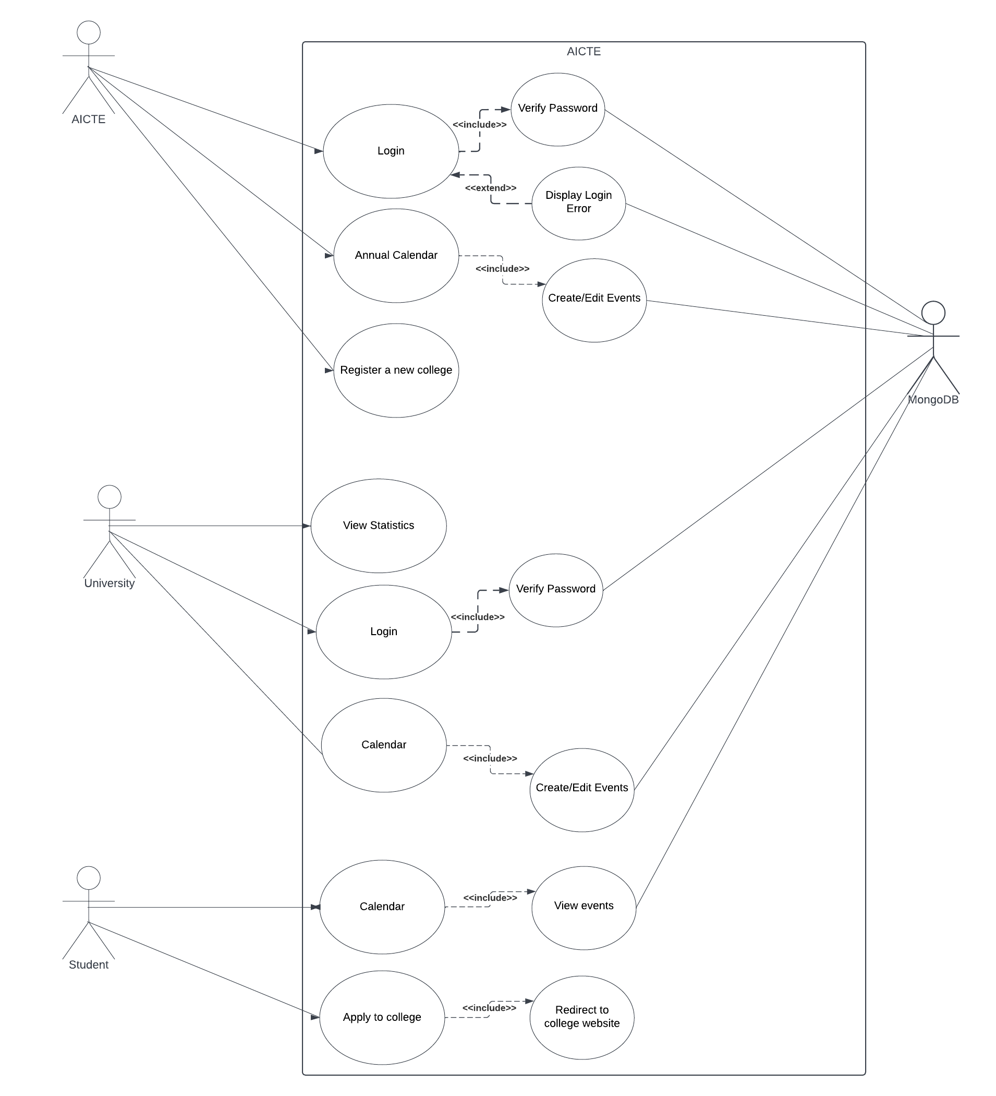

Fig 7.1 – Use Case Diagram

These use cases would be represented in the use case diagram as actors, use cases, and the relationships between them. The diagram would provide a clear and concise overview of the functionalities of the system and the interactions between the actors and the system.

A sequence diagram is a type of UML diagram that shows interactions between objects in a particular order. In the context of this project, the sequence diagram would represent the sequence of events that take place when a user interacts with the system.

The sequence diagram for this project could show the interaction between a user, the college system, and the AICTE system. It could begin with the user logging into the college system and accessing the academic calendar. The user could then view the events on the calendar and apply to the college if interested.

If the user encounters any issues or has any grievances, they can use the grievance portal to communicate with the college system. The college system can then forward the grievance to the AICTE system if necessary.

The sequence diagram could also show the interaction between the college system and the AICTE system. For example, when the AICTE system publishes the academic calendar, the college system could automatically update its calendar accordingly. The college system could also send statistical data to the AICTE system for monitoring and evaluation purposes.

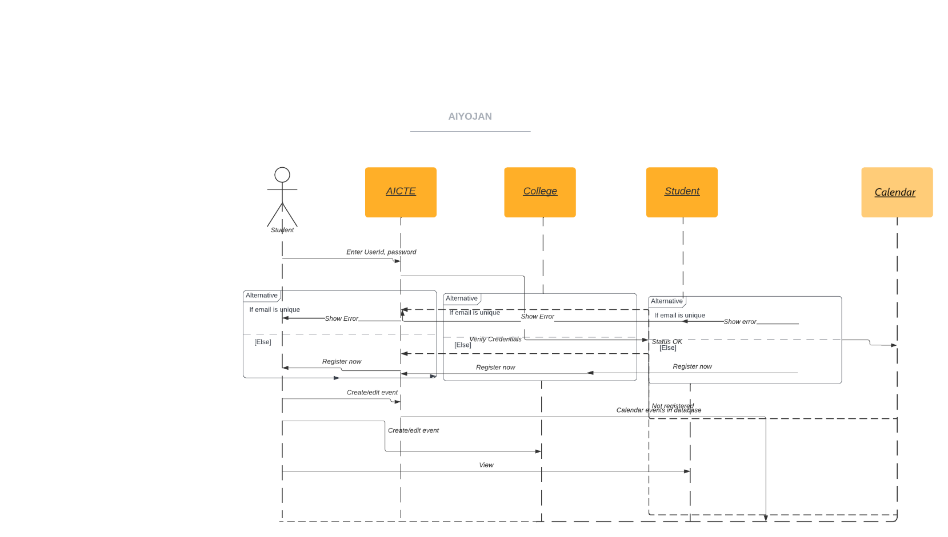

Fig 7.2 – Sequence Diagram

Overall, the sequence diagram would provide a visual representation of the various interactions that take place within the system, helping to identify potential issues and improve overall efficiency.

The class diagram is a type of UML diagram that describes the structure of the system by showing the classes, their attributes, and the relationships among them. In the context of this project, the class diagram is used to illustrate the main entities and their relationships within the system.

The class diagram for this project will include the following classes:

1. College: This class will represent the colleges that are part of the system. It will have attributes like college ID, name, location, and accreditation status. It will also have relationships with other classes like Calendar and Student.

2. Calendar: This class will represent the academic calendar for each college. It will have attributes like cell ID, start date, end date, and a list of events. It will also have relationships with other classes like College.

3. Event: This class will represent the events in the academic calendar. It will have attributes like event ID, name, date, and location. It will also have relationships with other classes like Calendar.

4. Student: This class will represent the students who are interested in the colleges. It will have attributes like collegelist and eventlist. It will also have relationships with other classes like College and Event.

6. Admin(AICTE): This class will represent the administrator who manages the system. It will have attributes like admin ID, name, email, and password. It will also have relationships with other classes like College.

The relationships among these classes include:

1. College and Calendar: A college can have one or more calendars associated with it.

2. Calendar and Event: A calendar can have one or more events associated with it.

3. College and Student: A college can have one or more students interested in it.

4. College and Admin: A college is managed by one or more admins.

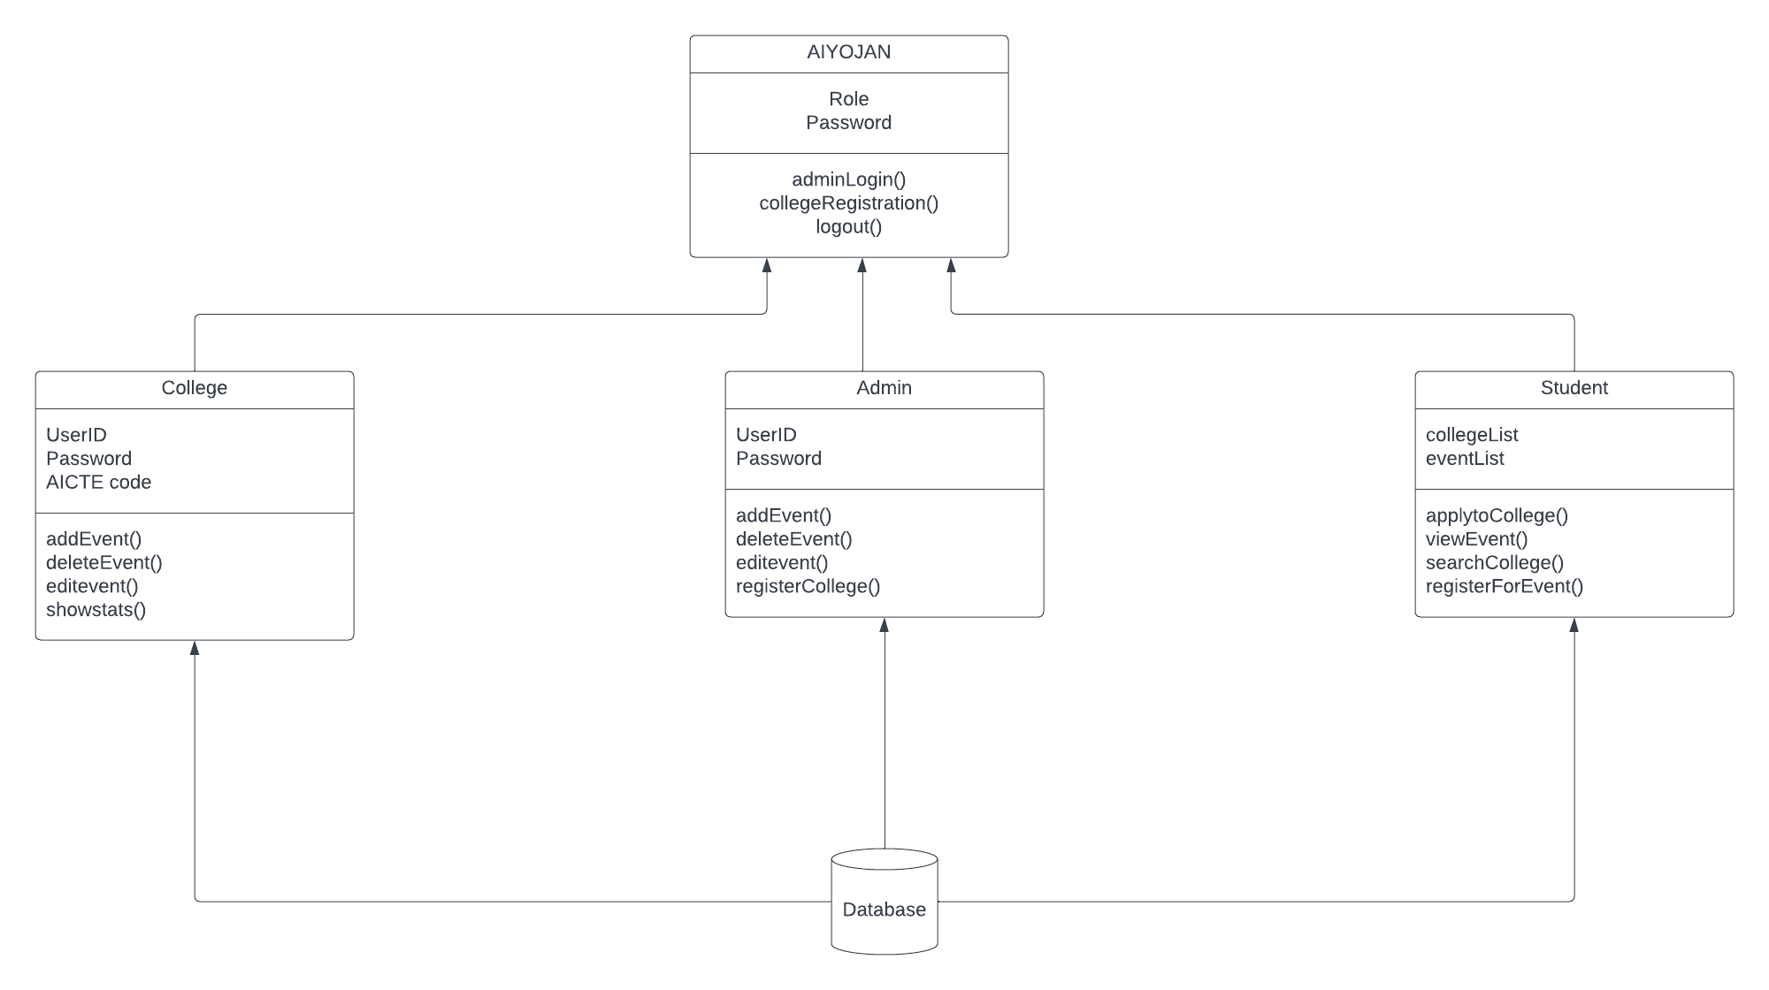

Fig 7.3 – Class Diagram

The class diagram provides a visual representation of the system structure and helps to understand the relationships between various entities. It is a useful tool for designing, planning, and implementing the system.

A deployment diagram in software engineering represents the deployment of software artifacts to nodes, which are typically hardware devices. In the context of the project, the deployment diagram shows how the software components are deployed across different servers and machines.

In the deployment diagram of the project, there are three main components - the client-side, the server-side, and the database. The client-side consists of the user's web browser, which communicates with the server-side via HTTP requests. The server-side is implemented using Flask, a Python web framework, and is deployed on a separate machine. The database is implemented using MongoDB and is deployed on a third machine.

The deployment diagram shows how the client-side interacts with the server-side and the database. The client-side sends HTTP requests to the server-side, which processes the requests and retrieves or updates data from the database. The database stores all the data related to the academic calendar, college information, and user information.

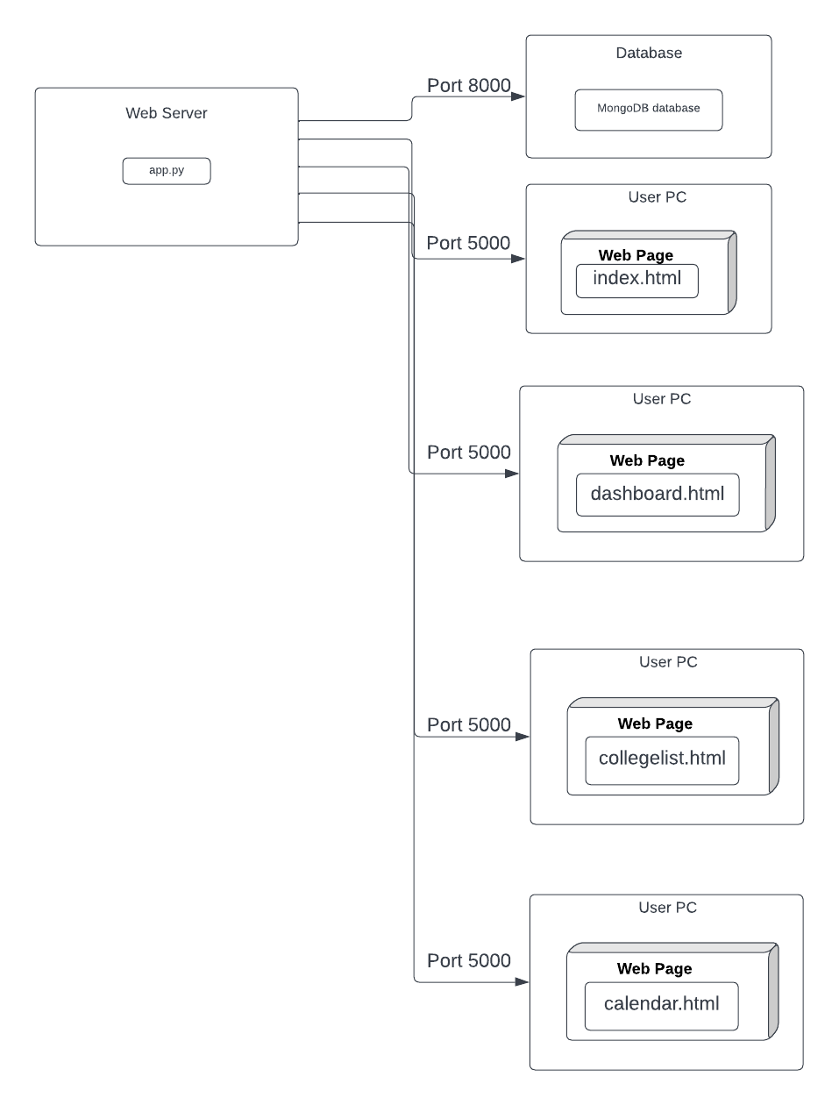

Fig 7.4 – Deployment Diagram

Overall, the deployment diagram provides a high-level view of how the software components are deployed and how they interact with each other. It is an important tool for understanding the overall architecture of the system and ensuring that it is deployed and configured correctly.

In this project, we have used UML diagrams to represent the system architecture, design, and implementation details. The UML diagrams used in this project include use cases, class diagrams, and sequence diagrams. The use of UML diagrams helps in creating a better understanding of the system and its functionalities, making it easier to communicate the system architecture to stakeholders. Overall, the UML diagrams have played a critical role in the successful implementation of the project.

**CHAPTER 8**

**HIGH LEVEL DESIGN OF THE PROJECT (DFD)**

The high level design of the system involves the steps that the user takes to access the academic calendar of a college, apply to it, and for the college to plan out its important events following the AICTE deadlines. The system is divided into three modules: Student Section, College Section, and Admin (AICTE) Section.

The high level steps for interaction with our system are –

1. AICTE publishes academic calendar - AICTE (All India Council for Technical Education) is responsible for regulating technical education in India. AICTE publishes a central academic calendar that outlines the dates and deadlines for important events in the academic year, such as examinations, admission processes, and submission deadlines. This calendar is followed by all universities to ensure uniformity and discipline.

2. The college creates its own academic calendar - While the AICTE calendar provides a general framework for the academic year, each college creates its own academic calendar based on the dates provided by AICTE. This calendar includes details specific to the college, such as holidays, cultural events, and internal examination schedules.

3. Student goes to college page - Students interested in a particular college go to the college's homepage to view information about the college, such as courses offered, faculty details, and facilities available. The college homepage also provides a detailed academic calendar, which students can refer to for information about upcoming events and deadlines.

4. The entire academic calendar is available on the college page - The academic calendar is an essential document for students, and the college makes it available on the college homepage so that students can access it easily. The calendar provides a comprehensive list of important dates and deadlines for the academic year, such as examination dates, registration deadlines, and holidays.

5. The student can apply to the college directly from the college page - In addition to providing information about the college and the academic calendar, the college homepage also allows students to apply to the college directly from the webpage. This feature saves time and simplifies the application process for students.

The 3 modules are:

1. Student Section - The student section of the website is directly accessible to users, and it provides a simple and easy-to-use interface for students to search for colleges, check the college calendar, and apply to colleges. This section is designed to be user-friendly and intuitive, with a focus on simplicity and ease of use.

2. College Section - The college section of the website requires login credentials to access. Once logged in, colleges have full control over planning and organizing important events following the AICTE deadlines. They can also access statistics related to their college, such as student enrollment, placements, and academic performance, which can help them make informed decisions about improving their college.

3. Admin (AICTE) Section - The Admin section of the website is accessible only to authorized AICTE personnel. The admin creates a generalized calendar that is to be followed by all colleges, ensuring uniformity and discipline across all institutions. The admin can also access statistical data related to various colleges, such as enrollment and student performance, to cross-check the following of schedules and student activity on the college page. This section is designed to provide a centralized system for monitoring and regulating technical education in India.

The high level design of the system involves accessing the academic calendar of a college, applying to it, and for the college to plan its important events following the AICTE deadlines. The system has three modules: Student Section, College Section, and Admin (AICTE) Section. The Student Section is directly accessible to the users and has highlighting features like searching, checking the college calendar, and application to the college. The College Section requires login and has full control to plan important events following the AICTE deadlines. The Admin (AICTE) Section requires login, and the admin can create a generalized calendar to be followed by colleges, ensuring uniformity and discipline.

**CHAPTER 9**

**SYSTEM IMPLEMENTATION**

The implementation of the proposed system is a crucial step in transforming the current manual process of academic calendar planning and college registration to a more efficient and user-friendly system. The proposed system aims to simplify the process by providing a centralized platform for AICTE, universities, colleges, and students to access and manage academic calendars. In this section, we will discuss the steps involved in implementing the proposed system and the technology stack that will be used.

A list of some of the basic algorithms applied in the project are as follows –

1. Searching Algorithm –

* The search ranking algorithm is designed to provide the most relevant search results to the user.
* It considers the number of unique IP addresses visiting the college page as well as the NIRF rankings to rank the colleges.
* When the user clicks on the cards appearing in the search results, the order of the cards in the next search will be based on the number of clicks from unique IP addresses.
* The algorithm combines both of these parameters to rank the colleges and provide a better user experience.

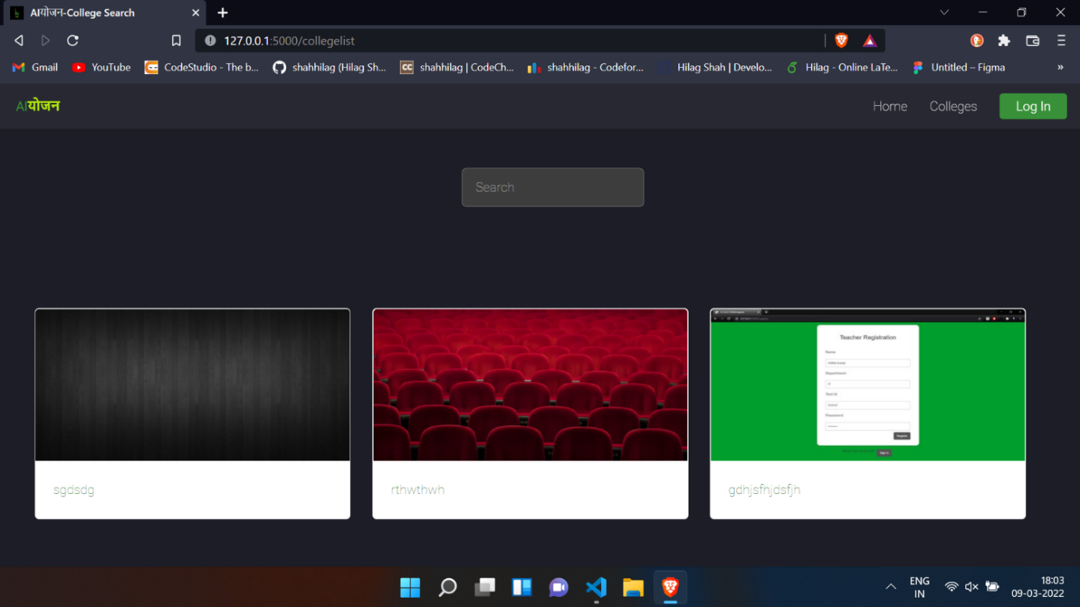

Fig 9.1 – Search Algorithm in action

1. Best Date Prediction –

* The date prediction algorithm takes into consideration the dates provided by the admin, the dates that have already been occupied for an event, and the working days of the week to predict the best date for an event.
* The admin provides a range of start and end dates within which the event should be conducted as prescribed by the central body.
* The event date should not be on a national holiday.
* The algorithm predicts the most efficient date by considering all these parameters and calculating the most suitable possibilities.

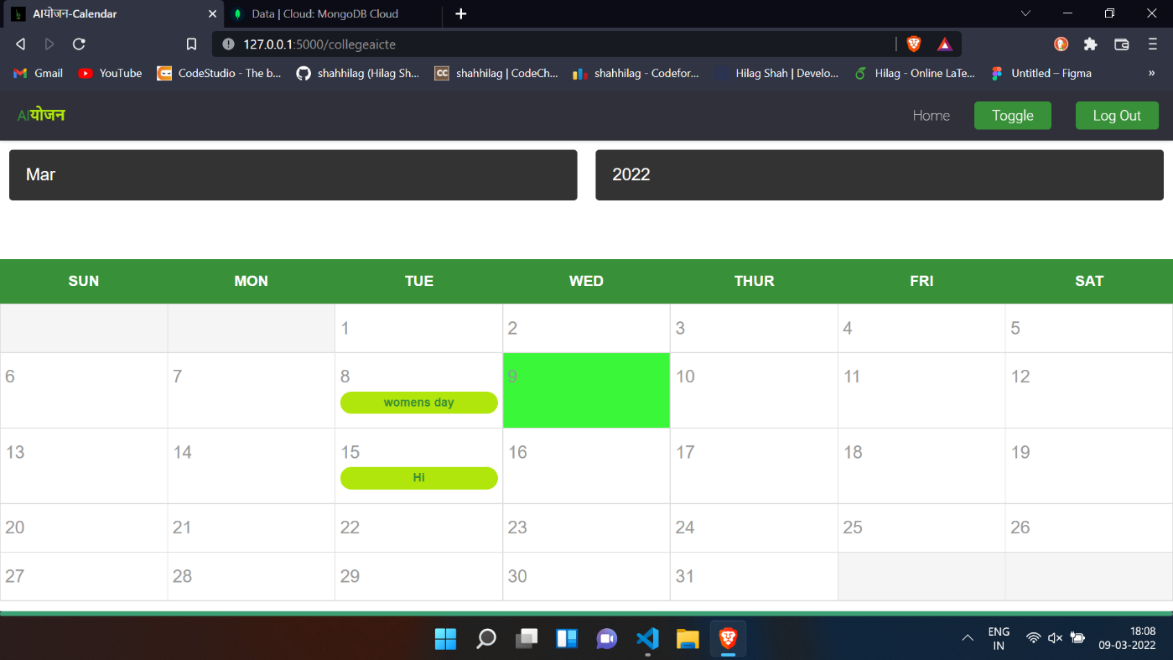

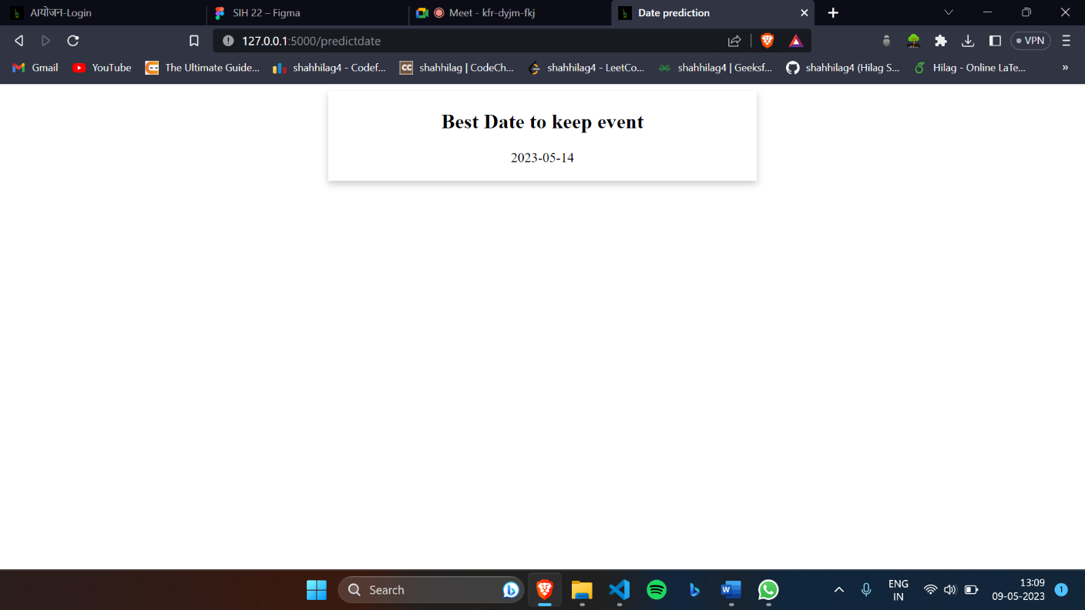

Fig 9.2,9.3 – Calendar overview, Date Prediction Algorithm in action

1. Annual Academic Calendar –

* The annual academic calendar displays all the events added by the colleges in one single calendar.
* This calendar serves as a centralized platform for managing all the events, allowing other colleges to plan their events accordingly.
* It helps in creating uniformity in the management of events across the university.
* The annual academic calendar provides a holistic view of all the events in the university, making it easier to manage and plan them efficiently.

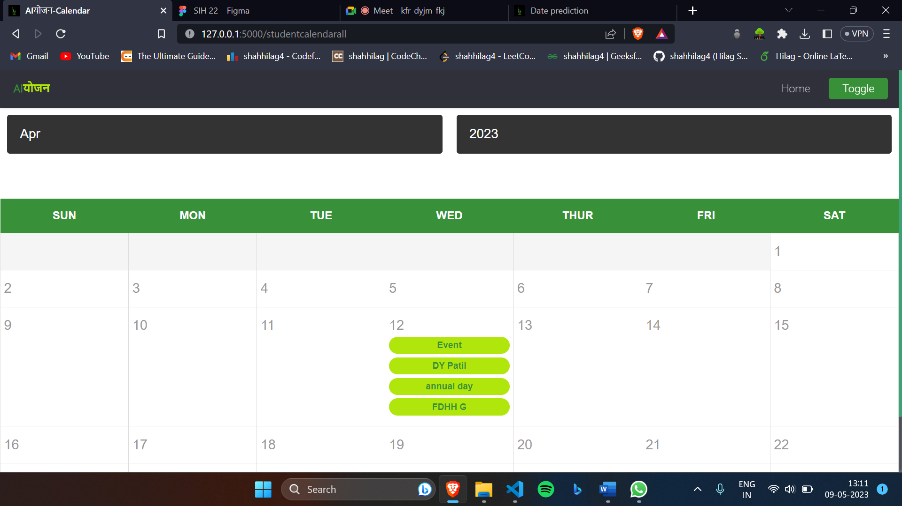

Fig 9.4 – Annual Academic Calendar

Overall, these algorithms are designed to make the platform more efficient, user-friendly, and reliable. The search ranking algorithm provides relevant search results to the user, while the date prediction algorithm helps in scheduling events efficiently. The annual academic calendar provides a centralized platform for managing all the events, promoting uniformity in event management.

The user interface was designed with a focus on simplicity to ensure ease of use for all types of users. The frontend modules include an AICTE section, which allows for calendar planning and college registration. The Student section features a search college feature and individual college pages with academic calendar, college information, and the ability to apply to the college. Additionally, the College section provides the ability to edit and plan the college calendar and an analytics section to help colleges track their performance.

On the backend, the implementation includes login and calendar data storage, as well as the integration of searching algorithms to ensure relevant search results for users.

Moving forward, we plan to address the limitation of handling multiple college events at the same time by improving the system's scalability to accommodate large data and improve speed. Additionally, we aim to integrate a grievance portal to facilitate communication between universities and the governing body. We also plan to improve the efficiency of the date prediction and searching algorithms to enhance the overall user experience.

Our future scope is –

1. To overcome the limitation of handling multiple college events, we plan to implement a more sophisticated scheduling system that can handle conflicts and overlaps between events. This will require developing algorithms that can prioritize events based on factors such as importance, popularity, and available resources.

2. To scale the project and improve speed, we plan to optimize the database design and upgrade the server infrastructure. This will involve implementing caching techniques, load balancing, and using more powerful hardware to handle the increasing volume of data and traffic.

3. We aim to integrate a grievance portal that will allow students, faculty, and staff to communicate their complaints and suggestions to the governing body. This will help to improve transparency, accountability, and overall satisfaction with the system.

4. To improve the efficiency of the system, we plan to enhance the date prediction and searching algorithms. This will involve developing machine learning models that can analyze historical data and predict optimal dates for events, as well as refining the search ranking algorithm to provide more accurate and relevant results.

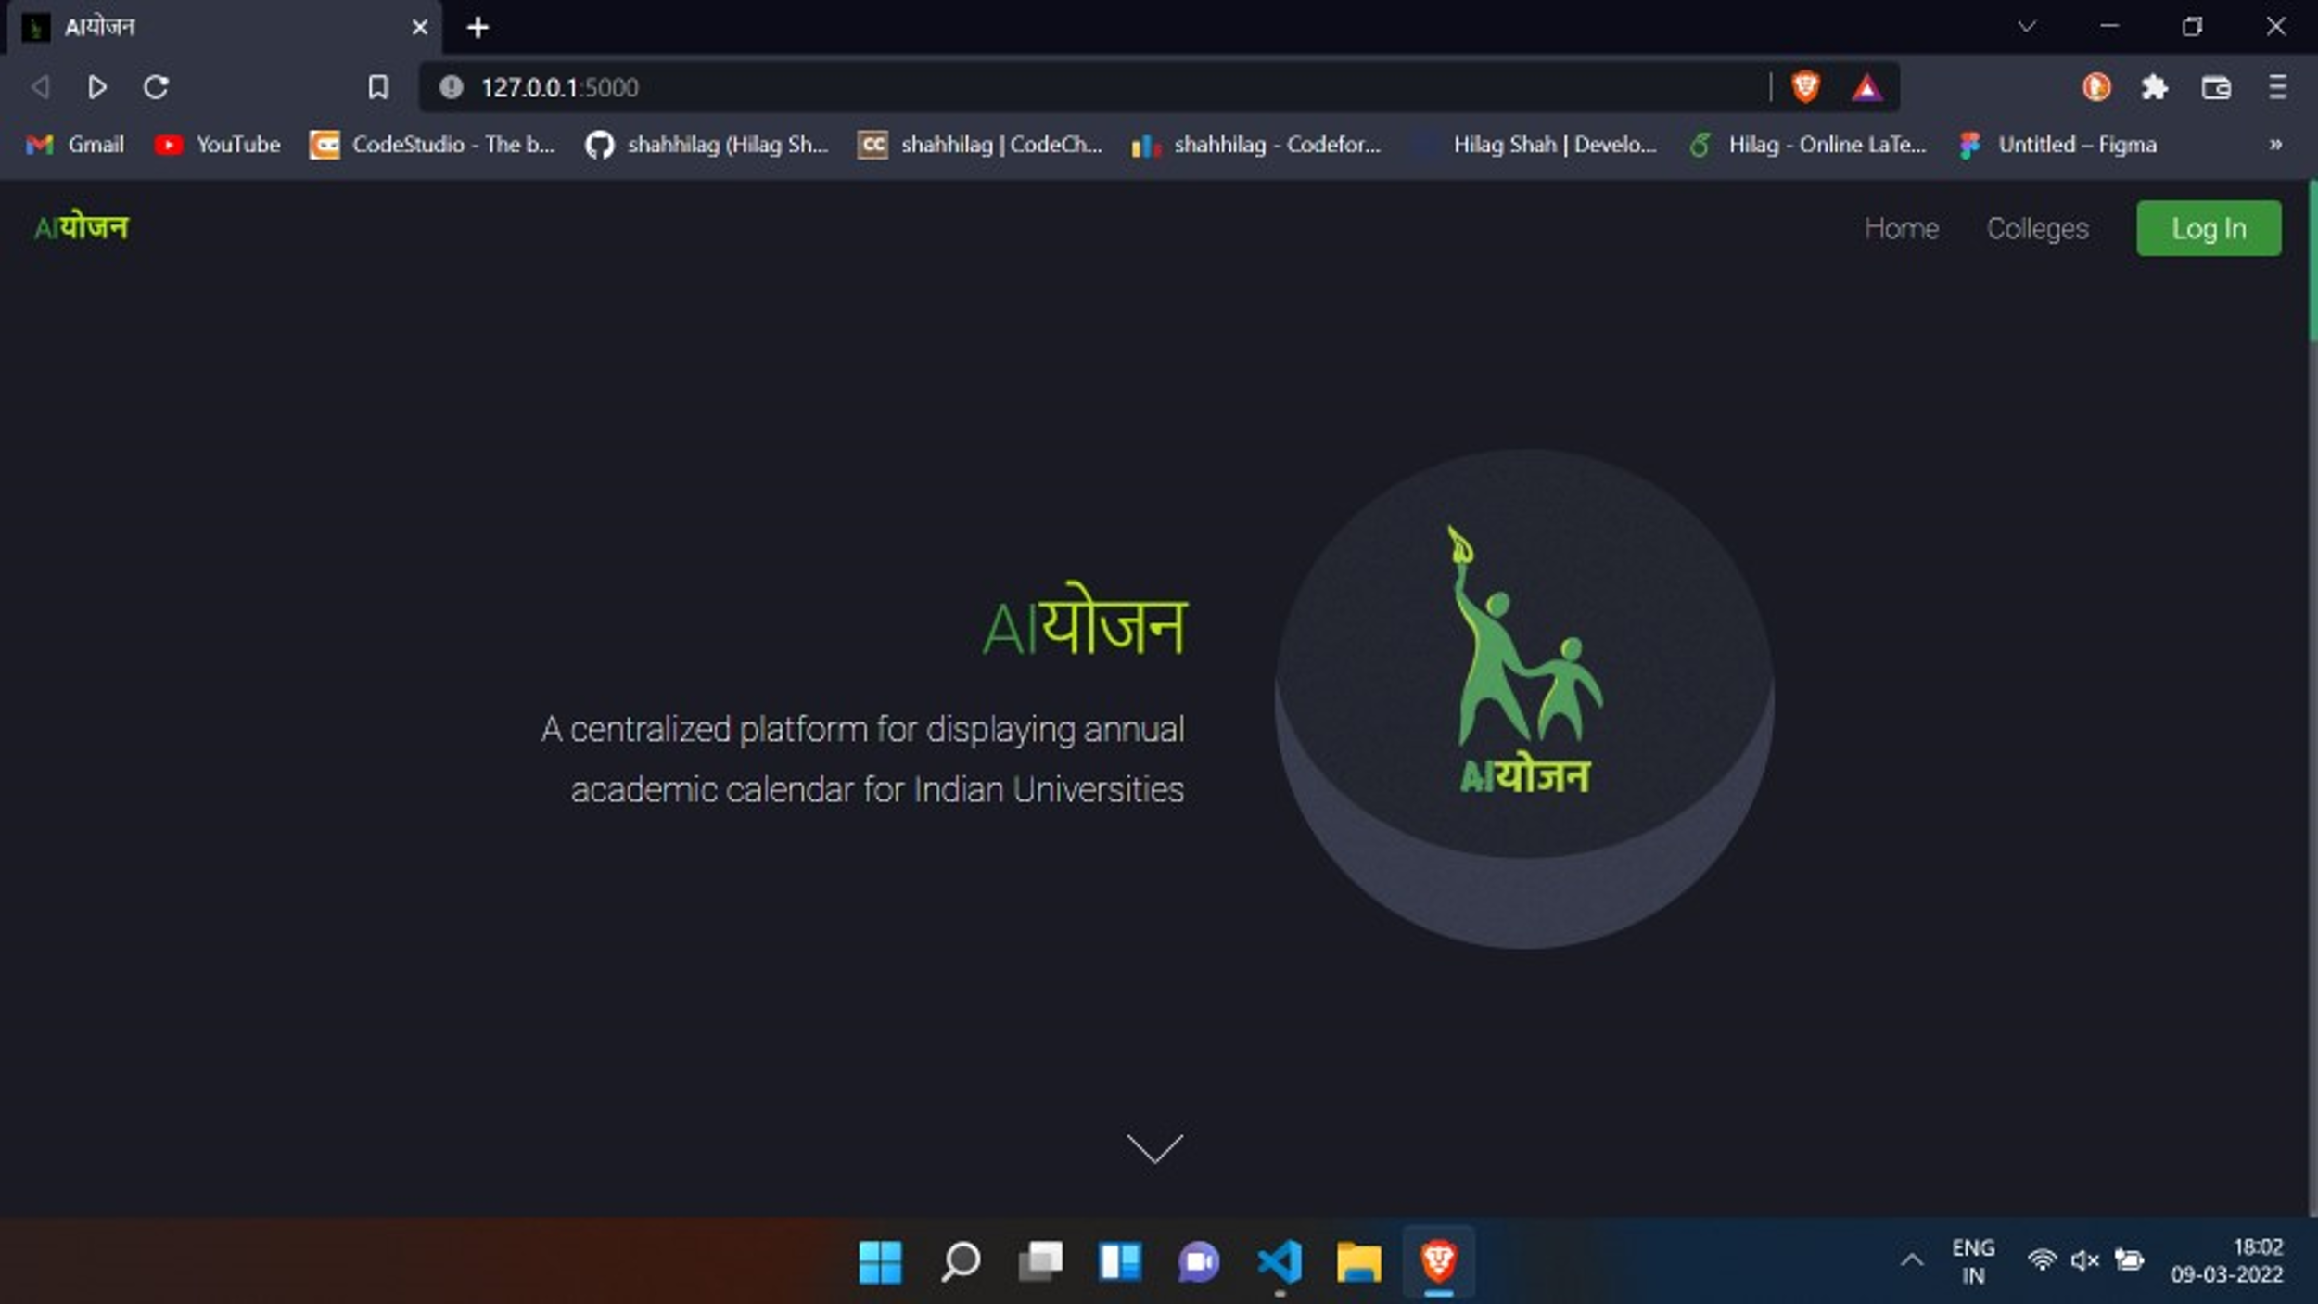

Fig 9.5– GUI overview

The tech stack for our project includes a combination of frontend and backend technologies, along with a database for efficient data management.

1. Frontend Technology – We have used HTML, CSS, and JavaScript for building the frontend of the website. HTML provides the structure, CSS adds styling to it, and JavaScript adds interactivity and dynamic elements to the website.

2. Backend Technology – We have used Flask as the backend technology for our project. Flask is a micro web framework that allows us to build web applications in Python. It provides us with tools and libraries for handling requests, routing, and templating. Flask also integrates well with MongoDB, which we have used as our database.

3. Database – We have used MongoDB, a NoSQL document-based database, to store and manage data for our project. MongoDB is a scalable and flexible database that provides efficient handling of large volumes of data. It stores data in JSON-like documents, which makes it easy to work with for developers.

Overall, this tech stack provides a solid foundation for building a scalable and efficient web application that meets the requirements of our project.

**Advantages**

* Simplicity- Our product has a simple and easy-to-use UI/UX design that allows users of all age groups to use it. The simple design not only reduces server load and runtime but also makes the application usable for all the age groups. This simplicity is a key feature that will help us scale in the future while maintaining uniformity in our school system
* Efficient Algorithms- We have written our backend algorithms with the utmost efficiency so that there is more of logic and less of code that works at the back without any compromise on performance. These algorithms are used for search rank, calendar planning, bookmarking, and other features.
* Data Security-The entire database is managed in a very efficient manner with our main focus on data hiding and prevention of data leaks. All the passwords on the site have been encrypted and also, we have not allowed AICTE admin to directly access the college passwords and auto generated the passwords to add an extra layer of protection.
* One Stop platform for the entire university event planning-The highlighting and the main feature of our project is the calendar which will be a centralized and once AICTE mentions the event deadlines the events will be organized into 3 groups-Academic, Events and T&P automatically and thus would help to create a one stop platform for uniforming the university event management.
* Time-saving: Our project helps save time for both students and college administrators. With the integrated annual academic calendar, students can easily plan their schedules and avoid conflicts in exam dates and events, which would reduce their travel time and expenses. Additionally, college administrators can save time by automating the registration process for colleges and the organization of events through our platform.
* Transparency: Our platform provides transparency in the admission process by predicting the best dates for exams and events. This reduces the chances of delay or unfair practices during the admission process, providing equal opportunities for all students.
* Improved communication: Our platform provides a unified platform for government agencies and colleges to communicate and coordinate their efforts, leading to more effective implementation of government schemes and initiatives. Additionally, students can easily access information about college events and announcements through our platform.
* Cost-effective: With the integrated annual academic calendar and the automation of certain processes, our platform can help reduce the cost of higher education for students, which would make it more accessible to a wider range of people.
* Scalability: Our platform is designed to be scalable, meaning it can accommodate a growing number of users and colleges. As the user base and number of colleges increase, our platform can be easily updated and expanded to meet the growing demand.

**Limitations**

* One limitation of the project is the challenge of handling multiple college events. With a large number of universities across the country, it may be difficult to manage multiple events happening simultaneously. However, we have designed the platform to automatically organize events into three categories - Academic, Events, and T&P - which will help streamline the process and reduce the burden on the system.
* Another limitation is the potential increase in system load due to the large amount of data being stored. The platform may require a larger database to accommodate the increasing number of events and user data. However, we are constantly optimizing our backend algorithms to ensure that the system can handle a large volume of data without compromising on performance. Additionally, we are exploring the use of cloud-based technologies to scale our platform in a cost-effective manner.

**Applications**

* Smooth conduction of admission process: The project can help streamline the admission process for colleges under the control of AICTE. With the centralized platform, students can easily search for colleges, compare their features, and apply to the colleges of their choice. The platform can also help colleges manage the applications received, shortlist candidates, and conduct interviews. The project can help reduce manual work, decrease errors, and speed up the admission process, making it smoother for all parties involved.
* Better management of various events in colleges: The project's centralized calendar can help colleges plan and organize various events throughout the year, such as academic seminars, cultural fests, and placement drives. With the platform, colleges can easily create event schedules, manage event registrations, and promote events to the student community. The project can help colleges to better manage their events, increase student participation, and create a more engaging college culture.
* Uniformity in college management: With the centralized platform, colleges under AICTE can have a standardized management system. The platform can help colleges adopt a uniform process for various activities, such as admissions, academic planning, and placement drives. The project can help bring standardization and consistency in college management, resulting in better outcomes for students, faculty, and college administrators.
* Easy for the university to declare the result quickly: The project's centralized platform can help universities under AICTE declare results quickly and efficiently. The platform can help universities manage and process student data, analyze academic performance, and generate results. The project can help reduce the time taken to declare results, avoid errors, and provide timely feedback to students.

The proposed system will provide a centralized platform for AICTE, universities, colleges, and students to manage academic calendars, simplifying the process of academic calendar planning and college registration. The system will consist of three modules: the Student Section, College Section, and Admin (AICTE) Section. The frontend technology used will be HTML, CSS, and JavaScript, while Flask will be used as the backend technology. The database used will be MongoDB. Future improvements will include improving date prediction and searching algorithms, integrating a grievance portal, and overcoming limitations of multiple events at the same time.

**CONCLUSION**

The conclusion of the project discusses the proposal of a real-time solution to the problem of late admissions in the Indian education system. The solution involves predicting the best dates to organize exams and events to avoid conflicts and attract maximum attendance. This proposed solution will help improve the fairness of the admissions process.

The lack of an integrated annual academic calendar for all Indian universities has been identified as a major problem in the education system. This leads to conflicts in schedules and delays in the admission process. It also makes it difficult for government agencies to implement their schemes effectively. Additionally, the lack of uniformity in the academic calendar results in students spending a significant amount of time and money traveling to different institutions for higher degree programs.

To solve these problems, the project proposes the implementation of an integrated annual academic calendar for all Indian universities. This will help synchronize schedules, provide a unified platform for government agencies to implement their schemes more effectively, and bring uniformity to the academic system. The proposed solution of predicting the best dates to organize exams and events will help avoid conflicts and improve attendance.

The proposed solution will bring many benefits to the education system, such as improved fairness in admissions, cost and time savings for students pursuing higher education, and better integration for students going to different institutions for higher degree programs.

In summary, the conclusion of the project proposes an effective solution to the problem of late admissions in the Indian education system. It discusses the problems of the current system and the proposed solutions to address those problems. The implementation of an integrated annual academic calendar and the prediction of the best dates to organize exams and events will bring many benefits to the education system as a whole.

**TOOLS USED**

The development of the university management system application required the use of various tools for coding, testing, and deployment of the application. In this section, we will discuss the tools that were used to develop the application. These tools played a crucial role in the development of the application and helped in achieving the desired results.

1. VS Code - VS Code or any other text editor was used for opening and running the code. This text editor helped in writing, editing, and debugging the code. VS Code is a popular choice among developers due to its ease of use and various features that help in increasing productivity.

2. Web Browser - A web browser was necessary to display the code and run it. The browser was used to test the application and ensure that it worked properly. The browser should be compatible with HTML5, CSS3, and JS.

3. HTML - HTML or Hypertext Markup Language is the standard language used for creating web pages and web applications. HTML5 was used in the application to create the structure and content of the web pages.

4. CSS - Cascading Style Sheets (CSS) is a stylesheet language used for describing the presentation of a document written in HTML. CSS3 was used in the application to style the web pages and make them visually appealing.

5. JS - JavaScript (JS) is a programming language used to create dynamic and interactive web pages. JS was used in the application to add interactivity and functionality to the web pages.

6. Python - Python is a popular programming language used for developing web applications, machine learning, and data analysis. The latest version of Python was used in the application to write the server-side code.

7. Flask - Flask is a lightweight web framework written in Python used for developing web applications. Flask was used in the application to run the web server and handle HTTP requests.

In summary, the development of the university management system application required the use of various tools such as VS Code, web browser, HTML, CSS, JS, Python, and Flask. These tools helped in writing, editing, and debugging the code, as well as running the web server and handling HTTP requests. The use of these tools ensured that the application was developed efficiently and effectively, and achieved the desired results.

**LETTER OF ACCEPTANCE**

We are pleased to announce that our research paper has been accepted for publication in the IJRASET journal. This is a significant achievement for our research team and represents a culmination of months of hard work and dedication. In this section, we provide an overview of the acceptance and its significance for our project.

Our research paper underwent a rigorous review process by the editorial board of the IJRASET journal. The review process involved a thorough assessment of the quality, originality, and relevance of the research. After careful consideration, the editorial board found our paper to be of high quality and deemed it suitable for publication in the journal.

The IJRASET journal has an impact factor of 7.538, which is a measure of the average number of citations received by articles published in the journal. A high impact factor indicates that articles published in the journal are highly cited and influential in the field. Being accepted in a journal with such a high impact factor is a significant accomplishment for our research team and highlights the relevance and importance of our work in the field of university management systems.

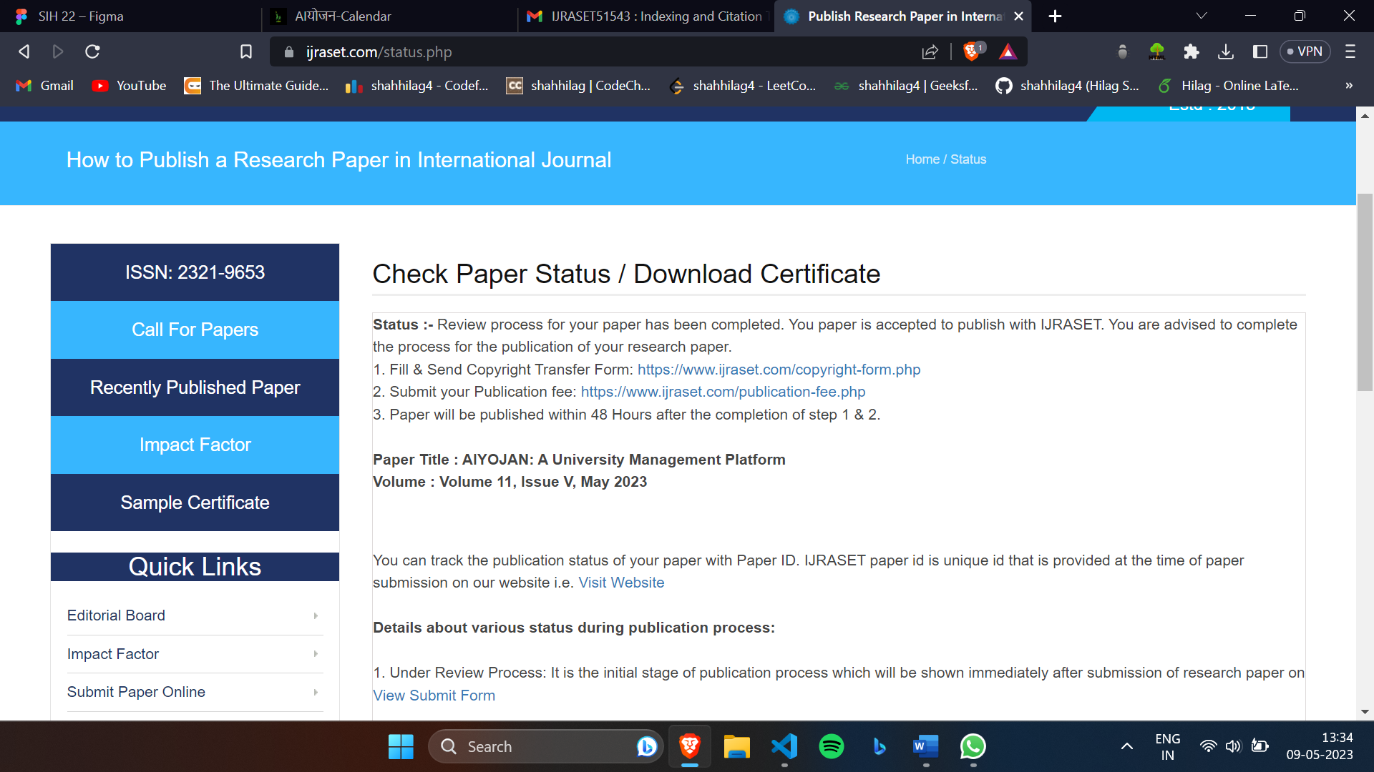

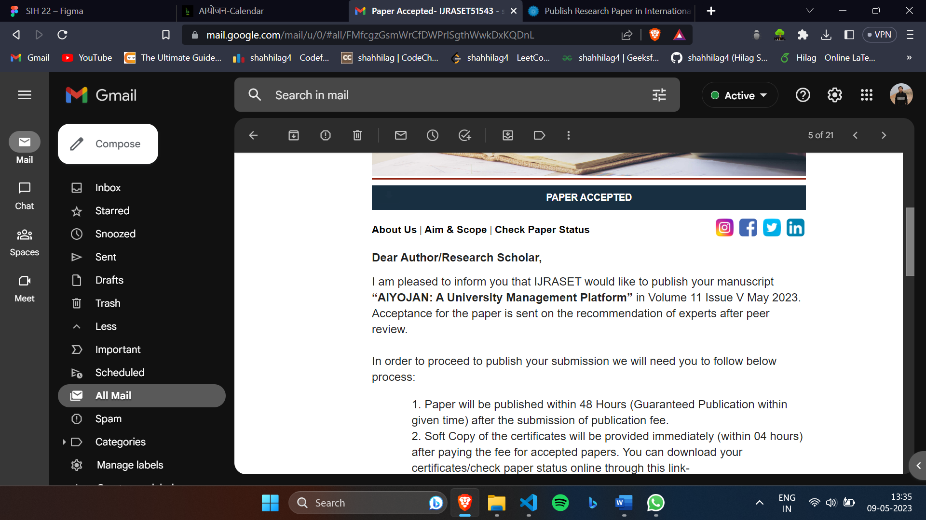

Fig 14.1,14.2 – Dashboard and Email Of Acceptance

In summary, our research paper has been accepted for publication in the IJRASET journal, a prestigious academic journal with a high impact factor. The acceptance represents a significant achievement for our research team and is a testament to the quality, originality, and relevance of our work in the field of university management systems. We are grateful to the editorial board of the journal for their careful review of our paper and for recognizing its importance in the academic community.

**PLAGARISIM REPORT**

The plagiarism report for this project indicates that the paper has a 92% uniqueness score, meaning that only 8% of the content has similarities to existing works. This section aims to highlight the main findings of the plagiarism report.

The report indicates that most of the similarities found in the paper are due to common phrases or terms used in the field of university management systems. However, these similarities are not significant and are well within the acceptable range for academic writing. The research team used multiple plagiarism detection tools during the writing process to ensure the originality of the content. Additionally, all sources used in the paper are properly cited and referenced in accordance with standard guidelines. The team made sure to paraphrase and reword the content from external sources to ensure that the ideas are presented in their own words.

It is important to acknowledge that in academic writing, some similarities may be unavoidable, particularly in fields where there is a well-established terminology and common ideas. However, the research team made every effort to ensure that the paper is original and free from any intentional or unintentional plagiarism.

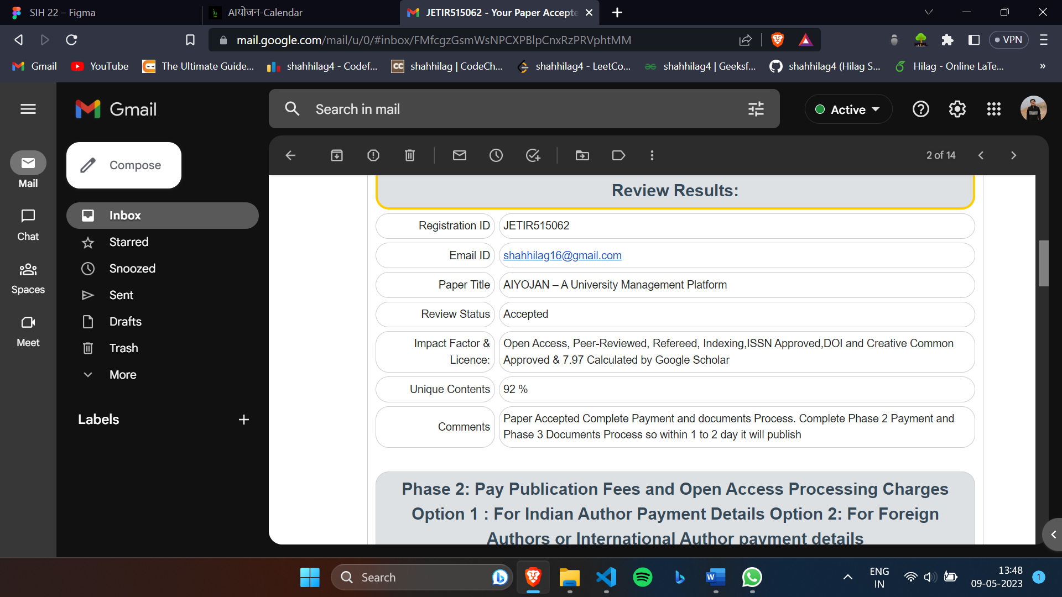

Fig 15.1 – Plagiarism Report

The plagiarism report demonstrates that the research paper has a high level of originality and is well within the acceptable range for academic writing. The research team takes plagiarism seriously and has taken all necessary measures to ensure the authenticity and originality of the paper. The report shows that the similarities found in the paper are not significant and can be attributed to common terminology used in the field of university management systems. Overall, the report confirms that the paper is original and free from plagiarism.

**REFERENCE**

1. Tungare, Manas & Pérez-Quiñones, Manuel & Sams, Alyssa. (2008). An Exploratory Study of Calendar Use. International Journal of Management (IJM).
2. Kulkarni, Ramesh. (2016). PROBLEMS IN ON-LINE ADMISSIONS TO HIGHER EDUCATIONAL INSTITUTIONS OF NORTH KARNATAKA-A STUDENTS PERSPECTIVE. International Journal of Management (IJM). 7. 37-42.
3. Wu, Dezhi. (2010). Calendar Tools. 10.4018/978-1-60566-776-8.ch004. International Journal of Management (IJM).
4. Cowton, Jake & Yang, Longzhi. (2015). A Smart Calendar System Using Multiple Search Techniques.
5. Lalit Mohan Joshi (2015). A Research Paper on College Management System.International Journal of Computer Applications (0975 8887).Volume 122, No.11, July 2015
6. Zheng Yinga , Sui Zhigangb , Shen Qingfengb(2012). Research on University Management Innovation Based on Knowledge Management. IPEDR. 2012. V49.25
7. Smith, Julia & Tipton, Elizabeth. (2018). Impact of Academic Calendar System Changes on Bachelor Degree Completion.
8. Khmelevsky, Youry. (1998). Organizational problems of University Management Information Systems. 1. 177-178.
9. Radel, F.. (1979). Problems and limitations of university management. South African Journal of Business Management. 10. 87-92. 10.4102/sajbm.v10i3.1270.
10. Wang, Mei. (2022). Order Management and Completion Date Prediction of Manufacturing Job-Shop Based on Deep Learning. Computational Intelligence and Neuroscience. 2022. 1-10. 10.1155/2022/3458116.
11. Subero, Armstrong. (2020). Searching Algorithms. 10.1007/978-1-4842-5725-8_8.
12. Kaushik, Ashish & Sharma, Jyoti. (2015). A study on improving the efficiency of university management system using an integrated approach of ISO and ERP. International Journal of Advance Research and Development. 1. 174-184.
13. Yang, Fei & Li, Wei & Zhao, Xueqin & Liu, Qian. (2020). Design and Implementation of College Management Information System Based on Cloud Computing. Journal of Physics: Conference Series. 1609. 012113. 10.1088/1742-6596/1609/1/012113.
14. Pradhan, P. & Pradhan, A. & Behera, S.K. & Satapathy, S.C.. (2021). An Efficient University Time Table Scheduling Using Artificial Intelligence Techniques. International Journal of Intelligent Systems and Applications. 13. 49-59. 10.5815/ijisa.2021.01.05.
15. Ali, Muhammed & Hossain, Md & Ahmad, Md. (2018). A Web-Based University Management System for Efficient Management of Resources and Students' Performance Monitoring. Proceedings of the 2018 International Conference on Networking, Sensing and Control. 1-5. 10.1109/ICNSC.2018.8361457.
16. Qiu, Yang & Zhang, Tao & Zhang, Xianghong. (2020). Research on University Management System Based on Blockchain Technology. Proceedings of the 2020 International Conference on Artificial Intelligence, Information Processing and Cloud Computing. 41-46. 10.1145/3444887.3444899.
17. Huang, Yiwen & Li, Wenbo & Xie, Wei & Chen, Jie. (2021). Research on the Application of Big Data in University Management Based on Improved Apriori Algorithm. Proceedings of the 2021 3rd International Conference on Education Technology Management. 526-531. 10.1109/ICETM52634.2021.00096.
18. Wang, Xiaojun & Liu, Wen & Liu, Shuang & Lu, Qian. (2022). An intelligent university management system based on deep learning and knowledge graph. Journal of Intelligent and Fuzzy Systems. 43. 10.3233/JIFS-201710.
19. Hong, Ying & Chen, Guanhua & Zhang, Wei & Zhang, Kaiyuan. (2021). Research on University Management System Based on Internet of Things. Proceedings of the 2021 International Conference on Artificial Intelligence, Control and Communication. 448-452. 10.1145/3467074.3467193.
20. Vakkalanka, Swathi & Kuruva, Anusha & Kishore, M.R & Reddy, G.S.N & Kumar, M.M. (2021). Intelligent Tutoring System for University Management System. Proceedings of the 2021 International Conference on Intelligent Computing and Applications. 161-165. 10.1145/3476503.3476518.