Experiment-1
Student Name:Raj Kumar Singh UID: 23BCS11393
Branch: CSE Section/Group: KRG-3B
Semester: 6th Date of Performance: 07/01/26
Subject Name: System Design Subject Code: 23CSH-314

- AIM : To design and understand a URL Shortener system that converts long URLs into short, unique links and redirects users to the original URL efficiently using system design principles.

- Objective:
- To study the working of a URL Shortening service
- To design APIs for shortening and redirecting URLs
- To understand functional and non-functional requirements of a scalable system
- To design a High-Level Design (HLD) for the URL shortener
- To analyze system components like database, cache, and load balancer

- Tools Required:
- Programming Language: Java / Python / JavaScript
- Backend Framework: Spring Boot / Express.js / Flask
- Database: MySQL / PostgreSQL / MongoDB
- Cache: Redis
- API Testing Tool: Postman
- Design Tool: Draw.io (for HLD diagrams)
- Web Browser
- SYSTEM DESIGN / SYSTEM SPECIFICATION:
  - Functional Requirements:
- The system shall accept a long URL from the user.
- The system shall generate a unique short URL.
- The system shall store the mapping of short URL ↔ long URL.
- The system shall redirect users to the original URL when a short URL is accessed.
- The system shall prevent duplicate short URLs for different long URLs.
- The system shall support URL expiration (optional).
- The system shall track click count (optional).

  - Non-functional Requirements:
- Scalability – Handle millions of URL requests per day
- Availability – System should be available 24/7
- Low Latency – Redirection should occur in milliseconds
- Reliability – No loss of URL mappings
- Security – Protect against malicious URLs
- Fault Tolerance – System should recover from failures
- Consistency – Same short URL must always redirect to the same long URL
  - API Endpoints Creation:
- POST Endpoint: /v1/url -> short-URL
Since this is POST request, we have to pass the body
{
longURL,
customURL ? (optional),
expirationDate
}
Now we have retrive the longURL also, we neet GET Request
- GET: /v1/url/{short-url} -> will redirect me to longURL

  - HLD(High Level Design) of URL Shortner:

Main Components:
- Client (Browser / App)
  - Sends requests to shorten URLs or access short URLs
- Load Balancer
  - Distributes incoming traffic across servers
- Application Server
  - Generates short codes
  - Handles redirection logic
- Cache (Redis)
  - Stores frequently accessed short URLs for faster lookup
- Database
  - Stores long URL ↔ short URL mappings


DEPARTMENT OF
COMPUTER SCIENCE & ENGINEERING

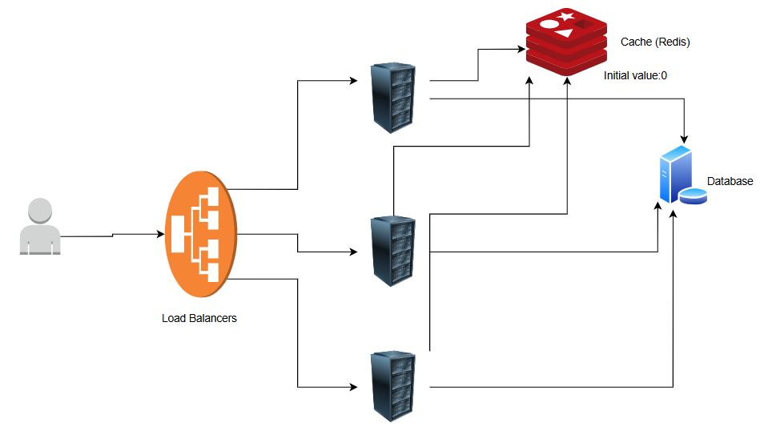

HLD Flow:
- User submits long URL
- Server generates unique short code
- Mapping is stored in database
- Short URL is returned to user
- User accesses short URL
- Cache is checked → Database fallback
- User is redirected to original URL

LEARNING OUTCOMES
After completing this experiment, the student will be able to:
- Understand real-world system design concepts
- Design APIs for scalable web applications
- Differentiate between functional and non-functional requirements
- Explain the working of a URL Shortening service
- Design a High-Level Architecture (HLD) for distributed systems
- Apply caching and database concepts effectively

